Reflective portfolio
Report - Task3

Student name: Ricardo Alexandre
Student number:2025546

Module Code: BMSW4005
Module: Professional Career Development
Assignment Title: Portfolio of work

Lecturer`s name: Dr Charles Nimoh
April 8th, 2022

Table of Contents
Introduction 2
Techniques for improving self-awareness 3
SWOT Analysis 3
Johari Window Model 4
Personality Test QI 4
Learning styles and personal learning 4
Learning Styles 5
Development training 7
Reflective models 10
Mock interview 12
UK Employment legislation 12
Alternative after graduation 14
Conclusion 15
References 16

Introduction
A reflective report is a self-analysis in which a person describes some scenes, whether they are real or imaginary. This paper provides a scenario based on the career field where I need to evaluate my skills and abilities using SWOT analysis and a Personal Development Plan.

Techniques for improving self-awareness
The ability to become the subject of one's own attention. The function of this state is to identify, process, and store information about the self (Morin, 2011).

This Photo by under Bing tool
It is crucial to know about myself that what could be doing within the organization. Knowing my strengths and weaknesses is essential in this regard. I will be able to work in a systematic toll can be one of the best tools to evaluate my own performance.

SWOT Analysis
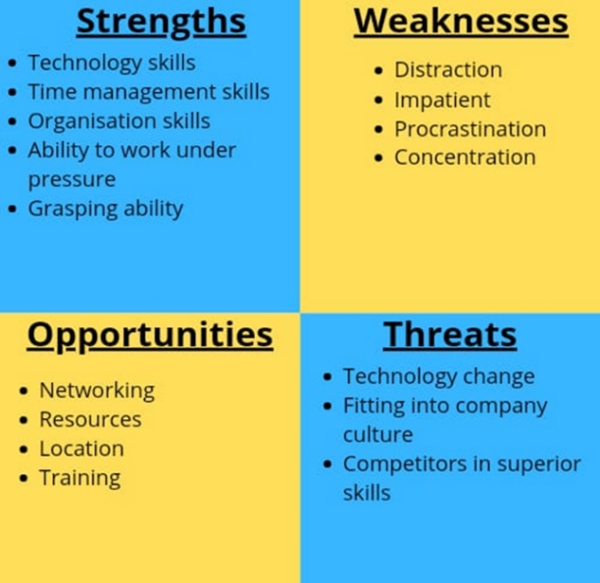
Strengths: Excellent communication and writing skills, as well as the ability to work in a team environment.
Weaknesses: Lack of time management skills and lack of computer skills.
Opportunities: Develop my leadership skills in group work, time management skills, career management skills, and IT skills.
Threats: I have difficulties communicating or writing because English is my second language.
I also disagree with certain members of the group.
SWOT is an acronym, which following these four stages. This is a tool that can provide information regarding an individual or organisation's internal strength. Ability to judge myself in the areas where I do not need to focus more (Vlados, 2020).

Johari Window Model
I aim to increase the "open self" and decrease the "unknown self." (Oliver & Duncan, 2019)
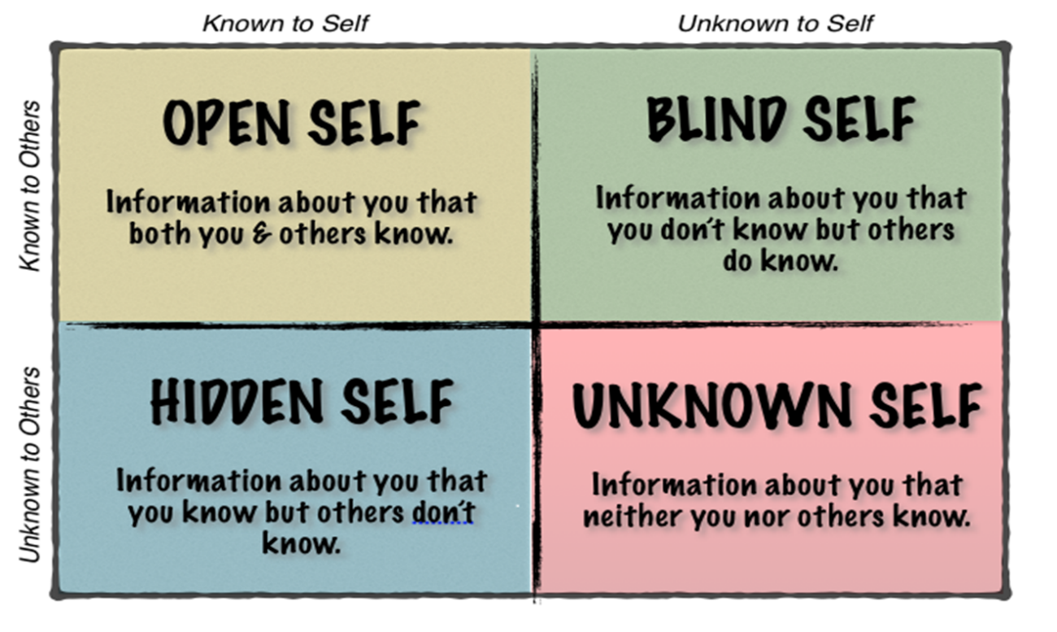

Personality Test QI
It was intending to make the psychological types described understandable and relevant.
Insights Discovery helps people work more productively, respectfully and positively even when working across virtual boundaries.
To measure an individual's propensity to act or behave in a certain manner, one needs to have a valid and reliable measure.
Learning styles and personal learning
It is my preference to learn visually and auditorily.
The use of Visual Learning allows for the ability to work with colours and pictures and to utilize the mind's eye.
Scenario as manager
I am currently employed by Wincanton Screwfix PLC; Kingfisher is a family-owned business that was incorporating more than 40 years ago. I am requiring working as a warehouse operative at Wincanton Logistic PLC. As a result of my rule, I am supervisory from managing goods In, picking, packing pallets, cages or totes manually. Having sufficient detail about the system is my duty and it is also necessary to check that the correct product has been saving from the truck.
Leadership
I must be able to set priorities and motivate my team members as a manager.
Communicating
The concept is to demonstrate self-knowledge, self-management and relationship management.
Collaborating
The key to effective communication is listening to them.
Financing
The basic principles of solid financial understanding do not require me to be an accountant to become a manager.
Critical Thinking
To succeed in management, I should have to develop everyday to better technical and functional skills.
Responsibilities
This includes recruiting, training, developing and managing staff, as well as making decisions and resolving problems (Neugebauer & Evans-Brain, 2016).

Learning Styles
Individuals differ in their learning style, which is a common concept. Neil Fleming
Diverse ways of thinking – Kolb (Vince, 1998).
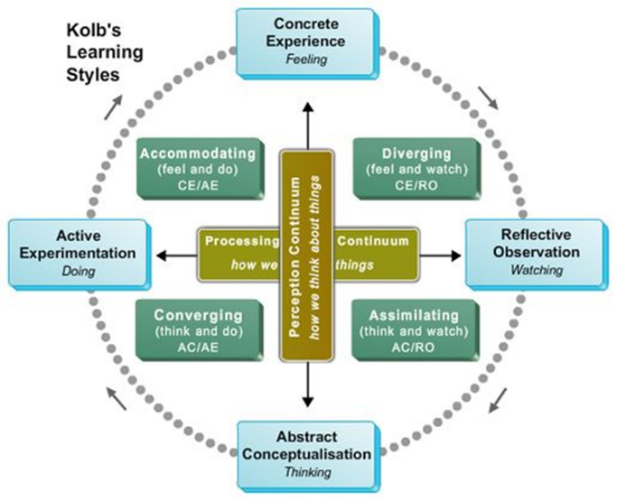
Source: Image is source by online Bing tool.
Evidence of logical analytical thinking
Questions by myself and improving task to keep customer happens. There are:
- How? Clear communicate and writing with staff to understand task.
- When? Start the shift a small brief with staff to get task done.
- Who? Manager with worker as team
- Where? At workplace or department.
- What cost? Overtime pays per hour to high special at weekends.
- Why? To achieve an intelligent and efficient outcome as a manager, it is imperative that I consider how to organise my staff and products to increase profit (Adair, 2013).

Different leaning Styles – Honey & Mumford (Ruby, 1986.).

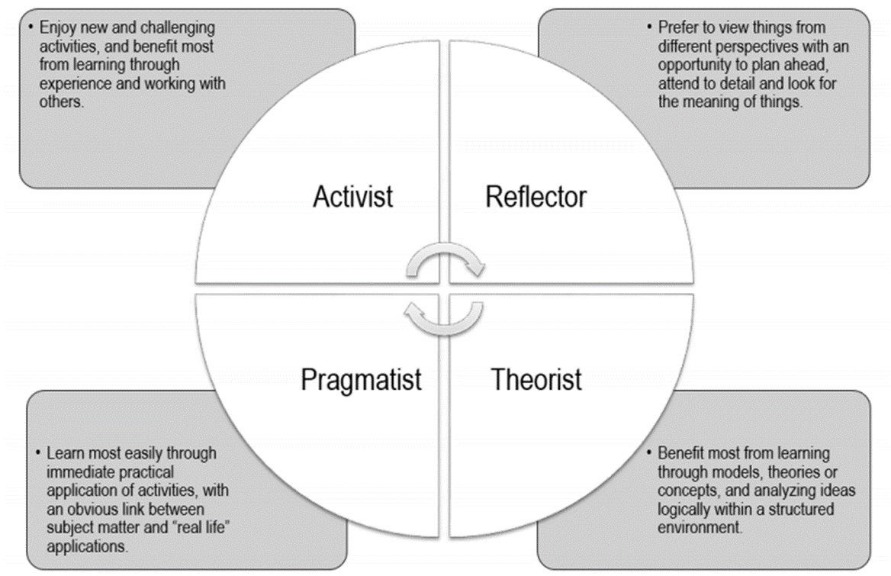
Source: Image is source by online Bing tool.

Development training
Inexperienced staff and permanent staff.
I may hear the terms used interchangeably in training, learning and development. There are differences in their emphasis, it is essential to recognise these differences:
The purpose of training is to improve current or specific knowledge, skills and attitudes that enable a person to perform the job accurately and effectively. Develop employees as a concept that is broader and longer term. Develop employees to face an uncertain future (McMurray & Leroy, 2018).

Recruitment process (Mahadevan & Yap, 2019).

Requires explaining and evaluate:
Step 1 - Planning and review.
- Select candidates overall to fit in the job.
- Forecast tools: Trend analysis, Ratio analysis and Scatter plotting (Kim, et al., 2021).
Step 2 - Strategy Development
- Recruiting challenges.
- Effectiveness of chosen.
- Effects issues and policies.
- Legal requirement associated.
Step 3 - Searching
- Development and use application Form information.
- Education, growth and stability background.
Step 4 - Screening
- Careful select candidature.
- As cost, legal obligation, performance as person in job or organisation fit.

Step 5 - Evaluation and Control
- Final selects.
- Candidate became employee.
- Offer make an offer to the candidate that in the best mutual fit.
By creating a Personal Development Plan (PDP), I can see where I want to take my career over the long term. As a result of the rapidly changing nature of the workplace, this would be deeming an advantage both short and long term. Planning, setting short-term objectives at work (Morgan, 2017).
Improve my knowledge and research more in the profession I want to further my career.
Self-managed learning is a process that allows individuals to manage their own learning and control how, when, what, why, and where they learn. I need to accept that responsibilities related to my job may not be as fulfilling as others.
To enhance my skills over the next two to three years so that I can further my career.
As a direct result of the project, the following are benefits that will be tangible, quantifiable and achievable:
- Using a more positive approach to work, I can change these things.
- To achieve my goals, I will develop a realistic view of how I should approach my work with a positive mental attitude.
- Explain how self-managing learning benefits individuals and organizations alike.
- Tell us about your experiences with self-managed learning.
- By managing my learning on my own, I can better understand and overcome obstacles at work.

The following are examples of quantifiable and measurable benefits:
Advantages | Quantified measurements
To compliance with new legislation | - To be approve by the regulatory authority  - To avoid fines
To improve efficiency and effectiveness | - Count the number of cases processed daily  - to determine staff costs
Improving public service to get better | - Improved answering inquiries  - A reduction in compensation costs
Future cost reductions | - Cost estimates for capital and operating expenses
To improve the working environment and conditions | - Public service work environment standards and guidelines
To improve communication within and beyond the organisation or company | - Based on speeding £££  - Channels of communication  - Information to be communicating clear  - Remote access capability
To reduce the amount of work required to follow up on customer complaints and errors | - At the workplace  - to minimize costs (fines?
Improved quality of information and decision making | - Faster access to information  - Diverse ways to present information  - Accuracy, completeness, timeliness, conciseness, and relevance.
Making use of innovative technologies | - Use of ICT systems, internet, intranet, and mobile communications to achieve specific business objectives.
To enable other initiatives to achieve their objectives | - Consideration of the benefits from the other projects.
Increasing staff motivation and morale | - Reduction in staff turnover, mistakes and complaints from customers.

Reflective models
Based on my module expectations, I am evaluating on my skills, qualifications, and competencies. This task includes the following learning outcomes:
- Examine the importance of continuing professional development and self-directed learning for the enhancement of professional identity and career opportunities.
- Identify my individual skills, competencies, learning styles and approaches.
- Create a professional development plan within the context of my work.
- Demonstrate a range of transferable skills for a job application in the service industry.
Action and Situation:
There are several avenues I can pursue to investigate my options regarding a career change or promotion. To achieve my professional development and skills enhancement goals, I have decided to retain the assistance of a career coach.
During the semester, I was asking by Dr Nimoh to describe the importance and benefits of pursuing further development in an organisation or company of my choice.
The following report should be complete based on the scenario above:
Evaluate critically how my abilities, competencies and experience meet the expectations of the employer in terms of competence for a particular position within a company. This includes the most appropriate developmental approach and various learning theories to develop personal and professional skills for that job. The process will also require me to evaluate the importance and benefits of continuing education for the various stakeholders and the associated requirements for professional skills within the company.
Develop measurable and clear targets for improving chosen skills, competencies, learning and training strategies within a specific work context.
Open book assessment
Would potential employers be interested in what capabilities you possess?
When candidates were seeking entry-level positions, employers used to look for those with critical thinking and critical thinking skills. New skills have been adding to this list in the past year, including self-management, active learning, resilience, and digital skills (Schafersman, 1991).
- Innovative ideas
- Participation in learning
- Possessing a working knowledge of the Internet
The graduates of the future will have to be capable of adapting to advances in technology, making digital literacy and computational thinking critical skills. The demand for SMAC (social, mobile, analytics, cloud) skills is increasing, which requires employees to be proficient in utilizing technology. The responsibility for preparing students for these positions falls to educational institutions (Laskowski, 2011 or 2012).

Mock interview
Effectively implementing the STAR process:
- Situation - Describe the issue.
- Task - Identify the responsibilities involved.
- Action - Identify the next steps.
- Results - Discuss the results.
My strengths should always be illustrating by an example. Whenever possible, I should discuss your weaknesses and show you the measures I have taken to help you overcome them.
Possess a polite manner
Referred to specific items on a resume.
It is always advisable to relate my experiences on your CV to the position.
Nevertheless, the S.T.A.R. interview process has both advantages and disadvantages if do not use it (Slep, et al., 2020).

UK Employment legislation
Employers and employees have governed by employment law.

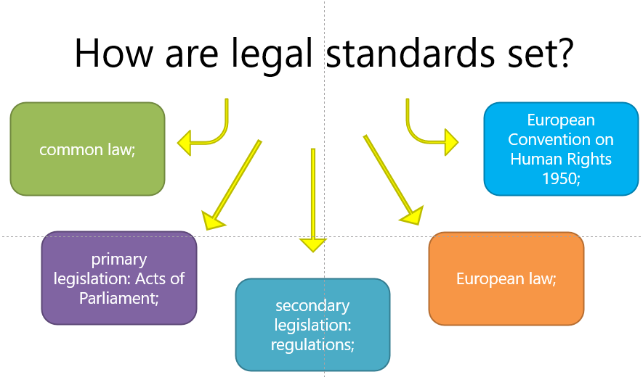
The law stipulates the responsibilities of employers and employees, as well as the rights of employees at work.
Common law has been developing by judges, courts and similar judicial bodies and is also known as case law or precedent.
Acts of Parliament constitute primary legislation. Existing legislation may be repeating, or existing obligation be reversing. This is how new rights and duties are granting.
The legislation made by statutory instruments is referee to as secondary legislation. They are fails before Parliament for approval in a simpler process than passing an Act.
European law - Directives and Court Rules.
European Convention on Human Rights 1950 - From 2 October 2000, this Convention was incorporating into law in the United Kingdom through the Human Rights Act 1998.

Employment law come to follow (Miller & Steele, 1993).
Protected Characteristic | People & Rights | Rules & Law
Recruitment staff | - Any age  - Disability  - Race  - Gender  - Religion  - Sex  - Status  - maternity | - Equality Act 2010
Employment contract | - Sundays  - Time off  - Suspension  - The right to workers | - ERA  - Employment Rights Act 1996
Data protection | - Data protection  - The right of private  - Penalties | - GDPR (Voigt & Bussche, 2017).  - General Data Protection Regulation  - Data Protection Act 1998
Pay and holidays intitle | - Agreement between employer and worker.  - Full time 28 days a year  - 5.6 weeks | - Inside the UK  - Working Time Regulations 1998
Working time | - Average of 48 hours  - 8 hours per day | - Working Time Regulations 1998
Heathy and safety job | - Assessment of risks  - Publication of a health and safety policy  - Nomination of a health and safety representative  - Training and informing people about safety | - Obligations relating to health and safety  - 1974 Workplace Safety Act
Discrimination | - Public areas  - Employer areas | - Equality Act2010  - Equality and Human Rights Commission  - European Union Legislation
Discipline and grievance | - Issues at work  - Workplace and relationship  - Formal Form | - Employment Act 2008 and Employment Tribunals
Dismissals and redundancies | - Unfair dismissal  - Wrong dismissal fixed term contract ends  - Employment`s conduct  - Guidance unfair dismissal | - Employment Rights Act 1996  - Case law

Alternative after graduation
I know, what path I will following by the next stage:


Source: Image is source by online Bing tool.

Path 1-Further Education
- Graduate
- Qualifications in the field of work
- Qualified professional
Path 2-Finding Employment
- Qualified job
- Internships
Path 3 -Become Self-employed
- I can juggle and manage all the responsibilities and uncertainties.
- Longer hours, no day off and feel the pressure of work.
Which is Path 1, I choose is Further Education and prospects about the university courses. It may not be necessary for me to obtain a postgraduate degree depending on my profession, but if you are seriously interested in studying an area of my undergraduate studies in more depth, I should consider this option. In cases, I could benefit from better employment and professional advancement prospects and a pay increase. Moreover, I may be interested in studying abroad to broaden my experience and cultural knowledge.

Conclusion
This term has afforded me the opportunity to improve and learn Personal skills, which are vital to what today's managers are looking for in graduate students. My objective in this self-analysis report is to identify the skills I have improved the most and those I need to improve more. Communication, writing skills, and group working skills are areas where I have seen the most improvement. I will be able to improve my relationships and increase my productivity by cultivating this characteristic.

References
Adair, J., 2013. Decision Making and Problem Solving. 2nd ed. London: Kogan Page.
Kim, E., Fiore, A. M., Payne, A. & Kim, H., 2021. Fashion Trends. In: 2nd ed. Analysis and Forecasting. Bloomsbury: Bloomsbury Academic, p. 184.
Laskowski, N., 2011 or 2012. SMAC (social, mobile, analytics and cloud), California: TechTarget.
Mahadevan, A. & Yap, M. H., 2019. Impact of Training Methods on Employee Performance. Journal of Business and Management, 21(10), pp. 7-14.
McMurray, A. & Leroy, S., 2018. Prepare Employees for an Uncertain Future. [Online]
Available at: https://www.nbs.net/articles/prepare-employees-for-an-uncertain-future
[Accessed 18 September 2018].
Miller, K. & Steele, M., 1993. Employment legislation: Thatcher and after. Wiley Online Library, 24(https://doi.org/10.1111/j.1468-2338.1993.tb00675.x), pp. 224-235.
Morgan, P., 2017. In: 1, ed. The Business Student's Guide to Study and Employability. 1 ed. London: SAGE, p. 204.
Morin, A., 2011. Self-Awareness Part 1: Definition, Measures, Effects, Functions, and Antecedents. John Wiley & Sons, 5(https://doi.org/10.1111/j.1751-9004.2011.00387.x), pp. 807-823.
Neugebauer, J. & Evans-Brain, J., 2016. Employability: Making the Most of Your Career Development. https://dx.doi.org/10.4135/9781473996694.n5 ed. s.l.: SAGE Publications Ltd.
Oliver, S. & Duncan, S., 2019. Editorial: Looking through the Johari window. Research for All, 3(DOI https://doi.org/10.18546/RFA.03.1.01), pp. 1-6.
Ruby, 1986. Honey and Mumford Learning Styles. [Online]
Available at: https://www.eln.co.uk/blog/honey-and-mumford-learning-styles
[Accessed 08 01 2017].
Schafersman, S. D., 1991. AN INTRODUCTION TO CRITICAL THINKING. [Online]
Available at: https://facultycenter.ischool.syr.edu/wp-content/uploads/2012/02/Critical-Thinking.pdf
[Accessed 14 02 2022].
Slep, A. M. S. et al., 2020. Evaluating the Effectiveness of NORTH STAR. Springer Nature, Issue tps://doi.org/10.1007/s11121-020-01156-w, p. 949–959.
Vince, R., 1998. Behind and Beyond Kolb's Learning Cycle. SAGE Journals, 22(https://doi.org/10.1177/105256299802200304), p. 304–319.
Vlados, C., 2020. SWOT analysis: A framework for comprehensively evaluating drivers and barriers to renewable energy development in significant countries. Elsevier, 6(https://doi.org/10.1016/j.egyr.2020.07.007), pp. 1838-1864.
Voigt, P. & Bussche, A. v. d., 2017. The EU General Data Protection Regulation (GDPR). DOI Ed. s.l.: Springer, Cham.

