Marketing plan written for

GRAND HOTEL
__________________________________________

Student Name

RENATA GUBANIOVA
_________________________________________________

Student ID number

2021116321

___________________

Marketing Essentials BMIH4005

Lecturer

Dr. Jayne Griffith-Parry
________________________________

Introduction

Grand House- Relais & Chateaux is in the Algarve’s eastern most corner, nestled across the river from Spain. Opened in the booming 20s as a historic hotel. Developing the first five-star hotel in the historical town of Villa Real de Santo Antonio. Is one of the kind sensual mixture of individuals, areas, and skills. It’s a fine collection of private comfort boutique, glorious history, and structural design. Purpose of this marketing plan is to attract new customers after the pandemic and lockdown. Reassure the guests about the safety aspect through the marketing plan. Marketing arrangement is a combination of controlled marketing variables that company uses to achieve required number of sales on a target market (Kotler 1988, 67)

- Marketing Mix

Product – Grand house recently providing Grand autumn flashes, Cheerful season, Christmas offers for eve dinner, Grand early bird special, Personalized golf experiences, Grand family sanctuary.

Price - Best fees offered for the early on booking. To preserve the most excellent possible position of the travel website. Certainly not miss an opportunity to sell competitively, market need has a great impact on room pricing. Price information will be given verbally or displayed on the internet and on an advert.

Place – Distribution is about how a business gets its the products to customers, this can be done immediately or service provider or using indirect channels at right time and place. Online travel agencies (OTAS) digital program that link up clients with travel suppliers will be used
. Hotel and information will be visible and available on a website Foursquare, Travel by Interest and Google.

Promotion – The organisation will be promoted on a website such a TripAdvisor, Hotel social media advertising, Hotel email marketing. Advertised on Google Hotel Ads and LinkedIn. Also, the video advertising is now more powerful then ever so content is easily viewed shared and interacted with, YouTube is great for that purpose. The achievement of a direct mail promotion campaign essentially varies on good aim for.

- The Marketing Environment (Micro-SWOT)-SWOT analysis Armstrong (2007 pg. 65) defines the microenvironment as performers impacting a company's ability to serve customers. The aim of the analysis of the microenvironment is to identify the basic operating forces that act in the industry and affect the activities of the company. The main micro-environmental causes for hotel are media, customers, suppliers, company, demographic environment. Hotel benefit from their amazing location and excellent reputation and loyal customers. Reputation is very important for marketing strategy; hotel appraisals have an immediate effect on hotel demands. Weakness coming in different formats and is very important to understand the problem and deal with it. The major move in marketing strategy is to recognise what the competitors do better and acknowledge what clients have highlighted in negative review. We must remember that comparing and categorising those factors is very subjective and what seems first as a weakness or threat it could be the opportunity for the organisation. The opportunities in hotel are factors that could improve reservations, raise client satisfaction results, or boost up the profile of the hotel. Threat now in general after the pandemic is almost equal for any organisations. Effects of the current crisis, prolongation of return crisis measures.

- The Marketing environment (Macro) PESTEL- Kotler (2009 pg. 48) states that recent marketing thinking that all businesses are in fact service companies and that we need to use a services point of view for marketing as the focus. PESTLE is a current topic in learning and training, organisation development and marketing courses as it underpins the meaning of think about the effect of outside powers on a range of plans for change (CIPD Pestle analysis) It can also highpoint the potential for extra costs, and quick further explore to be manufactured into upcoming plans. Macro environment is a problem what organisation can’t control it but can have a massive impact on organisations. The main factors are Political Economic Technological and Sociodemographic. Factors manipulating running a hotel are allowed regulation entrepreneurship and tax policy. The hospitality business is naturally extremely vulnerable to sensitive differences in the external environment (Baud-Bovy, 1982) and its operation is affected by various external factors such as political crises, terrorism, real catastrophes, and economic insecurity (e.g., Papatheodorou et al., 2010; Song and Lin, 2010; Chen et al., 2005; Leong and Hui, 2014). Macroeconomics impacts the growth of the company. Tourism is very delicate about adjustments in agricultural science and economic ground. People limit products consumption of economic recession in this case. One of the economic aspects which is observed is being short of a job, standard gross wage. Happy guest has tendency to come back. The higher the level of living is the higher need for relax, sport, free time services.

- Creating Customer Value & Engagement. As Jean-Baptiste Alphonse Karr a French critic, journalist and novelist said …” The more things change the more they remain the same “To find out what customers want these days and are searching is not difficult you can use the survey it works by asking them questions. Meeting them and tracking their answers it’s another option calling or skyping. Emailing them and asking them simple questions after they purchased or signed up for your service. The aim is to put itself in the shoes of its customers and give it what it wanted. Currently, clients have a developing environmental understanding, environmental theories, and a growing desire for sustainability (e.g., Frank & Brock, [14]). Service firms and tourism destinations can compete by establishing environmental concerns, adding environmental dimensions to their profile, and contributing to environmental protection (Kotler, [29]). Client commitment and related actions can be identified as the 'customers' behavioural expression (...), beyond purchase, resulting from motivational drivers' (van Doorn et al., [61], p. 254). As a valuable aspect of relationship marketing engagement considers many clients behaviour forms that go beyond the straightforward purchase, because it expresses in behaviours such as writing reviews and sharing word of mouth (Fehrer, Woratschek, Germelmann, & Brodie, [12]). Email marketing, social media marketing, WOMM, Offline Online Advertising will be used. Pete Druckers says; There are only two things in a business that make money Innovation and Marketing. Everything else is cost (January 2021)

- Effective Use of digital Marketing -Pandemic make a big flag how powerful is the digital marketing. Now people use the internet for everything, the internet has the answer to your every question. Not only food water are the basics needs of human also the internet…is the latest add-on to this list. Controlling digital action is all about handling the involved power of millions of net users to benefit the business (Heyman et al, 2009 pg. 17). Since quality constantly trumps quantity, it’s better to select two or three networks and post high quality, engaging content consistently rather than spreading over more channels and post low-quality content. Facebook, Instagram, Tic Toc will be used the most for the hotel Grand. Improving hotel visibility on Google will attract more client to the website. Boosting the conversion rate of website to improve direct booking. Electronic billboards are the one of the most successful methods to achieve and connect with clients in traffic or high football areas. Music venues theatres cinemas or housing buildings are great opportunities for showcase of the brand. Radio and tv is great digital use of marketing. The message to attract new customers will be clear visible the dynamic display solution will catch viewers attention any time of a day in any weather.

Conclusion – “To be working and valuable the relationship profits have to exceed the cost of the relationship “([29] Kotler et al., 2002). The client who comes to individual hotel, comes with an awareness that him/her and stuffs will be safe and protected through stay at hotel. (Education, Hotel Front office 2020) Make sure that provides safe feeling away from home. Strong employee attitudes, excellent customers service and best conversations with customers. Focusing on competitors the product should stand out from competitors, offering outstanding quality and safety. Investing in great social media and content production management. Used of someday bookings as well. Segmenting the market targeting best customers and find out what is it that makes the hotel stand out. Focusing on the emotional connection with the service brand or product and solve customers problem by providing them with genuine benefits. Since the hotel is far from the airport there will be offered for free the concierge helicopter transport, with the drink of their choice and preferred newspapers and magazines waiting on board. Offering free spa and relaxing massages to relieve stress. Package with free bottle of champagne for reconnect people, people taking time to connect with partners. Free cookery session with famous chef.

References

Armstrong G, P Kotler (2007)” Marketing an introduction “Upper Saddle River,N.J,;Pearson/Prentice Hall;8TH ed.

M. Baud-Bovy; “New concepts in planning for tourism and recreation
Tour. Manag.,” 3 (4) (1982), pp. 308-313

Marketing Channels Your Small Business Should Utilize
There are several marketing channels your small business can try. We break down the different marketing channels available to make your campaign a success.
https://www.fool.com/the-blueprint/marketing-channels/Peter Drucker

van Doorn, J., Lemon, K., Mittal, V., Nass, S., Pick, D., Pirner, P., & Verhoef, P. (2010). “Customer engagement behavior: Theoretical foundations and research directions.” Journal of Service Research, 13 (3), 253 – 266.

Fehrer, J. A., Woratschek, H., Germelmann, C. C., & Brodie, R. J. (2018).” Dynamics and drivers of customer engagement: Within the dyad and beyond”. Journal of Service Management, 29 (3), 443 – 467.

Heyman,Leland,Bob (2009); “Digital engagement:Internet marketing that captures”,American management association

Kotler,P(2009) “Marketing management, “Pearson Prentice Hall.

Kaar,Pijl,Wijnen et al.(2020)Business model shifts: “Six ways to create next value for customers “

Kotler,P(1988)”Upravljanje Marketingom,analiza”,planinranje,kontrola,Informator Zagreb

Kotler, P., Armstrong, G., Saunders, J. and Wong, V. (2002), “Principles of Marketing”, Pearson Education, Prentice-Hall Europe, London.

Kotler, P. (2011). “Reinventing marketing to manage the environmental imperative”. Journal of Marketing, 75 (4), 132 – 135.

Frank, P., & Brock, C. (2018). Bridging the intention–behaviour gap among organic grocery customers: The crucial role of point-of-sale information. Psychology & Marketing, 35 (8), 586 – 602.

A. Papatheodorou, J. Rosselló, H., Xiao Global economic crisis, and tourism: consequences and perspectives J. Travel. Res., 49 (1) (2010), pp. 39-45

PESTLE analysis

https://www.cipd.co.uk/knowledge/strategy/organisational-development/pestle-analysis-factsheet#gref

Safety and Security Tips for Hotels
“Home » Safety and Security Tips for Hotels https://bngkolkata.com/safety-security/”

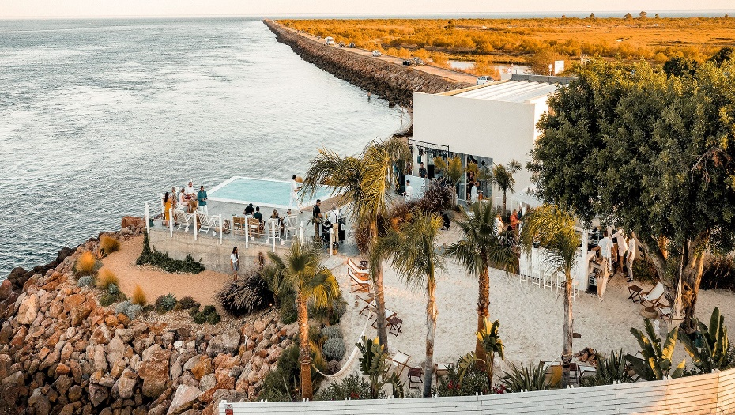

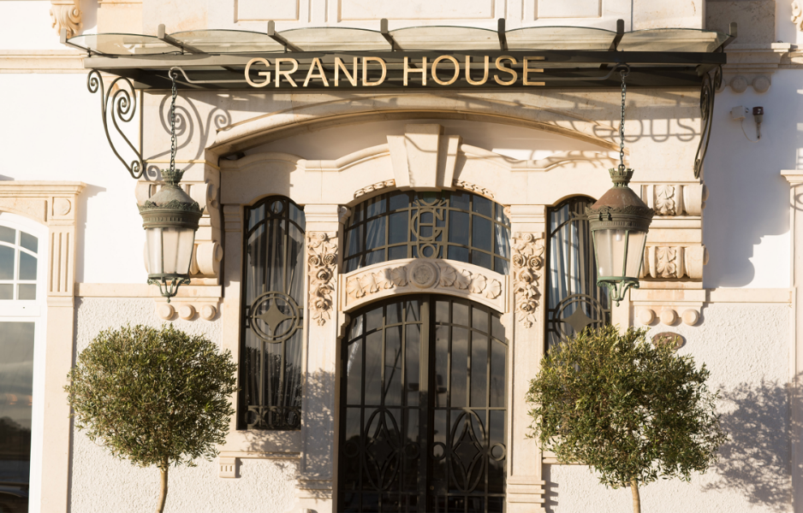

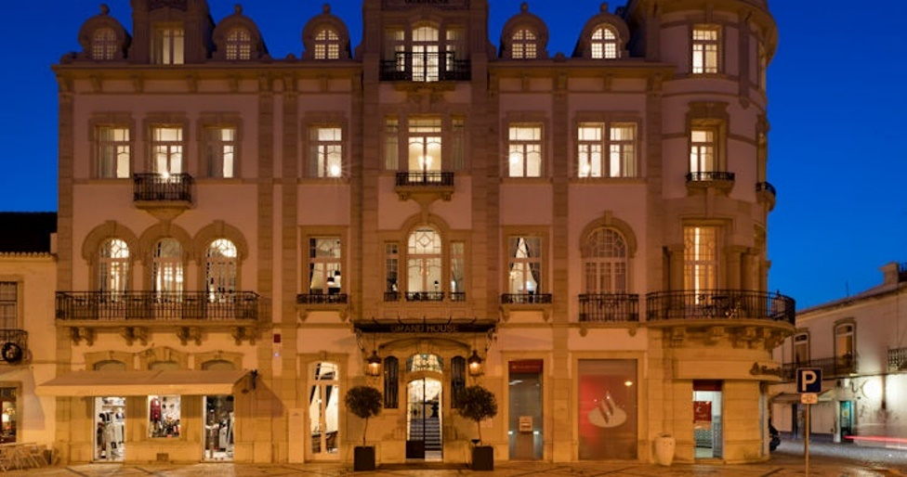



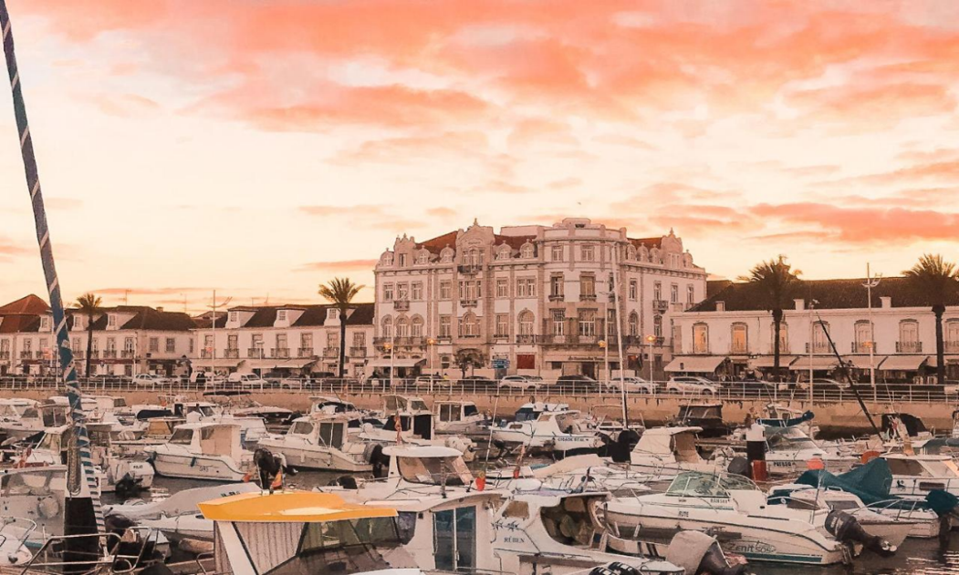
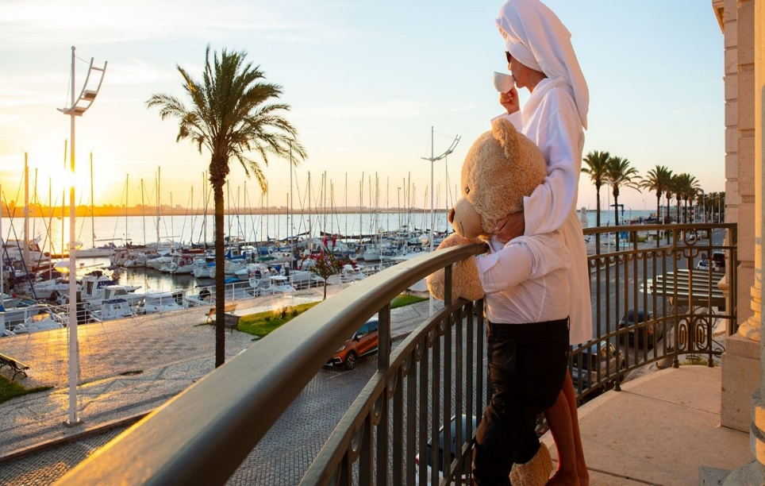

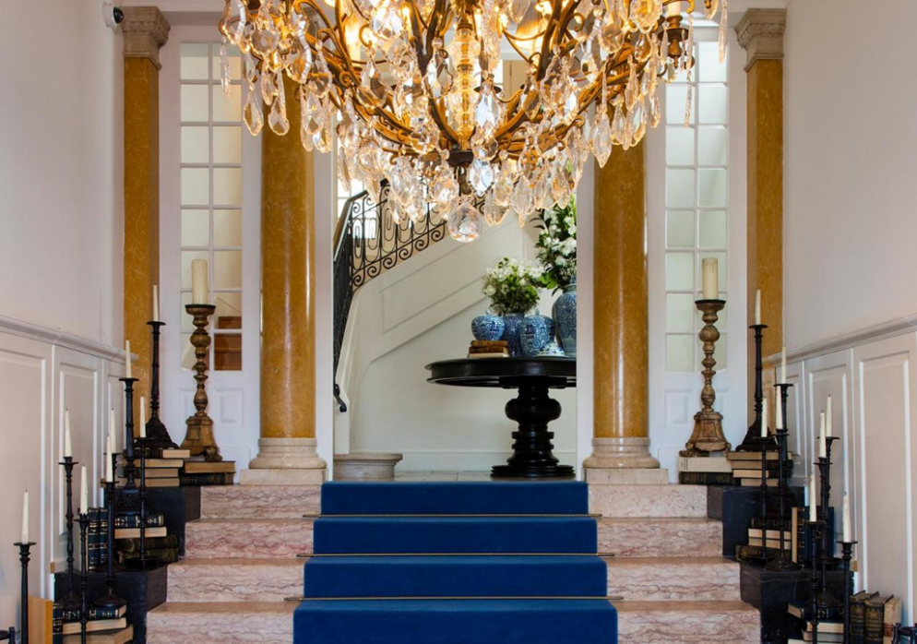
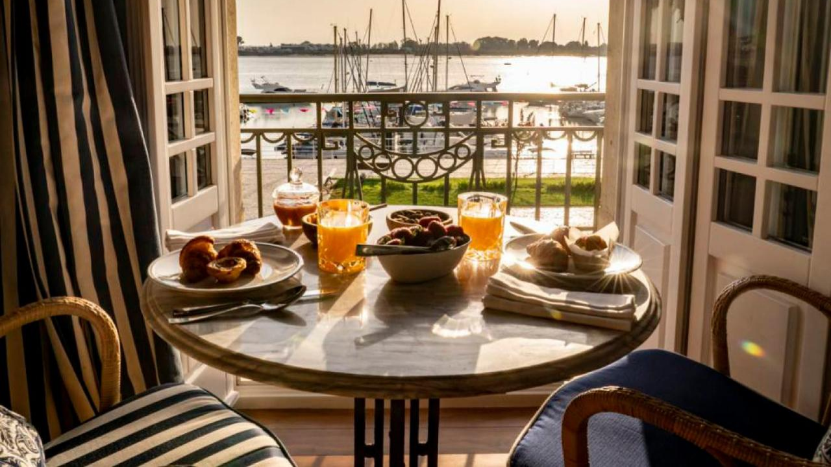

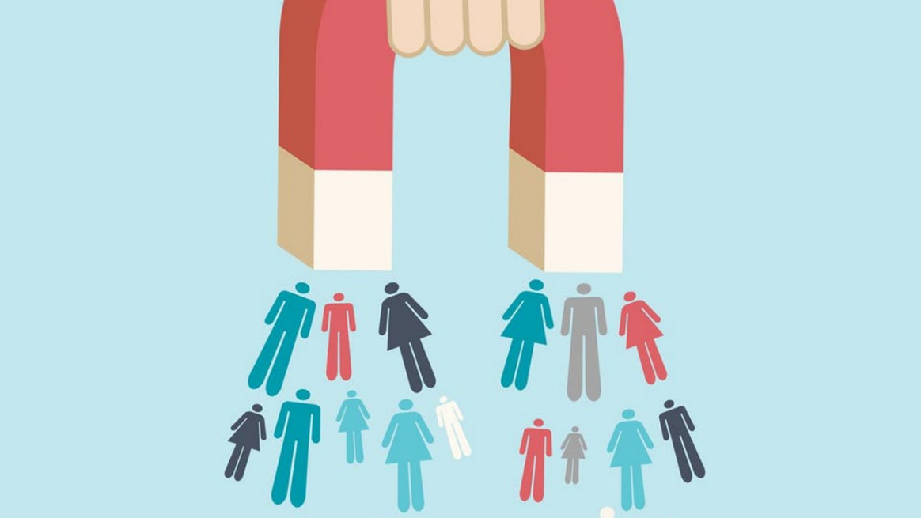



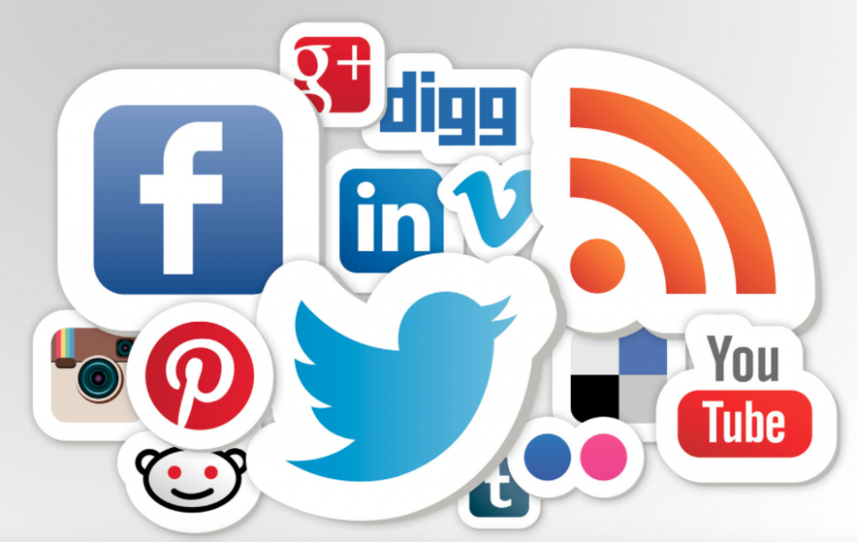

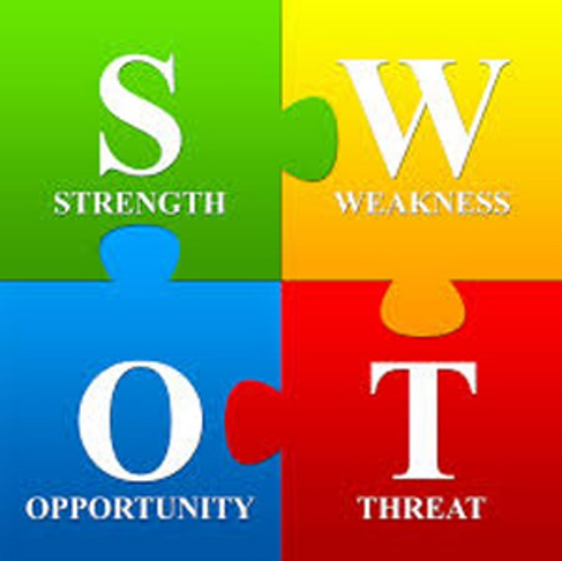

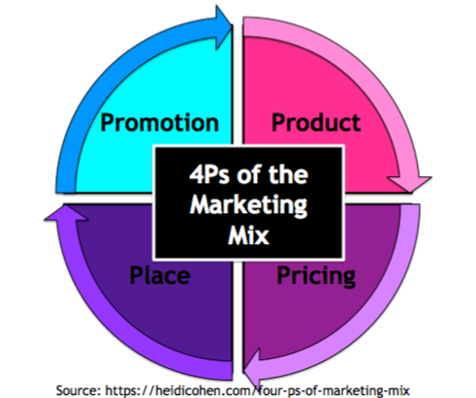
This Photo by Unknown Author is licensed under CC BY-SA-NC


