

University of Wales Trinity Saint David
School of Engineering

Mechanisms of Material Failure
ACEA7010

Jonathan Lloyd-Williams
1805620


Significance & Properties of Coatings
-Coating Applications in Piston Ring Manufacture-
Jonathan Lloyd-Williams
The University of Wales Trinity Saint David, MSc Motorcycle Engineering
UWTSD, Kings Road, Swansea, Wales, SA1 8EW (E-mail: 1805620@student.uwtsd.ac.uk)
Submitted on 24/1/2022

ABSTRACT: To ensure that the overall performance of a component is maintained, it is essential that the substrate is adequately protected against environmental degradation. Coatings are widely used in many industries to provide such protection, and can be applied through numerous methods in the form of any material category. This report will aim to explore a variety of coating materials and techniques that may be employed in the manufacture of piston compression rings to improve degradational resistance and reduce frictional losses.

KEY WORDS: Coatings, PVD, CVD, Ceramic coatings, Chromium plating, DLC, HVOF, Piston Ring, Automotive Engines.

Table of Contents
1. Introduction 4
2. Component Overview: Piston Rings 4
2.1. Piston Rings - Function, Operation & Degradation 4
2.2. Piston Ring Coatings – A Brief History 5
2.3. Piston Ring Coatings 5
2.3.1 Chromium Plating 5
2.3.2. Thermal Spray Processes 5
2.3.3 Ceramic Coated Piston Rings 6
2.3.4 Diamond-Like-Carbon (DLC) Coatings 7
2.3.5 Common Coating Choice & Performance 7
2.4. Conclusion 7
References 8

1. Introduction
This report will focus on the application of various coatings employed within the automotive industry, as commonly applied to piston rings for use in internal combustion engines (ICE). To ensure that the overall performance of a component is maintained, it is essential that the substrate is adequately protected against environmental degradation. Coatings are widely used in many industries to provide such protection, and can be applied through numerous methods in the form of any material category. Optimum performance of a coating may only be achieved if adhesion can be controlled. Additionally, particular consideration should be paid to control of a coating’s surface finish, mechanical properties, & thickness.

The scope of this report is limited to a literature review due to the affects of Covid and Lockdowns restricting the writer’s access to amenities for conducting practical applications and experimentation. The report will begin with a short explanation of piston rings functions and operational requirements with consideration to the component’s degradation. Following this, a brief history on the development of coating materials & methods applied to piston rings will be provided. A range of modern coating materials and methods applied to piston rings in ICEs will be explored and compared through a review of relevant literature & available secondary experimental data.

2. Component Overview: Piston Rings

2.1. Piston Rings - Function, Operation & Degradation

The primary functions of piston rings include sealing off combustion pressure, controlling distribution of oil, transferring heat to the cylinder liner, & stablising the piston. An example of a piston & piston ring assembly can be seen below in Figures 1 & 2.

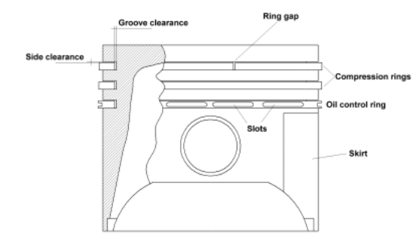
Figure 1. Piston & Piston Rings (Anderson, 2002).

The piston is designed for thermal expansion, with a desired gap between the linerwall and the piston surface. The rings and grooves work to form a labyrinth seal which reasonably isolates the combustion chamber from the crankcase. A ring’s sealing ability depends on a variety of factors such as ring & liner conformity, pre-tension, and gas force distribution. Heat energy from the combustion chamber is transferred out to the cylinder liner via the piston rings. The rings also prevent excess oil from entering the combustion chamber by scraping the oil down the liner wall during downwards strokes. Lastly, the rings provide support to the piston and reduce the pistons slapping motion, particularly during cold starts where ring clearance is greater than regular running conditions (Anderson, 2002).

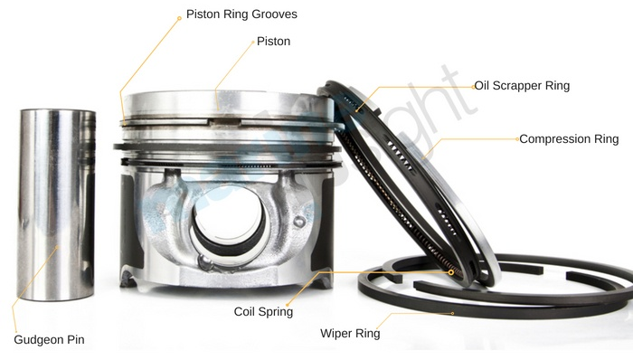
Figure 2: Piston & Piston Rings. (Marine Insight Ltd, 2021)

Piston rings generally form a pack consisting of 2-5 rings. This will include at least one compression ring which acts as the gas seal between the piston and the liner wall, preventing combustion gassess travelling down into the crank case. Oil control rings are also employed to control oil distribution. Generally oil control rings are perforated by slots in the peripheral direction which collect oil and transport it back to the crankcase. However, unlike compression rings, oil control rings are not necessarily essential, such as in two-stroke ICE where the lubrication oil is pre-mixed with the fuel (Anderson, 2002). For the purposes of this report, we are considering coating applications specifically for a compression ring.

Piston rings are expected to remain durable through rapid and large variations in load, speed, lubrication and temperature. The load on the rings is due to inter-ring gas pressure, and ring pre-tension. The total tension in the ring pack determines the effective coefficient of friction, and subsequently effects degradation. Wear of piston rings is largely due to the abrasive wear mechanism experienced, which is further increased when considering small volumes of solid particles within the lubrication oil. To reduce wear of the piston rings, and the cylinder liner, friction must be redced (Kumar, 2018).

Scuffing is one of the main tribological failure mechanisms that limits the lifespan of the piston ring & cylinder liner. It is often referred to as defects caused by an abrupt rise in the coefficient of friction or “localized damage caused by the occurrence of solid-phase welding between sliding surfaces without local surface melting (Tas, et al., 2017).” Scuffing is generally caused by high speed, high load or lubrication starved operating conditions. (Shen, et al., 2017)

Tribological improvements to piston rings and cylinder liners can be achieved through the use of coatings. Coatings can be used to alter the coefficient of friction, to reduce frictional losses experienced by an engine, and subsequently improve rate of wear.

2.2. Piston Ring Coatings – A Brief History

Material choice in piston ring design is generally dictated by the demands set by the operating conditions. This is also true for any coatings that may be applied to the substrate. The material(s) should be resistant to damage, even under emergency conditions. The elasticity, corrosion resistance, & thermal conductivity of any materials should also be considered. Traditionally, grey cast iron is used as the main material for piston rings, and is beneficial due to the dry-lubrication effect of the graphite phase of the material which can act as a reseviour, supplying oil during dry starts or instances of oil starvation (Anderson, 2002).

Various coating materials & methods have been applied to piston rings in ICEs. One such example includes chromium plating. In the 1940’s piston rings were mainly chromium plated for wear resistance. However, this was later superseded by the development of the thermal spray processes in the 1960’s (Metalisation Ltd, 2021). Nowadays, in addition to chromium plating, piston rings are commonly thermally sprayed with a uniform coating or inlay coating material consisting of molybdenum, metal composites, metal-ceramic composites or ceramic composites (Anderson, 2002).

Studies investigating new powder compositions for thermal spraying have included molbbdenum-nickel-chromium alloys, alumina-titania (Al2O3-TiO2), and chromium oxide (Cr2O3) with a metallic chromium binder to name but a few. Surface coatings for the entirety of the piston ring surface generally consist of materials such as phosphorus, nitrides, ferro-oxides, copper or tin (Anderson, 2002). Other examples of coatings that have been applied to piston rings include diamond-like-carbon (DLC) coatings, which have also shown to be beneficial to improving scuff resistance.

Thin, hard coatings produced through physical vapor depositition (PVD) or chemical vapor depositition (CVD) techniques include coating compositions such as titranium nitride (TiN) or chromium Nitride (CrN). However, traditionally these types of coatings have been reserved for small series production for competition engines (Anderson, 2002) and are less suited to piston rings manufactured in large quantities (Metalisation Ltd, 2021).

2.3. Piston Ring Coatings

A wide range of coating materials & techniques have been identified. This section of the report will focus on exploring a selection of the previously mentioned coatings in further detail, & exploring various coating properties by examining studies and experimental data produced by researchers investigating piston ring coatings. This section will also aim to highlight circumstances in which specific coatings may prove preferable over other coatings & address additional factors to be considered.

A brief summary of factors that should be considered when selecting a coating for piston ring manufacture is presented below.

- General design considerations such as geometry.
- Susbtrate material choice.
- Additional contact materials, in this case lubrication oil as highlighted in Kumar (Kumar, 2018) and further explored in (Rozario et al, 2018).
- Substrate surface finish and cleanliness is essential to successful adhesion of a coating as shown by Tas et al (Tas, et al., 2017).
- Tribological and thermal properties of proposed coating composition.
- Depositation method.
- Control of coating thickness. This is particularly important in piston/liner systems where specified desired clearences must be achieved (Gahlin et al, 2001).

2.3.1 Chromium Plating

Whilst chromium plating techniques have been available comerically since 1928, chromium plated piston rings were originally introduced during World War II for application in aircraft and tank engines (Charlesworth & Brown, 1968). Hard chrome plating is an electroplating process that involves using an electric current to reduce dissolved metal caitons so that they form a thin coherent metal coating on an electrode. Hard plating is particularly important with respect to the compression ring (Anderson, 2002).

Plating a component improves it’s corrosion resistance. (Makhlouf & Rodriguez, 2020). Galvanic chromium plating of the cylinder-piston group is the most common method of reducing component wear and improving engine performance. However, this process has disadvantages such as featuring high internal stresses which can lead to fracture, and the carcinogens produced during the process (Bryskin, et al., 2014). As previously mentioned hard chrome plating is often performed prior to additional coating materials & techniques. Chromium plating is a well established technique that is low cost and easy to perform. However, the enivromental and health implications of this process, during which carcinogens are emitted into the atmosphere, needs full consideration

2.3.2. Thermal Spray Processes

Several thermal spray processes have been developed such as plasma, powder spray, arcspray and flamespray, examples of which can be seen in Figures 3 & 4.

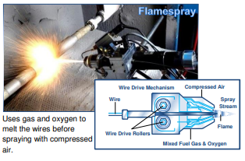
Figure 3: An example of Flamespray Technique.
(Metallisation Ltd, 2021)

All methods of thermal spraying involve the projection of small, softened particles onto a cleaned and prepped surface where they adhere to form a continuous coating.

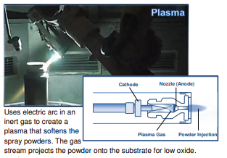
Figure 4: An example of Plasma Thermal Spraying Technique.
(Metallisation Ltd, 2021)

Traditionally, wire sprayed coatings were used on piston rings. However, using a flamespray pistol to deposit molybdenum to the surface of a piston ring results in a coating containing a mixture of molybdenum and molybdenum oxides. Whilst this produces a coating that is harder and more resistant than wrought molybdenum, the operating conditions of high performance engines can cause premature coating failures due to flaking. This failure is usually attributed to the presence of residual stress cracks, and lamellar oxides within the coating (Metallisation Ltd, 2021). Molybdenum coatings that are plasma sprayed overcome the problem of premature coating failure. Protective carrier gasses used in the plasma spray process reduce the number of oxides formed whilst retaining excellent adhesion.

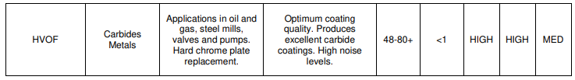
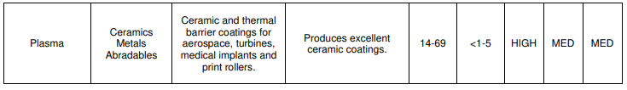
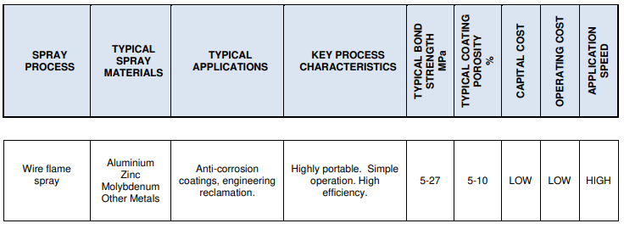
There are a wide range of of plasma sprayed compositions that may be employed in the design of piston ring coatings. Selections are based on the required properties of the coating. Most pivitol to piston ring coatings is the mutual wear compatibility between the piston ring and the cylinder liner. It is common to improve the bond strength of plasma sprayed coatings by incorporating NiCr, or cobalt within the coating compostition. Plasma spraying is an effective, low cost means of applying piston ring coatings (Metallisation Ltd, 2021). Tables 1 & 2 below show a comparisons of traditional thermal spray techniques.
Table 1: Comparison of traditional thermal spray techniques. (Metalisation Ltd, 2021).

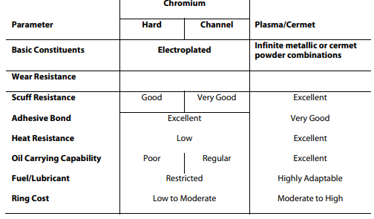
A table comparing the properties of chromium plated substrates against plasma spray coated piston rings can be also seen below in Table 2. As aforementioned, chromium plating is commonly used prior to additional coating applications (Anderson, 2002).
Table 2: Comparison of chromium plated vs plasma coated piston rings (Metalisation Ltd, 2021).

High velocity oxygen fuel (HVOF) coating is another thermal spraying process which utilisises a fuel gas & oxygen torch to disapate a powder coating over a substrate. HVOF coatings have been explored as a potential alternative to hard chrome coatings for engine internals by researchers such as Picas et al, due to the adverse enivronmental and health implications of chromium plating. Picas et al, were able to demonstrate that fine CrC-NiCr coatings applied via HVOF to piston rings provided superior degradation resistance than hard chromium plating (Picas, et al., 2006). Literature produced by Sonia et al provides a table of results from a large range of tribological studies of various coatings applied to varying substrate materials featuring studies such as Singh et al (Singh et al, 2019), and highlights various successes in reducing degradation through HVOF coatings (Sonia et al, 2021).

2.3.3 Ceramic Coated Piston Rings

Ceramic coatings may also be employed within the design of piston rings and are generally plasma sprayed onto a substrate. Numerous researchers such as Bantle & Matthews (Bantle & Matthews , 1995), & Chinnusamy et al (Chinnusamy et al, 2019), have experimentally tested the wear resistance of a range of ceramic coatings.

Further work on the wear resistance and thermal properties of various ceramic coatings has been produced by researchers such as Yao & Li (Yao & Li, 2019), Krishnamani & Mohanraj (Krishnamani & Mohanraj, 2016), & Wang et al (Wang et al, 2001). Such coatings include examples of various ceramic materials such as Al2O3, Cr2O3 & nickel/ceramic composites. Review of the aforementioned literature indicates ceramic coatings tend to feature good impact wear resistance, hardness & toughness, and adhesion. Ceramic coatings have proved effective in circumstances of adequate lubrication. However inadequate lubrication can prove detrimental and lead to coating failure (Anderson, 2002).

Various ceramic compostitions are available for use in piston ring manufacture. However, as with the application of ceramics in many instances, the main factor affecting it’s useablity involves the high cost of ceramic raw materials which can make this option considerably higher cost than other coating methods (Bantle & Matthews , 1995).

2.3.4 Diamond-Like-Carbon (DLC) Coatings

Diamond-like-carbon coatings exist in various forms of amorphous carbon materials that exhibit some of diamond’s unique properties. DLC coatings can be amorphous, flexible, strong, hard & slick depending upon the coating method and composition. DLC coatings can be applied through various means, such as plasma-assisted CVD, and RF plasma deposition. Benefits of DLC coatings include improved abrasional & corrosional resistance (Biron, 2016 ). As with ceramics, cost is a factor requiring careful consideration when considering composition and application technique of DLC’s

Tyagi et al (Tyagi et al, 2019), and (Kano, 2014) investigate the adhesion, wear resistance and thermal properties of a range of DLC coatings, and highlight the improvements seen in component durability, and frictional reduction. Examples of the coefficients of friction seen during the testing of various coatings by Tyagi et al can be seen in Figure 5.

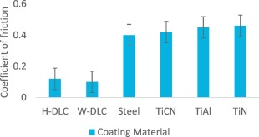
Figure 5: A chart showing various coatings against their coefficient of friction. (Tyagi et al, 2019)

Studies conducted by Tas et al (Tas, et al., 2017), show the use of DLC coatings on piston rings in cast iron cylinder liners resulted in significant reductions in wear rates and coefficient of friction values compared to CrN coated rings. This was mainly attributed to the formation of a mixed tribolayer on the liner surface. Tas et al, also highlights the importance of a mirror-polished surface finish to the liners, and showed that reducing the surface roughness of the contacting materials reduced the coefficient of friction, and subsequently wear rate (Tas, et al., 2017). Additional studies by Gahlin et al (Gahlin et al, 2001), show promising reductions in liner and piston wear rates when employing Me-C:H (a form of DLC) coatings. The varying levels of wear experienced by the ring and liner during the experimental testing procedure can be seen in Figure 6.

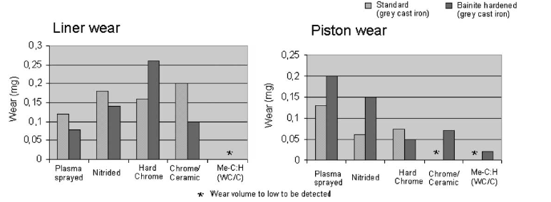
Figure 6: Laboratory test results obtained using a pin-on-plate set-up to simulate the wear mechanisms in a liner/piston ring group. (Gahlin et al, 2001)

2.3.5 Common Coating Choice & Performance

Several examples of literature highlighting the differing tribological and thermal performance characterstics of various coatings through experimental data have been examined. Figures 5-8 highlight the variations in properties of various coating materials and methods and provide evidence of potential to improve degradational resistance through coating applications. Figures 5 & 7 show that the coefficient of friction is dependent upon the coating material and technique, and Figures 6 & 8 show the improved wear rates associated with each coating during testing.

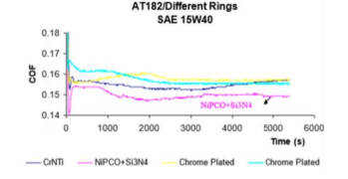
Figure 7: A chart showing varying frictional coefficient values for various coatings. (Shah et al, 2021)

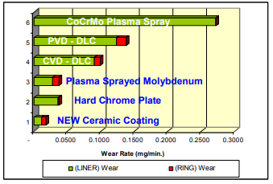
Figure 8: A chart showing the wear rate of varying coatings (Kamo & Saad , 2005).

Whilst several coating materials & methods have been identified, it has been established that the most common techniques employed currently in piston ring manufacture include chromium plating followed by plasma spraying of a material coating such as molybdenum. This has shown to produce coatings appropriate for use on piston/liner systems in high performance ICEs (Anderson, 2002). Shen et al further highlights the importance of this additional coating layer (Shen, et al., 2017). The resultant frictional losses provide benefits to degradational resistance, as well as engine performance with regard to fuel efficiency & emissions (Tas, et al., 2017).

2.4. Conclusion

The focus of this report has been to examine the significance and properties of coating materials and processes applicable to the manufacturing of piston compression rings. A range of literature has been reviewed that highlights a variety of materials and techniques that may be used. The function, operation and degradation of the coatings has been considered. Various coating materials and methods used to improve degradational resistance and reduce frictional lossess have been identified and explored, including chromium plating, ceramic and DLC coatings and a variety of thermal spray processes. Advantages and disadvantages of various coating materials and methods have been identified and explored. All coating applications explored appear to provide distinguishable benefits, not only in the form of improved degradational resistance, but also in improved frictional lossees and subsequent emission production during operation. It was however apparent from the literature review that chromium plating exhibited the most drawbacks, largely due to the environmental and health implications of the process. Potential alternatives to hard chromium plating have also been identified, such as HVOF techniques. Additional consdierations such as surface finishes and the necessity for controlling coating thickness have been addressed.

The current literature shows that the most common practice with regards to coating choice in piston/liner systems is generally considered to consist of a coating layer of chromium plating, followed by an additional coating material additive such as molybdenum. Coating design continues to be a developing field of investigation where new/reformed coatings can be discovered through exploration of cost-effective composite material mixes and additives, with a combination of various influencing degradation and sustainability parameters and new methodologies.

References

Anderson, P., 2002. Piston Ring Tribology: A literature survey , Helsinki: VTT Industrial Systems .
Assanis , D. & Mathur , T., 1990. The Effect of Thin Ceramic Coatings on Spark-Ignition Engine Performance. Journal of Materials & Manufacturing , 99(5), pp. 981-990.
Babu, M. & Kumar, K., 1996. Fracture Mechanics Approaches to Coating Strength Evaluation. Engineering Fracture Mechanincs , 55(2), pp. 235-248.
Bantle , R. & Matthews , A., 1995. Investigation into the impact wear behaviour of ceramic coatings , Hull: University of Hull.
Biron, M., 2016 . Diamond-like Coating . In: Material Selection for Thermoplastic Parts: Practical and Advanced Information . s.l.:Elsevier Ltd , pp. 603-653.
Bryskin, B., Kostylev, A. & Lumpov, A., 2014. CVD Technology for Preparing Wear-Resistive Chromium Carbide Coatings of Engine Components. SAE International Journal of Materials & Manufacturing , 7(3), pp. 630-632.
Charlesworth, W. H. & Brown, W. L., 1968. Wear of Chromium Piston Rings in Modern Automotive Engines. SAE Transactions, 76(1), pp. 386-399.
Chinnusamy et al, 2019. Experimental investigation on the effect of ceramic coating on the wear resistance of Al6061 substrate, Paavai: Paavai Engineering College.
Cho, D. & Lee, Y., 2009. Evaluation of ring surfaces with several coatings for friction, wear and scuffing life. Trasactions of Nonferrous Metals , Volume 19, pp. 992-996.
Dattatreya et al, 2019. Study of Combustion Characterstics on Single Cylinder Direct Injection Diesel Engine with Plasma and HVOF coated Ceramic Powders on Piston Crown. Matierals Today, Volume 16, pp. 621-628.
Gahlin et al, 2001. ME-C:H coatings in motor vehicles. Wear, Volume 249, pp. 302-309.
Herbst-Dederichs, C. & Muchow, F., 2002. Modern Piston Ring Coatings and Liner Technology for EGR Applications. Journal of Engines , 111(3), pp. 1044-1053.
Hyde et al, 1968. Piston Ring Coatings for High Performance Diesel Engines. SAE Transactions , Volume 76, pp. 3107-3139.
Jian et al , 2019. Investigation of wear behaviour of graphite coaring on aluminum piston skirt of automobile enginer. Engineering Failure Analysis , Volume 97, pp. 408-415.
Kamo , L. & Saad , P., 2005. Ceramic Coated Piston Rings for Internal Combustion Engines. Washington D.C, Worl Tribology of Congress .
Kano, M., 2014. Diamond-Like Carbon Coating Applied to Automotive Engine Components , Kanagawa: Kanagawa Industrial Technology Center .
Krishnamani, S. & Mohanraj, T., 2016. Thermal Analysis of Ceramic coated aluminum alloy piston using finite element method. Indian Journal of Science and Technology , 9(22).
Kumar, V., 2018. Wear Evaluation of Engine Piston Rings Coated With Dual Layer Hard and Soft Coatings , Kanpur: Indian Institute of Tecnhology .
Lin et al , 2016. Development and evaluation of low friction TiSiCN nanocomposite coatings for piston ring applications. Surface & Coatings Technology , Volume 298, pp. 121-131.
Makhlouf, A. S. M. & Rodriguez, R., 2020. Bioinspired smart coatings and engineering materials for indutrial and biomedical applications. Advances in Smart Coatings and Thin Films for Future Industrial and Biomedical Engineering Applications, pp. 407-427.
Metalisation Ltd, 2021. Thermal Spraying of Piston Rings: Application Data Sheet AU-WR-001. [Online]
Available at: https://www.metallisation.com/wp-content/uploads/2019/07/THERMAL-SPRAYING-OF-piston-rings.pdf
[Accessed 4 January 2022].
Metallisation Ltd, 2021. Introduction to Thermal Spray and Engineering Applications , Dudley: Metallisation Ltd.
Patterson et al, 1989 . Wear of Piston Rings and Liners by Laboratory Simulation. Journal of Engines , 98(3), pp. 149-158.
Picas, J., Forn, A. & Matthaus, G., 2006. HVOF coatings as an alternative to hard chrome for pistons and valves. Wear , 26(1), pp. 477-484.
Pusterhofer et al, 2019. Development of a Model Test System for a Piston Ring/Cylindeer liner-contact with focus on near to application seizure behvaiour , Leoben: Montanuniversitat Leoben.
Rozario et al, 2018. The influence of a piston ring coating on the wear and friction generated during linear oscillation, New York : Stony Brook University .
Salman et al, 2006. An Investigation of Different Ceramic Coating Thermal Properties. Materials & Design , 27(7), pp. 585-590.
Shah et al, 2021. Evaluation of a piston ring coating on the oscillation wear and friction with use of unique pre-screening SRV instrumentation, New York : Koeler Instrument Company Inc.
Shen, Y., Yu, B., Lv, Y. & Li, B., 2017. Comparison of Heavy-Duty Scuffing Behaviour between chromium-based ceramic composite and Nickel-Chromium-Molybdenum-Coated Ring Sliding against Cast Iron Liner under Starvation, Dalian : Dalian Maritime University .
Shuster et al, 1996. Piston Ring Microwelding Phenomenon and Methods of Prevention. Journal of Engines , 105(1), pp. 1014-1021.
Singh et al, 2019. An erosion and corrosion study on thermally spayed WC-Co-Cr powder. Wear, pp. 438-439.
Sonia et al, 2021. Potential applications of thermal spray coating for I.C engine tribology: A review. s.l., Journal of Physics Conference Series .
Tas, M. O. et al., 2017. Roles of mirror-like surface finish and DLC coated piston rings on increasing scuffing resistance of cast iron cylinder liners, Ontario : University of Windsor.
Tung, S. & Gao, H., 2003. Tribological characterstics and surface interaction between piston ring coatings and a blend of energy-conserving oils and ethanol fuels. Wear, 255(1), pp. 1276-1285.
Tung, S. & Huang, Y., 2004. Modelling of Abraisive Wear in a Piston Ring and Engine Cylinder Bore System. Tribology Transactions, Volume 47, pp. 17-22.
Tyagi et al, 2019. A critical review of diamond like carbon coating for wear resistance applications. International Journal of Refractory Metals and Hard Materials , Volume 78, pp. 107-122.
Tyagi et al, 2020. Tribological behaviour of carbon coating for piston ring applications using Taguchi Approach. Materials Today , Volume 25, pp. 759-764.
Wang et al, 2001. Wear and scuffing characterstics of composite polymer and nickel/ceramic compostie coated piston skirts against aluminum and cast iron cylinder bores. Wear , 250(1), pp. 706-717.
Wopelka et al., 2018. Wear of Different Material Pairings for the Cylinder Liner - Piston Ring Contact. Industrial Lubrication & Tribology, 70(4), pp. 687-699.
Yao, Z. & Li, W., 2019. Microstructure and thermal analysis of APS nano PYSZ coated aluminum alloy piston , Wuhan: Wuhan University of Technology.
Yates , A., 1939. Recent Developments in Piston Ring Materials. SAE Transactions , 34(1), pp. 49-58.
Yoshida et al, 1990. Effects of Surface Treatments of Piston Ring Friction Force and Wear. Journal of Engines , 99(3), pp. 1236-1245.
Young, W. & McComb, A., 1990. New Piston Ring Face Coatings Using Design of Experiments. Journal of Engines , 99(3), pp. 1228-1235.

