EFFECTIVE TEAM WORKING AND COMMUNICATION
  - A Detailed Case Study on the “Vodafone”



Student Name | Galeru Izabela-Mihaela
Student Number | 2107607
Module Code and Title | Effective Team Working and Communication (BMSW4002_BIRM)
Lecturer’s Name | Richmond Lamptey  Akash Puranik  Khaza Ahmed Joanne Davies

Executive Summary
Teamwork in the current scenario of the market has become highly essential for the company to deal with the changes and complexities of the organisation and manage the performance of the company to be above average. Teamwork also favours the business organisation with unique and differentiated ideas for the organisation as diverse people are working in a team that have extremely different thinking capacities. The report aims to discuss the relevant elements and aspects of teamwork and its significance to the workplaces in the light of the given case study of Vodafone. The report will provide the reasons of downfall in an organisations progress due to the poor team working. At last, the conclusion of the report states that there can be a seamless working environment for an organisation but only if the employees or the workforce of the organisation is cooperative and efficient.

Table of Contents
Executive Summary 2
Introduction 4
Vodafone Background 4
Development of an Effective Team 5
Tuck man team development model 6
Types of Roles Needs for an Effective Team Creation 7
Belbin Team Roles Model 7
Impact of Team Working on Team Success 9
Barriers to Effective Team Working 9
Conclusion 10
Reference List 11

Introduction
The concept of collaborative efforts of the people at the workplaces that results in the accomplishments of the common goals and objectives within workspaces is known as team working. In the current market and business environment team working have become an intrinsic necessity for the leaders to deal with the arduous complexities of the market and improve the survival duration of the company into the market (Bravo et al., 2019). The report displays all the relevant discussions related to the team working based on the case study given in the assignment brief focusing on the company named Vodafone. The report through light on the case study of Vodafone where Abdul is a project manager and assigned a new project for the company within a team of diverse people. Now the problem faced by Abdul is an inefficient team working and so the report suggests some solutions to Abdul regarding the development of the effective team, roles required to have an effective team, impact of effective team and barriers to effective team working at the workplace. also to add to the understanding of the report Belbin team roles and Tuck man team development model is being applied for the Vodafone.

Vodafone Background
One of the well known British International telecommunication Brands that is a public limited company and also found around 30 years back from now on 16th September 1991 is Vodafone. The founder of the Vodafone company was Gerry When and Ernest Harrison that has established the headquarter of the company in England, UK. The services and products of Vodafone are multitudinous as it provides services including internet, digital television, fixed telephony, mobile telephony, broadband etc. the estimated figure of annual revenue to Vodafone is around €43.809 billion, also the workforce of the company count approx 96000 in numbers. The services of communication by Vodafone are being provided at the Global level in 70+ countries of the world (Vodafone, 2021).

Development of an Effective Team
Effective team working in the present business environment have become equally important life other factors that are required to operate the business peacefully into the market. Effective working optimizes the productivity and efficiency of employees. The diagnosis by the expert researcher in previous times states that there is a requirement of a minimum of four elements to the company to develop an effective team for the timely completion of the tasks and manage the team working at the workplace (Haas et al., 2016). As Abdul is facing a lot of irregularities in the team and to correct the weaknesses of the team Abdul needs to focus on the development of the four elements that are mentioned below.
Leadership: it refers to providing all the required support and helping hand by the leader to the team members. There are multiple roles that a leader has to play for the effective working of the team and so Abdul needs to play all the roles like supporting the team, persuading, checking the performance etc (Hanaysha et al., 2016).
Work Methods: There needs to be approval of all the team members taken by Abdul on choosing certain work methods that need to be applied in the business environment. The examples that can be covered under effective work methods are timekeeping, smart objectives, following the code of conduct, feedback mechanism etc (Haas et al., 2016).
Climate: It is an important element that focuses on creating a healthy climate or work environment for the employees in an organisation that should have honesty, openness, trust, open communication etc within the team members (Hanaysha et al., 2016).
Skills and Knowledge: It relates to inducing all the necessary skills and knowledge by Abdul in the team members through several training and development programs and meet up to the need and requirements of the organizational working. Some of the examples of such skills and knowledge can be barnstorming skills, decision making, challenge acceptance skills etc (Haas et al., 2016).

Tuck man team development model
Here is a model of team development that can be used by Abdul to eliminate the non-performance of the team members during the Pandemic time or remote working. The model name is Tuck man team development mode (Jones, 2019). There are four stages in the model that would help Abdul to assist with improving the development of an effective team for the Vodafone for the new projects that have been recently assigned to Abdul.
Forming: It is the stage where the leader in an organisation will prepare the team members to accomplish a common goal and objective. For instance, under the forming stage, Abdul will be directing its team members and guiding the accomplishment of the team goals on time (Natvig et al., 2016).
Storming: It is the stage of group discussion where Abdul will be identifying the disagreements in the team and starting a group discussion to resolve the problem of team conflict and storm the progress of the team (Jones, 2019).
Norming: After an entire period of discussion the employees will be led towards the conclusion and resolve all the disagreements with mutual consent. In the third stage, Abdul needs to make clear each team member clear with their roles and responsibilities (Natvig et al., 2016).
Performing: It is the last stage where the implementation of the selected solution in the previous stages of the Tuck man model will be implemented by Abdul for developing an effective team at the Vodafone and accelerate the speed of new project assigned to Abdul to complete it within the deadline that too with remote working (Jones, 2019).
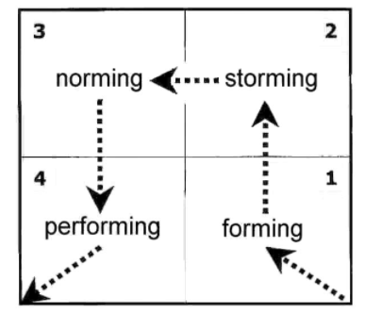
Figure 1: Tuck man Team Development Model
Source: (Bravo et al., 2019)

Types of Roles Needs for an Effective Team Creation
An effective development can be possible in an organisation only when certain essential roles will be played by an effective team member in the group. Creating an effective and efficient team is not possible without the support of essential roles and responsibilities that needs to be played by the team members. The roles required to form an effective team includes the generation of creative ideas, team cooperation, the building of a stronger network with the stakeholders and contributing to the increased sale of the organisation, effective leadership, demonstration of effective drive and ambition etc (Bednar et al., 2020). for having a better understanding of the required team roles to create an effective team here is the Belbin team role model defining the nine roles of effective team creation.

Belbin Team Roles Model
- The first role of a team member is to plant the unique, creative and problem-solving idea for an organisation that would provide and accelerate performance to the company in comparison to its competitors.
- Another role is to be a resource investigator in which the team member will procure and allocate more and more customers to the company and build contacts to improve the business of the organisation (Lynch et al., 2018).
- One more role of the team member will be to become a coordinator that will be managing and delegating the multiple roles and responsibilities smoothly within the team and ensuring the task is completed within the deadline.
- An effective team member also plays the role of a shaper that has the thriving performance and capability to deal with the obstacles in the business environment. The shaper team member will help in reaching the goal together with the team.
- Monitor evaluator is also a role that is equally required to be an effective member as the monitor evaluator have the responsibility to prepare strategically and judge the performance of the team members to ensure the accurate implementation of the strategic ideas.
- Team work is one more requirement to create an effective team because there are multiple tasks that one needs to perform within a team cooperatively at the workplace to accomplish common goals and objectives. During the disagreement time also teamwork role will have to settle conflicts of the team members (Bednar et al., 2020).
- The implementer is the role of a person in a team who has the qualities of being reliable, practical, accurate, challenge taker, turning ideas into actions etc. the implementer in a team must have the potential to convert their ideas into reality and implement it.
- One role in an effect is of complete finisher that is being responsible for completing all the tasks smoothly and performing the role of polishing the final work before delivering. The complete finisher in a team has the skills like anxiety, painstaking, perfection, searching out errors etc.
- Specialist refers to a role of a unique member of the team that has the quality of self-starting, dedication, single-minded etc. the contribution of a specialist will lead to the achievement of the goal with the efforts of the team members (Lynch et al., 2018).

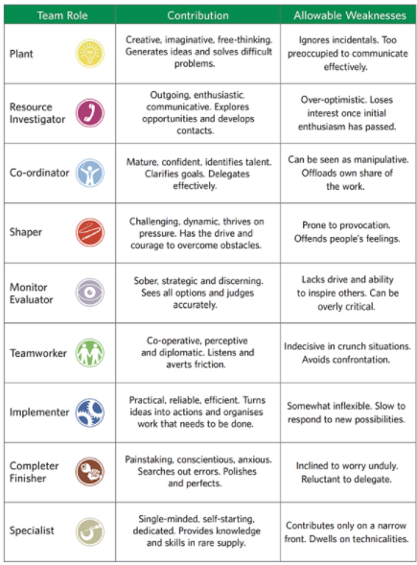
Figure 2: Belbin Team Roles Model
Source: (Jones, 2019)

Impact of Team Working on Team Success
Team working makes a great impact on the success of an organisation because it helps in developing all the qualities in an individual or the team member that are working on a common goal. For instance, cooperative work done in a team with equal contribution of all the team members will lead to the accomplishment of the target within deadline and also the progress of each team member with certain professional skills life team working, communication skills, interpersonal skills, decision-making skills, problem-solving skills etc (Riebe et al., 2016). Similarly in the given case also Abdul needs to focus on implementing the solution mentioned above in the report like applying different team development models to resolve the problem of inefficient working in a team and as a result, Vodafone will reach the path of success soon.

Barriers to Effective Team Working
There are many barriers a team working have to face to achieve the common target because of the diverse or variety of people working together that belongs to a different background. For example, in a team, 5 people are working together having and there will be different backgrounds belonging as well as different languages that make it more difficult and challenging to work in a team. Another challenge or barrier of an effective team is the poor leadership qualities of a leader because of it the entire team have to suffer failure and another adverse impact (Lanefall et al., 2015).

Conclusion
The conclusion of the report states that teamwork is highly efficient and effective in an organisation of current times, therefore, the leader and manager needs to work greatly on team working skills development in the employees to make sure that the employees of the company can work in any environment and have highly adaptable nature. The report contains all the relatable are you any and discussions related to the development of an effective in the light of given case study of Vodafone that would help Abdul to resolve the problem of the inefficient team working at Vodafone.

Reference List
Bravo, R., Catalán, S., and Pina, J. M. (2019). Analysing teamwork in higher education: An empirical study on the antecedents and consequences of team cohesiveness. Studies in Higher Education, 44(7), 1153-1165.
Haas, M., and Mortensen, M. (2016). The secrets of great teamwork. Harvard business review, 94(6), 70-76.
Hanaysha, J., and Tahir, P. R. (2016). Examining the effects of employee empowerment, teamwork, and employee training on job satisfaction. Procedia-Social and Behavioral Sciences, 219, 272-282.
Jones, D. (2019). The Tuckman’s Model Implementation, Effect, and Analysis and the New Development of Jones LSI Model on a Small Group. Journal of Management, 6(4).
Natvig, D., and Stark, N. L. (2016). A project team analysis using Tuckman's model of small-group development. Journal of Nursing Education, 55(12), 675-681.
Bednár, R., and Ljudvigová, I. (2020). Belbin team roles in a start-up team. In SHS Web of Conferences (Vol. 83, p. 01002). EDP Sciences.
Lynch, D. S., Lynch, M. J., and Clemens, C. M. (2018). Belbin Team Roles. The Handbook of Communication Training: A Best Practices Framework for Assessing and Developing Competence.
Riebe, L., Girardi, A., and Whitsed, C. (2016). Teaching teamwork skills in Australian higher education business disciplines.
Lane-Fall, M. B., and Gutsche, J. T. (2015). The challenge of studying and improving perioperative teamwork, and yes, another checklist. Anaesthesia and Analgesia, 121(4), 852-853.
Vodafone. (2021). Retrieved 23 February 2022, from https://www.myvi.in/investors/annual-reports

