

Developing Workplace Critical Thinking(BMSW5101)
Name of the Student:Monica Cernat 1913391
Name of the University:University of Wales Trinity Saint David
Lecturer name:Gregory Cowan
Executive summary
The current business optics in the UK retail sector is requiring enhanced organisational changes in terms of customer service, approach, organisational behaviour, production, marketing, operation etc. organisational behaviour, employee attitude, culture, value and the operating system helps employees to create inimitable performance and service quality. Due to the CoVID 19 situation, retail businesses all over the UK are struggling to manage the regular business workflow along with the corresponding employee turnover rate. ASDA is one of the most grossing grocery chains in the UK, the company is adjusting its policies and operations according to the changing norms in the post-pandemic market. The report is constructed to discuss the intrinsic-extrinsic driver and internal-external factors that stimulate the organisational performance, employee growth and satisfaction to create required value. The report has briefly introduced the organisation and its internal and external properties that separate ASDA from other companies. The report has proposed and introduces some management theories that have distinct expertise to deal with different organisational events. The report has critically evaluated the theories by applying them in practical business scenarios. The report has also proposed some suggestions based on the following study. The report has finally delivered a detailed recommendation for further improvement of the business value and management efficiency in ASDA.
Table of Contents
Introduction 4
1. Brief introduction about the Company 5
2. Brief introduction of several management theories which are underpinning in the report 7
3. Applying management practices to better understand the influence of organisational behaviour, attitudes, beliefs as well as value systems, and addressing post-Covid mindsets with change management methods in ASDA 13
3.1. The influence of organisational behaviour, beliefs, attitudes, as well as value systems at the workplace 13
3.2. Adapting workplace adjustments to meet current issues during the post-Covid timeframe 15
3.3. Creating a future-proof business 17
4. Examining diverse management theories critically in order to see how different attitudes, beliefs, and values perceive them 19
5. Recommendations for particular organisational adjustments of ASDA for the post-COVID mentality in order to address current issues and build future resiliency 23
Conclusion 25
Reference 26
Journals & Books 26
Webpages 27

Introduction
The Covid-19 epidemic has had a tremendous impact on everyone's life On a worldwide scale. As a result of the worldwide shutdown, businesses have altered their operations. During the epidemic, working from home has been more popular. Organizations have moved to traditional operating procedures once the Covid-19 has become a part of everyday life.
The purpose of this research is to better understand new types of change at ASDA in order to build more adaptable businesses there in future while maintaining core values, behaviours, and belief systems in consideration. ASDA is able to exhibit effective leadership as well as a pleasant work environment because of its organisational behaviour. Organizational behaviour between workers and management can help to encourage ethical conduct. The research explores ASDA's organisational structure in order to get insight into the company's corporate environment. The use of the Human Relations Management Theory, as well as Taylor's Scientific Management Theory within ASDA organisational setting, is addressed. Kotter's change management theory, X and theory Y, are all important for regulating behaviour of employees, according to the report. The paper discusses the recommendations for addressing ASDA's issues and building future stability.

1. Brief introduction about the Company
Products and services of ASDA: ASDA is a British international retailer with a diverse product as well as a service offering. Asda offers 33 outlets dedicated to clothing and other items. The usual ASDA shop is 28000 square feet that contain 23000 items (Corporate - ASDA, 2020). ASDA offers groceries, retail, and financial services in addition to food and goods. ASDA offers both online as well as traditional distribution channels for its items.
Size as well as Scope of ASDA: ASDA is the UK's second-largest supermarket chain, with 632 sites and a variety of shops. ASDA was established in 1949 and is headquartered in England. ASDA employs over 165000 people and has grown into a worldwide retail brand thanks to its innovative business practices. According to Corporate - ASDA, (2020), ASDA's function is to maintain key business skills through the use of human resources and a low-cost strategy for launching new goods. ASDA tries to create strategic initiatives to improve market conditions. The lower-cost methods including business deployment procedures are used to maintain ASDA's products or service distinctiveness. Such things create a good scope for the ASDA's operation in the UK as well as throughout the world.
Vision, mission and Objectives of ASDA: ASDA's vision is to focus on stakeholder relationships in order to enhance the company's supply chain. ASDA's goal is to maintain genuine brand identity while increasing profit margins by delighting customers. According to Corporate - ASDA, (2020), ASDA Group PLC seeks to deliver low-cost and accessible commodities and services for the general population. One of ASDA's main objectives is really to reduce packaging, so they are investigating all options to reach this aim. ASDA's objective is to establish a trustworthy corporate image. Becoming the highest quality retailer in the UK is the mission of ASDA by providing consumers with inexpensive services and products.
Stakeholders: ASDA has both internal and external stakeholders. Workers, management staff, the board of directors, and investors are among ASDA's internal stakeholders. According to Corporate - ASDA, (2020), the Founder and Chief Financial officer, SVP-People, Chief Customer Officer, Senior Vice President-Operations, and SVP-Commercial make up ASDA's board of directors. Suppliers, consumers, local communities, as well as the government are among ASDA's external stakeholders.
Organisational Structure of ASDA: As ASDA has many functional areas, it maintains hierarchical functional structures (Asda.com. 2021). ASDA's management focuses on the expansion of organisational subdivisions. ASDA's legal form is an LLC (Limited Liability Company), which provides flexibility as well as liability coverage to the organisation (Asda Stakeholders 2021).

2. Brief introduction of several management theories which are underpinning in the report
Theory of Human Relations management: The Human Relations Theory is introduced by Elton Mayo and Mary Parker Follet. Elton Mayo's Hawthorne investigation contributes considerably to this idea. Humans perform much better whenever they are given particular attention, as per the Mayo trial. Mary Parker Follet studied traditional management concepts in the realm of human factors. Her study used organisational psychology to better understand worker interactions and promote the effective utilization of human resources for organisational success. According to Cameron, (2019), Human Relations Theory is founded upon those two principles provided by Mayo and Follet. The idea focuses on the requirements of persons as well as the behaviours that emerge from those needs. As per Cameron, (2019), Human Relations Theory, this interpersonal strategy is crucial to effective human resource management. According to the notion, an organisation is made up of both informal and formal parts. The conventional aspect is concerned with an organization's structure, whereas the unofficial aspect is concerned with people's interactions inside an organisation. ‌ According to Bhatt, (2017), This implies that an organisation is a social structure that must be controlled in order to ensure employee happiness and engagement.
Theory of Kotter’s change management: In the year of 1996, John Kotter developed this 8-step change management approach for the first time. The theory was established after doing a study in around 100 businesses that have been in the midst of a transformation. Kotter divides the transformation process into eight phases, according to his study.
Creating urgency: As per the theory, every change process begins with the creation of a feeling of immediacy among an organisation's employees and management. According to Small, et al, (2016, pp.304-309), everyone participating in the procedure should recognise the need for change or recognise what change is necessary for progress in specific conditions. The main goal of this primary stage is to train the employees for transition while also inspiring them to participate in it.
Creating a strong coalition: In terms of giving strong leadership for the process of change, this step entails assembling a powerful and capable team with the necessary abilities, skills, credentials, and contacts. According to Small, et al , (2016, pp.304-309), this stage is also critical for persuading employees as well as other stakeholders to support an organization's change strategy.
Making strategic vision and initiatives: This stage's goal is to build a reasonable and acceptable vision in directing the transformation and design tactics to assist the organisation towards achieving it. According to Small, et al , (2016, pp.304-309), the stage aids in the formation of a picture and the comprehension of the effects of changes once they have been implemented inside an organisation. Leading and motivating the workforce to participate in the transformation, the strategy must be transparent and practical.
Enlisting the volunteer army: The change process can now assist in the communication of the strategy as well as activities to the rest of the company. The objective is to spread the word about the proposal and get widespread support for it (Creately, 2021). Begin recruiting people to assist in implementing the changes. It takes a lot of hands to do a lot of work.
Empowering action: Change inside an organisation can provide several challenges. These roadblocks might take the form of disempowered management, inadequate processes, organisational structures and strategies, stakeholder resistance to the change etc. This phase of Kotter's theory focuses on reducing the variables that are generating hurdles inside this process of change in order to properly execute the change.
Creating Short-term wins: It is critical to set and achieve short-term goals in order to motivate employees as well as other members participating in this procedure. Employees will be motivated and inspired to anticipate forward towards the change as well as work really hard all across the process, as per Kotter's theory (Creately, 2021).
Consolidating gains: The phase entails maintaining the change process inside an organisation by guaranteeing the team's, workers', and other stakeholders' continued performance. This phase also entails tracking the involved in the implementation of the change process regularly.
Institute change: The final stage of Kotter's Change Management theory, deals with fostering organisational change (Lumenlearning.com, 2021). In order to guarantee that every part of the organisation is oriented towards the transformation, this stage includes altering organisational beliefs and values, incentive compensation, procedures, and other foundational aspects.

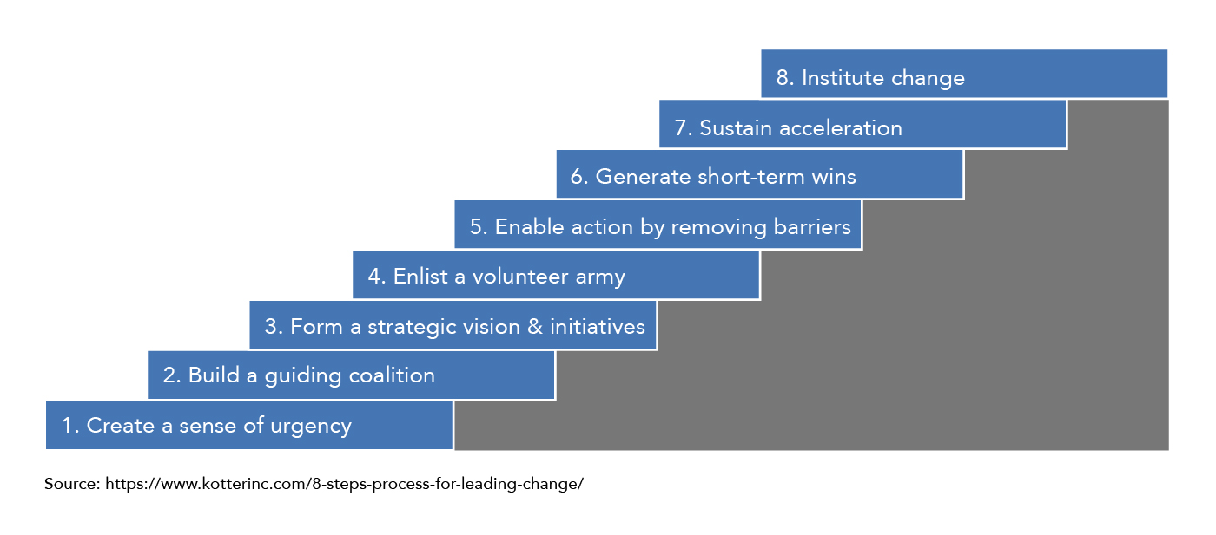
Figure 1: 8-step model of Kotter’s Change Management
(Source: Lumenlearning.com, 2021)

Theory of Taylor’s Scientific Management: The theory of Scientific management evaluates workflows in order to improve labour performance and work sustainability. According to the Church, (2020), the scientific management theory is made up of four fundamental ideas that are implemented in ASDA's organisational environment to maximise employee retention. ASDA's management focuses on scientifically completing each work in order to determine the best approach to do the job. He makes it his duty to help staff enhance their performance. According to the Church, (2020), this idea aids ASDA in analysing employee behaviour by continuously evaluating their performance. ASDA's management examines the behaviour of its personnel in order to assess their performance. According to this concept, the incentive system aids in the regulation of employee performance and provides a greater level of motivation. According to the Church, (2020), ASDA requires workplace study in order to determine the most cost-effective manufacturing techniques. As per this theory, this is critical to determine whether workers are accountable for their obligations and duties or not. Decreasing the workload, the job is distributed carefully among ASDA staff. Based on the capabilities to carry out management directions, this theory aids in identifying the most appropriate personnel.
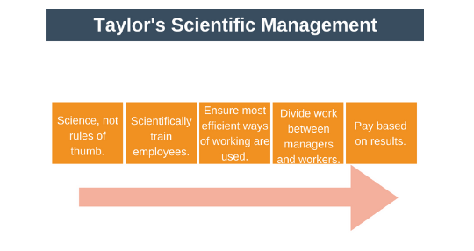
Figure 2: Scientific Management Theory
Source: (Expert Program Management, 2018)

Theory X and Theory Y of McGregor: Organizations use two specific management strategies, according to McGregor's theory. Inside an organisation, Theory X indicates a dictatorial management style whereas Theory Y indicates a participatory management style.
Theory X: As per Fingerprintforsuccess.com. (2021), Managers that follow theory X's approach are frequently regarded as gloomy. Managers, as per Theory X, think that the workers are typically uninspired and dissatisfied with their jobs. As a result of this assumption, organisations embracing Theory X think that there must be a continual need to compensate, penalise, or push employees in order for them to perform tasks and meet goals (Tang, 2019, pp.47-55). The ‘carrot and stick' approach of motivation is commonly employed in such situations, and it entails paying employees and evaluating their productivity based on their performance outputs. According to Ratana, et al (2020), workers need continual direction, as per this theory, since they desire to ignore their obligations, they must be managed, so there is a continuous need for monitoring in addition to maximizing shareholder value. Theory X, according to McGregor, works best in organisations with many levels of management as well as supervision. This is due to the fact that managing employees in huge organisations is difficult and necessitates a tight management structure.
Theory Y: Theory Y of McGregor is an idealistic management strategy that contradicts Theory X. Theory Y's style of management is participatory as well as decentralised. The method promotes a cooperative as well as trust-based connection within an organisation's employees and employer. According to Tutorialspoint, 2021, evaluations are also utilised in this method, and they are also intended to improve great results and interaction rather than manage the workers, unlike Theory X. In today's world, Theory Y is much more famous and extensively employed than Theory X, particularly in small businesses and contemporary workspaces. Organisations frequently utilise both Theory X as well as Theory Y in an attempt to optimise the efficacy of McGregor's theory, depending upon this changing scenario and corporate environment.
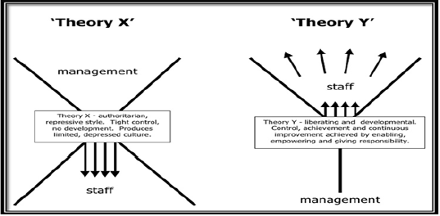
Figure 3: Theory X and Theory Y of Management by McGregor
(Source: Tutorialspoint.com, 2021)

3. Applying management practices to better understand the influence of organisational behaviour, attitudes, beliefs as well as value systems, and addressing post-Covid mindsets with change management methods in ASDA
The critical management practices in ASDA are directly interrelated with the operation, value system, OB, organisational culture and contingent workforce in post-pandemic situations. The CoVID 19 norms are creating changes in almost every business framework of ASDA (Sillars, 2021)‌. The company is struggling to impose an effective and equally budget efficient change in the post-pandemic market. The demonstration of organisational belief, behaviour, value proposition and corresponding managerial structure is described to demonstrate the matter in a detailed way.

3.1. The influence of organisational behaviour, beliefs, attitudes, as well as value systems at the workplace
Organisational Beliefs
Organisational beliefs in ASDA activates the behavioural approach and attitudes of employees. The time management, punctual workforce, operational terms and conditions endorse the productivity in the daily operation of the company. ASDA controls the behavioural tone of employees to enhance the customer service, experience and satisfaction in its online operations in this post-pandemic situation by implicating performance-based rewards and additional perks (Sillars, 2021)‌. Moreover, the usage of digital monitoring, communication, frequent conferences and HR policies also improves the culture and quality of workplace communication, especially in this post-CoVID situation. The theory of Scientific management postulates the adherence to higher ethical and moral values of employees aligned with the business objectives and organisational culture in ASDA. The functional structure in the ASDA workplace is effectively coordinated with the vision and mission of the company that influences optimistic and productive organisational behaviour and better peer management.
Organisational Behaviours
Organisational behaviour is one of the most important intangible assets for businesses like ASDA. The company uses motivational tools, talent management, reward system, and HR management to assure its performance relevance in the post-pandemic situation (Corporate Culture, 2018)‌. Due to the CoVID 19 situation, the company has faced a significant loss in terms of reduced financial and employee turnover. The unavoidable codependency of organisational motivation and employee behaviour can be conceptualised by the human relation management theory. The theory can be applied to generate a correlation between the management relation and productivity- performance norms in ASDA (Corporate Culture, 2018)‌. Due to the increased sales pressure and supply-demand deflection in the post-pandemic market, the operation in the company is at high stress. ASDA is constantly trying to establish relevant customer service by improving and redesigning its organisational behaviour.

Figure 4: In-store shopping in Post-pandemic Situation
(Source: Corporate Culture, 2018)

Value System of ASDA
The core value of ASDA indicates its social responsibility, creativity, innovative market approach, brand image, integrity to the product quality and customer satisfaction. The post covid changes in the value system of ASDA has effectively influenced organisational behaviour and productivity (Corporate Culture, 2018)‌. The post CoVID norms are forcing people to work remotely from their homes, the company is changing their organisational value accordingly and shifting their offline operations to an online delivery process. The scientific management theory insinuates the functional distribution of responsibilities to potential employees who can work in online portals. Similarly, the recruitment and training system in ASDA is changing according to the changing organisational demand. The company is arranging the waste management and carbon-neutral business operation model that is targeted to reduce operational waste and carbon footprints by at least 37% before 2025.

3.2. Adapting workplace adjustments to meet current issues during the post-Covid timeframe
Contingent Workforce
The change model in ASDA is highly interrelated with the mode of communication and communication frequency. The contingent workforce by ASDA employees is highly adaptive to changing market situations, company position, changed online operation and remote working systems in this post-pandemic situation (Corporate - ASDA, 2020)‌. The internal communication, project tracking, monitoring of storage and delivery, active customer portal and remote operational control has helped the company to enhance its online delivery efficacy and operational productivity. ASDA has instructed all its delivery partners and associates to use masks, gloves and frequent sanitisation drills in the storage as foods, packaging and storage is organised in its warehouse facilities. Theory X and theory Y postulates that the work from the home situation and post-pandemic norms are creating adversity for regular ASDA operations which are managed by the HR of the company. ASDA is availing all medical and essential equipment like MCP, disposable kits etc.
Remote Working System in ASDA
The remote working condition in the post-pandemic situation is effectively influencing the business process in ASDA. The theory of Kotter's change management can help to demonstrate the change implication in ASDA most efficiently. ASDA employees are facing difficulties to substitute all necessary functions in the operation management of the company. The in-store operations are becoming highly difficult to manage for lack of sufficient in-store employees. Kotter's Change management model is helping the company to slowly, relevantly and gradually implement training and utilisation of remote management software and monitoring applications to the working employees. The HR management is trying to develop relevant communication mechanisms between employees from different functional departments. The empowerment of successful change actions and embedment of organisational policies in these actions are helping ASDA to effectively implement the remote function in the marketing, customer service, product management and operation department.

Figure 5: Delivery Services During and After pandemic, 2021
(Source: Corporate - ASDA, 2020)

3.3. Creating a future-proof business
Operational Optimisation and Organisational Sustainability in ASDA
The changing norms in the post-CoVID situation is a highly indicative model of what the future business profile and operation might look like. Due to the CoVID 19 situation, the company has faced a significant financial loss (16.7% or £486.48 million) in 2020. The current operational design and administrative decisions are being formulated over better and secured future management (Corporate - ASDA, 2020)‌. Theory X and theory Y postulate two-directional aspects of the current situation wherein the company requires to adhere to strict and instructive organisational norms that can help the company with better productivity, health and safety control etc.
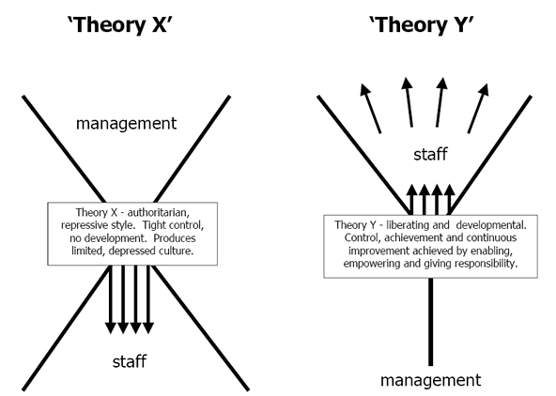
Figure 6: Theory X and Theory Y
(Source: Hubbard, 2021)
On the other hand, it also indicates the motivational drivers like reward, incentive and employee benefits policy modification that can help the company with long and stable business performance in the future market conditions. ASDA needs to use the best of both concepts. The company can use the concept of Theory X to strengthen the operational and delivery section with advanced pandemic measures and product quality control. The company can use the concept of Theory Y to sustain the job satisfaction and retention rate in the company along with better selection and training of potential new talents.
Changing Business Operations according to WHO standards
The WHO instruction for the post-CoVID situation is changing the market operation of almost all retail companies. Companies with a widespread structure like ASDA are facing some difficulties to implicate all instructions and standards in business operations overnight. The costume and mask standards are becoming essential in all departments (Corporate - ASDA, 2020)‌. Waste management and optimised inventory management is being more necessary for government policies (World Health Organisation, 2020). The net aero standards and transport restrictions are making ASDA change its regular distribution operation.

4. Examining diverse management theories critically in order to see how different attitudes, beliefs, and values perceive them
The management theories discussed above are of different values and usefulness. The proper application and emphasis on specific aspects of these theories can significantly improve the business dynamics of ASDA. The following sector is constructed to discuss the usefulness, vulnerability and concerns of mentioned theories to evaluate the individual potential of these theories.
Human Relation Management Theory
According to Cooke et al. (2020), the intangible resources in a business need to be highly correlated with the tangible resources. The human resources and service quality in the post-pandemic situation is the most vital factor for business resurrection. ASDA managers and leaders use human relationship management to improve the organisational motivation, job satisfaction and thereby the behavioural approaches of employees.
Benefits | Drawbacks
- ASDA can use the human relations management theory to improve the communication and relation between employees as well as managers and leaders.  - Moreover, enhanced communication, organisational culture and management compatibility increases employee reliability that ensures the value proposition, organisational culture, retention control and reduced turnover rate in any company. | - Human relationship management oversimplifies the behaviour influencing factors and thereby the management and administration of the company under this model ignore the individual's hard skill, satisfaction and passion of employees.  - Moreover, this management technique in post-pandemic situations is highly difficult to control for reduced opportunities of social interaction in the workplace and rarely arranged conferences between employees.
Table 1: Benefits and Drawbacks of Human Relation Management Theory
(Source: Author)
Scientific Management Theory
According to Merkle (2020, p. 46), scientific management is highly effective in operational departments in ASDA wherein it follows functional structures like accounting department, supply management department, product management department etc. The organisational culture, beliefs, value and employee attitudes in ASDA encompasses the quality of customer service.
Benefits | Drawbacks
- Scientific management theory can help ASDA with enhanced productivity and improved value proposition.  - The job distribution mechanism of this theory can contribute to the contingent operational change in ASDA in the post-pandemic market.  - This can help the company to impose better and more pragmatic business objectives for future operations. | - Scientific management restricts the growth of employees’ soft skills. It suppresses the operational flexibility in departments like market, product design, sales team etc.  - According to Pham et al. (2020), scientific management insinuates monotonous organisational culture and transforms the entire workforce to task-based frameworks.
Table 2: Benefits and Drawbacks of Scientific Management Theory
(Source: Author)
Theory X and Theory Y
According to Grigorov (2020, p. 78), theory X and theory Y stimulates two distinct schools of thought that are assumed to be highly contradicting yet interactive. The managers and leaders in ASDA need to identify which workforce and departmental culture are most compatible with which theory. This can help the company optimise its business functionality, productivity and increase the growth and performance of employees.
Benefits | Drawbacks
- ASDA can use Theory X in its production, manufacturing, supply, accounting, delivery department whereas the company can use the quality of Theory Y in its marketing and IT department for proper relevance and performance optimacy. | - Like human relation management theory, theory Y oversimplifies every action and performance of employees based on the employment relationship that sometimes neglects the hard skills and individuality of employees.  - According to Hubbard (2021), theory X on the other hand oversimplifies the performance based on the administrative order of chain and work pressure that sometimes hinders the criticality of the situation.
Table 3: Benefits and Drawbacks of Theory X and Theory Y
(Source: Author)
Kotter's Change Management
Kotter’s change management model highly reflects the quality of transformational leadership but in a more detailed way (Boff and Cardwell, 2020). The application of this model in ASDA in the post-pandemic situation can create a dynamic situation in the regular business model.
Benefits | Drawbacks
- Kotter’s change management theory is highly effective to implement singular change in a system like changing organisational value, offline to online shift, implementing communication software etc (Evans, 2020).  - This model is highly effective to make employees aware and demanding about the change along with establishing a full proof change in a business. | - This model requires critical demonstration and separate establishment of every step before moving on to the next one.  - Kotter's change model is ineffective to implement all changes required in the post-CoVID situation at once.  - This change model can create high conflict if some employees do not feel comfortable with the change.
Table 4: Benefits and Drawbacks of Kotter's Change Management
(Source: Author)

5. Recommendations for particular organisational adjustments of ASDA for the post-COVID mentality in order to address current issues and build future resiliency
Recommendation 1: Conducting training and developing a program about the remote working technology for the workers
As a result of the epidemic, traditional working procedures have been replaced with digital working procedures. Employees need to be able to operate successfully using digital sites and modern technologies. However, the firm ASDA needs to provide exceptional training and developing programs to their staff. Conversely, it could be argued that a few of the older staff were unaware of this new technology. According to Tang, (2019, pp.47-55), the Latest techniques are not required for individuals, however, the circumstances have compelled them to employ them uniquely. As a result, extensive training for getting acquainted and performing work effectively, especially on digital sites, is required. The firm must effectively build up knowledge about the use of technology inside the organisation. Furthermore, developing increased understanding as well as retraining in the use of enhanced technology is quite important. It is really important to remember that good training can help employees reach their full potential. Workers have the opportunity to improve their capability within their duties as well as the involvement rate may be considerably increased by implementing this technology as well as the working process. Furthermore, this method has provided staff with the chance to be more interested and concentrated on their specific task.

Recommendation 2: Providing work from home facilities
People have been unable to leave their homes due to the covid-19 epidemic, which has compelled them to remain indoors. According to Weiss et al, (2020, pp.735-741), the conventional way of working has evolved, and now companies are forcing their workers to perform from their homes exclusively. The term "remote working" has grown increasingly popular in the business sector. ASDA need to keep its technology up to date in order to efficiently function remotely. They may effectively use the remote workflow by transforming all services to digital sites thus they can connect with one another and significantly reduce the work gap. Furthermore, remote working is able to dramatically increase employee involvement in their duties, making it more valuable to the organisation. Working remotely has successfully improved the quality of jobs and also the workspace.
Recommendation 3: Maintaining social distance inside the workplace
ASDA's management is required to provide a healthy work environment in order to keep its staff fit and healthy. ASDA's management is required to undertake personnel training to educate them on the necessity of wearing masks and keeping adequate social distance. enticing consumers, ASDA will begin selling masks as well as sanitisers and displaying them in outlets. ASDA's management has to make contact with the masks as well as sanitiser providers. It will expand ASDA's profit for the future.
Recommendation 4: Hygiene maintenance
As businesses try to be renowned, the corporation is required to successfully manage its internal hygiene. This is the firm's obligation to create a safe working environment for its employees by establishing a good sanitary environment. ASDA needs to take care of their employees' health, safety and wellbeing by maintaining a hygiene free workplace.

Conclusion
The Covid-19 epidemic has produced difficulties in the commercial sector as well as inside the corporation's entrepreneurs. Companies are going through some different circumstances throughout the competitive industry. The method of efficiently executing duties inside the organisation is rapidly changing. Working remotely is already a well-known aspect among staff and businesses. The report has highlighted many problems that have arisen in front of the ASDA firm throughout that pandemic crisis. Numerous management theories have been given here which can considerably alleviate the difficulties of the retail sector, notably for ASDA. Different management theories benefits and drawbacks for ASDA are also mentioned in this report. Furthermore, the report includes some recommendations for resolving the business's situation.

Reference

Journals & Books
Bhatt, R. (2017). Theoretical perspective of change management. REQUEST FOR FEEDBACK & DISCLAIMER 40.
Boff, C.T. and Cardwell, C.A., 2020. Anchoring Change: Using the Kotter Change Management Framework to Analyze & Facilitate Change in Academic Libraries.
Church, A.H., (2020). The meaning of scientific management. In The Contributions of Alexander Hamilton Church to Accounting and Management (pp. 17-21). Routledge.
Cooke, F.L., Schuler, R. and Varma, A., 2020. Human resource management research and practice in Asia: Past, present and future. Human Resource Management Review, 30(4), p.100778.
Evans, T.R., 2020. Improving evidence quality for organisational change management through open science. Journal of Organizational Change Management.
Grigorov, G., 2020. Analysis of McGregor, aldelfer and murray's motivation theories and their applicability in the military. Science. Business. Society., 5(2), pp.76-78.
Hubbard, M., 2021. Choice Theory: Unlocking the Success of the “Japanese Post-War Economic Miracle” for American Companies.
Merkle, J.A., 2020. The National Crusade for Scientific Management. In Management and Ideology (pp. 43-80). University of California Press.
Pham, N.T., Thanh, T.V., Tučková, Z. and Thuy, V.T.N., 2020. The role of green human resource management in driving hotel’s environmental performance: Interaction and mediation analysis. International Journal of Hospitality Management, 88, p.102392.
Ratana, S., Raksmey, C. and Danut, D., (2020). CONCEPTUALIZING A FRAMEWORK: A CRITICAL REVIEW OF THE DEVELOPMENT OF CHANGE MANAGEMENT THEORIES. Studies in Business & Economics, 15(2).
Small, A., Gist, D., Souza, D., Dalton, J., Magny-Normilus, C. and David, D. (2016). Using Kotter's change model for implementing bedside handoff: a quality improvement project. Journal of nursing care quality, 31(4), pp.304-309.
Tang, K.N. (2019). Change management. In Leadership and Change Management (pp. 47-55). Springer, Singapore.
Weiss, P.G. and Li, S.T.T. (2020). Leading change to address the needs and well-being of trainees during the COVID-19 pandemic. Academic paediatrics, 20(6), pp.735-741.

Webpages
Asda Stakeholders (2021). Asda and Kellogg’s - Stakeholders. [online] Blogspot.com. Available at: http://sandystakeholders.blogspot.com/ [Accessed 17 Aug. 2021].
Asda.com. (2021). Asda.com - Online Food Shopping, George, & more. [online] Available at: https://www.asda.com/about [Accessed 17 Aug. 2021].
Cameron, S. (2019) “Human Relations Management Theory”. [Online] Available from: https://bizfluent.com/info-8197637-human-relations-management-theory.html [Accessed 17 Aug. 2021].
Corporate - ASDA. (2020) Steps we have taken in response to the Coronavirus outbreak. [online] Available from: https://corporate.asda.com/20200309/steps-we-have-taken-in-response-to-the-coronavirus-outbreak [Accessed 17 Aug. 2021].
Corporate Culture. (2018) Asda - Corporate Culture. [online] Available from: https://corporateculture.co.uk/case-studies/asda/ [Accessed 17 Aug. 2021].
Creately (2021) “The Easy Guide to Kotter’s 8 Step Change Model”. [Online] Available from: https://creately.com/blog/diagrams/kotters-8-step-change-model/ [Accessed 17 Aug. 2021].
Expert Program Management. (2018). Expert Program Management. [online] Available at: https://expertprogrammanagement.com/2018/05/taylors-scientific-management/ [Accessed 17 Aug. 2021].
Fingerprintforsuccess.com. (2021). What is the human relations theory (and why should you care)? [online] Available at: https://www.fingerprintforsuccess.com/blog/human-relations-theory [Accessed 17 Aug. 2021].
Lumenlearning.com. (2021). Models of Change Management | Organizational Behavior and Human Relations. [online] Available at: https://courses.lumenlearning.com/wm-organizationalbehavior/chapter/models-of-change-management/ [Accessed 17 Aug. 2021].
Sillars, J. (2021) COVID-19: Asda places 3,000 jobs at risk as part of online investment drive. [online] Available from: https://news.sky.com/story/asdas-new-owners-eye-3-000-job-cuts-alongside-online-investment-drive-12228450 [Accessed 17 Aug. 2021].
Tutorialspoint.com. (2021). Theory X & Theory Y. [online] Available at: https://www.tutorialspoint.com/organizational_behavior/theory_x_and_y.htm [Accessed 17 Aug. 2021].
World Health Organisation. (2020) Getting your workplace ready for COVID-19. [online] Available from: https://www.who.int/docs/default-source/coronaviruse/getting-workplace-ready-for-covid-19.pdf [Accessed 17 Aug. 2021].

