Fault Tree Analysis
Systems Engineering
ACDA 5021

]



Theodore Dunning
2317700
Table of Contents
2 Abbreviations 3
3 Table of Figures 3
4 Table of Tables 3
5 Abstract 4
6 Introduction 4
6.1 Definition & Purpose of FTA 4
7 Foundations of FTA 4
7.1 FTA Structure 4
7.2 Logic Gates 5
7.2.1 ‘AND’ Gate 5
7.2.2 ‘OR’ Gate 5
7.3 Minimal Cut Sets 6
7.4 Key Assumptions 6
8 Evaluation of the given Fault Tree 6
8.1 System Description 6
8.2 Probability Calculations 8
8.3 Probability calculations including human factors 9
8.4 Final Result Interpretation 10
9 Integration of Human Factors 10
9.1 Human Error as a Failure Source 10
9.2 Types of Human Error 11
9.3 Impact on Fault Tree Modelling 11
10 Conclusion 11
11 References 12

Abbreviations
FTA | Fault Tree Analysis
HF | Human Factors
RCM | Reliability Centred Maintenance
FMEA | Failure Modes and Effects Analysis
RCA | Root Cause Analysis
HRA | Human Reliability Analysis

Table of Figures
1 | Aircraft Engine Failure FTA
2 | Types of FTA Gates
3 | Given Fault Tree
4 | Given Fault Tree Calculations
5 | Given Fault Tree Calculations
6 | Given Fault Tree Calculations (Human Factors Introduced

Table of Tables
1 | Given Fault Tree Probabilities
2 | Calculated Fault Tree Probabilities
3 | Calculated Fault Tree Probabilities (Human Factors introduced)
4 | Calculated Fault Tree Probability Comparison

Abstract
In this report, fault tree analysis is applied to a simple system, the preparation of a hot drink. The specific case considers Billy, whose aim is to create a cup of tea. Using the provided fault tree with bottom level probabilities assigned, the probability of the top level event was determined through mathematical calculation. In addition, the role of human factors in influencing the system reliability was explored and implemented to the fault tree, with results compared to the original analysis.

Introduction

Definition & Purpose of FTA
Fault Tree Analysis (FTA) is a commonly used technique within systems engineering; it’s used to analyse causes of failures by breaking down a top level event into an expanding logical structure into its contributing causes. Originally, the method was created in 1962 by Bell Telephone Laboratories as a way of analysing the launch control systems of the intercontinental Minuteman missile, it was later picked up by Boeing Company who developed it further and enhanced its ability to support reliability and safety studies. [1]

The primary use of FTA is to highlight potential failure mechanisms while also quantifying their likelihood of happening, which allows engineers to assess and manage the risk at hand. Combining both Boolean logic and probability theory, it helps to provide understanding for how individual system component failures or human errors can combine to create a complete system failure [2]. Nowadays, FTA is a standard tool used throughout most industries, especially including areas like defence, aerospace and nuclear.

Foundations of FTA

FTA Structure
Fault trees are described as trees due to their branching structure; they are usually created following a top-down view, with the top system-level failure breaking down into intermediate events below it and then further into basic root causes of failure which cannot be further divided. [3]
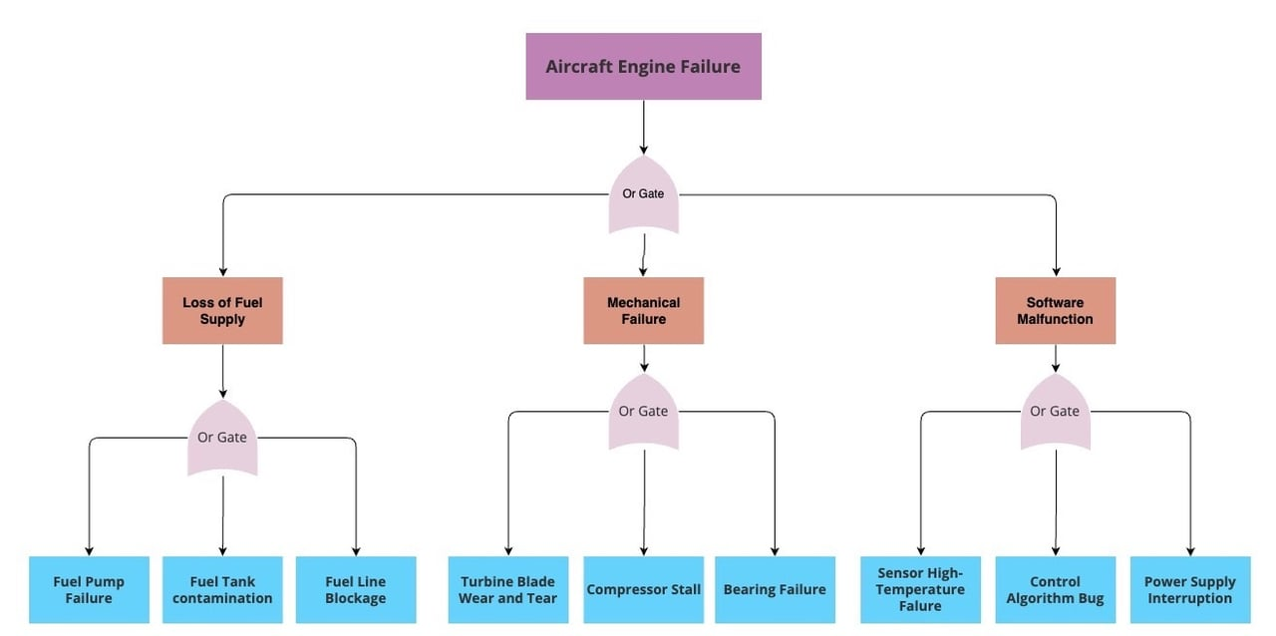

Figure 1, Aircraft Engine Failure FTA. [4]

Logic Gates
Relationships between events are shown using many different logical gates, the simplest being ‘AND’ and ‘OR‘ gates. These gates reflect the Boolean logic and allow the failure pathways to be expressed mathematically. There are many different types of gates, some shown in figure 2, but in this study only ‘AND’ and ‘OR’ gates are used.

‘AND’ Gate
When an ‘AND’ gate is used, all of the input events must occur simultaneously; the probability of the output event is calculated as the product of the input probabilities.

‘OR’ Gate
When an ‘OR’ gate is used, only one input event can cause the output, and the probability is calculated using the complement rule; this is where it is considered that neither event occurs, and this is subtracted from one (shown in figure 5).

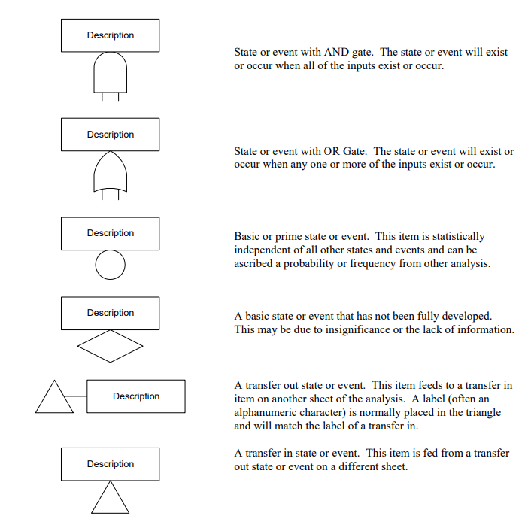
Figure 2, Types of FTA Gates [2]

Minimal Cut Sets
Minimal cut sets represent the smallest combination of input events for the top level event to occur. Identifying these sets is important as it allows complicated fault trees to be simplified into a series of critical failure combinations, making it easier to understand. From a quantitative perspective, minimal cut sets also forms the basis for calculating the probability of the top event; it allows engineers to identify which combinations of failures contribute most significantly to the overall system risk and therefore, where improvements need to be focused.

Key Assumptions
FTA relies on multiple simplifying assumptions. It is assumed that basic events are statistically independent, and system states are typically treated as either functioning or failed. These help to simplify analysis, but they reduce the realism of the model, especially in systems that involve human interaction.

Evaluation of the given Fault Tree

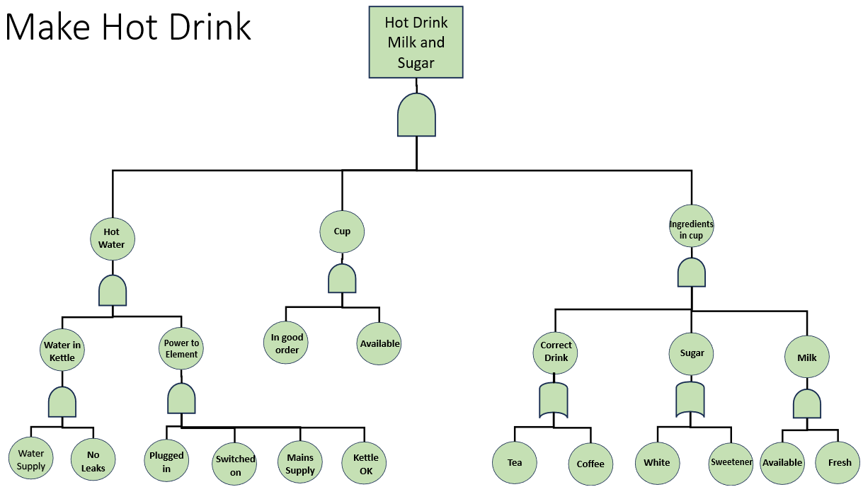
System Description
Figure 3, Given Fault Tree

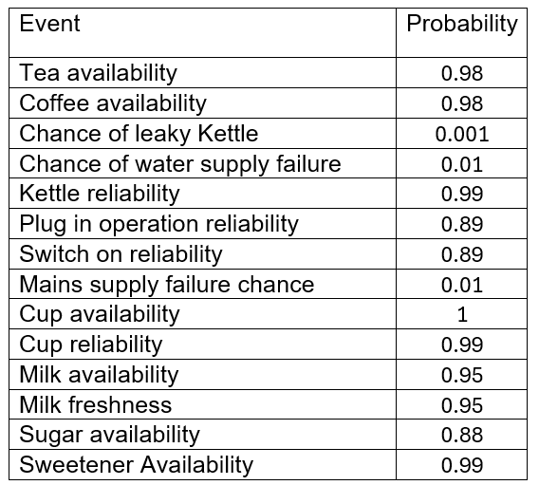

Table 1, Given Fault Tree Probabilities

The given fault tree uses 4 levels of events, 7 AND gates and 2 OR gates. With each bottom level event assigned to individual probabilities, the top level event can be calculated by working up the tree, following the AND / OR Gates rules.

At first, some of the probabilities had to be reversed, for the tree to work, all the probabilities needed to be either the probability of success or the probability of failure. This meant, for the probabilities like P(Chance of leaky kettle), it had to be reversed by subtracting it from 1 to find P(Chance of not leaky kettle) = 0.999. This was completed for P(Chance of water supply), and P(Mains supply failure chance) too.

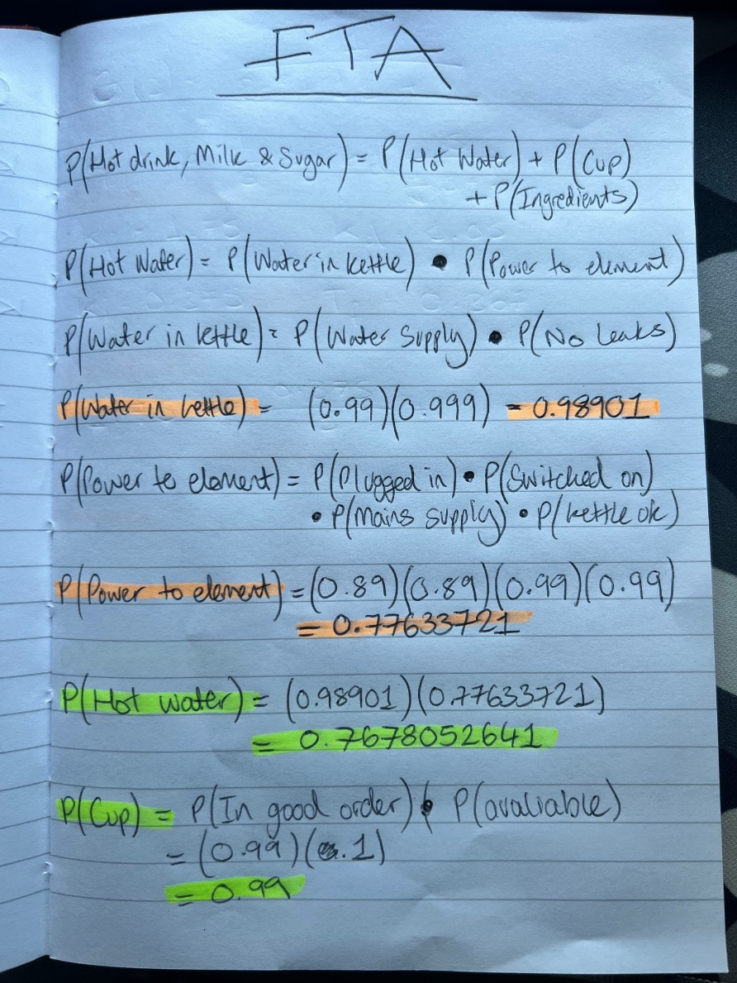
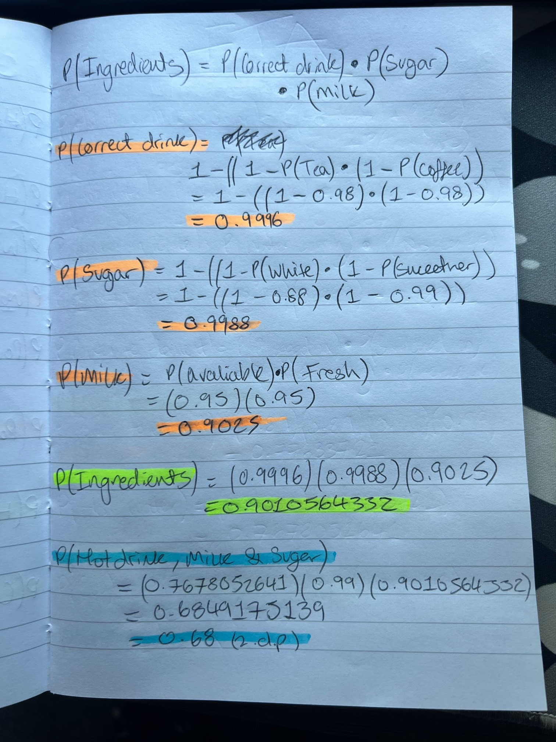
Probability Calculations
Figures 4 & 5, Given Fault Tree Calculations

Initially, calculations were started on P(Water in Kettle) and worked along to P(Power in Element) and up to P(Hot Water), this pattern from left to right was followed on the other branches to minimise confusion. Bottom event calculations were highlighted in orange, middle level in yellow and then top event in blue.

Bottom Event Probabilities (Orange) |  | Rounded Values (2 d.p.)
P(Water in Kettle) | 0.98901 | 0.99
P(Power to Element) | 0.77633721 | 0.78
P(Correct Drink) | 0.9996 | 1.00
P(Sugar) | 0.9988 | 1.00
P(Milk) | 0.9025 | 0.90
Middle Event Probabilities (Yellow)
P(Hot Water) | 0.7678052641 | 0.77
P(Cup) | 0.99 | 0.99
P(Ingredients in Cup) | 0.9010564332 | 0.90
Top Event Probability (Blue)
P(Hot Drink, Milk & Sugar) | 0.6849175139 | 0.68
Table 2, Calculated Fault Tree Probabilities

From this data, it can be seen that on the lowest level, P(Power to Element) is the most likely to fail. This has a knock on effect of lowering the probability P(Hot Water) as it shares the same branch. P(Correct Drink) and P(Sugar) are the most likely to succeed, but, P(Plug in Operation) and P(Switch on Reliability) are both the lowest.

Probability calculations including human factors
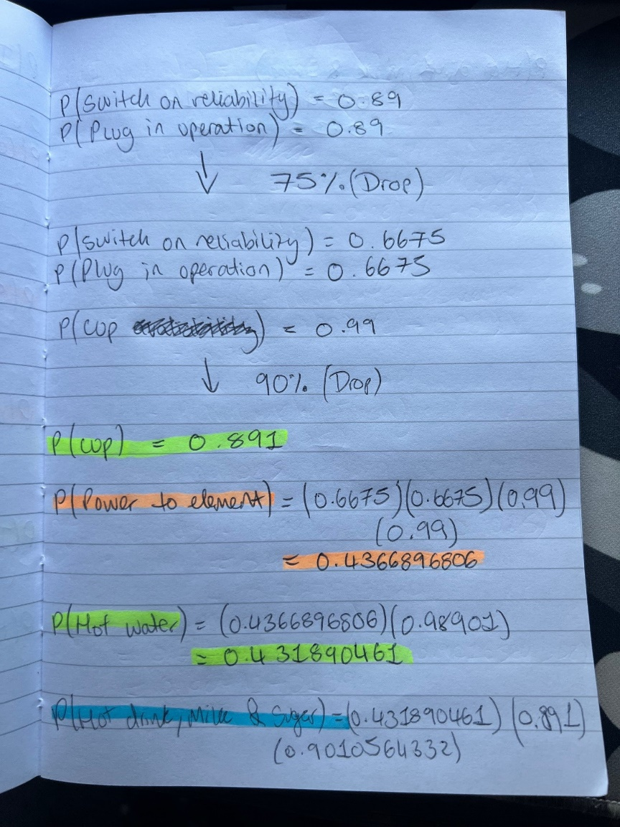
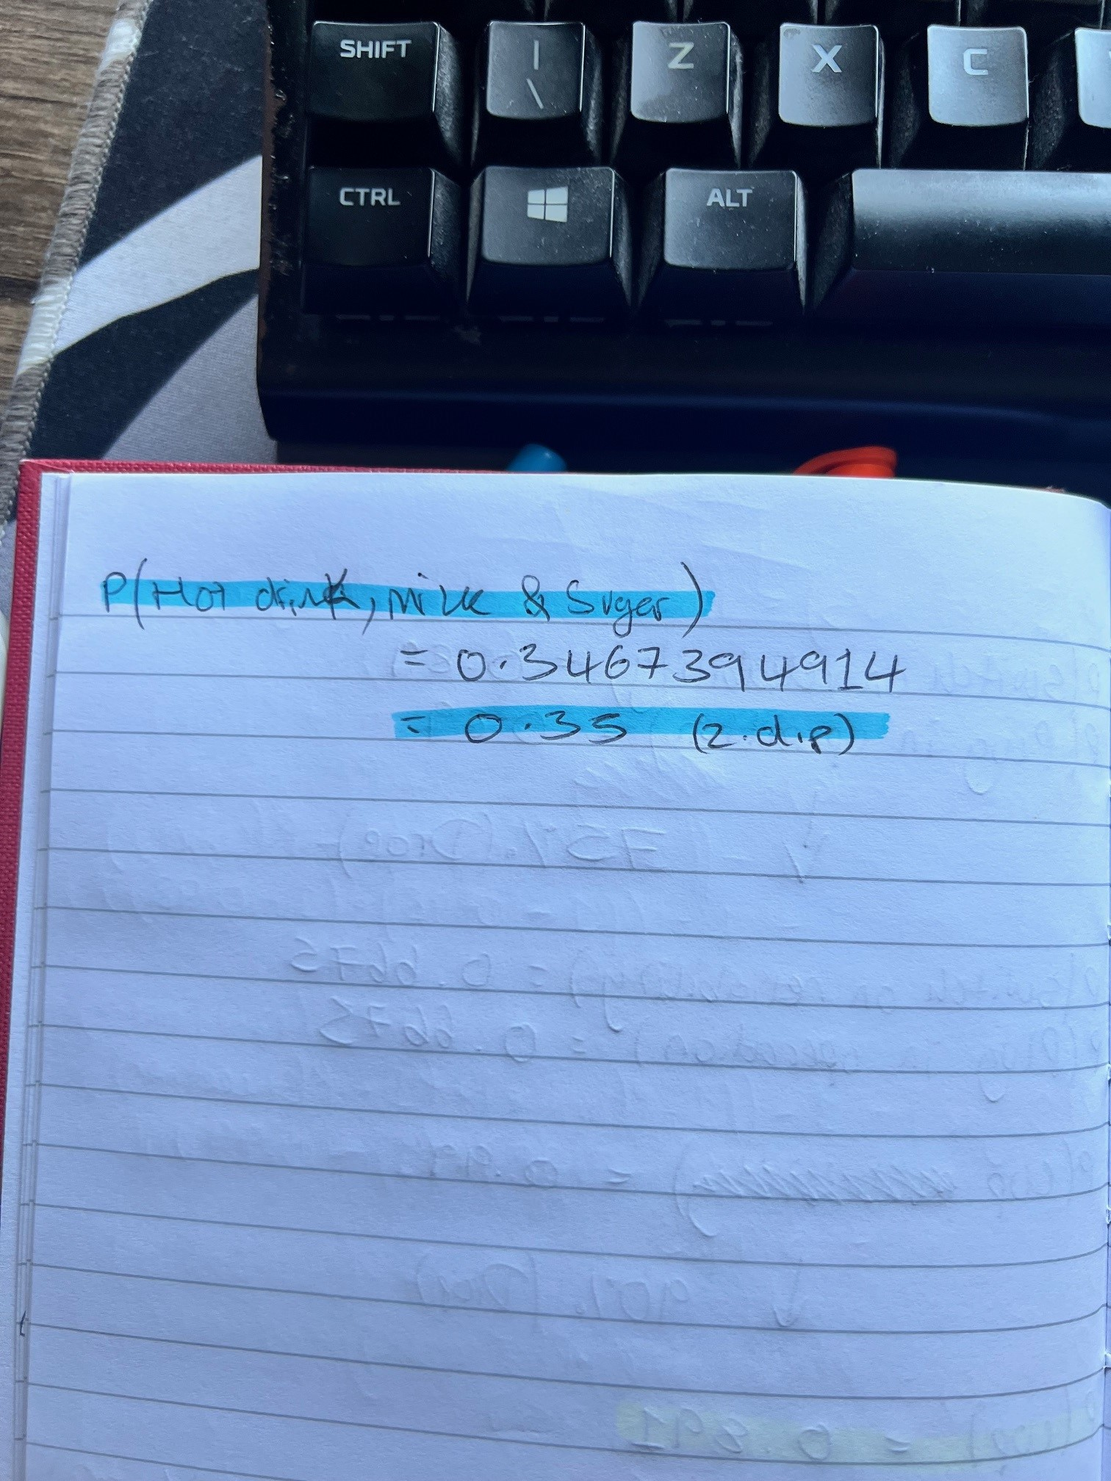

Figures 6 and 7, Given Fault Tree Calculations (Human Factors Introduced)

Billy decides to make a cup of tea in the middle of the night, introducing fatigue, lack of concentration and other human factors into the tree. This dropped Billy’s ability to plug in and switch on the kettle to 75% of his normal and ability to select a cup dropped to 90%. These values were calculated and then put back into the fault tree (figure 6 and 7).

Bottom Event Probabilities (Orange) |  | Rounded Values (2 d.p.)
P(Power to Element) | 0.4366896806 | 0.44
Middle Event Probabilities (Yellow)
P(Cup) | 0.891 | 0.90
P(Hot Water) | 0.431890461 | 0.43
Top Event Probability (Blue)
P(Hot Drink, Milk & Sugar) | 0.3467394914 | 0.35
Table 3, Calculated Fault Tree Probabilities (Human Factors introduced)

Results of the fatigue influenced events show that even a few small changes can drastically affect the final probability, in this case it almost halved the probability that Billy would successfully make a cup of tea.

Final Result Interpretation

Probabilities | Original Fault Tree | Fatigue Introduced Fault Tree | Difference
P(Power to Element) | 0.78 | 0.44 | 0.34
P(Cup) | 0.99 | 0.90 | 0.09
P(Hot Water) | 0.77 | 0.43 | 0.34
P(Hot Drink, Milk & Sugar) | 0.68 | 0.35 | 0.33
Table 4, Calculated Fault Tree Probability Comparison

The dropped probabilities due to human factors overall brought the chance of Billy making the correct cup of tea down by 33%. This is a large difference and should have controls implemented to reduce this difference for future use.

Controls that would benefit this system would be leaving the kettle plugged in all the time, or an automatic switch so when the kettle is placed onto the station it turns itself on. Adding automation can reduce human error and boost reliability, as long as the budget allows it.

Integration of Human Factors

Human Error as a Failure Source
When a system is under consideration, human factors play a significant part of the reliability of a system. In this example, the completion of making a hot drink relies heavily on Billy’s actions. Human errors are usually what make up the reasons for the lowest level failure events occurring, in Billy’s example, 8/12 bottom level events are human interaction specific.

Types of Human Error
Human error can come in the form of unintended actions. The person completing the operation may slip up and forget to check if the milk was fresh or select coffee rather than tea. These can be done by anyone, even well trained individuals that lose concentration for a moment. To reduce the occurrence of these, it is important to look into the design of the system rather than the training of the person, as the person may know the correct procedure but still make the mistake. Although, these mistakes can still be caused due to lack of training, if the person is not properly trained in the first place. [4]

Intended errors may occur when the person involved believes that they can get away with deliberately not carrying out a part of a procedure, this may be to save time or even deliberately to sabotage the operation. This is usually caused due to poor design of the system that encourages the person to try and make their job easier by cutting corners. For these errors it is important to involve detection methods and ensuring training explains the relevance of each step in the system. [4]

Impact on Fault Tree Modelling
Incorporating human factors into FTA is a difficult task because of having to give each error a representative probability. On mechanical components, probability of failure can be calculated through thorough testing and finding average failure rates between parts that have been manufactured to the same standard. With humans, each person is different, and the performance of one person is influenced by a large range of factors, these include experience, lifestyle, environmental conditions, mental health and many more. As a result of this, estimations are often inaccurate.

Conclusion
In conclusion, FTA provides a useful framework for understanding and quantifying system failures. The inclusion of probability theory and modelling allows for not only evaluation of failure pathways but also for identification of new ones.

By looking into the preparation of a hot drink, it showed how FTA can be used to analyse very simple systems and create results that highlight the importance of human factors in determining system reliability.

While FTA is a powerful analytical tool, it is highly dependent on the accuracy of probability values and that the validity of assumptions. It can be most effective is support alongside other methods to provide a wider understanding of system behaviours. Other documents that can be used to support an FTA are Reliability Centred Maintenance (RCM), Failure Modes and Effects Analysis (FMEA), Root Cause Analysis (RCA) or Human Reliability Analysis (HRA).
Total Word Count: 1366

References
[1] Xing, L., Amari, S.V. (2008). Fault Tree Analysis. In: Misra, K.B. (eds) “Handbook of Performability Engineering”. Springer, London. Book Available Online: Fault Tree Analysis | Springer Nature Link
[2] Shafiee, M., Enjema, E., Kolios, A. (2019). “An Integrated FTA-FMEA Model for Risk Analysis of Engineering Systems; A Case Study of Subsea Blowout Preventers.” MDPI. Article Available Online: An Integrated FTA-FMEA Model for Risk Analysis of Engineering Systems: A Case Study of Subsea Blowout Preventers
[3] Zoidii Ltd. “Fault Tree Analysis”. (2024). Dec 16. Website Available Online: Fault Tree Analysis: A Comprehensive Guide
[4] HSE, Health and Safety Executive. “Managing Human Failures”. Available Online: Managing human failures: Overview - HSE
[5] Li, Y. Zhu, L. “Risk Assessment of Human Errors in Interaction Design Using Fuzzy Fault Tree Analysis.” Appl. Sci. 2026. Available Online: Risk Assessment of Human Errors in Interaction Design Using Fuzzy Fault Tree Analysis
[6] K. M. Goth, S. Shen, J. Oxstrand, A. Mosleh, D. Kelly. “A Model-Based Approach to HRA: Example Application and Quantitative Analysis”. Available Online: A-Model-Based-Approach-to-HRA-Example-Application-and-Quantitative-Analysis.pdf

