

Advanced Web Development.

Development of a PHP Website Using Object-Oriented Techniques.

by
Andrew John Edward Cooper

Supervisor: Michael Dacey

Abstract
The use of version control systems are becoming crucial for development projects containing teams of all sizes due to the versatility and the ease of workflow. Systems such as Git are becoming increasingly popular within large companies as it allows for ease of code review, sharing of code between teams and simultaneous development of the same file with the ability to merge code changes together effectively with the build in merge feature. Agile development processes are also very hot in industry as methodologies that use Agile usually require input from all stakeholders, a method that can greatly reduce development times and ensures that all those affected by the project have a clear understanding of the project aims and end goals.

Contents
Abstract i
1 Introduction 1
2 User Stories 1
3 Version Control Systems (VCS) 3
3.1 Stages of a GIT Artefact 3
3.1.1 Untracked/Modified 3
3.1.2 Staged 3
3.1.3 Commit 3
3.2 Git Commands 3
3.3 Evidence of Version Control 4
4 Conclusion 6
References 7
Appendix 8

Figure 1 - User Stories [1]. 1
Figure 2 - User Stories for Developed Project. 2
Figure 3 - Evidence of Version Control 4

Introduction
This report aims to use a series of techniques that are currently widely used in industry, such as, user stories and the use of version control systems. The use of these within a project can greatly reduce development time, and potential hazards in implementation.

User Stories
User stories are a part of the agile process which aims to reduce the potential of misunderstanding between all stakeholders of a software project and include the client much more than other development methods as these will be collaborators through the planning and development process. Using an agile approach is beneficial for teams as they can develop further understanding of the project and requirements with the use of MVP (minimum viable product) which aims to show functionality of the project without being complete [1]. This means any changes the client wants made is not going to have drastic time delays.
User stories are used within development projects and work with great effect as they have the ability for teams to understand required functionality of the program which can then be delegated to the developers of the project to complete without the need to wait for others to complete their tasks.
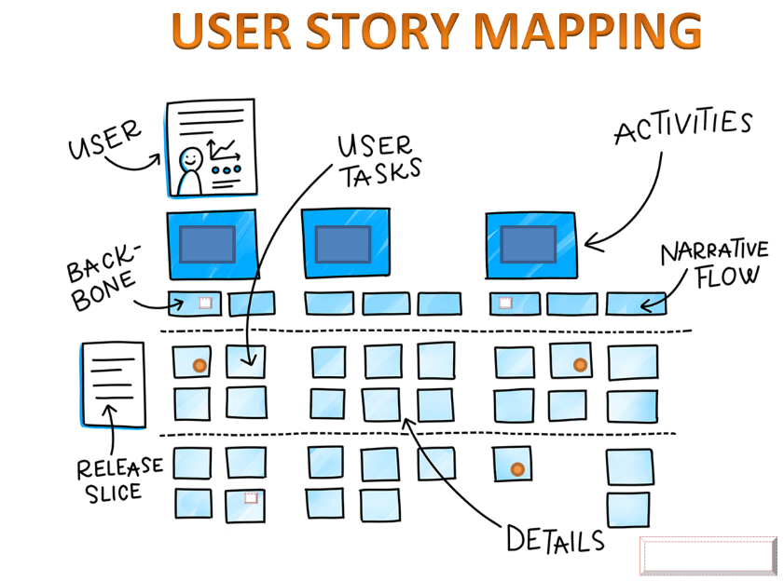
Figure 1 - User Stories [2].

Below (figure 2) are user stories developed for admin and users to describe interactions and narrative flow for the project.

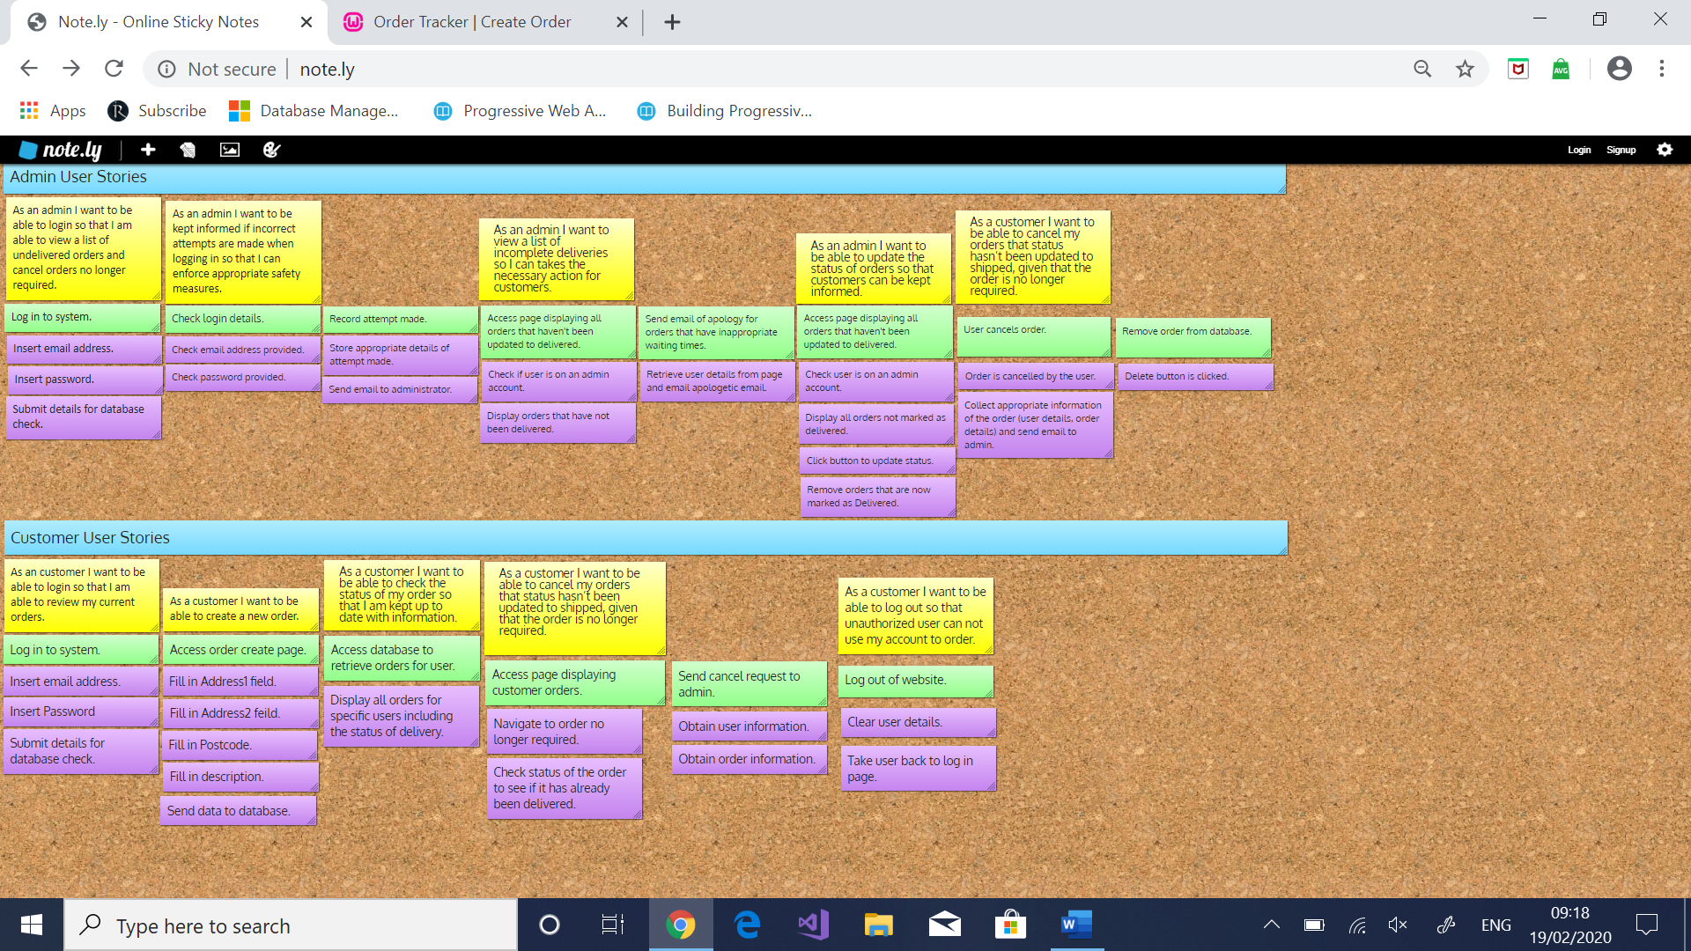
Figure 2 - User Stories for Developed Project.

Version Control Systems (VCS)
Version control systems are systems used to keep track of changes of files overtime and allow access to previous versions of the project files. Using version control systems can vastly improve productivity in development environments and makes for a better workflow.
There are many benefits to using version control systems as both a solo developer and within a team [3]. Not only can these systems be a safety net for development projects but the main reason of use is for the ability to track changes made to code through iterations of development. Past version of the code can also be used for developers to go back to a specified version (mentioned in Git Commands).
For teams of developers, version control systems are essential because it allows for multinational teams of developers to work on a project together with ease. Also, code developed by different team members can be merged together much easier than without the use of a VCS, without this teams run the risk of code being developed by two separate members being overwritten by the other as overwritten code could be very hard to get back. Furthermore, it gives developers the ability to review code submitted by other collaborators of the project, which is ideal if there’s an issue with the code as code changes can be developed by the developer who inserted the code into the repository.
As a solo developer, version control systems are beneficial because in solo development projects, keeping track of what changes have been made throughout the development, when and why certain changes were made, especially as the project gets larger can save a huge amount of time for the developer. Secondly, in some cases the best solution to fix problems in code is to restart from a point that the code was working as expected. Without the use of VCS, this would require the developer to potentially have a huge amount of backups of the project, taking up disk space. However, using a version control system means that code is kept secure in one location with a meaningful message describing what changes were made and with a timestamp of when the changes were added to the repository.
Lastly, using version control systems as a solo developer means that the project can easily be extended to allow for collaborative work in the future. A task that would be made much harder without the use of VCS.

Stages of a GIT Artefact
An artefact in GIT is the file being developed. Before artefacts are added to the main repository it must pass through three stages:

Untracked/Modified
This is the step in which changes have been made to the artefact within the users own remote repository, the repository stored on the users local machine which is a copy of the git repository. This means that changes can be made locally without causing undesired changes to the main project. However, although these files have been adjusted they will not be added into the repository when the commit command is executed. The artefact must be placed into the staged area before it will get added into the repository (ON THE NEXT CALL TO COMMIT).

Staged
After the changes have been made within the artefact, they need to be pushed onto the staging area. Staging the artefact is the process where changes have been made in the modified area and is now ready to be added to the project repository. Although the changes are ready to be added to the main repository, it does not get added until the user runs the commit command.

Commit
Artefacts that have been staged are eligible to be committed, the process of adding the artefact into the local repository. When making a commit, the developer must include a message to describe what changes have been implemented within this new commit. Once committed to the local repository, the artefacts can be synchronised to the main repository which can be viewed by viewed by other team members or everyone (if the repository is public).

Git Commands
There are a series of Git commands that are required for set up and use throughout the development of the project. The following are a list of relevant commands that are commonly used within the development of a project:
- Git config – This command is used to set up information in the configuration file. An example of this is setting the email and password git config --global user.email “Andrew-Cooperz@hotmail.co.uk”. Adding global means that this information will be stored in the operating system of the user therefore will be remembered across all projects.
- Git init – This should be used in the initial building of the development as this command is used to create a local repository for the user.
- Git remote add origin – This command is used to create a remote which is repository other than the one stored locally. These remotes are the ones that allow users to push and pull from with the use of synchronise. When creating a new remote, you must provide two piece of information, a name and a location for the remote. The following is an example of this:
“git remote add origin https://github.com/AndrewCooperUWTSD/TESTPOS.git”.
- Git add – This is used to track a new file or changes made to an existing artefact. When this command is run on either of these, they are placed in the staging area which is the stage before commit (see “Stages of a Git Artefact”).
- Git commit – As mentioned in the previous section, the git commit command is used when the developer wants to add staged artefacts into the local repository. The local repository works well if working on a project as a solo developer as it has a lot of the functionality as a remote repository.
- Git push – Unlike commit, push is used when the developer wants to add their code to the remote repository, making it sharable between teams and just about anyone in the world, depending on the setting of the project.
- Git pull – This command is used to access files from the remote repository and update the content stored on the local repository. This functionality is essential for teams of developers because it allows for all collaborators to have up to date copies of the code, especially if the project is at a working stage, or substantial changes have been made within the code by other members.
- Git clone – This command is used to copy an existing repository to a new directory. This is useful if the code is free for use publicly or if a new developer joins the team and needs a full copy of the repository to work from.
- Git log – Git log is the command used in figure 3, it displays information from previous commits made to the repository.
- Git branch – Branching is the method in which development can be performed from a branch that extrudes from the main branch. Developers can benefit from using this because it allows for test code or code that may not be completely working to be uploaded without causing disruption to the main repository line.

Evidence of Version Control
Figure 1, seen below, displays evidence that the developer has used git as a version control system to help keep track of changes that was made through iterations of the project. As mentioned previously, commits to the repository are timestamped, labelled with the author and a message describing what changes have been made. It is important to note that commits are also given a unique identifier, these are important as if the developer wants to recall to a previous version, they will need to use it’s identifier.
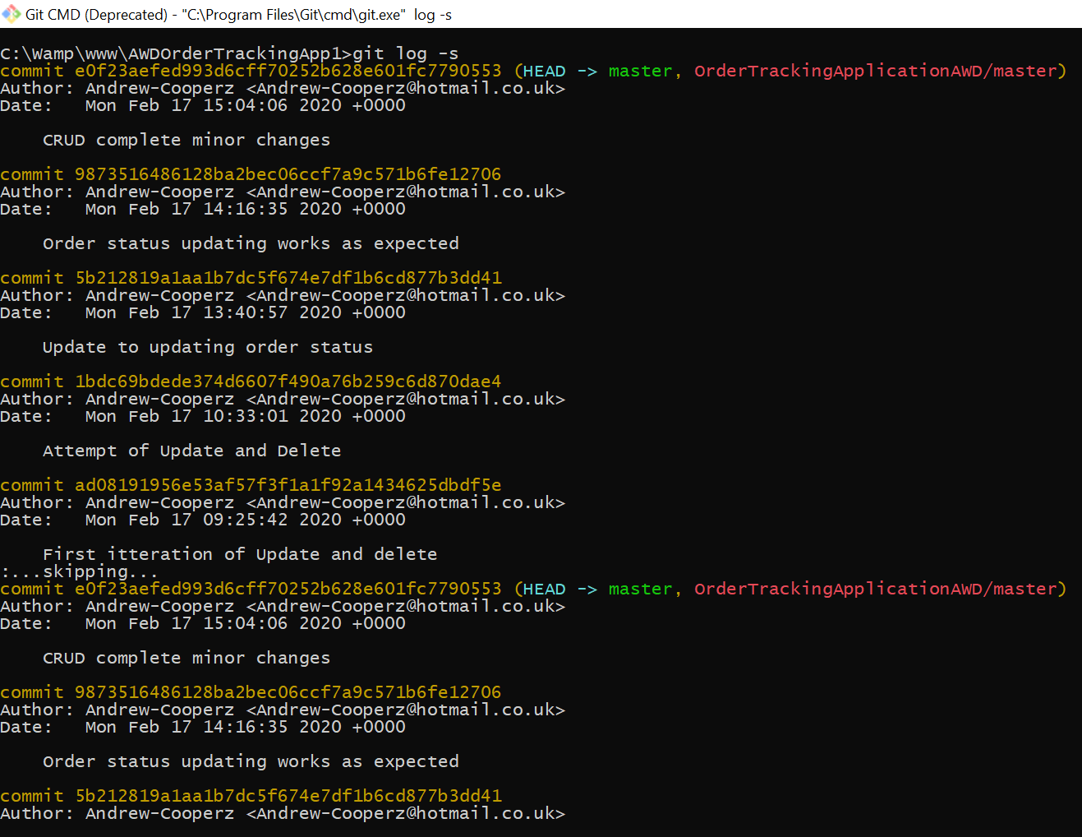
Figure 3 - Evidence of Version Control

Conclusion
To reiterate some of the core concepts discussed in this report, development teams are using development methodologies which inherit from Agile but with their own twist, such as SCRUM, feature driven development and Kanban as this is an extremely efficient way to include stakeholders within the planning and development of the project to help minimise miscommunication and resolve any ambiguity. Also, having the ability of obtaining a minimum viable product from early stages to display to stakeholders means issues can be rectified in a much quicker manner than if the project has reached the end of it’s development cycle.
Lastly, version control systems are database like structures used by solo and development teams to keep track of code changes made within a project on a main repository. This is ideal because it not only allows for simultaneous development of the same code by different users on a local repository with the ability to merge code changes from different developers, but, also allows for recall of code from previous timesteps should there be issues within newly developed code. Throughout the development of the order tracking application, git was used as a version control system by the developer. Using this system, it was discovered that files in GitHub are named “artefacts” and an artefact must go through three stages before it is added to the repository: untracked/ modified, staged and then lastly committed.

References

[1] | M. Cohn, User Stories Applied For Agile Software Development, Indiana: Addison-Wesley, 2004.
[2] | P. Shah, “User Story Mapping | Product Backlog Creation,” Medium, 16 May 2019. [Online]. Available: https://medium.com/@priyank.it/user-story-mapping-product-backlog-creation-7ea9a54f7f0e. [Accessed 19 Feb 2020].
[3] | e. a. Marko Mijač, “Version Control Systems, Tools and Best Practices: Case Git,” 2015.

Appendix

Index.php
<!DOCTYPE html>
<head>
<title>Order Tracker | Log in </title>
<meta name = "viewport" content = "width = device-width, initial-scale = 1.0, shrink-to-fit=no">

<!--Styles -->
<link rel="Stylesheet" href="css/bootstrap.min.css">
<!--<link rel="Stylesheet" href="css/style.css"> -->

<!-- Scripts -->

</head>
<body>
<main id = "main-section">
<div class = "row m-5">
<div class = "col-xs-12">
<h1> Welcome to your parcel tracker! </h1>
<h5> Log in to find out details of your orders </h5>
<form action = "Connector.php" method = "POST">
<div class = "form-group">
<label for = "Email"> Email </label>
<input type = "text" class = "form-control" name="Email" placeholder = "Email Address">
</div>
<div class = "form-group">
<label for = "Password"> Password </label>
<input type = "password" class = "form-control" name="Password" placeholder = "Password">
</div>
<button type = "submit" class = "btn btn-default"> Log in </button>
</form>
</div>
</div>
</main>
</body>
</html>

Connector.php
<?php

namespace App;
require_once "PDO_DB.php";
use App\PDO_DB;

$link = new PDO_DB();

if(isset($_POST["Email"]) && isset($_POST["Password"]))
{
$email = $_POST["Email"];
$password = $_POST["Password"];

session_start();
$_SESSION["Email"] = $email;
$link->CheckUser($email, $password);
}
?>

OrderCheck.php
<?php
session_start();
require_once "PDO_DB.php";
use App\PDO_DB;
if(@$_SESSION["Email"])
{
?>
<?php
$link = new PDO_DB();
$orders = $link->GetOrders($_SESSION["Email"]);
$admin = $link->GetUserId($_SESSION["Email"]);
?>
<!DOCTYPE html>
<head>
<title>Order Tracker | Current Orders </title>
<meta name = "viewport" content = "width = device-width, initial-scale = 1.0, shrink-to-fit=no">
<!--Styles -->
<link rel="Stylesheet" href="css/bootstrap.css">

<!-- Scripts -->
<script src="Scripts/jquery-3.0.0.min.js"></script>
<script src="Scripts/bootstrap.min.js"></script>
</head>

<body>
<header id="main-header">
<nav class="navbar navbar-expand-lg navbar-light bg-light">
<a class="navbar-brand" href="OrderCheck.php">Order Tracker</a>
<button class="navbar-toggler" type="button" data-toggle="collapse" data-target="#navbarNavAltMarkup" aria-controls="navbarNavAltMarkup" aria-expanded="false" aria-label="Toggle navigation">
<span class="navbar-toggler-icon"></span>
</button>
<div class="navbar-nav ml-auto">
<div class="collapse navbar-collapse" id="navbarNavAltMarkup">
<a class="nav-item nav-link active" href="OrderCheck.php">Home <span class="sr-only">(current)</span></a>
<a class="nav-item nav-link" href="CreateOrder.php">Create Order</a>
<li class="nav-item dropdown">
<a class="nav-link dropdown-toggle" data-toggle="dropdown" href="#" role="button" aria-haspopup="true" aria-expanded="false">Filter</a>
<div class="dropdown-menu">
<a class="dropdown-item" href="WarehouseOrders.php?statusId=1">In Warehouse</a>
<a class="dropdown-item" href="WarehouseOrders.php?statusId=2">In Transit</a>
<a class="dropdown-item" href="WarehouseOrders.php?statusId=3">Delivered</a>
<div class="dropdown-divider"></div>
</div>
</li>
<a class="nav-item nav-link" href="Contact.php">Contact Us</a>
<form class="form-inline" action="QueryLink.php" method = "POST">
<input class="form-control mr-sm-2" type="search" name = "search" placeholder="Search" aria-label="Search">
<button class="btn btn-outline-success my-2 my-sm-0" type="submit">Search</button>
</form>
<a class="nav-item nav-link" href="Signout.php">Sign out</a>
</div>
</div>
</div>
</nav>
</header>

<h1 class = "text-center m-5"> Welcome <?php echo $_SESSION["Email"]; ?> </h1>

<?if($admin == 1)
{?>
<h3 class = "text-center"> Here is a list of incomplete orders </h3>
<div class = "container">
<div class = "row mt-5">
<?$adminOrders = $link->GetAOrders();
if(empty($adminOrders))
{?>
<h4 class = "text-center"> All orders have been delivered </h4>
<? }
else{
foreach($adminOrders as $order){?>
<div class = "col-sm-12 col-md-4">
<div class = "card m-3">
<div class = "card-body">
<h3 class = "card-title text-center" name="orderId"><?php echo $order['Id'];?></h5>
<h5 class = "card-subtitle text-center text-muted"><?php echo $order['Description'];?></h5>
<p class = "text-center"><?php echo $order['Email'];?></p>
<p class = "text-center"><?php echo $order['ItemDescription'];?></p>
<p class = "text-center text-muted"><?php echo $order['DateAdded'];?></p>
<a href = "UpdateStatus.php?orderId=<?php echo $order['Id'];?>&statusId=<?php echo $order['StatusId'];?>" class ="btn btn-default"> Update Status </button></a>
<a href = "RemoveOrder.php?orderId=<?php echo $order['Id'];?>" class = "btn btn-default"> Remove Order </button></a>
</div>
</div>
</div>
<?}
}
}
elseif(empty($orders)){ ?>
<h4 class = "text-center"> You have no orders to show </h4>
<?}
else {?>
<h3 class = "text-center"> Here is a list of your orders </h3>
<div class = "container">
<div class = "row mt-5">
<? foreach($orders as $order){?>
<div class = "col-sm-12 col-md-4">
<div class = "card m-3">
<div class = "card-body">
<h3 class = "card-title text-center"><?php echo $order['Id'];?></h5>
<h5 class = "card-subtitle text-center text-muted"><?php echo $order['Description'];?></h5>
<p class = "text-center"><?php echo $order['ItemDescription'];?></p>
<p class = "text-center text-muted"><?php echo $order['DateAdded'];?></p>
<? if($order['StatusId'] == 3){

}
else{?>
<a href = "CancelOrder.php?orderId=<?php echo $order['Id'];?>" class = "btn btn-default"> Cancel Order </button></a>
<?}?>
<a href = "FullDetails.php" class = "btn btn-default"> View Details </button></a>
</div>
</div>
</div>
<?} ?>
<?
}
?>
</div>
</div>

<? }
else
{
header("Location: index.php");
} ?>

</body>
</html>

CreateOrder.php
<!DOCTYPE html>
<head>
<title>Order Tracker | Create Order </title>
<meta name = "viewport" content = "width = device-width, initial-scale = 1.0, shrink-to-fit=no">
<!--Styles -->
<link rel="Stylesheet" href="css/bootstrap.min.css">

<!-- Scripts -->
</head>

<?php
session_start();
if(@$_SESSION["Email"])
{
?>
<body>
<header id="main-header">
<nav class="navbar navbar-expand-lg navbar-light bg-light">
<a class="navbar-brand" href="OrderCheck.php">Order Tracker</a>
<button class="navbar-toggler" type="button" data-toggle="collapse" data-target="#navbarNavAltMarkup" aria-controls="navbarNavAltMarkup" aria-expanded="false" aria-label="Toggle navigation">
<span class="navbar-toggler-icon"></span>
</button>
<div class="collapse navbar-collapse" id="navbarNavAltMarkup">
<div class="navbar-nav ml-auto">
<a class="nav-item nav-link" href="OrderCheck.php">Home</a>
<a class="nav-item nav-link active" href="CreateOrder.php">Create Order<span class="sr-only">(current)</span></a>
<a class="nav-item nav-link" href="Contact.php">Contact Us</a>
<a class="nav-item nav-link" href="Signout.php">Sign out</a>
</div>
</div>
</nav>
</header>

<main id = "main-section">
<div class = "row text-center m-5">
<div class = "col-sm-12">
<h1> Welcome to your parcel tracker! </h1>
<h5> Create new orders here <?echo $_SESSION["Email"]; ?></h5>
<form action = "InsertOrderCon.php" method = "POST">
<div class = "form-group">
<label for = "AddressL1"> Address Line 1 </label>
<input type = "text" class = "form-control" name="Address1" placeholder = "Address Line 1">
</div>
<div class = "form-group">
<label for = "AddressL2"> Address Line 2 </label>
<input type = "text" class = "form-control" name="Address2" placeholder = "Address Line 2">
</div>
<div class = "form-group">
<label for = "Postcode"> Postcode </label>
<input type = "text" class = "form-control" name ="Postcode" placeholder = "Postcode">
</div>
<div class = "form-group">
<label for = "Description"> Description </label>
<textarea class = "form-control" rows = "3" name ="Description" placeholder = "Add a description of your order"></textarea>
</div>
<button type = "submit" class = "btn btn-default"> Create Order </button>
</form>
</div>
</div>
</main>
<?
}
else
{
header("Location: index.php");
}
?>
</body>
</html>

InsertOrderCon.php
<?php
namespace App;
session_start();
require_once "PDO_DB.php";
use App\PDO_DB;

if(isset($_POST["Address1"]) && isset($_POST["Address2"]) && isset($_POST["Postcode"]) && isset($_POST["Description"]))
{
$address1 = $_POST["Address1"];
$address2 = $_POST["Address2"];
$postcode = $_POST["Postcode"];
$description = $_POST["Description"];
$statusId = 1;
$dateAdded = date('Y-m-d H:i:s');
}

$link = new PDO_DB();

$customerId = $link->GetUserId($_SESSION["Email"]);

$link->WriteToDatabase($customerId, $statusId, $dateAdded, $description, $address1, $address2, $postcode);

header("Location: OrderCheck.php");
?>

FilterPage.php
<?php
namespace App;
session_start();
require_once "PDO_DB.php";
use App\PDO_DB;

$link = new PDO_DB();
$statusId = $_GET['statusId'];
$orders = $link->FilterOrders($statusId);

?>
<!DOCTYPE html>
<head>
<title>Order Tracker | Current Orders </title>
<meta name = "viewport" content = "width = device-width, initial-scale = 1.0, shrink-to-fit=no">
<!--Styles -->
<link rel="Stylesheet" href="css/bootstrap.min.css">

<!-- Scripts -->
<script src="Scripts/jquery-3.0.0.min.js"></script>
<script src="Scripts/bootstrap.min.js"></script>
</head>
<body>
<header id="main-header">
<nav class="navbar navbar-expand-lg navbar-light bg-light">
<a class="navbar-brand" href="OrderCheck.php">Order Tracker</a>
<button class="navbar-toggler" type="button" data-toggle="collapse" data-target="#navbarNavAltMarkup" aria-controls="navbarNavAltMarkup" aria-expanded="false" aria-label="Toggle navigation">
<span class="navbar-toggler-icon"></span>
</button>
<div class="navbar-nav ml-auto">
<div class="collapse navbar-collapse" id="navbarNavAltMarkup">
<a class="nav-item nav-link" href="OrderCheck.php">Home </a>
<a class="nav-item nav-link" href="CreateOrder.php">Create Order</a>
<li class="nav-item dropdown">
<a class="nav-link dropdown-toggle" data-toggle="dropdown" href="#" role="button" aria-haspopup="true" aria-expanded="false">Filter</a>
<div class="dropdown-menu">
<a class="dropdown-item" href="WarehouseOrders.php?statusId=1">In Warehouse</a>
<a class="dropdown-item" href="WarehouseOrders.php?statusId=2">In Transit</a>
<a class="dropdown-item" href="WarehouseOrders.php?statusId=3">Delivered</a>
<div class="dropdown-divider"></div>
</div>
</li>
<a class="nav-item nav-link" href="Contact.php">Contact Us</a>
<form class="form-inline" action="QueryLink.php" method = "POST">
<input class="form-control mr-sm-2" type="search" name = "search" placeholder="Search" aria-label="Search">
<button class="btn btn-outline-success my-2 my-sm-0" type="submit">Search</button>
</form>
<a class="nav-item nav-link" href="Signout.php">Sign out</a>
</div>
</div>
</div>
</nav>
</header>
<?if(empty($orders))
{?>
<h3 class = "text-center mt-5"> There are no orders that fit that filter </h3>
<?}
else{?>
<div class = "main-section">
<h3 class = "text-center mt-5"> Here is a list of your filtered items </h3>
<div class = "container">
<div class = "row mt-5">
<? foreach($orders as $order){?>
<div class = "col-sm-12 col-md-4">
<div class = "card m-3">
<div class = "card-body">
<h3 class = "card-title text-center"><?php echo $order['Id'];?></h5>
<h5 class = "card-subtitle text-center text-muted"><?php echo $order['Description'];?></h5>
<p class = "text-center"><?php echo $order['ItemDescription'];?></p>
<p class = "text-center text-muted"><?php echo $order['DateAdded'];?></p>
<a href = "CancelOrder.php" class = "btn btn-default"> Cancel Order </button></a>
<a href = "FullDetails.php" class = "btn btn-default"> View Details </button></a>
</div>
</div>
</div>
<?} ?>
</div>
</div>
</div>
<?} ?>

</body>
</html>

CancelOrder.php
<?php
namespace App;

require_once "PDO_DB.php";
use App\PDO_DB;

$link = new PDO_DB();

if(isset($_POST["search"]))
{
$searchItem = $_POST["search"];
$orders = $link->QueryDatabase($searchItem);
}
?>

UpdateStatus.php
<?php
namespace App;
require_once "PDO_DB.php";
use App\PDO_DB;

$link = new PDO_DB();

$orderId = $_GET["orderId"];
$statusId = $_GET["statusId"];

$link->UpdateStatus($orderId, $statusId);
header("Location: OrderCheck.php");
?>

QueryLink.php
<?php

namespace App;
require_once "PDO_DB.php";
use App\PDO_DB;

$link = new PDO_DB();

if(isset($_POST["search"]))
{
$searchItem = $_POST["search"];
$orders = $link->QueryDatabase($searchItem);
}

?>
<!DOCTYPE html>
<head>
<title>Order Tracker | Current Orders </title>
<meta name = "viewport" content = "width = device-width, initial-scale = 1.0, shrink-to-fit=no">
<!--Styles -->
<link rel="Stylesheet" href="css/bootstrap.min.css">

<!-- Scripts -->
</head>
<body>
<header id="main-header">
<nav class="navbar navbar-expand-lg navbar-light bg-light">
<a class="navbar-brand" href="OrderCheck.php">Order Tracker</a>
<button class="navbar-toggler" type="button" data-toggle="collapse" data-target="#navbarNavAltMarkup" aria-controls="navbarNavAltMarkup" aria-expanded="false" aria-label="Toggle navigation">
<span class="navbar-toggler-icon"></span>
</button>
<div class="navbar-nav ml-auto">
<div class="collapse navbar-collapse" id="navbarNavAltMarkup">
<a class="nav-item nav-link" href="OrderCheck.php">Home </a>
<a class="nav-item nav-link" href="CreateOrder.php">Create Order</a>
<a class="nav-item nav-link" href="Contact.php">Contact Us</a>
<form class="form-inline" action="QueryLink.php" method = "POST">
<input class="form-control mr-sm-2" type="search" name = "search" placeholder="Search" aria-label="Search">
<button class="btn btn-outline-success my-2 my-sm-0" type="submit">Search</button>
</form>
<a class="nav-item nav-link" href="Signout.php">Sign out</a>
</div>
</div>
</div>
</nav>
</header>
<?if(empty($orders))
{?>
<h3 class = "text-center mt-5"> Could not find results for that query </h3>
<?}
else{?>
<div class = "main-section">
<h3 class = "text-center mt-5"> Here is a list of your queryable items </h3>
<div class = "container">
<div class = "row mt-5">
<? foreach($orders as $order){?>
<div class = "col-sm-12 col-md-4">
<div class = "card m-3">
<div class = "card-body">
<h3 class = "card-title text-center"><?php echo $order['Id'];?></h5>
<h5 class = "card-subtitle text-center text-muted"><?php echo $order['Description'];?></h5>
<p class = "text-center"><?php echo $order['ItemDescription'];?></p>
<p class = "text-center text-muted"><?php echo $order['DateAdded'];?></p>
<a href = "CancelOrder.php" class = "btn btn-default"> Cancel Order </button></a>
<a href = "FullDetails.php" class = "btn btn-default"> View Details </button></a>
</div>
</div>
</div>
<?} ?>
</div>
</div>
</div>
<?} ?>

</body>
</html>

Signout.php
<?php

session_start();
session_unset();
session_destroy();

header("Location: index.php");
?>

RemoveOrder.php
<?php
namespace App;
require_once "PDO_DB.php";
use App\PDO_DB;

$link = new PDO_DB();

$id = $_GET["orderId"];

$link->RemoveFromDatabase($id);
header("Location: OrderCheck.php");
?>

Contact.php
<!DOCTYPE html>
<head>
<title> Order Tracker | Contact </title>
<meta name = "viewport" content = "width = device-width, initial-scale = 1.0, shrink-to-fit=no">

<!--Styles -->
<link rel="Stylesheet" href="css/bootstrap.min.css">

<!-- Scripts -->
</head>
<body>
<header id="main-header">
<nav class="navbar navbar-expand-lg navbar-light bg-light">
<a class="navbar-brand" href="OrderCheck.php">Order Tracker</a>
<button class="navbar-toggler" type="button" data-toggle="collapse" data-target="#navbarNavAltMarkup" aria-controls="navbarNavAltMarkup" aria-expanded="false" aria-label="Toggle navigation">
<span class="navbar-toggler-icon"></span>
</button>
<div class="collapse navbar-collapse" id="navbarNavAltMarkup">
<div class="navbar-nav ml-auto">
<a class="nav-item nav-link" href="OrderCheck.php">Home</a>
<a class="nav-item nav-link" href="CreateOrder.php">Create Order</a>
<a class="nav-item nav-link active" href="Contact.php">Contact Us<span class="sr-only">(current)</span></a>
<a class="nav-item nav-link" href="signout.php">Sign out</a>
</div>
</div>
</nav>
</header>

<div class="content-section">
<div class="container">
<div class="row">
<div class="col-xs-12">
<h1 class="text-center">Contact Us</h1>
<p class="text-center">Please enter any questions below in the text box to send us an email</p>

<form action="mailto:1704746@student.uwtsd.ac.uk" method="POST">
<div class="form-group">
<label for="name" class="control-label">Name</label>
<input type="text" class="form-control" id="name" placeholder="Your Name..." />
</div>
<div class="form-group">
<label for="email" class="control-label">Email</label>
<input type="email" class="form-control" id="email" placeholder="Your Email..." />
</div>
<div class="form-group">
<label for="comments" class="control-label">Comments</label>
<textarea type="text" class="form-control" rows="5" id="comments" placeholder="Your Comments..."></textarea>
</div>
<div class="col-xs-12">
<div class="row text-center">
<button type="submit" class="btn btn-default">Submit</button>
</div>
</div>

</form>
</div>
</div>
</div>
</div>

</body>
</html>

IDatabase.php
<?

namespace App;
Interface IDatabase
{
public function QueryDatabase($query);
public function WriteToDatabase($customerId, $statusId, $dateAdded, $description, $address1, $address2, $postcode);
public function RemoveFromDatabase($id);
public function UpdateInfoDatabase();
public function CheckUser($email, $password);
}

?>

PDO_DB.php
<?

namespace App;
require_once "IDatabase.php";
use \PDO;
use App\IDatabase;

class PDO_DB extends PDO implements IDatabase
{
//Attributes
private $_dbServer = "mysql:host=localhost; dbname=awd_assignment";
private $_dbUser = "root";
private $_dbPwd = "";
private $_link;

//Construct
public function __construct()
{
$this->_link = new PDO($this->_dbServer, $this->_dbUser, $this->_dbPwd);
}

//Methods for properties

//Methods

public function GetOrders()
{
$stmt = $this->_link->prepare("SELECT o.Id, o.ItemDescription, o.StatusId, os.Description, o.DateAdded FROM orders o INNER JOIN orderstatus os ON o.StatusId = os.Id INNER JOIN users u ON o.CustomerId = u.Id WHERE u.Email = '{$_SESSION['Email']}' ORDER BY o.Id DESC");
$stmt->execute();

while($orders = $stmt->fetchAll())
{
return $orders;
}
}

public function GetAOrders()
{
$stmt = $this->_link->prepare("SELECT o.Id, u.FirstName, u.Surname, u.Email, o.ItemDescription, os.Description, o.StatusId, o.DateAdded FROM orders o INNER JOIN orderstatus os ON o.StatusId = os.Id INNER JOIN users u ON o.CustomerId = u.Id WHERE os.Id != '3' ORDER BY o.DateAdded DESC");
$stmt->execute();

while($orders = $stmt->fetchAll())
{
return $orders;
}

}

public function QueryDatabase($query)
{
$stmt = $this->_link->prepare("SELECT o.Id, u.FirstName, u.Surname, u.Email, o.ItemDescription, os.Description, o.StatusId, o.DateAdded FROM orders o LEFT JOIN orderstatus os ON o.StatusId = os.Id INNER JOIN users u ON o.CustomerId = u.Id WHERE o.ItemDescription LIKE '%$query%'");
$stmt->execute();

$orders = $stmt->fetchAll();
{
return $orders;
}
}

public function FilterOrders($statusId)
{
$stmt = $this->_link->prepare("SELECT o.Id, u.FirstName, u.Surname, u.Email, o.ItemDescription, os.Description, o.StatusId, o.DateAdded FROM orders o INNER JOIN orderstatus os ON o.StatusId = os.Id INNER JOIN users u ON o.CustomerId = u.Id WHERE os.Id = '$statusId' AND u.Email = '{$_SESSION['Email']}' ");
$stmt->execute();

$orders = $stmt->fetchAll();
{
return $orders;
}
}

public function UpdateStatus($orderId, $statusId)
{
if($statusId == 1)
{
$stmt = $this->_link->prepare("UPDATE orders SET StatusId = '2' WHERE Id LIKE ?");
$stmt->execute([$orderId]);
}
else
{
$stmt = $this->_link->prepare("UPDATE orders SET StatusId = '3' WHERE Id Like ?");
$stmt->execute([$orderId]);
}

}

public function WriteToDatabase($customerId, $statusId, $dateAdded, $description, $address1, $address2, $postcode)
{
$stmt = "INSERT INTO orders(CustomerId, StatusId, DateAdded, ItemDescription, AddressLine1, AddressLine2, Postcode) VALUES (?, ?, ?, ?, ?, ?, ?)";
$stmt = $this->_link->prepare($stmt);
$stmt->execute([$customerId, $statusId, $dateAdded, $description, $address1, $address2, $postcode]);
}

public function RemoveFromDatabase($id)
{
$stmt = $this->_link->prepare("DELETE FROM orders WHERE Id = ?");
$stmt->execute([$id]);
}

public function UpdateInfoDatabase()
{

}

public function GetUserId($email)
{
$stmt = $this->_link->prepare("SELECT Id FROM users WHERE Email = '{$_SESSION['Email']}'");
$stmt->execute();
$result = $stmt->fetchAll();
$customerId = $result[0]['Id'];

return $customerId;
}

public function CheckUser($email, $password)
{
$query = "SELECT * FROM users WHERE Email LIKE ? AND Password LIKE ?";
$statement = $this->_link->prepare($query);
$statement->execute([$email,$password]);

$num = $statement->rowCount();
if($num == 1)
{
session_start();
header("Location: OrderCheck.php");
}
else
{
header("Location: index.php");
}

}
}
?>

