Developing relationships and workplace achievement
Lecture: Brynach Hefferman
Morom Ali: Student number: 1705273

This assignment will critically evaluate development vehicles that are available to organisations appropriate for the development needs of individuals. This evaluation of various development vehicles to start this off will be the evaluation of the meaning motivation.
Motivation
Motivation (Verywell Mind, 2018) originates from the Latin word for movement (movere). which can be defined as a necessity that requires satisfaction for doing something. Motivation is the strength and direction of behavior and factors that can influence how people behave in certain ways. These needs could also be wants or desires that are acquired through the influence of culture, society, lifestyle. An individual may be motivated because of both conscious and unconscious factors when they expect that a course of action may result in accomplishing a goal or valued reward that will satisfy their needs and wants.Motivation can refer variously to the goals that individuals have, the ways in which individuals select their goals and the ways others try to change their behavior .motivated individuals have a tendency to engage in positive discretionary behavior they decide to put in the effort. These types of individuals are usually self-motivated this usually means they are going in the right direction to attain what they are there to achieve. This is also a great quality for leadership, and various forms of recognition and reward, this will help their self-motivation and help to make the best use of their capabilities and perform well.
There are two types of motivation intrinsic and extrinsic.
Intrinsic motivation takes place when individuals sense that their work is important, interesting and challenging and that it provides them with a reasonable degree of independence and chances to accomplish and advance and the possibility to use and develop their skills and abilities. It can be defined as motivation by the work itself. It is not created
by external incentives. Deci and Ryan (1985) suggested that crucial motivation is based on the need to be knowledgeable and self-determining. Hackman and Oldman (1974) in their job characteristics model identified the five core characteristics of jobs that result in intrinsic motivation: skill variety, task identity, task significance, autonomy, and feedback.
Extrinsic motivation (Verywell Mind, 2018) arises when tasks are done for individuals to motivate them. These comprise rewards such as incentives, admiration, pay increase or promotions. These can also be done in a negative way to encourage the individual to work harder such as giving them constructive criticism punishments such as disciplinary actions or a deduction in pay. Extrinsic motivators usually have an immediate and forceful effect, this doesn’t mean that it will have a lasting effect, as they need constant rewards to motivate them or they usually or their motivation decreases.

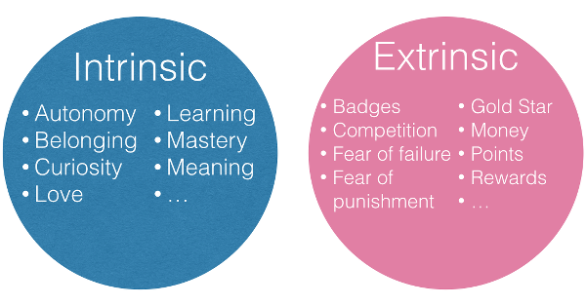
Image 1
There are three main areas of the motivation theory instrumentality, content, and process.
Instrumentality theory
Instrumentality theory states that rewards and punishments are the best instruments to shape behavior. It adopts the idea that people will be motivated to work if they are rewards and consequences are associated directly to their performance which will mean they will be rewarded for effective performance. This theory provides a rationale for financial incentives such as performance-related pay. Motivation using this approach is still broadly adopted in major business such as Tesco's.
Content theory
Content theory or needs theory sometimes referred to as was produced by Maslow and Herzberg was to identify the factors associated with motivation. This theory focuses on the content of motivation in the shape of needs. it believes that an unsatisfied need creates tension and a state of imbalance, to correct the balance then a goal will be identified that will please the needs and a behavior path is selected that will lead to the succession of the intended goal and satisfaction of needs. Therefore, behaviors are driven by unsatisfied needs.
Process theory
Process theory talks about the importance of phycological and mental process which affect motivation as well as basic needs. It is also known as a cognitive theory as it refers to people's perceptions of their working atmosphere. The main process of this theory is about understanding reinforcement, expectancy, goals, equity, social learning, and cognitive evaluation.
Appraisal
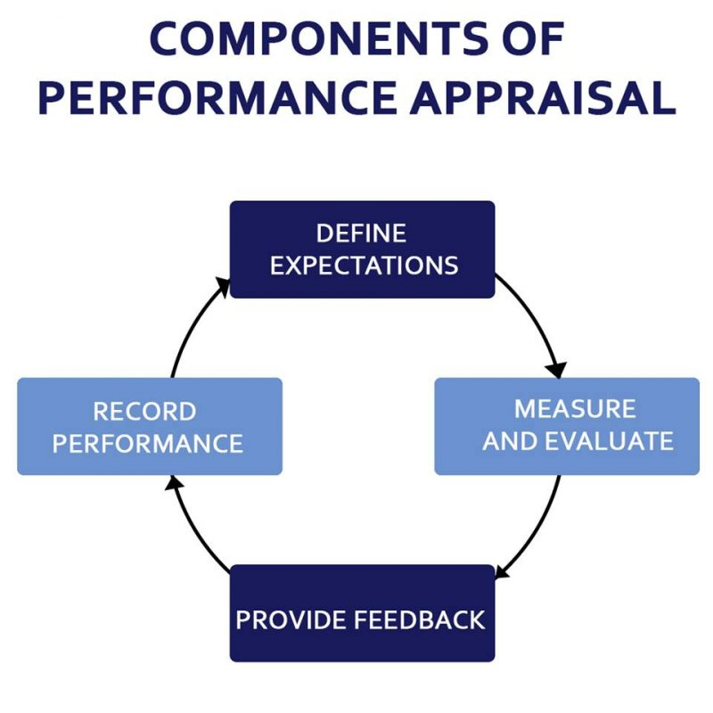
The purpose of an appraisal is to give the individual the opportunity to reflect on their work and need to learn to improve their performance in their jobs, this can be done through an effective personal development plan. This usually takes place yearly or twice a year. The objective of the appraisal stage is for the decision maker to develop insight into the decision and determine a clear course of action for the next yearly meeting. The employer there may
Image 2
possibly be underperforming the team and it is essential that this problem is spotted sooner than later so that we can understand the problem and decide on a solution to improve that individual’s performance that could have stemmed from poor leadership or problems in the system set goals and measures. Once these have been set, you can define and prioritise each job and responsibility and goal. They must also maintain records that will support their appraisal performance for both employer and employee and acknowledge their strengths and weaknesses in feedback and show them how they can grow over time and identify the areas needed for improvement.
Performance management
Performance management is the continuous process of refining performance by setting individuals and team goal which are aligned to the strategic goals of the organisation, developing performance to achieve the goal reviewing and assessing growth and developing the knowledge, skills, and capabilities of people. (Armstrong,2015)
Performance management is mainly used in places of work where there are large amounts of people interacting such as schools, social settings, health organisations etc. Armstrong and Baron (1998) described it as a "strategic and integrated approach to increase the efficiency of companies by improving the performance of the individuals who work in them and by developing the abilities of teams and individual contributors."
Pyramid encourages the spreading of power among workers. Employees who have a higher position hold the most power, while employees who are considered to have a lower position must report to those above them. Workers should respect their supervisors and be certain not to overstep any boundaries.
Ritzer (1975) believed that Weber's thoughts on the role of professionals and their relationship to the issues of bureaucratization and rationalisation is important for contemporary sociology.
Webber (1968) stated “life is focus not on persons but on impersonal rational goals”
By this Weber expresses that the goal is to reach the highest position in the hierarchy.
On the other side, the negative views on Weber's theory produce that a privileged group has more administrative power than those below their professional stance. There is also too much emphasis on rules and regulations, also no importance is given to informal groups on their views.it is unfair to think that these theories would fit in with the most organisation as the views can alienate others and doubts themselves. Another view that Weber has pointed out that those with higher qualification are the only ones suitable for higher job roles which are quite negative as people can learn more doing a job than studying for it to gain a qualification.
Weber's bureaucratic theory is useful within the workplace in some organisations as it gives order and structure within that establishment, therefore, it keeps a methodical workplace.
Training
The definition of training can be varied to many individual's nonetheless training is the teachings or development of oneself or others. Training can also advance skills and knowledge that relates to certain tasks. Training has certain targets which advance an individual's capability and compacity. It creates the essential needs for apprentices and delivers the strength of happy individuals.
Training is the best knowledge for an individual to be able to gain the understanding, skills, and attitude to be able to show their capabilities to perform at their job with the highest job satisfaction. "if you always do what you've always done, you'll always get what you've always got" (Henry Ford 1863-1947)
Without the precise training that person or persons will be unable to fulfill their requirement for the organisation and provide the services expected by them for the users who require their service, also with the adequate training, this will benefit the corporate image which will help on the growth of the business and sustainability as well as profits.
Training is a form of learning which means there are many benefits too, such as improved skills this can consist of multitasking, learning the needs to be flexible within the
establishment. Training can also enhance a person performance and efficiency plus there are fewer mistakes made give the right guidance.
There are advantages and disadvantages to different training methods such as it can be costly to give the training if they are required to travel to different locations and equipment is required. This can also be time-consuming, but it gives the individuals time to ask questions and learn from mistakes, so they do not make any when they are out of the training environment.
Donald Kirkpatrick's four levels of learning evaluation have been designed as an arrangement of ways to appraise training programs.it is believed that as you proceed through each of the levels, the evaluation becomes more difficult and requires more time, to guide your staff in what levels to apply to the evaluation task. In practice, then, it is common for managers to get caught in Levels 1 and 2 and never proceed to Levels 3 and 4, where the most beneficial information occurs. The four-level are:
- Reaction
- Learning
- Behavior
- Results
(Mindtools.com, 2018)

While Donald Kirkpatrick's four-level training evaluation model is widespread and generally used there are some deliberations that need to be considered. The first issues are that it can be time-consuming and expensive to use levels 3 and 4 and not always practical for all organisations, especially for an organisation that does not have a dedicated training and human resources department.
The model also displays that each levels importance is greater than the last level and that the levels are linked for example it suggests reactions are less important than results and that there must be positive learning for this practice to work. Kirkpatrick’s model is great for trying to evaluate training in a scientific way, yet so many changes can happen in companies that level 4 would be limited to its helpfulness

Task 2
In this segment I will be looking at the potential benefits certain organisations have on personally developing individuals in the workplace. I will start with the largest British retailer and the world’s third largest grocery retailer with outlets across Europe, USA and Asia Tesco’s.
Tesco’s identifies that increasing the knowledge of their employees’ skills will give them job satisfaction which factors in on the continued growth of the company. Tesco’s provides training and development opportunities for all its employees.
Tesco’s employs people of all diversity’s and backgrounds and have the opportunity to grow and develop, they are also able to input their ideas and thought so that Tesco’s have a better understanding of what consumers require in different locations so that they can adapt to the needs and demands, for example for a store with a highly populated diverse area they would need to make sure they have a high quantity of specialty stock to meet the requirements of its customers. Therefore, for this, they would need to train someone who has a clear understanding of customer profile in that area. Tesco's also frequently appraises the performances of its employees to anticipate any possible skills shortages. This helps the managers and employees decide whether they have the correct knowledge and skills, understanding and resources to carry out their job effectively and whether they need to do any additional training. Tesco’s also does annual appraisal reviews to discuss career development if an employee is wanting to progress on further in their job such as if they wanted to train to be a manager in a store they would make a personal development plan so that they can apply for training suited for their needs to progress, this make Tesco’s operation stronger. Tesco offers a highly structured monitoring and evaluation of training and development. This includes programmed tasks, timetables, measures, and checklists. Employees assess themselves by setting objectives in Activity Plans, Personal Development Plans and recording outcomes in Learning Logs. These continue to measure their improvement in performance after training.
Before undertaking training and development, employees identify gaps in their knowledge skills. The gaps are identified and then recorded in their personal development plan. Employees and line manager will decide on how to best fill the gaps by training or growth activities. Tesco’s offers employees both on the job training which is undertaken when doing the job, Off-the-job training is often more suitable for training in specific new skills or for evolving the individual, in areas such as team-building, communications (for example, making presentations), or organisation and planning. It typically involves attending external courses run by specialised training organisations or qualified Tesco training staff.
There is an A-level Options programme for developing new employees into managers provides comprehensive induction training from day one. This enables new employees to meet other trainees and learn about the company and the business objectives quickly. With a quick training timetable, they can develop to their first level management position whilst working as a Team Leader in a store within six months.
Shadowing involves the employee working alongside a colleague or manager watching them to learn what to do. Coaching provides feedback and support for staff to help them improve their performance in their role. A manager or colleague will help trainees work through problems and inspire them to find solutions. Mentoring is provided by a more experienced member of staff acts as an advisor. Job rotation is an opportunity for the employee to work in different sectors of the store to see where they thrive best. Secondment is where an employee goes to another workplace for a temporary period.
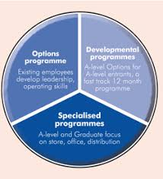
Image 3
Personal development helps to produce lifelong capabilities, meaning employees become more confident, productive and valued to the organisation in the long period. Recruiting new staff is usually more expensive than retaining present staff, so it is important for Tesco to retain their staff. Development also benefits employee motivation.
Previously I have mentioned that Motivation theorists advocate that if people are given the skills to do their jobs well, the support to grow their capabilities and greater responsibility, this makes them more effective in their roles. Tesco requires staff who can be flexible and who can adapt to change. It also needs to ensure it has the right standard of staff to build its management team of the future. Tesco’s structured approach to training and developing its existing and new employees provides a strong foundation for its continuing growth.
Another organisation that has a great training sector is Forestry Commission, we recognise that to make a positive impact on society, our people all need to have the right skills for today and tomorrow and be confident in their ability to use them. (Forestry.gov.uk, 2018) Forestry Commission is a government department making this a public sector organisation. Its mission is to protect and expand Britain's forest and woodlands and increase their value to society and the environment. Forestry Commission is Britain's largest land manager and is in control of some of Britain's most remarkable landscapes. Over the last two decades, they have expanded Britain's woods by an area more than three times the size of greater London.
Apprentices undertake a combination of formal training, practical work experience, informal on-the-job training as well as studying toward their SVQ qualification. Most of the formal training is supported out by our learning and development team in a forest environment. Apprentices are not required to attend a further education college on block release.
However, they don’t provide financial assistance for relocation but are able to help locate possible options for accommodation. Apprentices receive a salary considerably higher than the minimum wage offered by most government led schemes.
The other forms of apprenticeship include shadowing their staff over several months, which allows employees with an interest in pursuing a career in countryside management to develop on the job skills and experience. The forestry commission benefits by keeping its trained staff, which can sufficiently cost less than recruiting new ones.
Since beginning in 1993, Admiral Group has grown from a small start-up business to one of the largest car insurance providers in the UK with a presence in eight countries, the company has operations in the UK, France, Spain, Italy, the US, and Mexico.
Admirals aim is to provide exceptional service to customer but also to keep their employees happy by rewarding them with benefits such as when an employee starts working for the company they are made a shareholder of the company giving them the motivation to always deliver the best service as the employee has a part in the business to perform at their best as this affect them also.
Admiral’s working culture is based on four core values: communication, equality, reward and recognition, and fun. These values drive the company’s overarching vision of providing a workplace where people who like what they do, do it better. (Best Companies, 2018) Their aim is to provide better services each year as well as being a great employer.
Admiral runs a training academy which gives one-to-one teaching for all managers and provide additional support if required. They also have a graduate programme which gives the employee the opportunity to acquire a nationally recognised qualification with the Institute of leadership and management. Admiral also arranges training days for teams so that they can bond and get to know each other and have time out from working these are all paid for and happen often to give morale to the team and show that employees work does not go unnoticed.
Many of their employees have followed a stable career path through Admiral gaining experience and additional qualifications along the way with 99% of the team managers have worked their way up from entry level.
Admiral runs flexible working hours with a free gym membership, eye tests, and private health insurance and train and bus season ticket loans.
Admiral also gives back to charity and have given a big donation in the past to show their generosity to the public for supporting them.

The final company that I will conclude this part of the assignment with is EE (Everything Everywhere) which has been voted the best company to work for by times 100 in the year of 2018. EE is a telecommunication company established in 2010 it is apart of the BT communication company in the UK. The main values of EE are embedded in performance culture. ‘Personal’, ‘simple’ and ‘brilliant’ are the words used to provide a universal language for employees to describe their common approach to delivering individual and business objectives.
EE has a range of employee engagement schemes in place, covering every aspect of the workplace. One example is their dedication to personal development - last year, they successfully launched their Digital Academy to help staff improve their digital skills based on their personal needs and ability. They also provide an extensive amount of training so that employees have the knowledge of all the latest phones and other services they provide such as broadband and data packages. All the training is paid for such as accommodation, food, and car expenses the training tends to happen in main headquarters where all new employees are trained where all employees will be picked up an taken for training which has a positive effect on employees and it shows they care about their employees and wellbeing. Once there they will be given all the required training in customer satisfaction and knowledge of all systems and equipment to give them the confidence to be able to communicate with customers. Once the employee is trained and instore they have targets that are given so that they can earn commission which can make a considerable contribution to their wage. Staff is also given incentives for working hard and giving customers high satisfaction such as vouchers to spend how they wish. The employee will also have weekly meetings with the manager to raise any concerns or problems they may be having and how to best tackle the problem whether it be more training or guidance.

Task 3
objectives | measures | priority | Support and  Internal | development  external | Review dates | Other comments
Training  Time management  Communication  Conducting a meeting  Appraisals | Attend training course to further skills needed to do the job.  Keep a timetable to track agendas  and goals  keep in contact with line managers and supervisors  shadow senior personnel  have one two one sessions with managers and senior staff | High  Medium  High  Medium  High | Yes  Yes  Yes  Yes | Yes | 3 months  3 months  6 months  6 months  3  months

In order for an individual to be able to have the right skills to acquire a job in any of the above organisations they would need to develop their skills and have an expectation of what can be achieved if they follow a personal development plan which identifies the aspects the individual must concentrate on to be able to climb the hierarchy if they want to get to a higher position. It is a high priority for the employees to attend all training courses available so that they can gain knowledge of products and improve skills they may already hold to better their understanding to deal with customers to a high satisfaction it would be ideal for this to be review by senior staff every three months so that gives a good timescale for the employee to show what they have gained from training and also it would give them the encouragement to do better or give them satisfaction they are doing well once reviewed by a senior member. Another factor which is important is time management it is important to manage time very well as this can improve the employee’s ability to function more effectively even when under pressure. It’s a good idea to set goals that the employee would like to achieve by a certain timescale so that they have a focus and platform they would like to work towards. Good time management lets you work smarter and not harder. (Mindtools.com, 2018)
Communication is a high priority on the personal development plan it is extremely important that the employee communicates with the managers and supervisors so that any concerns can be dealt with in a timely manner so that there are no obstacles in the employee fulfilling their jobs to a high standard, this is also important that they can communicate well with customers to show that the organisation cares for their consumers. This is also a good way to get ideas and across to managers.
Conducting a meeting has been put on the development plan as medium this is because this is a long-term goal that can be achieved over a period of time and gives the employee to observe and shadow managers to see how they conduct meetings and gain experience for the sessions to give them an idea of whether this is something the employee would like to pursue in the long term.
Appraisals are very important for the development of an employee it gives the employee the opportunity to set plans and goals to achieve before the next appraisal then the employee can use the advice given from managers or supervisors to strengthen the areas that need the most attention. If also gives the employee an idea of how much they have learned and grown since the last time they were reviewed.

Appendix
Image 1
Businesstopia.net. (2018). [online] Available at: https://www.businesstopia.net/wp-content/uploads/2018/03/components-of-performance-appraisal-e1521023498651.jpg [Accessed 17 Nov. 2018].
Image 2
Google.co.uk. (2018). intrinsic and extrinsic motivation - Google Search. [online] Available at: https://www.google.co.uk/search?q=intrinsic+and+extrinsic+motivation&source=lnms&tbm=isch&sa=X&ved=0ahUKEwiY1Yqrp9zeAhUsM-wKHXoDAOUQ_AUIDigB&biw=1366&bih=657&dpr=1#imgrc=e-SytMeQLeIiIM: [Accessed 17 Nov. 2018].
Image 3
Google.co.uk. (2018). tesco training - Google Search. [online] Available at: https://www.google.co.uk/search?q=tesco+training&source=lnms&tbm=isch&sa=X&ved=0ahUKEwiD39Sp85jfAhURVBUIHW58CmMQ_AUIDygC&biw=1366&bih=657#imgrc=IYPIiqFIKOhhqM: [Accessed 11 Dec. 2018].

References

Admiraljobs.co.uk. (2018). Admiral Employee Benefits and Rewards. [online] Available at: https://admiraljobs.co.uk/employee-benefits/ [Accessed 13 Dec. 2018].
Armstrong, M. (2012). Armstrong's Handbook of management and leadership for HR. 4th ed. London: Kogan Page, pp.188,189.
Best Companies. (2018). Admiral Group Company Profile | Best Companies. [online] Available at: https://www.b.co.uk/company-profile/?admiral-group-plc-47426 [Accessed 13 Dec. 2018].
Best Companies. (2018). EE Company Profile | Best Companies. [online] Available at: https://www.b.co.uk/company-profile/?ee-55478 [Accessed 12 Dec. 2018].
business.com. (2018). The Management Theory of Max Weber. [online] Available at: https://www.business.com/articles/management-theory-of-max-weber/ [Accessed 24 Oct. 2018].
BusinessDictionary.com. (2018). Which of your friends needs to learn this term?. [online] Available at: http://www.businessdictionary.com/definition/motivation.html [Accessed 17 Nov. 2018].
Faculty.londondeanery.ac.uk. (2018). What is appraisal? — E-Learning Modules. [online] Available at: https://faculty.londondeanery.ac.uk/e-learning/appraisal/what-is-appraisal [Accessed 17 Nov. 2018].
Forestry.gov.uk. (2018). Personal development opportunities. [online] Available at: https://www.forestry.gov.uk/forestry/infd-7kgdvx [Accessed 12 Dec. 2018].
Hansson, B. (2008), "Job-Related Training and Benefits for Individuals: A Review of Evidence and Explanations", OECD Education Working Papers, No. 19, OECD Publishing, Paris,https://doi.org/10.1787/237755412637.
Kaufman, R. (2000).Mega Planning: Practical Tools for Organizational Success. Thousand Oaks, CA. Sage Publications.
Leadership Choice. (2018). The Power of Good Communication in the Workplace | Leadership Choice. [online] Available at: https://leadershipchoice.com/power-good-communication-workplace/ [Accessed 13 Dec. 2018].
LLP, B. (2018). Training - How training and development supports business growth - Tesco | Tesco case studies, videos, social media and information | Business Case Studies. [online] Businesscasestudies.co.uk. Available at: http://businesscasestudies.co.uk/tesco/how-training-and-development-supports-business-growth/training.html [Accessed 11 Dec. 2018].
Mindtools.com. (2018). Kirkpatrick's Four-Level Training Evaluation ModelAnalyzing Training Effectiveness. [online] Available at: https://www.mindtools.com/pages/article/kirkpatrick.htm [Accessed 24 Nov. 2018].
Mindtools.com. (2018). What Is Time Management?Working Smarter to Enhance Productivity. [online] Available at: https://www.mindtools.com/pages/article/newHTE_00.htm [Accessed 13 Dec. 2018].
Ritzer, G. (1975). Professionalization, Bureaucratization and Rationalization: The Views of Max Weber. Social Forces, 53(4), 627-634. doi:10.2307/2576478
Running effective appraisals MTD training. (2010). Ventus publishing ApS.
Saba.com. (2018). How to prepare for your performance appraisal | Halogen Software | Resources. [online] Available at: https://www.saba.com/uk/resources/how-tos/how-to-prepare-for-your-performance-appraisal [Accessed 13 Dec. 2018].
Skills.sa.gov.au. (2018). Benefits of training your staff | WorkReady - Skills and Employment. [online] Available at: http://www.skills.sa.gov.au/for-employers-business/training-your-staff/benefits-of-training-your-staff [Accessed 18 Nov. 2018].
Verywell Mind. (2018). How Does Extrinsic Motivation Influence Behavior?. [online] Available at: https://www.verywellmind.com/what-is-extrinsic-motivation-2795164 [Accessed 17 Nov. 2018].
Viskovatoff, A. (1999). Foundations of Niklas Luhmann’s Theory of Social Systems. Philosophy of the Social Sciences, 29(4), 481–516. https://doi.org/10.1177/004839319902900402

