Assessment Form

Module: Preparing for Professional Policing
Student Name: Matthew Rees
Module Tutor (s): Kelly Andrews
Question | 1  Situation | 2  Task | 3.  Action | 4.  Result |  | Total Mark
1 | 4/5 | 1/5 | 12/15 | 3/5 |  | 20/30
2 | 4/5 | 1/5 | 11/15 | 2/5 |  | 26/30
3 | 4/5 | 1/5 | 13/15 | 3/5 |  | 21/30
 |  |  |  |  |  | Total Mark 67/90
Key
No Reference | Minimum | Satisfactory | Exceptional
0 | 0-4 | 5-10 | 11-15

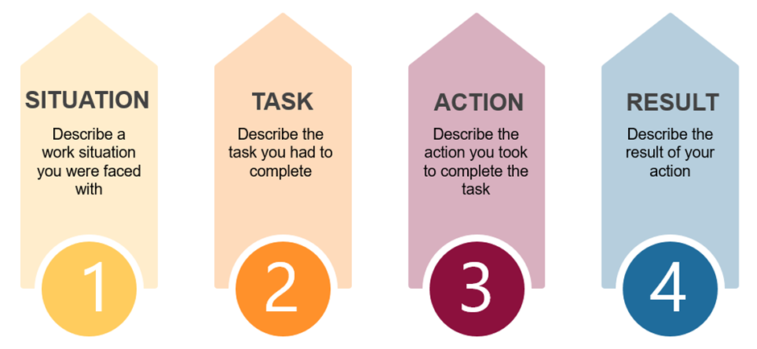

Question | Comments
1 | Q2:  Duke of Edinburg Award in Scotland.  One of the team broke her leg halfway up a mountain. We took it upon other ourselves to organise the situation.  No phone signal.  We made a sling out of rucksacks to then carry her down the mountain – a few minutes at a time.  Used communication to navigate way down.  Result- managed to get down to base and mountain rescue came to take her and we were able to go on to complete the challenge.  Used communication to keep calm and trying to stay calm inside so not to upset injured person.  She was ok in the end.  Good example.
2 | Q7:  Situation: Work example in Amazon. Customer returns- processing used items coming onto a belt. Once we have done this we move the items onto another belt.  So a colleague was cheery picking the easy work, selecting easy items to work on.  With person was going against Amazon policy – someone made an inappropriate comment about the person’s race.  I got his attention and took him to the side; it was getting very tense.  Took them aside told them they couldn’t say that. Also spoke to the other person who was cherry picking – so spoke to all persons.  Went to the manager to explain what had happened – to make him aware  Good example but needed to use STAR in a clear manner.
3 | Q5:  Duty manager in LC Swansea.  As duty manager you are in charge of large busy building which is full of people – Group booking with Jewish people having a party in the summer – the nature of their religion they needed all male lifeguards and only males in the pool.  Same for females. They had booked the pool out  Family told they couldn’t use the pool because of the situation – parent got very angry. Starting an argument-  Used initiative, took the male into the office, acknowledged that they had come a long way. Gave him a voucher for food for compensation. Vouchers to come back the following day.  Went above and beyond at the time to avoid the situation getting worse and to calm situation.  Good explanation around decision making.  .

.

.

