AdventureWorks Cycles’
Database Design &
Implementation
Databases and Application Development (ACCA5026)

Mathew Jones – 2317425
Computing (Software engineering)
Contents
Introduction 2
Database Creation 2
SQL code used to generate each table structure including integrity and check constraints 4
SQL code to populate each table with sample data 6
Validate constraints operate as intended 7
Demonstrate the use of rollback and commit operations and explain the reason you have used them 8
Improving the performance by using tuning enchantments 9
References 10

Introduction
AdventureWorks Cycles is a bicycle manufacturer and has been in the industry for many years. They have reached out to my consulting firm to set up a database that can deal with future expansion of the company as well as their next move onto the online marketplace. This paper will be showing the creation of said database and explaining the reasons certain things were done, from unique/check constraints, using indexes to improve search speed, commit and rollout operations and explaining why I picked the tables, entities, attributes, primary key as well as foreign keys. Additionally, I will ensure all entities are normalised to 3rd Normal Form (3NF) and ensure that it looks organised and professional. [1]

Database Creation
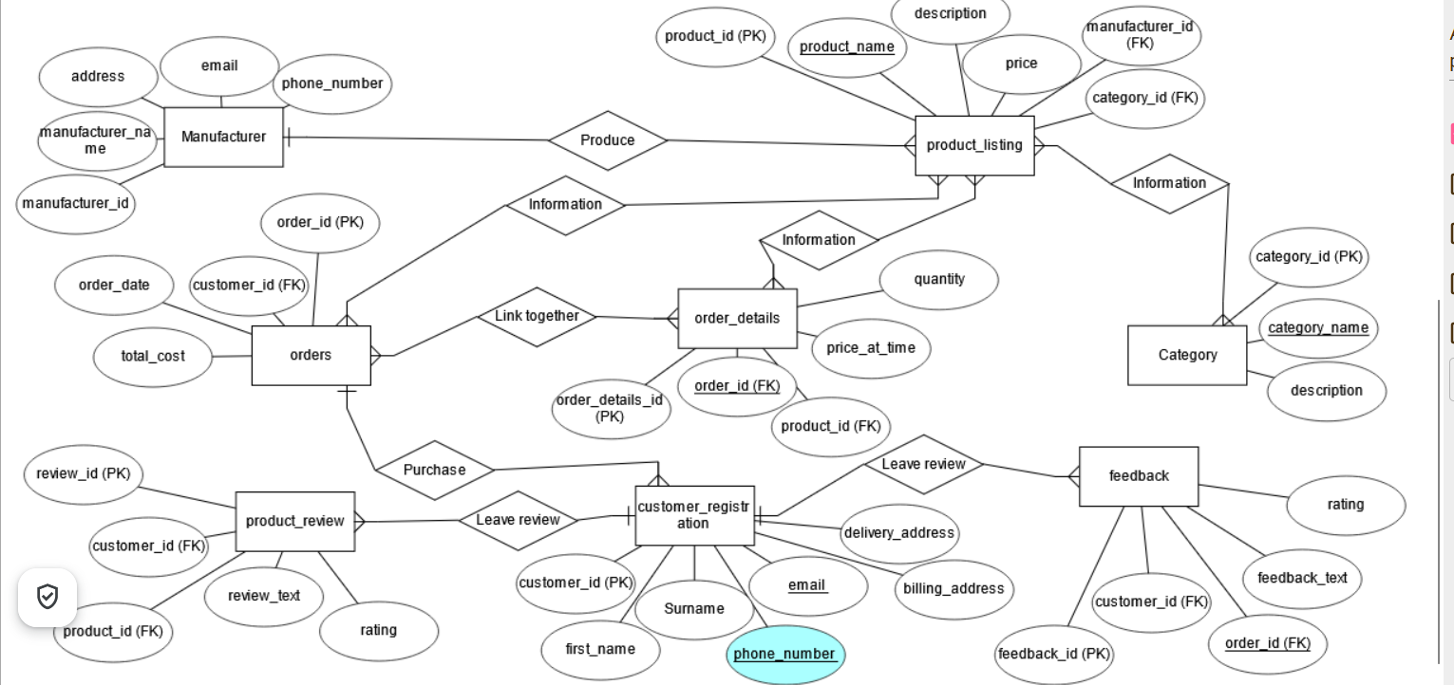
This is the ERD diagram I created to guide me in creating this database. I have 8 Entities which are manufacturer, product listings, orders, order details, categories, customer registration, feedback and product review. There are 5 attributes linked to manufacturer, they are manufacturer ID, which is the primary key, manufacturer name, they address of the companies, there email and contact details and the entity is linked to product listings as the manufacturer produces the product and they are a one-to-many relationship.
Product listing is where they product details are kept such as the names, description and price. The primary key is product ID and there two foreign keys, manufacturer and category ID. It also has another 3 relationships with another 3 entities all being many to many relationships. The category entity only stores category ID as the primary key, category name and description as it only purpose is to create categories. The order details entity is linked to the order entity the difference is the order details just as more information. They share a many to many relationships and both have information such as pricing, order date and quantity.
Customer registration entity was created to store information on customers as it is an essential part of any business. The kind of information stored is the customers first name, surname, contact details such as phone number, email address and their address for delivery and billing. The primary key was customer ID, and the entity is linked to order one to many and many to one with the entities feedback and reviews. There are two more entities, and they are product review and feedback on customer support both of which will be designed in such a way only one review will made per order. The attributes with the two are text for leaving reviews ratings and primary/foreign key linking customer entity and the review entity. Below is a schema version of what was just discussed.
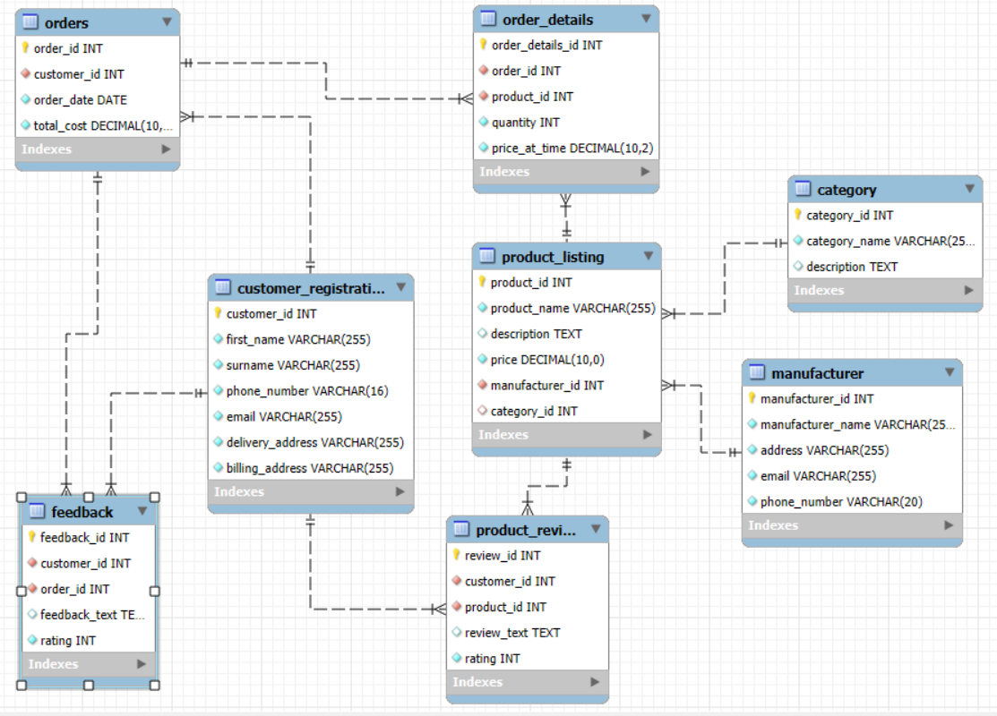

SQL code used to generate each table structure including integrity and check constraints
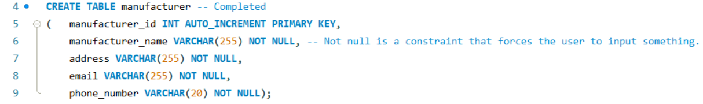
In the manufacturer table I used lots of NOT NULL constraints as all this information is required. Not NULL forces the user to input some sort of information into the field. [2]
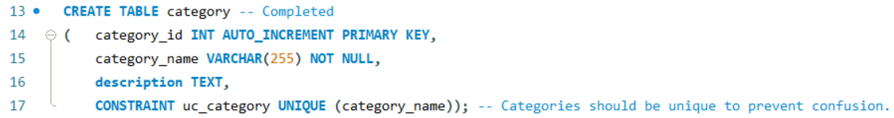
I have made the category_name unique in the category field as having multiple bike categories called road bikes would not make sense and would be complicating to anyone who operates on the database. The unique operation is a constraint that prevents repetition in a table. [3]
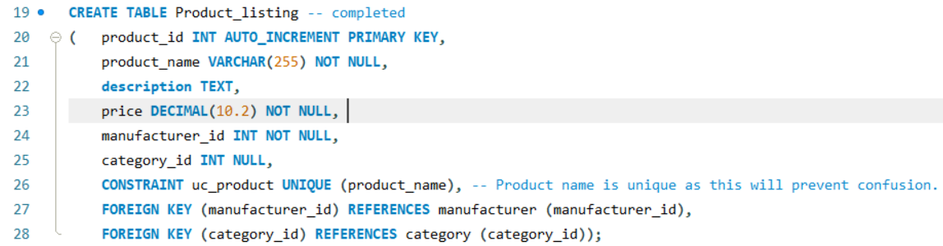
The product listing has two foreign keys which links these tables together as they have a relationship. [4] There is also a constraint for the product name as they require being unique to prevent confusion from customers as well as individuals working on the database.
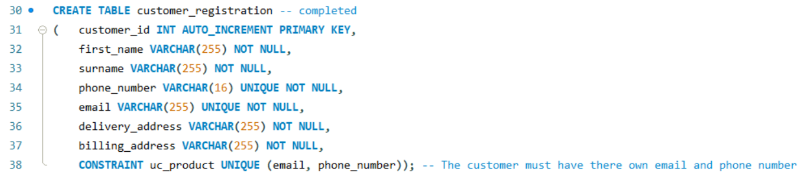
Making the emails and phone numbers unique in the customer registration is important as customers may forget their login details for the accounts so they will require their own phone number and email address to reset their account to access it. Additionally, the company will be able to send advertisement and offers to customers who have registered for it. This will assist the business in promoting their business.
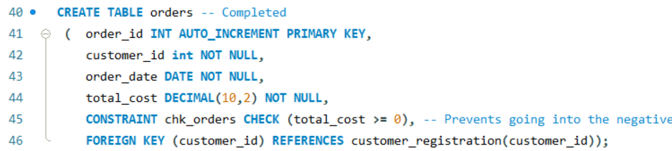
In the order table I have made a constraint to ensure the total cost of the order is above £0 as it would be impossible to go negative. I did this by using the CHECK constraint. Check constraints are used to prevent input of data that the user does not want, such as ensuring a customer is 18 or over. [5]
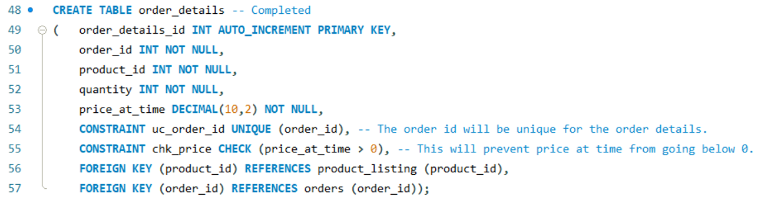
The order table has two foreign keys but more importantly has two constraints unique and check. The unique constraint is being used to ensure that is one order ID linking order details ID and order ID. The check constraint is being used to prevent the price at the time from going negative, the reason for this is it is impossible for that to happen in real life.
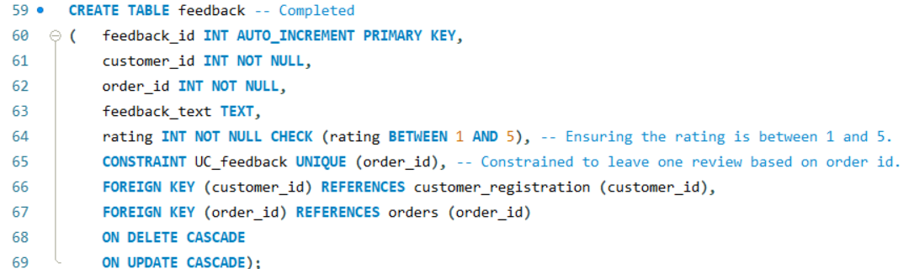
The feedback table also has two foreign keys to link customer and order ID. The order ID has a unique constraint as I want to use it as proof of purchase as I do not want random users leaving reviews when they haven’t even purchased anything from the AdventureWorks cycles. There is also a CHECK constraint in rating to ensure the user inputs between 1 and 5.
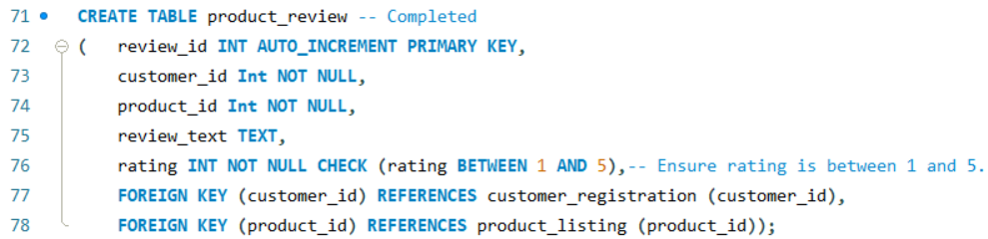
The product review table links customer, product ID and has a check constraint on rating to ensure the user inputs between 1 and 5.

SQL code to populate each table with sample data
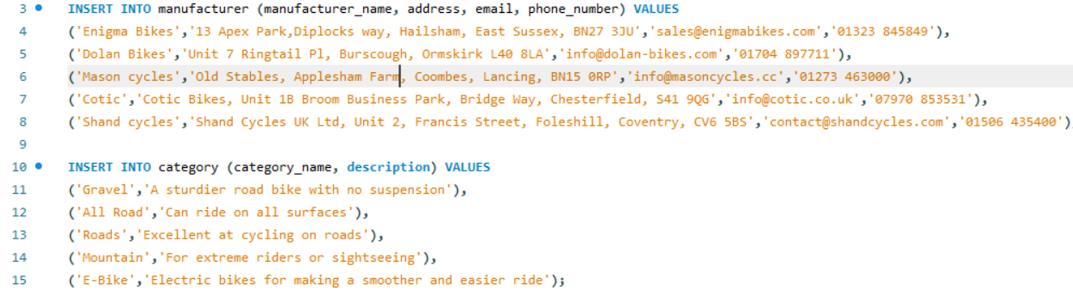
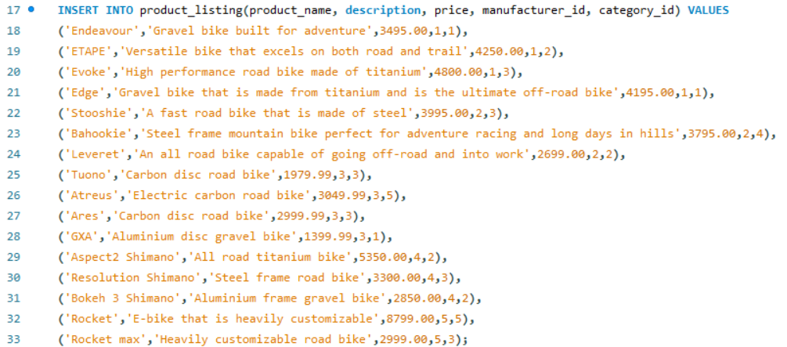
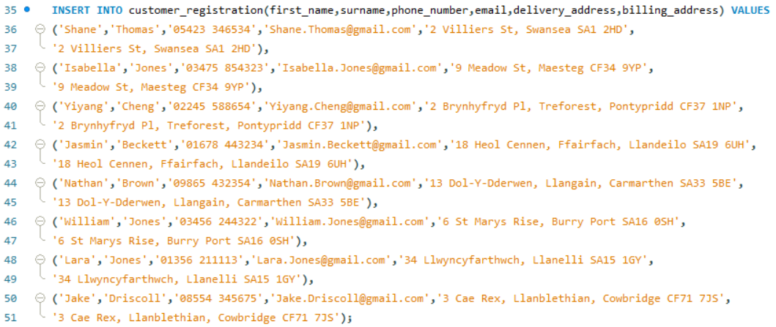
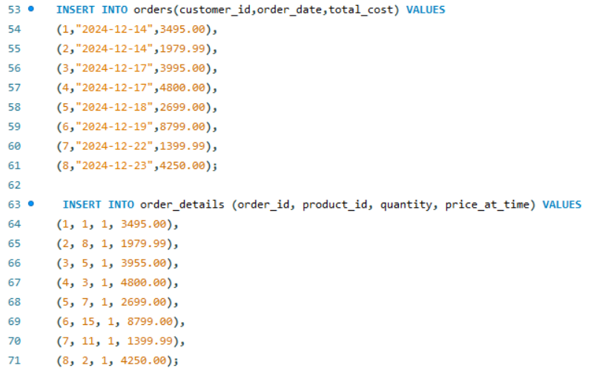
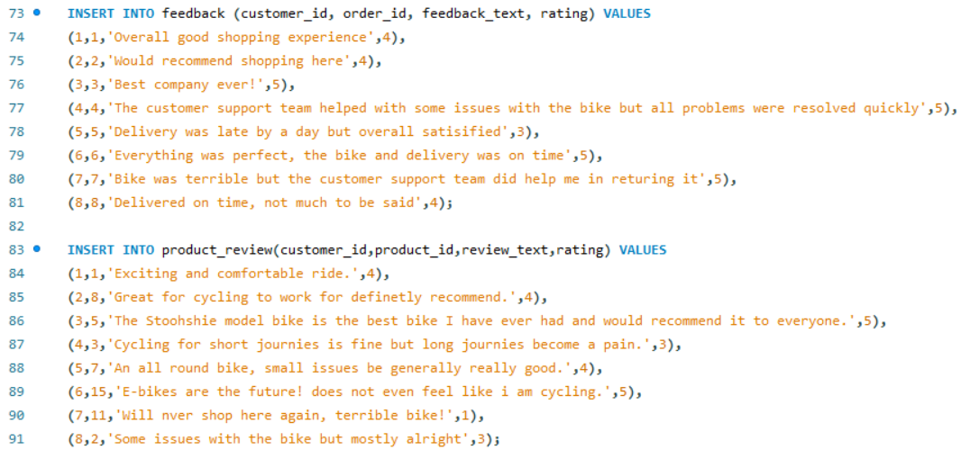
The INSERT INTO statement inputs data into the desired table and attributes. To insert you will require the table name and the attributes inputted in a manner like the images above. [6]

Validate constraints operate as intended
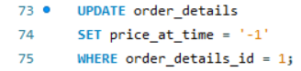
These commands would have updated the price at time in the order details table but there was a Check constraint that prevented any negative numbers from being inputted and it was successful in doing so.
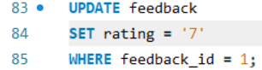
The constrain prevents users from inputting anything other than the numbers between 1 and 5 was successful. As shown above it even changed to it 4 but disallowed 7.
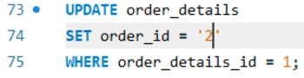
The above image is showing that the unique constraint worked as there was already an order ID 2. The reason was to ensure only one order ID is being used in the order details.
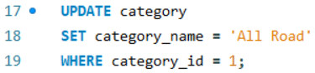
This image shows an attempted update of a category name but was unsuccessful as there was a unique constraint preventing repetition of the word All road as there was all ready a category called this.

Demonstrate the use of rollback and commit operations and explain the reason you have used them
Rollback and commit are an essential part in SQL as Rollback allows the users to roll back any errors inserted into tables and COMMIT saves all data inserted up to that point. [7]
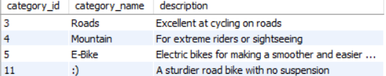

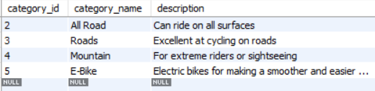
The above images are showing the use of COMMIT and ROLLBACK. The ROLLBACK removing number 11 category ID as it was wrongly inserted and COMMIT saving the data up to that point.

Improving the performance by using tuning enchantments
I have chosen first name and surname in the customer registration for an index because as the company grows more and more customers will shopping and additionally searching customer information will be a regular thing. Creating an INDEX increases the speed in which query runs especially as tables are increasingly filled in large organisations. [8]
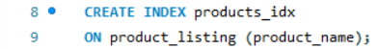
Product listing will be a common field to search up and will require and index to speed up searching. As the organisation grows there will be more products as well as customers contacting for details about bikes and costs so being able to the products name faster is a must.
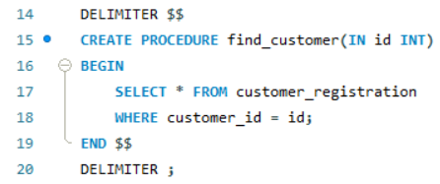
To search for customer id.
To finalise I created this procedure to increase the simplicity of searching for a customer by just knowing their ID. Not are they quicker to operate due to create an index but the user can access them simpler as well.

References
[1] geeks for geeks team. "Third Normal Form (3NF)." geeks for geeks. https://www.geeksforgeeks.org/third-normal-form-3nf/ (accessed Jan 9).
[2] w3schools team. "MySQL NOT NULL Constraint." w3schools. https://www.w3schools.com/mysql/mysql_notnull.asp (accessed Jan 9).
[3] Javatpoint team. "MySQL Unique Key - javatpoint." Javatpoint. https://www.javatpoint.com/mysql-unique-key (accessed Jan 9).
[4] w3schools team. "MySQL FOREIGN KEY Constraint." w3schools. https://www.w3schools.com/mysql/mysql_foreignkey.asp (accessed Jan 9).
[5] w3schools team. "MySQL CHECK Constraint." w3schools. https://www.w3schools.com/mysql/mysql_check.asp (accessed Jan 9).
[6] w3schools team. "MySQL INSERT INTO Statement." w3schools. https://www.w3schools.com/mysql/mysql_insert.asp (accessed Jan 9).
[7] MY SQL Team. "MySQL :: MySQL 8.4 Reference Manual :: 17.7.2.2 autocommit, Commit, and Rollback." MYSQL. https://dev.mysql.com/doc/refman/8.4/en/innodb-autocommit-commit-rollback.html (accessed Jan 9).
[8] w3schools team. "MySQL CREATE INDEX Statement." w3schools. https://www.w3schools.com/mysql/mysql_create_index.asp (accessed Jan 9).

