

Master of Business Administration (MBA)
Module: International Marketing: Principles and Practices
Module Code: LCMB7026
Assessment Component 1: Individual Report
International Market Entry Strategy and Marketing Mix of Adidas:
A Comparative Study of Germany and Japan
Lecturer: Tushara Balendran
Student Name: Md Asif Reza
Student ID: 2523547

Acknowledgment
USE OF GENERATIVE AI IN ASSESSMENT

RESEARCH | For this assessment, you can use Generative AI to support you in research and data analysis. | Yes ☐  No ☒
STRUCTURE | For this assessment, you can use Generative AI to support you in structuring your submission, including creating a draft argument structure, identifying parts  and headings, etc. | Yes ☐  No ☒
PROOFREADING | For this assessment, you can use Generative AI to check your own text/creation for grammatical and syntactical mistakes, including getting suggestions to  rephrase your work. | Yes ☐  No ☒
WRITING | For this assessment, you can use Generative AI to create text for submission. | Yes ☐  No ☒
CREATIVE | For this assessment, you can use Generative AI to create creative materials, such as images. | Yes ☐  No ☒
PROGRAMING | For this assessment, you can use Generative AI to create and check code. | Yes ☐  No ☒
NONE | For this assessment, you are not allowed to use any type of Generative AI support. This includes research support, structure support, writing/proofreading  support and creative support. | ☐

Table of Contents
Section 1 4
Introduction 4
1. Organisational Classification and Global Strategy 5
1.1 Strategic Categorisation: Bartlett and Ghoshal's Transnational Model 5
1.2 Global Configuration and Competitive Advantage 5
2.0 Comparative Macro-Environmental Analysis (PESTEL) 6
2.1 PESTEL Analysis: Germany 6
Cultural Factors: Hofstede Model 8
2.2 Segmentation, Targeting and Positioning (STP) 12
STP in Germany 12
STP in Japan 13
2.3 International Marketing Mix (7Ps) 15
2.3.1 Product 15
2.3.2 Price 16
2.3.3 Place 16
2.3.4 Promotion 18
2.3.5 People 19
2.3.6 Process 19
2.3.7 Physical Evidence 20
2.4 Market Entry Strategy Analysis: Japan 22
2.4.1 Entry Mode Adopted 22
2.4.2 Advantages and Disadvantages 23
3. Ethical Evaluation of Adidas' Marketing Mix 24
3.1 Examples of Ethical Marketing Practice 24
3.2 Examples of Unethical Marketing Practice 24
3.3 Recommendations 25
Section 2: Reflective Account 27
Using Gibbs' Reflective Cycle (1988) 27
References 30

Section 1

Introduction
Multinational companies deal with a variety of regulatory, cultural and economic situations in international sportswear marketing (Hasan et al., 2024). In the era of globalisation, a brand should adjust to local markets while at the same time, it should remain the same all over the world, especially in the digital world where people have access to information about a brand almost instantly (Katsikeas, Leonidou and Zeriti, 2020). This report focuses on Adidas' international marketing strategy and compares its marketing philosophy in its home market (Germany) with important host market (Japan). The report explores macro-environmental differences, cultural differences, market entry strategy, ethical issues using PESTEL, Hofstede, STP and 7Ps frameworks, and finally recommends strategies and includes a Gibbs reflective account. A reflective account of the report will be provided with the Gibbs reflective cycle.

1. Organisational Classification and Global Strategy

1.1 Strategic Categorisation: Bartlett and Ghoshal's Transnational Model
Bartlett and Ghoshal (1989) have categorized the MNCs on the basis of integration-responsiveness continuum as four types – international, multidomestic, global, and transnational. Adidas could be described as a transnational organisation and as such is efficient, responsive at the local level and learning on a global scale (Bartlett and Ghoshal, 1989). Adidas centralises their brand, sponsorship and sustainability strategy from Herzogenaurach all over the world. It's a local adaptation, working with NIGO in Japan, and focusing on performance and sustainability in Germany. Japanese digital innovations are then transferred and scaled globally and European sustainability initiatives are transferred and scaled globally.

1.2 Global Configuration and Competitive Advantage
With subsidiaries, franchise agreements, third-party retail partnerships and direct-to-consumer e-commerce, Adidas has a strong and diversified presence in 160+ countries around the world. Geographic diversification involves spreading the business across different geographical regions, which helps mitigate the impact of any single market on the business. Geographic diversification means spreading business across different geographic areas, which helps to offset losses when consumer spending declines in Europe, but not in Asia-Pacific. Scale benefits the company in manufacturing, procurement and marketing, too, in multiple markets, further enhancing the profit margins. In addition, Adidas' strategic footprint in six specific key cities across the world ensures that the brand remains at the forefront of the global sports and lifestyle scene (Adidas Group, 2024).

2.0 Comparative Macro-Environmental Analysis (PESTEL)
The PESTEL analysis can be used strategically to determine the factors that will impact on an organisation's competitiveness in a market, including political, economic, social, technological, environmental and legal (Morgan et al., 2019). Using PESTEL on Germany and Japan can help to understand why, as a global brand, Adidas' marketing strategies need to be different in both countries, and can explain if each of the factors is an opportunity or a constraint for the company.
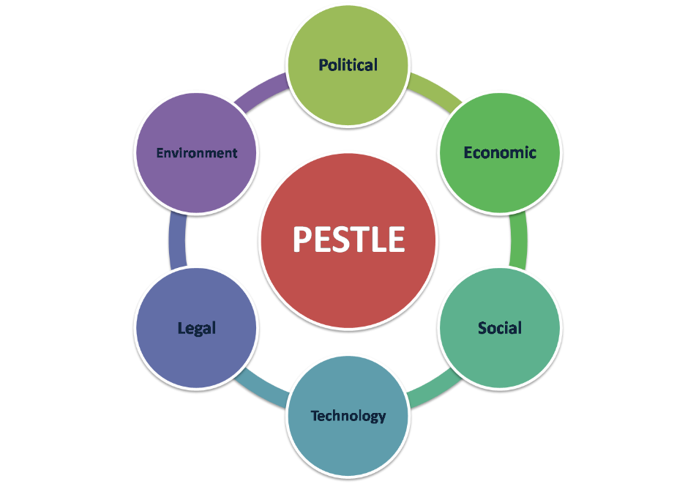

Figure 1 PESTEL Analysis (Clarke, 2023).

2.1 PESTEL Analysis: Germany
Political:
The political situation in Germany is favourable for Adidas. Germany is a stable liberal democratic country and a founding member of the European Union, which means that Adidas can easily access the EU single market in 27 countries, free from import tariffs and trade barriers. The governing coalition has fallen in late 2024, but Germany has ample institutional safeguards for business continuity. This political stability leads to a solid environment for Adidas to be able to plan their long-term marketing strategy in the domestic and European market.
The political climate is also generally good in Japan. Japan is a stable Parliamentary democracy with a good rule of law. The country has joined the Comprehensive and Progressive Agreement for Trans-Pacific Partnership (CPTPP), which streamlines trade with key partners and sustains Adidas' import supply chain. The minor restriction for international brands is, however, Japan's traditionally conservative stance on foreign business regulation and its bureaucratic processes, which can help to delay decision-making.
Economic
The environment is good for the economy in Germany. Germany is home to one of the largest economies in the world, with GDP of around €4.1 trillion and household disposable income levels among the highest in the world. German shoppers are ready to pay for the high-quality sportswear, right in line with Adidas' positioning. GDP growth slowed in 2024 and 2025, however, driven in part by higher energy prices and sluggish exports, which could limit consumer confidence and spending on non-essential items in the near-term.
The economic climate in Japan is a mixed one. The GDP of Japan is around $4.2 trillion and there is increased consumer interest in sportswear, which is valued at $10.17 billion in 2024 and expected to hit $15.17 billion by 2032. But low prices and a shrinking customer base due to an ageing population and the weak yen is an issue for foreign brands.
Social
The social climate in Germany is good. Health, fitness and outdoor activities are important in German society. There is great demand for performance sportswear, as gym membership and participation in recreational sports continue to increase. Additionally, German consumers have become more inclined to purchasing sustainable products that are ethically produced, thereby contributing to Adidas' sustainability efforts, including its collection of ocean plastic via Parley.
Japan's social environment is extremely favourable. The Japanese people are known for their high-quality consciousness and fashion sense. Street wear and sneaker culture is an integral part of the lives of the urban population, especially the young ones, in Japan. The study reveals that 71% of Japanese consumers (ages 15-29) follow fashion influencers on social media, while 42% say they are influenced by celebrity endorsements when purchasing sportswear. Japan is the perfect market for Adidas collaborations and Originals.

Cultural Factors: Hofstede Model
The Hofstede Cultural Dimensions model is a comparison of national cultures on six dimensions: Power distance, Individualism, Masculinity, Uncertainty Avoidance, Long-term orientation and Indulgence. These dimensions provide an explanation for the fact that a marketing approach that can be successful in one country may need to be adapted whether applied to another country and in a culturally different context as in fashion and sportswear, for example, and hence why strategic marketing plans may need to be developed for such different contexts.
Hofstede Dimensions: Germany and Japan
Japan is much higher in uncertainty avoidance and masculinity, and much lower in individualism than Germany, with a culture that is collectivist, achievement-oriented, risk-averse, and is oriented toward group harmony and long-term thinking. In contrast to Germany, which is more individualistic, more direct, more at home with the subtle, Germany is more comfortable with ambiguity. Both countries are high in LTO, so they tend to react positively to brand messages relating to heritage and durability. These differences will have a direct impact on Adidas' promotions, positioning and business relationships in every market (Clarke, 2023).

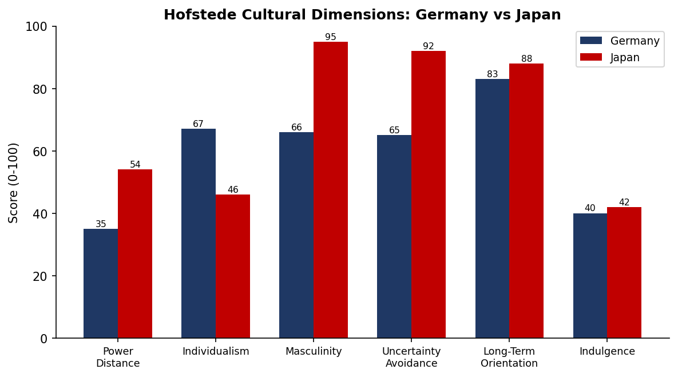
Figure 2: Hofstede Cultural Dimensions Comparison – Germany vs Japan (Source: adapted from Hofstede Insights, 2023).
Strengths and Limitations of the Hofstede Model
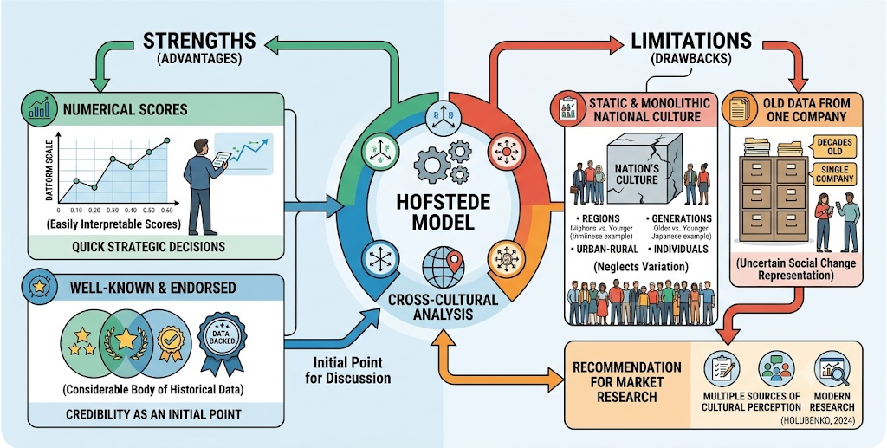
Figure 3 Strengths and Limitations of the Hofstede Model (Author)

One of the advantages of the Hofstede model is the availability of numerical scores which use a uniform scale and give an easily interpretable score in each country to marketers, enabling them to make strategic decisions at a quick glance when entering a new country.

Technological
The technological environment is good in Germany. Germany is a leader in Industry 4.0 and Adidas' e-commerce and direct-to-consumer business is boosted by its sophisticated digital infrastructure. Adidas has been able to effectively target consumers via digital channels, thanks to the ubiquity of mobile and online shopping.
The technological environment in Japan is very favourable. Japan's consumer technology sector is one of the highest-tech in the world. The mobile commerce, AI in retail and smart city infrastructure are well-developed. The fashion e-commerce sector is expected to expand in Japan from $23.2 billion this year to $72.6 billion by 2032, providing great potential for the brand to establish its digital sales footprint.
Environmental
The environmental conditions are good, but challenging in Germany. The EU's Green Deal has strict requirements for sustainability for companies doing business in Germany, such as recycled materials and carbon reductions. This inevitably results in costs for compliance but inevitably also drives Adidas - a brand dedicated to using 100% recycled polyester - towards practices that will enhance the brand image and consumer trust.
In Japan, the environmental environment is favourable. Japan's consumers are more and more concerned about "green" products and the government is encouraging sustainability. In Japan, where the reuse of polyester is particularly valued, adidas' collaboration with Japanese designers to create a World Cup kit from recycled polyester with NIGO in 2022 is in line with the regulatory goals and the consumers' preferences.
Legal
Germany has a moderately constraining legal environment. The German and EU laws have strict obligations with respect to consumer protection, GDPR data privacy, labour standards and advertising. Digital marketing operations are especially challenging when it comes to GDPR, and need to invest a lot in data management systems. Germany is still a predictable country to do business in as the law is clear and consistent.
The legal atmosphere is generally good in Japan. The Japanese legal system is strong and will provide protection to a brand such as Adidas, which has been plagued by counterfeit goods in other Asian markets in the past. Consumer contract law and advertising standards are well regulated and gives consumers a fair commercial environment.
Comparative Summary

The main similarities and differences between the two markets are summarised in Table 1. How both countries provide political and economic stability, and a good buying power for the premium sportswear brand.
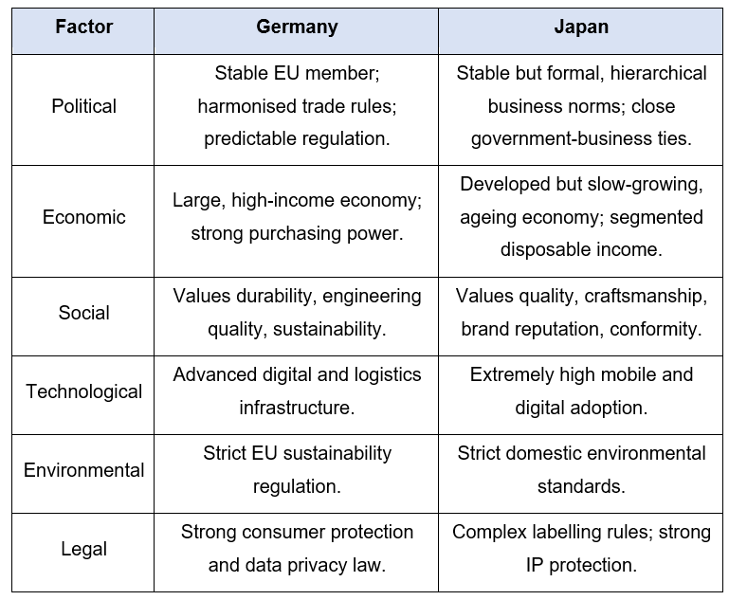
Table 1: Comparative PESTEL Analysis of Germany and Japan (author's own compilation, 2026).

2.2 Segmentation, Targeting and Positioning (STP)
A segmentation, targeting and positioning should be aligned with the consumers' behaviour of the countries, as digital channels are transforming the way companies discover and engage the right segment of consumers in different countries (Rosário and Raimundo, 2021).

STP in Germany
Segmentation
Adidas has developed four key variables to segment its market in Germany.
- Demographic: Age (16-45), gender (Male and Female), income level (Mid to high income earners)
- Psychographic: Lifestyle and personality - serious performance athletes; casual sport and fitness participants; and fashion-conscious lifestyle consumers.
- Behavioural: Frequency of purchase, brand loyalty, type of activities, benefits sought (technical performance, comfort, style, etc.).
- Social Economic: As the demand for sportswear is highest, and the wealth of the people is also high in the major cities,
- Geographic is in the category of social economic.
Targeting
In Germany Adidas focuses mainly on the performance athlete and the lifestyle consumer, with an increased focus on functional performance, technical credibility and sustainability; a focus on these arguably values that resonate most with German consumers.
Positioning
Adidas places itself in the centre of a true and genuine German sport brand. The positioning is supported with the help of the sport clubs and national teams in the region, adding extra credibility to the brand in a competitive domestic market, both in terms of technical performance as well as lifestyle competition.

STP in Japan
Segmentation
Adidas differs in its product offering based on the following factors in Japan:
- Demographic: Male/female, age (16-35), income (young urban middle income earners)
- Psychographic: Lifestyle and personality — Streetwear lovers, sneaker collectors, fan of celebrity culture, and fashion-conscious youth consumers
- Behavioural: Buying intentions (novelty, exclusivity, trend-following), participation in limited edition items, being sensitive to celebrity and designer collaborations
- Geographic: Streetwear culture and digital sales presence is dominant in major urban centres like Tokyo, Osaka and Nagoya.
Targeting
The Japanese market is dominated by young urban consumers, especially those in the 16-35 age group who are avid aficionados of streetwear and sneaker culture, as well as celebrity collaborations, on which Adidas focuses. This segment is very big in Japan, and it is important segment for its commerce. The brand targets digital shoppers with a high frequency and trend-sensitive consumers who are highly agitated by drops and co-created collections with local designers and artists and streetwear brands.
Positioning
Adidas in Japan is not only a performance brand, but is also a lifestyle and cultural brand. The company takes a novelty and exclusivity-driven approach, fostering emotional engagement with younger audiences through collaborations with local Japanese designers (like NIGO in 2022) and limited editions that establish brand-relevant and desirable cultural relevance. This positioning creates an emotional connection with youth and made Adidas stand out from the functional sportswear.

Perceptual Map
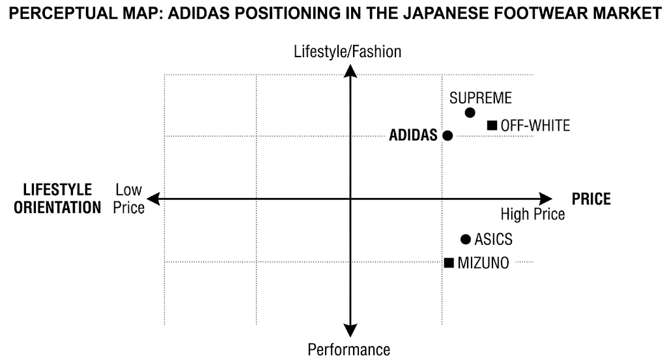

Figure 4 Perception Map (Marques, 2021)
The axes on an Adidas perceptual map in Japan would be price (low to high) and lifestyle orientation (performance to lifestyle/fashion). Adidas is in the high price, high lifestyle section in Japan, sandwiched between fashion and culture labels like Supreme and Off-White, and shoes geared towards performance like Asics and Mizuno. This attitude is in line with Japanese consumers' choice of "exclusivity" and "cultural identity" over technical performance alone.
Compare and contrast Germany and Japan.
Adidas uses behavioural and psychographic segmentation and positions itself as a premium brand with good sporting history in Germany and Japan, both of which has a population of consumers in the age group of 16-45. The strategies are, however, quite distinct. Germany focuses on performance, technical credibility and sustainability, with serious athletes and active lifestyle consumers as their target customer. The emphasis on Japan is youth streetwear culture, novelty and exclusive collaborations. In contrast, this shows how Adidas aligns its brand message to the unique cultural expectations for each market, instead of a global strategy (Katsikeas, Leonidou and Zeriti, 2020).

2.3 International Marketing Mix (7Ps)
Comparative examination of marketing mix in the developed and emerging countries reveals that the same element of the marketing mix can perform differently in each country, thus affecting the overall success of the marketing mix strategy (AL-Nsour, Bin Zaid and Al-Sbini, 2026).

2.3.1 Product
The width of the product range is the number of different product lines a brand has and the depth of the product range is the number of variants within each product line. Adidas offers a broad product portfolio all across 4 main product lines: Performance, Originals (lifestyle), Collaborations (premium) and Y-3 (luxury). Table 2 below shows the breadth and depth of Adidas's product offering and the different ways in which they are used in Germany versus Japan.
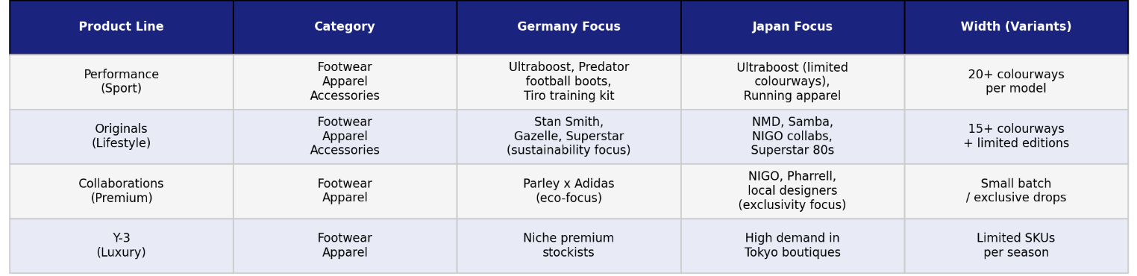

Table 2: Adidas Product Depth and Width – Germany and Japan (Source: adapted from Adidas Group, 2024)
Adidas' focus in Germany is heavily on the Performance brand, especially its flagship products like the Ultraboost running shoe and Predator football boots. The products are a reflection of the German consumer's wish for technical credibility, function innovation and sustainability. To meet local demand, some of the core performance products are now incorporating recycled materials, such as trainers created using Parley-ocean plastic, which fits in with Germany's high environmental values (Šeda, Janikovičová and Pollák, 2025).
Adidas' Originals and Collaborations collections are more important to the Japanese brand. Popular products like the NMD, Samba and Superstar 80s are all in high demand, and the brand is actively producing limited drops in collaboration with local designers and artists.

 |  | 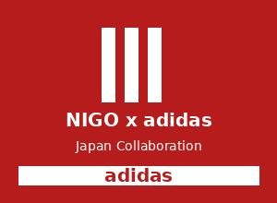
Ultraboost (Germany) | Stan Smith (Both markets) | NIGO Collab (Japan)
Figure 4: Key Adidas Products – Ultraboost (Performance/Germany), Stan Smith (Both Markets), NIGO Collaboration (Japan) (Source: Adidas Group, 2024)

2.3.2 Price
Germany has high average incomes and a strong brand trust, providing a relatively stable premium end; Japan has a broader tiered pricing model that appeals to premium collaboration customers willing to pay much more than the retail price as well as more price-sensitive younger consumers purchasing at the basic end of the value. International market price strategies need to consider local purchasing power, cost and pricing of competitors and cost base, which is different from a price point (Marques, 2021).
Pricing Strategies Used
Adidas is known for its premium pricing strategy, which is in line with the high purchasing power of consumers and their trust in the brand in Germany. Whereas in Japan, Adidas uses a layering approach, with much higher prices being sold for limited edition collaborations using psychological and prestige pricing, but with a lower entry point for younger consumers who value price less. Both strategies consider the local purchasing power, the competitor pricing and differences in cost base (Marques, 2021).

2.3.3 Place
In Germany and Japan, Adidas relies on a multi-channel approach for distribution, bearing in mind that this strategy is suited to the widest possible reach and the greatest accessibility to the markets.
The Adidas products are sold in Germany via three channels: through its own brand stores (e.g. the Adidas Brand Centre in Berlin), through sports retailers that are authorised by Adidas (e.g. Intersport and SportScheck) and the Adidas.com e-commerce site. These channels are indicative of German consumers' in-store product testing and ease of online shopping.
Partnerships with high-end department stores like Isetan and Takashimaya, as well as relying on digital and mobile commerce, play a greater role in distribution in Japan. Adidas also has experience centres in the most important fashion centres of Tokyo, such as Harajuku and Shibuya, which are not just retail outlets but also brand experience centres (Katsikeas, Leonidou and Zeriti, 2020).
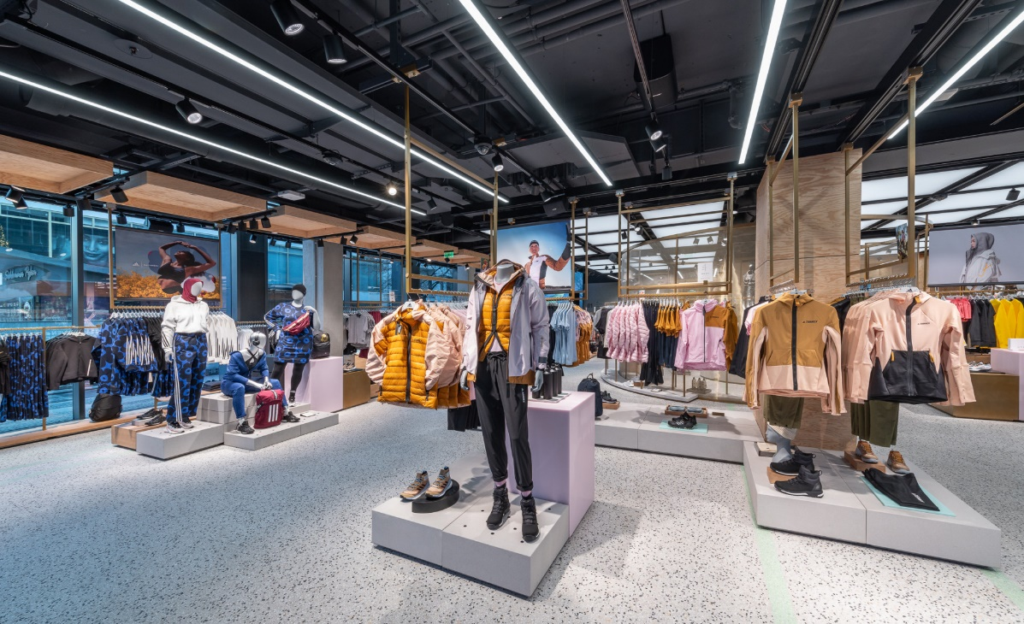

Figure 5 Adidas Brand Centre Berlin store interior (Adidas Group, 2024)



Figure 6 Adidas flagship store Harajuku Tokyo Japan (Adidas Group, 2024)

In both markets, it has been shown that using a mix of physical and digital is a successful strategy in boosting market penetration. The digital channel is, however, more strategic in Japan than in Germany due to their better mobile commerce culture (Marques, 2021).

2.3.4 Promotion
Integrated Marketing Communications (IMC) is a strategic approach in the management of all of the promotional channels and messages in order to provide a unified and consistent brand experience to customers at various touch points (Katsikeas, Leonidou and Zeriti, 2020).
While Adidas is using the same framework, IMC, the way they promote and the channels they use in Germany differ from those in Japan. Promotional activities focus on athlete endorsements, proof of performance and sustainability messages in Germany. Adidas has teamed up with top German athletes and national sport teams to create credibility and authenticity. The messages are conveyed via traditional media (television and print) as well as digital media (Instagram and YouTube), where content with a performance effect has proved to be very successful with the target group in Germany.
Japanese promotions move towards using local celebrities, animating characters, and street fashion culture. Adidas actively involves young consumers by participating in social media sites that are frequented in Japan, including Instagram, LINE, and TikTok, with the help of influencers and limited-edition product launches. Due to different consumption habits and preferences of platforms in different markets, it is suggested that the planning of promotions should be platform-specific and region-specific, and not applied in a global manner (Yingrui, 2023).

2.3.5 People
Frontline employees are key to providing the same brand experience across the different international markets and therefore training also varies, with local training being more formal, more detailed and more focused on staff service expectations, which tend to be higher in Japan than Germany (Sahir, 2020). In Japan, the staff members in the stores are generally expected to deliver very attentive and ceremonial customer service and in Germany their service is rather efficient and functional.
The number of employees at Adidas is around 59,000 worldwide (Adidas Group, 2024). About 16,000 employees are employed in the retail business and in the global headquarter in Germany. Adidas has around 2000 employees in Japan, at their stores and regional offices.

2.3.6 Process
Order fulfilment, returns management as well as the formulation of loyalty programmes should be tailored to local perceptions of speed, formality and convenience, and firms need to be strategic and coordinate marketing-mix processes in different segments and competitive settings to be effective and compelling in each market (Mergner, Brüggemann and Olbrich, 2026).
Customer Complaints Process
Adidas's process for dealing with customer complaints is structured and transparent, and is used in Germany. Customers can reach out to the customer service through calling, email or online chat, and the time frame for solving a problem is stated at the beginning. Throughout, the data privacy compliance is kept a strict one according to GDPR.
Complaints in Japan are more services oriented. Customers want to be acknowledged, communicated with politely and formally and have their problem solved quickly. Employees of the stores are trained to deal with the complaints with high level of ceremony and paying attention to customers' needs, which is the extremely high level of customer service in Japan (Sahir, 2020).

2.3.7 Physical Evidence
In every market, store design, packaging and interfaces (digital) work differently to help strengthen Adidas' brand image: German stores tend to be clean and functional, with a focus on technical performance, while Japanese stores may be more immersive, eye-catching and work on collaboration launches. Physical Evidence decisions can be influenced by competitor's behaviour in the same market because brands have to differentiate themselves from the close product or service competitors in market purely based on the physical experience shoppers have with the product or service (Abedian et al., 2022).
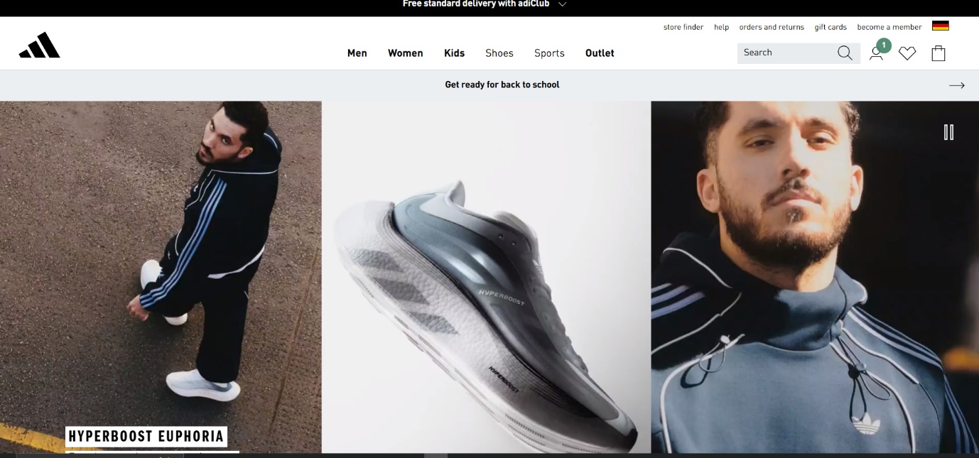
Figure 7 German Webside (Adidas Group, 2026)

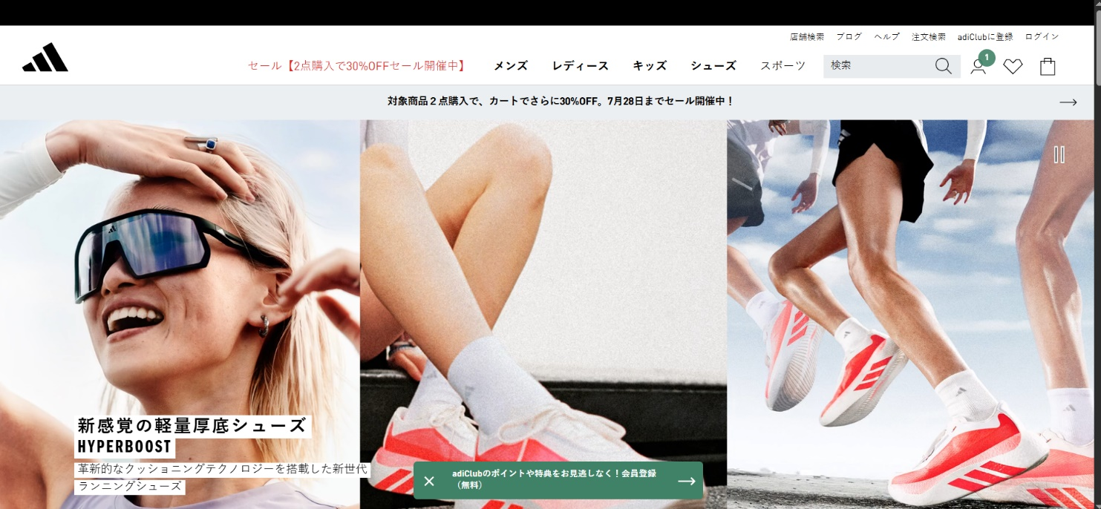
Figure 8 Adidas Japan Webside (Adidas Group, 2026)

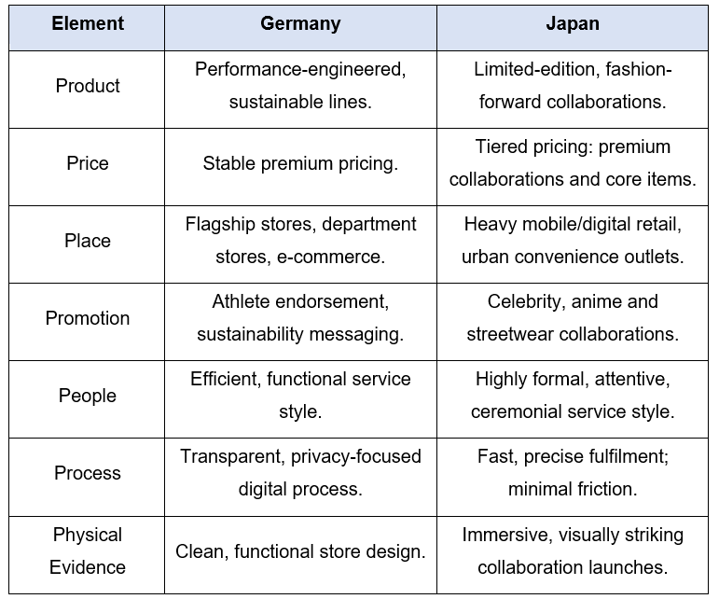
Table 2: Comparative International Marketing Mix (7Ps) of Adidas in Germany and Japan (author's own compilation, 2026).

2.4 Market Entry Strategy Analysis: Japan

2.4.1 Entry Mode Adopted
Adidas also got its launch into Japan organised in an early and low-risk licensing and distribution agreement before moving onto a full subsidiary arrangement in which it handles retail, marketing and distribution. Generally speaking, strategies for entering the international market can be pursued on a relational, digital or hybrid basis, reflecting the combination of caution and control that was traded off and that Adidas adopted as it began to move from licensing to direct ownership (Watson IV et al., 2018). Structured multi-criteria decision analysis might be needed to evaluate the different entry mode options in terms of risk, cost and control, rather than just using informal judgement to consider the different market options (Tanrıverdi, Kundakcı and Ertuğrul, 2026). The choice and eventual success of an entry strategy is also significantly affected by comparative legislative and regulatory environment in host markets; the high requirements in Australia, Japan, and Europe regarding the products labels and imports, probably pushed Adidas to tighter control over time.The selection and eventual success of an entry strategy is also significantly influenced by the comparative legislative and regulatory environment in the host markets, with strict regulatory requirements in labelling products and imports in Australia, Japan and Europe, probably pushing Adidas towards tighter control over time (Matějková and Dohnal, 2025).

2.4.2 Advantages and Disadvantages
The wholly owned subsidiary model ensures that Adidas has complete control over the brand image, pricing and retail experience in Japan, enabling the company to swiftly respond to what is happening in the market without having to depend on the products launched by the third-party partner. An entry approach that is specifically designed to local competitive conditions is more likely to establish a competitive advantage than can be applied everywhere and is such the best way for Adidas to compete with established strong local and international brands in Japan (Xiong, 2027). This does involve a much larger initial outlay in capital, however, than more limited entry ways like licensing or franchising, which come with the extra risk of local regulation, culture, and currency risks. To optimize selection of the entry mode it is imperative to consider the risk exposure, cost, and market control issues, rather than take the direct ownership as the best option (Kharel, 2025). Continuous research is needed even after the entry to ensure the continued alignment of the subsidiary model with the changing consumer behaviour in Japan (Lazoriková, 2021).

3. Ethical Evaluation of Adidas' Marketing Mix

3.1 Examples of Ethical Marketing Practice
Adidas's actions have proven that it is a leader in the ethical marketing arena with several noteworthy campaigns that extend beyond brand promotion to provide social and environmental benefits that are tangible.
As far as the environmental aspect is concerned, Adidas has joined forces with environmental organisation Parley for the Oceans to develop performance sporting goods and apparel from recycled plastic ocean waste. Instead of setting general sustainability goals, Adidas has set clear and measurable goals, like it, which is a clear sign of transparency and accountability in environmental marketing communications. The use of this approach creates trust of the consumers and not only positive press coverage (Šeda, Janikovičová and Pollák, 2025).
As a social responsibility, Adidas has dedicated a lot of resources to grassroots community sports programmes, and promotes participation of underrepresented groups such as minorities, low-income classes and women. Ethically, these initiatives are valuable because they create real social value (health and wellbeing of the community) not just as a sales machine. As Teixeira (2025) points out, community-based marketing initiatives of this nature can help pave the way for sustainable growth that is socially responsible which will boost long-term brand equity.
These instances illustrate that, when done well, Adidas' marketing activities steer clear of being purely business-driven and work toward creating shared values for the company and the communities it is marketing to.

3.2 Examples of Unethical Marketing Practice
Give some examples of ethical marketing.
1. Greenwashing Allegations
Adidas has been slammed for using the term sustainable when it comes to its products, including the recent "End Plastic Waste" campaign which it was accused of using without enough proof the environmental statements are entirely accurate or relevant.

2. Kanye West (Ye) Partnership Termination
In October 2022, Adidas broke off the partnership with Kanye West as he made antisemitic and hateful statements publicly. Some critics noted that Adidas was also hindered in its response because of the anticipation of the situation, and questioned whether or not there was ethical due diligence carried out when partnering with celebrities.
3. Misleading Advertising - Germany
Adidas was under the microscope in Germany for claims in its advertising that were deemed to be exaggerated and not supported by independent evidence.
4. Labour Rights in Supply Chain – Japan
Ethical concerns have been raised about adidas' business practices with factories in the Asian supplier chain used to make goods sold in Japan, due to the factories' lack of adherence to the company's standards for fair working conditions and transparency.
From the above examples it is clear that fashion, sportswear and other brands are being increasingly called to account for the sustainability messages they are promoting, but also for the cultural sensitivity of the message; that moral risk is well correlated to the capacity to give an ethical message – in a credible and verifiable way.

3.3 Recommendations
It is important for Adidas to have the mechanisms in place for ongoing market research, so as to ensure it is able to respond to cultural and consumer change within its host markets, instead of waiting for occasional and dated information, especially in the light of how fast consumers of fashion-driven markets such as Japanese streetwear customers can change. Opportunities for further investments in digital marketing capability are also identified, as more powerful digital marketing capabilities are repeatedly linked to better firm performance in increasingly digital international markets, which in turn facilitate targeted efforts and quick actions on local opportunities (Homburg and Wielgos, 2022). Adidas should also continue to adapt the marketing mix, specifically the promotion and product, in relation to the cultural profile of each market, but not copy/paste its marketing strategy everywhere in the world, and further ensure that communication on such matters as sustainability claims is clear and verifiable both in Germany and in Japan, preventing future and current exposure to ethical criticism, while maintaining maximum brand trust. Last, collaborative efforts between local designers and local community groups in Japan should be continued and increased as that has been a successful strategy in creating real local "relevancy. To avoid reputational damage after consumers criticized their content, Adidas should ensure that culturally acceptable content gets identified and fixed prior to it being launched in new areas, rather than after.

Section 2: Reflective Account

Using Gibbs' Reflective Cycle (1988)



Figure 9 Using Gibbs' Reflective Cycle (Marques, 2021)

Description
In this assessment I had to write an individual report which explores the international marketing strategy of Adidas in two different markets Germany and Japan. This required the application of a number of analytical frameworks such as PESTEL, Hofstede's Cultural Dimensions, STP analysis, the 7Ps marketing mix, the Bartlett and Ghoshal transnational model as well as Gibbs' Reflective Cycle itself. The other main aspect of my project was finding a way to launch into the Japanese market that Adidas has taken and analyzing the ethical dilemma associated with the marketing mix and giving them evidence-based recommendations to strategically enter the market. The report had to include no less than 10 to 15 credible academic references and be delivered professionally to meet post-graduate (Level 7) standards.

Feelings
Initially, I was excited and somewhat nervous about the assignment. This was an interesting topic and I knew nothing about Adidas I know it is a brand I’m personally familiar with but I wasn't sure what sort of reports I could make based on this and how it would all fit into the word count. I was more worried about the Hofstede section since I had not had much experience applying cultural dimension models to actual marketing situations. Then, too, I was feeling a bit pressured to find legitimate and credible (Academic) sources, not just a random business website or a textbook. With an increasing understanding of the structure of the market as the research went on, though, my confidence was strengthened and I started to look forward to the analytical aspect of comparing two very different markets.
Evaluation
I feel that the research and writing process was successful in a number of important aspects. As a result, I was able to find a wide variety of reliable sources in the indexed journals from Scopus, and Web of Science that increased the rigor of my analysis. I used the PESTEL framework and analysed each factor as it is favourable or unfavourable to Adidas in each country and beyond simply describing the factors, I came to better understand how I was able to offer genuine critical analysis, which I am aware is an essential element of level 7. The Hofstede section also did a good job after I knew how to directly relate the dimension scores to Adidas's marketing activities for each market, e.g., 'individualistic' advertising in Germany, and 'collective' advertising based on celebrities in Japan.
But I had some difficulties with it as well. It was tricky to keep word counts in sections consistent and yet have enough analytical depth in each section. In some cases, the descriptions in the early drafts were too descriptive and had to intentionally step back and be more critical with the evaluation, assuming more evidence-based judgement.
Analysis
Upon reflection, I can see that perhaps I struggled with the Hofstede section because I made it too real or like a fact. Through reflection, I realise I had the wrong mindset for the Hofstede section, perhaps I thought of it as a fact, or something which had to be taken at face value. But once I critically analysed it, paying attention to the subject matter of the original study, which gathered data from IBM employees, and also considering it to be an older cultural sphere, I could write a more holistic, and more well-informed analysis. This echoes one of the important concepts of the module – that frameworks are not end points but a beginning for analysis. The authors of the book, Katsikeas, Leonidou and Zeriti (2020), claim that marketing strategy is not one of those things that should be applied mechanically from one country to another, but should be constantly reviewed and questioned.
I also acquired a real understanding of the notion of "globalisation," meaning that the successful international brand has to consider both global and local needs, so it's really a combination of global and local. Prior to this assignment I only knew this concept by reading it in lectures and reading. It is an experience I gained when putting it into practice for Adidas: How the same brand promise can be interpreted in distinctly different ways in each cultural, economic and social context. This realization was an important step in my appreciation of the nature of international marketing compared with domestic marketing, in that I now understood why it was so more complex and more interesting.
Conclusion
Overall, this paper assignment was a challenge to approach the task with a bit more depth than I had taken on in other papers and exercises—thinking of this piece critically, researching it more critically, writing more analytically than I would have in a previous assignment. I was introduced to the knowledge of frameworks but also to the skills of applying these frameworks comparatively, critically, and sensitively to real-world business contexts.
Action Plan
In the event that I had to deal with an assignment like this one in the future, I would start looking for literature earlier than I did so I would have more time to check the accuracy and credibility of the academic sources I used. I would also develop an outline for each section clearly outlining the words per section. Also, I would seek to connect more with the primary sources that complement with the academic literature in order to further ground my analysis in the empirical detail such as Adidas' annual reports and sustainability publications.

References
Abedian, M., Amindoust, A., Maddahi, R. and Jouzdani, J. (2022) 'A game theory approach to selecting marketing-mix strategies', Journal of Advances in Management Research, 19(1), pp. 139-158.
AL-Nsour, I.A., Bin Zaid, Y.A. and Al-Sbini, S.F. (2026) 'A meta-analytical examination of marketing mix strategy between developed and emerging markets', Tianjin Daxue Xuebao (Ziran Kexue yu Gongcheng Jishu Ban)/Journal of Tianjin University Science and Technology, 59(04), pp. 152-200.
Azizi, M. and Mansouri, H. (2021) 'Analysis of marketing strategic planning in the home furniture industry by applying ANP: a case study of the Iranian home furniture industry', International Journal of the Analytic Hierarchy Process, 13(1).
Bilovodska, O., Kravchuk, T., Ponomarenko, I., Bliumska-Danko, K. and Kononenko, A. (2024) Artificial intelligence for marketing product strategy in the online education market.
Clarke, S.J. (ed.) (2023) Contemporary Strategic Chinese American Business Negotiations and Market Entry. London: Palgrave Macmillan.
Eriksson, T., Bigi, A. and Bonera, M. (2020) 'Think with me, or think for me? On the future role of artificial intelligence in marketing strategy formulation', The TQM Journal, 32(4), pp. 795-814.
Hasan, M.M., Rayhan, Z., Mukta, R.T. and Faruq, O. (2024) 'Research on adapting marketing techniques to different culture economics and regulatory environment to entering new international markets', Информатика. Экономика. Управление/Informatics. Economics. Management, 3(4), pp. 0257-0277.
Hofstede Insights (2023.) Country Comparison Tool. Available at: https://www.hofstede-insights.com/country-comparison-tool (Accessed: 7 July 2026).
Holubenko, M.А. (2024) The Marketing Research Organization Mechanism at the Enterprise Entering the International Market.
Homburg, C. and Wielgos, D.M. (2022) 'The value relevance of digital marketing capabilities to firm performance', Journal of the Academy of Marketing Science, 50(4), pp. 666-688.
Ievseitseva, O. and Bebko, S. (2025) 'Logistics and international marketing as factors in optimizing the marketing policy of distribution', European Science.
Katsikeas, C., Leonidou, L. and Zeriti, A. (2020) 'Revisiting international marketing strategy in a digital era: opportunities, challenges, and research directions', International Marketing Review, 37(3), pp. 405-424.
Kharel, N.G. (2025) Optimizing International Market Entry Strategies for Shri Antu Gorkha Tea Estate.
Lazoriková, L. (2021) Market Research: Market Research of Selected European Countries and Creating Market Entry Strategies.
Lee, H.S. and Griffith, D.A. (2019) 'The balancing of country-based interaction orientation and marketing strategy implementation adaptation/standardization for profit growth in multinational corporations', Journal of International Marketing, 27(2), pp. 22-37.
Marques, M.B.F. (2021) Field Lab on Internationalization: A Case Study of a Portuguese SME in the Floor Covering Industry - Marketing Plan (Marketing Mix: Price, Promotion and Place). Master's thesis. Universidade NOVA de Lisboa.
Matějková, J. and Dohnal, R. (2025) 'Strategic entry of Czech construction companies into the Bosnian public procurement market: a comparative analysis of legislative frameworks and market conditions', Sustainability, 17(1), p. 115.
Mergner, N., Brüggemann, P. and Olbrich, R. (2026) 'Mastering the marketing mix: an empirical approach to strategically orchestrate the marketing mix across segments and competitors', Journal of Marketing Analytics, pp. 1-20.
Morgan, N.A., Whitler, K.A., Feng, H. and Chari, S. (2019) 'Research in marketing strategy', Journal of the Academy of Marketing Science, 47(1), pp. 4-29.
Rosário, A. and Raimundo, R. (2021) 'Consumer marketing strategy and e-commerce in the last decade: a literature review', Journal of Theoretical and Applied Electronic Commerce Research, 16(7), pp. 3003-3024.
Sahir, I. (2020) 'Improve marketing mix for marketing plan strategic in coffeeshop business', Management Analysis Journal.
Šeda, M., Janikovičová, S. and Pollák, F. (2025) 'Optimization of the marketing mix for sustainable building materials: the case of wooden buildings in the Czech Republic', Acta Montanistica Slovaca, 30(4), p. 1108.
Tanrıverdi, Y., Kundakcı, N. and Ertuğrul, İ. (2026) 'International market entry strategy analysis with hybrid fuzzy multi-criteria decision-making methods', Review of International Business and Strategy, 36(1), pp. 97-128.
Teixeira, M.J.F.D.C.A. (2025) A Marketing Plan for CRCQL Female Basketball Teams - Grassroots Growth Through Strategic Marketing Initiatives.
Watson IV, G.F., Weaven, S., Perkins, H., Sardana, D. and Palmatier, R.W. (2018) 'International market entry strategies: relational, digital, and hybrid approaches', Journal of International Marketing, 26(1), pp. 30-60.
Wiltshire, J. and Cousins, C. (2026) Fashion Marketing: Strategies, Trends and Innovation. London: Kogan Page.
Xiong, Z. (2027) 'Jiumaojiu's overseas market strategy: competitive advantages and market entry approaches', in Cases on Chinese Brands' Globalization Strategies. Hershey, PA: IGI Global Scientific Publishing, pp. 371-394.
Yingrui, L. (2023) Research on the Marketing Strategy Optimization of Ctrip Air Ticket Products. Doctoral dissertation. SIAM University.

