

Programme: Certificate in Higher Education Skills for the Workplace

Module code and name: BMSW 4006_ Managing Enterprise in the 21st Century

Name of the Students and ID Numbers:
Ivaylo Georgiev _ 2128090
Aneliya Georgieva _ 2125657
Slavina Stoyanova _ 2127720
Petko Petkov _ 2125440

Name of Group: Group 2
Lecturer Name: Umar Sadaat
Title: Business plan_ Balkan Street food Industry

Table of contents:
1. Overview of the business idea, product and/or service……………………………………….
2. Legal format of the startup company and Management of the company……………………
3. Explanation of the target market and the marketing strategies the company will adopt to reach their customers………………………………………………………………………………..
4. Evaluation of the business idea by using the SWOT analysis model……………………….
5. Assessment of the current external environment by using the PESTEL analysis model….
6. Identification of the key marketing factors by using the 4Ps of marketing model…………..
7. A cash flow forecast for the first 12 months…………………………………………………….
8. Reference List ……………………………………………………………………………………

Overview of the business idea

Street food is a type of food business that operates in public spaces, such as sidewalks, parks, and markets. The street food business is becoming increasingly popular in many countries due to its convenience, affordability, and variety of food options.
Our idea is to start a street food business that serves a variety of delicious and healthy Balkan food options to customers in public spaces. The business will aim to attract a diverse range of customers, including office workers, students, tourists, and local residents.

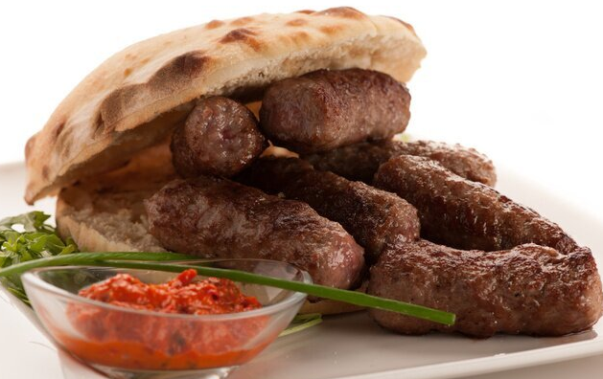
Source: https://myloview.de/sticker-photo-of-cevapi-cevapcici-traditional-balkan-food-delicious-nr-A89A3B1

.

Legal format of the startup company and Management of the company

BG Group Ltd. will be registered as a limited by shares company, with corporate headquarter Stafford, 1 Sandon Road, ST123 AA, with the UK government’s official register of companies Company House. A limited company is an entity that "has separate finances from our personal ones" and it is "legally separate from the people who run it “(Gov.uk., 2021).
It will be owned 25% by Ivaylo Georgiev, Director and Accountant, with seven years’ experience as a small team leader and a company’s owner; 25% by Petko Petkov, Driver and Buyer, with established reliable positive relationships with the local farm owners; 25% by Aneliya Georgieva, keen Cook and Seller, with ten years cooking experience; and 25% by Slavina Stoyanova, Food preparer and Cashier, enthusiastic environmentalist with vast knowledge in healthy eating. All of the shareholders are able to execute multiple job’s role at ones. BG Group will be with a flat organizational structure. (Figure 1)
“Flat organizational structures help organizations facilitate employee participation. A participative management style improves the quality of work life.” (Jain & Thomas, 2016)

Figure 1. Organizational structure of the business

- Evaluation of the business idea by using the SWOT analysis model

“SWOT (the acronym standing for Strengths, Weaknesses, Opportunities and Threats) analysis is a commonly used tool for analyzing internal and external environments in order to attain a systematic approach and support for a decision situation”.
(Kartika et al., 2000)
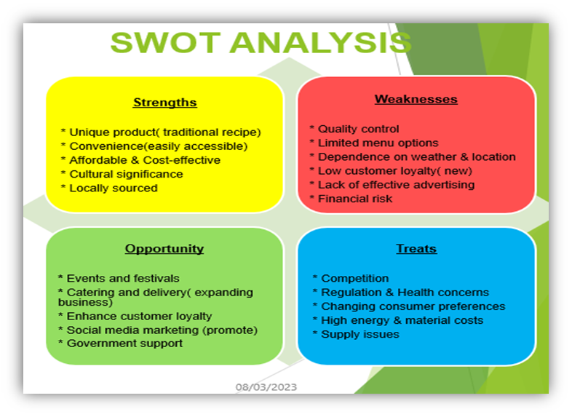
Applying a Swot analysis, we assess our company’s position on the existed market:
Our strengths:
- Balkan cuisine is unique and less widely available in the UK, offering a competitive advantage for the business, which could help our business to differentiate from others.
- The street food industry has grown lately in the UK, providing a strong market for new entrants.
- A street food truck can be more flexible and cost-effective than a traditional restaurant, allowing the business to operate in multiple locations and adjust to customer demand.
- Balkan street food can be marketed as a healthier alternative to traditional fast food, appealing to customers looking for healthier options.
Our weaknesses:
- Balkan cuisine may be unfamiliar to some customers, which may require additional marketing efforts to educate them on the cuisine and its unique offerings.
- The food truck may face regulatory hurdles and require permits or licenses to operate legally.
- As with any street food business, the weather can be a challenge and can impact the business's earning potential.
- The quality of food and hygiene standards may be difficult to maintain in an outdoor setting.
Opportunities:
- The Balkan street food market may be less saturated in the UK, offering opportunities for the business to stand out and establish itself as a unique culinary experience.
- The food truck can be used to attend food festivals and events, helping to increase brand awareness and reach new customers.
- The business can offer catering services, targeting corporate and private events.
- Balkan street food can be marketed to customers looking for authentic and unique culinary experiences.
Threats:
- Economic downturns and uncertainty can impact discretionary spending, which may negatively impact the street food market and the business's revenue.
- Rising food costs or supply chain disruptions can impact the profitability of the business.
- Increased competition from other street food vendors or traditional restaurants
- Health concerns or food safety issues can damage the reputation of the business and the industry as a whole.

- Assessment of the current external environment by using the PESTEL analysis model
“PESTEL analysis, as it stands, mainly provides general idea about the macro environmental conditions and situation of a company” (Yüksel, 2012) and it “serves as the foundation for identifying opportunities and threats” (Vokhta, 2022).


Political factors:
- Regulations: around food safety, hygiene, and preparation that street food vendors need to comply with.
- Licensing: business may need to obtain licenses to operate in certain areas or during specific times.
- Brexit: Changes in trade and immigration policies after Brexit could potentially affect the availability and cost of certain ingredients.
Economic factors:
- Income: The level of disposable income of consumers will impact their willingness to purchase street food.
- Inflation: Inflation rates can affect the cost of ingredients and the pricing strategy
- Competition: The level of competition in the street food market can impact prices and sales.
Sociocultural factors:
- Diversity: The UK's diverse population may influence the types of cuisine that are in demand.
- Health and wellness: Consumers may be increasingly interested in healthier food options.
- Convenience: Street food's convenience and on-the-go nature may appeal to consumers who are busy or on-the-move.
Technological factors:
- Social media: It could be used to promote offerings and reach a wider audience.
- Payment methods: The availability of mobile payment methods can make it easier for consumers to purchase street food.
- Food delivery apps: The rise of food delivery apps may present opportunities to reach more consumers.
Environmental factors:
- Sustainability: Consumers may be increasingly interested in environmentally friendly practices, such as compostable packaging and using locally sourced ingredients.
- Weather: Inclement weather may impact the demand for street food.
Legal factors:
- Employment laws: The company must comply with employment laws, such as minimum wage requirements.
- Intellectual property: Street food vendors must be aware of intellectual property laws and ensure they are not infringing on anyone else's trademarks or patents.
Overall, while the street food industry in the UK faces some challenges in terms of regulations and competition, it also presents opportunities for innovation and growth, particularly in terms of catering to changing consumer preferences and adopting new technologies.

References:
Gov.uk. (2021). Setting up a limited company. Available at: https://www.gov.uk/limited-company-formation (Accessed:4/3/23)

Jain, Y. and Thomas, R. (2016). A study on quality of work life among the employees of a leading pharmaceuticals limited company of Vadodara district. IJAR, 2(5), pp.926-934.

Kartika, M., Pesonen, M., Kangas, J. and Kajanus, M., 2000. Utilizing the analytic hierarchy process (AHP) in SWOT analysis—a hybrid method and its application to a forest-ertification case. Forest policy and economics, 1(1), pp.41-52.
Available at: https://doi.org/10.1016/S1389-9341(99)00004-0 (Accessed:26/02/23)

Yüksel, I., (2012). Developing a multi-criteria decision-making model for PESTEL analysis. International Journal of Business and Management, 7(24), p.52.

Vokhta, A., 2022. External Communication Strategy for International Student Recruitment at Karelia University of Applied Sciences., p.9

