Developing Relationships and Workplace Achievement
BMSK5002

Student - Rume Meah
ID - 1813924
Lecturer – Sujeewa Herath



Contents page

- Aims & Objectives……………………………………………………….…………3
- Methodology…………………………………………………………….………….3
- Introduction…………………………………………………………………………3

- What are Development Vehicles………………………………………………....4
  - Motivation………………………………………………………………………..….5
  - Commitment………………………………………………………………………...7
  - Employee Engagement………………………………………………………..…..8

- Development Vehicles in the Workplace: Organisational example…………..10
  - Profile of Business…………………………………………………………………10
  - Potential Benefits to the organisation……………………………………………13
  - Potential Benefits to the individual……………………………………………….14

- Personal development plan……………………………………………………….16
  - Profile of person – Helen Morgan………………………………………….…….16
  - Identified individual needs: SWOT……………………………………………….18
  - Personal Development plan……………………………………………………....19

- Conclusion…………………………………………………………………………23
- References…………………………………………………………………………25
- Appendixes…………………………………………………………………………27

- Aims and Objectives
The aim of this report is to critically assess whether developing employees with development vehicles, will benefit the organisations. I will conduct a case study based on a leadership role on Capita, who are a global innovative company specialising in digital services, consulting and software business.
- Methodology
In order to evaluate the aim and objectives, I will be using primary and secondary data collection. I will be conducting a questionnaire to be answered by a manager if development vehicles have been conducted within their workplace environment and the results.
The secondary data will be collected from books, journals and internet.
- Introduction
Throughout the history of mankind, we have evolved from the first primates, to what we see now. Over 4 million years ago, one of the earliest human development was - bipedalism within humans, which is the ability to walk on 2 legs. In addition to this they made innovative tools to survive, language development etc, (Smithsonian, National Museum of Natural History, 2019).
The bottom line you cannot stop evolution, it will happen regardless, as it is in our nature to innovate and change. This is true in all matter of things, be it millions of years ago to present day. From manual labour in manufacturing cars, developing 3rd world countries, studying to improve one’s capability to better ourselves, businesses and the workplace, everything evolves with innovative ideas. As humans it our basic psychological behaviour which defines where we want to improve and succeed.
The nature of workplace environment has changed significantly over the years, industries have globalised, making way for lateral thinking. Organisations have evolved and moved with the times to accommodate new business trends in markets, intensifying competition. Stressed workers with high demand output and less time to complete objectives has become normalised. Organisations are managing this by applying modern HR organisational system, which has been highly credible in promoting employee wellbeing.
Organisational HR, use development vehicles to enhance employees’ skills, developing cognitive/ soft skills.
I will be critically evaluating the importance of 3 development vehicles:
- Motivation
- Commitment
- Employee Engagement
How important are theses attributes, in relation to employee’s fundamental behaviour in the workplace?
- What are Development Vehicles
These are essentially the self-development tools required to help individuals learn and progress in any aspect in life, be it social or professional career development.
Development tools range from motivation, Commitment, Employee engagement, Feedback and Rewards etc. There are many ways which organisational HR can support employee’s growth by conducting regular 1-2-1’s, creating company goal based personal development plan, investing in Computer based learning, workshop/ course learning, on the job learning.
You can make a huge difference to your organisation by positively implementing these tools. As it demonstrates to your employees, that you are committed to support their personal growth and professional advancement.
These tools are derived from Organizational theories developed over time, the timeline (fig 1) is demonstrated by Prof. Lars Groth, who has 20 years’ experience in consultation work and academic research (Groth, 2020).
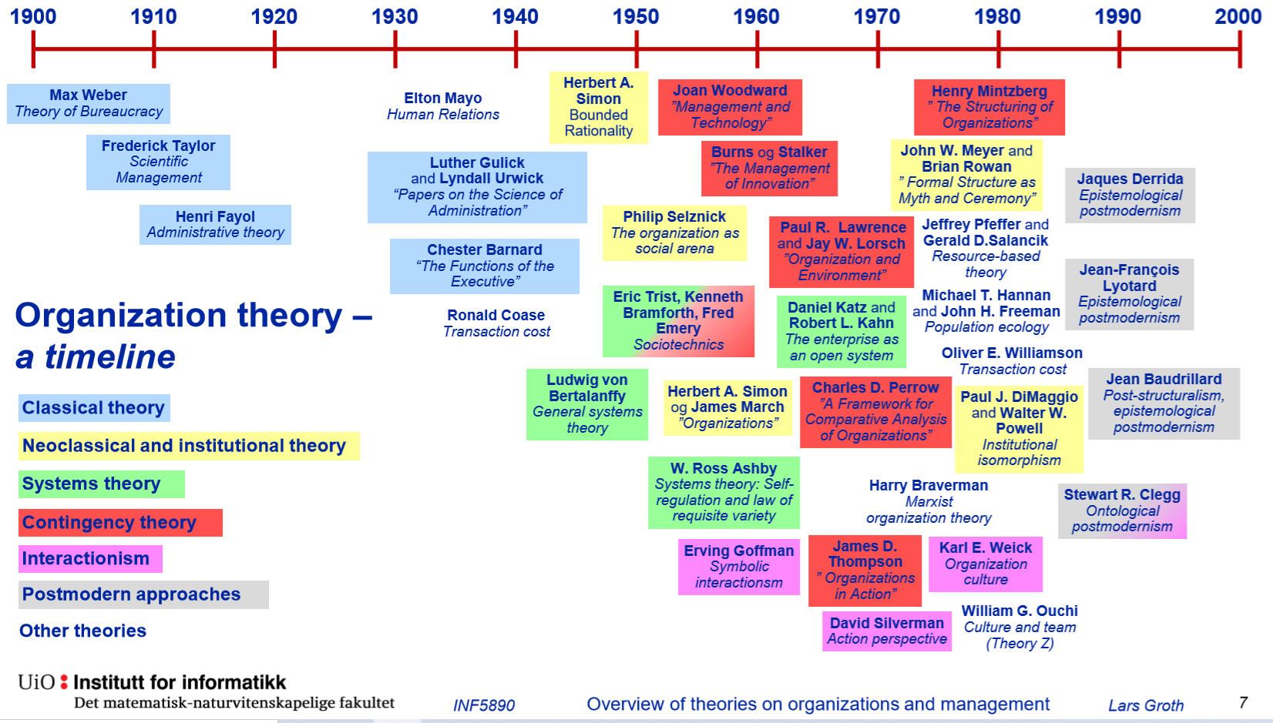
Fig 1

  - Motivation
Motivation represents the energy that helps an individual to reach one’s goal by stimulating their sensory and biological needs. There are essential 2 types of motivation -
- Intrinsic motivation is when a person is gratified from a personal sense of satisfaction.
- Extrinsic motivation is when a person is performing to gain something from others.
According to Steinbauer, R (2018), intrinsically motivated individuals are independent, self-driven and do not require external validation but rely on their interest towards their work and feel self-worth from the completion of their task. Employees who are extrinsically motivated, only work toward towards a means to an end i.e. – pay, work environment etc.
Over time our individual needs have changed due to progression and innovation change, so to be successful, motivation is key.
One of the key theories which is still being used is the Herzberg 2 factor model. This is based on motivators and hygiene factors (fig 2). Its analysis is that you need to fulfil the hygiene factors before motivation can happen.

Fig 2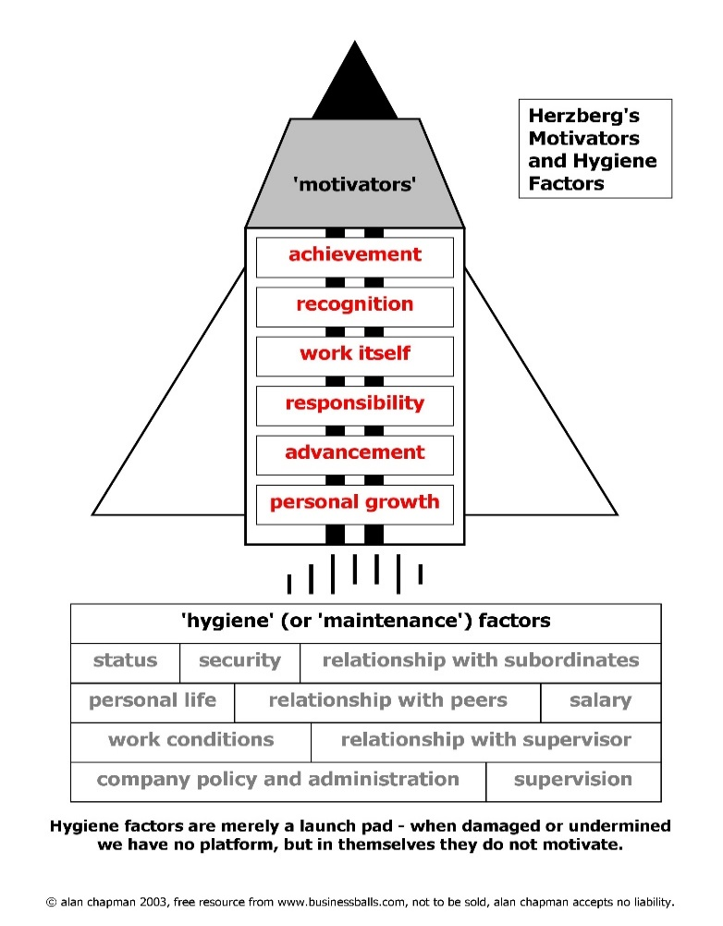

According to Herzberg (Herzberg, 1973) he states in his interview with BBC –
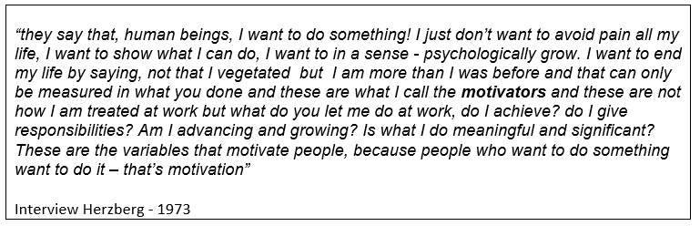
(Appendix 1 – full transcript)
Herzberg theory demonstrates, as people we want to be successful, there is an art in how we manage people, by touching the right nerve is the essence of what motivates a person. Each person is unique, not one person is the same BUT fundamentally we do have basic needs. Once these basic needs are met (hygiene) then we are motivated enough to excel.
According to Sinha, K (2020), the Herzberg theory was developed in the 1960/70’s. The analysis of his theory was based on interviewing 200 employees (accountants/ engineers) over 11 firms based in the USA. The small quantity and the type of workers would hugely affect the outcome of the study. Herzberg study was based on professionals, you cannot apply this to all level of workers i.e. Lower end workers who are motivated by pay and benefits, the hygiene and motivating circumstances will be reversed depending on their needs. The essence of his theory makes sense, but this study should have reflected opinions of different positions, with more quantity. Another aspect was that the data collected was based on 2 respondent answers – Exceptionally bad or Exceptionally good, there was not movement on the answers, so this is biased.

4.2 Commitment
Commitment is a person’s psychological behavioural approach. This evokes a person’s intention and focus by following up with a plan of action.
One organisational commitment model developed by John Meyer and Natalie Allen is the “The three Component Model of Commitment which is based on an individual’s psychological state, it has 3 components (fig3) –

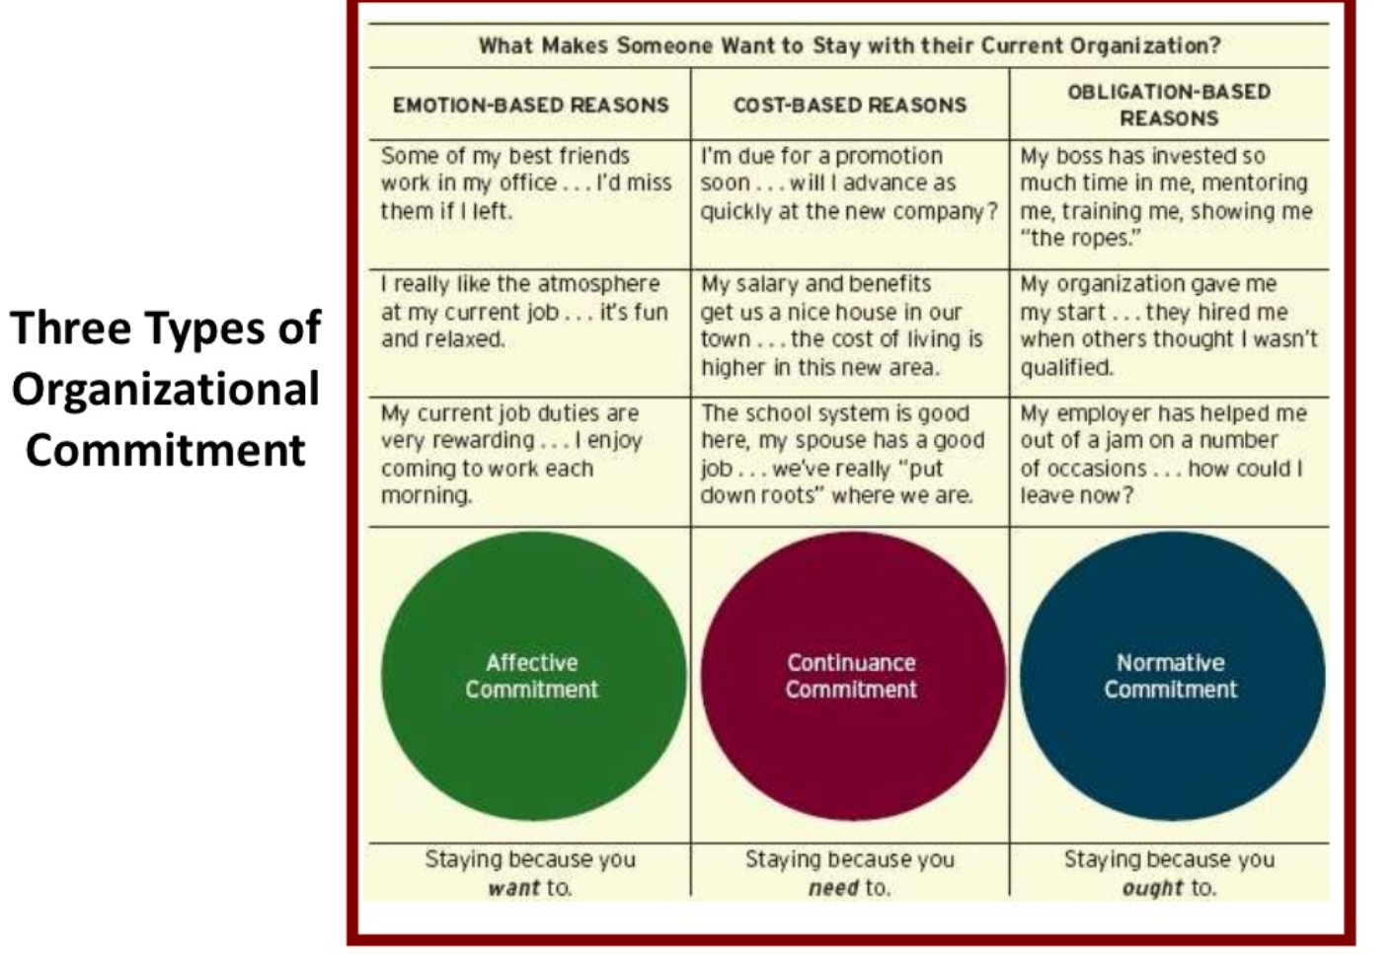 Fig 3
- Affective – These are willing employees who “go above and beyond” and exert extra effort for their job. Affective occurs when the employee feels a strong genuine, emotional attachment with a feeling of belonging to their organization, through core goals and values. Your productivity will increase with job satisfaction – this is affective commitment

- Continuance – This is usually felt with employees who are already established and are successful in their role, having acquired promotion. An employee may weigh up the advantages and disadvantages of staying with the company i.e. salary/ benefits/ job role or developed friendship if they wanted to leave the organization

- Normative – Employees who feel obligated to stay at an organization even though you are unhappy. If your organization has invested in your training and you have fundamentally developed through them then you would feel that you “owe” them through loyalty. These feeling develop through your upbringing, the right and wrong thing to do.
Employees who fall under continuance and normative commitment will not be motivated and be bored, and they may hinder the morale of their group. By doing that, influence the employees who are productive.

It is important to positively apply these components to help develop an individual by recognising which component they fall under and use HR strategies to provide affective commitment. It is up to the manager to find out where their employees fall under and see what is lacking in their motivation via 1-2-1’s.
According to Journal of Applied Science (2008), is not best used for a general model of commitment. As it has discrepancies, in lacking empirical sustenance. It is only good for predicted employee turnover.
4.3 Employee Engagement
Employee engagement is based on a person’s internal state of mind both physically and emotionally. Employee engagement is being dedicated and enthusiastic, by being fully involved in a team. An employee cares about what they contribute, who focussing on goals, is trusted, and has regular constructive feedback and support. This provides empowerment and that their contribution is praised and recognised.
This approach can be measured depending on the managers, if you do recognise individual needs then you can easily demotivate employees and hinder productivity. To increase engagement, organizations need to understand what drives their employees and commit them to taking action.
How do organizations engage employees? According to CMI (2015) various well-known global company’s engage employees through organisational culture such as -
Google - “Transparency” is the culture that they have applied. To encourage teamwork and creativity, Google break down the barriers between hierarchy and which provides ownership to employees to flourish.
Virgin – Incorporate “Listening” into their culture, by listening ang taking in employee’s opinions and taking action provides self-importance thus engages the employee.
Southwest Airlines – Provide “purpose” within their culture, they feel that providing a purpose as a goal, engages employees to working.
SHRM Foundation (2006), acknowledge that it is hard to quantify the definition of employee engagement as it is subjective to each individual organisation aim and goals. In depth research has been developed to try at least to identify the core of engagement, one such study is reflecting on employee surveys conducted (fig 4)

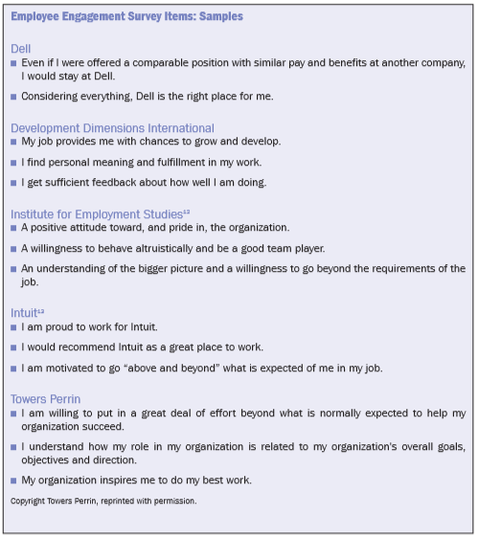
Fig 4
The surveys concluded (fig 1) that there are basic employee engagement specifics -
- Pride in their employer
- Satisfaction with employer support
- Work fulfilment
- Given the chance to perform well at work
- Appreciation and constructive feedback for one’s contributions
- Support provided from manager
- Outperform and beyond the minimum work
- Understanding the organisations core mission in line with your job
- Individuals recognise the prospect for future growth with the organisation
- Willingness to stay with organisation
However even though we have engagement specifics, there are still factors to be considered regarding employee engagement, (Open Learn, 2020) in order for positive engagement to take place, collaboration between managers and employees must be unified and respectful as without this employee’s will not respond positively towards management initiatives. But there is also a worry of over-engagement, this is when the employee becomes a workaholic. Presenteeism is when an employee tends to stay at work, more than necessary to complete the work, causing fatigue and psychological issues.

- Development Vehicles in the Workplace: Organisational example

  - Profile of Business
Capita
Website - https://www.capita.com/
Linked in - https://www.linkedin.com/company/capita/
Twitter - https://twitter.com/CapitaPlc
Capita is a global outsourcing company, founded in 1984, employing over 61,000 people. Specialising in Software, People Solutions, Customer Management, Government Services, Technology Solutions and provide Specialist services. HR management is fundamental in running its organisation.
Capita uses the Cultural Organisation based on their Values (fig 5).

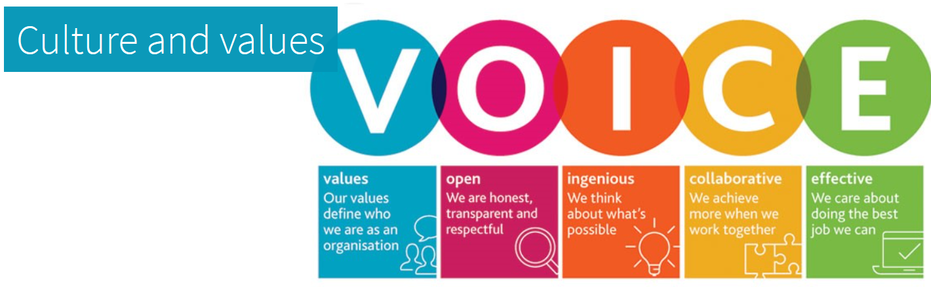
Fig 5
They are an outsourcing company, with a huge client base across the world. It is imperative that their Culture and Values is predominant within their workforce. Training and development needs are required to optimise the employee’s worth to the company.
Capita’s main cliental is administratition and IT, (Independent, 2018) the main 2 high profile administrative contracts that they look after is BBC and NHS. Over the last 2 years they have managed to secure 226 public contracts, making them the cornerstone of public sector dependency. According the stock market chief executive “Jonathan Lewis” Capita has issues by underinvesting and capitalising in too many markets. In the drive to grow quickly they have declined in new sales. Even though Capita have a debt of £1.15bn, their cash position is better than the £390m that competition Carillion are at.
On the face of the matter it appears that Capita has too many fingers in too many pies. And have stretched themselves too thin, the threat of losing contracts is real. If this does happen Michael Donnelly (stockbroker Panmure Gordon) suggests that £469m public sector contracts will be up for retendering, which is detrimental, as finding other outsourcing companies who are able to compete with the complexity and volume will be hard.
Capita need to readjust their organisation HR tactics in accommodating their current clients, by finding out the areas of their short comings. There are many HR Organisation structures, but because they are a huge global company, the most in line with their company would be the Divisional Structure (fig 6)
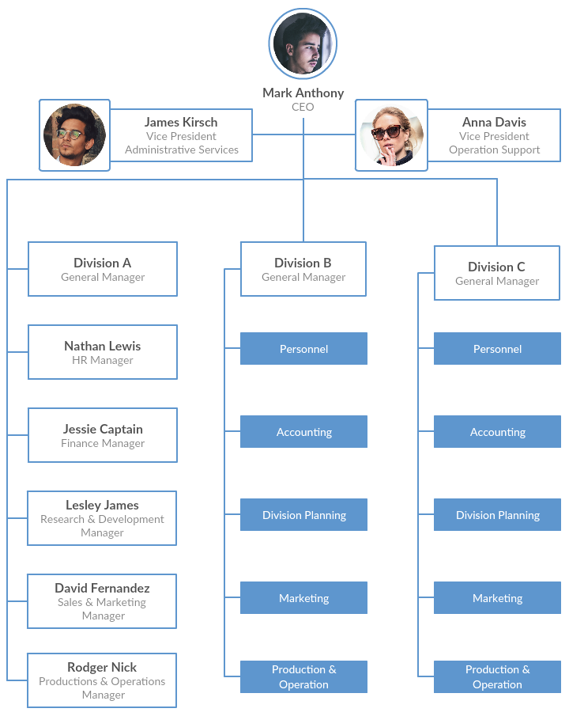fig 6
This structure divides each section into products/ geographies (Creately, 2019). Each section is provided with the functions and resources required to perform. There is also another divisional structure called the “M-form”, this is when a parent company has several subsidiary companies, with different brand names etc. This advantage of this structure is that if one company fails it will not have knock on effect to the other company, but also as it isn’t as integrated, there will be operational inconsistences, to overcome this in-depth regular collaboration must take place.
As Capita is a company with a vast clientele globally, they cannot work with a HR system, which is static. Different geographical areas must manage within their stand-alone HR system in each country and report back to Headquarters regularly, transparency and open culture is a must to develop positively.

  - Potential Benefits to the organisation
How Capita can use developmental vehicles through organizational HR (fig 7) -
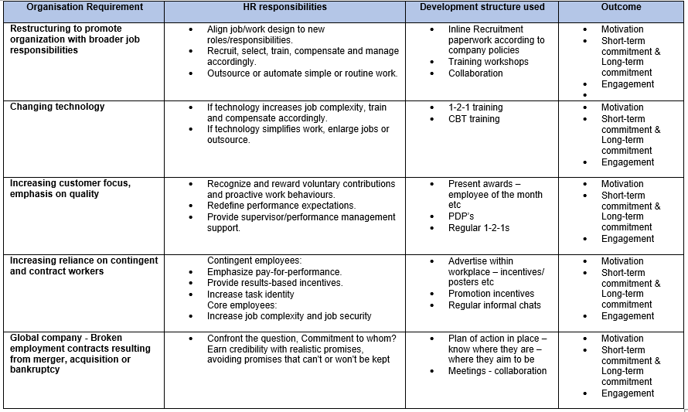
Fig 7
By providing developmental vehicles, Capita can reach success if implemented to their company goals and objectives. Each HR responsibilities must be structured in aligned to self-assessment vehicles i.e. New technology which makes jobs more complex, employees will require adequate training which should provide knowledge and practical assessment. Once an employee is fully trained and supported, they will be confident in completing their task.

  - Potential Benefits to the individual
There are many benefits to using develop tools, as an individual, by reflecting and understanding your core is the starting point of progressing. You can start with doing a online Personality test – evaluate you as a person, psychologically, one test available is the Myer Briggs Personality Test (onlinepersonalitytest, 2020), - https://www.onlinepersonalitytests.org/mbti/. This will provide an insight into yourself, example done based on myself (appendix 2).
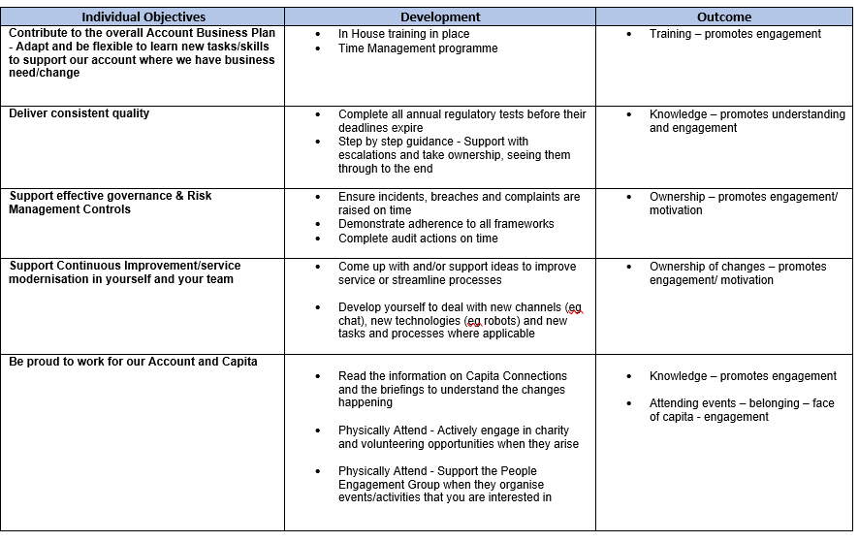
Fig 8

To provide employee engagement – Capita have structured this form to associate attitude to their Values – this in effect helps identify in how they reflect in occardance to Capita Values – a measuring board. 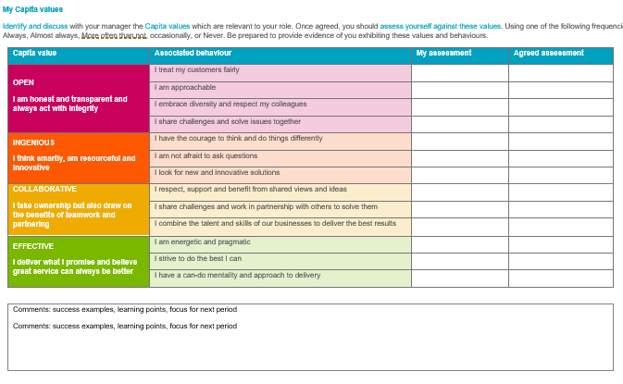
- Personal development plan

  - Profile of person – Helen Morgan
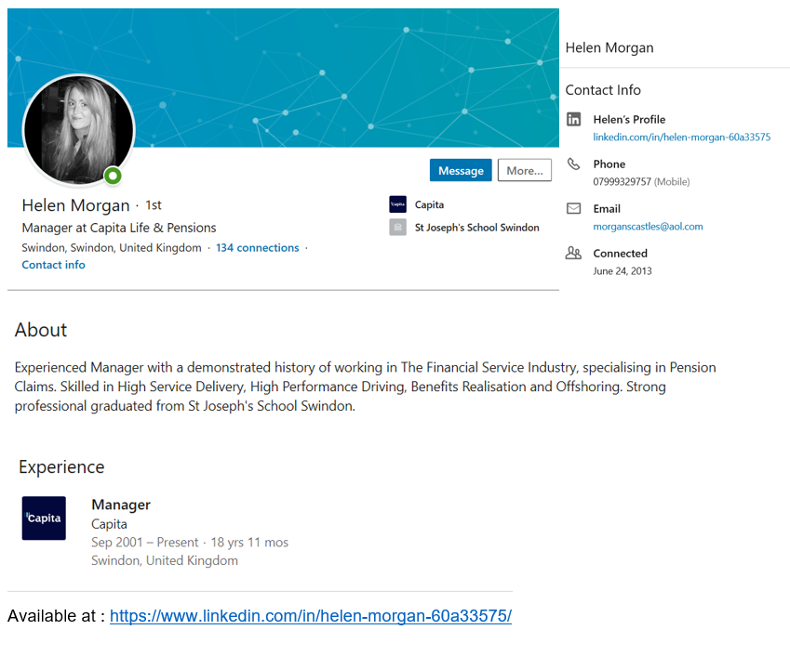Helen has been working at capita since September 2001. She started as an administrator and has progressed through out her career.
Managerial Style – Helen Morgan (Morgan, 2020) (Questionnaire – Appendix 3)
Helen has been in a managerial position for 9 years, and this is her first target driven role. This questionnaire has been devised to find out her management style. It concludes that as a manager she is fair but firm, she feels that this is required as you cannot always be overfriendly with employees as you may lose the professional element of your position, if you bond too closely. Maintaining a good workplace relationship is important for success.
- Monday morning team meeting, to provide information to the employees what the weeks agenda is in completing task – engagement
- Capita has incorporated team building – paid for lunches etc, and as an incentive they hold annual functions for the best team etc who are awarded with an engraved cup – this will provide motivation for being recognised.
- There is a quarterly formal 1-2-1 with team members, which helps with any underlying issues, where both management and employee have a chance to speak. If there are underlying issues with an employee, supportive documents have been completed to action these – Commitment to improve
- Provides weekly informal chats/ lunches with team members to ascertain wellbeing, praise etc.– engagement/ motivation
- Overtime is provided on a regular basis – monetary motivation
- Repetitive work – demotivating

Current role profile
- Team Leader for Pensions, managing a team of 25 administrators (new target driven role)
Basic outline of role (full profile appendix 4)

In the 1960’s a self-analysis tool called SWOT (Strength, Weaknesses, Opportunities, Threats) was devised by Credible Business Gurus (Pestleanalysis, 2015). This framework was originally designed for Businesses but has since been adapted to assess personal attributes. This framework can identify your strengths, help reduce your weaknesses, take advantages of opportunities available and help minimise potential threats by having a plan of action in place.

  - SWOT provided by Morgan, 2020 (Personal SWOT) -
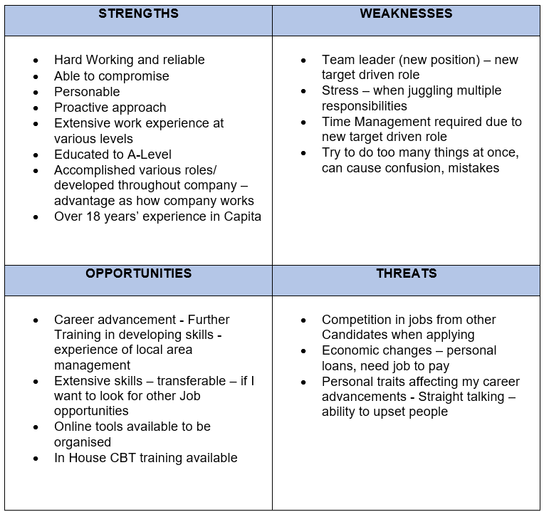

6.3 Personal Development plan
The ideology of the PDP (QAA, 2009) was recognised as part of a Report produced by Dearing and Garrick and developed in 2000, by the National Committee of Inquiry in Higher Education, as a tool to aid development of a person in a learned environment.
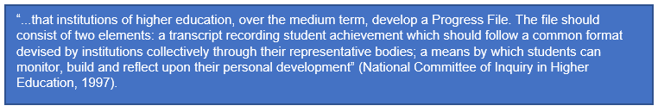
Personal Development plan is an important professional tool which helps an individual identify shortcoming and help action their growth. It is effective in reaching set individual goals. Empirical studies taken, have identified 9 areas which PDP’s primarily function towards (Beausaert, et al. 2011) -
- professional development; Where do you see yourself in 5 years’ time?
- reflective learning; ability to learn from past experiences
- providing evidence; promotes self-awareness
- documenting; certification, selection; Provides personal clarification
- promotion; helps validate why individuals should be promoted
- external mobility; You can apply for roles further afield
- coaching; Able to learn from peers – support
- stimulating confidence; challenging roles defined
- organizing; Where to go from here – step by step
PDP’s (Open University, 2020) is an important structured framework in which you can identify your current skills and where you are required to develop, how to action these, helps toward potential career development by supporting promotion opportunities, appraisals, external job applications.

As Helen is already an experienced manager, I have based this development plan on the Objectives that Helen has provided from Capita (Appendix 5)
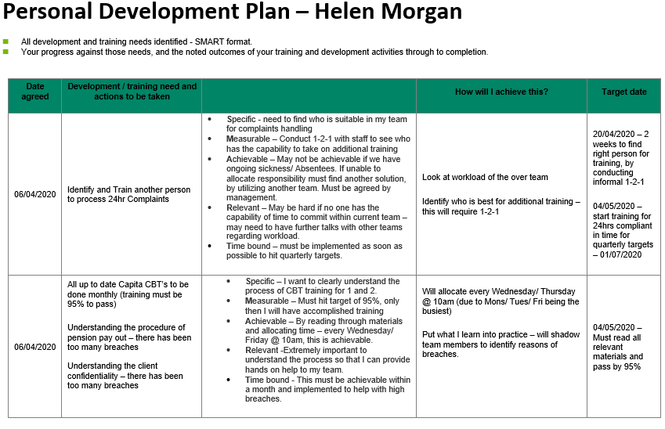
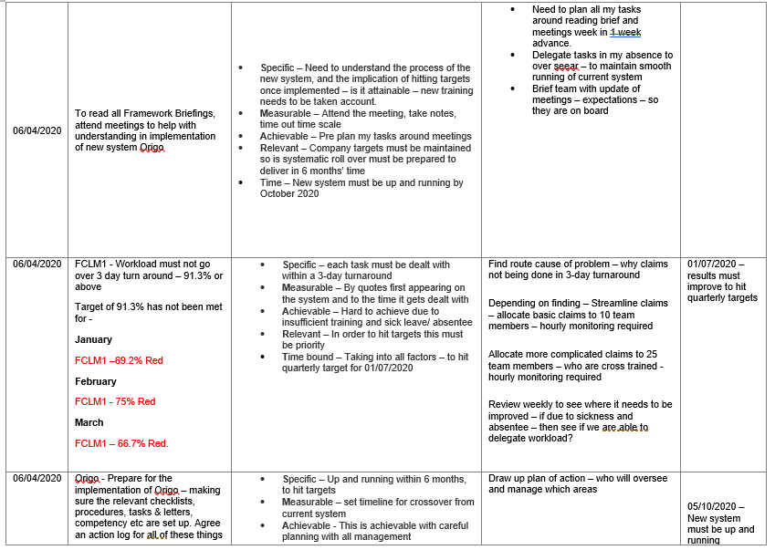
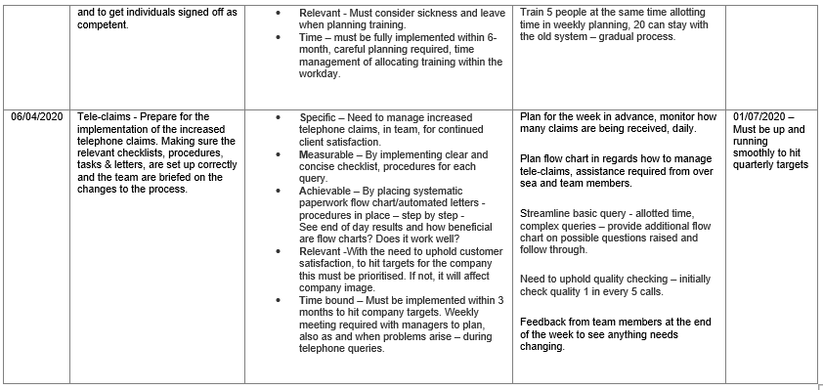
In addition to PDP’s, Capita have incorporated “My Contribution”, this provides the employee to provide additional contribution, going above and beyond to give a sense of belonging and engagement (Appendix 6).
- Additional work completed which goes over and above your objectives.
- Positive feedback received from others (customers, colleagues or clients).
- Your continuing professional development in your role.

- Conclusion
Organisational HR has evolved with the changing needs of the workplace environment, people require encouragement to learn and to be supported. As an employer it is important that we can relate psychologically to ones needs, once these needs are met then you can provide the tools/ training requirements of the individual. Development vehicles are key in successful company BUT must be implemented correctly.
Employee motivation, commitment and engagement, are fundamental in impacting an individual’s performance, these all interact with one another. Developmental vehicles increase efficiency, which helps the organisation to reach higher levels of productivity. These need to be incorporated in the individuals work routine consistently – regular appraisals, PDP’s.
Organisation to be successful, employee fulfilment is key. Collaboration is required across all stakeholders, the more you invest in your employee the better the outcome, providing you have tapped into their psychological need to want to progress, which would be helped with development vehicles.
The process starts with the HR recruitment process, by sifting candidates through their professional/ social achievements. After employment, training needs to be implemented. Systematic 1-2-1’s has to be conducted to find out employee’s strengths and weaknesses. The applying the correct development vehicles in a structed manner.
In is important that divisional management identify the specific employee developmental areas, by sharing knowledge, analysing employee trends, and actioning these shortfalls. By investing time and money you can promote growth and success.
According to Indeed,com (2020), (Appendix 7) based on 3,286 employees 2,335 are content in their positions at Capita. Another Capita review at Glasshouse (2020) employees rated Capita 3 out of 5, this is based on reviews collated by 2,999 employees. (Appendix 7), overall these reviews are positive but there are also reviews at Indeed.com (Appendix 8) which indicate an employee was happy with pay and work but left due to staff bullying etc, Also employee training not being met, being thrown in the deep end and to carry on regardless, these show that development vehicles have not been utilised correctly, or if they have then the individual clearly required additional training, so management have not shown support. But this is not a true reflect as there are over 61,000 employees worldwide.

It is common sense to say you cannot keep everyone happy (appendix 8), this shows that not all values have been upheld.
Organizational HR is a very complex and diverse, as there are many structures available, each organisation must choose which HR method is better suited to their company Aims and Goals. However once this has been implemented, you must construct your organizational structure – depending on the size of the company.
Bottom line – development vehicles are the backbone of employee fulfilment if used proactively, without investing in employees, Organisations will NOT be successful. Once you have recruited your staff, it is Organisational HR’s responsibility to help retain good employees.

- References

- Beausaert, S., Segers, M.R., van der Rijt, J. and Gijselaers, W.H., 2011. The use of personal development plans (PDPs) in the workplace: A literature review. In Building learning experiences in a changing world (pp. 235-265). Springer, Dordrecht.

- Chartered Management Institute (2015) 6 Companies that get employee engagement – and what they do right. Available at: https://www.managers.org.uk/insights/news/2015/december/six-companies-that-get-employee-engagement-and-what-they-do-right (Accessed: 15 July 2020)

- Creately (2019) Types of Organizational Charts (Organizational Structure Types) for Different Scenarios. Available at: https://creately.com/blog/diagrams/types-of-organizational-charts/ (Accessed: 19 July 2020).

- Glassdoor (2020) Capita. Available at: https://www.glassdoor.co.uk/Reviews/Capita-Reviews-E10883.htm (Accessed: 18 July 2020)

- Groth, L. (2020) Overview of theories on organisation and management. Available at: https://www.uio.no/studier/emner/matnat/ifi/INF5890/v13/material-to-download/lecture-presentations/Feb_6_organization-and-management-theories/overview-of-theories-on-organizations-and-management-inf5890-v2013.pdf (Accessed: 14 July 2020).

- Indeed (2020) Capita PLC Employee Reviews. Available at: https://www.indeed.co.uk/cmp/Capita-PLC/reviews?fcountry=ALL (Accessed: 18 July 2020)

- Independent (2018) Capita: What does the company actually do? And is it another Carillion in the making? Available at: https://www.independent.co.uk/news/business/analysis-and-features/capita-shares-profit-warning-carillion-private-firm-contractor-government-what-does-it-do-explainer-a8187451.html (Accessed: 19 July 2020).

- Morgan, H. (2020) Personal SWOT, Rume Meah, 7 July

- Morgan, H. (2020) Questionnaire, Rume Meah, 7 July

- Onlinepersonalitytest (2020) Free Myers Briggs (MBTI) Personality Test – No Email Required. Available at: https://www.onlinepersonalitytests.org/mbti/ (Accessed: 19 July 2020).

- Open Learn (2020) Employment relations and engagement: a collaborative approach. Available at: https://www.open.edu/openlearn/money-management/employment-relations-and-employee-engagement/content-section-1.3 (Accessed: 18 July 2020).

- Open University (2020) Develop your career/ Personal Development Plan. Available at: https://help.open.ac.uk/pdp (Accessed: 18 July 2020).

- PestleAnalysis (2015) Why SWOT Analysis is Essential in Personal Development. Available at: https://pestleanalysis.com/swot-analysis-in-personal-development/ (Accessed: 18 July 2020)

- QAA (2009) Personal development planning: guidance for institutional policy and practice in higher education. Available at: https://www.qaa.ac.uk/docs/qaas/enhancement-and-development/pdp-guidance-for-institutional-policy-and-practice.pdf?sfvrsn=4145f581_8 (Accessed: 18 July 2020).

- Sinha, E. (2020) Herzberg’s Motivation-Hygiene Theory: Factors and Critical Analysis. Available at: https://www.yourarticlelibrary.com/motivation/theories-motivation/herzbergs-motivation-hygiene-theory-factors-and-critical-analysis/63879 (Accessed: 16 July 2020).

- SHRM Foundation’s effective practice guidelines (2006). Available at https://www.shrm.org/hr-today/trends-and-forecasting/special-reports-and-expert-views/Documents/Employee-Engagement-Commitment.pdf (Accessed: 15 July 2020).

- Smithsonian, National Museum of Natural History (2019) Introduction to Human Evolution.Available at: https://humanorigins.si.edu/education/introduction-human-evolution (Accessed: 8th July 2020)

- Solinger, O, Van Olffen, W, Roe, R (2008) Beyond the Three-Component Model of Organizational Commitment 93(1), pp.70-83. DOI: 10.1037/0021-9010.93.1.70

- Steinbauer, Robert. "Workplace Ostracism, Self-regulation, and Job Performance: Moderating Role of Intrinsic Work Motivation." Journal of Social Psychology 158.6 (2018): 767-84. Web

- Tales from the Board (2014) Herzberg Two factor Theory: Jumping from the Jellybeans [video]. Available at: https://www.youtube.com/watch?v=i6gD9ZKiElk&feature=emb_rel_pause (Accessed: 9 July 2020).

- Appendix

Appendix 1
Herzberg Two Factor Theory – “Jumping for the Jelly bean “
A short explanation of Hygiene and motivators by Prof, Fredrick Herzberg (BBC 1973)
Transcript Interview with Herzberg -
There are 2 sets of needs people have one set of needs are people which I call hygiene needs and these hygiene needs deal with man’s relationship to the environment they consist of how you treat people do you pay them well, good working conditions, human relations, status everything that surrounds what you do in a job, now these are what I call hygiene factors because they prevent people from hurting, or dissatisfaction and then environmental, and these hygiene needs keep people from being unhappy – that’s their function they don’t motivate people.
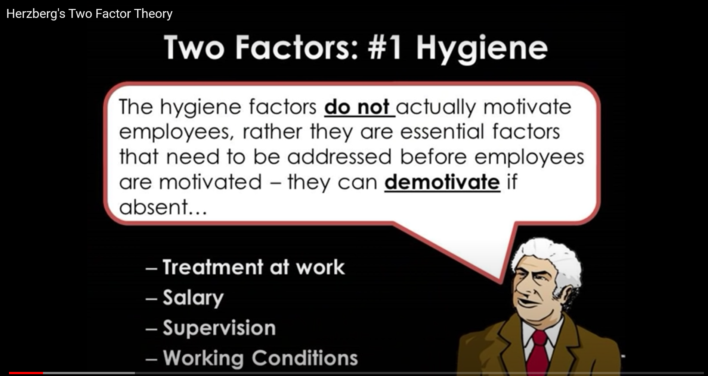
Now another set of needs that people have is that they are human beings and they say not only do I hurt and I don’t want to hurt so keep me well hygiene but they say that human beings I want to do something I just don’t want to avoid pain all my life I want to show what I can do, I want to in a sense psychologically grow I want to end my life by saying not that I vegetated but I am more than I was before and that can only by measured in what you done AND these are what I call the motivators and These are not how I am treated at work but what do you let me do at work do I achieve do I give responsibilities am I advancing and growing is what I do meaningful and significant these are the variables that motivate people, because people who want to do something want to do it – that’s motivation, people can be almost made to do anything if you threaten them enough or bribe them enough that’s Hygiene.

Transcript: Lecture with Herzberg –
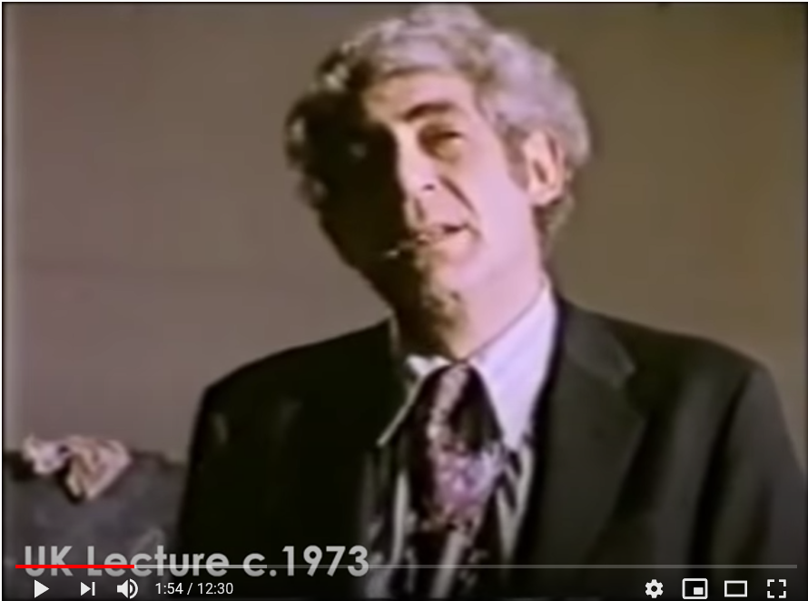
If I offer £10,000 as a bonus will you do something for me? I’m just trying to find out your price sure you’ll do something for me I can threaten or bribe you if you are hungry and I offer you food you will do something for me – do you wanna do something for me the answers no well but if you are hungry enough will you the answer is yes in other words I can get you to move and this is what I call KITA.
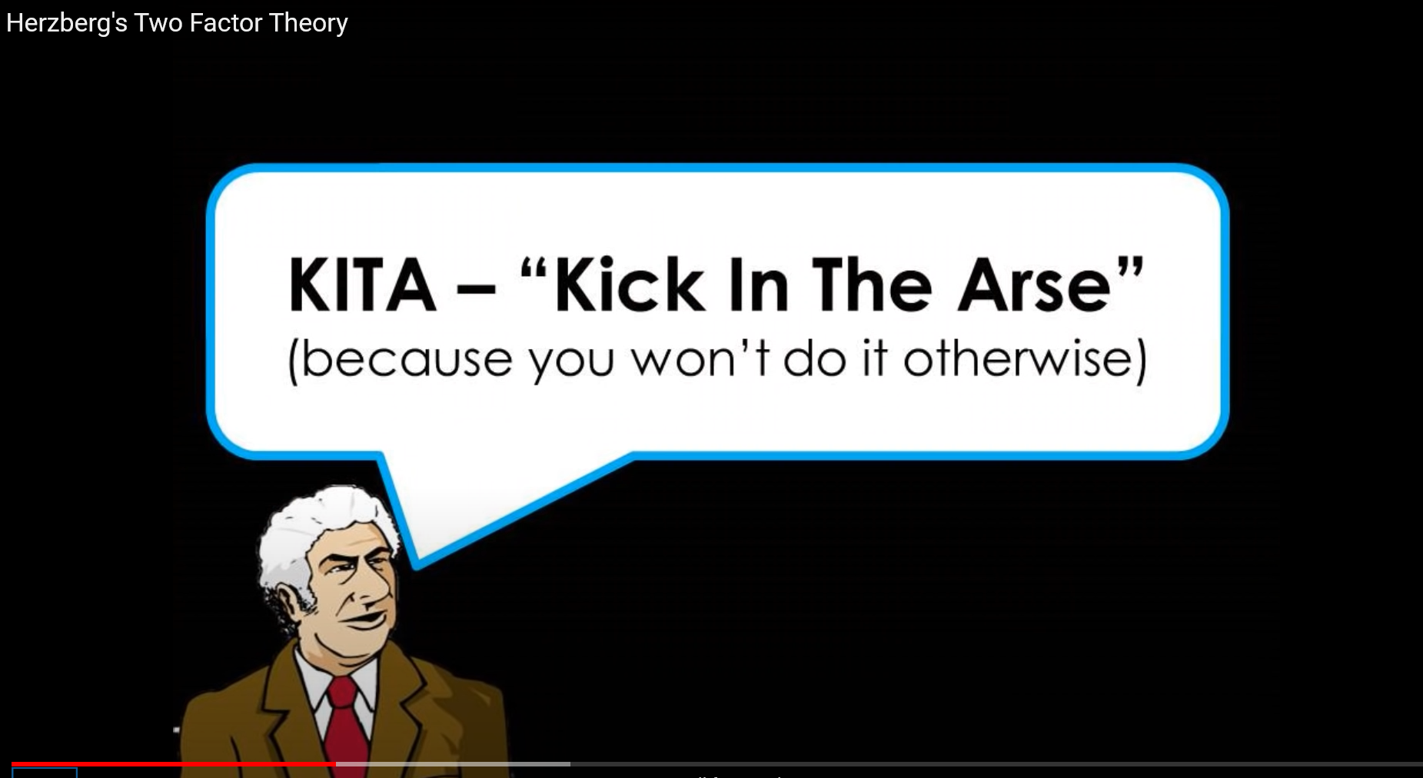
That the simplest way and easier way to get anyone to do anything is to kick them in the arse you can do it either positively or negatively, negative KITA is threaten them positive KITA is offering them a reward one is a carrot one is a stick. If I kick you in the arse you will move and I if want them to move again what must I do you gotta keep dig in right, in other words I can charge a mans a battery but unless he has his own generator he’s not motivated. Does he want to do a good job because he wants to do a good job that’s motivation, does he want to do a good job because he gets a bonus wants a house and jaguar that’s movement. So what do you get by treating people well, you can get some movement that’s not motivation, That is achievement recognition for achievement meaningful interesting work, increase responsibility and go for an advancement at work in other words the quality of the human experience at work (Appendix 1 cont)
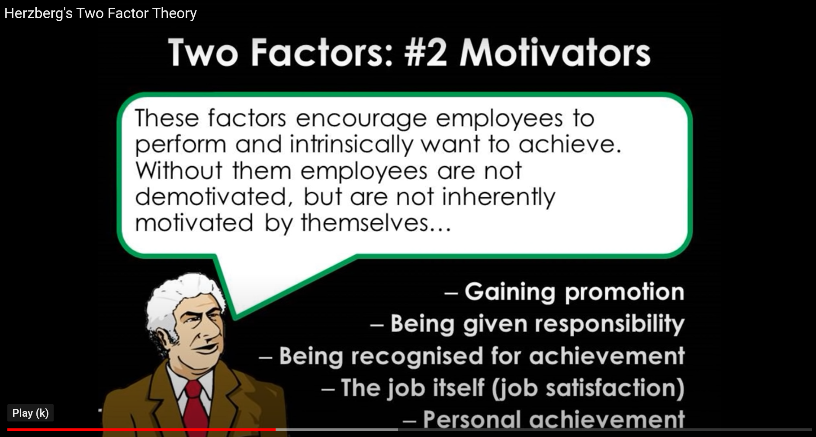
What will determine my motivation the play the piano? (Appendix 1 cont)
Well what of the most obvious at determine of my motivation to play the piano, is can I play the piano? You can’t motivate me to play the piano if can’t play the piano, you can’t motivate me to fly an aeroplane if I can’t fly an aeroplane, so one of the most basic variable that we forget with all the psychologising in about people attitude and so on is can they do it? Ability, you can’t motivate anybody to do a good job who can’t do a good job, so one of the most powerful motivators that you have in your personal auditorium is your training the more a person can do the more you motivate them. If you want to motivate me to play the piano I have to know how to play the piano, now that I can play the piano, what will motivate me to play the piano, well do I have a piano to play? That very simple and that is opportunity, motivation is a function of ability and a function of the opportunity to use to use that ability , the biggest problem that we have in industry is the opportunity to use ones ability, what we substituted for opportunity is cultural noises, of responsibility, that’s a very responsible job, I want you to be responsible to be an idiot, I need responsible idiots and this is where job enrichment comes in, the job enrichment movement is to give people the opportunity to use their ability all jobs that people have, should have a number of responsivities and activities sort of a concentric circles in which you are hired for this job - the largest job, though you come in with the ability to only do this, you are hired to do that and expected to eventually to do that and you are paid for that, what this does is put in one of the most important ingredients in life in activity – all jobs should be a learning experience, a growth experience inherent in the job, within this module of work within this concentric circle job you have to make sure a number of things occur first of all that the individual gets direct feedback, this is very important how am I doing should be built into the system automatically, how am I doing should not be a formalised outside my job system, that is a supervisor telling me, how am I doing should not be dependent on a appraisal system, how am I doing should not be dependent upon somebody else telling along with the direct feedback should be the responsibility for self-checking man should always be responsible for his own quality you cannot pass that buck off to an inspection team, but you cannot hold anyone for being an idiot, so if you are going to hold them responsible for checking his results he has to have a meaningful thing to do to check, if he is doing idiot work then you cannot hold them responsible for checking it. Now as an industry we communicate too damn much, the worst thing to do, and most of the communication we do of course is passive communication, the idea is if you tell the worker what it’s all about he will be more motivated, so you tell him why he has to be an idiot, and we get too much communication - one because we feel we that have to tell everyone everything and he doesn’t give a damn if he’s done an idiot job he doesn’t give a damn. Another reason is for too much communication in a company , is because we don’t allow the person doing one job communicating with the person that he has to communicate with, we have to go through to a supervisor over to his supervisor down to communication, so one important ingredient in job enrichment is direct communication let the man talk directly to the person he has to not go through mediators, the worst way to pay people is peace rate that is absolutely the worst way to pay people, that is paying people constantly with jelly bean reinforcing each little bit behaviour, the next worst pay to pay people is on a hourly rate , the best way to pay them is a salary a yearly salary period. Now let me make a point here, hygiene is as important as the motivators for different reason that the reason, one is not important than the other, lets not put a value judgement, I don’t know which is kpre important, write a book or eat, its like asking do you want to kill your wife or daughter, it’s a none competitive question. Quite frankly ladies and gentleman I wallow in hygiene, I love hygiene, there’s an article by a Columbian university professor the wage and salary administration, and the gist of his argument was watch out for Herzberg he does not believe in money, now a lot of companies picked this out, wonderful you don’t believe in money, I had to run around all these companies, this is not true, its misinterpretation of my theory, “no no no fred you don’t believe in money, great great”. So, in sheer desperation I had to raise my fees. Can I make the point when I say hygiene it is not a second class citizen concept, treating people well and using them well is equally important for different reasons.
(Appendix 1 cont)

Appendix 2
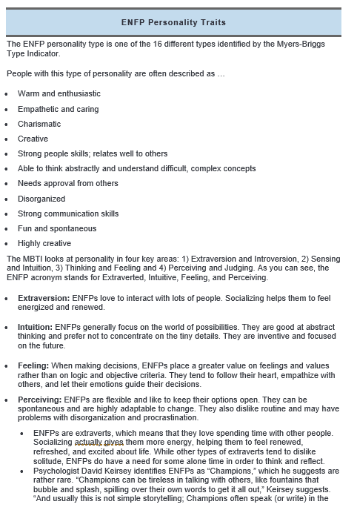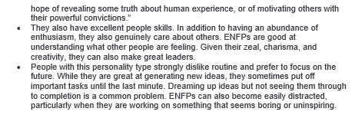

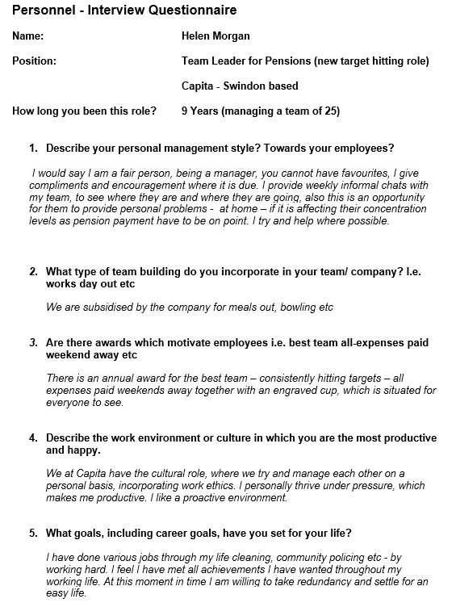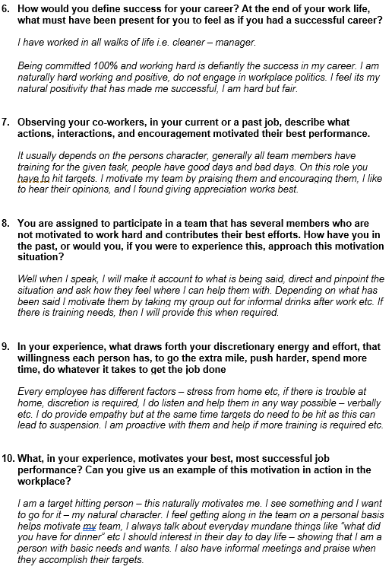
Appendix 3
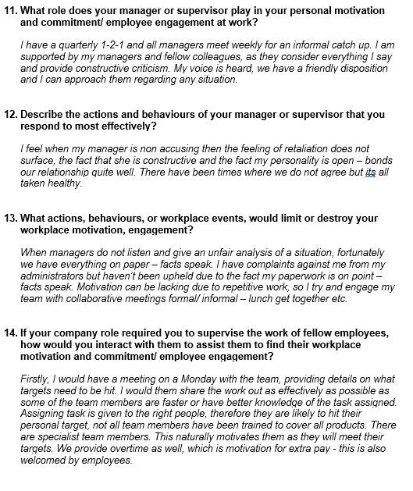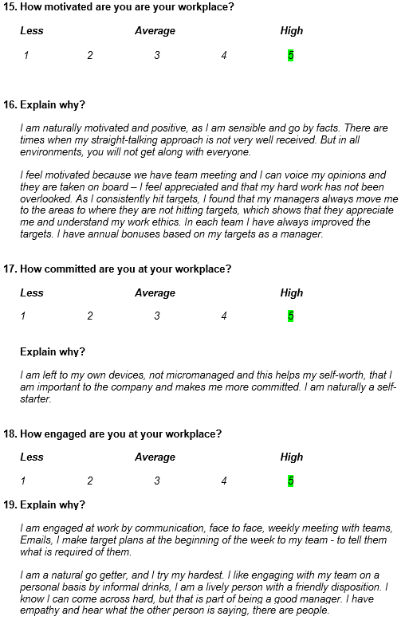
Appendix 3 Cont
Appendix 4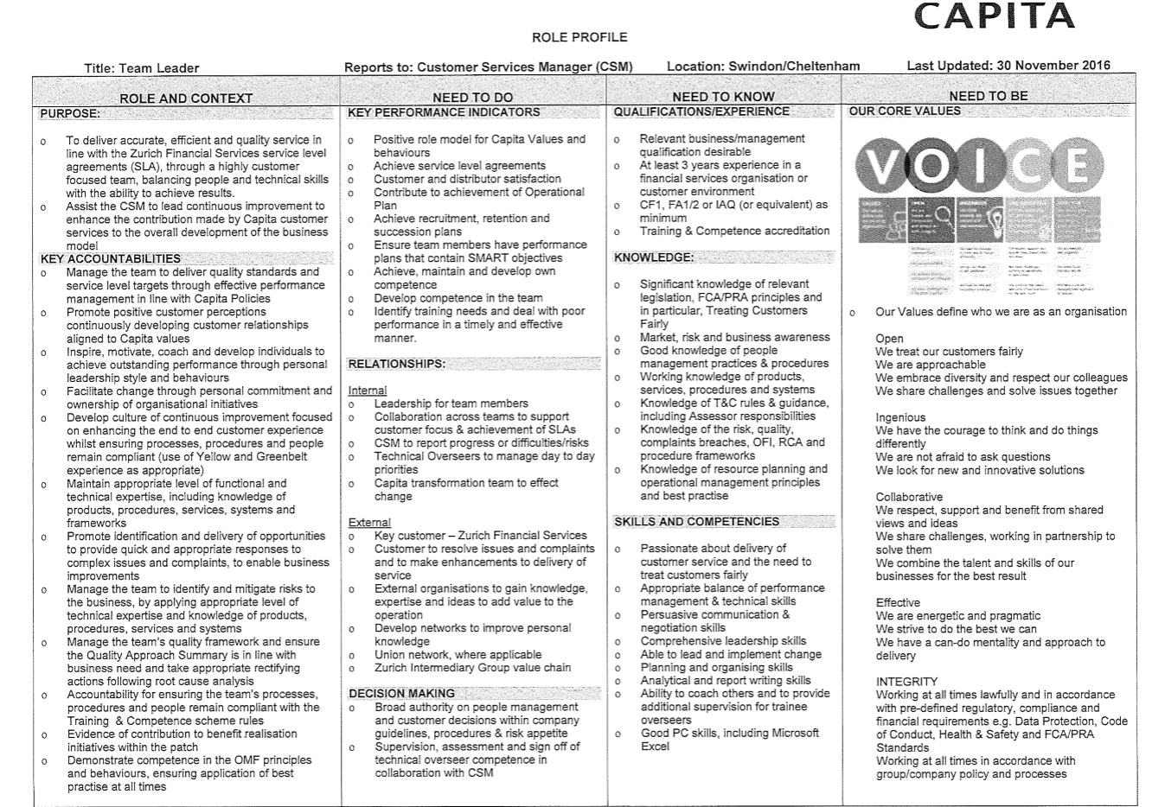
Appendix 4 cont
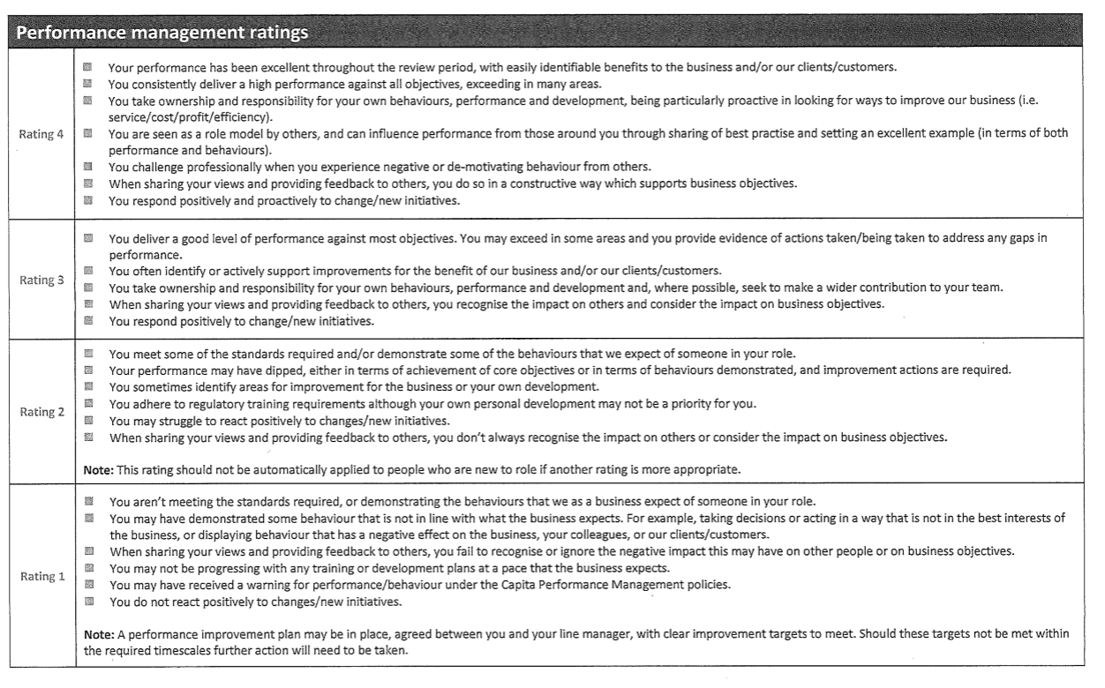

Appendix 5





My Details |  | Reviewer Details
Name: | Helen Morgan | Name: | Elizabeth Hewlett
Role: | Team Leader | Role: | CSM
Employee number:
Business unit: | Life & Pensions - Claims

Review information
Agreed frequency of reviews | Quarterly | Period covered by this review | Jan – March 2020
Date this review took place | 26/04/2020 | Date content formally agreed

Appendix 5 cont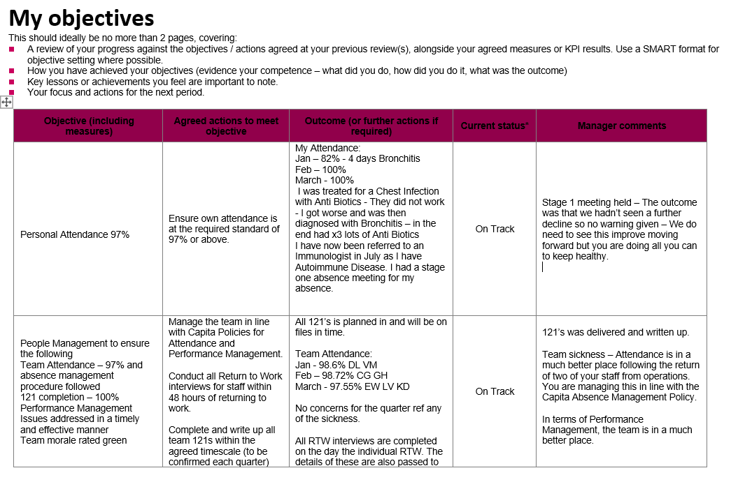
Appendix 5 cont
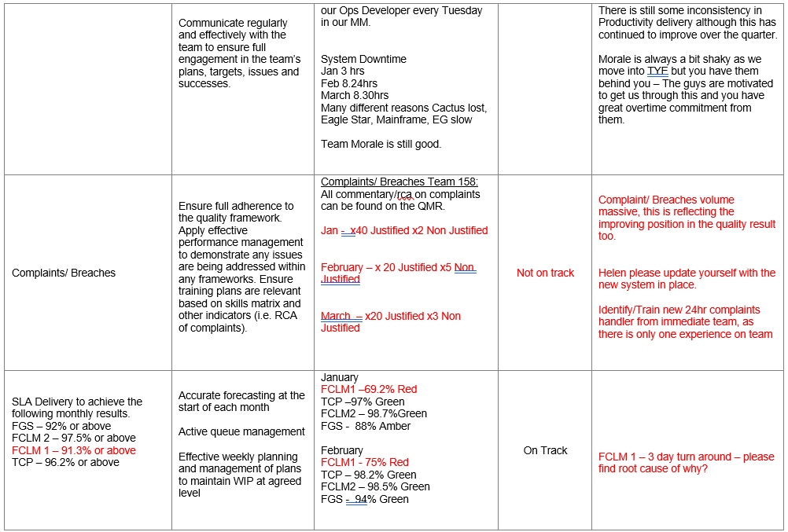
Appendix 5 cont
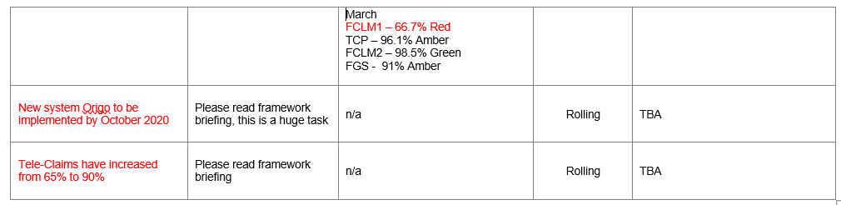
Appendix 6
My contribution
This should ideally be no more than 2 pages, covering:
- Additional work completed which goes over and above your objectives.
- Positive feedback received from others (customers, colleagues or clients).
- Your continuing professional development in your role.

What did you do, and why? | What skills/experience/behaviours did you use or learn? | Outcome  (including feedback where relevant) | Manager’s comments
Jan 2019 - Attended “We Create Better Outcomes Roadshow” with MR | I have now understood Capita’s vision and how they want to create better outcomes for everyone. | Received an overview of what we achieved in 2018 and what we aim to achieve for 2019. | Glad you found this useful
Jan 2019 – Attended A Town Hall meeting with TN from Zurich | This was good to understand TN’s vision - how she is committed to working alongside us. | It was nice to hear TN explain how passionate she is in working with us to improve our services to our clients. It was also nice to hear how complimentary she was about the good work we do. | Great
Jan – March 2019 – Attended TYE Planning Meetings | I was able to bring my knowledge and experience of running this for the last 5yrs to the meetings. | Good outcomes at each meeting. Full understanding of cut off dates times etc to allow us to deliver the best service possible to our clients without causing any breaches in the cross over period between Tax Years | Really good planning here and we understood early the system constraints and what you needed to get through – Hopefully we are all set for success. Just one area to improve on next year which is challenging us being able to auth on PPD system to support the higher volume. We will book a meeting in Q3 once all has settled to see what options we can pursue here.
Feb 2019 – Attended a session with BH & GB ref using VoiceSage | Again I was able to bring my knowledge of our processes to the table. | Good discussion and looks like we are good to go with this as soon as Zurich Signs of the wording we will Pilot it in my team. | Great
Feb 2019 – Attended a year ahead meeting with MR | I learnt MR plans for the building, furniture, how we can improve survey results. | MR discussed the year ahead plans with us and what JL vision of Capita going forward is. | We all know the priorities for the year.
March 2019 – Attended a Service Modernisation Meeting | This was interesting - I have learnt that this will commence at a very fast pace. | JB from another account gave us an insight into what they did on that account and how they did it and covered off what the plans were for us this year ref Service Modernisation. | This is going to be fast paced and reactive. It will give us great benefits though so worthwhile.
March 2019 – Delivered The Year Ahead Meeting to my team with my CSM BH. | Prepped for the meeting gathering information such as below  - Key achievements for 2108  - Team weaknesses  - What frustrates us  - What can we do to improve our service?  - What will our Team Pledge be | I thought it was a really good meeting. The team engaged well, and the feedback received from them was all really positive. They seemed keen to give JL a chance to change things for the better. | I really enjoyed this meeting and spending quality time with your staff.
March 2019 – Attended a Support/Coach session with LG | I didn’t learn anything – this was more of LG asking me questions. These are supposed to be ongoing monthly. | Open discussion with LG - She asked me about several questions about how, on give worked here what I have done /do. What do I think about Capita etc etc | This is a support for TL’s we have not had before so hopefully you will find this useful as we move forward.
To come up with a team pledge | Life Is Short  Let’s make the most of the time we are in the office  Take time to think about your peers and the good work they do.  A Thank You, Smile, A Well Done, Be Grateful.  Put Things into Perspective  Up-Skill the team so ANY pressures are shared | This can be monitored through feedback, our local heroes’ nominations. Up skilling individuals is also discussed in every weekly loading and variance meetings as individuals are signed of as competent.  ] will look at getting a vision board in the team so the team can see who and when individuals are signed off on new tasks. | So I am thinking that an increase in the results is the success here.  We can also discuss how it is going when we have another meeting at the half year.

Appendix 7 (Indeed/ Glasshouse)
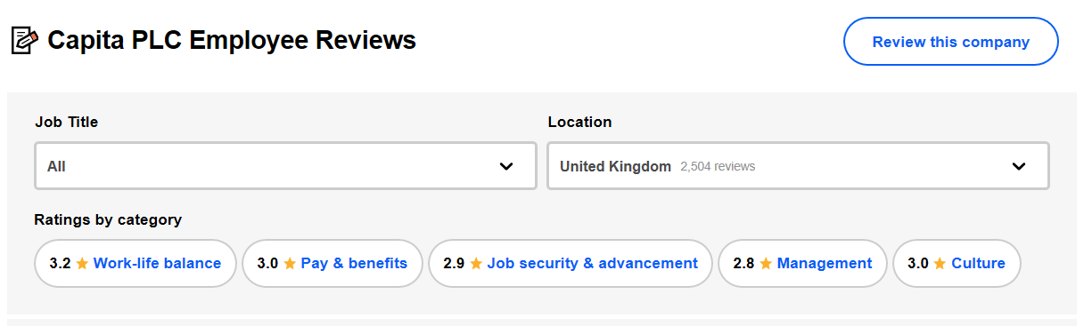
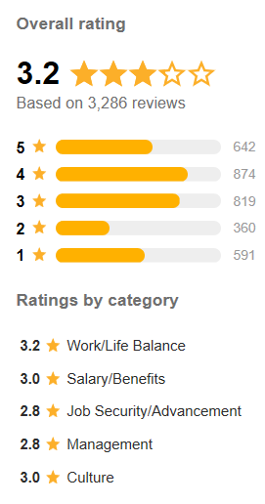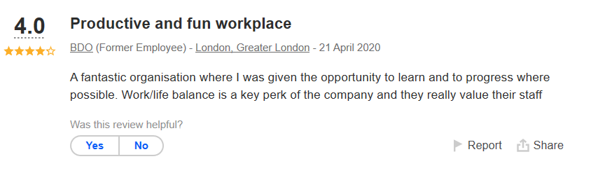
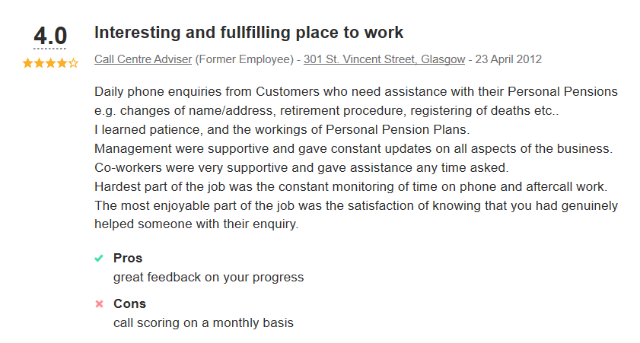
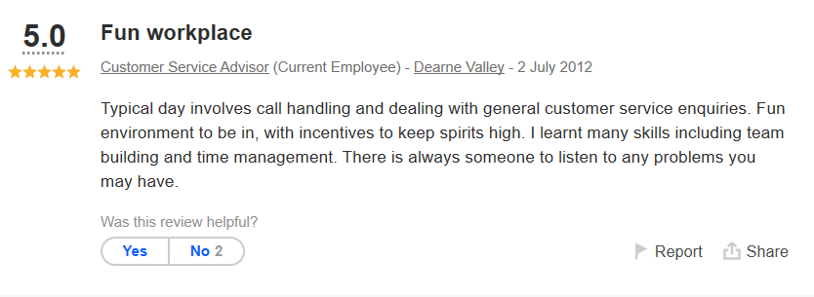

Cont – Appendix 7 - Glasshouse
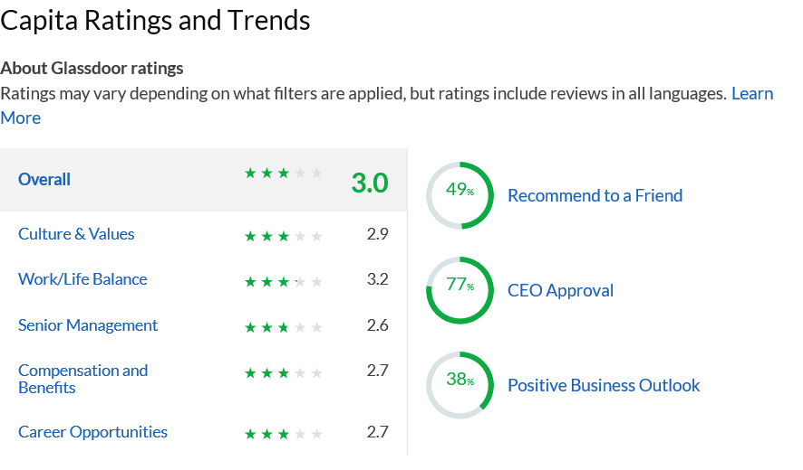
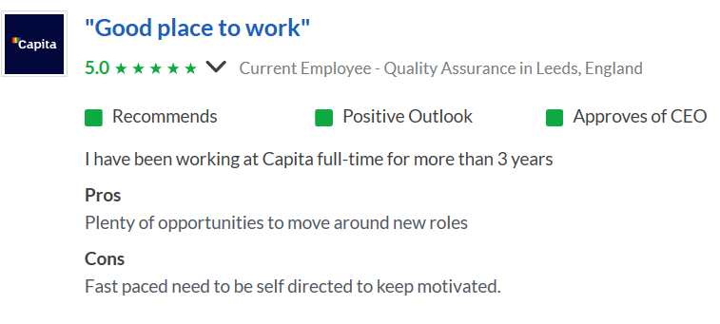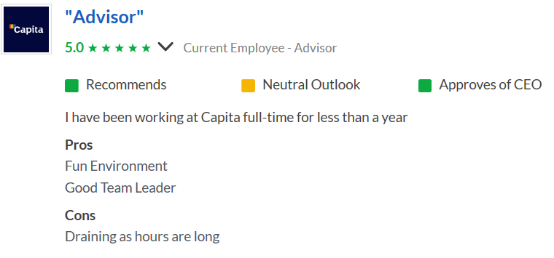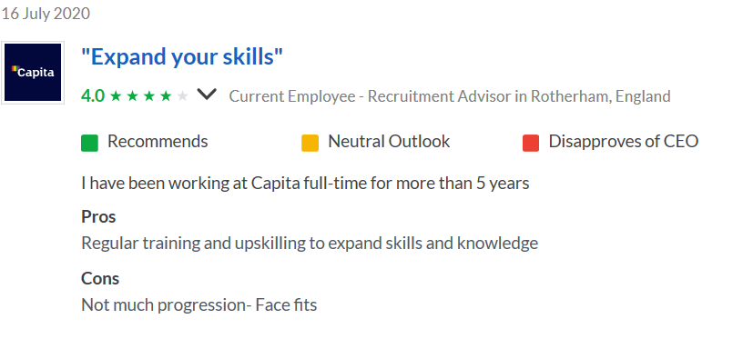
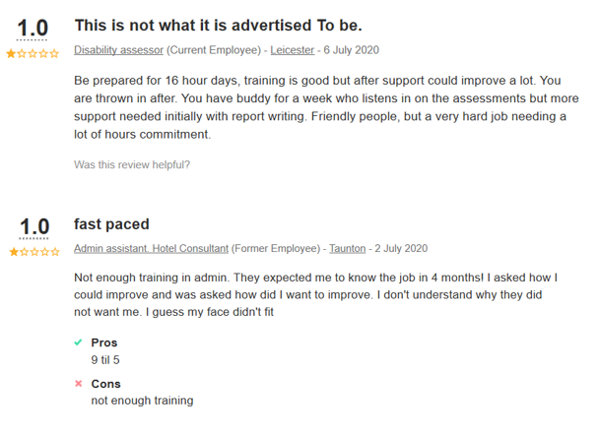
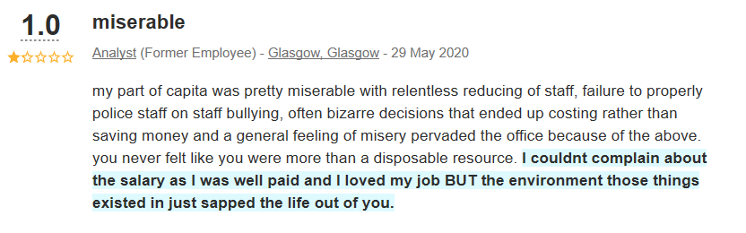
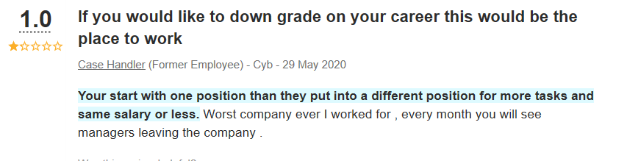
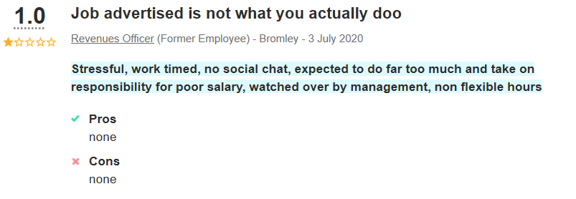

Appendix 8

