Toxic Masculinity and
the Fear of Femininity.

Name: Christian Thomas Jenkins
Course: BA(Hons) Fine Art: Studio, Site and Context
Student Number: P127251
Word Count: 5655
Dissertation Supervisor: Tim Davies
Toxic Masculinity and the Fear of Femininity

What is masculinity? By definition, masculinity refers to the elements or qualities usually associated with men. As an empathetic heterosexual male, all throughout my life I have had manly ideals pushed upon me. During my childhood as an excessively sensitive child, I felt extremely subjected by these ideals “Boys don’t cry”, “man up”, “are you a man or a mouse?”. My eldest brother (being 7 years older than me) has always been a role model for me, although he came out as homosexual when I was about 8, his sexuality did not affect the way I regarded him as a man. He also practiced as a professional Drag Queen for a few years, under the pseudonym Ivanna Man (a play on words for “I want a man”). I believe that this factor allowed me to be more in touch with my feminine side, as my brother embraced his. Generally, I have always had an inclination to play with toys that may be classed under the feminine gender role, a preference to stuffed animals to action men. Due to my connection with the effeminate, I developed an air of superiority. My beliefs were that I had an insight into femininity, therefore I have no issues with my own masculinity. Whilst travelling back to the United Kingdom from the Venice Biennale, I was reading Grayson Perry’s book - “The Descent of Man”. In his book, Perry speaks of a “corny” saying amongst therapy circles, “if you spot it, you’ve got it”, which essentially indicates that if you are able to identify demeanors, it is more than likely because you behave in the same way. This triggered an epiphany, I started to question the established comfortable identity that I have constructed. Am I noticing toxic masculinity in others because my masculinity is actually toxic? If I was able to meet myself, would I be intimidated by my own masculinity? I have always thought I understood myself, I knew who I was, but this epiphany upset my equilibrium. How can I possess the authority to assess the masculinity of others when I cannot comprehend my own masculinity? It became clear to me, that if I wish to follow the endeavour of self discovery and understanding, then an involvement of my physical being in my practice is essential. Performance art seems to be the adequate direction, by using my body as “sculpture” and potentially displaying a notion of androgyny to envision the implications carried by the construct of masculinity or femininity. I feel as though I must figuratively forget everything I thought I understood about masculinity, and I must reassess the construct in order to inaugurate a coherence.
It becomes apparent very quickly, by reviewing history, that the qualities of masculinity that traditionally defined manliness has not always confirmed the modern ideas of what a man is. Historical writing, written by heterosexual males, often bewilders the population due to the literature detailing the intimate love for other men. The bewilderness is amplified by the tuition that in a socio-historical context, the writers were not seen to be homosexual or epicene. Antithetically, male to male intimacies were more likely to assert and reinforce their masculinity. Powdered wigs, pale makeup with rouge blusher, red lipstick and dark eyebrows were traditionally fashionable elements among wealthy Englishmen in the eighteenth century. Customarily use of makeup and wigs were displayed as masculinities, even the use of artificial beauty spots. “In order to reach a pale complexion they whitened their faces with lead powder, then they applied “rouge” in circular or triangular shapes on their cheeks and even on their lips.”

Ironically, the campaign for beauty often contributed towards death due to the use of lead or mercury in the makeup. The use of makeup and wigs in the eighteenth century was not connected to gender differentiation until the mid 18th century. There was a metrosexual fashion movement among young aristocrats (and those who wished to be aristocrats) in which young men would dress in an effeminate manner. During The Grand Tour, which was a rite of passage trip around Europe taken by mainly the upper class, the elation of Italian pasta caused the derivation of the word “Macaroni” being used to describe anything contemporarily fashionable. Thus, this trend was dubbed Macaroni. Imitating clothing styles that were traditionally deemed feminine was a fashionable trend amidst the rich, constructing a style that “shared the delicate sensibility of women’s fashion of the period”. Melodramatic elements with simplistic incarnations of male dress combined with Macaroni style - “huge club wigs, tiny Nivernois hats, short waistcoats, high red heels, parasols, inside breast pockets, striped stockings and shoes with the buckles within an inch of the toe” - were ridiculed. In The Oxford Magazine, published in 1770, the Macaroni was characterised:

“There is indeed a kind of animal, neither male or female, a thing of the neuter gender, lately started among us. It is called the Macaroni. It talks without meaning, it smiles without pleasantry, it eats without appetite, it rides without exercise, it wenches without passion.”

Eventually, the Macaroni spread into the middle classes. No longer just reserved for the aristocrats, this transitory craze seemingly posed a threat to masculinity. The construct of masculinity was therefore reconsidered, rejecting the ideals of the Macaroni. Regularly referred to as “monkeys”, “women” or “hermaphrodites”, outlining the obvious fear of gender indifference. By the end of the eighteenth century, abstract or extravagant fashion had become “socially unacceptable”. In response to the effeminate Macaroni, the middle class man created a style that was aesthetically sober but still embodied the passionate belief of metrosexuality. This encouraged the rise of a very important figure in the history of masculinity, a fashion development called the Dandy. Antipathy for the upper class exaggerated dress and articulation of their ideals of masculinity fueled the middle class man in this trend. Although they did not share the same class or privilege, the elegance of the dandy’s dress seemed to outweigh that of the higher classes. The arguably most famous dandy was George Bryan “Beau” Brummell. Being educated at Oxford University and with a friendship to the future king, Brummell was able to deviate the direction of male dress. Flamboyant wear was combated by the resistance of Brummell and his refinement of simplistic style, instead of wearing vividly coloured clothing he opted for clothing made from wool or cotton, neutral coloured trousers, jackets and white shirts. Wearing no makeup or wig, a cravat tied in a large bow shape around Brunell’s neck was the only ornamented piece of clothing he would wear (see figure 1). Although the trend of Dandyism was aesthetically underwhelming, the narcissism that followed was overwhelming. “Brumell took up to five hours to dress every day, though his goal was to make it appear as though he had not.” Dandyism has been described as the “aesthetic form of nihilism”.

“The dandy creates his own unity by aesthetic means. But it is an aesthetic of negation. "To live and die before a mirror": that according to Baudelaire, was the dandy's slogan. It is indeed a coherent slogan. The dandy is, by occupation, always in opposition. He can only exist by defiance. Up to now, man derived his coherence from the Creator. But from the moment that he consecrates his rupture from Him, he finds himself delivered over to the fleeting moment, to the passing days, and to wasted sensibility. Therefore he must take himself in hand. The dandy rallies his forces and creates a unity for himself by the very violence of his refusal. Profligate, like all people without a rule of life, he is only coherent as an actor. But an actor implies a public; the dandy can only play a part by setting himself up in opposition. He can only be sure of his own existence by finding it in the expression of others' faces. Other people are his mirror. A mirror that quickly becomes clouded, it's true, since human capacity for attention is limited. It must be ceaselessly stimulated, spurred on by provocation. The dandy, therefore, is always compelled to astonish. Singularity is his vocation, excess his way to perfection. Perpetually incomplete, always on the fringe of things, he compels others to create him, while denying their values. He plays at life because he is unable to live it.”

In modern times this incarnation of masculinity may seem bizarre, the notion of turning the male body into a work of art. But, for the people of this era, the dandy was a “figure of what a man could or possibly should be”. One could argue that the construct of traditional masculinity has only changed aesthetically since the second half of the eighteenth century, the “manly virtues” such as willpower, honor and courage still remain as projections of traditional masculinity. Despite the increase of momentum of change towards the end of the twentieth century, these “attributes of manliness” have not undergone a climactic revolution. Under the collective jurisdiction of the Evangelical faith and subjective romance, early Victorian ideals of manliness construct an individual identity that renounces self consciousness as a mark of theatricality. Religious virtue and social autonomy, both rudimental to manhood, are betrayed by the notion of theatricalities being applied to previous connotations of aristocratic manhood by dismissing the manifestation of a socially constructed identity. Social acceptance and narcissism that is ostensibly excelled by manhood must “nonetheless be proved in the theater of the world”. The logic of the dandy suggests a reliance on acknowledgement, although this acknowledgement is proclaimed unnecessary or unworthy by the dandy. Unavoidably, the intransigent aspect of theatricality in masculine self fashioning makes an overture to a physical or imagined audience. Developments of masculine identity, the relation of social and literary dialectics, are accentuated by the requirement of recognition. By regarding masculinity as a rhetorical transaction - the notion that the meaning does not solely reside in the participant or the perceiver, but the meaning is manifested by synergy of both - the construction of gender is informed by human interaction and shaped by reasoning, rather than intuition.
A significant symbol of masculinity derived from the evolution of masculinity, the three piece suit and tie. The suit was described to accentuate the sexuality of the man by widening the shoulders and narrowing the hips. The tie, in Freudian terms, aesthetically links the Adam’s apple directly to the genitalia. In the 2017 Venice Bienalle an Israeli born artist called Michal Cole occupied the Pavillion of Humanity. Cole collected 27,000 ties and created a room that resonates the traditional gentlemen’s room (see figure 2) illustrating a “silent embroidered scream” against worldwide patriarchy. A mounted stag head and rifle are a few of the symbolistic masculine items entirely covered in ties. For Cole, being born in Israel, the ties are an analogy for the oppression of women - from the pay wage gap in worldwide offices to politically appointed men. The initial idea was conceived when Cole met a groups of bankers interested in purchasing her work, upon meeting the group, the conversation shifted into inappropriate direction rapidly. Cole asked them for their ties and the men complied thinking Cole was trying to flirt with them. Just after Cole collected the ties, she left. Following that event, Cole actively collected ties from men who have harassed her, or given her unwanted attention. “I feel like we are going backwards in time, back to an era where misogyny was acceptable and all the efforts, all the achievements that has been made is unravelling.” Despite this is being Cole’s “loudest feminist statement”, Cole noted the irony of her spending 18 months ironing and sewing men’s ties.
From history, it becomes evident that the notion of masculinity was deemed a harmonious whole; body and soul, aesthetics and virtues, constructing a perfect masculine identity. Stereotypes are defined as “the unchanging representation of another”, the standardized mental image of modern masculinity conforms to this. By conforming to stereotypes, traditional masculinity objectifies human nature. Conspicuously, the foundations of the essence of masculinity are cultural and sociohistorical constructions. A blatant example would be that regarding the divide of labour brought about by the Industrial Revolution. The naturalized notion that men were “innately practical, rational and competitive” resulted in an economic superiority for men, a patriarchy where women were consigned to the domestic and men were assigned to work. This suggests that to understand the construct of modern masculinity, one must look at contemporary sociological culture and also the theatricality or facade masculinity can induce. Judith Butler is one of the most well known and forefronting gender theorists of the modern age. Butler describes gender as a “public action and performative act” and not as a “radical choice or project that reflects a merely individual choice, but neither is it imposed or inscribed upon the individual”. Butler believes there is not cultural codes that gradually script your body, as if your body was a “lifeless recipient”. Actors, within the premise of a performance, will always be ready when they are on the stage. Interpretation and text are both required by the play and just as the enactment of the script can be carried out in many ways. The part of the gendered body acts out in “a culturally restricted corporeal space” and, within the boundaries of existing mandates, the interpretations are enacted. There is often a divide between the notions of gender. Gender reality refers to the notion that gender is binary, generally speaking, human beings are always - or the most part - female or male. Gender ideology indicates the notion that human beings are attributed to multiple gender groups. Although gender reality denotes a philosophy that gender is binary, Butler illustrates gender reality still falls under the category of performance. Gender reality can only be considered “real” to the degree that it is performed. Maintained social performances constitutes gender reality which implies that the perceptions of an “essential sex”, which can be defined as an enduring or persistent masculinity or femininity, establish a concealment of the performative factor of gender. Due to these factors, expression or suppression of an internal “self”, gender cannot be regarded to as a “role”. Gender is an act, “as performance which is performative”, composed of the social facade widely based upon the psychological subjectivity of the individual. An example of performed gender is Drag culture. What is drag? What is the distinction between long-term cross dressing and drag? Drag is not the occasional private crossdressing, or trying to pass as a member of the opposite gender. The intrinsic principles of drag are performance and parody. Drag can be defined as the over exaggeration of gender, hypermasculinity or hyperfemininity. “In the exaggeration lies the parody.” Similar to that of a Dandy, the drag artist requires an audience in order to pursue the performance. The running joke in drag is to imply that the construct of masculinity and femininity as pure performance, carried out by using melodramatic presentation of gender, eventually breaking down this demonstration as a charade. Assumptions that reality of gender as an immovable sentiment is challenged by drag. By exposing the delicate essence of gender reality, drag is able to oppose the “violence performed by gender norms”. RuPaul, a worldwide famous Drag Queen, has a very well known phrase that was made into a music single - “We’re all born naked and the rest is drag”. This moral enhances the notion of performative genders, a powerful statement that denotes all human beings as equal (ie. naked) and everything else is an exaggerated performative action.
As a self proclaimed transvestite and Turner Prize winner, Grayson Perry is one of the pioneer artists in the movement against the crisis of masculinity. When prompted to explain the reasons of what may have led Perry into becoming a transvestite, Perry is often asked “isn’t a putting on a dress a rather simplistic way of trying to renounce maleness or adopt femininity?”. Perry begins to elaborate that with the fundamental “psychological wiring” that occurs during childhood to develop an internal understanding of your sexuality, is it really that surprising that Perry uses the “seemingly childish tactic of cross dressing”? Symbolism, or association is generally how a child’s conscious mind works, potentially this is also how a child’s unconscious mind works. “Mummy is a woman, and woman is “person in dress”, like the symbol on the toilet door.” Perry goes on to explain the irony of dresses being a symbol of femininity, when Perry is dressed as Claire (his transvestite persona) in mixed company, often enough he is actually the only person in a dress. A recurring joke at transvestite gatherings, Perry reveals, is that if a transvestite is consistently wearing trousers they were intending on having sexual reassignment surgery. This was due to how modern day women generally wear trousers, and only transvestites, “dressing as a fantasy of femininity”, wear dresses constantly. Upon talking to men’s groups, the “headline of masculinity” that they agreed on, including Perry, was “No Sissy Stuff” which can be translated to the repudiation of the effeminate. When examining masculinity or manhood, there does not seem to a level of homophobia but instead a fear of appearing gay. This outlines the complex acumen with the male’s love/hate relationship with femininity.
“Object in the Foreground” is a ceramic sculpture by Perry, constructed in 2016. “There’s no disputing what it is. It’s a big cock” Perry reveals (see figure 3). Perry’s conception of an object that could “hold its own” amongst the marble lobbies of the banks of London, whilst drawing consideration to the “unquestioned maleness” in the world. Perry indicates that in the financial sector of London, men constitute 84% of senior bankers. Whilst observing that men are generally at the top of the financial subdivision, Perry wanted to structure a form that voiced constant presence and participation which was also the cause of the gravitational effect that pulls one in. Perry characterizes his objection as trying to “unpick masculinity from the background of a world entirely made by men”. The suggestion that the performance that the individual displays, conceiving a gendered reality, just to pass as a member of the “dominant binary system” is distressful. Performance of gender is so ingrained within social structures, that some may deny the performative factor. “To the traditional man, performance might also imply theatrical, which in turn implies camp, which implies gay”. We can all be seen as both the figure of authority and the captive, we trap ourselves within this performed binary gender classification only allowing ourselves to perform actions that can be associated with the gender we are trying to distinguish ourselves as. Men often appear as fatalities of the masculine drive of gender performance. “A giant gym monster waddling alongside his family”, Perry portrays this so called masculine figure as appearing strained by his “bulging plumage”. Why is this man struggling with his over exaggerated masculinity? To signal to other men. “Only men truly have the power to bestow phallic power on another man”. Although the fancy cars, magnified muscles and classy suits have been described as traits to impress the opposite sex, the truth is that they are used to appeal to and deter other male rivals. Conclusively, when there is a man longing to validate his masculinity, who is the best person who would realize his achievement? Other men. Albeit gender may be considered a performative act, it cannot be considered as “playing pretend”. Performing the role of a man, for many males, may involve operating in manners that could have serious repercussions. By deconstructing masculinity into its basic form, it appears to be a conquest for dominance and the primeval way is to claim this dominance is by force. There is a blatant intrinsic, and potentially instinctive, violent capability in men. Physical strength and a risk taking attitude are obvious attributes that evolved with the traditionally masculine male, but Perry still believes that the upbringing of the male conditions them into traditional masculinity. In regards to emotions in boys, the only emotions often fortified are violence and anger. Justifying a little boys forceful actions based purely on the fact that he is “just being a boy” will, needless to say, have a detrimental effect. “Stand up for yourself, hit him back” is something you may hear a father tell his son after discovering the boy is being bullied. Typically, men are still contemplated to act out in a violent demeanor, however being a martyr to this action can be gravely traumatic. Violent nature and traumatic experiences are closely linked when deciphering the hardwired code of masculinity. When being raised in a household suffering from domestic violence, a man is three to four times more likely to develop violent dispositions and grow up to be a violent victimizer himself. Perry notes that, suggested from many global surveys, of all the women who have their lives taken due to homicide, at least half is constituted by current or former partners. “Violence begets violence”
To get his own way, to proclaim his dominance, a boy is instructed he must take part in skirmishes and never walk away from strife. By removing (or rejecting) human qualities, such as tenderness, compassion, fear, sadness and joy, he is taught to persevere. Severing his reliance or support from others, the child has directed himself into the independence that apparently defines you as a man. After all, “a man is independent, and to be independent is to not need anything from anyone.” The facade that this boy has manifested must be maintained in order for the illusion to demonstrate his strength. Perception from others is critical, they need to believe he is not a man to be “messed with”. Improper socialization of traditional masculinities can cause boys feelings of anxiety of being considered similar to the opposite sex. In most cultures, maintaining a physical and emotional durable psyche whilst authenticating competitivity and domination is synonymous with manliness. In 2015, there was 6,639 suicides recorded in the United Kingdom and the Republic of Ireland. Among these fatalities, 4,997 deaths were recorded to be male whereas only 1,642 were recorded as female. Why is the suicide rate of males three times that of female suicide rates? Most of the issues can be associated with masculinity. Stereotypically, gender roles of the male will encourage actions that distances them from others, emotionally and socially. When stereotypically concerning the female gender role, realization and expression of emotions allows the development of several interpersonal relationships. Masculinity is so intertwined with the males social role that they refuse to show actions or behaviours to others in the risk of appearing unmanly, even if it is prejudicial to their self awareness. A “gender strait jacket”. Creating a “mask of masculinity”, men are able to hide their internal emotions. On the contrary, some men may feel intimidated by seeking support, even though they are complacent with emotive feedback, purely down to their procedure potentially being deemed feminine. What is so compelling is how traditional masculinity is applicable to the vast majority of cultures, from the westernized America to the primitive tribes in the Amazonian rainforest. The traditional Trukese (potentially more commonly known as the Chuukese) man, located on the pacific islands, promotes a robust masculine image. As a consequence, the youths encounter an ordeal of unrelenting anxiety, not of failure because that is a factor of testing, but the fear that their “external mask” will crumble away, exposing the “trembling baby” within. In Ethiopia, they believe that boys will never naturally mature into men without specific conditioning. Flesh is lacerated and the blood is left to run out, without this rite of passage of hazing the Ethiopians speculate that boys will remain powerless and naive. “Real men are made, they insist, not born.” Despite the fact there seems to be a relevance between violence and masculinity, the adoption of violence may be understood better by regarding it as a tool “used” by masculinity to achieve a goal, rather than referring to it as indispensable peripheral.
Considerable persistent themes in men’s health are related to poor health; morbidity, high mortality and low life expectancy. One could argue that masculinity is actually perilous to their well-being. Although the gap may be lessening in young people, the majority of alcohol consumer and drug abusers are men. Concerns relevant to aesthetics in men, although things are altering, are generally derided as frivolous. This can be seen as extremely alarming, at least one in ten people with eating disorders are male and even a larger portion of men suffer from issues of compulsive exercise. The availability of reshaping your body has become a lot more desirable to younger men, and they have developed a self consciousness of their non-muscular bodies. Men generally do not possess the proficiency to communicate their feelings, and often enough cannot correspond their health. Is it really that surprising that many young men fall into the toxic province of eating disorders or compulsive exercise? “Society is telling them now, more than ever before, that their bodies define who they are as men.” It seems, in modern times, there is a growing number of men who have become infatuated in achieving a sublime, Adonis-like body. The term “The Adonis Complex” was coined to identify muscle dysmorphia. Gaining relevance from the Greek Mythos, Adonis was a half man half god - arguably the embodiment of masculine beauty. Muscle dysmorphia, by definition, is a syndrome seen in men where the individual feels discontented with their appearance, concluding that they do possess an adequate muscular form. Frequently the condition is easily rejected as a form of vanity or narcissism which precariously neglects the calamity of the condition. A muscle dysmorphia sufferer may ask how they look, not to gain commendation, but because they legitimately see themselves as scrawny. Whilst growing up in contemporary culture, the “super male” image subjects young males. Linking the images with social, financial and sexual prosperity. As time has passed, the images of the super male has grown leaner and more robust, inevitably affecting the image of the ideal man. The icon of the ideal man gradually, over time, becomes more and more unattainable. In society and media, there seems to be a disconcerting double entendre that the self esteem of a male is directly based on their appearance, but considering the “modern super male” images, practically no man can meet these standards. The creation of the stereotype of masculinity was heavily based on an entirety influenced by the essence of a man’s body. In contrast to the Dandy, who based their aesthetics heavily upon their adornments, the significance of the physical structure of the body of the modern ideal man has become equivalent, if not preeminent, to the importance of adornments. Who is to blame for all these “super male” images? Has this caused men to be captivated between their impotence to convey feelings and the male body ideals? One could argue that the media is to blame, but the general idea of advertising is to make sales and the amount of sales is massively regulated by the instigation of discontent. Contentment is, essentially, induced by shopping. This is the purpose of advertisement, “we can no more blame advertising or it’s medium, men’s magazines, than to blame a frog for croaking.” On the contrary, the society that we currently live in, the average male student wishes and aims to have a body weight that is 14kg more muscular. Emulating the prevalent belief that at a lower body weight, a woman will become more alluring. Commonly, just as men still favour the size 16 figure of Marilyn Monroe, the majority of woman spurn these images on many men’s magazine of these “‘brawny monstrosities.”
A Canadian performance artist, also a transgender bodybuilder, called Cassils (formally known as Heather Cassils) challenges the social norms with the physicality of their body. “It is with sweat, blood and sinew that I construct a visual critique and discourse around physical and gender ideologies and histories". In a performance piece titled “Cut: A Traditional Sculpture” (see figure 4), Cassils reinterpreted a 1972 performance titled “Carving: A Traditional Sculpture” by Eleanor Antin. Antin started dieting heavily over 45 days and documented the change in her physicality daily. By using their “mastery” of bodybuilding and nutrition, Cassils replicated Antin’s performance but instead of losing weight, they gained 23 pounds of muscle over 23 weeks. This enabled Cassils to contrast the “feminine” action of weight loss by evolving their form into a traditional masculine figure. When one “gets cut” it refers to the act of gaining muscularity, Cassils demonstrates a play on words by referring to the transgressive operations that a transgender individual may go through during their transition.
Many young boys go through a stage of “hero worshipping” cultural icons, such as body builders or super heroes, which may be amplified by society’s representation of what being a boy is and with prevailing psychological and physical bullying, some boys may respond by shaping their bodies into a different form. “You either have sand kicked in your eyes or you do the kicking”. Prevention of being a victim becomes a function of your physical prowess, instead it causes an association with the aggressor. With the conception of masculinity being so intertwined with society, and with a teenager who is getting bullied and is potentially perplexed with what is expected of them, it’s utterly anticipated that they may address fictitious representations as the ideals of what a man is meant to be. In 1964 toy company Hasbro marketed a “groundbreaking” extension to the toy industry. A twelve inch tall military toy with fully articulated body parts was created, this was the birth of GI Joe. This was seen as a critical movement for the touy industry, but it was even more significant that this was the first mass produced doll for boys. Although there was a Mattel’s Ken doll being marketed at the same time, Ken being the famous Barbie’s boyfriend/husband, Ken was intended as a male doll for females, whereas GI Joe was a male doll for males. During the development, Hasbro became increasingly concerned with the toy being identified as a feminine toy due to the common association of the term “doll”. To counter this, they were prohibited from using the word “doll” and were constantly reminded that GI Joe was a “movable fighting man”. Following this, the term “action figure” was coined. Physically shaped around the ideals of masculine form, Hasbro designed GI Joe to display more predominantly masculine features than Mattel’s Ken doll. GI Joe’s chest was wider, his shoulders were broader and his face, baring a scar, was more “chiseled”. The hypermasculine occupation of GI Joe of being a military man, unlike Barbie who did not have an occupation prescribed, was crucial to the branding. Although generally the aesthetics of GI Joe are directly correlated to what “mission” he has at hand, the connotations have gradually been getting more and more muscular. A particularly famous incarnation known as “GI Joe Extreme” attracted a large amount of attention due to his unrealistically gigantic form. An interesting contrast on all embodiments of GI Joe is that all of them had just a “slight bump” on the crotch to suggest genitalia. A noteworthy implication that masculinity has brought about is regarding Star Wars figures. The original trilogy featured a main character called Luke Skywalker, a young man who learns of his origins as a Jedi and thus sets out to become a Jedi and save the galaxy. Luke Skywalker was presented as a small, slim built young man, not abiding to the ideals of traditional masculinity. In 1978 alongside the first movie being released, Kenner Toy company released action figures (see figure 5, on the left). Upon the re-releasement of Star Wars in the mid 1990s, a new version of the action figures were also issued endowed with larger physiques similar to that of body builders, exhibiting bulging chest muscles and shoulders (see figure 5, on the right). A perhaps apocryphal story involving a toy dealer and Mark Hamil, the actor who portrayed Luke, where Hamil apparently picked up the 1995 rendition of himself and pronounced “Good God, they’ve put me on steroids.” If this blatant display of hypermasculinity is convincing enough, by referring to figure 6 - from the left you have the Gold Ranger, Ahmed Johnson, Iron Man, Batman and Wolverine, all hold appearances that are evocative to steroid using bodybuilding. Wolverine, the figure on the far right, displays measurements that are completely unattainable, even with the use of drugs. If Wolverine was 5 foot and 10 inches tall, he would “sport a 32 inch bicep - only an inch smaller than the circumference of his waist.”
To conclude, there seems to be a blatant stigma surrounded by masculinity which is enhanced by the dissension of gender performance. The patriarchy has acted as a stimuli, implicating culture as well as the arts, flourishing into a power to be challenged. A fear of femininity, or even having actions deemed feminine, seems to cause a negative effect on the male psyche, preventing them from shattering the “mask of masculinity”. There needs to be a realization, that rather than regarding masculinity and femininity as contrasts, or opposites, alternatively viewing them as two components of the same function. Displaying more feminine properties than masculine, or vice versa, does not define an individual. It’s okay to be competitive, or to dislike losing - but it’s also okay to watch a Romantic Comedy and be moved by it. Demonstrating emotion it what helps define a human, when did “being a man” become more important than “being a human”? Glorification of femininity and acceptance of performative gender will surely facilitate the escapade from the confinement of masculinity. “To imply that gender is a performance carries with it the notion that we have a choice, and that in turn implies we can change.”
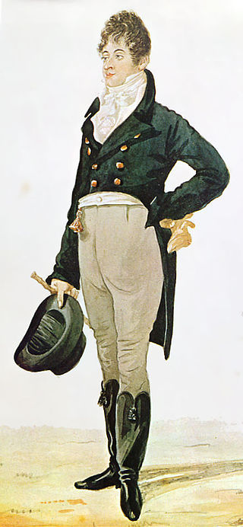

Figure 1

Richard Dighton (1805),
Beau Brummell.
[Watercolour]


Figure 2 Michal Cole’s necktie room, The Pavillion of Humanity, Venice Bienalle 2017. Photo by Christian Jenkins on 10th November 2017.

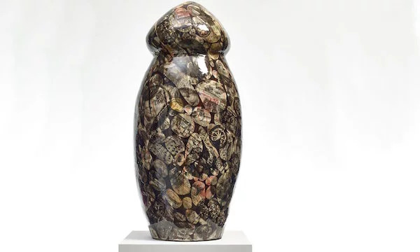
Figure 3 Grayson Perry (2016) Object in the Foreground [Ceramic]

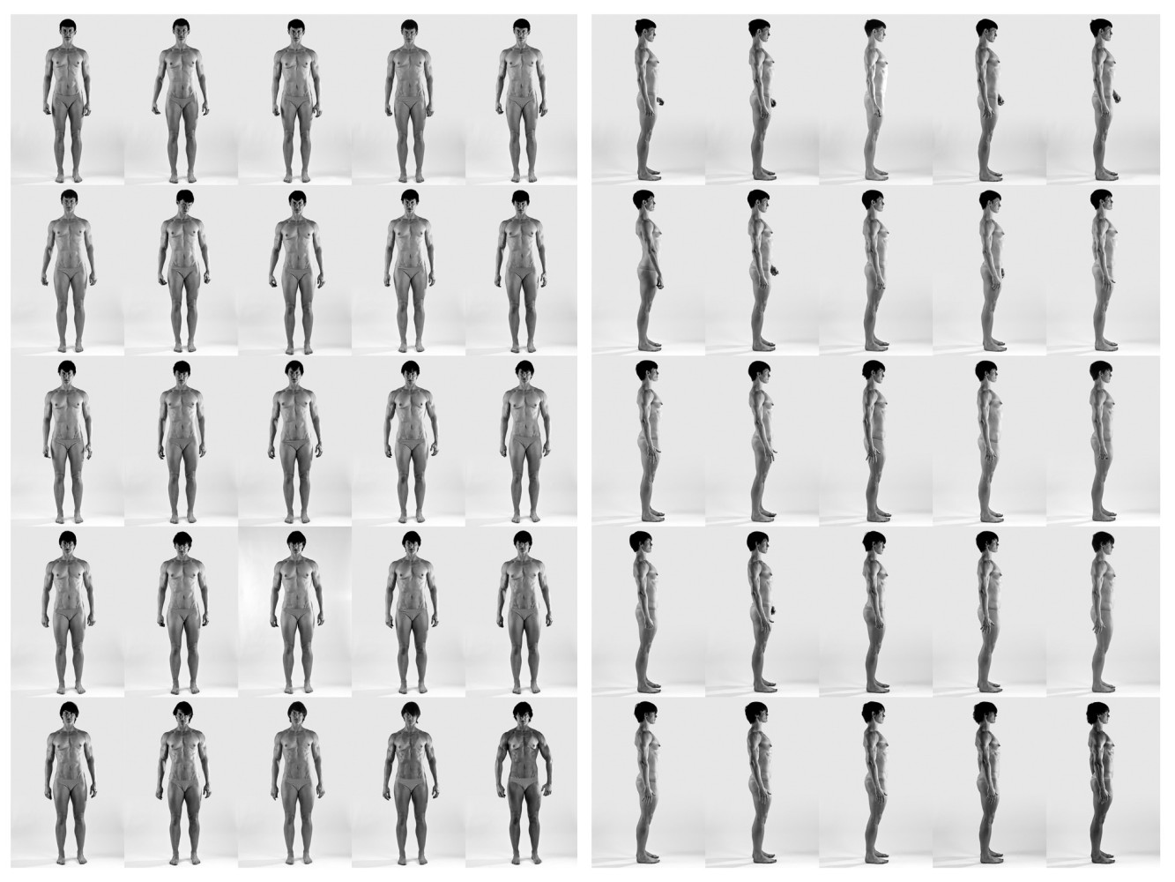
Figure 4 Cassils (2011) Cuts: A Traditional Sculpture [photography]

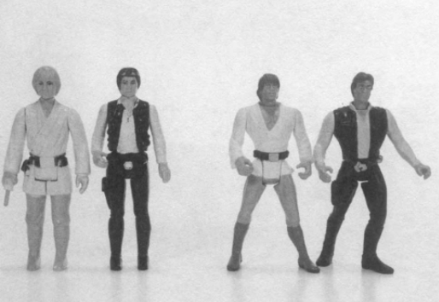

Figure 5

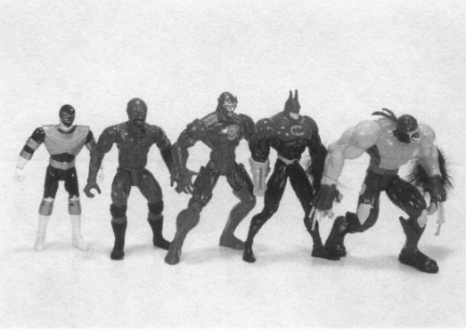

Figure 6

- Todd W. Reeser (2011) Masculinities in Theory, John Wiley & Sons
- Male Makeup in Eighteenth Century England (2013) Retrieved from https://18centurybodies.wordpress.com/2013/06/05/male-make-up-in-eighteenth-century-england/ [accessed 29/11/17]
- The Macaroni, The Dandy and Gender Identity (2011) Retrieved from https://kingpinchic.com/2011/10/01/the-macaroni-the-dandy-and-gender-identity/ [accessed 29/11/17]
- Kirstin Olsen (1999) Daily Life in 18th Century England, Greenwood Publishing Group
- Joesph Twadell Shipley (2001) The Origins of English Words: A Discursive Dictionary of Indo-European Roots, Language Arts and Disciplines
- The Dandy (n. d.) Retrieved from http://www.fashionencyclopedia.com/fashion_costume_culture/European-Culture-19th-Century/The-Dandy.html [accessed 30/11/17]
- Jean Baudrillard (n. d.) Simulacra and Simulations - XVIII. On Nihilism. Retrieved from https://web.archive.org/web/20130419220351/http://www.egs.edu/faculty/jean-baudrillard/articles/simulacra-and-simulations-xviii-on-nihilism/ [accessed 30/11/17]
- Albert Camus (2013) The Rebel, Penguin UK
- George L. Mosse (1998) The Image of Man: The Creation of Modern Masculinity, Oxford University Press
- James Eli Adams (1995) Dandies and Desert Saints: Styles of Victorian Masculinity, Cornell University Press
- Figure 1 Richard Dighton (1805) Beau Brummell. Available at http://todayindresshistory.tumblr.com/post/115024110030/caricature-of-beau-brummell-richard-dighton [accessed 30/11/17]
- Judith Butler (1988) Performative Acts and Gender Constitution: An Essay in Phenomenology and Feminist Theory, The John Hopkins University Press. Retrieved from https://www.amherst.edu/system/files/media/1650/butler_performative_acts.pdf [Accessed 1/12/17]
- Lisa Underwood (2004) The Drag Queen Anthology: The Absolutely Fabulous but Flawless Customary World of Female Impersonators, Routledge
- Sr. Mary Prudence Allen (2014) Gender Reality. Available at https://researchonline.nd.edu.au/cgi/viewcontent.cgi?referer=https://www.google.co.uk/&httpsredir=1&article=1051&context=solidarity [accessed 1/12/17]Alberto Minzer (2006) Boys Don’t Cry; Men Do, AuthorHouse
- Frances Cleaver (2002) Masculinities Matter!: Men, Gender and Development. Zed Books
- Sarah Lindsey Gray (2007) Masculine Gender, University of New Hampshire
- David D Gilmore (1990) Manhood in the Making: Cultural Concepts of Masculinity, Yale University
- Terry L Martin, Kenneth J Doka (2000) Men Don’t Cry - Women Do: Transcending Gender Stereotypes of Grief, Psychology Press
- Michael S Kimmel, Jeff Hearn, Raewyn Connell (2005) Handbook of Studies on Men and Masculinities, SAGE
- John F Morgan (2008) The Invisible Man: A Self Help Guide for Men with Eating Disorders, Compulsive Exercise and Bigorexia, Routledge
- Harrison Pope, Katherine A Phillips, Robert Olivardia (2000) The Adonis Complex: The Secret Crisis of Male Body Obsession, Simon and Schuster
- Micheal S Kimmel (2004) Men and Masculininites: A Social, Cultural and Historical Encyclopedia, ABC-CLIO
- Jodi O’Brien (2009) Encyclopedia of Gender and Society Volumes 1-2, SAGE
- Figure 5 Harrison Pope, Katherine A Phillips, Robert Olivardia (2000) The Adonis Complex: The Secret Crisis of Male Body Obsession, Simon and Schuster. Pg 43
- Figure 6 Harrison Pope, Katherine A Phillips, Robert Olivardia (2000) The Adonis Complex: The Secret Crisis of Male Body Obsession, Simon and Schuster. Pg 44
- Figure 4 Cassils (2011) Cuts: A Traditional Sculpture. Available at http://cassils.net/portfolio/cuts-a-traditional-sculpture/ [accessed 12/12/17]
- Peter Yueng (2014) The artists subverting the gender binary. Available at http://www.dazeddigital.com/artsandculture/article/22646/1/the-artists-subverting-the-gender-binary [accessed 12/12/17]
- Cassils (2011) Cuts: A Traditional Sculpture. Available at http://cassils.net/portfolio/cuts-a-traditional-sculpture/ [accessed 12/12/17]
- Dr Tim Edwards (2014) The Suit: A Symbol of Masculinity? Available at https://www2.le.ac.uk/projects/social-worlds/all-articles/sociology/suit [accessed 12/12/17]
- Hannah Ellis-Petersen (2017) Hot under the collar: Venice Bienalle Artist uses 27,000 neckties for installation. Available at https://www.theguardian.com/artanddesign/2017/may/11/hot-under-the-collar-venice-biennale-artist-uses-27000-neckties-for-installation [accessed 12/12/17]
- Hannah Ellis-Petersen (2016) Grayson Perry creates huge phallus to represent bankers worldwide. Available at https://www.theguardian.com/artanddesign/2016/may/19/grayson-perry-all-man-huge-phallus-bankers-worldview [accessed 12/12/17]
- Lorena Munoz-Alonso (2016) Grayson Perry Unveils Giant Ceramic Penis to Represent London’s Bankers. Available at https://news.artnet.com/art-world/grayson-perry-giant-penis-sculpture-500663 [accessed 12/12/17]
- Figure 3 Grayson Perry (2016) Object in the Foreground. Available at https://news.artnet.com/art-world/grayson-perry-giant-penis-sculpture-500663 [accessed 12/12/17]
- N. a. (n. d.) Definition of masculinity. Available at https://en.oxforddictionaries.com/definition/masculinity [accessed 12/12/17]
- N. a. (2017) Samaritans Suicide Statistics Report 2017. Available at https://www.samaritans.org/sites/default/files/kcfinder/files/Suicide_statistics_report_2017_Final.pdf [accessed 12/12/17]

https://en.oxforddictionaries.com/definition/masculinity
Perry (2016) pg. 7
Reeser (2011)
https://18centurybodies.wordpress.com/2013/06/05/male-make-up-in-eighteenth-century-england/
https://18centurybodies.wordpress.com/2013/06/05/male-make-up-in-eighteenth-century-england/
https://kingpinchic.com/2011/10/01/the-macaroni-the-dandy-and-gender-identity/
https://kingpinchic.com/2011/10/01/the-macaroni-the-dandy-and-gender-identity/
Olsen (1999) pg 107
Shipley (2001) pg. 143
https://18centurybodies.wordpress.com/2013/06/05/male-make-up-in-eighteenth-century-england/
https://kingpinchic.com/2011/10/01/the-macaroni-the-dandy-and-gender-identity/
http://www.fashionencyclopedia.com/fashion_costume_culture/European-Culture-19th-Century/The-Dandy.html
https://web.archive.org/web/20130419220351/http://www.egs.edu/faculty/jean-baudrillard/articles/simulacra-and-simulations-xviii-on-nihilism/
Camus (2013)
Reeser (2011)
Mosse (1998) pg 3-4
Adams (1995) pg. 10
Adams (1995) pg. 10
Adams (1995) pg. 11
https://www2.le.ac.uk/projects/social-worlds/all-articles/sociology/suit
https://www.theguardian.com/artanddesign/2017/may/11/hot-under-the-collar-venice-biennale-artist-uses-27000-neckties-for-installation
Mosee (1998) pg. 5
Beynon (2001) pg. 18
Butler (1988) pg 526
https://researchonline.nd.edu.au/cgi/viewcontent.cgi?referer=https://www.google.co.uk/&httpsredir=1&article=1051&context=solidarity
Butler (1988) pg 528
Underwood (2004)
Butler (2011)
Thomas (2017) pg 204-205
Perry (2016) pg 52-53
Perry (2016) pg 55
https://news.artnet.com/art-world/grayson-perry-giant-penis-sculpture-500663
https://www.theguardian.com/artanddesign/2016/may/19/grayson-perry-all-man-huge-phallus-bankers-worldview
Perry (2016) pg 54
Pery (2016) pg. 74
Perry (2016) pg. 73
Perry (2016) pg. 74
Minzer (2006) pg 20
Cleaver (2002) pg. 168
https://www.samaritans.org/sites/default/files/kcfinder/files/Suicide_statistics_report_2017_Final.pdf
Cleaver (2002) pg. 10
Gray (2007) pg 11
Martin, Doka (2000) pg 5
Gilmore (1990) pg 77
Gilmore (1990) pg. 14
Cleaver (2002) pg 78
Kimmel, Hearn, Connell (2005) pg. 144
Perry (2016) pg 54
Morgan (2008)
Pope, Phillips, Olivardia (2000) pg. 4
Pope, Phillips, Olivardia (2000) pg. 7
Pope, Phillips, Olivardia (2000) pg. 6
Elliot (2014) pg. 3
Morgan (2008) pg. 42
Pope, Phillips, Olivardia (2000) pg 13
Pope, Phillips, Olivardia (2000) pg. 5
Morgan (2008) pg. 36
http://www.dazeddigital.com/artsandculture/article/22646/1/the-artists-subverting-the-gender-binary
http://cassils.net/portfolio/cuts-a-traditional-sculpture/
Morgan (2008) pg 36
Kimmel (2004) pg 354
O’Brien (2008) pg. 392
Pope, Phillips, Olivardia (2000) pg 43.
Perry (2016) pg 54

