

Name – Joseph Humphreys

Student Number – 2504075

Course – HNC Quantity Surveying

Module – Digital surveying and highway design

Introduction-

Digital building surveys are becoming increasingly common in the construction industry because they provide a fast and accurate way of collecting information about existing buildings. One of the most effective methods is terrestrial 3D laser scanning, which uses a laser scanner to capture millions of measurement points and create a three-dimensional digital model known as a point cloud. This information can then be used to produce accurate floor plans, elevations and building measurements without needing to revisit the site.
(Sandeep Dhage, 2024)
For this project, a 3D laser scanner will be used to survey the first floor of the university’s IQ building. Careful planning is important to ensure that all areas of the building are scanned safely and accurately. This survey plan explains the purpose of the survey, the areas that will be captured, the site assessment and the main health and safety risks involved
Purpose for this survey-
The purpose of this survey is to accurately record the internal layout of the selected area on the first floor of the IQ building using a terrestrial 3D laser scanner. The scanner will capture the size and shape of the rooms, corridors, walls, doors and windows to create a detailed digital model of the first floor.
This digital model will allow measurements to be taken later without needing to return to the building. It also reduces the chance of human error because millions of points are collected during each scan instead of relying on individual tape measurements. (Leica Geosystems, 2023).
Information that is gathered from this could then be used for multiple purposes such as refurbishment projects, planning future maintenance or creating floor plans. Using laser scanning is especially useful for buildings with complex layouts because it records much more information than traditional measuring methods. This is good as the area being surveyed has lots of doorways and pillars which can be challenging to record if the survey was being done manually (RICS, 2024).
This survey is being done to
- Produce an accurate digital record of the building.
- Capture sufficient information to extract measurements from the processed point cloud.
- Demonstrate the practical application of digital surveying technology within the construction industry.
Survey Area Definition-
This survey area will consist of the selected loop on the first floor of the IQ building. The floor contains an irregular arrangement of rooms connected by a long-angled corridor, together with several changes in wall direction and multiple internal corners. Every accessible room, corridor, doorway and circulation area will be captured during the survey.
The required level of detail is sufficient to accurately identify:
- Internal wall positions
- Room dimensions
- Corridor widths
- Door openings
- Window positions
- Structural columns or protrusions
- Ceiling heights (where visible)
Site assessment-
A site assessment will be undertaken before commencing the survey to identify any factors that may affect data collection, equipment positioning or site safety. (Health and Safety Executive, 2024).
Access-
Access to the first floor will be gained through the building's main entrance before proceeding via the internal staircase. Emergency exits will be identified during the initial walk-through to ensure evacuation routes remain unobstructed throughout the survey.
Scanning positions-
The irregular building layout requires careful planning of scanner locations.
Scanner positions will be selected to maximise visibility into adjoining rooms while maintaining sufficient overlap between scans for successful registration.
Priority scan locations include:
- Corridor junctions
- Doorway entrances
- Large open rooms
- Ends of corridors
- Central positions within larger spaces
Additional scans may be required where furniture or internal partitions restrict visibility.
Lighting conditions-
Although terrestrial laser scanners measure distances using laser technology rather than ambient light, lighting conditions can influence the quality of the panoramic photographs captured alongside each scan. Internal lighting should therefore remain switched on wherever possible to improve image quality and assist with point cloud interpretation. Luckily, in this area of the IQ building the lighting is on point and makes the corridors very clear with minimal shadows.
Environmental Conditions
Potential obstructions include:
- Office furniture
- Storage items
- Open/closed doors (we will ensure all doors are opened throughout the corridor to get an accurate reading)
- Glass partitions
- Building occupants moving through the survey area
These factors may temporarily obstruct the scanner or introduce unwanted objects into the point cloud. Where practical, scans will be repeated if significant movement occurs during data collection.
Health and Safety Considerations-
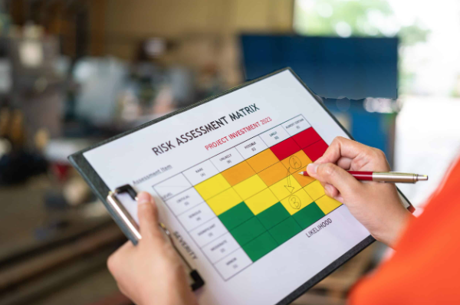
All surveying activities will comply with the Health and Safety at Work etc. Act 1974 and the Management of Health and Safety at Work Regulations 1999.However, there are a handful of occasions where we could come across a risk. Trip hazards created by tripod legs will be managed by positioning equipment away from pedestrian routes wherever possible. (Coleman and Karim, 2023)
Manual handling risks associated with transporting the scanner and tripod will be minimised through correct lifting techniques and by sharing equipment between team members where appropriate. As I am already familiar with the building, I am already aware of fire escape routes throughout the survey and ensure no emergency exits become obstructed. (Health and Safety Executive, 2024).
Risk assessment-
Hazard | Potential Risk | Control Measures
Tripod legs | Trips and falls | Position equipment away from walkways and maintain good housekeeping.
Moving occupants | Interrupted scans or collisions | Display warning signage and repeat scans if required.
Manual handling | Musculoskeletal injuries | Use correct lifting techniques and carry equipment safely.
Uneven flooring | Slips, trips and falls | Conduct a pre-survey inspection and identify hazards.
Low battery power | Loss of survey progress | Carry fully charged spare batteries.
Equipment damage | Loss of survey accuracy | Secure tripod, always supervise equipment, and avoid unstable surfaces.
Reflective surfaces | Incomplete or distorted scan data | Increase the number of scan positions and verify data during registration.
Restricted access | Incomplete survey coverage | Obtain access permission before commencing the survey and adapt the scan sequence where necessary.
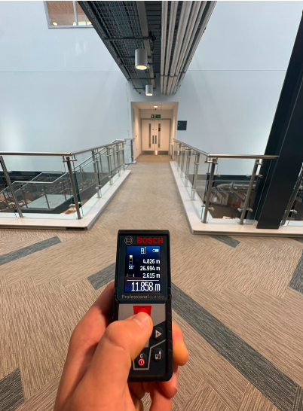
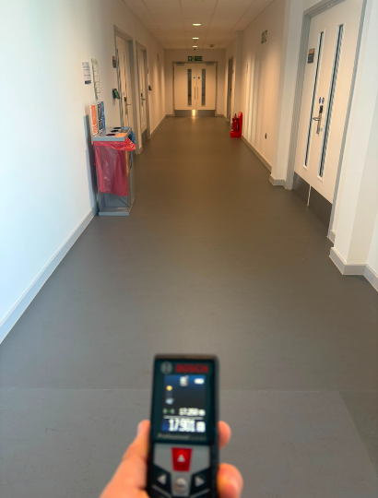
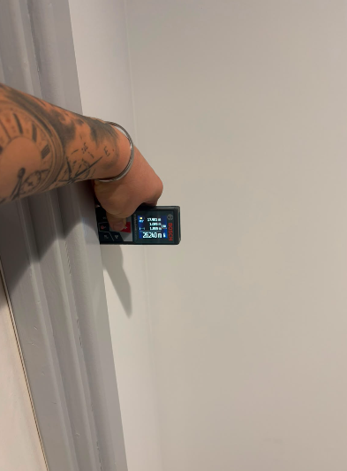
Part 2- practical -see the below images for proof of my presence on site.
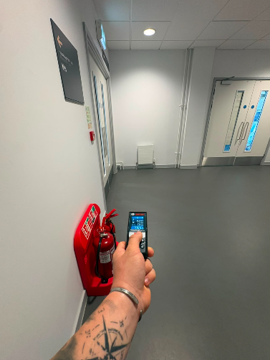
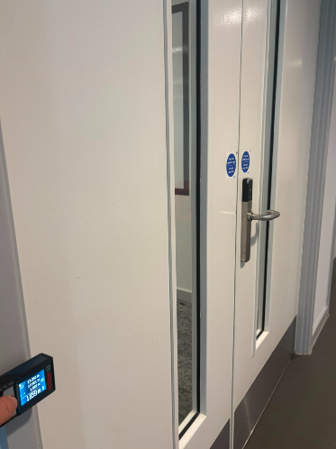
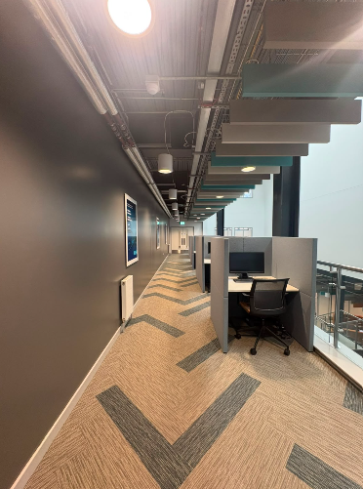
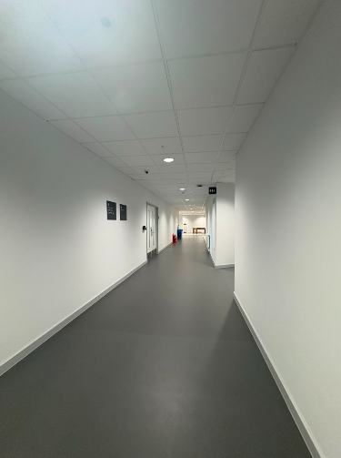
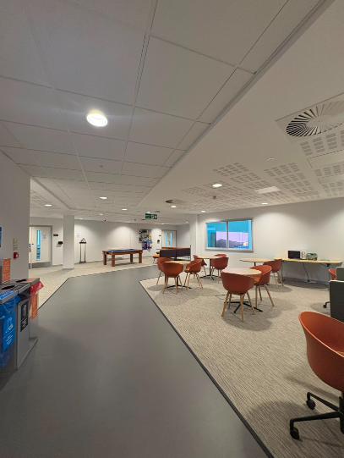
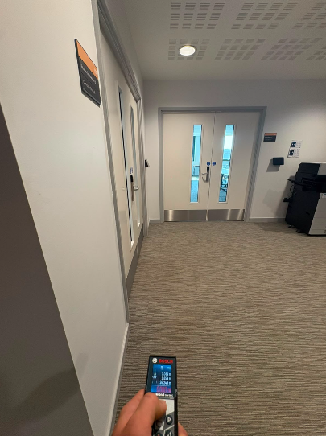
(Humphreys, 2026).
These photos were taken during my survey; it shows some measurements and in general the areas on site where I took my measures from.
Overall, the survey was completed successfully, and the main objectives were achieved within the time available. Before starting, the team discussed the survey plan and allocated responsibilities to ensure the work was carried out efficiently. However, not everything went as planned. When we arrived on site, the laser scanning equipment would not connect to the tablet, preventing us from using the original survey method. As the survey had to be completed within a limited time, we adapted by using a handheld measuring device instead (the Leica BLK2GO handheld laser scanner). This alternative required very little setup compared to the laser scanner, which would have needed to be mounted on a tripod and calibrated before use. Although this meant we could not capture the same level of detail that the laser scanner would have provided, the handheld device enabled us to collect all the necessary measurements and complete the survey successfully. This experience highlighted the importance of being flexible and having a backup plan when carrying out site surveys. Equipment issues can occur unexpectedly, so being able to adapt quickly helped ensure the project remained on schedule.
Another challenge was ensuring that all measurements remained accurate when using the handheld device. Since measurements had to be taken using the Leica BLK2GO handheld laser scanner there was a greater chance of human error compared to using the stationary laser scanner. To reduce this risk, when measuring, we ensured that every detail of the rooms/corridors were covered. We made sure of this by holding the laser scanner at the correct height, to be able to give accurate readings, double checking our reading when walking through doors or complicated areas, finally the laser measure was connected to the tablet so we were able to watch our readings as we were carrying them out.
(Leica Geosystems, 2023).
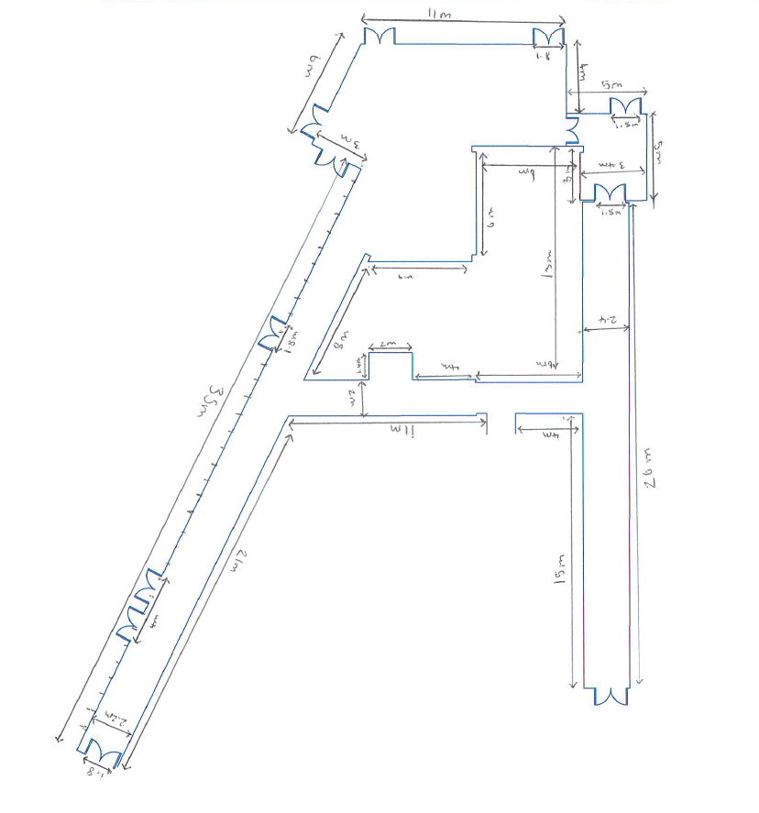
Part 3- Measurement and Analysis
(Humphreys, 2026)
The processed laser scan was used to obtain accurate dimensions of the building without returning to site. Measurements were taken directly from the scan to determine overall room sizes, wall lengths, and the dimensions of doors and windows.
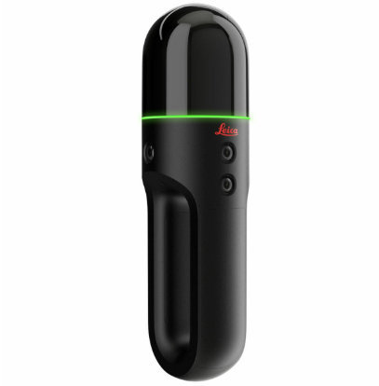
During this survey, we used both the scanner Leica BLK2GO handheld laser and traditional manual measurement methods, including tape measures and laser distance meters. Using both methods allowed us to compare their performance in terms of time, accuracy, and completeness while also verifying that the measurements collected were correct.
One of the main differences between the two methods was the amount of time required. Manual measurement involves physically measuring each wall, doorway, window, and room before recording the dimensions. This can be slow, particularly in larger buildings or where there are many rooms to measure. In comparison, the Leica BLK2GO captures millions of measurement points while the operator walks through the building. Once we had resolved the initial connection issues between the scanner and the tablet, the scanning process was completed much more quickly than manually measuring every feature. However, we still carried out manual measurements of key dimensions to check that the scanned data was accurate and to record any areas that may not have been captured clearly by the scanner.
(Survey Tech, 2026)- photo
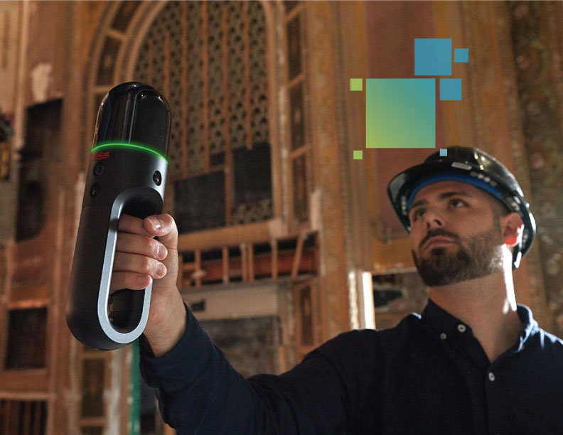
-In terms of accuracy, both methods produced reliable results, but the laser scanner offered a higher level of precision. Manual measurements depend on the surveyor correctly reading and recording measurements, meaning mistakes can occur if dimensions are read incorrectly or written down inaccurately. The completeness of the survey was another area where the laser scanner performed better. Manual surveying only records the measurements that are taken on site, meaning if additional information is required later, another visit to the building may be necessary. The BLK2GO creates a complete digital record of the building as the operator walks through it.
(BIM News, 2019)
Although the BLK2GO offers many advantages, it also has some limitations. The equipment is considerably more expensive than traditional measuring tools and we required surveillance to operate the machine effectively. In addition, the quality of the final scan depends on the operator maintaining a steady walking pace and ensuring all areas of the building are covered. This is why there were multiple walkthroughs, before the final plan was chosen. (Leica Geosystems, 2023).
Overall, using both methods gave us the best results. The Leica BLK2GO made it much quicker to collect survey data and produced an accurate digital model of the building. Manual measurements were still useful for checking important dimensions and making sure the scanned data was correct. Using both methods together made the survey more accurate and reliable. (RICS, 2024).

References-
BIM News (2019). Handheld Imaging Scanner Enables High-Speed Indoor As-Built Data Capture. [online] BIM Learning Center. Available at: https://bimlearningcenter.com/handheld-imaging-scanner-enables-high-speed-indoor-as-built-data-capture/ [Accessed 23 July 2026].
Coleman, B. and Karim, A. (2023). When Should a Risk Assessment be Carried Out? [online] Human Focus. Available at: https://humanfocus.co.uk/blog/when-should-a-risk-assessment-be-carried-out/ [Accessed 23 July 2026].
Health and Safety Executive (2024) Managing health and safety in construction (CDM 2015). Available at: https://www.hse.gov.uk/construction [Accessed 23 July 2026].
Health and Safety Executive (2024) Risk assessment: A brief guide to controlling risks in the workplace. Available at: https://www.hse.gov.uk/simple-health-safety/risk [Accessed 23 July 2026].
Humphreys, J. (2026) Survey photographs of the IQ Building first floor. Personal photographs taken during university fieldwork, July 2026.
Leica Geosystems (2023) Leica BLK2GO Handheld Imaging Laser Scanner. Available at: https://leica-geosystems.com/products/laser-scanners/scanners/blk2go [Accessed 23 July 2026].
Leica Geosystems (2023) Reality Capture Solutions. Available at: https://leica-geosystems.com [Accessed 23 July 2026].
Royal Institution of Chartered Surveyors (RICS) (2024) Surveying and geomatics guidance. Available at: https://www.rics.org [Accessed 23 July 2026].
Sandeep Dhage (2024). Modern LiDAR and GPS Usage in Land Surveying - Gsource Technologies. [online] Gsource Technologies. Available at: https://www.gsourcedata.com/modern-lidar-and-gps-usage-in-land-surveying/ [Accessed 23 July 2026].
Survey Tech. (2026). Leica BLK2GO Handheld Laser Scanner. [online] Available at: https://survey-tech.co.uk/products/leica-blk2go-handheld-laser-scanner [Accessed 23 July 2026].

