Tina Webb 1910813



Tina Webb 1910813

Table of Contents
Table of Contents 1
Executive Summary 1
Business Overview 1
Markets and Competition 1
Target Markets 1
Competition 1
Sales and Marketing 1
Product Positioning 1
Marketing 1
Sales 1
Management 1
Key Personnel 1
Operations 1
Premises and Equipment 1
Employees 1
Suppliers 1
Financial Forecast 1
Sales 1
Cashflow 1
Profitability 2
Financing 2
Executive Summary 3
Business Overview 4
Markets and Competition 5
Target Markets 5
Competition 5
Sales and Marketing 6
Product Positioning 6
Marketing 6
Sales 6
Management 7
Key Personnel 7
Advisors and support services 7
Operations 8
Tina Webb 1910813

Premises and Equipment 8
Employees 8
Suppliers 8
Financial Forecast 9
Sales 9
Cashflow 9
Profitability 9
Financing 10

Executive Summary.

I am a proud sole trader of ‘Tendahand’, I managed this business from my home the business started off with the help of my family and my own savings, so no bank or business loan needed which was great for me. My business focuses on cemetery’s, where I clean the area of the diseased plot and grave, from the stone to the bedding plants, pots, cut grass, raked and flowers placed if desired. I do this throughout the year I have collated customers which are loyal to me they like what I do and what I offer. Including within my package deal(s) I offer consist of a visit to their loved ones place of rest during the year and sometimes there is that special occasion of delivering a special message on that special day, this can be birthdays, anniversaries, Easter and Christmas and this is very warming and rewarding for me to be able to offer my services for such occasions. I use the internet for advertising my business on a web page, I have also had business cards made which I have been able to place in funeral homes, stonemasons and cemetery’s. Sometimes involving the old-fashioned word of mouth which plays a big part in what I have done for people; so often information about me and what you do gets past around. I have taken into consideration that not all cultures need my services, for instance Muslims prepare their own families for burial and care for their graves. In time I would love to incorporate the experience I have gained from working in a funeral home and the qualifications I have in hairdressing/beauty, to prepare the deceased before burial or cremation for the families who want to pay their final farewell through the use of hair, makeup, and dresswear. I have done some private work on this in the past, where the family of the deceased were very happy with the work I did. If there would be an issue for my business, it would mean being to busy for a one-man operation. so, this would mean I would need to employ people which would mean I would have to pay wages.

Tina Webb 1910813

Business Overview

My business is called ‘Tendahand’, it is a sole business which looks after basic plot maintenance. It is a business that truly helps people in need of looking after their loved one’s gravesites. These people for one reason or another cannot for fill this service which I provide. It could be for any of the following reasons; they could be elderly, sick, disabled, vulnerable, live away from their loved ones resting place, even work long hours so they don’t have the time to go. The service I offer is plot maintenance care, this is clearing up the area of the deceased resting place, grass cutting, trimming, leaf raking, shrubs removed, replanting, cleaning of the headstone, floral replacements on request, special services on special days such as Christmas, Easter, birthdays and anniversaries. Often deliver a special message of their choice. I can provide a plot finding service if this is not known to the customer, with every plot having a reference number. This I can do by having the name of the deceased and logging on to a website and or through utilising the plot number. I have enclosed an example website address in reference to this process below: https://www.ehow.co.uk>how_7839781_cemetery-plot-numbers-uk.html. If you are given only the name of the deceased, you could use: https://www.ancestry.ca/cemetery/records.

I will keep a record of the information I have gathered, including website information involving the research required for the type of service I offer. I provide a photograph before and after my services so that customers can monitor progress and see what I have done allowing for good communication and clearness during this process so that customers are happy with what they have asked for and with what has been achieved. This will contribute to what will be showing in my sales and marketing records.
Tina Webb 1910813

Markets and Competition.

My markets are widely ranged from people from all walks of life.

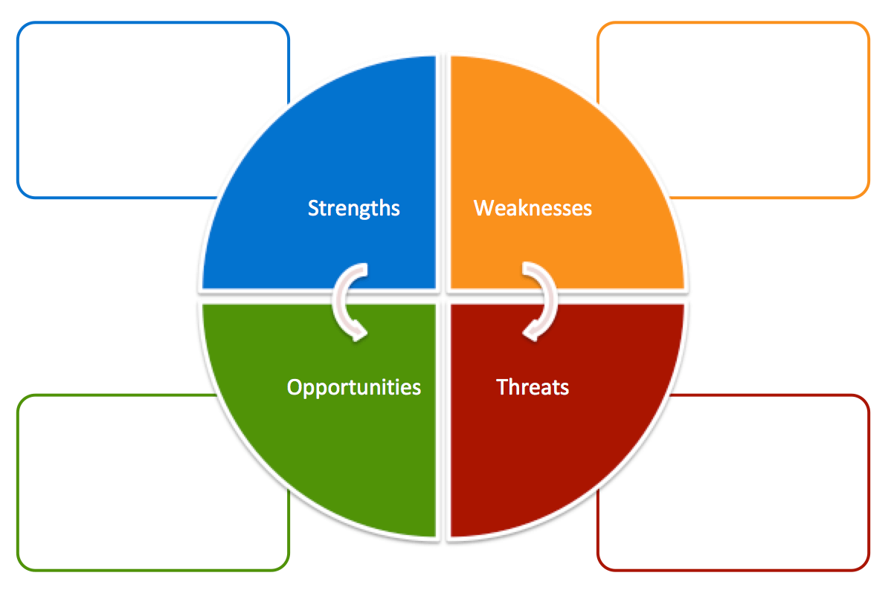
Sole trader
Flexibility
Friendly service

Advertisement
New to the market
Competitors.
Pricing.

Growth
Package deals

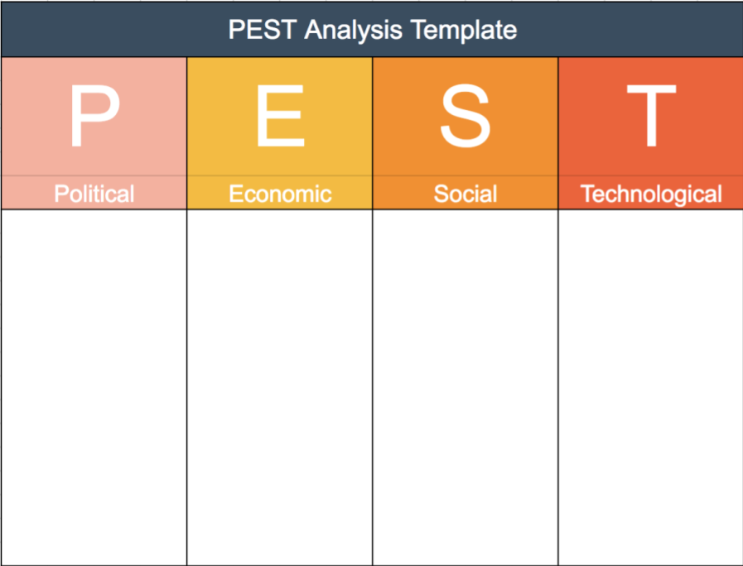

Internet/social media platforms

Phones/computers

Information and communication

Seasons/weather

Growth

Home situation

Population

Age

Distribution

Media

Less social time

Licences

Public liability insurance.

Register as a sole trader.

Permit requirements.

Tina Webb 1910813

Target Markets.

The customers I would be dealing with will vary.

I may be offering my services to people who have moved away from the area of their loved ones resting place, people who are unable to get back and forth for one reason or another, which may include being too far for them to travel. I might be dealing with customers where they may have migrated abroad, but still want peace of mind that their loved ones resting place is cared for. Elderly customers may be unable to travel to resting sites, who may potentially be unable to drive and have health related matters potentially restricting them; they may also have no other family members to help them tender the grave. I may be assisting people who are vulnerable, whom may have a disability who cannot get about themselves. There are many other reasons for people who cannot tender the graves which may include people who work long hours and are unable to find the time to tender loved one’s graves. I find a lot of my customers are very happy for me to step into their lives to help manage the upkeep of their loved ones resting place.

Competition.

I am aware of the competition, which is already out there. By keeping my services competitive and prices affordable within this competitive market I can offer incentive deals to loyal customers. Alongside this incentive, find that customers are satisfied in receiving a hands-on personal service. The other services I would like to offer to my customers eventually is the ‘hair & makeup’, dresswear of their choice for their loved ones before they are laid to rest. This can be done within their home or at the funeral parlour of their choice. I have gained valuable experience of this type of service from working within funeral homes and within private dwellings of the diseased which I really enjoyed. I understand the importance of the delivery of detailed services and attention of care to the diseased. This is where I would be able to contribute to making a difference during this sensitive time. I believe my experience as a hairdresser and beautician will enable me to be able to specialise this type of service, however there isn’t a need to have qualifications to perform this type of service.

Tina Webb 1910813

Sales and Market.

Product Positioning.

The quality of the service which I’m offering is affordable to my customers, this is based on having researched that market and am able to price match other competitors fees. As a sole trader my customers will receive 100% of attention to detail, where I will work to the highest of standards. I can offer a range of services to meet the needs of individual expectations and offer a value package. I have found customers to have provided me with positive feed-back based on the packages I am offering; alongside being able to offer personal professional and courteous approach. I believe my personal attention to detail and values as a company proves to be beneficial in retaining my customers.

Marketing

I promote my business through my website ‘Tendahand’. I also have had business cards made which are not a cost to me through family advantages. I’ve promoted my business where I have handed these cards within; stonemasons, funeral homes, cemeteries, keeper’s offices and where cemetery managers are stationed. Not all cemeteries have appointed offices within them so the few that do I have handed them in. Another benefit to ‘Tendahand’ is that customers often promote me through the use of word and mouth. To show you below I have included a before and after picture of the type of service I offer. This may involve contacting the stone mason’s office if the writing has faded where it is difficult to read. However, can assist with the cleanliness of the head stone if this would allow the writing to be read clearly. You can see from the pictures I have included what can be achieved using ‘Tendahand’ as a service.

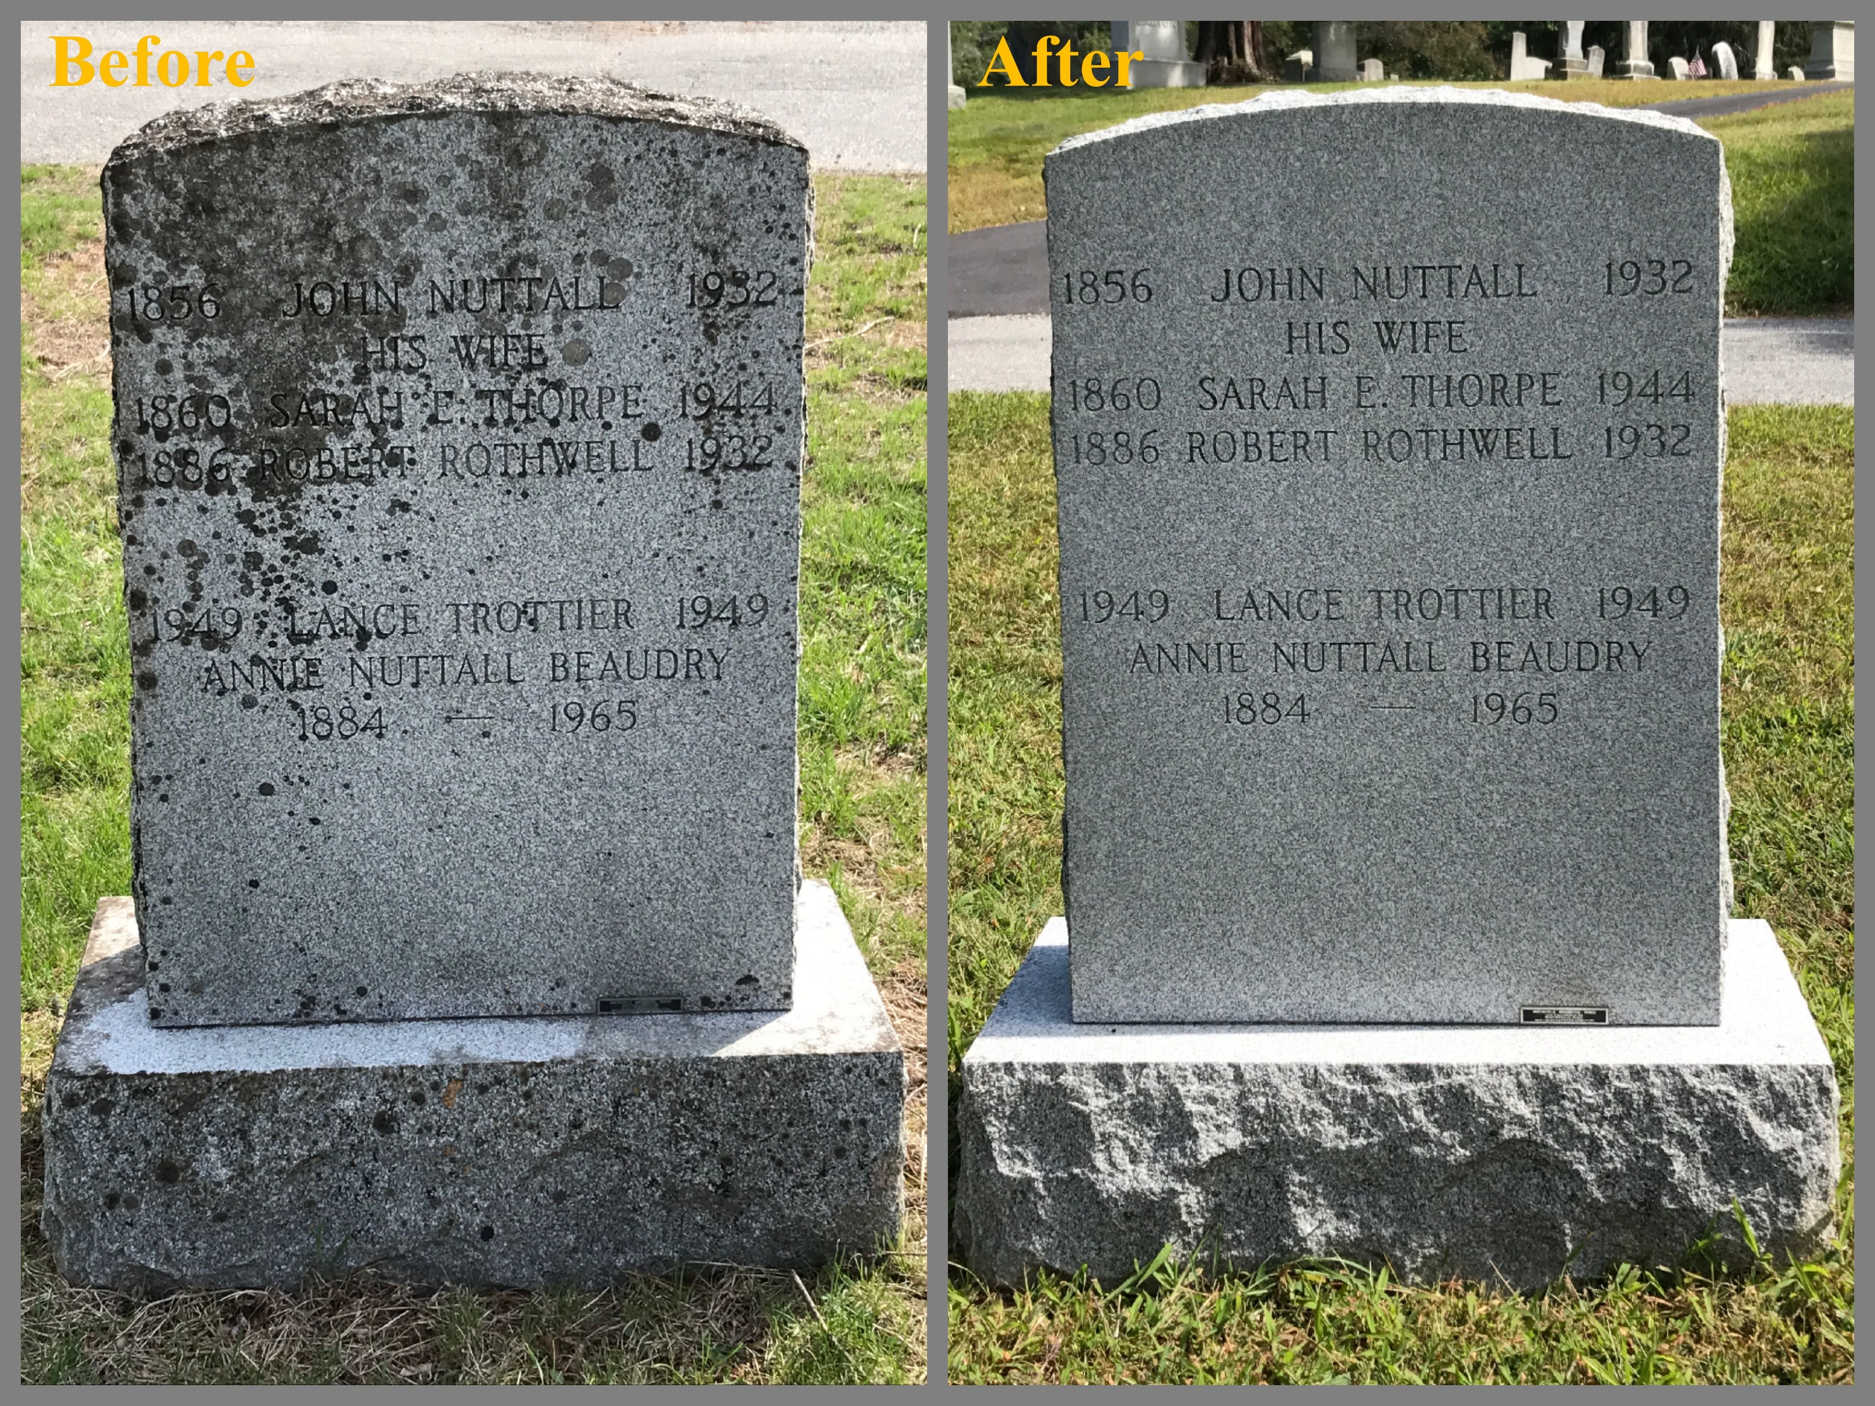

Tina Webb 1910813

Sales

On receiving requests through an email system or via telephone, I will inform the potential customer of the services I feel may be beneficial to them. I will then try to organise a meeting with them at a comfortable place of their choice, which is often usually within their home. ‘Tendahand’ offers a service where customers can choose the type of package, they feel would be suitable to them through the use of the website. I will then go through the step by step process involving the service(s) they wish to proceed with. When they’re happy to proceed with one of my packages, we will then go ahead with the next stage in providing the actual service. Customers will be able to contact me to discuss packages even if they are happy to proceed through my website. During this whole process I will have a full idea of their wishes, my customers can contact me and ask any questions they may have where we can also discuss what is achievable and at what cost or package, I can offer them. Depending on what they want I will then provide a rough idea of how long the job may take. I may need to visit the site (plot) prior to accepting a job before any of my services can be priced appropriately. I will be able to provide a rough estimate over the telephone before attending the plot due to varying plot sizes. The few customers am already offering a service to, involving monthly visits for the up keep of their plot includes all shrubs and grass are maintained, head stone cleaned with fresh flowers or plants placed (if agreed); these plots are on a 50 year term with the council, in some cases it can be up to 100years. I believe I retain customers because of the attention to detail and the competitive packages I am able to offer as a sole trader.

Operations.

This business is a sole trade company, which I run all aspects of the business by myself.

Premises and Equipment.

The premises of my business is within my own personal dwelling.

The equipment I use involves; internet and phone line.

Financial Forecast.

Sales

I would like to think that at the end of my first year in business I would achieve a profit of some kind, but just braking even would be an achievement.

Cashflow

A one-off payment of £75 for chemicals, cloths garden tools.

Tina Webb 1910813

Grave care.

For one plot the price I charge is £81, roughly one and a half hours of work, so it works out that I get £40.50 hr. Flower and plants will be charge extra for on request.

Body Preparation

For me to do a body preparation, this would take around four hours. This consists of dress wear to hair and makeup this would cost £200 so this works out that I’m paid £50hr.

Sole trader Public Liability Insurance.

£7 a month.

Profitability

With the way things are at this moment and time, my business has been extremely busy, I do hope that this continues for me as a sole trader just having started, so my profits at the end of the year will be looking good.

Financing Guidance Notes:

To start my business off I had help from my family and I put my savings in.
Appendix.

Public liability insurance is needed, and I have enquired about, this is there to help you against any claims made against you, i.e. someone falling over your equipment, tools so forth, and hurting themselves. https://www.compairthemarket.com

When registering as a sole trader in simple set up in just 3hours, which all gets done in four simple steps, companies house approved, approx. £29.99 a month.
www.companiesmadesimple.com/

This is how I will find out about the record of the diseased, one by number one by name.
https://www.ehow.co.uk>how_7839781_cemetery-plot-numbers-uk.html
https://www.ancestry.ca/cemetery/records

This is a site where I have managed to get information about costings. These I will explain below: Memorial cleaning and tidied, once a year from £99 picture sent after visit. (CARE)
As above but more often four times a year £189. (CHERISH)
One off restorative deep clean when a plot hasn’t had any attention for a long time, £199. If the stone has weathered, you need to seek stonemason’s advice.
Reference: Grave care international.com-grave care maintenance. www.gravecareinternational.com/

Tina Webb 1910813

Nearly all burial grounds are owned by the council: https://www.valeofglamorgan.gov.uk
But there are the odd one privately owned, which are known as natural burial grounds, this is for the ashes to be scattered only.

There are no qualifications needed to perform hair beauty on a diseased.
http://uk.answers.yahoo.com/question/index?qid=20080124225043AAAGCTW. Date 24/01/2008.

