Module name: Entrepreneurship
Module number: BMIH5001
Student name: ZakiaShirin Nishai
Student Id: 2208336
Lecture's name: Ka Po Chong

Table of Contents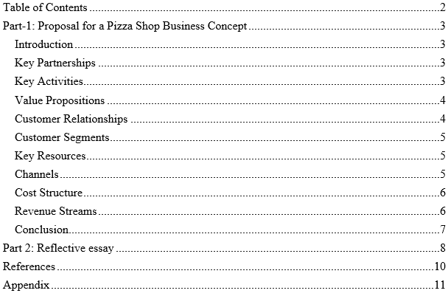

Part-1: Proposal for a Pizza Shop Business Concept
Introduction
It is imperative for the neighbourliness industry to be able to alter and meet the requirements of clients since the industry is continuously changing and exceptionally competitive, particularly when it comes to nourishment. This arrange is for an unused pizza shop that needs to be different from other pizza places. It'll offer clients extraordinary things that they can’t get anyplace else, and the pizzas will be truly great as well (Glackin, 2012). The company is centered on being naturally neighbourly and proficient in everything it does. This proposition carefully clarifies the essential parts of the Pizza Shop idea employing a BMC. In arrange to stand out within the changing nourishment benefit advertise, it's vital to have strong reasons, current cases, and pertinent sources for each portion of the arrange.
Key Partnerships
Providers and trade accomplices are truly critical for a neighbourliness commerce to be fruitful, so it's truly vital to have great associations. It's truly vital for the Pizza Shop to create great companions with the individuals who give them the stuff they ought to make pizza, like flour, vegetables, cheese, and meat. The Pizza Shop wants a good deal with the correct cost and high-quality fixings. They will arrange to induce the most excellent terms (Rae, 2008). This arrange spares cash and makes beyond any doubt that our items are continuously truly great. The reason for these associations is to form sure the items are truly great and both sides make a benefit. Both sides can advantage from working together and building great connections to keep clients cheerful and effective. The Pizza Shop is well-respected and trusted within the eatery commerce since it works difficult to construct great connections and is committed to running productively and giving astounding nourishment encounters.

Key Activities
To form exceptional pizzas, an exact prepare is fundamental, which incorporates fundamental steps to guarantee brilliance in each portion. The Pizzeria will use the most recent hardware to form batter and garnishes, using technology to form the method more productive and steady. We are going frequently check the crude materials to create beyond any doubt they are great quality and to keep our items secure. Moreover, utilizing effective ask administration frameworks will offer assistance arrange assignments easily and give convenient help, which is able improve the by and large involvement for clients (Spinelli, 2008). Considering carefully and solving issues will be really important for managing with challenges and doing way better. Exact objectives will direct the group, making beyond any doubt they meet quality and efficiency targets. Frequently talking to clients makes a difference us get it what they like and don't like, so ready to keep getting superior. Information analytics and cutting edge cash enrol frameworks are two cases of the innovation that can be utilized to create superior choices and make operations more effective. By working difficult, the Pizzeria will not as it were make incredible pizzas but too pick up a notoriety for being solid, inventive, and centered on client fulfilment within the competitive neighbourliness industry.
Value Propositions
The Pizza Shop's offers are centered on giving truly great client benefit and clean, reasonable pizzas. The nourishment is one of a kind since it employments batter with mushrooms and parcels of meat. Individuals will keep in mind this uncommon nourishment encounter. The Pizza Shop is diverse from other pizza places since it incorporates a special taste that individuals who like attempting modern flavors truly appreciate (Scarborough, 2011). Moreover, the Pizza Shop is pleased to offer numerous diverse sorts of pizzas that can be personalized to coordinate distinctive tastes and dietary needs for numerous distinctive sorts of clients. The Pizza Shop has something for everybody, whether you like attempting unused pizzas or staying to the classics. The costs are set so everybody can manage the delightful and different nourishment without compromising on taste or esteem.

Customer Relationships
The Pizza Shop needs to form beyond any doubt that clients are truly upbeat, so they continuously make sure to allow each client the finest benefit. The Pizza Shop works difficult to assist each client rapidly and viably. We are committed to giving extraordinary benefit, building believe, and keeping clients coming back. Diverse ways of talking to individuals, like talking in individual, utilizing social media, giving out papers, hanging up signs, and enhancing with streamers, are all cases of this personalized arrange (Ireland, 2018). Working closely with others gives a great opportunity to work together, permitting representatives to share personalized thoughts and address questions in real-time. Meanwhile, online stages for amusement are utilized as uncommon ways to conversation around things, permitting the Pizza eatery to conversation to clients, share overhauls, and respond to criticism rapidly. Besides, conventional showcasing materials such as standards, pamphlets, and trims are utilized to associate with a changed group of onlookers in individual. The pizza put employments distinctive ways to communicate with clients to gotten to be way better and make beyond any doubt they continuously get criticism. This helps them in upgrading their administrations and fulfilling their clients.
Customer Segments
The Pizza Shop needs to draw in parcels of diverse clients in Central London, counting individuals of all ages, occupations, and regions. The Pizza Shop is devoted to making pizza that everybody will like. They make all diverse sorts of pizza to if it's not too much trouble everybody. The Pizza Shop guarantees to form yummy pizzas that are clean and not as well costly. This makes individuals need to come and eat there since they know they will get good-tasting nourishment at a great cost (Williams, 2021). The Pizza Shop is diverse from other popular pizza places in Soho like Genuine Pizzas, Five Folks, and Pizza & Lobster since they have special nourishment and deliver uncommon consideration to their clients. The Pizza Shop is diverse from other places since it features an interesting pizza with parcels of meat, mushrooms, and big servings. Besides, the Pizzeria's guarantee to personalized benefit guarantees that each interaction contains a long-lasting affect, supporting client dependability and setting a standard for greatness within the competitive neighbourliness industry. Also, the Pizzeria makes beyond any doubt to donate personalized benefit to create an enduring impression, which makes a difference keep clients coming back and sets a tall standard within the neighbourliness industry.
Key Resources
The Pizza place needs individuals, cash, and things to do their work. Genuine things just like the store, furniture, computers, and stoves are vital for day by day exercises and make the customer's involvement way better. Gifted specialists are exceptionally imperative for keeping up item quality and giving amazing benefit, making beyond any doubt clients are cheerful and keep coming back (Nelson, 2013). The Pizza Shop can begin and compete within the showcase with £20,000 for things like inquiring about unused formulas, promoting, paying representatives, and other costs. These things offer assistance the Pizza eatery to progress, draw in clients, and recognize ranges where they are great, driving to long-term development and victory within the competitive neighbourliness industry.
Channels
The Pizza Shop is advanced in numerous distinctive ways, counting social media, talking to individuals in individual, and utilizing conventional advertisements like pennants and trims. These different ways of coming to individuals are awesome for getting the word out and drawing in clients, which makes a difference the Pizzeria reach more individuals. The Pizza Shop comes to a parcel of individuals by posting shrewd advertisements on social media. This makes a difference individuals interface with each other and ended up more commonplace with the brand (Roddick, 2013). Confront to confront shows, such as tastings or neighbourhood occasions, give personalized encounters that profoundly interface with clients. In addition, utilizing old-fashioned promoting strategies such as standards and enhancements makes a difference individual within the region take note the Pizza Shop and see what it needs to offer. Within the tough food industry, these advancements make beyond any doubt that clients can effectively get and just like the pizza since there are numerous sorts to select from and the costs are great.
Cost Structure
Expense Category Amount (£)
Research and Development £10,000
Marketing £3,000
Staff Salaries £7,000
Other Operational Costs £0
Total £20,000
This table shows how the Pizzeria spends £20,000 on different expenses. The biggest amount of money, £10,000. This money is used to make products better and more creative. It is used for research and development to improve the quality of the products. To bring in more customers and make more people know about the brand, we spend £3,000 on marketing efforts. Employees are paid £7,000 for doing their regular jobs. The set budget includes all the other costs, making sure that the £20,000 budget pays for everything.
Revenue Streams
The Pizza Shop monetizes its business by advertising brief enlightening recordings on a pay-per-use premise, permitting clients to get to profitable substance whereas producing income for the trade. This inventive approach adjusts with modern buyer inclinations for locks in mixed media substance and gives an extra income stream past conventional item deals. The estimating procedure is carefully made to adjust reasonableness for clients with productivity for the Pizza Shop, guaranteeing that the taken a toll of getting to recordings remains competitive whereas producing adequate wage to support operations and drive development (Shepherd, 2008). To encourage exchanges, the Pizza Shop acknowledges instalments through an assortment of channels, counting debit/credit cards and portable budgetary administrations. These instalment alternatives offer clients comfort and adaptability, permitting them to total exchanges consistently whether in-store or online. By giving numerous instalment channels, the Pizza Shop improves the generally client encounter and diminishes obstructions to buy, advance empowering engagement with both its items and educational substance. This comprehensive approach to monetization and instalment preparing reflects the Pizza Shop's commitment to development, client fulfilment, and money related maintainability within the competitive neighbourliness industry.
Conclusion
In summary, the Pizza Shop arrange carefully clarifies its primary parts, thoughts, and ways to do well within the competitive eatery trade utilizing the Trade Demonstrate Canvas. The Pizza put needs to be known for high-quality nourishment, great costs, and making clients cheerful. They want to stand out within the showcase and make the nourishment scene in Central London way better (Glackin, 2012). With a strong commitment to development, maintainability, and client benefit, the Pizza eatery is situated to do well within the competitive neighbourliness industry. It offers a one of a kind and enjoyable experience for clients and includes to the assortment of eating choices within the city.
Part 2: Reflective essay
I have been utilizing the Gibbs intelligent cycle to think approximately my reasons for being a business visionary and director. The things we learned from in-class surveys, particularly the GET2 Exploratory results, have made a difference us to assess and analyse ourselves way better. The GET2 Test gave me a point by point see at my aptitudes and interface by assessing diverse characteristics critical for business people and directors. The results appear that there's a direct probability of being a business person with a score of 59% for Once in a while Venturesome (Rae, 2008). This revelation makes me think almost what impacts my trade interface and gives me more openings to consider this assist. This implies being cautious some time recently taking dangers and inclining toward to think carefully some time recently making choices. In spite of the fact that assessing things can be accommodating in diminishing dangers, it can moreover lead to overthinking and halt us from making the leading choices and taking activity. Additionally, a score of 67% for Require for Freedom appears an inclination for opportunity and being able to form choices on me possess. This want to be autonomous goes in conjunction with being ambitious, since being free often leads to unused thoughts and inspiration. Be that as it may, the Locus of Control score of 42 percent recommends that an individual accepts that results are more impacted by outside variables instead of their individual control. Considering almost how to gotten to be more sure and in control of ourselves is caused by this realization (Spinelli, 2008). The half of the individuals scored modestly on being imaginative and open to modern thoughts. Having a solid creative ability is critical for making modern disclosures. But ready to moreover get superior at being imaginative and empower a culture of development in businesses. Considering these comes about, I get it the significance of utilizing qualities to move forward in certain ranges. Scholastic models and systems, such as the Entrepreneurial Introduction system and Enormous Five identity characteristics, provide us supportive data approximately what persuades and what characteristics business visionaries and directors have. The Huge Five identity characteristics can offer assistance survey a person's qualities for being a business visionary or director. These characteristics are extraversion, pleasantness, neuroticism, honesty, and openness to encounter. By examining these characteristics in my tests, I can learn more around my authority and organizational abilities. For case, being dependable might make me more imaginative, and being open to modern encounters might make me cautious when taking dangers (Scarborough, 2011). The Entrepreneurial Orientation (EO) system could be a way to degree how entrepreneurial individuals act in organizations. It looks at things like being creative, taking dangers, and being competitive. By comparing my unused thoughts with these things, I can see where I can make strides and alter my commerce exercises to fit the organization's objectives. In common, individuals have found my administration and administration abilities to be noteworthy and rousing.

Appendix

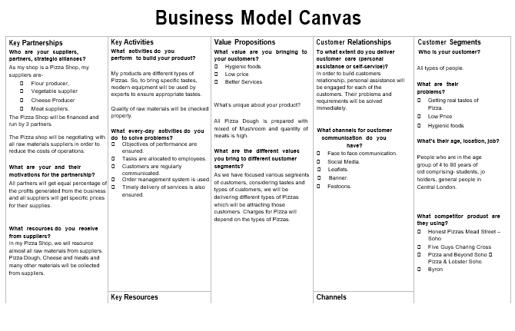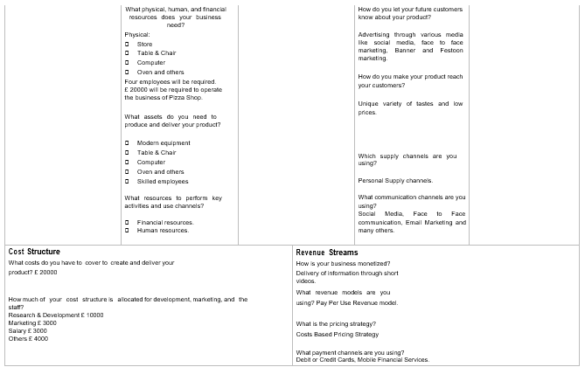
References
Barringer, B. R. & Ireland, R.D. (2018) Entrepreneurship: Successfully Launching New Ventures, 4th Ed., Prentice Hall: New Jersey
Williams, S. (2021) FT Guide to Business Start Up: The most comprehensive guide for entrepreneurs, 32nd Ed., Financial Times Press: Harlow. Recommended
Nelson, O. (2013) Enterprise development in SMEs and entrepreneurial firm’s dynamic processes. IGI Global.
Rickman, C., & Roddick, D. (2013) The Small Business Start-Up Workbook: A step-by-step guide to starting the business you’ve dreamed of. London, How to Books
Blackwell, E. (2011), How to Prepare a Business Plan: Planning for Successful Start-up and Expansion, (5th Ed) Sunday Times Business Enterprise Series, Kogan Page
Hisrich, R.D., Peters, M.P. & Shepherd, D.A. (2008) Entrepreneurship, 7th Ed.,McGraw Hill: NY
Mariotti, S. and Glackin, C. (2012) Entrepreneurship: Starting and Operating a Small Business (3rd Ed), London: Prentice-Hall.
Rae, D. (2008) Entrepreneurship: from opportunity to action, 2nd Ed., Basingstoke: Palgrave Macmillan
Timmons, J. &Spinelli, S. (2008) New Venture Creation: Entrepreneurship for the 21st Century, McGraw Hill: Boston
Zimmerer, T.W. & Scarborough, N.M. (2011) Essentials of Entrepreneurship, 6th Ed., Prentice Hall: New Jersey

