PROBLEM SOLVING AND DECISION MAKING
MODULE – BMSW-4004

LECTURER – Mr Kingsley Omeihe

NAME – Esther Akpanmkpuk
STUDENT ID – 2108030

A REPORT ON DECLINING PROFITABILITY FOR TM LEWIN

Table of Content

Introduction …………………………………………………………………………………….. 3
Problem solving & Decision making ……………………………………………………… 3

Abstract ………………………………………………………………………………………… 4

Ishikawa Diagram ……………………………………………………………………………… 5
What is the Ishikawa diagram ……………….……………………………………………..5/6
Root causes and solutions ……..…………………………………………………………..5/6

PESTLE Anaysis ….……………………………………………………………………………7/8

Evaluation ………………………………………………………….……………………………. 9
Plus, Minus, Interesting.………………………………………….……………………………9

Conclusion ……………………………………………………………………………………….10

References ……………………………………………………………………………………….11

INTRODUCTION

TM Lewin, a successful retail company well known for its men’s apparel and formal wear faced major challenges due to the pandemic. This had a significant impact on working standards for staff, as they had to commence working from home. Consequently, demands waned and pressure from inflation inevitably caused reduction of profit for TM Lewin.
This report is aimed to explore the nature and impact of declining profitability on TM Lewin and their employees, through a research informed discussion. An analysis of the complex problem using the Ishikawa diagram will be used to dissect the cause and effect. Joined with a PESTLE analysis to further analyse the macro environmental factors that contribute to the complex problem. Through extensive evaluation of both methods, this report will identify the most effective solution, whilst implementing a constructive plan to assist TM Lewin.

Problem Solving & Decision making

The importance of decision-making lies in the way it helps in choosing between various options. Oxford reference (2022) describes it as the process of acting upon the best information available in order to determine the most appropriate course of action. Due to the predicament TM Lewin faces, which may potentially undermine the continued existence of the business if not resolved. TM Lewin must decide on implementing a solution that will ease the decline in profit and eventually increase their profits. A solution which this report will give through an action plan. TM Lewin now only has to decide whether to implement it or not. The action plan is an effective method to solving TM Lewin’s problems as it will identify the clear goal and break down the problem into parts. Making it easier for TM Lewin to tackle in stages. This will slowly take effect, bringing stability if not increase in profit.
The manner in which a problem is solved is very important, as if done incorrectly could result in added problems. “Problem solving is the act of defining a problem; determining the cause of the problem; selecting alternatives for a solution; and implementing a solution” (asq 2022). According to an article by (Beate Eichmann 2018) problem solving involves four major processes: "exploring and understanding," "representing and articulating," "planning and executing," and "monitoring and reflecting." All which are detrimental to the success of solving a problem. The process of planning and executing however, involves the ‘setting of goals and sub-goals’ (Beate Eichmann 2018).
Abstract
Due to the pandemic which started in 2019, businesses like TM Lewin who have 68 stores in the UK as well as other retailers were subsequently affected most, due to majorly being store front companies. Government policies introduced to contain the spread of the virus meant shopping in person was no longer possible, TM Lewin having established 150 shops worldwide where no exception to the loss of consumers. “The increase in UK redundancy rates during the coronavirus pandemic is faster than during the 2008 to 2009 economic downturn” according to the data analysis from (Census 2021). The chart below shows the rise in redundancy in the wholesale, retail industries from January 2020 to November 2020.
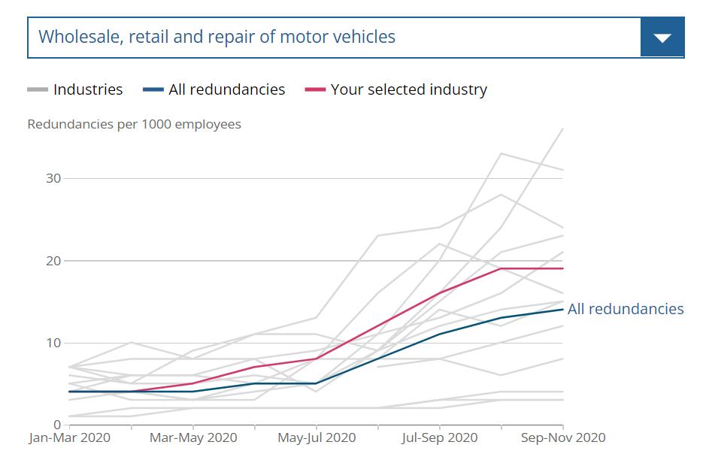
Census (2021)

The Shirtmaker company which employs around 50 staff had to follow the regulations to implement working from home for their staff. A solution which was meant to be short term, but only lifted after 12th April 2021. For TM Lewin’s staff, this brought its challenges, especially for employees who struggled with changes to working online. Changes such as routine change and interaction, as they would have to use online applications such as emailing, web chat and social media platforms e.g Facebook, Instagram to correspond with customers and deal with purchases. Unfortunately, the social advantages they had with colleagues and customers working in store would have been restricted.

ISHIKAWA DIAGRAM
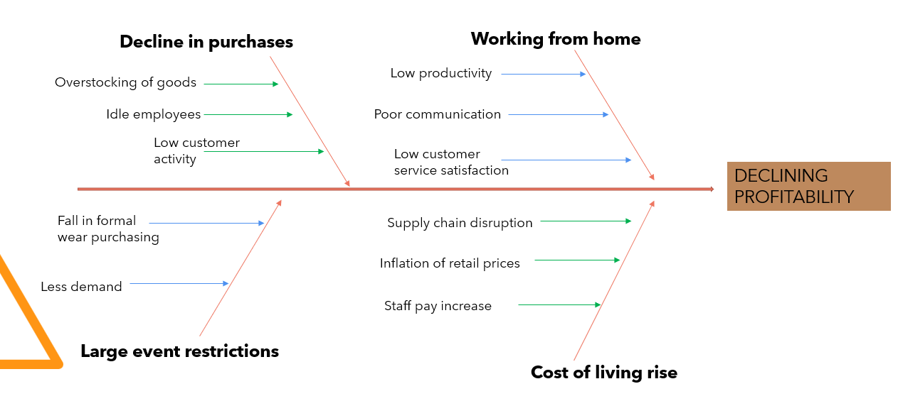
What is the Ishikawa diagram?

The Ishikawa Fishbone is a Cause-Effect Diagram that helps to find the Root causes of any type of Problem. It is known as the Fishbone Diagram because of its resemblance to a Fishbone. (Consunnt 2022)
The diagram identifies the main issues as:
Decline in purchases – As a result of the restrictions, customers are less persuaded to buy clothing, leading to low customer activity online and subsequently idle employees, as they have a low rate of customers to help or interact with. Overstocking of goods, as the rate of purchases does not meet the stock purchases. To overcome this TM Lewin will have to adapt to current ways of marketing. Using technology to market their brand, create advertisement for seasonal wear. This will work as bait for customers to click and browse their website and buy. Employees will have a project to work on e.g Christmas poster/ advert, a way to keep them productive by designing and creating adverts. To reduce overstocking, TM Lewin will have to invest in inventory software to be able to store data from their online sales and predict future sales so they can buy stock according to what will be needed.
Large event restrictions – Due to popular events such as weddings and birthday’s being stopped, there is less demand for formal wear. Unfortunately, since this is a government policy, it cannot be changed. However, TM Lewin can work around promoting their clothing for when restrictions are ease or lifted. This will keep customers on their toes and anticipated to celebrate and occasion they were not able to celebrate over lockdown. E.g. anniversary.
Cost of living rise – Cost of living impacts both TM Lewin and their customers due to inflation of prices, customers can not pay because the price is high and because of the need to prioritise more important purchases like electricity and gas.
It causes a supply chain disruption for TM Lewin as their stock may be delayed or not of the best quality due to change for a more affordable material. There has been a decline in retailers buying stock from foreign countries such as China. Fellow company Charles Tyrwhitt is just one of dozens of multinationals scaling back manufacturing in China due to such concerns. As China was reported to be the country the pandemic first broke out from, consumers are less inclined to purchase goods that are manufactured from the company. Harriet Denny’s reports that the “british shirt-maker Charles Tyrwhitt is scaling back manufacturing in China after customers said they no longer wanted to buy products from the country” (Dailymail 2021). To overcome this, TM Lewin may have to look for the best manufacturing company, without limiting their search to one country. One that offers a more stable pricing option without losing the quality of material and won’t greatly impact their stock prices.
As well as this, cost of living rise means that TM Lewin would have to increase their staff wages so they can meet the demand of living. Even by a few pounds makes a great impact on their profit, especially when customers are not buying as regularly anymore. TM Lewin will inevitably loose profit due to this but can even their profits to not much loss by being able to put prices up with awareness of the cost of living on customers.

Working from home – Due to working from home regulations there is a risk of decrease in customer service satisfaction, because of employees interacting online, it is easy to miscommunicate or misunderstand. This also brings challenges to communication, poor communication between management and staff is a concern if the right channel of communication is not established. To prevent this, management most establish a stable way to communicate with their staff, that is accessible for everyone. The most effective channel is using Teams or Zoom. This way important information is easily communicated, and staff can share their problems and ideas with the team. Low productivity also comes to play, as staff may easily loose motivation to work especially with not having a lot of customers to keep them busy. The motivation to market the brand will be low due to not being able to have social interaction. Proficient training given every 3 months should be established to prevent or overcome this challenge. It will keep employees refreshed with new ways to interact with their customers as well as employee activities to keep them motivated on the quiet business days. Creating teams to do this together will increase excitement and socialising.
PESTLE ANALYSIS

What is PESTLE?
PESTLE is a mnemonic which in its expanded form denotes P for Political, E for Economic, S for Social, T for Technological, L for Legal, and E for Environmental. It gives a bird’s eye view of the whole environment from many different angles that one wants to check and keep a track of while contemplating a certain idea/plan. (Pestle 2022)

Political - Political factors are important. Due to the imposition of lockdown limitations, organisations such as TM Lewin, which is partially a brick-and-mortar corporation, are forced to shift their workers to work from home. With 150 outlets, this shift has had a significant impact on customer activity and productivity.

Economic - Consumer purchasing decisions are greatly influenced by the cost-of-living rise, which affects consumer spending owing to price inflation, resulting to a drop in profit for TM Lewin. Not only are they not achieving optimal sales but can result to overstocking. In such an unpredictable environment, the expectation for consumer demand to be low may change and could increase during certain times of the year, such as Valentine's Day. Because TM Lewin is a retail organisation, customers may look for formal attire for an indoor celebration. This will result in supply chain issues, making it more expensive to stock merchandise and diminishing earnings.

Social - Retail industries, heavily depend on different demographic and socio-cultural factors. As a company that sells formal wear, arguably the demographic which TM Lewin targets are older and more mature, however being a well-known British brand, it is possible to diverse to the younger demographic. One of the UK’s most popular events, includes prom. An end of high school event, organised by schools in the UK, once a year as a formal congratulatory party for those in their final year of secondary school. It is a recognised British tradition and as such, requires students to be in their best and formal dressing. This is a great example TM Lewin’s inclusion of the younger demographic. However, due to the pandemic, a lot of social events requiring large groups of people were restricted. This change to social behaviours majorly affected TM Lewin's ability to sale into the large events cliche in ANY demographic which declined their profit majorly. Cultural and religion celebration which happens all year round, would be heavily impacted resulting to a decrease in demand for custom made formal wear.

Technology - TM Lewin will have difficulties because of reassigning their workers to work from home. Challenges include technological complications caused by employees' lack of IT literacy, a lack of employee enthusiasm developing low customer satisfaction rate. Companies have had to teach their employees online on a new company structure due to the abrupt lockdown restrictions. Training all employees in such short period of time necessitates careful planning. Planning that organisations like TM Lewin may not have had enough time to make. As a result, workers may lack basic and correct knowledge, leading to customer dissatisfaction and a decrease in purchasing. In addition to this, because the majority of worker in the uk are based online, this will lead to high internet penetration, meaning staff may see delays in service.

Legal – A few laws that TM Lewin as a retailer had to follow where sale of goods act, which meant goods sold must be of good quality. This restricts TM Lewin from perhaps looking for a cheaper manufacturing alternative that will ease their supply prices and price of goods. This is because most cheaper alternatives have issues with being of bad quality. This falls into the Unfair terms in consumer contracts regulations. This law is to ‘exclude the retailer’s liability for delays or failure to perform, and terms allowing the retailer to change the price at a whim may all be deemed unfair’ (Pete Maguire 2017). This ultimately makes it a problem if TM Lewin can not deliver their goods within a time frame which working with supply chain delays during the pandemic, puts them at risk. (CIPD) Further adds for the disability and discrimination law, that ‘people with a disability or long-term health condition do not face additional barriers in recruitment, at work, or when accessing training.’ Due to this, employees that work for TM Lewin, who have disabilities would have the biggest readjustment to working from home. Not just for their mental health but with training and using of technology when they can’t physically get any assistance. Having to close their stores, this will mean a much lower crime rate.

Environmental – The main environmental challenge that TM Lewin faces is that of getting supply from countries that are probable to natural disasters and extreme bad weather. Which will cause delays in supply for TM Lewin.
EVALUATION
Two solutions how TM Lewin can stabilise their profits which have been put through the plus, minus and interesting method. This methos will indicate which solution is best of the two and why.

Solution 1: Find a new affordable supplier
Plus + | Minus - | Interesting
Cheaper Supply prices (+4) | Long search time due to quality check (-3) | Could find a better deal (+2)
No retail inflation (+4) |  | Different Shipping times and routine change (-2)
Score = 8 | Score = 3 | Score = 2 | Total = 7

Solution 2: Training on Marketing strategy
Plus + | Minus - | Interesting
Employee productivity & motivation (+3) | Requires a lot of time (-2) | Promotes the brand in a fun way (+1)
Customer online engagement (+4)
Score = 7 | Score = 2 | Score = 1 | Total = 6

CONCLUSION

Action Plan
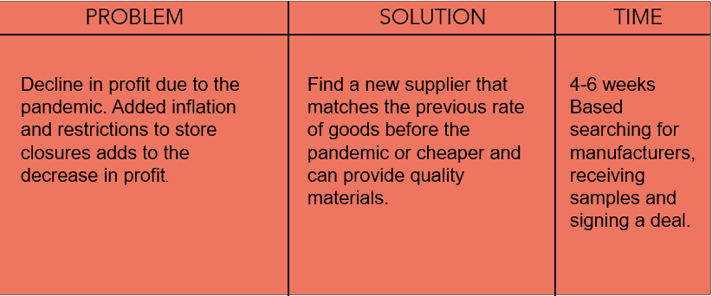
For this plan to be successful, TM Lewin must make sure that they deliberate carefully and choose the right manufacturer that meets their needs as a brand. To be able to uphold their quality which is what they are well known for.

This study evaluation the case of TM Lewin. Their journey through the pandemic and the macro environmental factors that played into their complex problem, which was declining profit. In conclusion study has shown that the most effective solution for TM Lewin, is for them to find a new supplier for their clothing. Despite the time this will take to do, if thorough search is done, not limiting them to one country but worldwide they will be able to find a supplier that will agree to their terms or possible as close to their terms as possible. This will either increase their profit or stabilise their profit to a rate that is affordable for them to manage, this will be as a result of not needing to raise their retail prices and if so not much and can work with their online marketing to promote their products on a fair and even price.

REFERENCES

Asq 2022 What is problem solving – Online
https://asq.org/quality-resources/problem-solving
Beate Eichmann (2018) The role of planning in complex problem solving - Online
https://www.sciencedirect.com/science/article/pii/S0360131518302082#bib4
CIPD Disability at work – Online
https://www.cipd.co.uk/news-views/viewpoint/disability-work
Census 2021 Coronavirus and redundancies in the UK – Online
https://www.ons.gov.uk/employmentandlabourmarket/peopleinwork/employmentandemployeetypes/articles/labourmarketeconomicanalysisquarterly/december2020
Dailymail (Harriet Dennys 2021) Charles Tyrwhitt is scaling back shirt-making in China after customers complained about the government in Beijing – Online
https://www.dailymail.co.uk/news/article-9106997/Charles-Tyrwhitt-scaling-shirt-making-China-customers-complained-government.html
Oxford reference (2022) Decision Making Definition – Online https://www.oxfordreference.com/view/10.1093/oi/authority.20110803095705774
Pete Magure 2017 Must know legislation for retailers
https://www.wrighthassall.co.uk/knowledge-base/must-know-legislation-for-retailers
Pestle 2022 Pestle Analysis – Online
https://pestleanalysis.com/what-is-pestle-analysis/

