

International Business Communications

"The Cultural Differences: Establishing a Management Office in Germany for Tesco”

Student name: Ana-Maria Ciobanu
Student ID:2123843
Module code: LCBB6001
Lecturer name: Dr Charles Nwaogwugwu
Table of Contents
Introduction 3
The German Culture 4
Success and failure factors of succeeding In Germany 5
Cultural Sensitivity in Germany: 6
Understanding Cultural Dimensions: UK and Germany 7
Hofstede Cultural Dimensions: UK vs. Germany (Cont.) 8
Hofstede Cultural Dimensions: UK vs. Germany (cont.) 9
Recommendations 11
Conclusion 12
References 14

Introduction
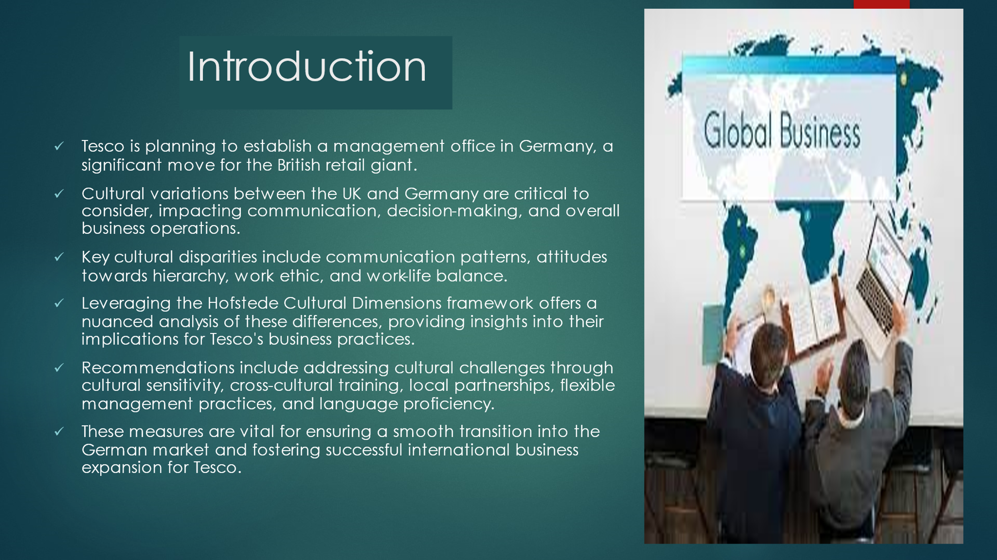
Tesco is a well-known British retailer is preparing to set up an office for management in Germany. Understanding cultural differences is vital for this venture, since the differences in the process of communication, decision-making, as well as general business operations. The major cultural differences in those in the UK and Germany include communication styles and attitudes to the hierarchy of work and work-life balance. The Hofstede Framework for Cultural Dimensions permits an in-depth study and analysis of the disparities and provides insight into the implications to Tesco's practices in business (Chouaibi et al., 2022). The recommendations are designed to tackle challenges in the field of culture and to ensure that the transition is smooth into Germany. German market, highlighting the importance of intercultural sensitivity, cross-cultural learning and local partnerships, as well as flexibility in management practices, as well as the ability to communicate in German. These are the essential elements for the successful expansion of international business for Tesco.

The German Culture
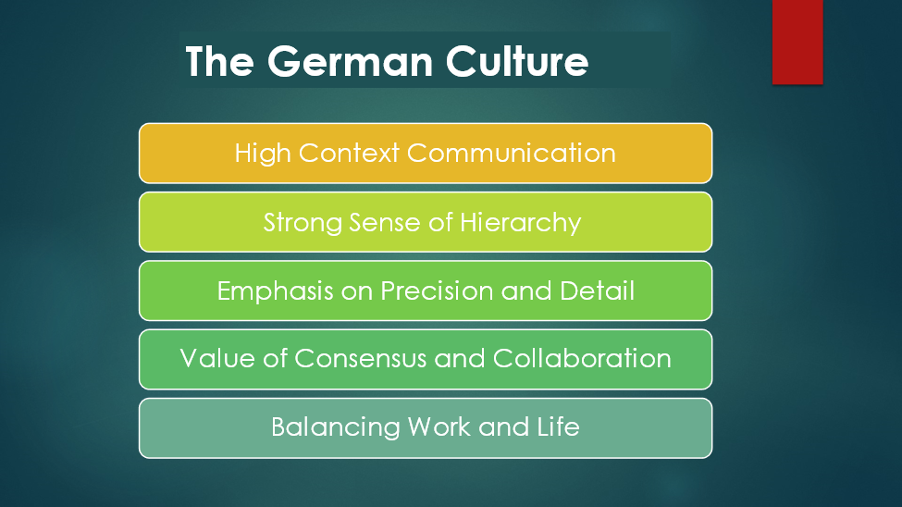

- High Context Communications: German culture tends to favor high-context communication in comparison with the UK, which is heavily reliant on the context, non-verbal cues and implicit knowledge, rather than verbal explicit communication. This can affect the way Tesco interacts with German counterparts.
- Strong sense of Hierarchy In contrast to the more streamlined organizational structures that are commonly used throughout the UK, German companies often have a more pronounced sense of the hierarchy and respect for authority that clearly define the roles and responsibility. Understanding and managing the hierarchical structure is crucial for Tesco's management team in Germany (Manhart et al., 2020).
- Emphasis on precision and Detail: Germans are renowned for their focus on specifics and precision in both personal and professional situations. The same attention to detail is evident in their professional ethics in punctuality, punctuality, and adhering to the rules and regulations. Tesco's business operations in Germany should be in line with the expectations of German culture to ensure efficiency and efficiency (Deissinger and Gonon, 2021).
- Consensus and Collaboration Teamwork is a valued trait in both the UK as well as Germany, Germans tend to place a high value on consensus-building and collaboration when it comes to decisions. Tesco might need to alter the way it makes decisions to incorporate the input of all stakeholders prior to making decisions, which is in line with German culture norms.
- Balancing Life and Work: Germans place a large emphasis on having the balance of work and family life. This is accomplished through reduced working hours, plenty of vacation days and a society which values leisure and time with loved ones and family. Tesco's management strategies in Germany must be based on these values of the culture to ensure employee satisfaction and efficiency.

Success and failure factors of succeeding In Germany
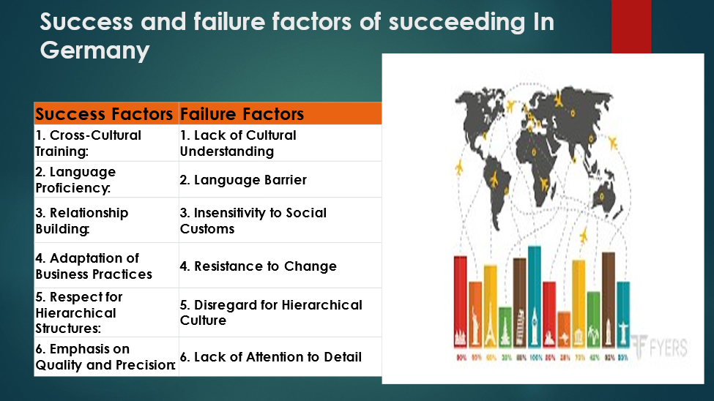
Many crucial elements must be in place to allow a British multinational such as Tesco to be able to establish a managerial office located in Germany. Employees can avoid conflicts and miscommunications by studying German business etiquette with an extensive cross-cultural education. So, investing money in training in German can improve communication and teamwork in a German business. German language environment. Thirdly, putting relationship-building first and adhering to German societal norms fosters rapport and trust among stakeholders (Brown et al., 2020). Furthermore, the flexibility and adaptability are shown through its ability to change the corporate procedure to be more in line with German preferences. Tesco is a reputable company within the German market because of its reputation as reliable and exact and its strict adhering to the hierarchy. If these aspects aren't addressed and thought of in a timely manner, there may be miscommunications between cultures or resistance to change or harm to the brand. This could make it more difficult for Tesco to remain on top of market competition in the German market. Due to this, Tesco must take the time to think about these factors when deciding whether or not to open a managerial branch in Germany.

Cultural Sensitivity in Germany:
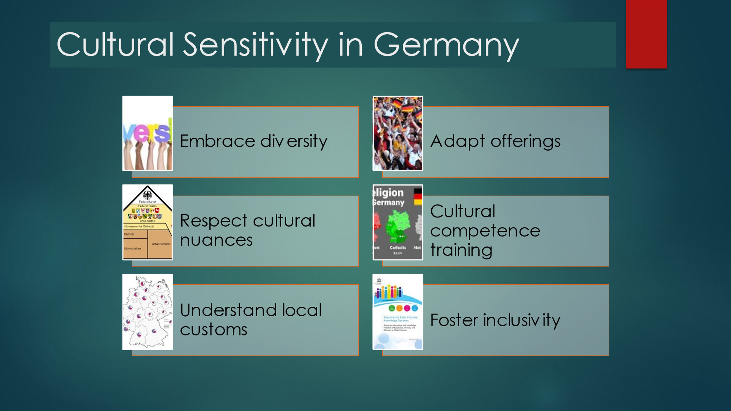
To definitely navigate to be successful in the German market Tesco must give consideration to cultural diversity when establishing an office. To allow Tesco to succeed in the German business climate and to build strong relationships with its customers it is crucial that it understands the local culture. To encourage tolerance and engagement, Tesco should priorities embracing the diversity of its customers, tailoring products to the local market and embracing those subtle differences in culture in Germany. German market. Tesco's challenges in foreign markets like the US are an illustration of how vital the ability to communicate with customers in a culturally competent manner is. Tesco's US experience, in which it was forced to shut down its stores due to low sales, highlights how crucial the ability to be sensitive to culture is essential important for international business endeavors. Tesco should conduct in-depth study of German different cultures as well as attitudes, values, and beliefs that impact business relationships to acquire insight from its mistakes in the past (Ermasova and others. 2021). Tesco could be able to anticipate and address possible issues arising from differences in culture in Germany by equipping its employees with cultural competency training. Through this program, Tesco employees will be more prepared to navigate the cultural differences by understanding how Germans in Germany think, behave and conduct business. Additionally, promoting an inclusive workplace, as stated in Tesco's policies on diversity and inclusion, can rise the reputation of the company and its effectiveness in Germany.

Understanding Cultural Dimensions: UK and Germany
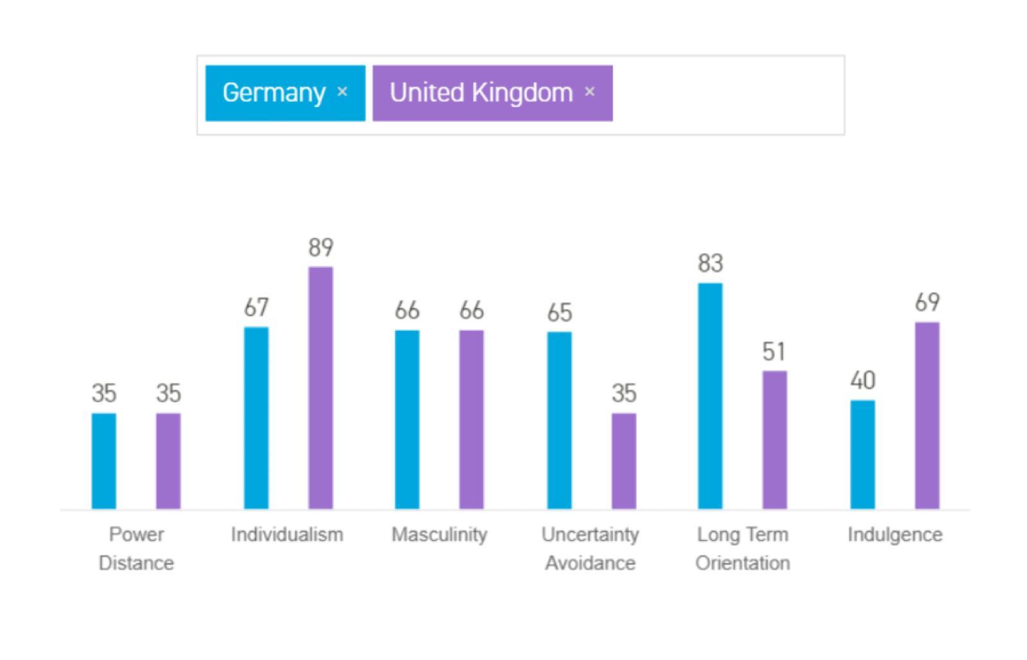
The Hofstede Cultural Dimensions framework, advanced by Geert Hofstede, presents insights into cultural disparities among international locations through six dimensions: Power Distance, Individualism vs. Collectivism, Masculinity vs. Femininity, Uncertainty Avoidance, Long-Term Orientation vs. Short-Term Orientation, and Indulgence vs. Restraint. This presentation delves into the cultural variances between the UK and Germany making use of this framework (Zeller, 2022). By examining these dimensions, we are able to parent differences in hierarchical structures, values towards character autonomy, attitudes toward assertiveness and nurturing, methods to uncertainty and chance, perspectives on time orientation, and attitudes in the direction of indulgence and gratification. Understanding these variations is important for the successful established order of a management office in Germany by using Tesco.

Hofstede Cultural Dimensions: UK vs. Germany (Cont.)
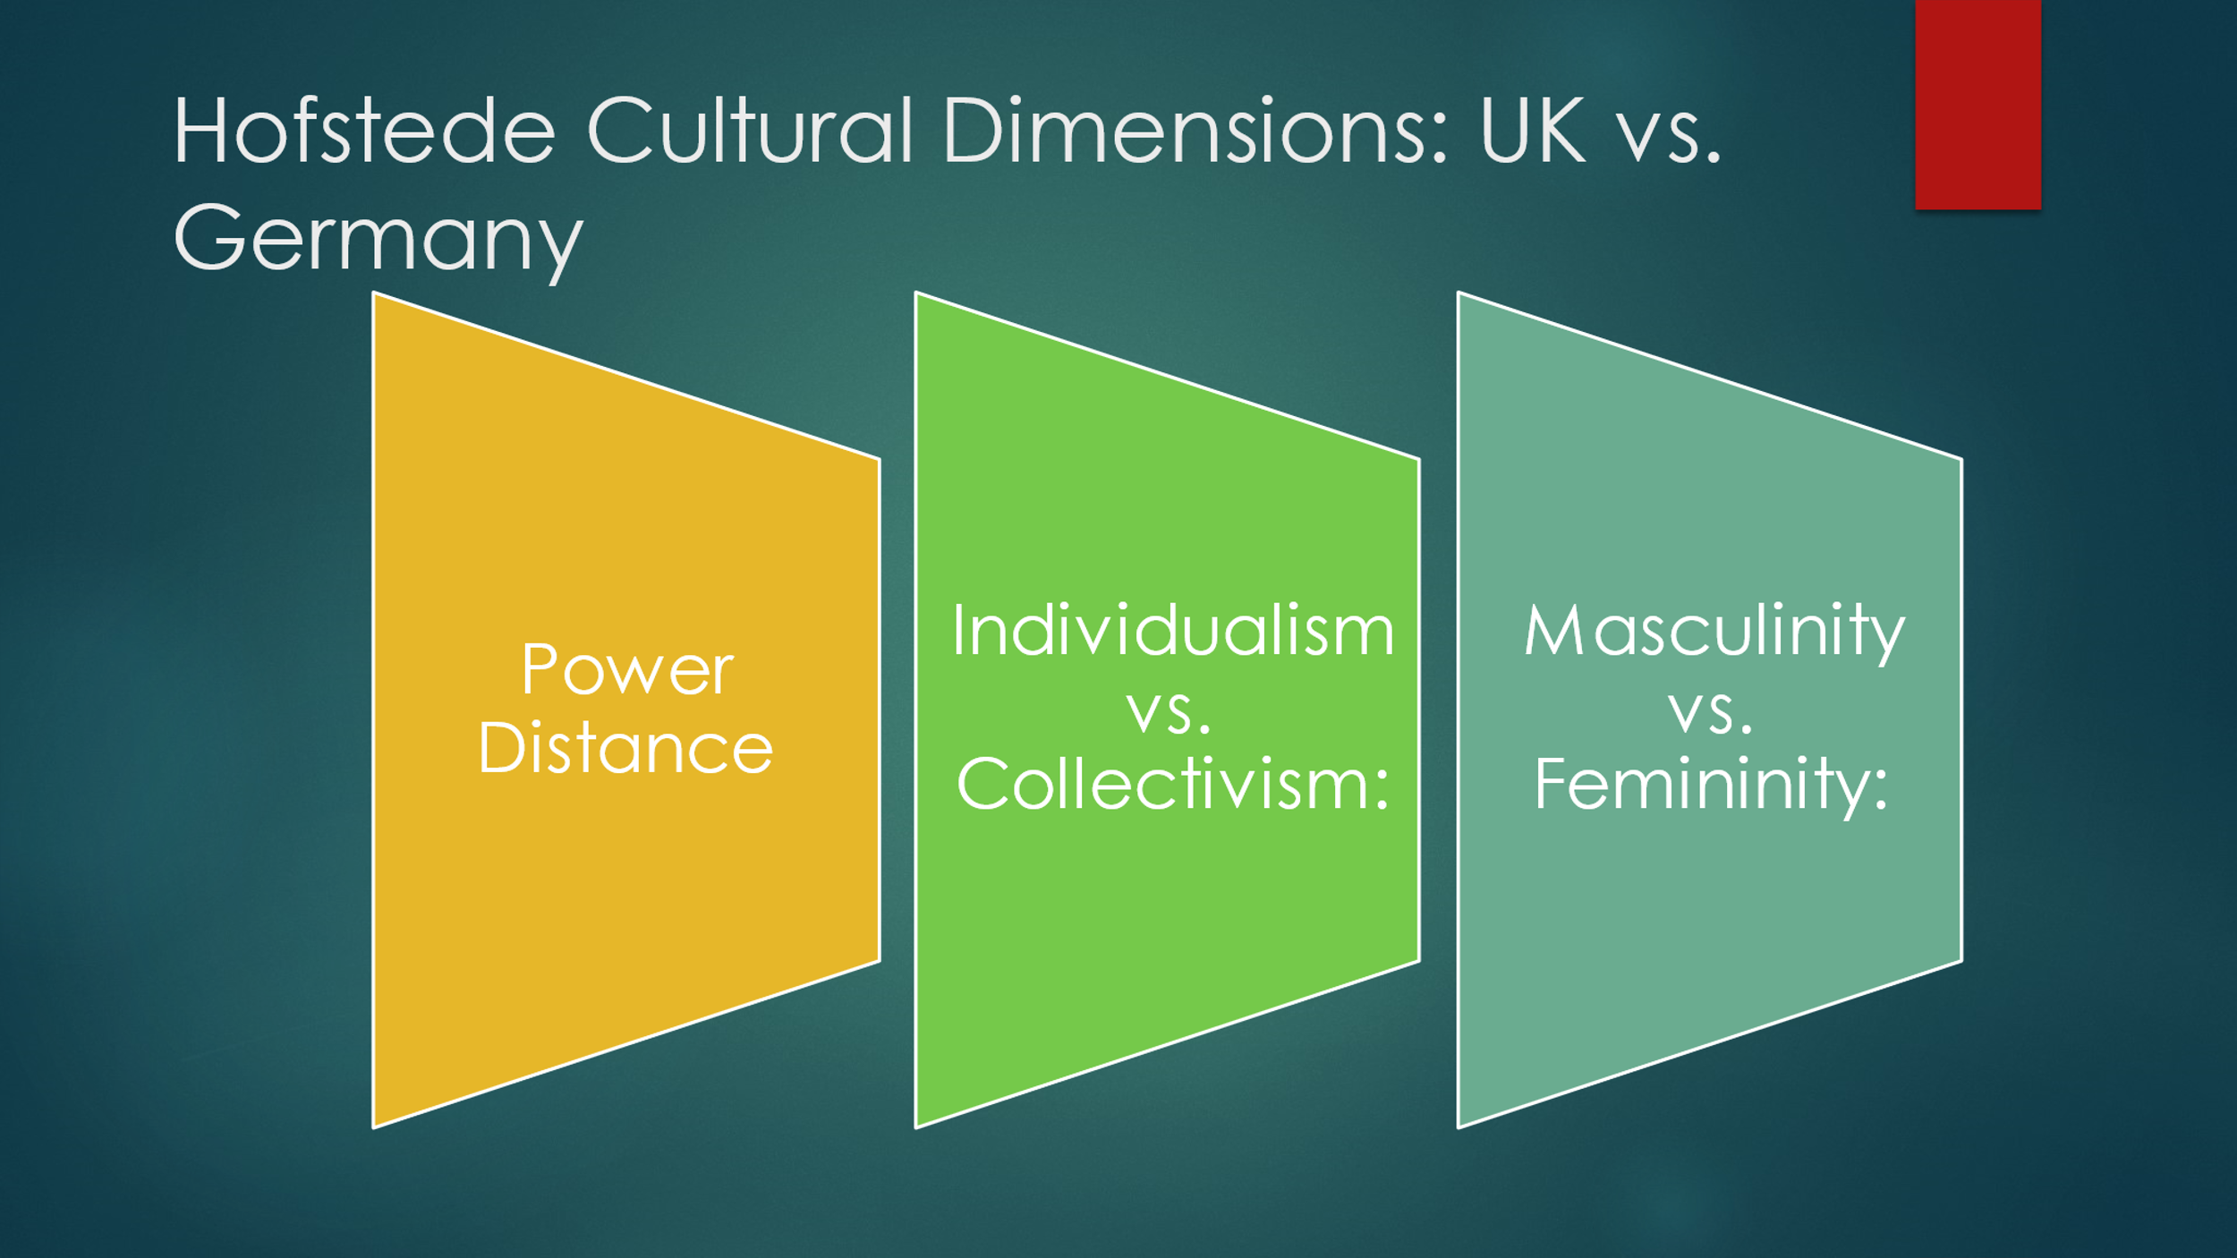The Hofstede Cultural Dimensions display awesome differences among the UK and Germany. In terms of Power Distance, while the United Kingdom exhibits moderate reputation of hierarchy, Germany prefers flatter organizational structures. Regarding Individualism vs. Collectivism, the UK leans closely closer to individualistic values, prioritizing autonomy, while Germany moves a balance among character wishes and organization concord. In Masculinity vs. Femininity, both countries proportion mild masculinity, valuing assertiveness and achievement, but also emphasizing nurturing and pleasant of existence (Li et al., 2022). These cultural nuances spotlight the need for tailored processes in organizational structures, communique styles, and control practices for Tesco organizing a control office in Germany, ensuring alignment with the triumphing cultural values.

Hofstede Cultural Dimensions: UK vs. Germany (cont.)
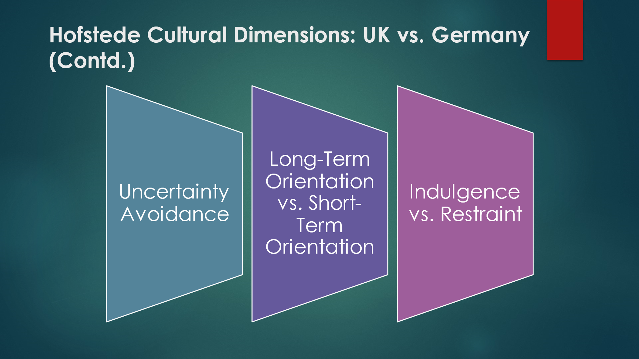In the Hofstede Cultural Dimensions between the UK and Germany, variations in Uncertainty Avoidance are obvious, with the United Kingdom embracing change whilst Germany prefers structure. Regarding Long-Term Orientation vs. Short-Term Orientation, the UK makes a specialty of on-the-spot outcomes, contrasting with Germany's emphasis on lengthy-time period making plans. Lastly, in phrases of Indulgence vs. Restraint, the United Kingdom promotes enjoyment and enjoyment, while Germany presentations a greater limited approach to gratification (Deissinger and Gonon, 2021). These differences underline the need for nuanced strategies in organizational planning, communication, and control for Tesco organizing a control office in Germany. Understanding and adapting to these cultural disparities will facilitate a hit integration and operations in the German business environment.

Recommendations
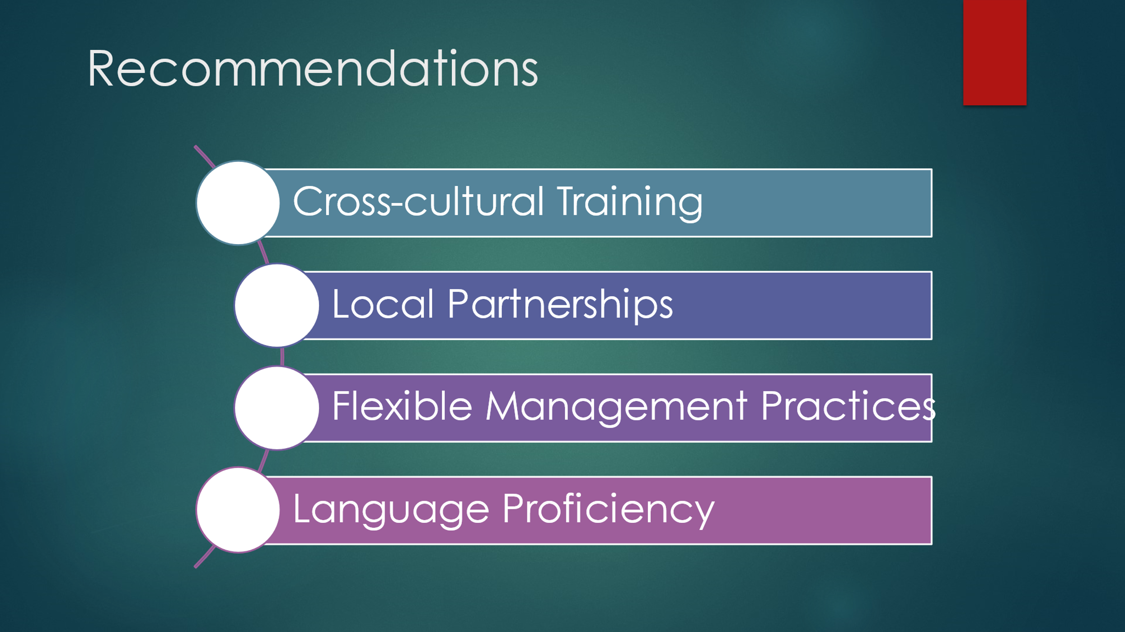

1. Cross cultural training: It's the right time for Tesco to establish comprehensive cross-cultural programs for employees who are planning to move to Germany. The goal of these classes should be to instruct people how to behave in social settings in Germany in addition to the proper manners of business and culture. behavior.
2. Local partnership: Tesco may form strategic alliances with German businesses in the region and with professionals who know much concerning Germany. German market. This is the German market. These connections can help Tesco ensure that its activities conform to local regulations and provide them with useful information on how to handle minor cultural differences (Loft, 2020).
3. Flexibility Management practices: Tesco must change the way it operates and the way it manages its employees in order that it can be able to adjust to the different ways people interact and work in Germany and in the UK. With this change, Tesco will be better in its ability to compete in those in German market. This will also contribute to an open and collaborative workplace (Manhart et al., 2020).
4. Language Proficiency: It is essential for employees to develop their German proficiency to be able communicate better and establish contacts with German colleagues. Tesco can assist you in learning the language through the opportunity to exchange with other people or taking language classes.

Conclusion
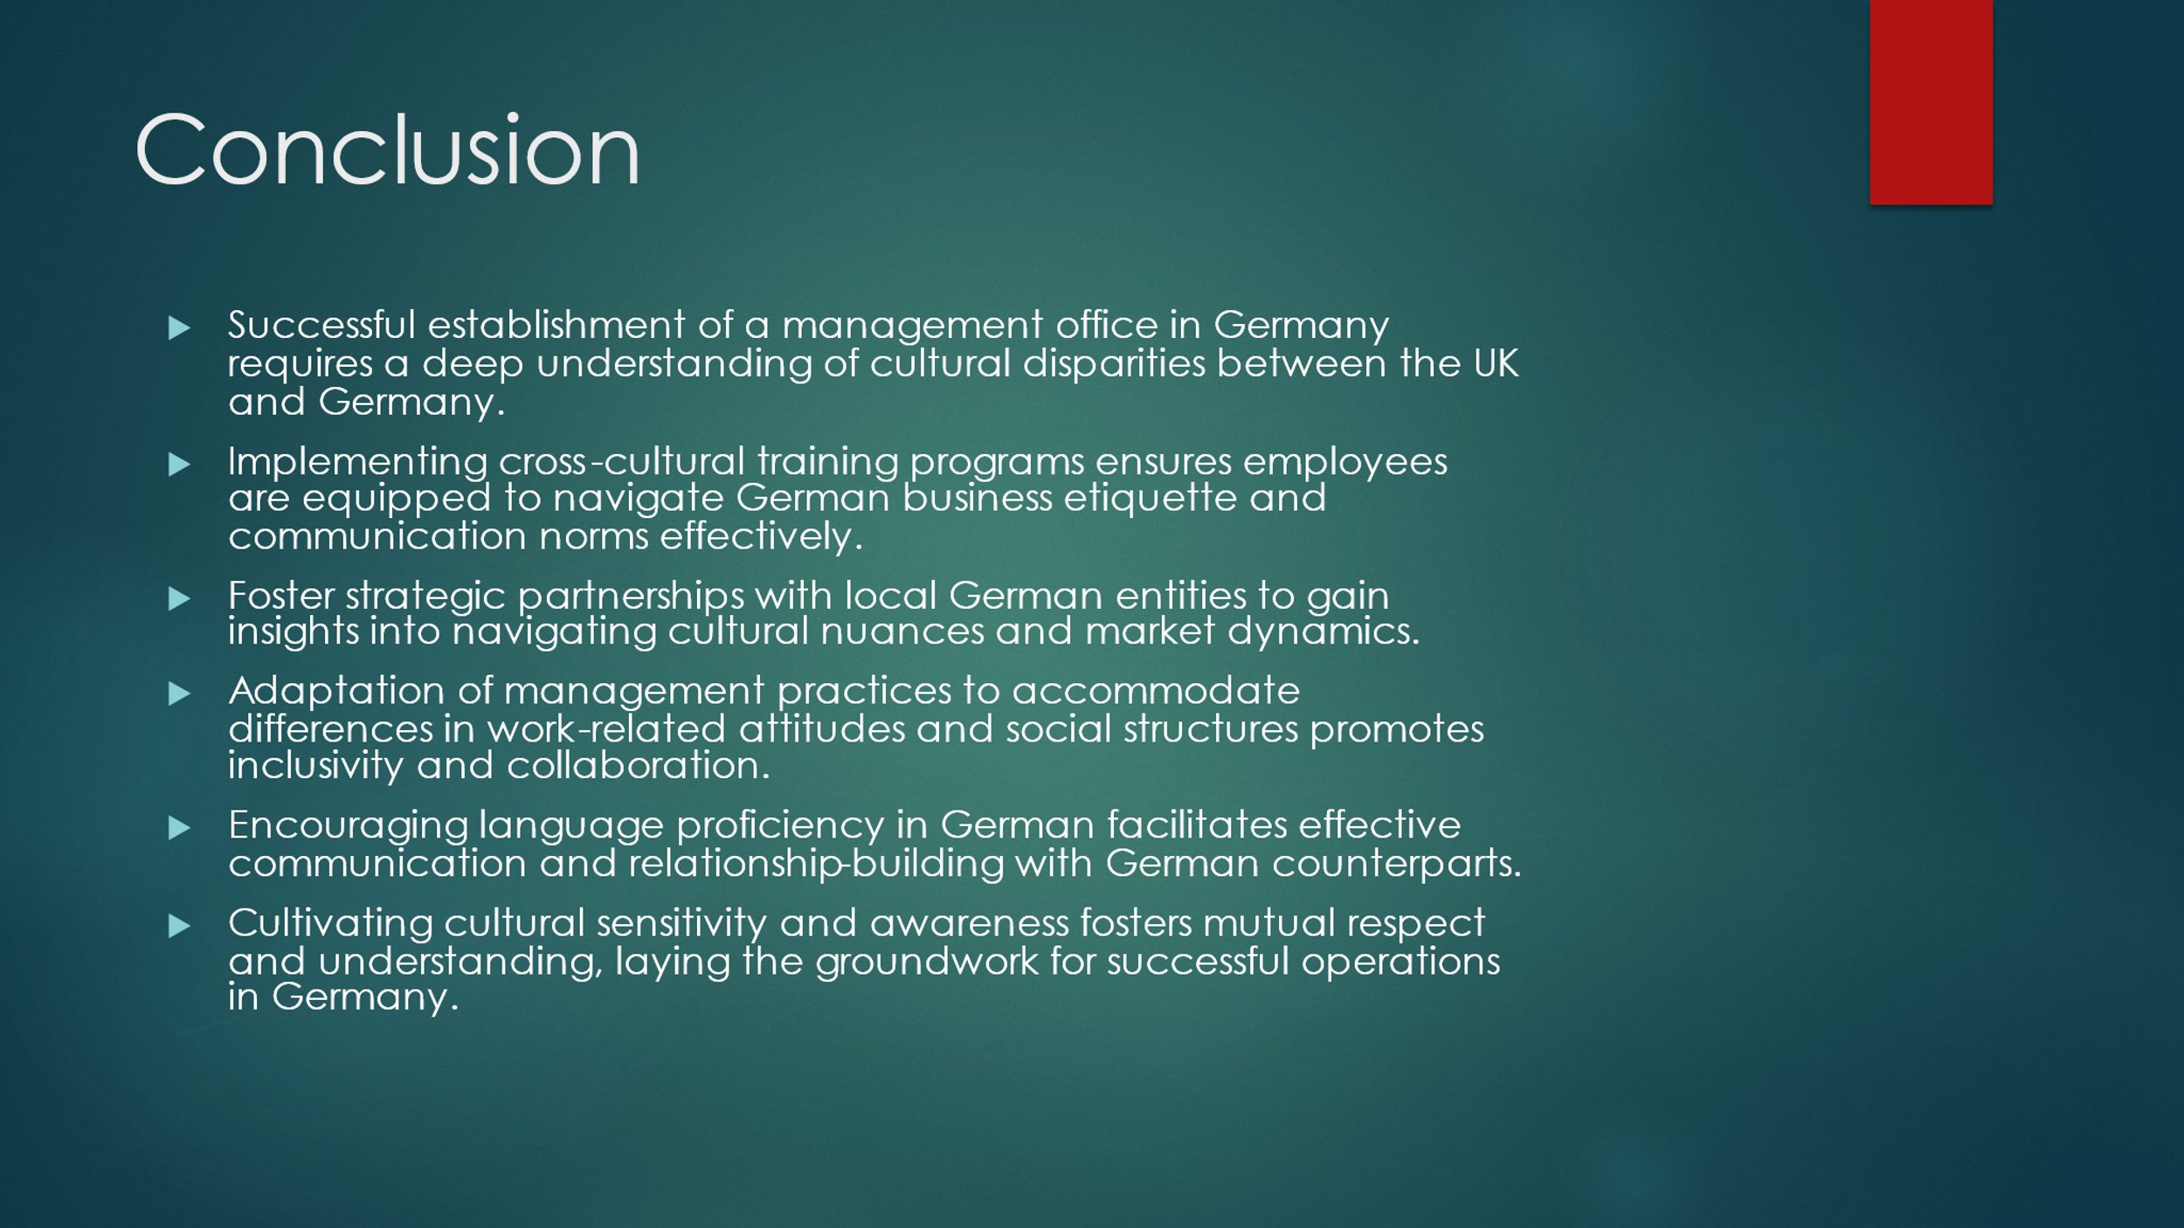
Tesco must be aware of the differences in culture in Germany as well as the UK to be able to establish an office for their management team to work located in Germany and make the country their home. The employees at Tesco must undergo special training in culture to be able to speak and behave in a professional setting in German. Tesco's growth plans are supported by smart collaborations with German groups in the region that provide information about the market and differences in culture (Brown et al., 2020). In light of the various ways that people interact and work within the UK and in the US, Tesco may also modify its policies to encourage collaboration and diversity. A workforce who is flexible in their language and can speak German well will be able to establish relationships and communicate with regional partners (Manhart et al., 2020). Promoting the Tesco approach to business helps build trust and respect and creates the foundation for the future success of business ventures in Germany. Tesco can easily deal with cultural differences and continue to be a part of Germany market.

References
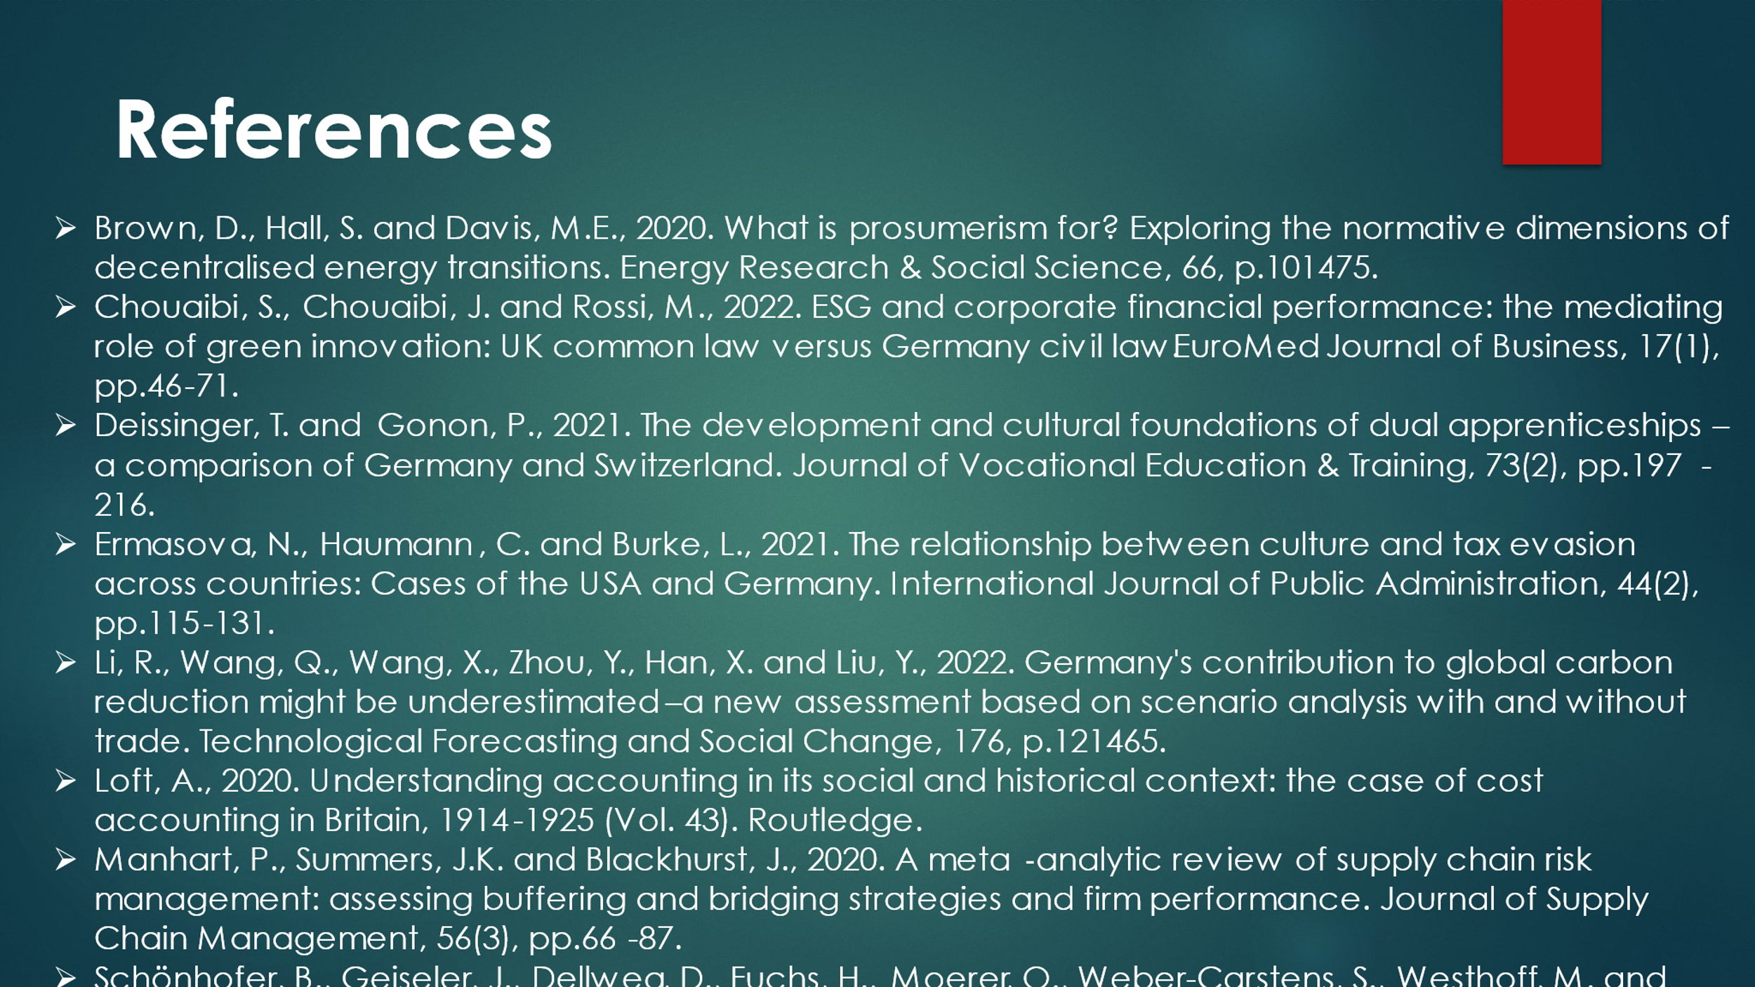Brown, D., Hall, S. and Davis, M.E., 2020. What is prosumerism for? Exploring the normative dimensions of decentralised energy transitions. Energy Research & Social Science, 66, p.101475.
Chouaibi, S., Chouaibi, J. and Rossi, M., 2022. ESG and corporate financial performance: the mediating role of green innovation: UK common law versus Germany civil law. EuroMed Journal of Business, 17(1), pp.46-71.
Deissinger, T. and Gonon, P., 2021. The development and cultural foundations of dual apprenticeships–a comparison of Germany and Switzerland. Journal of Vocational Education & Training, 73(2), pp.197-216.
Ermasova, N., Haumann, C. and Burke, L., 2021. The relationship between culture and tax evasion across countries: Cases of the USA and Germany. International Journal of Public Administration, 44(2), pp.115-131.
Li, R., Wang, Q., Wang, X., Zhou, Y., Han, X. and Liu, Y., 2022. Germany's contribution to global carbon reduction might be underestimated–a new assessment based on scenario analysis with and without trade. Technological Forecasting and Social Change, 176, p.121465.
Loft, A., 2020. Understanding accounting in its social and historical context: the case of cost accounting in Britain, 1914-1925 (Vol. 43). Routledge.
Manhart, P., Summers, J.K. and Blackhurst, J., 2020. A meta‐analytic review of supply chain risk management: assessing buffering and bridging strategies and firm performance. Journal of Supply Chain Management, 56(3), pp.66-87.
Schönhofer, B., Geiseler, J., Dellweg, D., Fuchs, H., Moerer, O., Weber-Carstens, S., Westhoff, M. and Windisch, W., 2021. Prolonged weaning: S2k guideline published by the German respiratory society. Respiration, 99(11), pp.982-1084.
Zeller, T., 2022. Driving Germany: The Landscape of the German Autobahn, 1930-1970. Berghahn Books.

