Section 1: What?

Background:

Weather is a difficult thing to predict with 100% accuracy but it influences everyone across the globe differently. The way it can affect someone daily life can be something as mild as rain or something extreme like a hurricane.

This and our in born curiosity of a world around us created a need for a methods of predicting and minimizing negative effects that weather can have on our life. To this end we have created large Weather Stations that allow us to gather and store meteorological data, in a certain degree allowing us to predict weather in a region.

In modern society common citizen does not always have time to watch a weather forecast, or is only interested in his local area, which can lead him to buy a small home weather station, but current market only has two ranges of products to choose from.

On the bottom he has a cheap Station with maximum of two sensors with varying accuracy which may be enough for their needs and on the other end he has expensive weather station with wide variety of accurate sensors but this may be too much for their needs.

In this situation this projects seeks to design affordable alternative in the middle with an option to extend or shrink their weather station as they see fit by removing or adding modules, to suit their needs.

In the late stage of this project give them option to subscribe to a service allowing them to easily view meteorological data for their specific area without a need to buy a weather station. This would be achieved by connecting to a weather station located in their neighbourhood, bought either by local council or with shared funds from people in their area.

Idea of this project was conceived as a part of 2nd Year Electronics Engineering course in University of Wales Trinity Saint David by two students.

Purpose:

This project’s purpose is to design & construct an affordable and accurate Weather station, with option to add or remove modules of the system to suit customers needs. In the initial stages of this project the weather station will only contain 4 sensors those being: Temperature/Humidity, Rainfall and Wind Speed/Direction.

Unfortunately it will not be possible to add or remove a module this future will be added as a part of the later stages of the project.

Objectives:

- The prototype of the weather system will be built.
- The system will be up to strict industry standards.
- The system will contain 4 sensor types.
- The unique selling points will be identified.
- The market will be thoroughly researched.

Scope: (say what it will do)

- Resources
- Time
- Man Power

Deliverables:

- Working Simulation
- System Prototype
- Market Research Results
- Unique Selling Points

Constraints:

- Time
- Budget
- Hardware/Software
- Working Space

Authority:
Stakeholders
Project sponsor
Project manager/team

Section 2: Why?

Business Case:

Benefits:

This project is being carried out for three reasons first being it’s a part of multiple modules in HND Electronics Engineering second year, second being to see if already tried concept with few unique modification can make it in the modern market and last is to test capabilities of the team members.

There are few benefits to be taken from this project most important one is its contribution to multiple modules all of which add to completion of the second year with pass or higher grade. Second is if this project to be market worthy it could enable the team to start a real company. Third reason is it enables the team to extend their skill and knowledge range by working on this project. Last reason is that it will look well on the CV, increasing employability.

Options:

- Hover Rod
- Magnetic Stairs
- Clock Robot

Cost and Timescale:

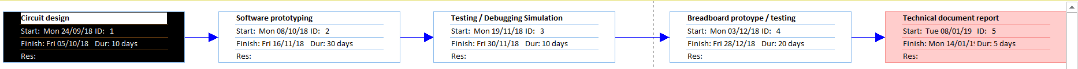

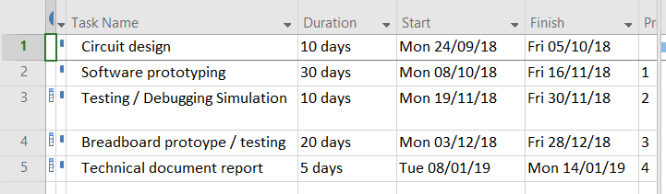

Risk Analysis:

Risk Identification:

- Insufficient funds
- Insufficient equipment
- Insufficient expertise in later stages
- Hardware Malfunctions
- Software Errors
- Market rejection

Risk Prevention:

- Sell the idea to a wealthy sponsor
- Create extensive project plan and consider mass manufacturing
- Seek to acquire new talents as required
- Use higher quality components and good circuit design
- Release updates as they are required
- Circulate questionnaires and investigate competition

Risk Management:

- This risk can be easily avoided by speaking to multiple sponsors with a sales pitch but continued sponsor support is essential. To keep sponsors regular progress updates will be provided. If everything else it will be necessary to seek a new sponsor.
- This risk can be easily avoided by creating a extensive project plan and discuss mass production costs, it will also help to speak with various manufactures to try get cost estimate. Also new equipment can be acquired as needed. If everything fails the team will have to do with what they have on hand or re-evaluate priorities until the problem can be resolved.
- This risk is avoidable with a long term planning covering what and when new skills and talents will be required for the work on the project to cover or alternatively existing team members will need to expand their knowledge in other fields. If this fails the team will need to carry on working on other parts of the project while searching or expanding their own knowledge in the field necessary.
- This risk is unavoidable but the effects of hardware malfunctions can be minimized by creating the interior working from higher quality components and a design made to last longer. If this happens only two things can be done repairs carried out or new product needs to be purchased.
- This risk is unavoidable but effects of software errors can be minimized by writing the code as efficiently as possible but if they occur updates containing will be written and released.
- This risk is avoidable by thoroughly researching the market and competition. This will allow the team to tailor the products to fit with the target market and customer base. If this happens only thing that can be done is to minimize the losses.

Section 3: Who?

Roles and Responsibilities:

Project Sponsor: Vice chancellor of University of Wales Trinity Saint David
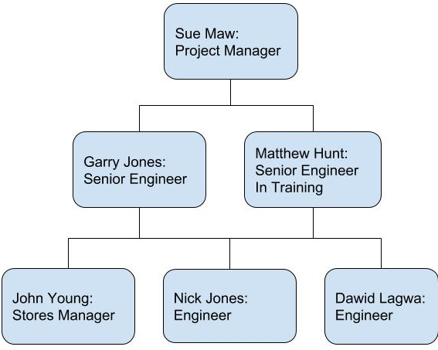
Project Manager:

Nick Jones: As a project manager it’s his responsibility to hold weekly meetings with team leaders to receive updates on their progress and assigning any additional tasks or resources as necessary. He also meets with important stakeholders to update them on the progress and/or to request additional resources if needed.

Project Team:

Sue Maw - Project Manager

Garry Jones - Senior Engineer

Matthew Hunt - Senior Engineer in Training

John Young - Stores Manager

Nick Jones Technician - Researcher - Engineer

Dawid Lagwa Technician - Marketing - Public Relations - Engineer

Section 4: How and When?

Initial Project Plan

Assignments:

1.Produce Project Initiation Document.
-Milestone: Completed PID will be created and presented.
2.Create Initial Product Prototypes.
-Milestone: Proteus Circuit Diagram Created.
3.Present Prototypes to Stakeholders
-Milestone: PowerPoint Presentation made and presented.
4.Finalize Product Design.
-Milestone: Physical Circuit will be built.
5.Product Testing.
-Milestone: All standard quality checks will be carried out.
6.Crate Technical Documentation
-Milestone: Extensive Technical document will be produced.
7.Public Exposure
-Milestone: Number of Advertising Material will be created.

Schedule:

-Circuit Design 24/09/18-05/10/18
-Software Prototyping 08/10/18-16/11/18
-Testing Debugging Simulation 19/11/18-30/11/18
-Breadboard Prototype and Testing 03/12/18-28/12/18
-Technical Document Writing 08/10/18-14/01/19

Project Control:

The project will be monitored via weekly team meeting during which work carried out in the week and other matters will be discussed by all present team members. The team will be employing email, text, calls and phone apps to communicate with each other.

Quality Control:

All deliverables will be created to industry standards and other team members will examine their work along with that of his colleagues if necessary senior Engineers will be consulted and their comments or suggestions will be considered during team meetings.

