P149251

Pip Standing

Pre-Production Portfolio & Reflection

Pitch
The working title for my film is A Life to Many Dreams, the story is about a young woman named Ebony who is stuck in two worlds, one being supposedly a dream world and one being reality. Ebony is unable to tell the two from apart because both seem very realistic. The link between the two dreams is a man named Eric that Ebony meets, she comes to realise that he is the one controlling and manipulating her dreams. In both worlds, she must face upsetting scenarios, Eric makes Ebony realise she has to decide which one is her reality, although it must be what seems more to her what feels like a dream, rather than it being about choice. In one of her dream worlds, her best friend dies due to have a severe reaction to a spiked drink. The other dream world, everything seems frightening to her and she has to spend her life whole life scared. At the end, she realises both of the worlds were a dream and that Eric was a manifesting of her subconscious, and this helps her realise her own morals and how much her best friend Olivia means to her.

Proposal
The aim of this film is to have Ebony be a character that the target audience can easily relate to, even though she is trapped in these dream worlds, she is still unable to tell dream from reality and is under the constant fear of not knowing what is real and what is not.
Furthermore, having nasty dreams that seem very realistic is a very common thing to happen to people, this making the audience have a lot of sympathy for Ebony. That being said, as the dreams go on, there is a build-up of excitement for the audience to find out what her dream and what her reality is, and what the overall outcome will be. I also hope that this film broadens people’s perspectives on dreams and how they can interfere with one person’s life due to how terrifying they can be.

Treatment
A Life To Many Dreams fits into the Psychological Thriller genre, a big theme that consists in films that fit into this genre is Reality, which is the main theme of my film. The reason this being is the protagonist is unable to tell what her reality is, and does not find out until the end that none of it was real and that it was all a dream. Researching into some of the codes and conventions of the Psychological Thriller genre, I found Symbolic and Technical codes. Researching Conventions, I found Form, Story and Genre. The Symbolic codes were the location i.e. using the park and it could be empty, as well as using streets. Another example could be doors opening and closing, which could imply finding new clues. Another code could be Ebony seeing shadows and not knowing where they came from, and this implies that she could be searching and not always finding answers. The Technical codes were dark lighting which could give a sense of terror to Ebony, the use of music to make a scene either seem emotional or have tension build up in the scene, as well as the use of wide and close- up shots, and continuity editing. The Form conventions were starting the film with a scene to begin with, followed by a potential title sequence, this could interest the audience and give them a brief idea what the film will be about and then they can enjoy the title sequence. The Story conventions involve the point of view always being on the protagonist’s side, the story is based in the mind of Ebony and the audience will focus on how she decides what is reality and what is dream, and this gives the audience a sense of disbelief. The Genre conventions involve a question of reality and perception, another example is the mind in the sense that Ebony has to make a choice in order to escape all of this, and another example being death, which would be Ebony losing her best friend Olivia, finally there would be leaving the audience with questions.

In Ebony’s dream world where everything seems more frightening to her, I am going to make the colour pallet more blue and have dark lighting, I will also make the editing faster for this world than the other. The reason I have chosen to do this is because I think it would help make that dream world seem tense with more terror in it, just how Ebony sees that world. The other dream world, I am going to put it on a more orange pallet and the editing slightly slower, the reason for this is because this just seems like a normal world to Ebony, the downside is losing her best friend. I also think having a different colour pallet for each world helps differentiate the two and make the audience really believe one is reality and one is the dream. Also, since typically in Psychological Thriller genres the dream part to it tends to be on the blue pallet, it could make the audience believe the world where Ebony is in constant fear really is the dream world. Whereas, the other world being on a more orange side of the pallet seems more realistic, this is the reality despite Ebony not choosing this dream to be her reality because she does not want to lose Olivia. Last of all, I will make the scene at the end have a neutral colour to it and not add effects to it, or maybe slightly brighter than the dream worlds. The editing for this scene will also be a lot slower than the editing used in the dream worlds.

Character Profiles
Ebony is the protagonist, she is quite an emotional character, has a strong personality and a short temper, can also be sarcastic and tends to react on the spot. As she is faced with different scenarios throughout the film, this comes to show. There are often scenarios when Ebony shows frustration towards Eric due to being upset or annoyed, especially when she finds out her best friend Olivia dies.

Eric is the antagonist of the story, he is the one controlling and manipulating her dreams. His personality seems different in both dream worlds. The dream world where Olivia dies, Eric seems very careless and doesn’t care to help Ebony figure out what she needs to do and usually winds her up. However, Ebony’s dream world where everything seems more frightening, Eric is a lot friendlier and genuinely seems like he wants to help her. Eric changes his personality in the dream worlds in the hopes that it would make her fall for one world being a dream world, and one world being reality. Also, if the world where everything seems scary to Ebony, she would find comfort in talking to Eric and this is why he chose this reality to be the friendlier version of himself.

Olivia isn’t in the film that often, but she also has an important role. She has been best friends with Ebony since nursery, she is very outgoing and very friendly, and spends a lot of time with Ebony. The film is introduced by showing them both going out for a drink and having fun, until Olivia gets spiked and Ebony later finds out that this leads to Olivia’s death. At the end of the film, Olivia is talking with Ebony about her dreams and helps her realise what the dreams meant, more importantly who Eric was.

Target Audience
I think my target audience will be young adults, verifying from ages 18-25. I think it will also potentially interest more women than men. The reason this being, the plot is a bit too dark for kids and young adults are lot more common of having dreams than older adults are. I think having a young female protagonist will interest women of a similar age to her as they would find her character easy to relate to, as well as understand her struggles of not knowing dreams from reality and have a lot of sympathy for her. The story could also potentially help the audience learn more about themselves and what their own dreams could mean.

Locations
One of the locations I chose to use for my film was a park, two locations I thought could be suitable for this would be Rosehill Quarry Community Park, the other one being St James Gardens. Most likely I will be going for St James Gardens, as when I was writing my script, the scenes that were set in the park, this was the park that I pictured in my head. However, if I changed the scenery and wanted an area that seemed to have more grass and trees then Rosehill Quarry Community Park will be suitable. The other location I will need is a house, preferably one near one of the parks. So I will need to find a suitable house on either Terrace Road, Hanover Street or Ffynone Road, this being for when Ebony and Eric walk from the park to the house. If the walk is too long, then I will have to cut out some of the walk from the film. Another location I will need to use is a bar for the first scene.

Schedule
I think suitable filming dates would be the 2nd and 3rd of March. As in early Spring it does not get dark too early and I think going over two days would be more ideal, if the weather isn’t decent enough for that weekend, I could also look at 1st and 4th March if needed. Filming over a few days would be more suitable as well as certain scenes require different times of the day.

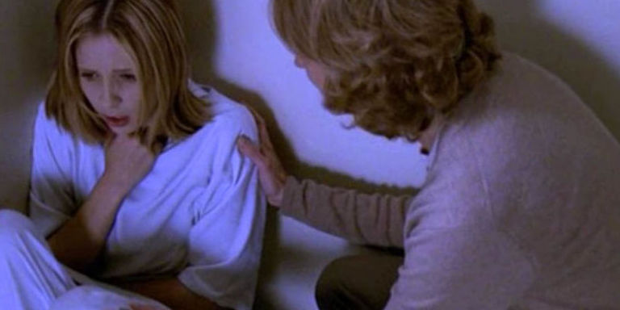
Influences
An influence for my film idea was the episode ‘Normal Again’ from Buffy The Vampire Slayer, in this episode Buffy is poisoned and it makes her believe that she has been in a mental hospital for six years and that her slayer life is all her imagination. When there are scenes that are happening in her slayer life, it gives her flashbacks to her mental hospital. In order to escape her slayer reality and for her hallucinations of it to stop, she has to kill her friends. Joyce, who is Buffy’s Mother encourages her to fight against her slayer reality and to believe in herself, and Buffy listens to Joyce and believes in herself, only she chooses her slayer reality and says goodbye to her Mother and thanks her for helping.

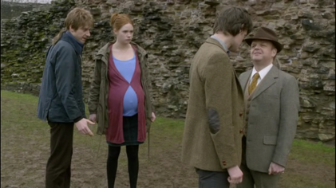
Another influence of mine was the Doctor Who episode ‘Amy’s Choice’, in this episode The Doctor, Amy and Rory are stuck between two realities and fall asleep at the sound of birdsong in one and waking in the other. In one reality, Amy and Rory are happily married and Amy is pregnant, the downside of this reality is that they are attacked by elderly people who are possessed by aliens and one ends up killing Rory, in the other reality The Doctor, Amy and Rory are stuck in the TARDIS heading towards a cold star and are all going to be frozen to death. They come to realise a Dream Lord is controlling both realities, and he forces them to decide which one is reality and which one is dream. At the end, they realise that the Dream Lord is actually a manifestation of The Doctor’s dark side.

The Buffy The Vampire Slayer episode influenced me to give my character a choice between the two dreams, more importantly going for the dream that does not really benefit that protagonist, proving them to be a selfless character. The Doctor Who episode gave me the idea to have someone controlling and manipulating the dreams, but that someone was actually a manifestation of another side to the protagonist.

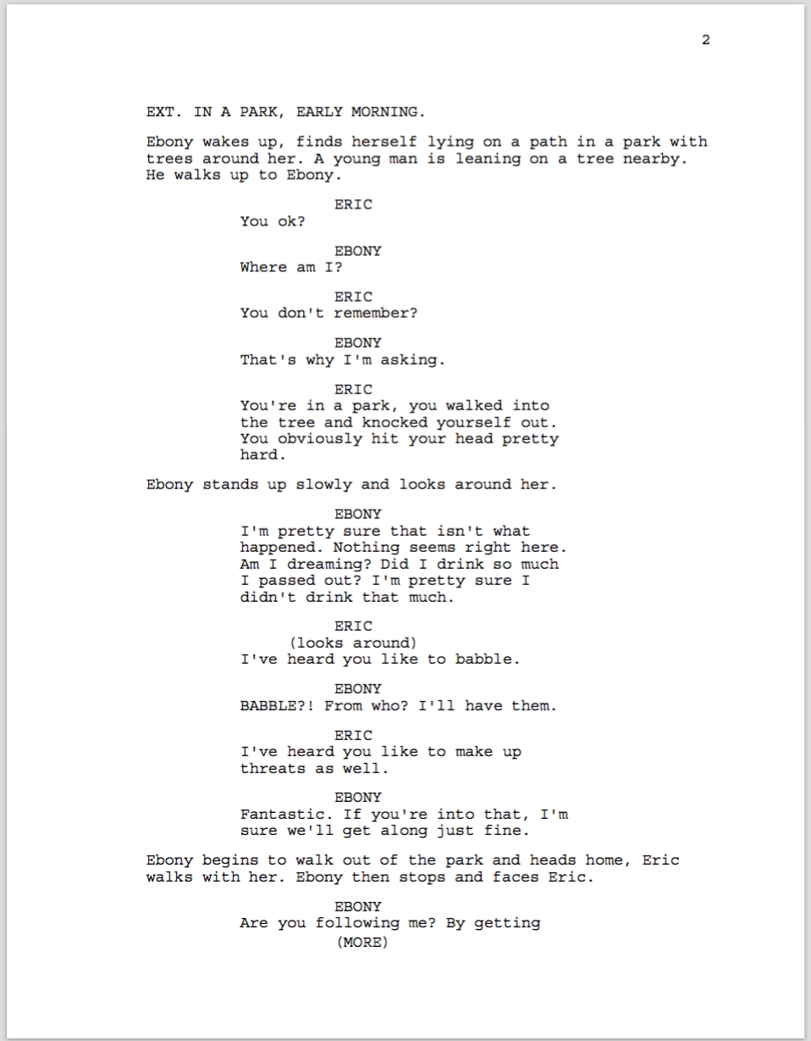
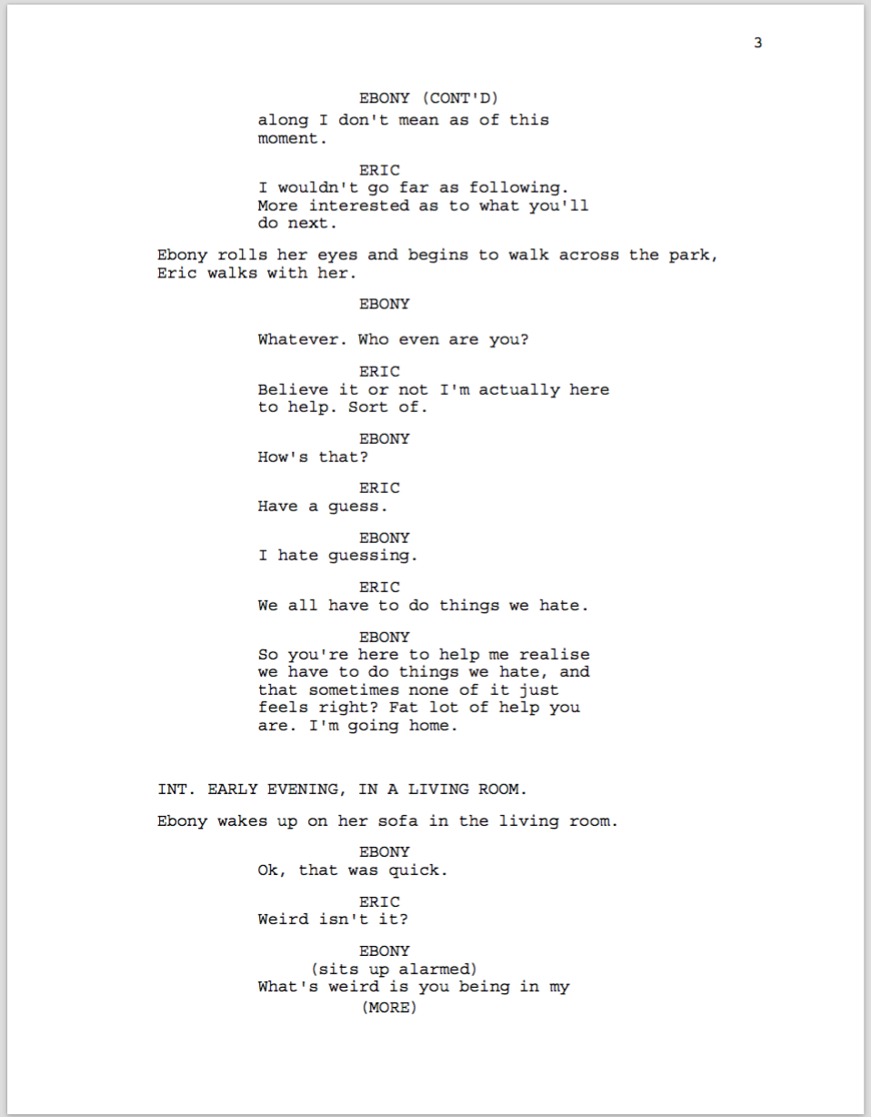
Script
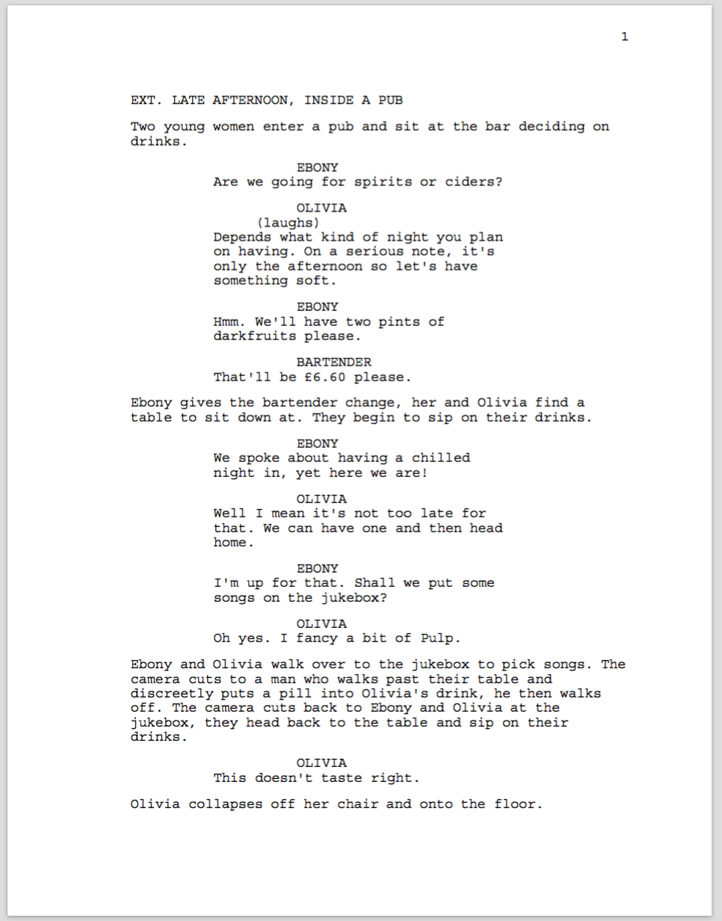

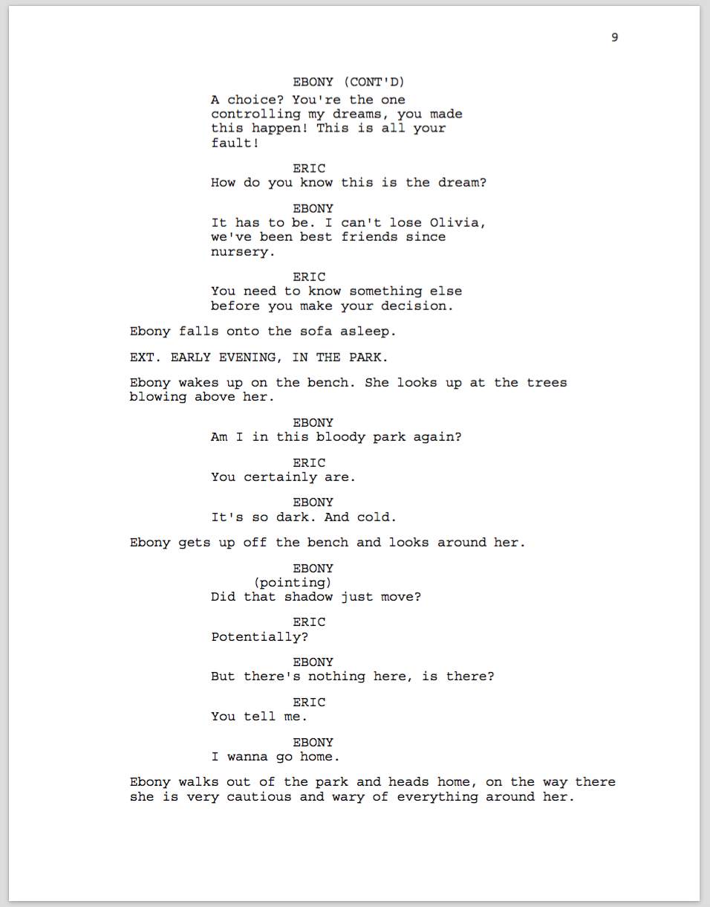
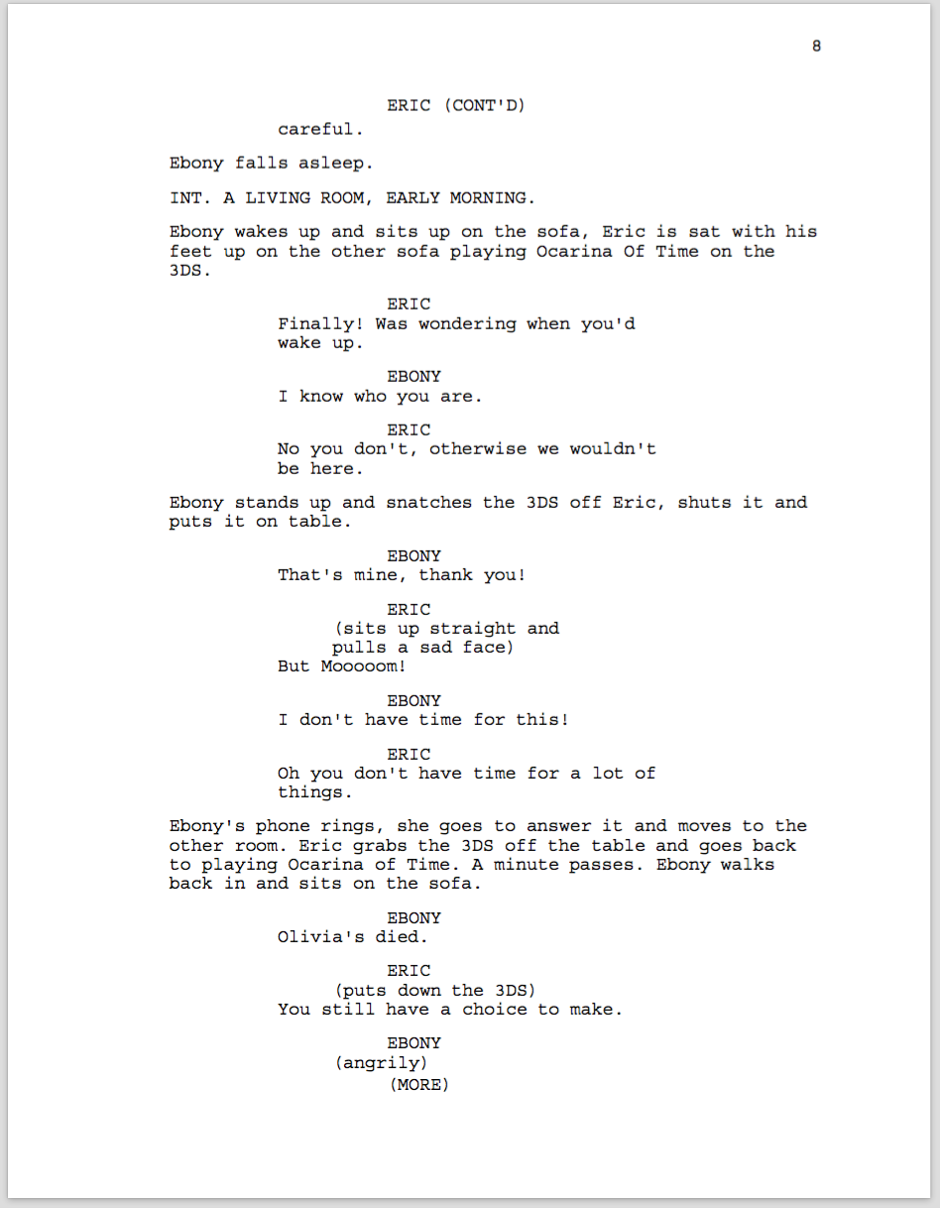
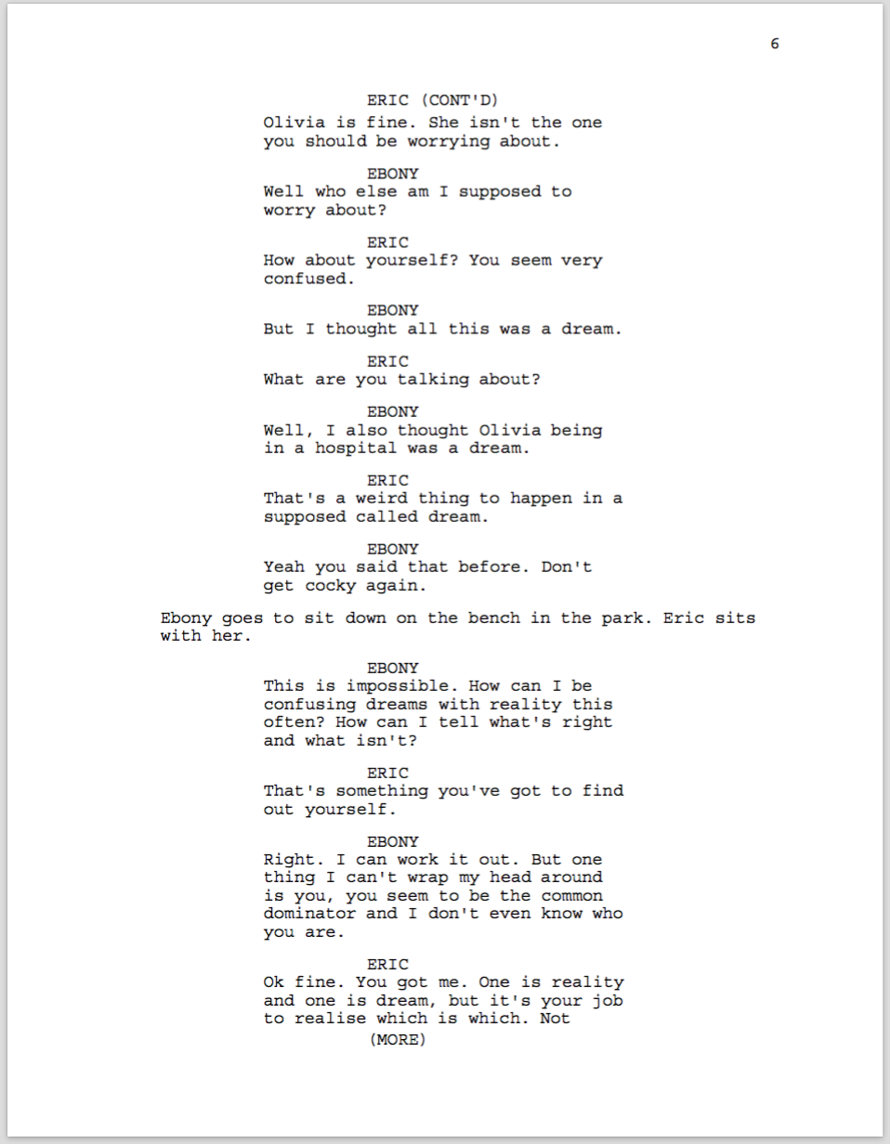
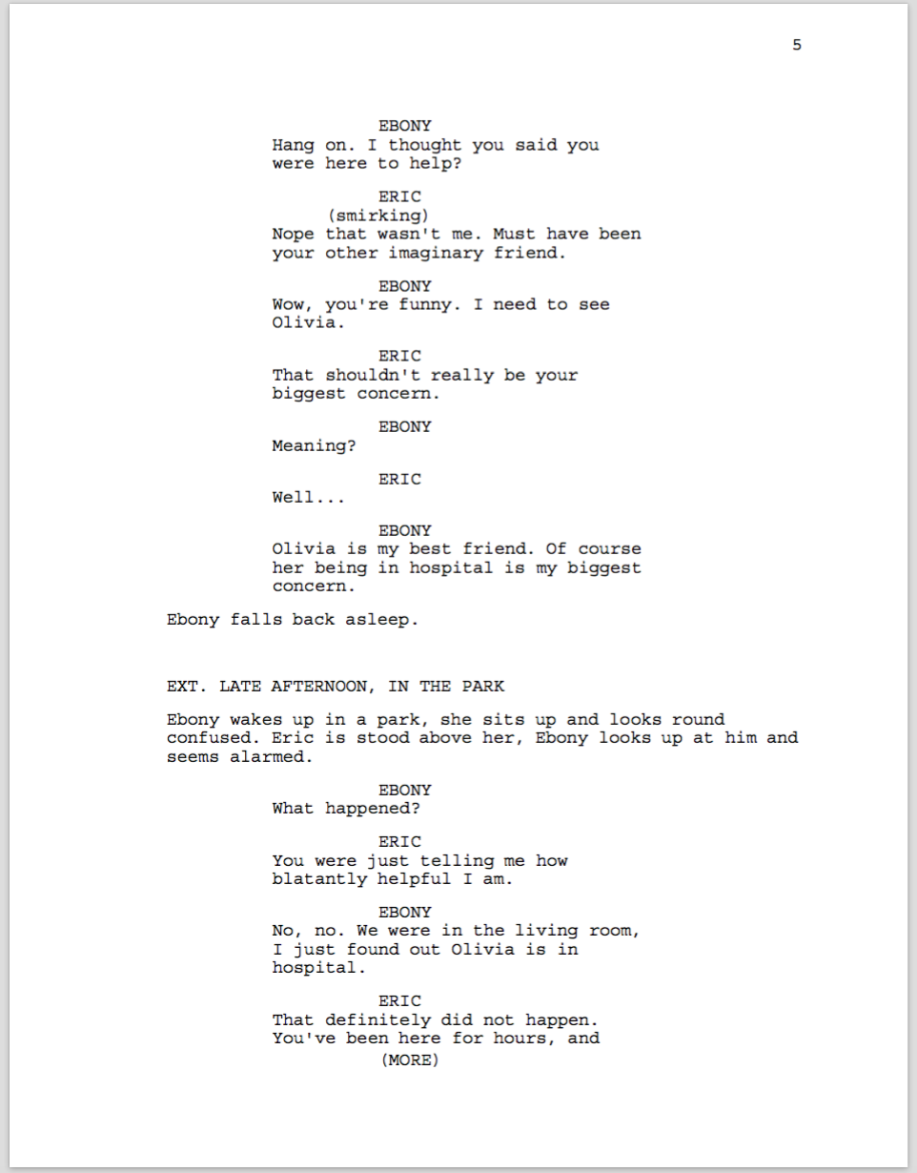
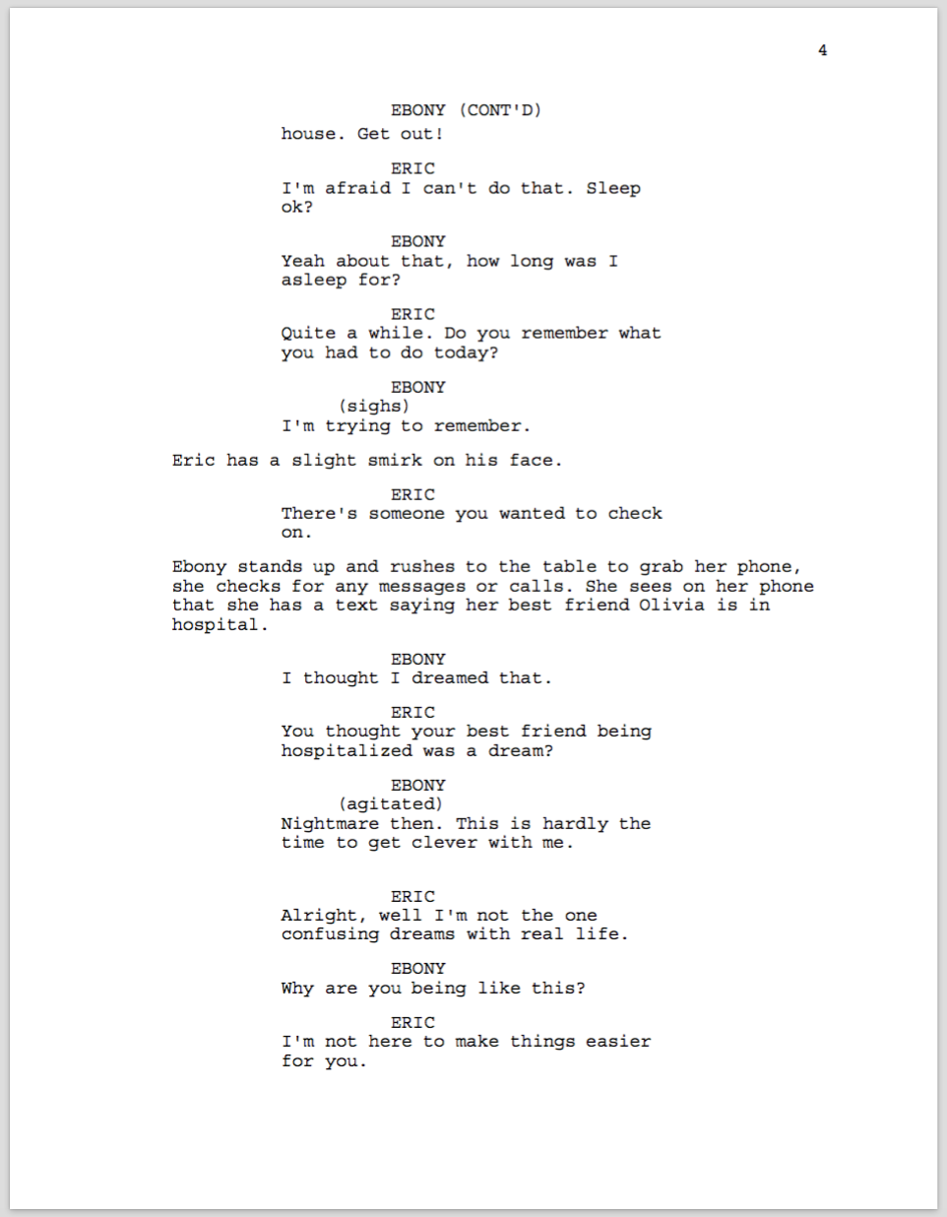
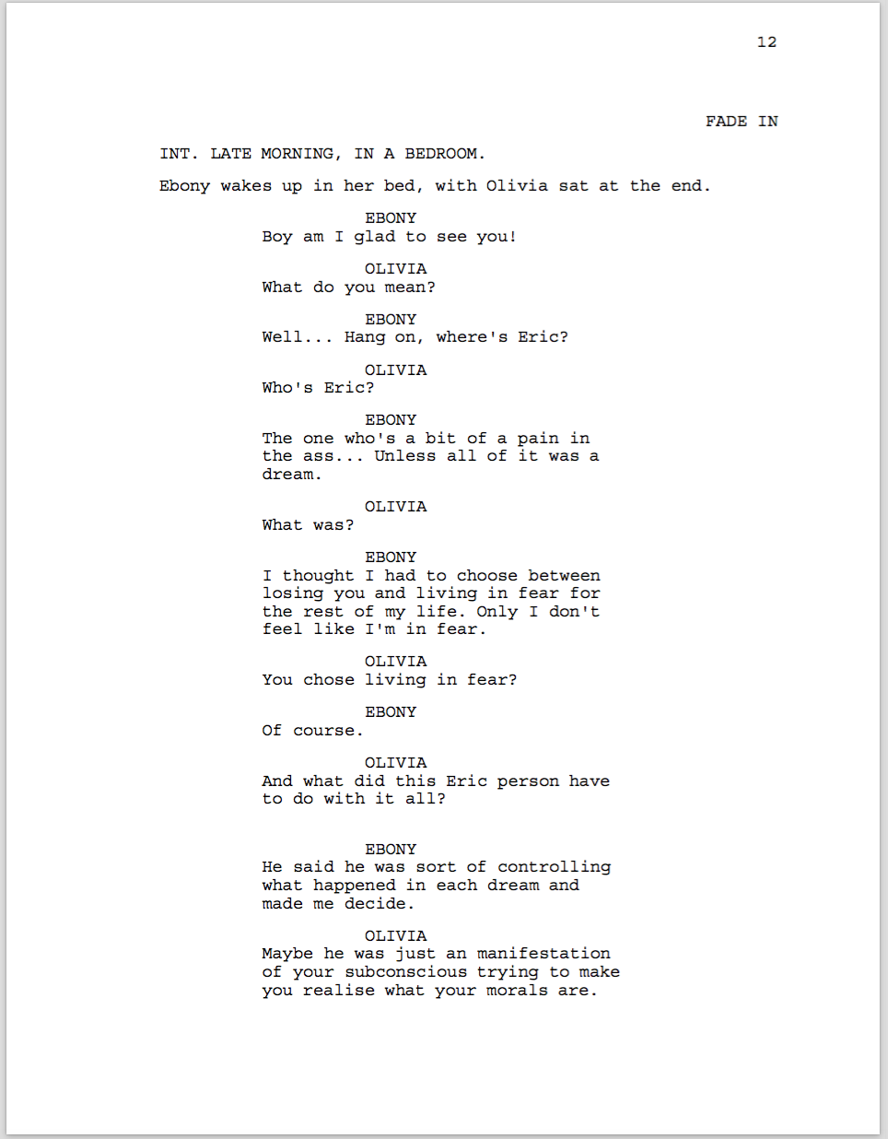
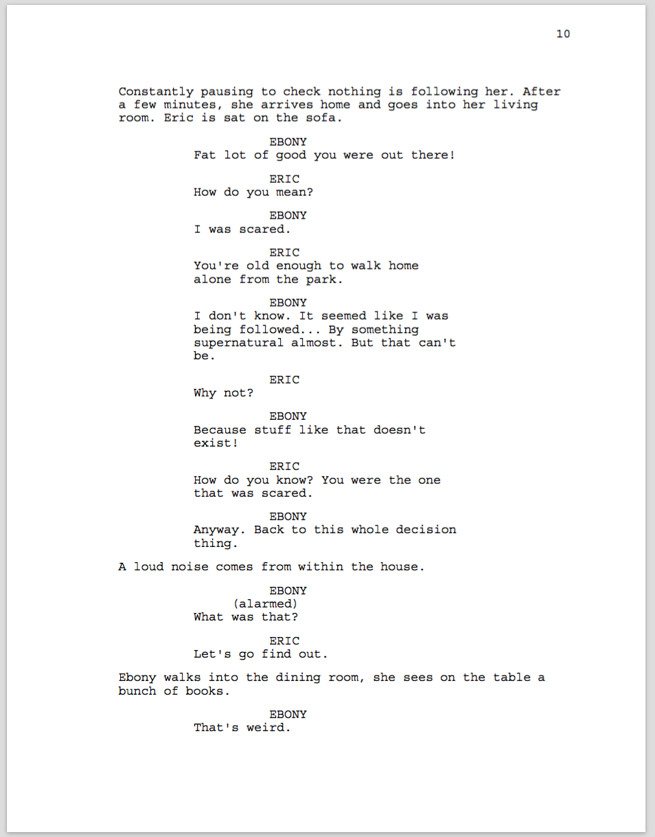
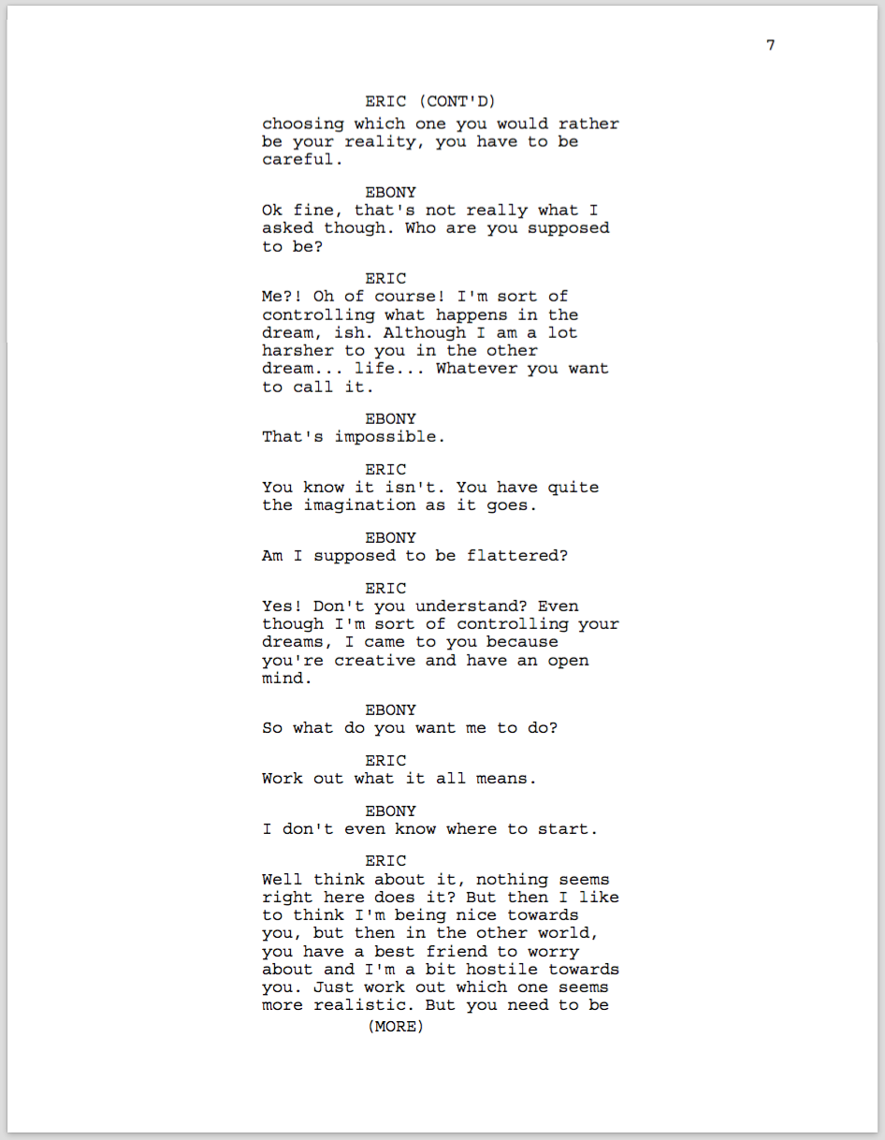
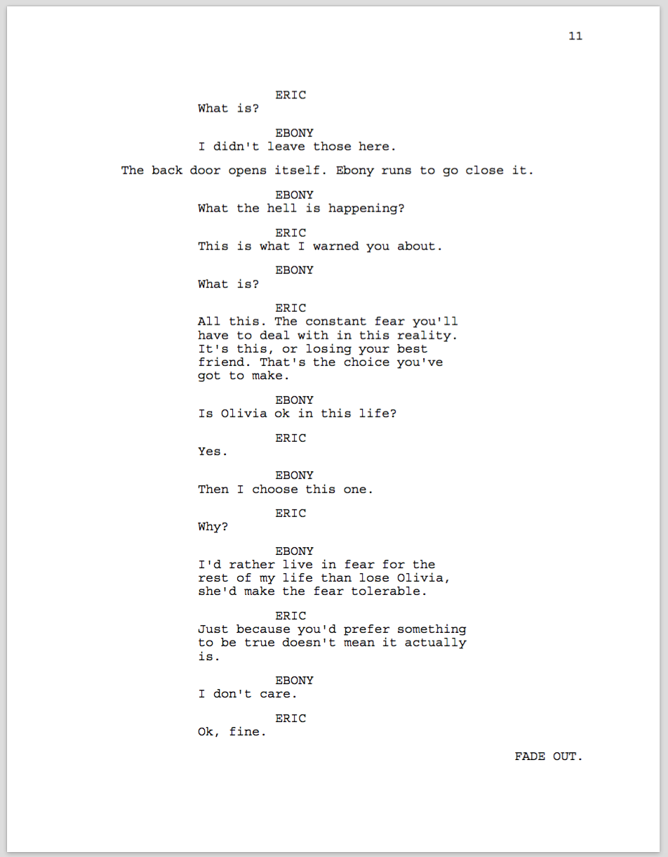

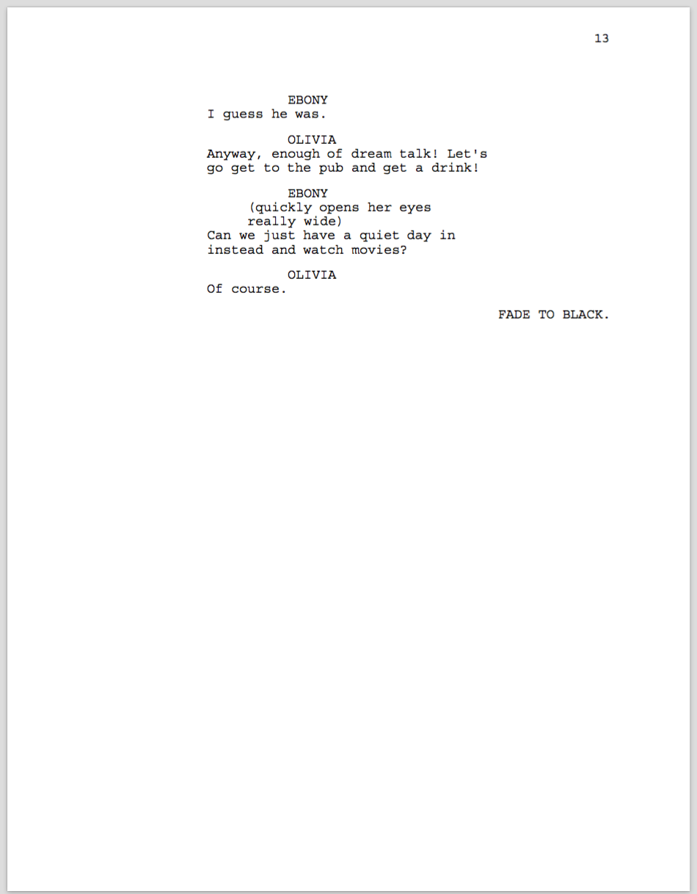

Reflection

Originally, my first idea was a film named Crossing The Line, this film also fitted into the Psychological Thriller genre. The film was about a young woman who found out her brother went missing and begins to hear his voice and sometimes sees brief glimpses of him, eventually she actually sees him. This gives the audience a disbelief of him being there and just thinks she is just hallucinating from the trauma of losing him and potentially his death.

I then decided to change my idea to the film with the title Dream A Little Dream, this second idea was about a young woman named Ebony who keeps having dreams, and these dreams begin to control her real life, this forcing herself to go back to sleep in the hope she can have more control, only the people around her just believe she’s starting to go insane.

I then decided to expand this idea and have the young woman being trapped between two dreams and is having to face a man, who is a manifestation of her subconscious. This man is named Eric and is the one controlling and manipulating her dreams. Ebony is asleep and is stuck between two dreams, only one she believes is her reality and the other is a dream, the problem being she does not know which is which. She must face two upsetting scenarios and has to choose which one she would prefer to be her reality. Once she decides which is the one she would prefer to be her reality, this wakes her up from both dreams, making her realise what her morals are and what caused these dreams. The title of this film is A Life To Many Dreams, I decided this was my final idea as I found the story more interesting and found coming up with a script more enjoyable, this being because I had a lot more to work with as it is based on a dream world. Also, being someone who has a lot of troubling dreams, I believe this would give me the advantage of making the protagonist relatable and knowing how to make the audience have sympathy for her. As this film also fits into the Psychological Thriller genre, I used the research for Crossing The Line and looked into the codes and conventions of the genre.

Whilst writing the script, I thought of the idea that in one of her dreams she loses her best friend due to suicide, and in the other dream her sister had a life threatening accident. I decided not to go for these scenarios as, although they are realistic, they are also sort of cliché and rather complex. Instead, I thought going for more simple scenarios such as one of her friend facing consequences due to being spiked, and everything seeming on edge is also realistic and rather scary. I think this is also a good way for the audience to learn about Ebony and watch her journey in her dreams, how she handles the situations that she’s forced to face, and helps to learn about herself. When I came up with this idea, I decided it was my final idea as I found the script an interesting read, as well as intriguing. “Reflection is a basic mental process with either a purpose, an outcome, or both, applied in situations in which material is unstructured or uncertain and where there is no obvious solution.” (Moon, 1999)

One of the challenges I faced whilst writing the script was thinking of ideas that were in my filming budget. Another reason I did not go for the idea of Ebony losing her best friend due to suicide and her sister having an accident was because I did not think it would be possible approach to film and would be difficult to even imply. Reflective practice begins “where practitioners are problematizing their practicing and learning afresh about both the knowledge and skills and attitudes that their practice demands.” (Jarvis, 1999)

Another challenge I faced during writing the script was the structure of how the script went and the order of how each dream went, more often than not I had to rearrange the scenes in the script. My aim was for it to switch from one dream to the other when Ebony fell asleep, but at one point she was in one of the dreams, fell asleep and then woke up in the same dream so I had to find a way for a scene to fit between the part she fell asleep and then woke up. For example, when she says in one dream that she was going home, when she wakes up she says “ok, that was quick” originally this was said in the same dream, but I thought if she falls asleep in one dream and wakes up in the same one it would be confusing for the audience and a tough story to follow. “Experience is valuable in helping us reflect on how we learn – particularly on how, as learners, we experience the interplay between cognition and metacognition.” (Webb, 2006)

Overall, I am happy with my idea and the script and I do not believe it will need to be changed again. I think the locations are also suitable for the story. To improve in the future, I think I would structure the story more roughly and write down which scene goes after the other and make sure they make sense, this would save me the time of changing the scenes around constantly on the script. “By three methods we may learn wisdom: First, by reflection, which is noblest. Second, by imitation which is easiest; and third by experience, which is the bitterest.” (Hinnett, 2002)

Bibliography
Hinnett, K., 2002. Developing Reflective Practie in Legal Education. Warwick: Warwick Printing Press.
Jarvis, P., 1999. The Practitioner-Research: Developing Theory from Practice. San Francisco: Jossey Bass.
Moon, J. A., 1999. Refletion in Learning and Professional Development: Theory & Practice. Sterling, Virginia: Kogan Page.
Webb, J., 2006. "The Ambitious Modesty" of Harry Athurs' Human Professionalism. s.l.:Osgoode Hall L.J. .

