2021
Steven James (1810370)
Supervising Lecturer (TBD)
AWE plc
4/22/2021
Project Proposal Laboratory Scale Spigot Intrusion Test

Project Proposal Laboratory Scale Spigot Intrusion Test
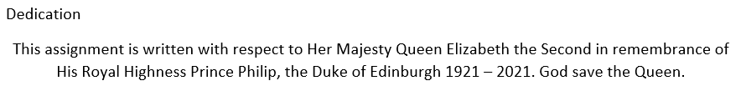
Contents
Table of figures 3
Introduction 4
Background to the proposed research 5
Aims and objectives 7
Expected outcomes 9
Experimental plan 9
Ethics 9
Approach 10
Review 10
Software/hardware 10
Experiment 10
Risks/limitations 10
Resources and planning 10
Resources required 10
Time plan 11
References 12
Bibliography 13
Appendix 1 14

Table of figures
Figure 1 - Example of ammunition lighter, showing non perfect surfaces [7] 5
Figure 2 - EMTAP Small Scale Spigot Test design [2] 6
Figure 3 - AWE Spigot Intrusion Test design [2] 7
Figure 4 - AWE Small scale Spigot Intrusion Test design [10] 7
Figure 5 - Time plan page 1 12
Figure 6 - Time plan page 2 13
Figure 7 - Time plan page 3 14

Introduction
Explosives are used in defence to disable or neutralize an adversary. In working with explosives, it is critical that the munition operates only when required to. In 1995, the HSE (Health and Safety Executive) reported 12 accidents involving explosives in UK ports between 1950 and 1995 [1]. Since the 1940s specific tests have been developed to establish the safety of explosives both as raw material and as full munition. Currently the MoD (Ministry of Defence) use test methods in the EMTAP (Energetic Material Test and Assessment Policy) Committee manual of tests [2]. The EMTAP manual concentrates on explosive materials that are put into munitions, as opposed to the munition as a whole. The tests consider how the material will react to impact, friction, heat, flame, incendiary spark and electrostatic discharge (ESD).
The UK is part of NATO (North Atlantic Treaty Organisation), which includes a requirement to meet certain criteria for munitions before they can be put into service. These criteria are laid out in STANAG 4170 (NATO Standardized Agreement) [3] which is bound with AOP 7 (Allied Ordnance Publication) [4]. The aforementioned documents require member nations to provide information on how material will react to accident situations, and so the UK uses the tests in the EMTAP manual for evidence to fulfil this requirement. However, these documents are also used to give evidence on how the munition as a whole will react to certain accident stimuli.
Naturally munitions have to be transported, and as a member of the UN (United Nations), the UK also must prove that the munitions are safe to be moved via land, sea and air. These test requirements are set out in the United Nations Transport of Dangerous Goods Model Regulations, ‘The Orange Book’ [5], and is used to determine the hazard category of a material or munition, which includes when in its packaging.
One particular test used throughout the qualification process is the spigot intrusion test. The test is used to show how the munition/material will react should it be dropped onto, or have, a spigot dropped onto it. There is more than one version of the test, however, they all require a large quantity of material, meaning that the explosive will have to be quite a way through its scale up process. The focus of this project is to identify how the material will react to a spigot intrusion accident at an earlier stage in the scale up process, when less material is available. To be known as the LASSIT (LAboratory Scale Spigot Intrusion Test), the test shall attempt to provide evidence on how the explosive will react to a slow speed spigot intrusion accident, using minimal amounts of explosives material. As opposed to existing spigot intrusion tests, which only use one size spigot, the LASSIT test will use an array of spigots representing both standard spigots, as well as novel spigots, which include hand tool representations and other possible puncturing devices.

Background to the proposed research
The UN ‘Orange Book’ [5] requires a munition to be dropped in its packaging from 12 metres. This is designed to show that a munition remains safe in its packaging whilst being subjected to impact forces that are severe. The HSE [1] accept that that although this test is severe, it does not provide sufficient evidence to characterize a worst-case accident scenario in a port area. Firstly, as at some ports, mostly commercial, the lift height may be greater than 12 metres. Secondly, the munition may not impact a flat surface as quaysides contain deck fittings and other objects, and it is also possible for a munition on the quayside to have sharper objects dropped onto them. Both of these scenarios can create a crush or nip between the explosive and two surfaces. Should it be a bare munition subject to the assault, casing failure may result in a disk of hot metal being pushed into the explosive, commonly known as a spigot intrusion. The HSE recognise that although unpackaged explosive articles are not commonly seen through commercial ports, results of tests showed that some munitions, when subject to spigot intrusion, do show explosive reactions [1].
Mawbey [6] assumes that a munition will receive accidental stimuli at some point in its life. His paper considers accident scenarios of fire and impact. Ignoring the stimulus of fire, Mawbey explains that the UK has experienced accidental dropping of munitions (impact insult) with severe damage, but no explosive events. The best way to assess a munition to impact, is to test through trial. Mawbey states it is:
“the most satisfactory method of assessing its safety.” [6]
Impact tests developed over a number of years include dropping munitions onto a flat plate and sections of angled steel. This was due to common practice which showed munitions being moved over spigot objects. Mawbey cites an unavailable private communication which stated that munitions are more sensitive to a spigot intrusion than the well tested flat plate impact, and that the weight of the munition may also influence the result. It is also likely that an object may fall onto a munition. With this in mind, it was found that dropping a weighted spigot onto a munition provides consistency between trials, and is also more convenient [6].
CINO (Chief Inspector Naval Ordnance) Wallace [7] proposes that traditional safety drop tests onto a flat surface do not represent the reality of how naval munitions are actually handled, with docksides having many potential spigots. He suggests that dropped munitions will more likely land on edges, corners or protrusions. Such accidents, although unlikely, do happen. Between 1980 and 1994, 1404 incidents occurred, 40% involved a drop/impact, of which many resulted in a spigot intrusion of the explosive material [7].
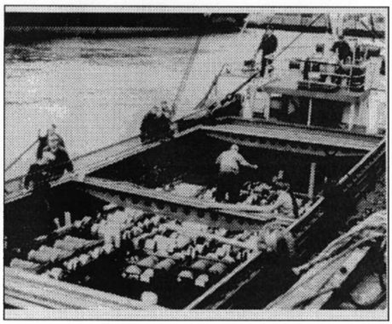
Figure 1 - Example of ammunition lighter, showing non perfect surfaces [7]
In accepting that dropping a munition onto a spigot is both cumbersome and not particularly reproducible, a test was devised whereby a weighted spigot was dropped onto a static munition, with both the weight of the spigot and the drop height being experimental variables. From over one thousand tests, Wallace pointed out that on some occasions, ‘modest’ drops produced a violent result. Tests were conducted on a variety of explosive materials and evidence found that older explosive materials that may out gas are more likely to give a violent response. Should the case be thick/strong enough to prevent intrusion, no explosive response was seen. Where a response was seen, a case made of steel was more susceptible than other metals. The most likely cause of reaction was determined to be a piece of case material being punched into the explosive material. Therefore, a flat cylindrical spigot was found to be best for the test, and so the standard test is configured with a 1 inch diameter steel cylinder. Wallace summarised though, that other shapes of spigot have also been tested giving ignition results that do not conform to the standard spigot [7].
Cartwright and Lewis [8] state that a blow to a munition from a tool, or dropping of a munition from relatively low heights, are cause for accidental initiation of the explosive. They pronounce that the ignition occurs due to hotspots being created in the material where the heat created from the hotspots outweighs the heat loss during the incident. Their experiments, conducted to investigate ignitions from low-speed impacts, involve using a 50 mm gas gun to fire a 50 mm projectile into a target which contains an explosive charge. One such target design had the explosive in a reasonably heavy confinement with a 3 mm steel cover. A ‘piston’ was held in a ‘barrel’ in front of the explosive with a steel spigot set up to be rammed into the explosive when struck by the projectile. Depth of penetration was controlled by the use of shims around the explosive sample. HSV (High Speed Video) was employed to record the explosive events.
Cartwright and Lewis used a variety of test arrangements including 13 mm and 4 mm flat and round nosed spigots. They continued testing using different depths of penetration as well as grit on the surface of the spigot. No responses of detonation occurred, however they did report responses of deflagration which did not completely consume the explosive sample. No explosive responses were recorded at a velocity under 42 m/s, and the 4 mm spigot needed to be fired at 115 m/s to get a response.
In 1993/4 a trial was carried out on the configured warhead of a specific munition. Two tests were carried out which involved a weighted spigot being dropped onto the target; one drop from 10 m and one drop from 1.75 m. The 10 m drop caused the explosive in the warhead to ignite, and the explosive to catch fire. The fire was not vigorous and consumed all the material, which was the expected result. The drop from 1.75 m gave an unexpected response. Upon impact, from the spigot into the explosive, the warhead gave a high order response, most likely detonation. The results of this trial prevented the munition from going into service [9].

Aims and objectives
Existing spigot intrusion tests for qualification in the UK include the SSST (Small Scale Spigot Test) and the AWE spigot intrusion test, both are found in the EMTAP manual [2]. The SSST requires a spigot to be dropped from up to 10 m onto the sample.
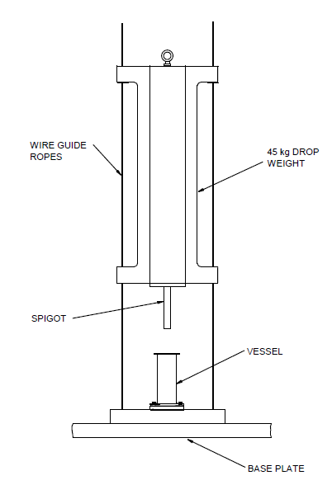
Figure 2 - EMTAP Small Scale Spigot Test design [2]
15 drops are completed to ascertain the ignition threshold. This test is carried out at few UK test sites and requires ~15 kg of material to be manufactured.
The AWE spigot intrusion test requires a ~3.2 kg explosive charge encased in a ~23 kg Jabroc holder to be dropped from 140 ft onto a flat target surface. A steel spigot is supported on the front of the holder to intrude into the explosive when the unit hits the ground.
Figure 3 - AWE Spigot Intrusion Test design [2]
Approximately 10 drops are performed. 32 kg of explosive overall is required to complete the test. This test is currently only available at one location and requires significant maintenance before the facility can be used.
A version of the test conducted by Cartwright and Lewis [8] is performed by AWE, known as the AWE small scale spigot intrusion test, which requires a minimum of five tests to be performed with 180 g per sample, and therefore 900 g of explosive is needed overall.
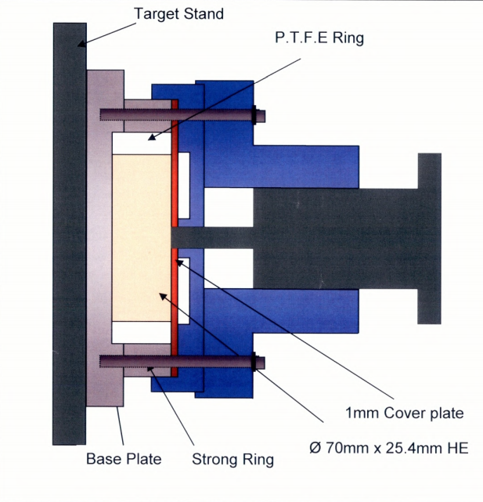
Figure 4 - AWE Small scale Spigot Intrusion Test design [10]
For the safety of operators and other persons, it is best practice to complete safety tests using the minimum amount of explosives possible. This can also assist with scale up tests as if explosives can be found to be abnormally reactive at early stages of production, they can then be removed from the scale up process, minimising potential of accident effects. The manufacture of explosives is also expensive, and so demonstrating a material to be susceptible to accident earlier can reduce the cost of manufacture. Cost of manufacture is the not the only financial concern to manufacturers. Use of external facilities can cost between £10,000 and £50,000 per week depending on the facility required.
This project has two main purposes. Primarily, this project aims to investigate whether a low-speed spigot intrusion test can be performed at AWE on a laboratory scale as opposed to the existing larger scale tests. The benefit to such a test will allow early stage testing to rule out any materials with increased reactivity on a scale small, and so reduce need for and cost of offsite testing and large-scale formulation. A secondary aim of this project is to investigate whether different ‘realistic’ spigot types will cause a reaction in the explosive.
The goal of the project is to perform a number of spigot drop tests onto an explosive sample which is to be no more than 25 g. The sample must be this weight as this is the maximum quantity of explosives permitted in the proposed firing chamber. The spigot will be dropped from a maximum height of 1.5 m and weights from 1 to 50 kg can be used.

Expected outcomes
- Research into the use of a laboratory scale spigot intrusion test.
- Determine whether a laboratory scale spigot intrusion test is feasible.
- If the test proves of no significant use, determine why this was.
- Explain how the test can be fully implemented into the required facility, should the results show the test is worth pursuing.
- Conduct tests with further variations, based on the requirements of the high explosives safety study team, highlighting process considerations and how the results can assist in accident scenario models.

Experimental plan
Techniques used in this project to perform the tests and acquire the planned results are detailed in this section.

Ethics
The ethics of explosives are commonly questioned in the public domain this is acknowledged by all involved. The author specifies that this project will be conducted with the highest ethical standards. Using only SQEP (suitably qualified and experienced personnel) to perform the testing at a suitable location. The purpose of the test is to examine the safety of explosives to ensure that all persons both general public and those in the armed forces are protected as far as reasonably practicable. The author advises that this project is presented with no conflict of interest. Due to the nature of the project, it should be accepted that some (material specific) information may not be fully presented.

Approach

Review
The project report shall be kept up to date throughout the planned execution. Frequent reviews shall be adopted with the supervisor for assistance to ensure that the document meets the required standards for those set by the institution.

Software/hardware
Vision Research ‘Phantom’ cameras and their associated software, commonly used for HSV of explosive reactions, will be the primary technique for data collection. Evidence of explosive reaction shall be determined, with evidence, by the author.

Experiment
Due to the nature of the project, the experiments shall take place at a suitable off-site location. A suitable housing for the explosives as well as the primary spigot shall be designed and manufactured, then employed throughout the project. Each explosive sample shall be manufactured to a constant geometry. A test plan for the drop heights and weights of the spigot shall be determined by discussion with a SME (Subject Matter Expert) at AWE.
The spigot, at the required weight, shall be raised to the desired height, then dropped. Evidence of reaction shall be determined by review of the HSV. The result (go/no go) shall determine whether the next drop is higher or lower. Once a threshold is determined, or no response at the maximum height, the next weight/height combination shall be tested.
Should the primary aim of the project be completed, the project can investigate other spigot designs, including representations of flat/Philips/posidrive screwdrivers as well as different angled (pointed) spigots. As supplementary experimentation, the testing will be conducted on a more ‘ad-hoc’ plan.

Risks/limitations
Working with explosives always carries a certain amount of risk. This will be assessed by the facility where the experimentation will take place.
There are two major risks/limitations associated with this project. Firstly, should AWE not be able to provide explosive material, the experiments will not be possible. As a contingency, a limited number of samples shall be purchased from an external source. Secondly, the off-site location cost, at ~£10,000 per week, for between one and two weeks. Should the funding not be made available, a minimum of £2,000 must be made available for one day of any experimentation. If this funding is unavailable, no experiments, or evidence will be provided for this project.

Resources and planning
This project is one of a complex design. Significant planning is required for the two weeks of tests, likely to take place between March 2022 and March 2023.

Resources required
For this project to be completed the following resources are required
- Explosive samples (minimum 25)
- Test consumables (one set for each test, minimum 25) – to be designed
- Two weeks at an off-site location (funding £20,000)
- Two weeks at offsite location (Time)
  - Drop tower and release mechanism
  - TCO (Trials Conducting Officer)
  - Required safety paperwork
- Phantom 2512 High Speed Camera
- Phantom 1610 High Speed Camera
- Laptops for recording data (x2)

Time plan
A time plan has been created using Microsoft Project and can be found in Appendix 1.

References

[1] | Health and Safety Executive, Risks of handling explosives in port, Sudbury: Health and Saftey executive, 1995.
[2] | Ministry of Defence, Energetic Materials Test and assessment Policy Comitee manual of tests, Bristol: Ministry of Defence, 2016.
[3] | North Atlantic Treaty Organisation, STANAG 4170, Brussels: NATO.
[4] | North Atlantic Treaty Organisation), AOP 7, Brussels: NATO.
[5] | United nations, United Nations Transport Of Dangerouse Goods Model Regulations, New York: United Nations.
[6] | M. W. S. Mawbey, "Assessing the response of naval armament stores in credible accident environments," Journal of Energetic Materials, vol. 7, no. 4-5, pp. 231-232, 1998.
[7] | D. I. G. Wallace, "Spigot Intrusion," in Proceedings of the Twenty-Sixth DoD Explosives Safety Seminar, Miami, Fl, 1994.
[8] | M. Cartwright and A. Lewis, "Use of a compressed Gas Gun to Investigate Response of Explosive to a Range Of Initiation Stimuli," Central European Journal of Energetic Materials, vol. 4, no. 4, pp. 33-43, 2007.
[9] | P&EE(S), "MDC and (REDACTED) reports, Trial report number 11412 and 11849," MoD internal report, 1993/4.
[10] | T. Stewart, "AWE Small Scale Spigot Test Live Prove Out Notes," AWE Internal report, Reading, 2004.

Bibliography
S. K. Chidester, I. G. Green, C. G. Lee, “A Frictional Work Predictive Method for the Initiation of Solid High Explosives from Low-Pressure Impacts”, Tenth International Detonation Symposium, Boston, MA, July 1993
P. J. Rae, P. M. Dickson, “Some Observations About the Drop-weight Explosive Sensitivity Test”, Journal of Dynamic Behavior of Materials, Springer, October 2020
D. Ma, P. Cen, K. Dai, Q. Zhou, “Specimen size effect of explosive sensitivity under low velocity impact”, Journal of Physics, vol. 500, iss. 5, IOP, 2014
J. E. Reaugh, J. P. Curtis, M. A. Maheswaran, “Computer Simulations to Study the Effects of Explosive Energetic and Constitutive Properties on the Deflagration-to-Detonation Transition (DDT)”, Fifteenth International Detonation Symposium, San Francisco, CA. July 2014
M. D. Holmes, P. A. Schultz, M. A. E. Erickson, G. R. Jr. Parker, “Case Penetration and Detonator Crush FY2019 Report”, Los Alamos National Laboratory, November 2019
M. D. Holmes, G. R. Jr. Parker, P. Dickson, E. M. Heatwole, R. M. Broilo, “Low-velocity impact ignition of thin metal-cased charges of PBX 9501”, AIP Conference Proceedings, vol. 1979, iss. 1, St Louis, Mi, September 2017
M. D. Holmes, P. Rae, G. R. Jr. Parker, “Viscous Heating via Low-Velocity Crushing Impact of High Explosives”, Sixteenth International Detonation Symposium, Cambridge, MD, 2018

Appendix 1
Prospective timeline of proposed works
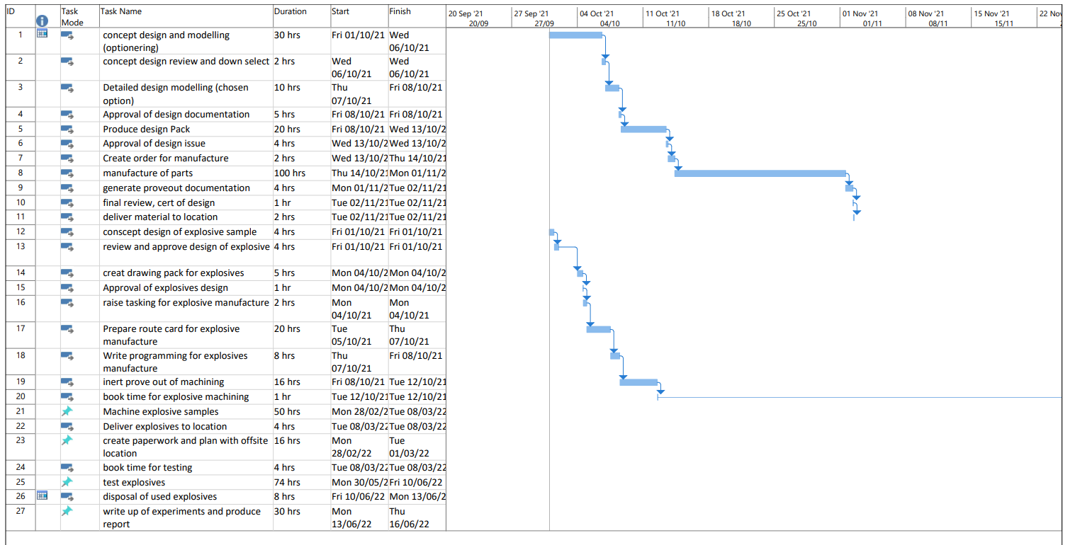
Figure 5 - Time plan page 1
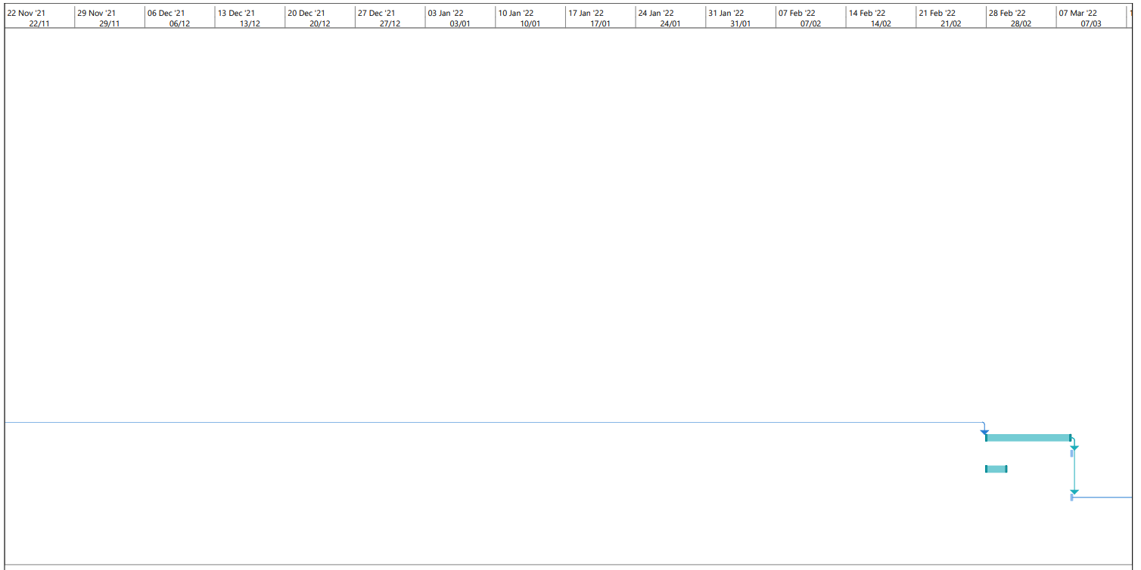
Figure 6 - Time plan page 2

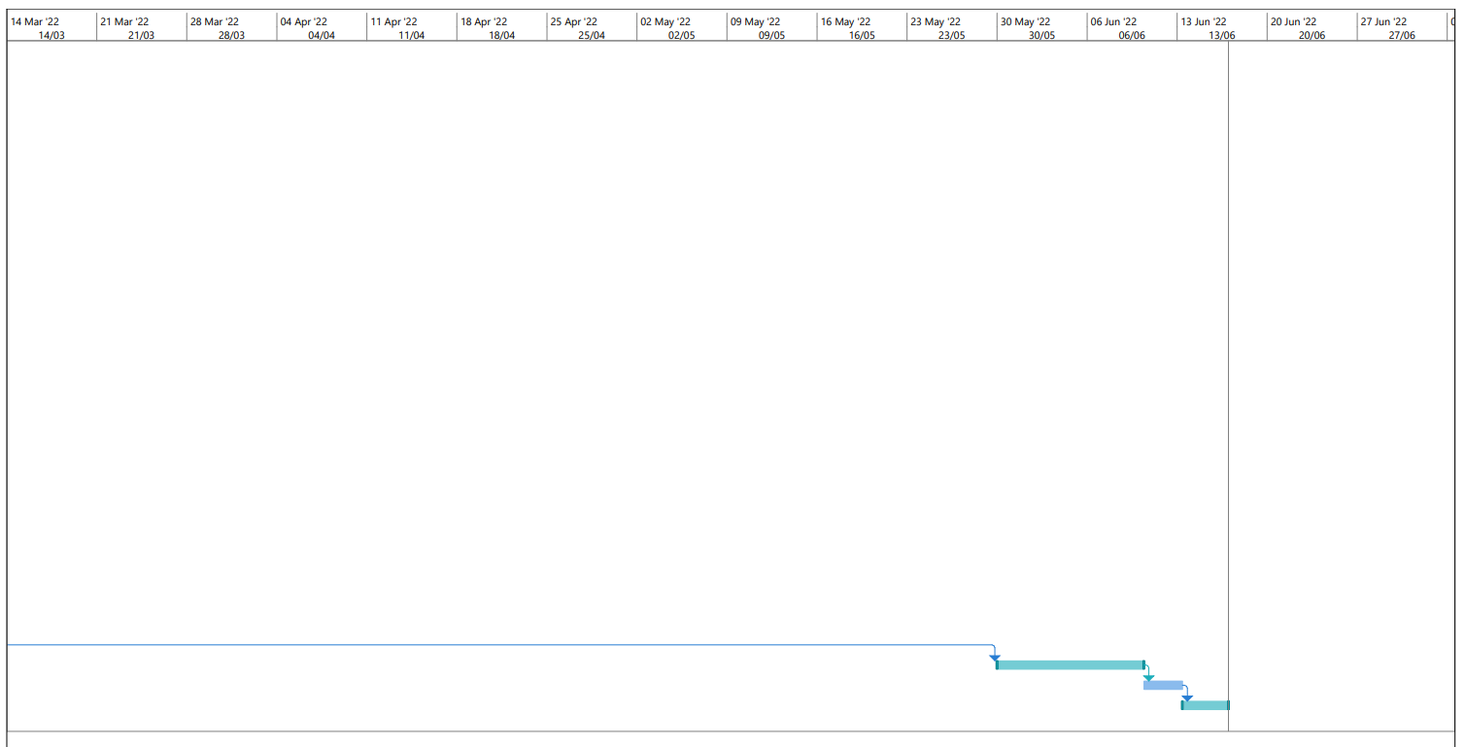
Figure 7 - Time plan page 3

