A critical evaluation and the identification of next teaching and learning steps focusing
on a case study of an individual learner or a group
of learners, based on an observed critical incident.

Introduction

This assignment will identify a critical incident within a primary school setting using observation strategies. Then using reflective practice, recognise and evaluate a critical incident to identify next steps to improve future practice. A critical incident is a personal opinion on the significance of an event. As Tripp (1993) suggests viewing a critical incident is a judgment that is made, and the basis of the judgment is the significance we attach to the meaning of the incidents.
Raj Joshi (2018) explains that critical incidents are something that educational practitioners interpret as a problem or a challenge. The use of critical incidents in terms of reflective practice have a benefit to a teacher’s continual development. Richards and Farrell (2010) say that the cycle of documenting and reflection provides opportunity for teachers to learn more about their teaching, the pupils and themselves. Teachers must think about not only what happened but also why it happened. This can be considered good practice as the analysis of what occurred can be undertaken, next steps identified, and the outcomes can be used for future reference towards their professional development (Raj Joshi, 2018).
The use of reflective practice helps facilitate the development of new knowledge, skills, and dispositions in teachers by promoting observation of actions in a real-world environment (Slade, Burnham, Catalana and Waters, 2019). The use of reflective practice in this study will help identify issues that arose from the observations undertaken and help uncover the link between theory into practice and the next steps for potential improvement in practice for future lessons. As Tripp (1993) states that there are valuable trends in regard to investigating critical incidents in schools, one being the use of applying the knowledge of research methodology used in the university to school-based learning.

Observation
The observation will take place in primary School A, located in the Vale of Glamorgan. The school currently has 471 pupils, aged 3-11, with 14 single-year classes. The national average for free-school meals (FSM) in Wales is at 19%, whereas this school has 36% eligible for FSM. The majority of pupils enrolled are of a White British demographic and come from homes where English is the main language. The school is categorized green for support needed which is the highest category for schools (Estyn, 2017). As of 2018, School A receives an average of £3500 per pupil per annum (Mylocalschool.gov.wales, 2019)
As familiarity with a child’s community and culture may provide the researcher with informative context which could lead to assumptions (Bates, Schneck and Hoover 2019) it was important for the researcher to remain impartial at all times after gathering evidence on the educational setting. The school has also identified there being 31% of students having Additional Learning Needs (ALN) with the national average being 21% (Estyn, 2017). The observations will focus on the nursery setting. The nursery has around 50 students, which are split into morning and afternoon classes. The researcher undertook two days of observations in a particular class having 7 children, in each of the morning and afternoon sessions.

Methodology
Observations were completed during lessons specific to literacy, numeracy and experiential learning, where children learn through play and the environment around them. The research will be undertaken in an educational environment by observing a number of lessons. There are a number of qualitative research methods that could have been used, with the chosen one being a case study approach. A case study analyses an incident rather than gathering more general statistical evidence as case studies develop a theory of causal factors which can help researchers to understand similar situations (Cohen, Manion and Morrison 2017). Comparing this to the Critical Incident Technique (CIT), helps collect and analyse data about human activity in authentic situations and can become significant to the people involved (Hughes, Williamson and Lloyd, 2007). A critical incident method is used when there is an event-based focus, it is then used to investigate said events that are perceived critical by the researcher (Mills, Durepos & Wiebe, 2010).
There are a number of potential disadvantages to using qualitative research methods. As Nisbett and Watt (1984) explain, this method can be prone to “observer-bias” meaning that the person observing will only see what they want to see and that these methods can be selective and subjective. Although different to bias, subjectivity has been related to the expression of personal opinions and beliefs that are considered too ‘fleeting and personal’ to the researcher to be considered for scholarly attention (Athanasiadou, Canankis and Conillie, 2019). On the other hand, qualitative research is interpretive in nature and requires detailed observation, looking at the whole picture rather than excluding evidence (Atieno, 2009). This highlights the importance of having a holistic approach in the classroom. Atieno (2009) continues, that the purpose of qualitative research, particularly the use of the critical incident method, is to learn from the participants in a setting or a process by which experience it, the meanings they put on it, and how they interpret the experience. It was vitally important to look at things from a students point of view in this setting, looking at how behaviours have transpired and certain learning techniques created by the environment they are in. It was important for the researcher to record this during the evidence gathering and see how it affected the learning.
Another problem while undertaking observations was the ‘Hawthorne Effect’ which includes the participant having awareness of being studied and therefore altering their behaviour (McCambridge, Witton and Elbourne 2014; Cook, 1967). The children being observed are more likely to modify their ‘performance’ in front of an observer, with a possibility that pupils will respond in some way to any change in their environment (Woolfolk & McCune-Nicolich, p.35 cited in Chiesa & Hobbs 2008). While observing, researchers should either undertake the role of a participant observer or a non-participant observer. Undertaking participant observation would enable the researcher to understand the learning environment in its natural setting while potentially taking part in activities with subjects (Kawulich, 2005). Non-participant observations are unobtrusive research strategies meaning the researcher does not engage with the subjects and takes a “fly-on-the-wall’ approach and being spectators in the environment (Given and Williams, 2008). With this method, it is claimed, the researcher is able to act objectively and able to make notes in a setting fully focused on direct observation. Given and Williams (2008) argue that this may be seen as intrusive to the participants which may affect their behaviour. While undertaking this study, the researcher took part in non-
participant observation at the beginning, but transitioned to a participant observation strategy because it enabled the researcher to establish a rapport with the students promoting non-threatening observation (Kawulich, 2005). In this way potentially more accurate and authentic data was collected, through mitigation of the Hawthorne Model, the children became more comfortable with the researchers presence leading to authentic incidents taking place.

While evaluating the different research methodologies, looking at the benefits and limitations of qualitative research and the data gathering, it was decided that using index cards based on key words and details from observation would be best so as to not distract the researcher from engaging fully in the environment, allowing him to look at the incident from an holistic point of view. When there was time shortly after the incident it would be written up fully with more detail (McFarland, 2008). Subsequently the researcher was able to apply context to the incident and reflect. When logging the observations, it was important to make sufficient notes on the incident so it gives the researcher a well-defined description of what took place and help to identify next steps (Bates et al 2019). Shortly after the observations were completed the notes were then transcribed onto a more detailed observation sheet, written in full (see Appendices). Questions on the observation sheets were then answered to provide a deeper understanding of the critical incidents. Overall, 4 observation sheets and 4 Assisted Reflective Conclusion (ARC) forms were also completed.

Critical Incident

The incident occurred during the nursery ‘village time’ where at the end of the day the teachers gather all the children together and sit them on the mat in front of them. In this session the children and teachers interact either to discuss a problem, ask a question or read a story to the children, which is where this incident occurred. The teacher began reading a picture book to an estimate of 20 children, while other members of staff were occupied dealing with a separate incident. The children were sat on a large carpet in front of the teacher and after the first few pages of reading a child (Child-A) was sat at the front near the teacher and began to shout loudly to a friend (Child-B) sat next to them. The teacher asked calmly if Child-B would like to sit next to her and Child B then moved. Child -A was clearly being disruptive in the lesson. In Successful Futures (2015) Donaldson, introduces the concept of developing an ethically informed citizen, with a particular focus on respecting the needs of others as members of society. As Child-A was being disruptive, they may have distracted other children in the class which can have an effect on their learning. A short time later, Child-A continues to shout loudly again with the teacher this time trying to stop the child shouting by staring solely at them while continuing to read the book, Child-A stops once more and the teacher continues but a few moments later, Child-A shouts loudly, with other children in the group looking at them, which shows disengagement with the activity. The teacher addresses the behaviour, asking the child “Child-A, what should we do when someone is speaking?” The child answered “Listen” the teacher then replied, “Well done, now can we give it a try?”. The teacher goes on to praise other students in the class that are sat nicely and are engaged. Child-A then sat properly and listened to the remainder of the story and when the teacher finished the book, praised Child-A for adjusting their behaviour. This again links with the four purposes mentioned by Donaldson (2015), in this instance, showing the importance of creating ambitious and capable learners. In this incident the child had not been engaged for the majority of the reading and was disruptive to others learning, as well as their own. Children should set themselves high standards and be ready to learn throughout their lives (Donaldson 2015).
This incident highlights the importance of classroom management. Classroom management is crucial for teachers as it is seen as one of the most difficult problems they face (Jones and Jones, 1998). Classroom management includes strategies that help develop a child’s engagement in a lesson and improves their behaviour for the benefit of themselves and others in their classroom (Emmer & Sabornie 2015).

Literature Review

In this section, after observing and reflecting on the incident, questions have been raised regarding the importance of classroom management and whether having poor classroom management can lead to behaviour issues or vice versa. Another topic that will be reviewed is the use of behaviourism in education, in particular the use of positive reinforcement and its effectiveness and moral use in an educational setting, looking into this is important as the researcher can consider the effectiveness of reinforcement in managing behaviour and how it can affect the motivation of students. The reason for looking at these particular topics relates back towards the incident where the teacher used several methods to try and stop a behavioural issue that was ongoing during the lesson, used a behaviourist tactic in positive reinforcement in the hope that will stop the behaviour reoccurring. The discussion of these topics are important as it will allow the researcher to understand what is involved in classroom management and the effect it can have on the students learning. Additionally, while also considering the use of behaviourist techniques such as reinforcement and its strengths and limitations in an educational environment.

Classroom management can be defined as actions taken by teachers to build a beneficial learning environment for all students (Evertson & Weinstein 2006). It is somewhat believed that classroom management has an effect on students behaviour and their level of attainment (Gage, Scott, Hirn & Macsuga-Gage 2017; Chandra 2015; Lopes, Silva, Oliveira, Sass & Martin 2017). These authors argue that strong classroom management strategies can be linked with positive student outcomes, these strategies can include caring relationships with students; clearly stated expectations; use of collaborative learning to encourage student engagement with tasks problems and being an involved participant in the learning process (Chandra, 2015; Gage et al. 2017). They also argue that when children are involved in the learning process, problem behaviour decreases and desired behaviour increase through engagement in the lesson (Chandra, 2015; Karakaya & Tufan 2018). Referring to the incident, the teacher read a story to the class and by the literature, suggests that perhaps the behavioural issues that occurred may have been caused by disengagement with the lesson. Gage et al. 2017 found that students in lessons with low classroom management strategies were significantly less engaged. Therefore, by developing a lesson where children are involved in an active learning process, inappropriate behaviour can decrease therefore improving learning through the avoidance of disruption and being engaged with the tasks set.
The research above suggests that ‘classroom management’ is multi-faceted with many different factors needing to be considered to implement good classroom management, and that negative or disruptive behaviour is an outcome of low classroom management. The avoidance of negative or disruptive behaviour by good classroom management is considered better than having to cure it.
Canter (2009) on the other hand emphasises that establishing an environment where the learners’ needs are met, behaviour is dealt with and learning follows the structure intended, are key attributes to classroom management. Although Canter (2009) supports teachers taking an assertive approach, he believes that the best way to control a class is through a teacher-in-charge approach where student compliance is important to building a positive learning environment. This contrasts with approaches taken by the other researchers who argue that learners need to be a participant in the learning process. An example of this would be that researchers above believe that students should be involved in the rule-making process whereas Canter (2009) and Charles & Senter (2005) believe that teachers should formulate rules and make them clear for the students, explain them and model positive behaviour for them. Through this approach students will learn how to manage their behaviour (Chandra 2015; Dustova and Cotton 2015).
It’s important to address the need for having good classroom management strategies, through reviewing literature, its shown that the term classroom management is extremely broad and multi-faceted, with a range of differing opinions on what is the most important aspects of classroom management. However, by addressing the research it shows that the authors put an importance on setting clear, structured rules and informing the class of potential consequences when rules are broken. There is variation in how the rules are designed, as one approach seeks to involve the learner, to engage them in the process to avoid disruption through disengagement while the other looks to be assertive and concise, to make sure the students understand what is expected of them and how they can succeed in class.
Looking at the incident, see Figure 1, on the first two occasions where the child was being disruptive there was no reminder of class rules from the teacher and the child continued being disruptive. Through the use of questioning however, the teacher reminded the child of a rule that when the teacher is speaking the class should listen. When the child was told this, they stopped causing disruption. There is also agreement that teachers should be assertive, in how they act and what they do, to maintain discipline and engagement in the classrooms (Canter 2009; Chandra 2015). Lopes et al. 2017 directed a study which shows that classrooms with more controlling teachers and had less classroom misbehaviour. This informs the researcher that to be an assertive teacher, means they are in control of the classroom environment which lowers the chances of classroom misbehaviour.
There is a differing opinion from the authors stated above, they have different theories about what comes first, misbehaviour or poor classroom management. Canter 2009; Charles & Senter 2005, argue that teachers should be assertive and be in control of how things work in the environment which lowers misbehaviour. Yet, Gage et al. 2017; Chandra 2015 say that pupils should be actively involved in the learning process to improve engagement which lowers the chance of misbehaviour. The implication of this means that teachers have different options and can decide what is best for their classroom and for themselves as practitioners as some can thrive in an autocratic environment and some may thrive in a learner-voice approach, taking the needs and wants of the students into account.

The next topic is behaviourism which is a learning theory developed B.F. Skinner, where he believed that behaviour could be controlled through consequences (Bufford, 2006). During the incident, the teacher used a method within behaviourism known as positive reinforcement. McLeod (2006) states that through reinforcement ideal behaviour can be strengthened and behaviours that are not, will diminish. Positive reinforcement includes providing feedback and praising students motivating them to participate and remain engaged in learning and not to cause disruptions. Linking with the incident, the child is praised for conforming to the rule after causing disruption, with the teacher hoping to increase the probability that the preferred behaviour will happen again (Diedrich, 2010; Phelps 1997). They argue that the simplest form of praise is verbal and is one of the best ways to motivate pupils and emphasise rules (Phelps, 1997). A study by Deci (1972) found that when students were given physical rewards for their work the quality was lower than that of students who completed a task where their reward was verbal praise.
Some practitioners avoid using positive reinforcement as they believe that rewards and praise have a negative impact on intrinsic motivation (Parsonson, 2012; Eisenberger & Cameron, 1996; Kohn 1993). These researchers found that the use of rewards for tasks lowers the quality of work and is less creative than those completing comparable tasks that are non-rewarded. This opinion suggests that the use of reinforcement in a classroom can make students less enthusiastic and could affect the behaviour of a class when rewards are unable to be used. The implications could be detrimental to classroom culture as students will not be ambitious or creative because they will only be willing to do enough to receive a reward and not push themselves to the best of their ability. The research above shows that rewards that are physical and can be used by students can affect intrinsic motivation and harm the development of learners but using praise as a reward can be beneficial to the learners as being praised may encourage them to continue and improve.

It is also argued though that positive reinforcement can leave children only behaving to seek a reward (Rhode, Jenson & Reavis 2010; Kohn 1993) the issue being that children are likely to misbehave then adjust their behaviour to receive praise. Kohn (1993) believes that positive reinforcement, such as praise, can be counter-productive and harmful to the learning of the students. A scenario in an article by Brandt (1995) whereby Kohn described an incident where praising a single student, for example, for sitting nicely and quietly can mistakenly introduce competition between students in the classroom and manipulates them to get a desired behaviour from the children which can cause the motivation of students to decrease, fracture relationships and become disengaged. Researchers such as Kohn (1993) and Kelsey (2010) argue that a child will only behave to receive a reward and that when the reward ends the behaviour will gradually return.
Positive reinforcement strategy allows teachers to control behaviour in the short-term but can damage them in the long-term as it does not allow students to be self-directed learners with a moral value system or allow them to take risks and challenge themselves (Kohn 1993; Polley 1995; Kelsey 2010).

While stating that reinforcement can be counter-productive, Kohn (as cited in Charles & Senter, 2005) argues that teachers should not punish or reward but encourage students to work collaboratively and build a sense of community within the classroom. This links to the ‘ethically informed’ purpose by Donaldson (2005) who explains that students should respect the needs of others while having involvement in ‘society’. Even though Kohn (1993) and Phelps (1997) have differing opinions on positive reinforcement, they are of the same opinion that humans have a basic need to belong with Kohn suggesting that ‘class meetings’ be held to discuss topics and make group decisions, arguing that positive reinforcement can negate that feeling of belonging in a classroom though and Phelps states that humans strive to be a valued member of a group and are made to feel valued through positive reinforcement strategies such as feedback/praise, to have others recognise personal achievement (Kohn, 1993; Phelps, 1997).

There are arguments that Kohn ignored a lot of literature regarding the use of positive reinforcement as a behaviour strategy, leading to it being misunderstood (Maag, 2001). Positive reinforcement is perceived to be time-consuming, have contradictory views on cognitive development and demeans humans (Axelrod 1996 cited in Maag, 2001). Maag (2001) also argues that reinforcement is not used because punishment is the preferred method for practitioners and children should not be coerced into behaving as the teacher wants.

All things considered, the use of positive reinforcement can be used as a tool to control and modify behaviour but should be used cautiously. When overused the students may become dependent on rewards or praise and may hinder their learning and development. When not used enough, students may become disheartened and disengage altogether.

Reflection

The advancement of teaching and teacher education over the years has made teachers question their practices for their own development in order to improve the education of their students and through engaging with reflective practice teachers can become more effective. Through reflection teachers can unpick difficult situations that they encountered and develop an understanding of the underlying issues and formulate a solution to the problem. As a teacher becomes more adept at critically reflecting, they can develop new skills and theories to enhance their professional development (Mathew, Peechattu and Mathew, 2019; Cimer, Cimer and Vekli, 2013).
The critical incident brought up many interesting ideas that could have been explored but the researcher chose to explore the importance of classroom management and its links to behaviour issues and the use of positive reinforcement to manage behaviour. Through the use of Kolbs (1984) reflective cycle the researcher was able to evaluate the research completed, which brought up a variety of opinions and sources arguing over the correct way to approach misbehaviour, particularly the use of positive reinforcement. My experience of what happened made me question what was the use of it in terms of improving behaviour in the classroom, I believed it to have a positive and immediate effect in the short term as the child continued the desired behaviour until the end of the lesson but I was unable to continue my observations further to see if there was a long-lasting effect. Many researchers are of the opinion that positive reinforcement should not be used in education as it can harm the student’s learning and development through the use of a rewards system and its negative link with intrinsic motivation. My opinion is that when used correctly positive reinforcement can be a good behaviour management strategy but should not be used all of the time due to the consequences laid out in the research, including the negative connotations it has with motivation. Kohn discussed its use and its creation of competition in class as a negative, but I believe when used correctly it highlights modelling of other students behaviour as something for other students to aspire to and when a child follows that model and receives praise themselves they may repeat it in hope of further reinforcement. For future teaching practice the teacher may want to consider the effects of reinforcement on motivation as the research suggests there is a negative correlation between reinforcement and motivation. The teacher might look to use other behaviourist techniques such as negative reinforcement or punishment and see that a more adept strategy for their class.

For classroom management, the incident occurred during a reading session and the behaviour happened when Child-A was not engaged with the learning. Reflecting on the incident and the research there is evidence to suggest that when learners are not engaged in the experience, problem behaviours can develop where there is low classroom management. For future reference the teacher may want to consider using a shared reading technique, where the children are involved in the reading by being asked questions to develop their understanding of the story. As the children engage, problem behaviours may decrease. Another alternative might be to read to smaller groups of children throughout the lesson so it is easier to control the classroom while other groups are completing separate tasks with different members of staff. This may also lower the chances of disruptive behaviour.

Conclusion

The approach taken in this study was to use a non-participant approach initially and just to observe the pupils in the environment but when pupils became familiar with the researcher, a participant approach was used to build relationships and make them comfortable in expressing themselves. During the incident itself, the observer was in a non-participant position watching the teacher lead the children in a reading session. The approach used by the researcher modelled the Professional Standards for Teaching and Leadership and through reviewing the literature and critically reflecting on the incident the researcher was able to look at differing opinions on the topic of positive reinforcement and classroom management and was able to provide suggestions to improve future practice. This study shows the importance of using reflection to inform professional learning to develop future practice. Critical reflection is a vital component of the Professional Teaching Standards for Wales in terms of developing Professional Learning (Welsh Government, 2018). It was important that this was used because it influences development into furthering professional growth and through introducing reflection into everyday practice it will benefit not only the practitioner but also the learners will have a more authentic and rich experience.

Reference List

Athanasiadou, A., Canankis, C. And Conillie, B. (2019). Subjectification. [online] Degruyter.com. Available at: https://www.degruyter.com/viewbooktoc/product/61942 [Accessed 20 Sep. 2019].
Atieno, Ochieng Pamela (2009). An analysis of the strengths and limitation of qualitative and quantitative research paradigms. Problems of Education in the 21st Century. Vol 13, 13-18.
Axelrod, S. (1996). What's wrong with behaviour analysis? Journal of Behavioural Education, 6,247-256.
Bates, C. C. Ed., Schenck, S. M. Ed. And Hoover, H. J. Ed. (2019) ‘Anecdotal Records’, YC: Young Children, 74(3), pp. 14–19. Available at: http://search.ebscohost.com/login.aspx?Direct=true&db=eue&AN=137223390 (Accessed: 4 October 2019).
Brandt, R. (1995). Punished by Rewards? A Conversation with Alfie Kohn. Educational Leadership, 53(1).
Bufford, R. (2006). B.F Skinner. In: New Dictionary of Christian Apologetics. England: Inter-Varsity Press, pp.1-2. Https://www.researchgate.net/publication/304540692_BF_Skinner
Canter, L. (2009). Assertive discipline: positive behaviour management for today's classroom. Solution Tree.
Chandra, R. (2015). Classroom Management for Effective Teaching. 4th ed. International Journal of Education and Psychological Research (IJEPR), pp.13-14.
Charles, C. And Senter, G. (2005). Building classroom discipline. 8th ed. Pearson, pp.37-54.
Chiesa, M. And Hobbs, S. (2008). Making sense of social research: how useful is the Hawthorne Effect?. European Journal of Social Psychology, 38(1), pp.67-74.

Cimer, A., Cimer, S. and Vekli, G. (2013). How does Reflection Help Teachers to Become Effective Teachers?. International J. Educational Research, 1(4), pp.133-149.

Cohen, L., Manion, L. And Morrison, K. (2003) Research Methods in Education. London: Routledge. Available at: https://search.ebscohost.com/login.aspx?Direct=true&db=nlebk&AN=77071&site=ehost-live (Accessed: 20 September 2019).
Cook, D. (1967). The Impact of the Hawthorne effect in experimental designs in educational research. 3rd ed. US Department of health, education and welfare, p.2.

Deci, E. (1972). Intrinsic motivation, extrinsic reinforcement, and inequity. Journal of Personality and Social Psychology, 22(1), pp.113-120.

Diedrich, J. (2010). Motivating Students Using Positive Reinforcement. Education and Human Development Master's Theses., 9.
Donaldson, G. (2015). Successful Futures. 1st ed. [ebook] Cardiff: Welsh Government, pp.21-27. Available at: https://gweddill.gov.wales/docs/dcells/publications/150225-successful-futures-en.pdf [Accessed 4 Oct. 2019].
Dustova, G. Gdustova@bsu. Ed. And Cotton, S. Scotton@bsu. Ed. (2015) ‘Classroom Management Strategies’, CTE Journal, 3(2), pp. 32–42. Available at: https://search.ebscohost.com/login.aspx?Direct=true&db=eue&AN=110305602&site=ehost-live (Accessed: 17 October 2019).
Eisenberger, R. and Cameron, J. (1996). Detrimental effects of reward: Reality or myth?. American Psychologist, 51(11), pp.1153-1166.
Emmer, E. T. & Sabornie, E. J. (Eds.) (2015). Handbook of classroom management (2nd ed.). New York: Routledge.
ESTYN (2017). A Report on Primary School A. Cardiff: Publication Section, p.1.
Evertson, C. M., & Weinstein, C. S. (2006). Classroom management as a field of inquiry. In C.M. Evertson & C. S. Weinstein (Eds.), Handbook of classroom management: Research, practice, and contemporary issues (pp. 3-16). Mahwah, NJ: Lawrence Erlbaum Associates.
Gage, N., Scott, T., Hirn, R. And macsuga-Gage, A. (2017). The Relationship Between Teachers’ Implementation of Classroom Management Practices and Student Behaviour in Elementary School. Behavioural Disorders, 43(2), pp.302-315.
Given, L. And Williams, J. (2008). The Sage encyclopedia of qualitative research methods. Los Angeles, Calif.: Sage Publications, pp.561-562.
Hughes, Hilary and Williamson, Kirsty and Lloyd, Annemaree (2007) Critical incident technique. In: Lipu, Suzanne, (ed) Exploring methods in information literacy research. Topics in Australasian Library and Information Studies, Number 28 . Centre for Information Studies, Charles Sturt University, Wagga Wagga, N.S.W., pp. 49-66.
Jones, V. and Jones, L. (1998). Comprehensive classroom management. 5th ed. Boston.

Joshi, K. (2018). Critical Incidents for Teachers’ Professional Development. Journal of NELTA Surkhet, 5, 82-88
Karakaya, E. And Tufan, M. (2018). Social Skills, Problem Behaviors and Classroom Management in Inclusive Preschool Settings. Journal of Education and Training Studies, 6(5), p.123.
Kawulich, B. (2005). Participant Observation as a Data Collection Method. Forum: Qualitative Social Research, [online] 6(2), pp.1http://www.qualitative-research.net/index.php/fqs/issue/view/12. Available at: http://www.qualitative-research.net/index.php/fqs/issue/view/12 [Accessed 11 Oct. 2019].

Kelsey, J. (2010). The Negative Impact of Rewards and Ineffective Praise on Student Motivation. ESSAI, 8, pp.24-32.

Kohn, A. (1993). Punished by rewards. Boston: Houghton Miflin.
Kolb, D.A. (1984). Experiential learning: experience as the source of learning and development. Englewood Cliffs, NJ: Prentice Hall.
Lopes, J., Silva, E., Oliveira, C., Sass, D. And Martin, N. (2017). Teacher’s Classroom Management Behavior and Students’ Classroom Misbehavior: A Study with 5th through 9th - Grade Students. Electronic Journal of Research in Education Psychology, 15(43).
Maag, J. (2001). Rewarded by Punishment: Reflections on the Disuse of Positive Reinforcement in Schools. Exceptional Children, 67(2), pp.173-186.

Mathew, P., Peechattu, P. and Mathew, P. (2019). REFLECTIVE PRACTICES: A MEANS TO TEACHER DEVELOPMENT. Asia Pacific Journal of Contemporary Education and Communication Technology, 3(1), pp.126-136.

Mccambridge, J., Witton, J. And Elbourne, D. (2014). Systematic review of the Hawthorne effect: New concepts are needed to study research participation effects. Journal of Clinical Epidemiology, 67(3), pp.267-277.

Mcfarland, L. (2008) ‘Anecdotal Records: Valuable Tools for Assessing Young Children’s Development’, Dimensions of Early Childhood, 36(1), pp. 31–36. Available at: https://search.ebscohost.com/login.aspx?Direct=true&db=eue&AN=31371628&site=ehost-live (Accessed: 4 October 2019).
McLeod, S. A. (2007). Skinner - Operant Conditioning. Retrieved from http://www.simplypsychology.org/operant-conditioning.html
Mills, A.J, Durepos, G., and Wiebe, E. 2010, Encyclopedia of case study research, vol. 0, SAGE Publications, Inc., Thousand Oaks, CA, [Accessed 11 October 2019], doi: 10.4135/9781412957397.

Mylocalschool.gov.wales. (2019). School A. [online] Available at: http://mylocalschool.gov.wales/?_ga=2.96130009.439721580.1570729308-685801957.1570202673 [Accessed 10 Oct. 2019].
Parsonson, B. (2012). Evidence-based Classroom Behaviour Management Strategies. Ministry of Education: Special Education, 13(1), pp.22-23.

Phelps, V. (1997). TheEffect of Positive Reinforcement on Students in Juvenile institutions. Master Theses. [online] Available at: https://files.eric.ed.gov/fulltext/ED416429.pdf [Accessed 18 Oct. 2019].

Polley, R. (1995). Punished by Rewards: The Trouble with Gold Stars, Incentive Plans, a's, Praise, and Other Bribes: A review. Society, 32(5), pp.92-94.
Richards, J. C., & Farrell, T. S. C. (2010). Professional development for language teachers. Cambridge: CUP.
S3-eu-west-1.amazonaws.com. Welsh Gov. (2018). Professional standards for teaching and leadership. [online] Available at: https://s3-eu-west-1.amazonaws.com/hwb-live-storage/fc/a7/a4/e2/e348428381e68434ea93f611/professional-standards-for-teaching-and-leadership-interactive-pdf-for-pc.pdf [Accessed 26 Oct. 2019].

Slade, Mary L.; Burnham, Tammy J. Dr.; Catalana, Sarah Marie; and Waters, Tammy (2019) "The Impact of Reflective Practice on Teacher Candidates' Learning," International Journal for the Scholarship of Teaching and Learning: Vol. 13: No. 2, Article 15. Available at: https://doi.org/10.20429/ijsotl.2019.130215

Tripp, D. (1993). Critical Incidents in Teaching: Developing Professional Judgement. 1st ed. New York: Routledge, p.8.

Appendices

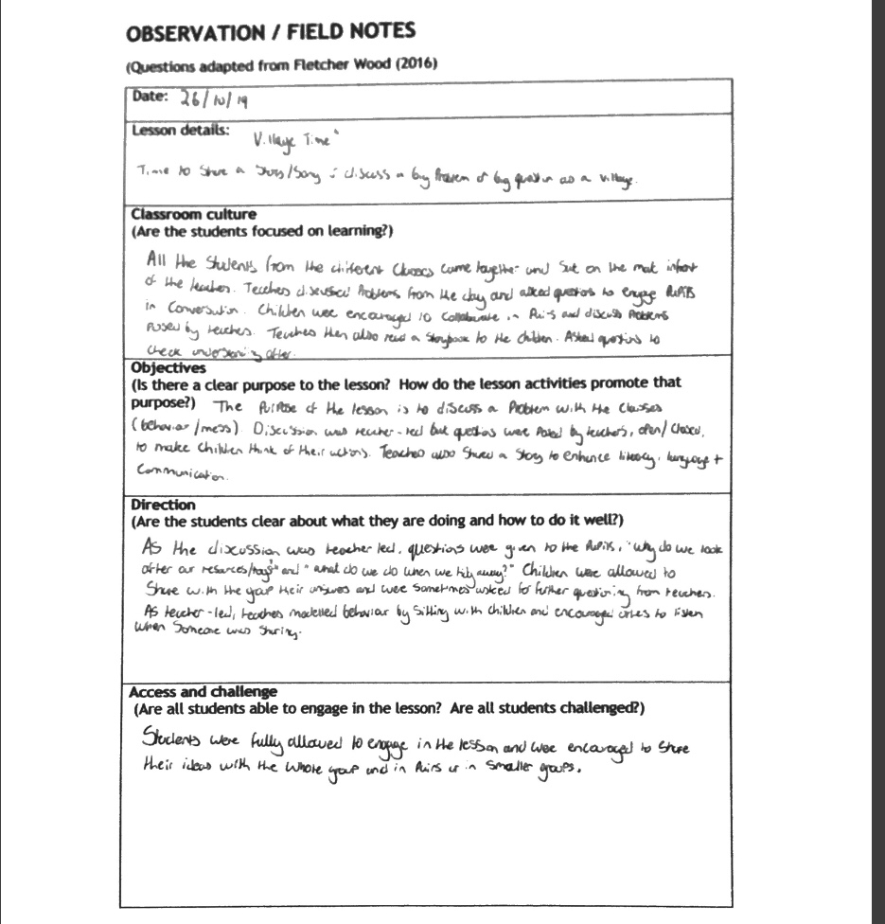
Figure 1.
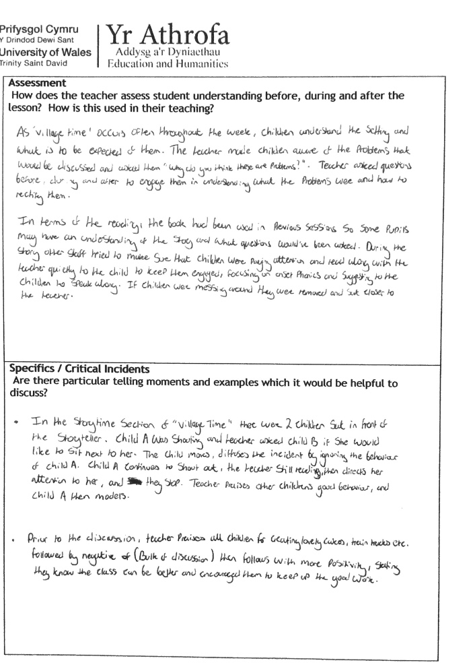
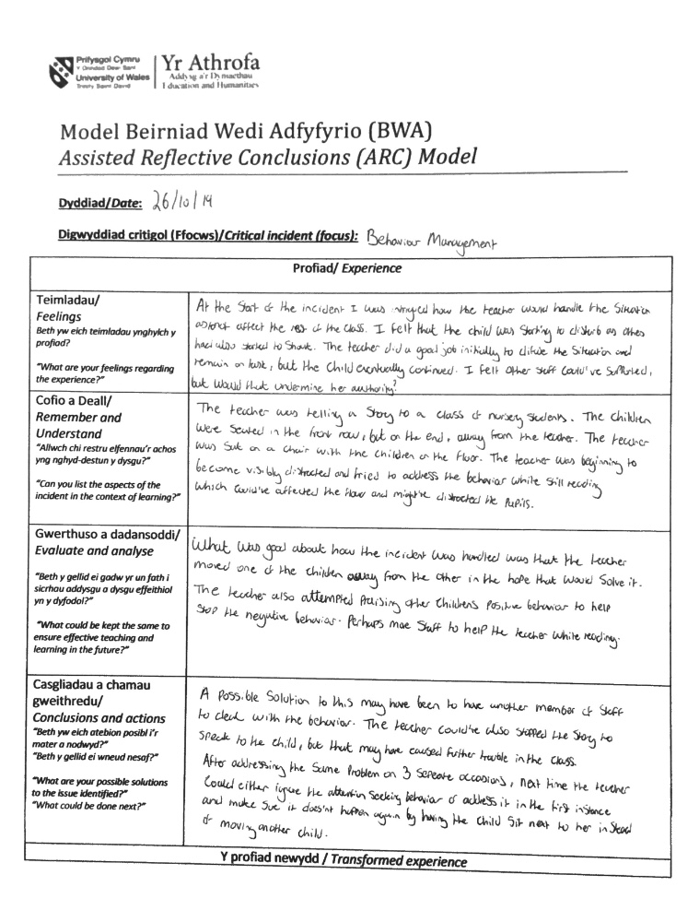

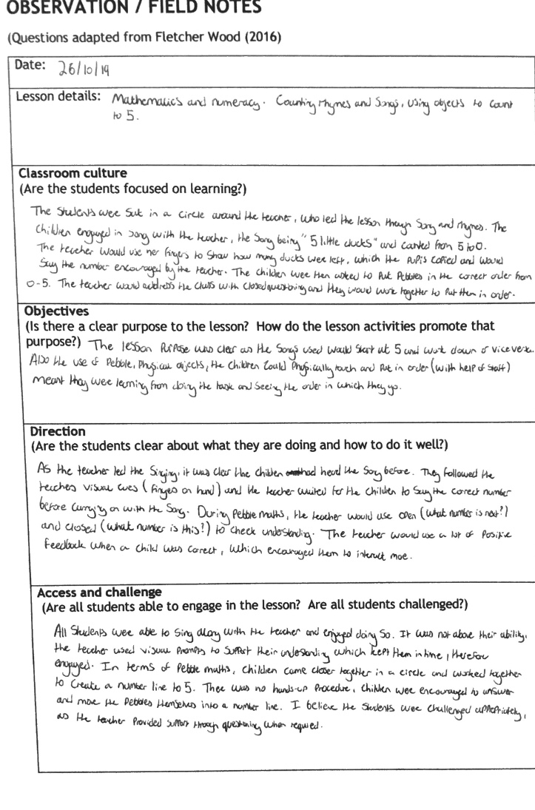
Figure 2

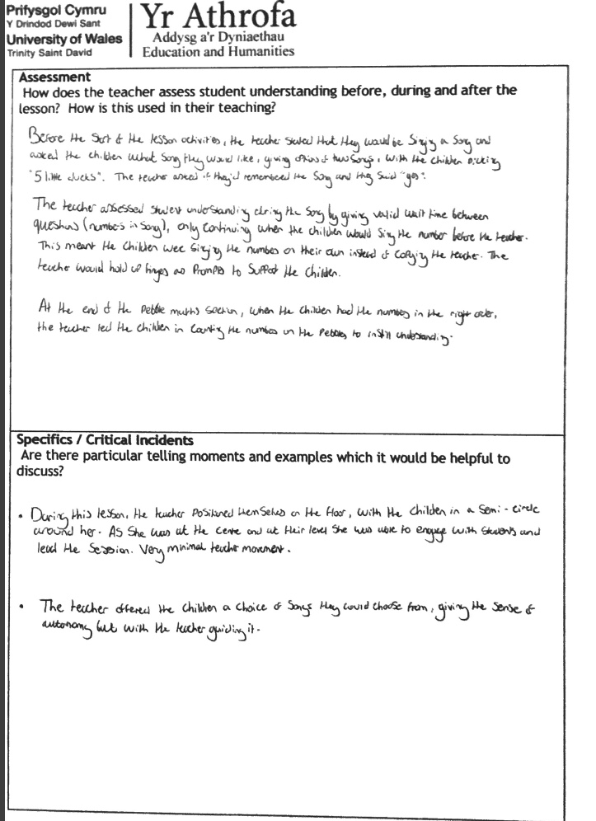

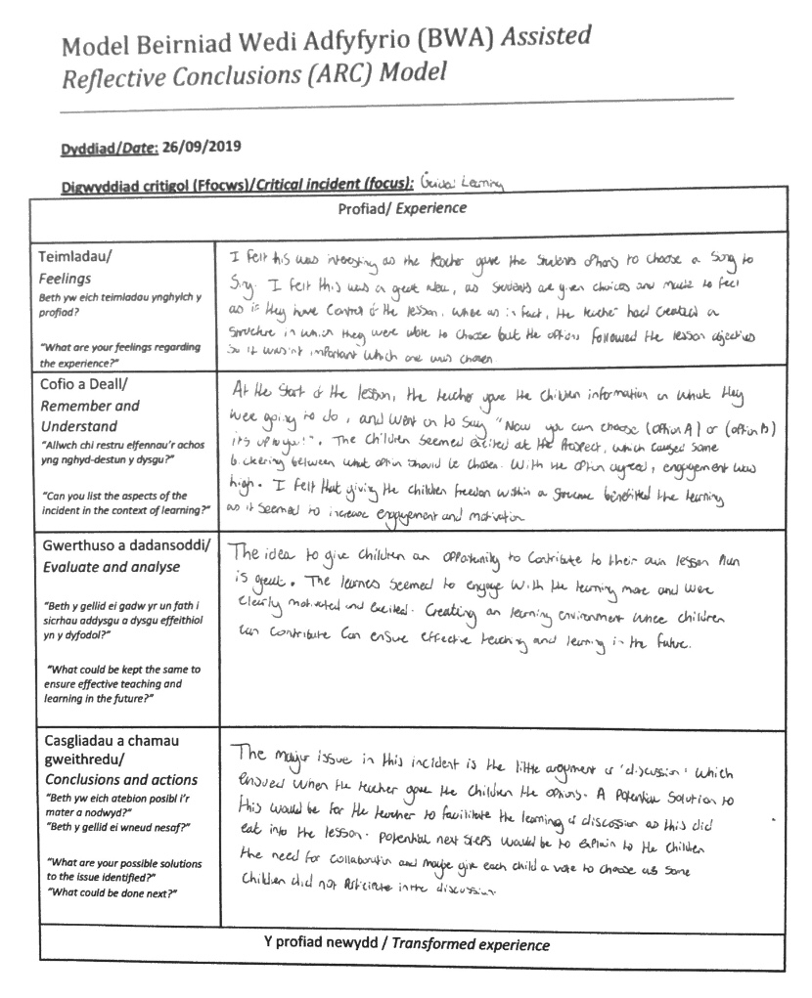

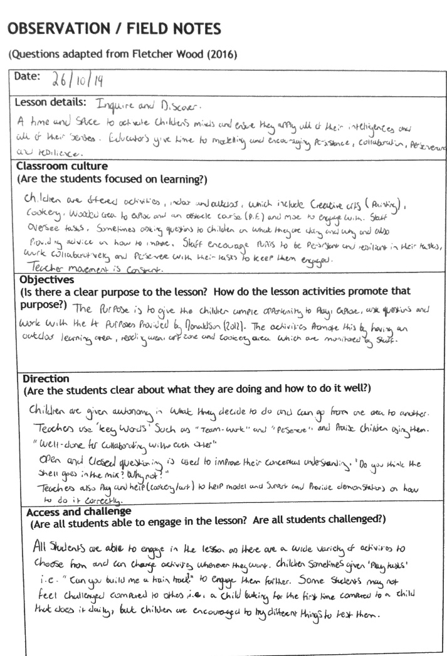
Figure 3.
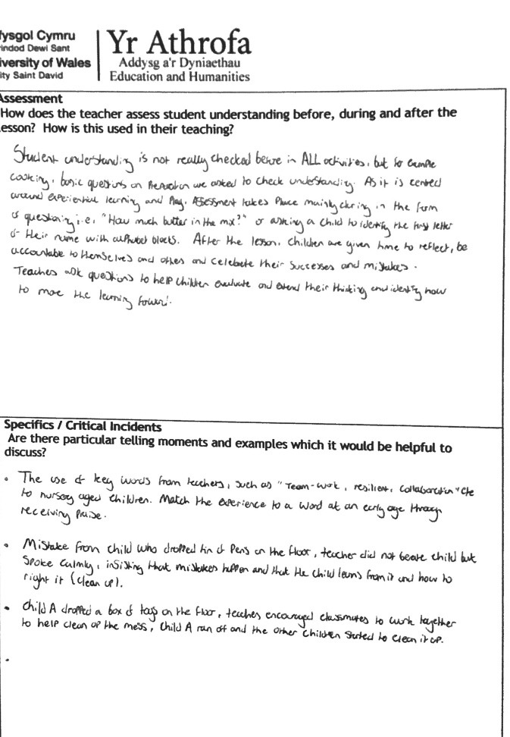

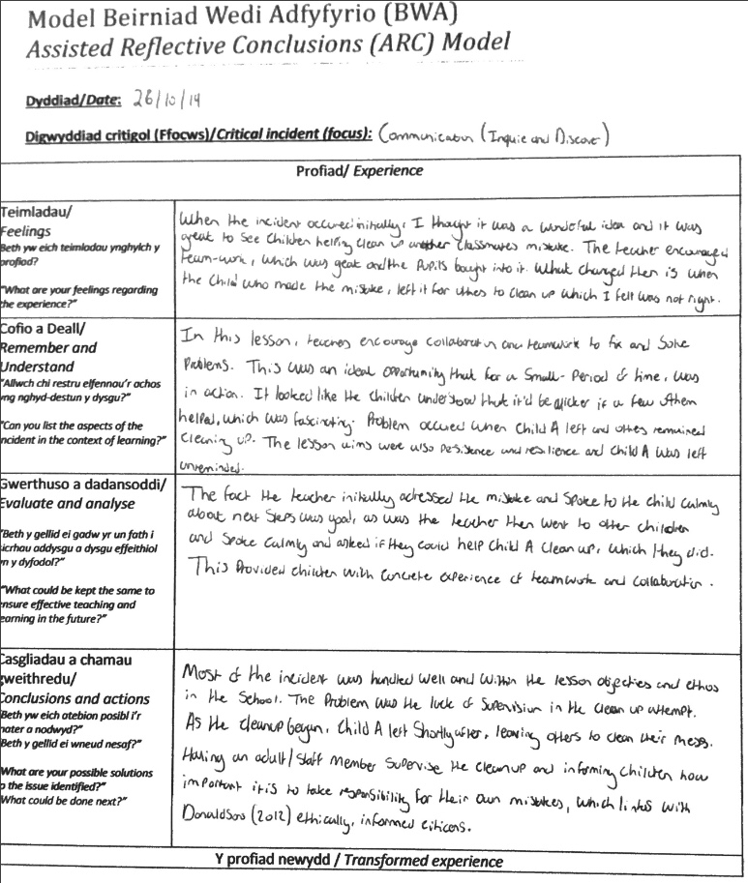
Figure 4.


