Data Handling and Business Intelligence
Assessment 2

Contents
Overview 3
Explanation of Data warehouse 4
Explanation of Business intelligence (BI) 6
Explanation of Data mining 7
Solution for the Part - 01 8
Pre-processing of Data 8
Data Visualisation along with Analysis 9
Solution for the Part – 02 10
Answer for 1 10
Answer for 2 11
Answer for 3 12
Answer for Q – a 13
Answer for Q – b 15
Answer for Q – c 16
Conclusions 18
Reference List 18

Overview

Organizations and entities that offer products or services for profit are known as businesses. One of the most critical aspects of this concept is the idea that a company exists only for the purpose of making money. Profitability isn't the primary goal of every company, but that's not to say that none of them are. Businesses now are very different from the rural stores of yesteryear, which only took cash or barter for goods (Rădulescu et al., 2018). Companies are now able to communicate with customers from all around the globe while selling their products globally. In the present world, operating a company is conceivable because of the role technology has played in transforming the way it is done. Maintaining and improving company operations requires effective management. An essential part of the job of a manager in any company is to ensure that all of the moving parts are working together in harmony (Business Management, 2022). Innovation and marketing are often involved in this, as is the creation of resources, finance, and machinery. Management of business is important for any organisation to control and increases their revenue growth. In this report several business management tools and techniques will be discussed. To manage business there are three important management tools, Data warehouse, Business Intelligence, Data mining. In this report these systems will be discussed. This report has three segments, in first general theoretical discussion will be done, in the second segment the analysis for attached data and result will be shown with procedure. In the third part the analysis and solution of asked questions are discussed. At the end SPSS and excel benefits and other issues regarding them are also discussed in this report.

Explanation of Data warehouse
Repository of electronic data collected from operating systems and made accessible for ad hoc inquiries and scheduled reporting are called data warehouses (DWHs). As opposed to this, creating a data warehouse requires creating and using an analytical data model. The data in the DWH is distinct from the operational data that may be found (Vaisman and Zimányi, 2014). In order to ease day-to-day activities, monitoring, and presentation, relevant data is grouped together. This aids in identifying long-term patterns and enables users to develop strategies based on that knowledge. The significance of warehouses in organization is reinforced by this. Tools like SQL clints along with the Business intelligence is used in this process.
Although data warehousing systems were also a feature of BI solutions for more than three decades now, new data types and hosting techniques have forced them to adapt. In the past, a data warehouse was often housed on-premises, generally on a mainframe computer, and its functioning was centred on collecting data from various sources, purifying and processing of the data, then importing & managing the information in a structured database. It’s totally maintained with different tiers; analytics engine is in charge of gaining access to and its position is on the intermediate layer. Amazon S3 is currently the most widely used object store. The feature of Amazon Web Services, allows customers to record and maintain any quantity of data from anywhere at any time. As well as offering 99.99999999% uptime, AWS S3 offers simple data management tools for a wide range of uses, including web hosting, mobile apps, backups, and restores (Amazon S3, 2022).
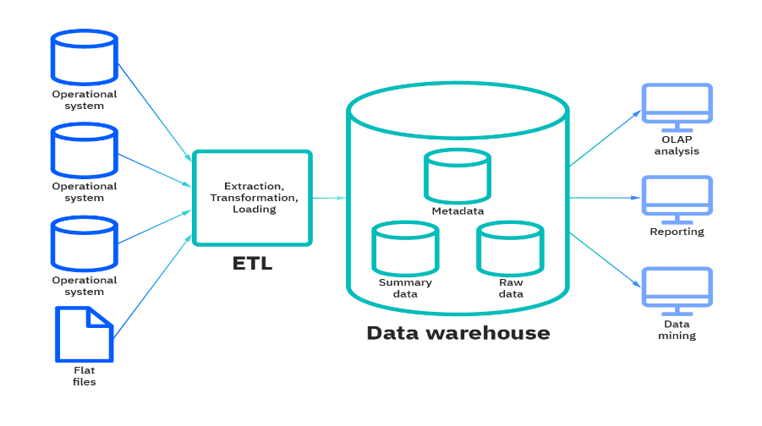
Figure: Data Warehousing (Kimball and Ross, 2021)
Among many warehousing system cloud data warehousing is a type. A cloud data warehouse is a client-provided cloud-based data warehouse. Recently, cloud-based data warehouses have grown more popular as companies strive to reduce their on-premises data centre footprint. With a licence, a corporation may build its own data warehouse (Vaisman and Zimányi, 2014). A cloud data warehouse gives you less control over the data and may not help to fulfil security and privacy regulations unless it’s a government agency, financial institution, or other business. Connecting a data warehouse appliance to the network and using the pre-installed hardware and software is easy. A data warehouse appliance is a hybrid solution that combines the benefits of both cloud and on-premises systems.
Data warehousing is often questioned by corporate users. Advantages are explained below:
- Enhanced user accessibility to a wider range of company data
- Increased productivity and cheaper computing costs are possible outcomes of this new technology.
- More statistics to back up your claims.
- Ad-hoc queries and reports may be performed by end users with little influence on the operating systems.
- Consistency of data has improved.
- Providing a central location for integrating data from several sources.
- Developments in data systems and company structures need a flexible computing infrastructure.
In a data warehouse, vast amounts of data are analysed. For example, financial transactions need a database. In warehousing system unstructured data cannot be organised or semi-data. Data warehouses need data tables, which is where the schema enters in. Unless the data is tabular, SQL can be used to analyse it (Kimball and Ross, 2021). However, there seem to be exceptions to the norm when putting data in a table. However, some services, such as machine learning, big data analytics, complete search and may access semi-structured or unstructured data.

Explanation of Business intelligence (BI)

It's common to refer to the application of data analytics to corporate decision-making as "business intelligence" (BI). It includes gathering data, analysing it, and translating it into understandable components for later part, and also implementing the knowledge learned through reports and visualisations to improve performance (Božič and Dimovski, 2019). A company's ability to function and adapt to the ever-changing marketplace depends on its Business Intelligence (BI) capabilities, which go well beyond just converting raw data into useful information.
Managers, directors, and other officials can see what is going on in a firm thanks to data-driven insights. These decision-makers are informed of the present and the previous events that have brought them to this point in time. Many advantages accrue to organisations that make use of data-driven decision-making tools. In addition to higher profitability, the following benefits are worth noting:
- Internal process optimization.
- A location of employment that runs smoothly.
- Creating new sources of income.
- The ability to make judgments more quickly.
- The ability to accurately forecast one's own success.
- Reducing the amount of trash produced.
- Identifying and addressing organisational issues.
- finding fresh opportunities in the market and making use of them

Business Intelligence is run with five phases; all phases are important for its operation. Five phases are described below:
Data sourcing
Business intelligence gathers data from many sources and synthesises it. Data types include papers images, sounds, tables (formatted spreadsheets), and URLs (web addresses). When sourcing data, it's critical to receive it online (Božič and Dimovski, 2019). Data sources include scanners, digital cameras, database searches, web searches, and computer files.
Data analysis
It's all about converting raw data into usable information in BI. There is a lack of understanding or forecasting about future trends. This kind of data analysis is also known as knowledge discovery.
Situation awareness
The purpose of business intelligence is to sift out the noise and put what's left in context with the organization's goals and surrounds. A user's utilisation of a service requires data summaries and important information about their needs (Rikhardsson and Yigitbasioglu, 2018). To make effective decisions, one must be well-versed in the surrounding conditions. Automated situational assessment algorithms produce these reports.
Risk assessment
Business Intelligence seeks to discover viable actions or options at certain periods. This tool's main objective is to help you weigh the immediate and long-term risks, costs, and rewards of different options. This includes summarising and determining your finest choices.
Decision support
Data intelligence is the clever use of data. As a result, it intends to alert you of takeovers and market developments so you can prepare (Rikhardsson and Yigitbasioglu, 2018). This programme aims to increase revenues, customer happiness, and staff morale. There's information when you need it.

Explanation of Data mining

It is the method of analysing large amounts of data to uncover patterns, trends, and acquire an understanding of how that information might be utilised. Data miners may then utilise their results to make judgments or anticipate future outcomes (Data mining, 2022). The sciences of analytics, AI, deep learning, and machine intelligence are all intertwined in data mining.
Many types of businesses rely on data mining to run efficiently. In order to identify fraud, manage risk, forecast demand for resources, predict customer sales and companies utilise data mining. To put it simply, data mining is good for company; it can save money, boost competitiveness, enhance customer service, and uncover new consumers and income streams. Basically, data mining is good for business.
Data mining is the process of sifting through enormous amounts of data to identify patterns and trends. Email spam filtering; Credit risk, database management; fraud detection as well as the ability to learn about the opinions and sentiments of users are all examples of data mining's various applications. There are five stages to the data mining process. In the beginning, the data warehouse is set up and the data is gathered. After then, the data is either saved with in cloud or on the company's own servers (Data Mining Benefits, 2022). A team of managers, analysts, and IT specialists examine the data and decide how it should be organised. After that, the programme sorts it depending on the input from the people. End-users may easily communicate their findings by displaying the data in a visually appealing graph or table.
Customers' preferences and segments can be identified, new customers can be attracted, cross-sale and up-sale opportunities improved, customer loyalty and retention increased, ROI from marketing campaigns increased, fraud and credit risk identified and operational performance monitored through the use of data mining.

Solution for the Part - 01

In this part two process will be done by using Microsoft excel and dataset of crime rate. The data will firstly process and then will be visualised in this part. The process is begun from below:

Pre-processing of Data
Data preparation transforms raw data towards a format suitable for data mining. Raw data is typically incomplete and inconsistently arranged. Poor data preparation is important to the project's success. Pre-processing includes data validation and imputation. This step of data collection assuring the data is complete and correct.

Data Visualisation along with Analysis

Data visualisation is the process of presenting data in a graphical or visual style. Data analytics is the study of data to make decisions based on the information contained within.
Chart presentation for crime rate:

Figure: Crime Rate Analysis
Comment: Above chart is showing that there are 1028 of violations in per million individuals at US.
Analysis of Pivotal table to analysis the sum of crime rate and the table is attached below:
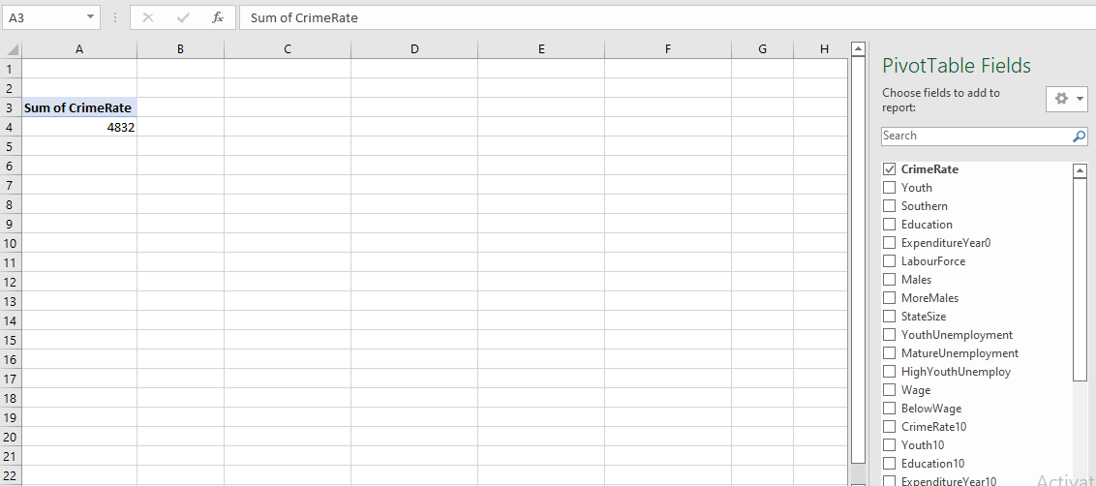

Figure: Pivot table Analysis
The VLOOKUP is used in this process and the goal of using this is to find the value in the crime rate table. The used formula and calculated answer are attached in below section:
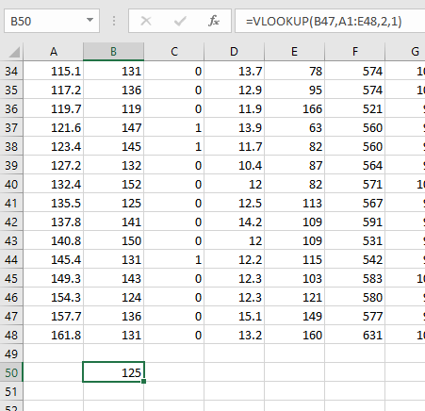
Figure: Result after using VLOOKUP

Solution for the Part – 02

Answer for 1

Analysis for number of students likes vanilla flavour:
Ice-cream
 |  | Frequency | Percent | Valid Percent | Cumulative Percent
Valid | Vanilla | 95 | 47.5 | 47.5 | 47.5
Valid | Chocolate | 47 | 23.5 | 23.5 | 71.0
Valid | Strawberry | 58 | 29.0 | 29.0 | 100.0
Valid | Total | 200 | 100.0 | 100.0

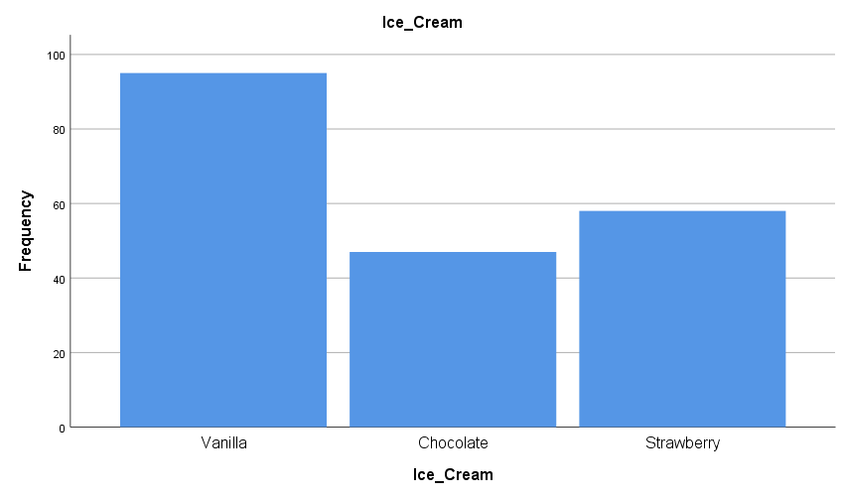
Figure: Chart for Ice-crems consumer frequency
Comment: As the above analysis represents that the percentage of students likes vanilla ice-cream are 47.5%. In between the other two the percentage of vanilla likers are way more. The calculated frequency is 95. The chart also represents the frequency for all three flavours.

Answer for 2

Analysis for number of male and female:

The SPSS is used in this analysis and the SPSS result is attached below. Here, the categorial variable is analysed here, male and female are the two subcategories. The frequency table is analysed and the result is:
Gender
 |  | Frequency | Percent | Valid Percent | Cumulative Percent
Valid | Male | 91 | 45.5 | 45.5 | 45.5
Valid | Female | 109 | 54.5 | 54.5 | 100.0
Valid | Total | 200 | 100.0 | 100.0

From the result a pie graph is attached below to better present the percentage. As the male is 45% and female is 55%. Female numbers are greater than male.

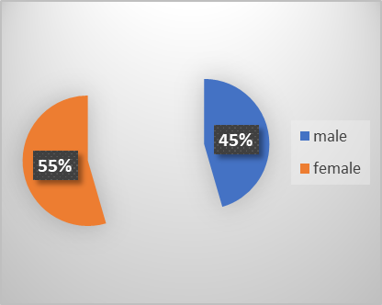
Figure: Pie chart for number of male and female

Answer for 3

Analysis for the mean and median of chocolate and strawberry flavour likers:

The analysis is done on the SPSS and the result is attached below. Mean ad median is analysed in SPSS for the chocolate and strawberry flavour. Variation in the mean and median is analysed. Chocolate has the median of 47 compared to strawberry.

Statistics
 |  | Video | Puzzle
N | Valid | 47 | 47
N | Missing | 0 | 0
Mean |  | 47.70 | 47.32
Median |  | 47.00 | 46.00
Ice-Cream = Chocolate

Statistics
 |  | Video | Puzzle
N | Valid | 58 | 58
N | Missing | 0 | 0
Mean |  | 55.45 | 57.14
Median |  | 58.00 | 61.00
Ice-Cream = Strawberry

Answer for Q – a

Analysis of K- means clustering in SPSS
Data may be processed using a statistical approach known as cluster analysis. It operates by grouping or clustering elements according to the degree to which they are related to one another. Dataset matrices wherein the parameters have not yet been partitioned into criteria versus predictor subsets are the focus of both cluster analysis and reduction spaces analysis. ANOVA will be used in this process (Romesburg, 2018). There are two types of systematic and random elements that contribute to the observed aggregate variability in a data set when doing an analysis of variance ANOVA. The result us attached below:

Initial Cluster Centers
 | Cluster
 | 1 | 2 | 3
video | 29 | 55 | 72
puzzle | 26 | 71 | 31

Iteration Historyª
Iteration | Change in Cluster Centers
Iteration | 1 | 2 | 3
1 | 16.278 | 12.775 | 17.567
2 | 3.070 | 1.812 | 1.037
3 | 1.793 | .967 | .327
4 | 1.400 | .798 | .373
5 | 1.096 | .682 | .471
6 | .406 | .114 | .616
7 | .000 | .000 | .000
a. Convergence achieved due to no or small change in cluster centers. The maximum absolute coordinate change for any center is .000. The current iteration is 7. The minimum distance between initial centers is 43.290.

Final Cluster Centers
 | Cluster
 | 1 | 2 | 3
video | 41 | 58 | 56
puzzle | 46 | 61 | 39

ANOVA
 | Cluster |  | Error |  | F | Sig.
 | Mean Square | df | Mean Square | df | F | Sig.
video | 5889.952 | 2 | 39.226 | 197 | 150.153 | <.001
puzzle | 7430.226 | 2 | 40.994 | 197 | 181.253 | <.001
The F tests should be used only for descriptive purposes because the clusters have been chosen to maximize the differences among cases in different clusters. The observed significance levels are not corrected for this and thus cannot be interpreted as tests of the hypothesis that the cluster means are equal.

Number of Cases in each Cluster
Cluster | 1 | 67.000
Cluster | 2 | 101.000
Cluster | 3 | 32.000
Valid |  | 200.000
Missing |  | .000

Comment: The two-cluster data was inputted and they are initial and final history of iteration. The result for the both inputted clustered is not same sized. Dendrogram is used to analyse the cluster size approximately in the analysis. The final result indicates that the puzzle is showing more effect in the variable.

Answer for Q – b

Analysis of enormous datasets for characteristics which may be utilised to make business choices is known as data mining. In both information processing and in data science, it's a crucial part. Businesses may employ a variety of data mining techniques to turn unstructured data into meaningful information (Data mining, 2022). Text mining is a critical tool for analysing and managing the world's data, accounting for around 80% of all data. This data will continue to rise exponentially because more data is absorbed from different sources. Database systems and cloud - based services are currently being utilised by the plurality of institutions and organizations to store huge volumes of data.
Most common Method with examples:
Retail sector
It is possible to discover client preferences using data mining. Data mining methods may be used to uncover information about a customer's purchase behaviour.
Stores utilise the results of these research to organise product placements on bookshelves and to develop special offers, which may include discounts for similar products or discounts on specific items. These efforts are based on the RFM grouping method of classification. RFM is an abbreviation that stands for recency, frequency, and financial grouping (Data mining, 2022). Each of these markets has its own advertising and marketing effort, which is distinct from the others. Your treatment will fluctuate depending on your spending patterns and the frequency with which you make purchases. When it comes to providing product suggestions and cross-references, data mining may be quite useful.
E-commerce Business
Many e-commerce enterprises use data mining techniques in attempt to cross-sell & upscale their products. When customers check in to Amazon and Flipkart, for example, they will notice things such as "People Also Viewed" and "Commonly Purchased Together" that are shown. These suggestions are generated based on the purchases made by prior customers.

Answer for Q – c

Discussion is attached below:
Categories | The SPSS | The Excel
Full Form | Statistical Package for the Social Sciences | Electronic Xylophones Create Electronic Listening.
Explanation | SPSS is statical analysis software, used for quantitative analysis and quantitative analysis. | Excel is a Microsoft's spreadsheet programme. It’s a Software from the Microsoft Office family.
Used in | Academic and any kind of Research purposes. | Academic and any kind of Research purposes.
Software Type | Statical Analysis software | Spreadsheet software
Analysis | Complex Analysis | General and semi complex tasks
Usage | Widley used for statical analysis like, corelation, cluster, regression. | Simple statical analysis and multiple data analysis systems.
Advantages | It has a good speed with large performance. | Better helps in data collection, processing and analysis.
Academic Use | SPSS is used to complete many analyses and statical analysis. It helps in academic career. | Used in the data analysis process and great assistant in academic works.
Career | Bright career can be developed in this sector like data analysis and developer. | With excels helps a mighty career can be built. A good skill in this will help in any sector.
Owner | IBM | Microsoft Corporation
Field | Data science is integrated into a diverse variety of fields. | In this discipline of computer science, many techniques and methods are utilised to analyse data.
Analysis of Big data | Not widely used and less suitable | helps in data collection but less suitable for analysis.

Conclusions

Data is the fuel for success in today's information-driven corporate climate. In order to plan for future growth, decision-makers need to know more about their workers' requirements, changes in the industry, and the wants of consumers. Data helps organisations better and understand their operations, helping them can save cost and resources in the process. As a result of its drain on resources and negative effect, waste has a negative impact on every firm. Inefficient data used to make advertising selections has shown to become one of the costliest mistakes a corporation can make. Data may be used to enhance customer service and customer experience, but it can also be used to target marketing, save money, and increase process efficiency, as well. Data storage, mining, and Business Intelligence (BI) technologies are all included. Businesses use data warehouses to consolidate information from several sources into one location for analysis and decision-making purposes. Businesses may decrease risks and increase profits by using business intelligence (BI) technologies. Every day, firms employing business intelligence systems examine both external and internal data, including economic and market trends, to make informed decisions. BI uses periodic data to run its operation. Using historical data seems to be rather frequent in this kind of reporting. It's still possible to go on. Predictive models will be used more and more in the future. Cloud computing, IoT system, the big data analysis with internal data base management system enables analysis of client perceptions and overall corporate efficiency and market valuation.

Reference List

Amazon Web Services, Inc. 2022. Cloud Object Storage – Amazon S3 – Amazon Web Services. [online] Available at: <https://aws.amazon.com/s3/> [Accessed 16 April 2022].
Božič, K. and Dimovski, V., 2019. Business intelligence and analytics for value creation: The role of absorptive capacity. International journal of information management, 46, pp.93-103.
business.com. 2022. What Are the Branches of Business Management? - business.com. [online] Available at: <https://www.business.com/articles/8-branches-of-business-management/> [Accessed 16 April 2022].
Butler Analytics. 2022. Data Mining Benefits. [online] Available at: <https://www.butleranalytics.com/data-mining-benefits-costs-and-risks/> [Accessed 16 April 2022].
Data mining. 2022. [online] Available at: <https://www.simplilearn.com/what-is-data-mining-article> [Accessed 16 April 2022].
Kimball, R. and Ross, M., 2021. The data warehouse toolkit: the complete guide to dimensional modeling. John Wiley & Sons.
Rădulescu, C.V., Dobrea, R.C. and Burlacu, S., 2018. The business management of distress situations. In The 12th international management conference “Management Perspectives in the Digital Era” November 1st-2nd (pp. 741-747).
Rikhardsson, P. and Yigitbasioglu, O., 2018. Business intelligence & analytics in management accounting research: Status and future focus. International Journal of Accounting Information Systems, 29, pp.37-58.
Romesburg, C., 2018. Cluster analysis for researchers. Lulu. com.
Vaisman, A. and Zimányi, E., 2014. Data warehouse systems. Data-Centric Systems and Applications.

