
Workshop & Practices
FMEA (assignment 1)

submission date: 8/03/2021
Josh Brown
2004738

Contents
Introduction 2
Research 2
Risk Management 2
FMEA 2
H&S Legislation 2
PPE 3
Machinery 3
Initial FMEA 4
Discussion and Justification for Rankings and Mitigating Actions 4
Post FMEA 5
Discussion and Justification of Ranking and Potential Risk remaining 6
Conclusion 6
References 7

Introduction
During this assignment I was set the task of assessing a company’s production line from the perspective of a process engineer working for a large automotive company. I had to find potential areas of failure on the line and provide ways to resolve these issues and reduce the likelihood of failure in the future. Identify and finding ways to reduce potential failure in a production line is crucial because it allows you to predict problems before they even occur.

Research

Risk Management
Risk management is how you react and control various potential risks in a production line or product. FMEA is a very common method of risk management. Risk management allows you to identify risks early and minimise the potential risk in the future. “Safety hazards, aging assets and security threats can negatively impact your business, including your employees, revenue, plants, intellectual property, vehicle quality and customers.” (Smentowski, 2017) this highlights how dramatic ramifications can be when risk management is not used effectively. Risk management is vital in helping build a good brand within a business and making sure that all sectors in a business are regarded highly. “To prevent risks from reaching this point, your risk-management efforts should focus where many problems can be controlled.” This shows that the main way risks can be contained is not by identifying the risks but by producing potential mitigating factors. Identifying risks will only bring the risks to light where mitigating actions helps to reduce the likelihood of occurrence.

FMEA
FMEA is a way used to bring any potential issues in a production line to light and provide ways to negate these issues. FMEA stands for failure mode and effective analysis and is a main form of risk management. “Failures are prioritized according to how serious their consequences are, how frequently they occur, and how easily they can be detected.” This means that the potential failures are measured by likelihood of occurrence, severity if the mistake happens and the likelihood of detection. These three measurements are then used to create a main measurement which would be the risk priority number. This then makes it so that the potential failures can be ranked on which ones have the biggest priority. "Effects analysis" refers to studying the consequences of those failures.” This shows that the purpose of FMEA is to provide suggestions in ways to negate the potential failures of a production line of product.
H&S Legislation
These are legislation that are put in place by the government to ensure a safe working environment. The legislations cover all parts of the workplace e.g., Employer, employee, COSH, electrical safety, maintenance and PPE. The legislation would cover what is allowed and disallowed in the workplace. There would be specific pieces of equipment which is verified by the H&S legislation meaning they are deemed safe to use in the workplace.

PPE
Personal protective equipment (PPE) this is another form of risk management. PPE is usually items that a person would wear in order to reduce potential harm to a person. Common examples of PPE are steel toe cap boots, eyewear and gloves. These are PPE items that you would see in many workshops. PPE is heavily scrutinized due to the number of accidents that take place when PPE is not being warn. “Choose products which are CE marked in accordance with the Personal Protective Equipment Regulations 2002” (Health and Safety executive, 2014, p.81) from this I take that PPE has a CE marking on them to show that they have been approved as appropriate PPE. If an engineer was harmed while using PPE which is not CE marked, then this could lead to large consequences for the company. “Managers and supervisors have an important role to play” (Graveling, 2011) this backs up the point that the employer will be at fault if an accident takes place when the incorrect or no PPE is being worn at the time of an incident.

Machinery
Machinery can cause major harm to a person and in extreme cases even death. This outlines how important it is that all staff have a safe environment to work in and that they are aware of the damage in which heavy machinery can cause. The government implemented legislations which companies must follow. These legislations are in place to make the workspace a safe place. “man was working on a piece of heavy machinery at the time of the incident. While he was doing so, he was hit in the head by a large steel bolt.” (Banger, 2020) This outlines that machinery is dangerous and can still cause harm to a person even with how advanced the machinery is that is used in industry today. “Additional hazards can occur when machinery becomes unreliable and develops faults.” (Health and Safety Executive, 2014, pg. 68) this highlights that the fact that all machinery must be maintained to a high standard to ensure reliability and that a machine does not develop faults.

Initial FMEA
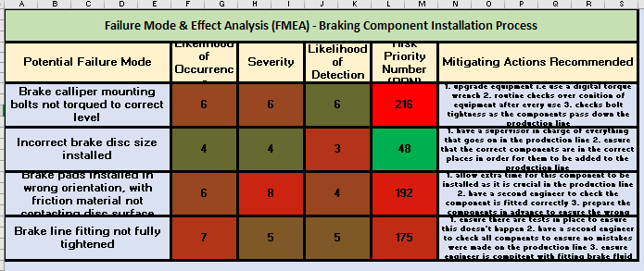
I had an excel document which I used to create my FMEA charts, I had one chart for initial FMEA and then a second chart for the FMEA once the mitigating actions had been put into place. The chart above shows initial FMEA. I came up with a figure between 1-10 for likelihood of occurrence, severity and likelihood of detection. When I had figures for these three things, I was able to come up with a risk priority number (RPN), this figure was found by multiplying the first three figures together. I then had to suggest mitigating actions which could be put into place to reduce the risk of any of the potential failure modes (PFM) from happening.

Discussion and Justification for Rankings and Mitigating Actions
Looking at the figures in the FMEA chart the PFM with the lowest RPM is installing the incorrect brake disc size. This is because I felt that the likelihood of this happening would be low since all the brake discs that are the same size are kept in the same place therefore making the chance of the wrong size disc being installed slim. Also, the likelihood of detection is low meaning there is a high chance of an engineer noticing if the wrong size disc is installed this is because an experienced engineer would be able to notice this just by looking at it. As for mitigating actions, I suggested that it would be good to have a supervisor to ensure that the correct parts were being placed onto the production line. This would eliminate the chance of this happening early on.
The second lowest RPM came for the brake line not being tightened correctly. This again is because the likelihood of this happening should be low because an experienced engineer should not be making a mistake as simple as this however, I do see how it is an easy mistake to make and needs mitigating actions put into place. I believe that it could be hard to detect an issue like this as the brake fluid lines are well hidden. The main time you would be able to detect this is when the component is tested as this would impact how well the component does its job. The mitigating actions I suggested for this was to put more frequent tests on the components so that any mistakes would be detected. There could be a document that logs who checks each component this would make sure that all checks are thorough.
“brake pads installed in wrong orientation with friction material not contacting disc” this issue had the second highest RPM. This is due to the extremely high severity figure; I came up with this figure due to the big ramifications if this mistake Is made. I felt that there was a large chance that this mistake would be detected due to the issues this would cause for the component. The mitigating actions I suggested was allowing extra time for the component to be installed. This is because this component is difficult to fit so allowing extra time would relieve pressure on the engineers so they can make sure the component is fitted correctly. I also suggested that a second engineer was to check this component which would allow any mistakes to be picked up.
The PFM with the highest RPM was the calliper mounting bolts not being tightened to the correct torques. This had a high figure for RPN due to the figures for likelihood of occurrence, severity and likelihood of detection all being high. I rated the likelihood of occurrence high because I feel that this is an easy mistake to use. The torque wrench may not be set correctly meaning the bolts would not be tightened correctly, this may lead to the bolts becoming loose. For mitigating actions, I suggested that the equipment used could be upgraded. For example, a digital torque wrench could be used to ensure the bolts are always tightened to the correct level. I also suggested that there were routine checks of the condition of equipment and checks on the component in order to correct any mistakes that may have been made.
For each of the PFM I suggested that there would be a superior to the engineers that are working on the line. The superiors would run the line. They would be responsible for the checks on the components and equipment and making sure that the correct components are on the production line at the correct time.

Post FMEA
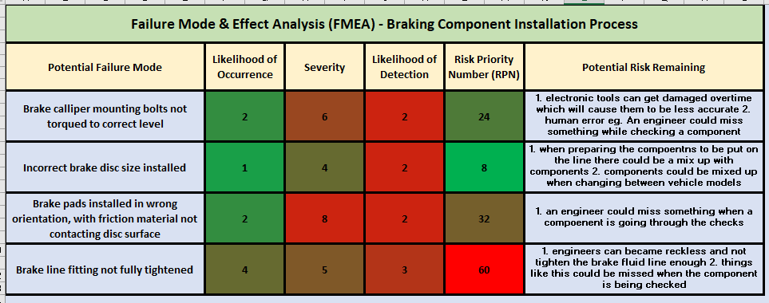
The chart above displays the figures for likelihood of occurrence, severity, likelihood of detection and RPN after the mitigating actions had been put into place. As expected, every figure decreased after the mitigating actions had been put into place suggested that the mitigating actions did their job. The severity for each PFM has stayed the same because if these mistakes did happen then they would still have the same ramifications.

Discussion and Justification of Ranking and Potential Risk remaining
Fitting the incorrect disc size still has the lowest RPM. This is due to how low the values are for likelihood of occurrence and likelihood of detection. The low chance of this happening is because of the way the lines are organised. If the supervisor keeps on top of which components are on the line at different times, then this mistake should never happen. The low likelihood of detection is good because you would be able to see if a different size brake disc were fitted. The only remaining risk would be if the components were to get mixed up when switching between vehicle models.
The RPN for the brake calliper mounting bolts not torqued to correct level dropped from 216 to 24. This was due to the mitigating actions that I suggested were to be put into place. For example, the main reason for the drop was due to the upgrade in tools. After using a electronic torque wrench there would be a minimal chance for a mistake as long as the condition of the tools is kept to a high standard. The fact that I suggested a supervisor watch over the production line would also have helped due to all the other engineers making sure that they do their job properly. However, there is still some remaining risk regarding this issue. Such as electric tools can become inaccurate if not maintained properly and/or get overused. Also, in all these cases there is always room for human error when fitting a component or checking over a component.
in terms of the brake line being fitted correctly this now has the highest RPM. This is because of the likelihood of occurrence remaining high after mitigating actions had been put into place. This is since engineers can become complacent after a fair amount of time meaning they could make a mistake. There is still risk remaining when the supervisor is checking over the components as they could not check the component thoroughly.
Finally, fitting the brake pads in the wrong orientation also had a sufficient drop from 192 to 32. The main drop in this number was due to the decrease in the likelihood of occurrence this dropped from a 6 to a 2. This is due to the organisation of the line after the mitigating actions was put into place. Only the correct brake pads were near the line at the appropriate times. The supervisor would also help this situation as they would check if the wrong components were being put on the line or if the wrong component were already fitted. However, there is still a small remaining risk that there is room for human error. The supervisor can miss something when organising the line or checking over the components that come off the production lines.

Conclusion
In conclusion, this assignment has highlighted the important of risk management. Not just the fact that risks need to be highlighted but the key is that the risks need to have mitigating actions put in place in order to minimise future potential issues in a production line or product. Furthermore, FMEA is a very efficient method of identifying risks and putting them in order in terms of a risk priority. It is clear to see that since the introduction of the H&S legislation safety in the workplace has increased by a great amount. The introduction of consistent and safe PPE has also been a great factor in increasing safety in the workplace.

References
Smentowski, L. (2017) risk management in automotive manufacturing: stop problems at their roots. Available at: Risk Management in Automotive Manufacturing: Stop Problems at Their Roots | IndustryWeek accessed on: 26/02/2021.
Graveling, R. (2011) challenges of PPE.
Available at: Challenges of PPE - Health and Safety International (hsimagazine.com). accessed on 29/02/2021
Health and Safety Executive. (2014) The health and safety toolbox How to control risks at work. Available at: The health and safety toolbox: How to control risks at work (hse.gov.uk). Accessed on: 02/03/2021.
Banger, C. (2020) risks of machinery in the workplace
Available at: One person seriously hurt after workplace incident in Arthur | CTV News. Accessed on 04/03/2021

