

Postgraduate/Distance Learning
Assignment coversheet & feedback form

THIS SHEET MUST BE THE FIRST PAGE OF THE ASSIGNMENT YOU ARE SUBMITTING (DO NOT SEND AS A SEPARATE FILE)

For completion by the student:
Student Name:
Judith Beton
Module code: HPMS7006  Module title: Thomas Becket | Student ID number:  2005762 |  |  | Educational support needs:  No
Module tutor: Prof. Janet Burton

Assignment due date: 22/11/21
If your module has multiple submissions please indicate which piece of work this is.

1st 2nd 3rd 4th 5th 6th
I confirm that this is my original work and that I have adhered to the University policy on plagiarism.
Signed …Judith Beton…………………………………………………………
Email submission: if you are submitting this form via email, please tick this box □
(as a substitute for your signature) to confirm that you agree to the above declaration.
Assignment Mark
1st Marker’s Provisional mark
2nd Marker’s/Moderator’s provisional mark
External Examiner’s mark (if relevant)
Final Mark

NB. All marks are provisional until confirmed by the Final Examination Board.

For completion by Marker 1 :
Comments:

Marker’s signature: |  |  | Date:
For completion by Marker 2/Moderator:

Comments:

Marker’s Signature: |  | Date:
External Examiner’s comments (if relevant)

External Examiner’s Signature: |  | Date:

The Martyrdom of Thomas Becket

Visual Image Commentary

London
British Library
Cotton MS
Claudius B II

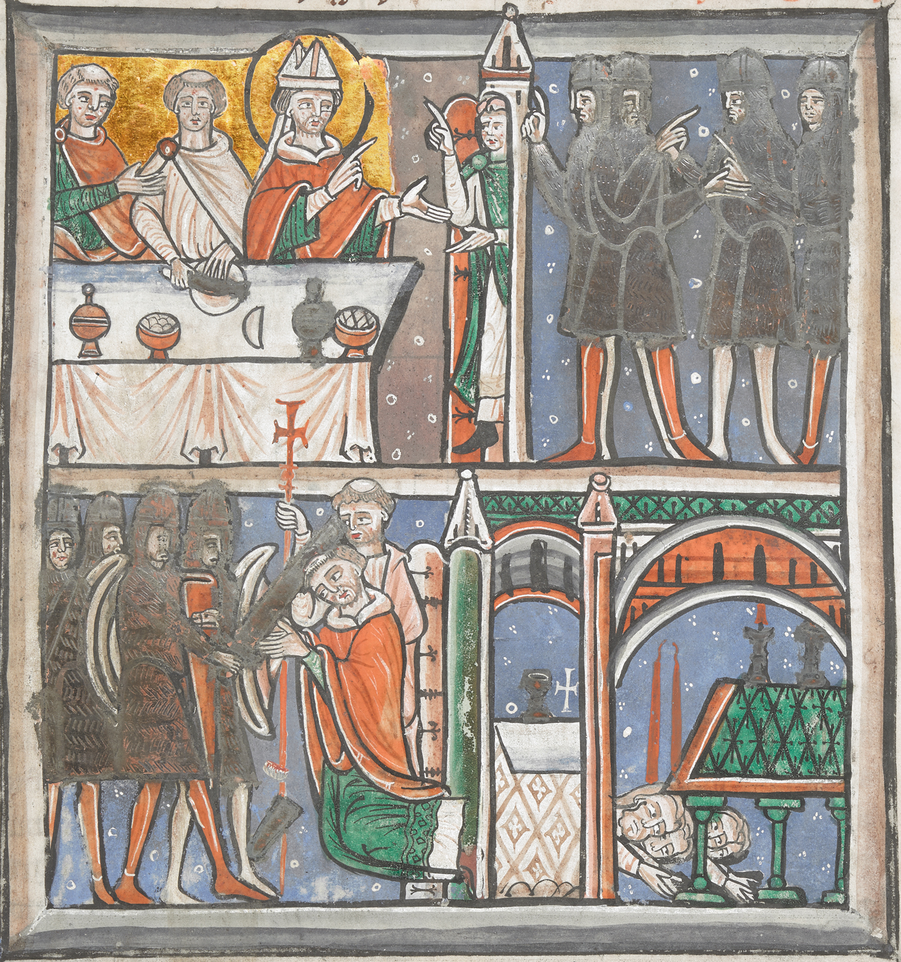
This illumination, depicting Thomas Becket’s martyrdom, comes from Alan of Tewkesbury’s comprehensive collection of Becket’s correspondence, assembled whilst Alan was a monk of Christ Church Canterbury, between 1174 and 1176. The collection includes John of Salisbury’s Vita and a supplementary work by Alan of Tewkesbury, the Explanatio. This image was used to illustrate a letter of John of Salisbury contained in the book and is the earliest known representation of the martyrdom. Since Alan of Tewkesbury was compiling this collection of correspondence at Canterbury, it is likely that the artist producing this image would also have been a Canterbury monk. The image comprises four sections, telling the story of events from the arrival of the four knights at Canterbury, to the murder and the subsequent veneration by pilgrims at Becket’s tomb.

The first panel, at the top left, shows Becket sitting at a table with two tonsured clerics. Becket is identified by his mitre and halo. The halo spreads beyond the margins of the picture into the frame area, thus drawing attention to it, and the whole background is suffused in its golden light. The table appears to be set with food and drink, though one of the vessels has been crudely painted over in black. The item on the plate is indistinct but may be a fish. Readers in the twelfth century would have been familiar with images of the Last Supper as it had been frequently depicted on wall paintings and in manuscripts since the early days of Christianity, so it is hard to avoid the conclusion that the illustrator was deliberately identifying Becket with the figure of Christ at the Last Supper, shortly before His death and where His betrayer was named. If the object on the plate is a fish it would not be out of place, as fish were commonly included in depictions of the Last Supper.

To the right of the table a figure is seen in a doorway, whose hand gestures suggest he is engaged in animated conversation with Becket. In the context of the Last Supper the position of the figure between the lit room and the dark panel to the right is reminiscent of Judas leaving the upper room. ‘As soon as Judas had taken the bread he went out. And it was night.’ There is a strong suggestion of betrayal. The identity of the figure is uncertain but it is probably William FitzNeal, the archbishop’s steward, who led the knights to Becket’s room and later assisted them in securing the building. It was common knowledge that Becket’s subdeacon Hugh of Horsea (nicknamed Mauclerk, meaning Evil Clerk) was involved in the murder, so he is another candidate. The shape of the tower above the figure’s head resembles a bishop’s mitre; though this may be unintentional, it may be a veiled accusation of betrayal by certain bishops.
The four unarmed knights to the right of this tableau are dark, shadowy figures against a deep blue background. They were well known to have been Reginald FitzUrse, William de Tracy, Hugh de Morville and Richard Brito, though there is no means of identifying each one in this part of the image. It is noticeable that in this panel, and that to the left below, the knights’ tunics appear to have been painted over crudely in black. The way the black paint strays messily over onto the frame and beyond the outline of the figures indicates that it was added later by a less expert artist. Some red colour is visible below the black, particularly in the bottom left panel, and this may have been the original colour used. It may have been felt that the moral and spiritual degeneracy of the knights was better represented by black against a dark background, thus contrasting more starkly with the holy light surrounding Thomas. Alan of Tewkesbury’s manuscript in the British Library is believed to have been a work in progress due to the number of corrections and additions it contains; the addition of black paint over the knights’ tunics may have been one of these editorial emendations.

At the bottom left the knights are now shown armed with swords and shields. The figure striking Becket is identifiable by the bear’s head on his shield – this is Reginald FitzUrse, whose name translates as ‘son of the bear’. It was widely believed that he was the unofficial leader of the group and struck the blow which killed Becket. Pilgrim badges were available which featured the bear’s head, and one in Latin read ‘Reginald FitzUrse brought to pass the martyrdom of Thomas’. The top of Becket’s head and the tip of the sword used to strike him are shown falling to the ground. Again, these were a highly significant part of the story to twelfth century readers as they became objects of veneration to pilgrims in their own right.

Becket is shown facing his assailants, hands outstretched in an attitude of prayer. In hagiographical works red symbolised violent martyrdom, therefore the colour of Becket’s vestments sends a significant message to his detractors that this was a martyrdom, justifying his position amongst the saints. Behind him the figure carrying the cross can be identified as Edward Grim who stayed with Becket throughout the assault. His arm carrying the cross was to be injured but this is not shown in this image, ensuring that nothing detracts attention from the martyrdom. Behind Becket a door is open to a tower with perhaps a faint suggestion of a spiral staircase. This is an important part of the image as it indicates that Becket had an easy means of escape but deliberately turned his back on it; something that was pointed out by the eyewitness FitzStephen in his Vita. The altar shown to the right of the tower is likely to be the altar of St.Benedict, beside which the murder was thought to have taken place. This was the burial site of four Anglo-Saxon and two Norman archbishops, emphasising Becket’s credentials as the representative of archiepiscopal authority which stretched back well before the Norman Conquest.

The final tableau shows pilgrims worshipping at Becket’s tomb, reaching into the cavity between the pillars in an attempt to be as close to the body of the saint as possible. The image pre-dates the translation of Becket’s remains in 1220 and so must represent his first tomb, within the cathedral crypt. The long tapers above the heads of the pilgrims may be those used by pilgrims who were unable to go on pilgrimage, but who had candles made to the length of their bodies as a means of asking the saint for healing. These would signify that Becket’s healing powers extended even beyond those who were present in person.

To understand the context for the image it is important to examine the purpose of the book. It was produced after the canonisation of Becket in 1173 but at a time when those who had known Becket were still living and the events which led to his death were well within living memory of witnesses. Pilgrimage and veneration of Becket were developing strongly, but criticisms still lingered and detractors still questioned his sanctity in life. Alan’s collection of letters itself contained correspondence from those bitterly opposed to Becket, including Gilbert Foliot’s Multiplicem Nobis, and to counter this Alan’s work is strongly concerned with responding to those criticisms. It is believed there were many copies of the book in circulation, held by churches, monasteries or in private ownership, therefore the image was to be viewed by literate clerics or high ranking educated lay people.

It is easiest to point out first what the image was not trying to achieve. Since the readership was literate and John of Salisbury’s account of the murder was contained within the book, the image was not an attempt to tell a detailed or accurate narrative of events. In fact, many of the scenes depicted are clearly inaccurate, for example John of Salisbury reports that Becket was sitting on his bed in his inner room when the knights arrived, not at a dining table. Brito was the knight whose sword broke, not FitzUrse. The image does not give detailed inside information and adds nothing that was not common knowledge at the time amongst pilgrims.

It also does not apportion blame beyond the obvious culpability of the knights and treacherous steward. Though there may be a veiled criticism of the bishops, there is absolutely no hint of criticism directed towards the king. Events were too recent and the situation too volatile to risk offending Henry II, unlike some contemporary images from countries sufficiently far away not to fear his anger, such as the font in Lyngsjö Church in Sweden, which specifically names Henry as the authority behind the murder.

What the image does achieve, however, is to address those questioning Becket’s right to sanctity and to make clear his qualification for sainthood. Whilst detractors may be unimpressed by the manner of his life, it is the manner of his death which earns him the right to sanctity, and the artist takes every opportunity to demonstrate this. In doing so he is very much in line with Alan of Tewkesbury’s own hope of laying to rest remaining criticisms of Becket. By setting out Becket’s qualification for sainthood, the artist also asserts Canterbury’s right to be at the centre of the burgeoning cult of St. Thomas.

Bibliography

Primary sources
Staunton Michael, The Lives of Thomas Becket (Manchester and New York: Manchester University Press, 2001)

Secondary Sources
Barlow Frank, Thomas Becket (London: George Weidenfeld and Nicolson Ltd, 1986)
De Beer Lloyd and Speakman Naomi, Who Killed Thomas Becket? https://blog.britishmuseum.org/who-killed-thomas-becket/
British Library, Martyrdom of Thomas Becket, https://www.bl.uk/collection-items/martyrdom-of-thomas-becket

Duggan Anne, Reputations: Thomas Becket (London: Arnold, 2004)
Staunton Michael, Thomas Becket and his Biographers (London: Boydell Press, 2006)

Frank Barlow, Thomas Becket (London: George Weidenfeld and Nicolson Ltd, 1986) p.7
Ibid. p.7
British Library, Martyrdom of Thomas Becket, https://www.bl.uk/collection-items/martyrdom-of-thomas-becket [accessed 15 November 2021]
One example can be seen at Ickleton Church in Cambridgeshire, in Great English Churches - Ickleton. https://greatenglishchurches.co.uk/html/ickleton.html [accessed 15 November 2021]
New International Version Bible, John 13 v.30
Barlow, pp.241-243
Anne Duggan, Reputations: Thomas Becket (London: Arnold, 2004) p208
British Library, Martyrdom of Thomas Becket, https://www.bl.uk/collection-items/martyrdom-of-thomas-becket [accessed 15 November 2021]
Lloyd de Beer and Naomi Speakman, Who Killed Thomas Becket? https://blog.britishmuseum.org/who-killed-thomas-becket/ [accessed 15 November 2021]
Barlow, p.245
ibid, p.245
Michael Staunton, Thomas Becket and his Biographers (London: Boydell Press, 2006) p.47
Michael Staunton, The Lives of Thomas Becket (Manchester and New York: Manchester University Press, 2001) p.203
Constitutions of Clarendon, The Baptismal Font at Lyngsjo Church in Skane, Sweden, https://conclarendon.blogspot.com/2013/12/the-baptismal-font-at-lyngsjo-church-in.html [accessed 20 November 2021]

