Referencing practice activity
In the following Activity you will find 9 different credible sources, comprising of books, journal articles and websites.

The actual websites are connected to the website image with a link, so you can access the original source to look around for information if needs be. To access this please right click on the image and open the link.

For each source, please provide the citation (both variations – eg (Cottrell, 2019) or Cottrell (2019)) and the full reference.

Once complete, make sure you are happy and confident with your answers before submitting to the Turn-It-In link.

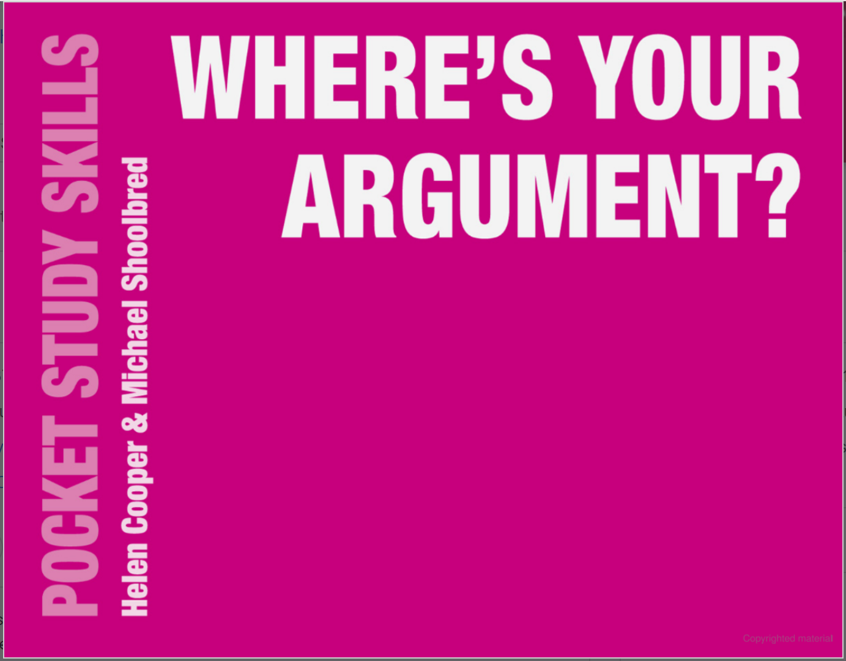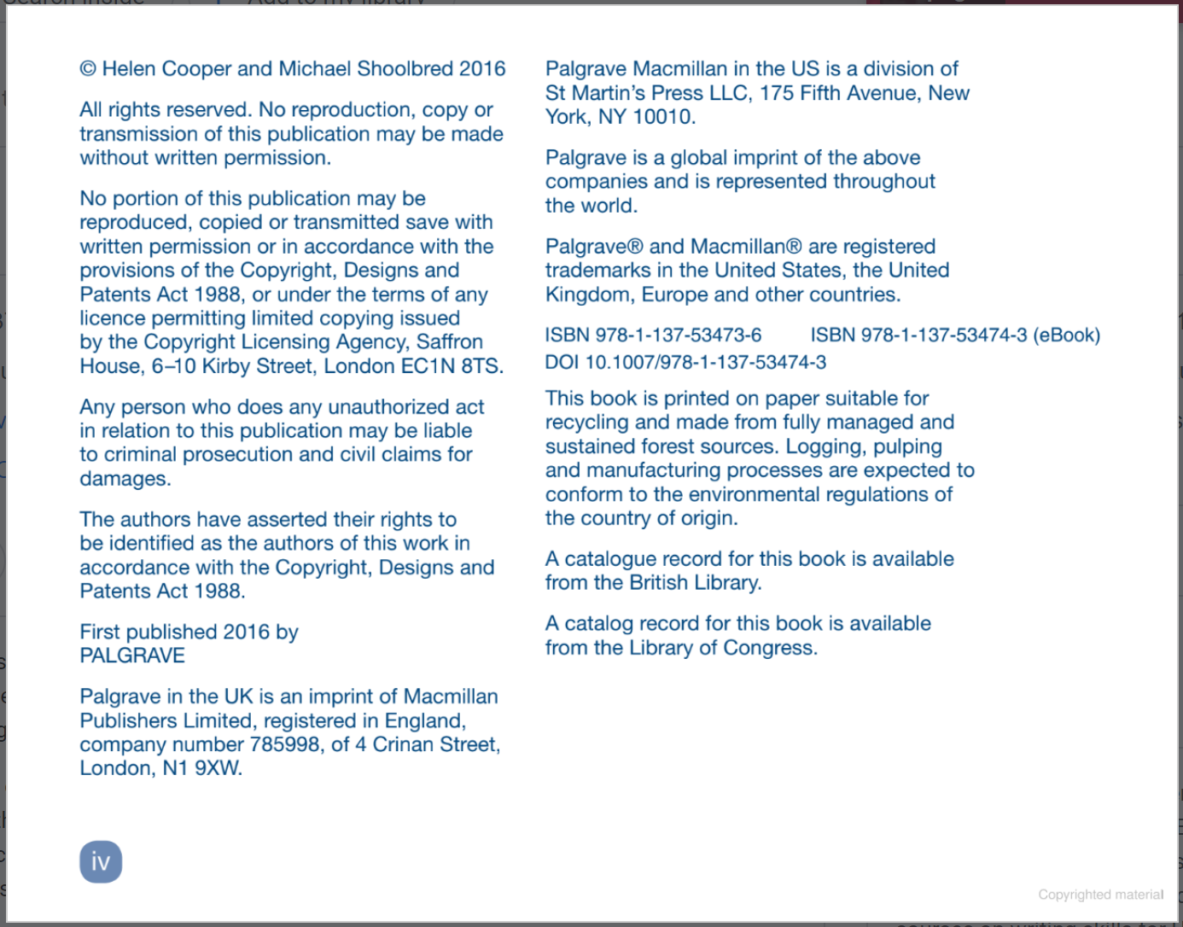

Citation: (Cooper and Shoolbred, 2016)
Cooper and Shoolbred (2016)
Reference: Cooper, H. and Shoolbred, M. (2016) Where’s your argument? London: Palgrave
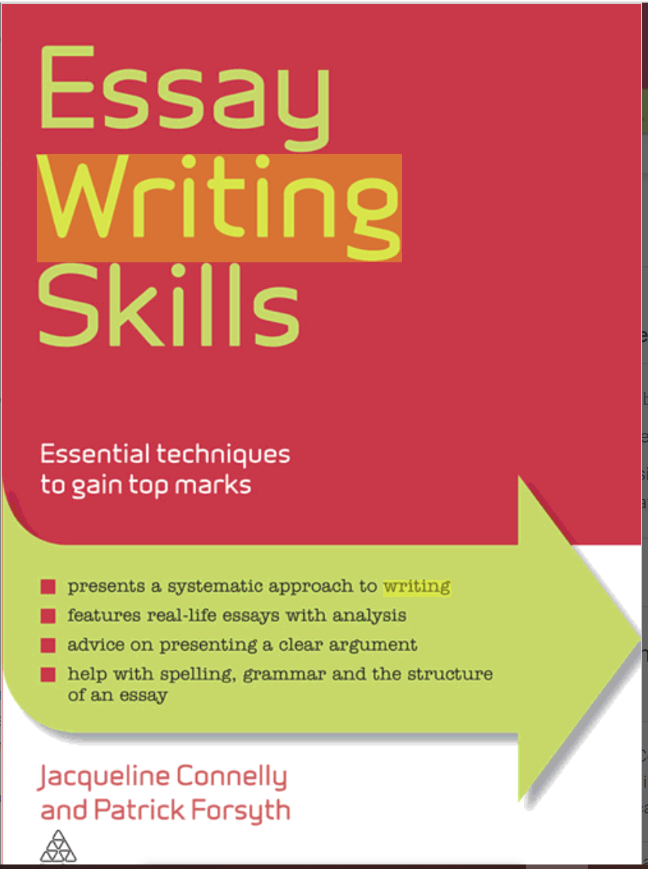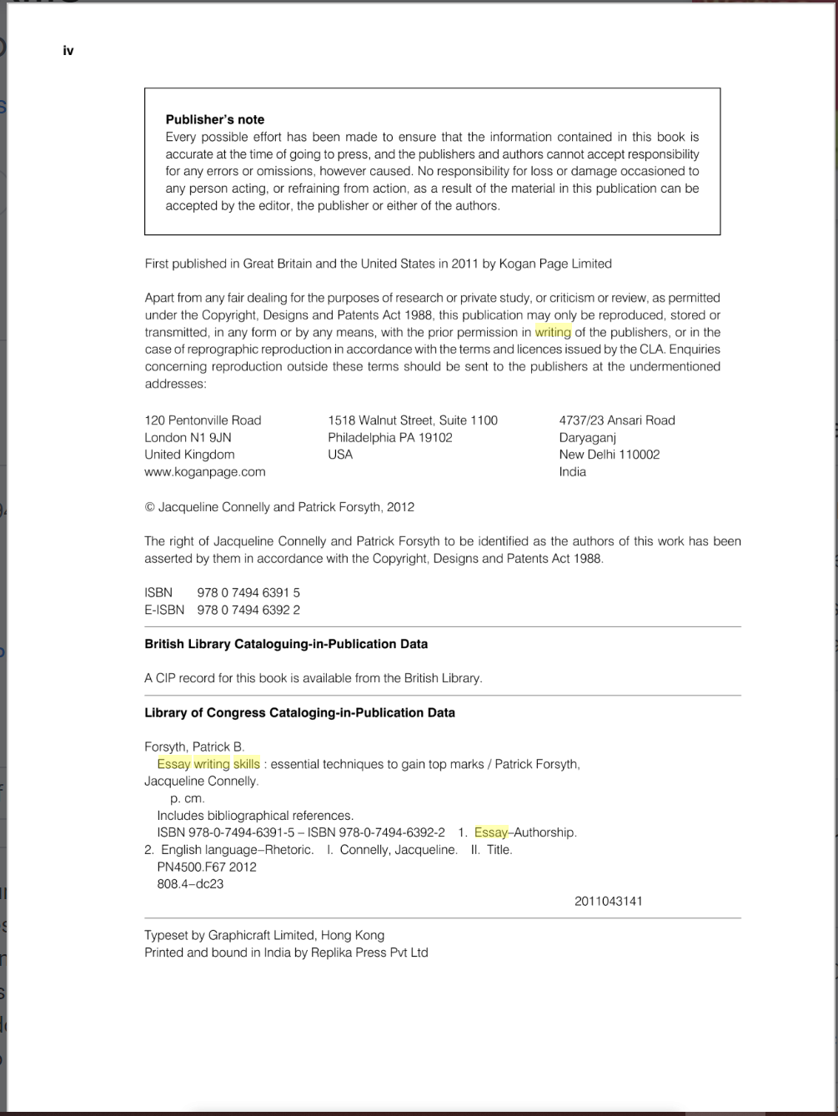
Citation: ( Connelly and Forsyth, 2012)
Connelly and Forsyth (2012)

Reference: Connelly, J. and Forsyth, P. (2012) Essay writing skills: Essential techniques to gain top marks. London: Kogan Page

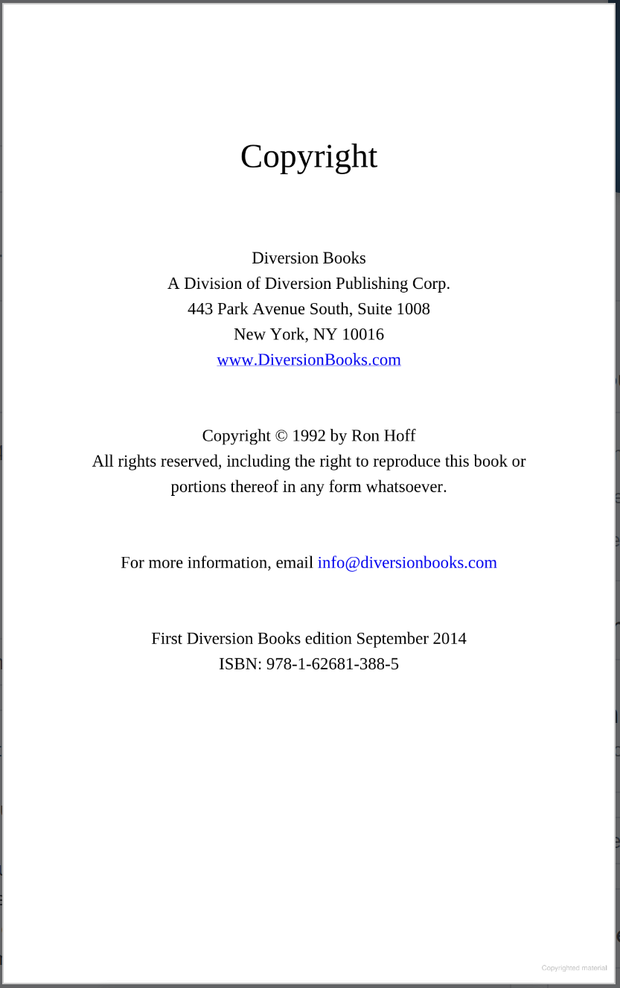
Citation: ( Hoff, 2014)
Hoff (2014)
Reference: Hoff, R. 2014 I can see you naked: A fearless guide to making great presentations. New York: Executive books
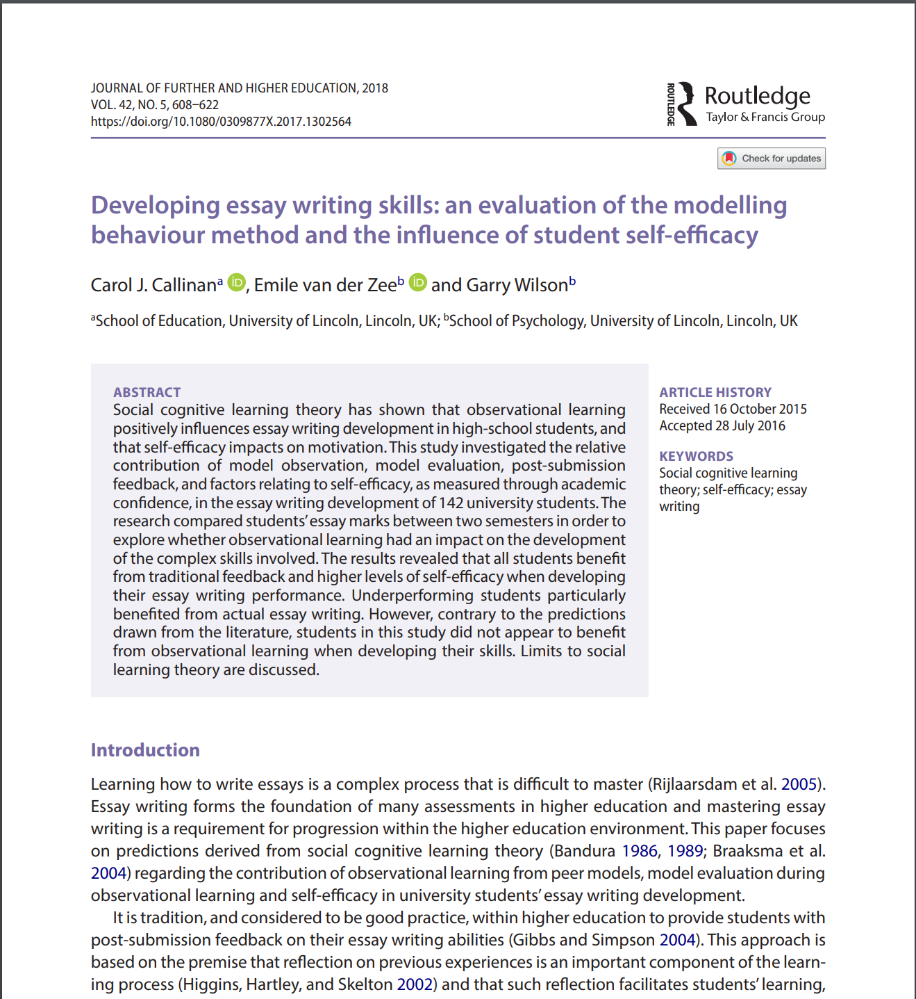
Citation: (Callinan, van der Zee and Wilson, 2018)
Callinan, van der Zee and Wilson (2018)

Reference: Callinan, C.J., van der Zee, E. and Wilson, G. (2018) 'Developing essay writing skills: an evaluation of the modelling behaviour method and the influence of student self-efficacy', Journal of Further and Higher Education, 42(5), pp. 608-622.

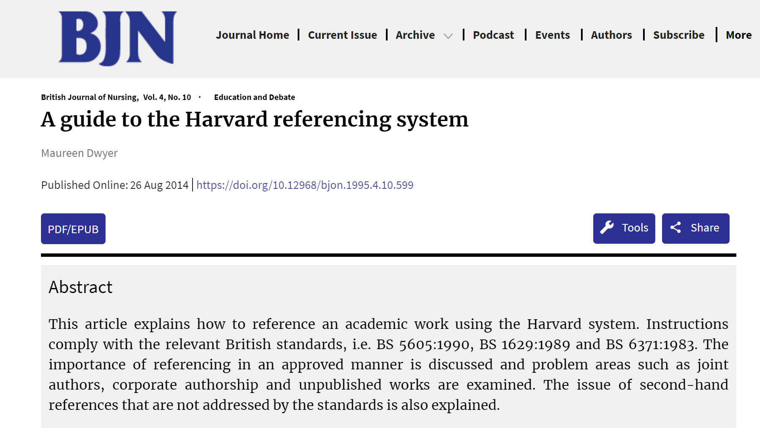
Citation: (Dwyer,2014)
Dwyer (2014)
Reference: Dwyer,M.(2014) ‘ A guide to the Harvard refrencing system’, British Journal of nursing, 239160,pp. 876-878.
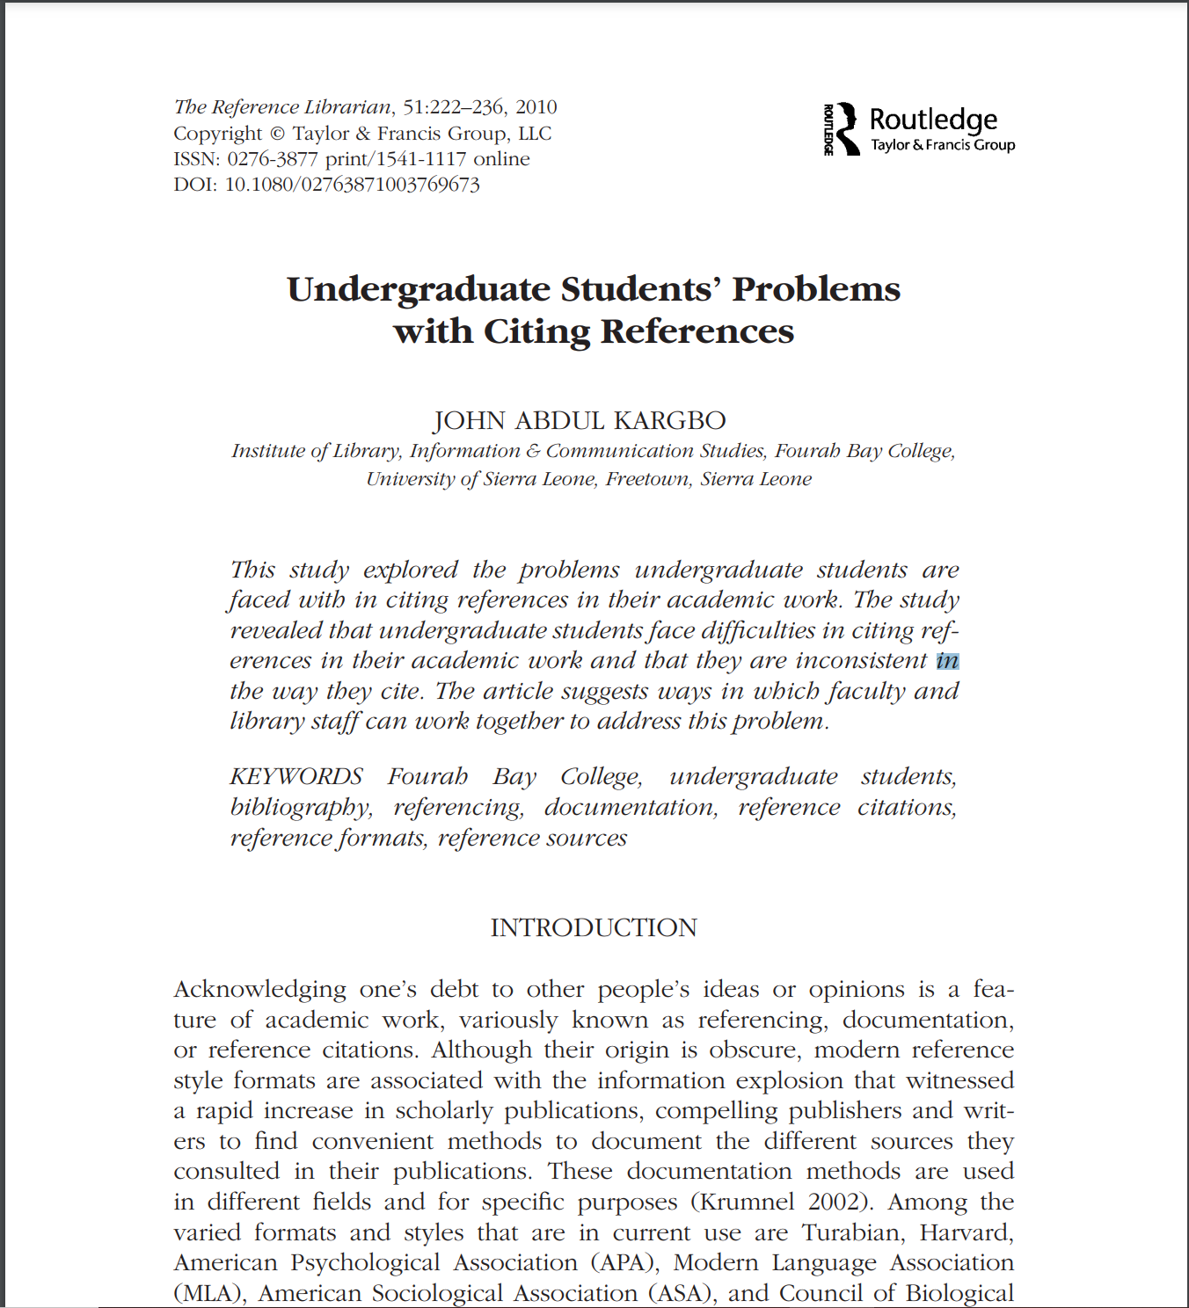
Citation: (Kargbo, 2010)
Kargbo (2010)
Reference: Kargbo, J.A. (2010)’Undergraduate student’ problems with citing references’., The Reference librarian,51(3), pp.222-236

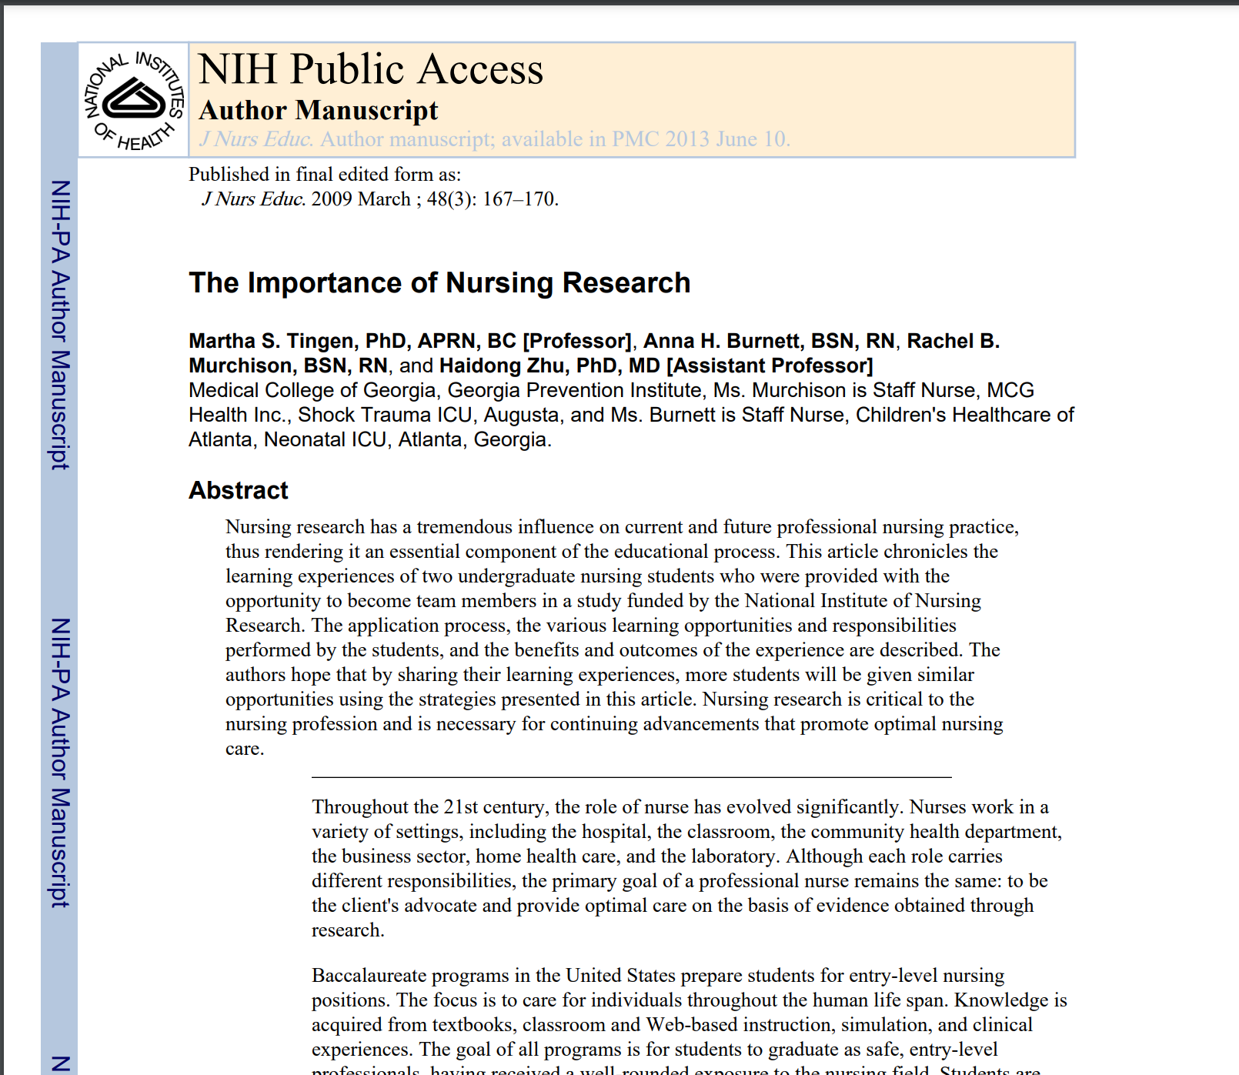
Citation: (Tingen et al., 2009)
Tingen et al. (2009)
Reference: Tingen, M.S., Burnett,A.H., Murchison and Zhu,H. (2009)’The importance of nursing research’, Journal of nursing education, 48(3),pp. 167-170. Doi:10.3928/20090301-10.
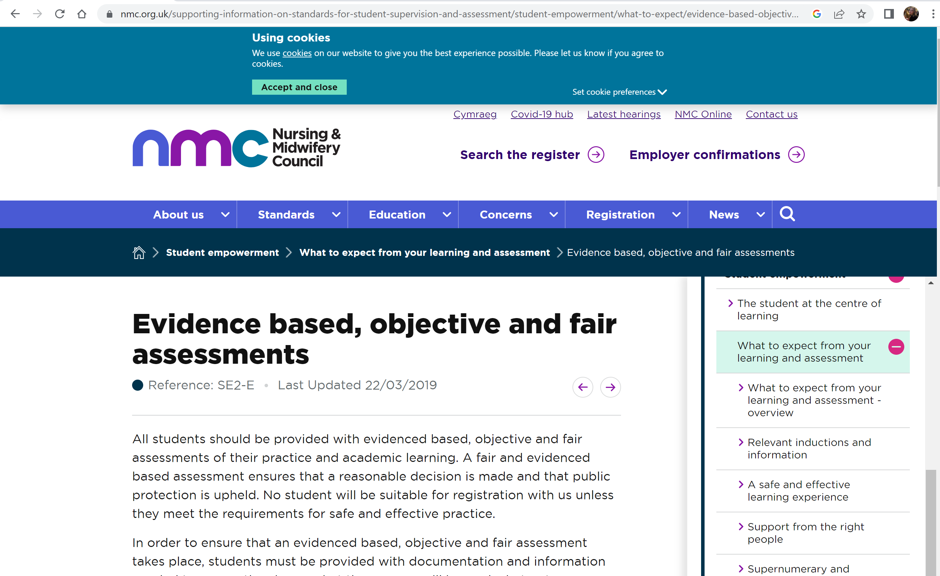
Citation: (Nursing and Midwifery council,2019)
Nursing and Midwifery council (2019)
Reference: Nursing and Midwifery council (2019) Evidence based, objective and fair passements. Available at: https://www.nmc.org.uk/supporting-information-on-standards-for-student-supervision-and-assessment/student-empowerment/what-to-expect/evidence-based-objective-and-fair-assessments/ ( acsessed: 8 october 2026)

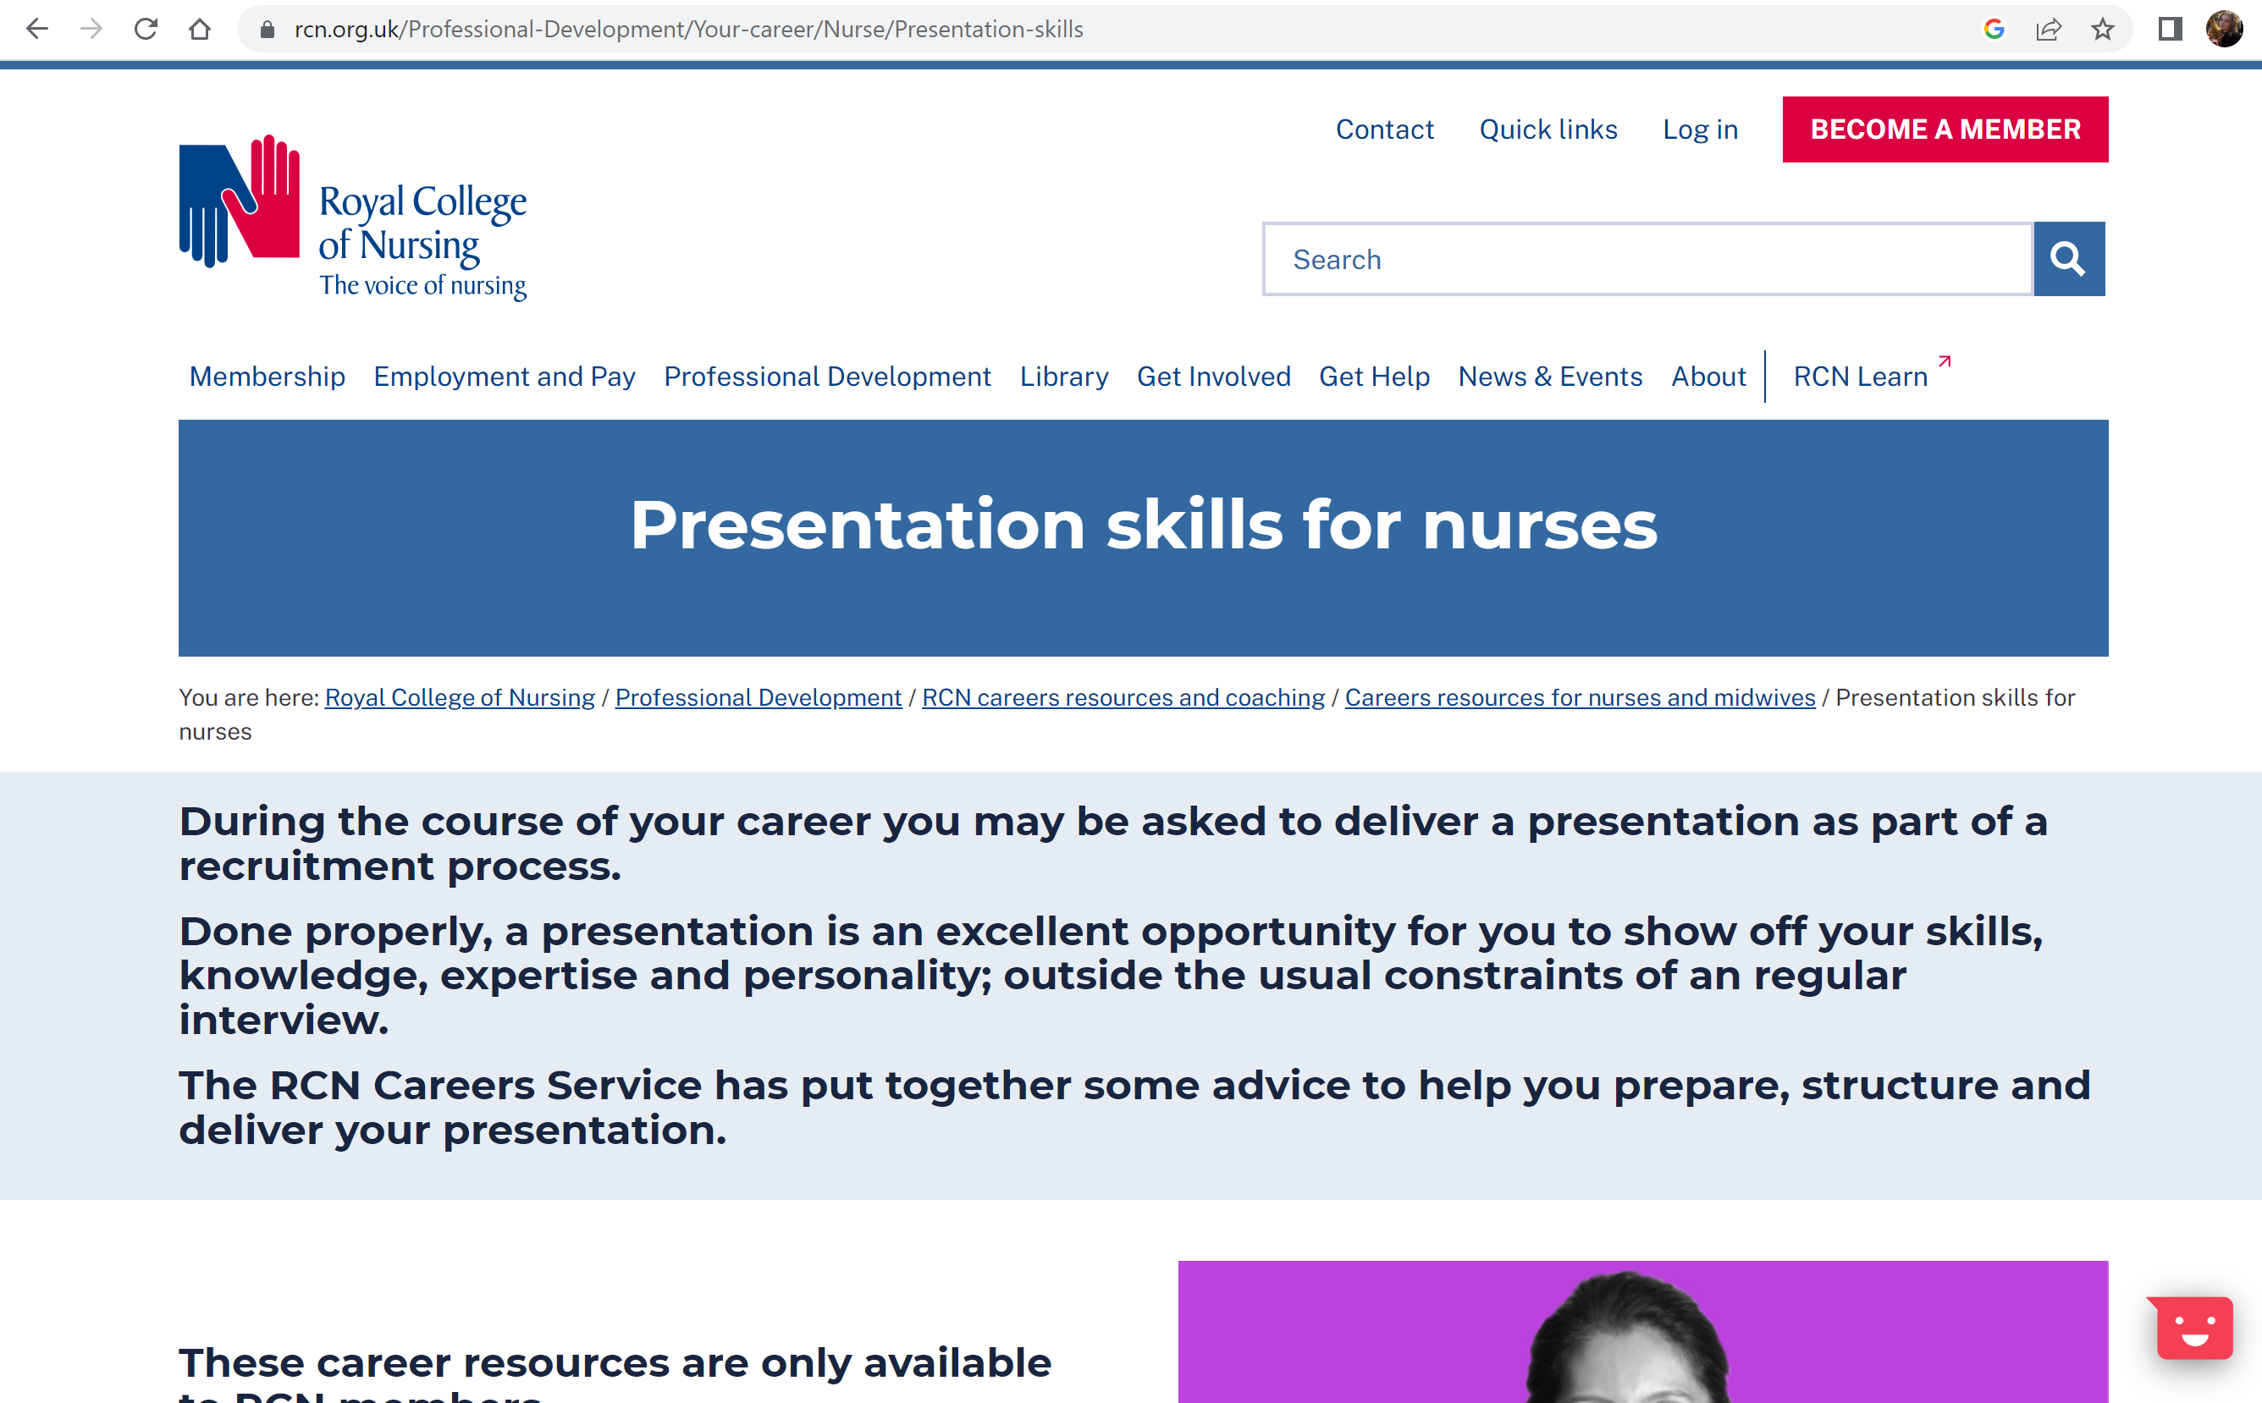
Citation: (Royal collage of nursing, 2026)
Royal collage of nursing (2026)

Reference: Royal College of nursing (2026) Presentation skills for nurses. Available at: https://www.rcn.org.uk/professional-development/your-career/nurse/presentation-skills (accessed; 8 October 2026).

