Task 1: Locating Sources
Identify and locate three different sources (a report, a journal article, and a website) related to the question
“What employability skills do university graduates need to succeed in the workplace?”
Show how you used keywords, search terms, and Boolean operators to find them, and explain how you know which type of source each one is and why it is appropriate for the research question.

Source Type & Why It Is Appropriate | URL/DOI | What search engine did you use? Google/Online Library/Library AI Assistant | Keywords/Boolean Operators Used
Gives perceptions of their own skills, better communication and understanding among employees and graduates | Expectations of Competency: The Mismatch between Employers’ and Graduates’ Views of End-User Computing Skills Requirements in the Workplace - ProQuest | Online library | workplace required skills and Business Graduates
Valuable resource for university students on any level or ability who wish to improve confidence, improve performance, and succeed in their Studies . | ProQuest Ebook Central - Book Details | Online library | essential skills and graduates’ success

Task 2: Evaluating Information (CRAAP Test)
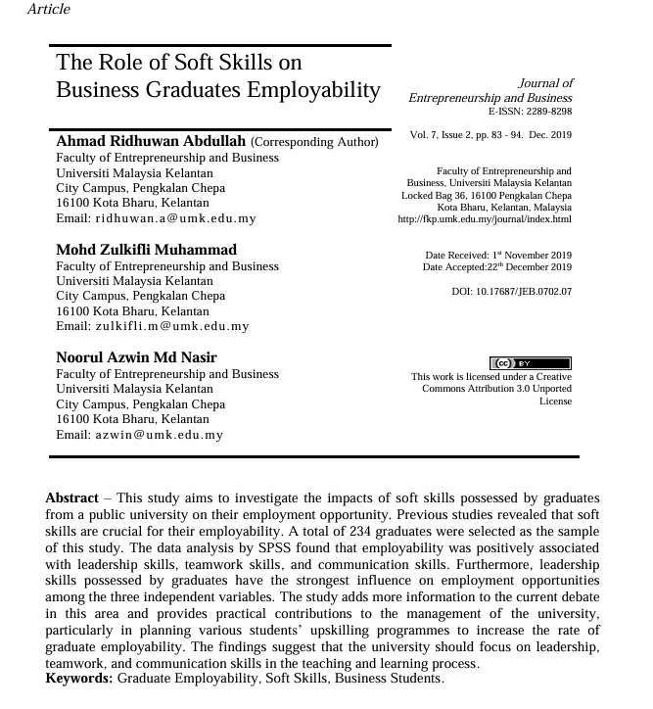
Your colleague has forwarded you a source from a peer reviewed journal, and they are not sure whether it is appropriate to use and has asked for your help. Your task is to evaluate the source by using the CRAAP Test to assess its appropriateness for the following question “What employability skills do business university graduates need to succeed in the workplace?”

CRAAP Test
Currency | study (Data Analysis )
Relevance | Soft Skills and why they are crucial for employability  Current debate  Information on practical contributions
Authority | Students
Accuracy | Employability positively associated with leadership skills, teamwork and communication.  Findings suggest what Skills are needed for Employability i.e.: Leadership and Communication
Purpose | Study To show why these Skills are essential for employability, current debate
Task 3: Source Analysis
Your manager has provided you with a short extract from a source and has asked you to analyse the source by Identifying one strength, one weakness, and providing a brief explanation of the strength and weakness identified.
If you want to read the article online, please click the following link: https://www.universitiesuk.ac.uk/latest/news/strong-demand-graduates-employers

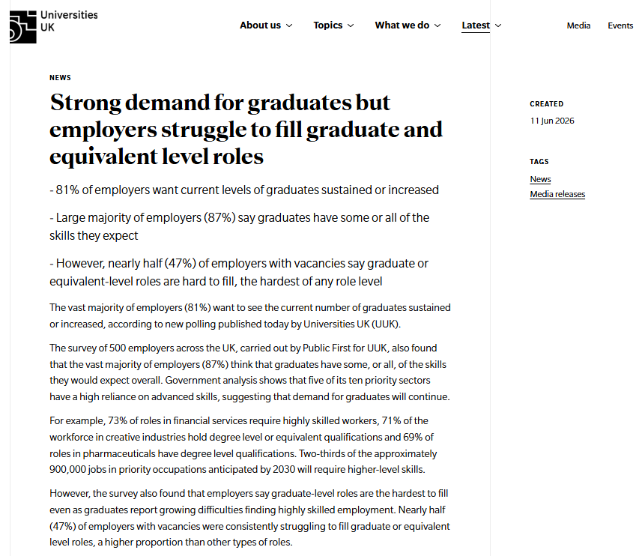
.

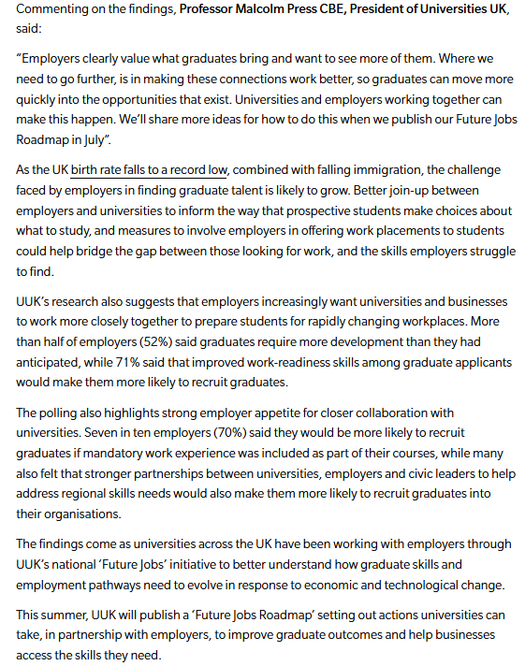

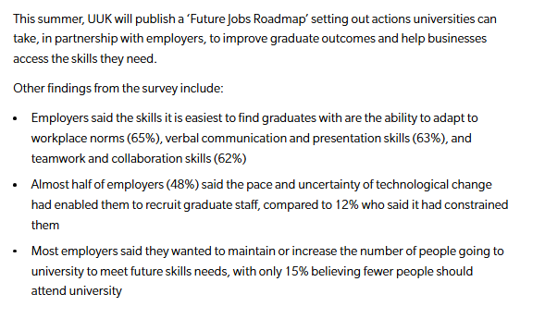

Strength of the Source:

500 employers carried out by public first for UUK,
Employers value the skills Graduates bring .
7/10 employees said they would recruit graduates in mandatory work experience

Weakness of the Source:

Employees say 47% of graduate levels are hardest to fill .

