

NAME: POOJITH VEMULA
STUDENT NUMBER: 2212578

MODULE: Human Resource Management
MODULE CODE: LCBM7000

TITLE: Assessment 1 Human Resource Management

LECTURER: Mushfiqur Rahman

Submission Date: 04/01/2023

Executive summary
Brexit and the pandemic both had immense influence over the labour market of the United Kingdom. After these two incidents, a few changes were noticed in the labour market of the country. This report has tried to focus on the related issues while understanding the prospects of the labour market of the United Kingdom. Meanwhile, it is also needed to understand certain changes in human resources management. The external environment and its influences are also demonstrated here in this report.

Table of Contents
1.0 Introduction 3
2.0 Main body 3
3.0 Tools and theories 7
4.0 conclusion 8
References 10
Appendices 12

1.0 Introduction
Human resources management is an integral part of any organisation because without proper human resourcing, no organisation can function properly. Currently, in the United Kingdom, the labour market has faced huge turmoil because of the pandemic and Brexit. A recent war between Russia and Ukraine also harmed it. The employment rate of the country as of 2022, was around 75.5 percent and the number of employees is gradually decreasing. Self-employment is increasing in the country as well. The unemployment rate in the country has decreased by 0.2 percent. After the pandemic and Brexit, human resources and the strategies associated with it have evolved to some extent. These strategies will help any organisation control human resources and fulfil their requirements to retain them. This report will try to explore the current status of the labour market in the United Kingdom and the latest strategies which will be controlling human resources.

2.0 Main body
Current status of the labour market in the United Kingdom
Current situation:
The global labour market is also a bit volatile right now. Currently, the employment rate growth in the world is 2.3 percent while the unemployment rate is about 6.2 percent as per the reports of 2021. In developed countries, the unemployment rate is quite less while the employees are offered more job security (Buchan, and Seccombe, 2018). Meanwhile, developing countries are witnessing significant growth as well. More requirements in the fields of technologies and highly skilled employees are stirring the market of labour. Currently, the labour market in the United Kingdom is quite volatile. The employment rate was 75.5 percent for the first two quarters of 2022 and in the last three months self-employment increased while steady growth can be seen in the employment rate as well. The most up-to-date estimate of the payrolled workforce for October 2022 indicates a new monthly upsurge, up 74,000 from the updated September 2022 estimates to a combined total of 29.8 million (as in Appendix 1). The rate of unemployment this year has decreased by 0.2 percent while the number of unemployed people was rarely seen in the last three months. The inactivity rate for 2022 was 21.6 percent which was raised by 0.2 percent. The main reason behind this inactivity rate was the sickness of the employees across the country. At the same time, the number of vacancies in all possible sectors in the United Kingdom is about 1,225,000 and previously the number was only 46,000 (Bratton et al., 2021). Historically this huge number of vacancies is considered a very high level for the United Kingdom. During this time, growth can be seen in the total payment of an employee and the rate was around 0.6 percent. 5.7 percent growth can be witnessed in the regular pay of an employee excluding all the benefits and essential bonuses provided by the employers. After the pandemic, this raise in wages is the strongest and most predictive growth of the year. For the private sector, the growth in payment was 6.6 percent while in the public sector employees were given a raise of about 2.2 percent. After the pandemic, this growth difference is the strongest and highest one this year (Cumming, Wood, and Zahra, 2020). Presently the labour market of the United Kingdom has seen enough growth but in the last year due to the pandemic, the country and its labour market were not doing well.
Reasons behind it
This change in the labour market of the United Kingdom has three reasons behind it. The first one is covid pandemic where the statistics remained highly volatile in the past two years. For a long time, due to the lockdown, many businesses were shut down (Dirani et al., 2020). As per the reports, 14 percent of businesses closed their operations for the time being and this created a huge issue in the market of labour in this country. At the same time, people could not go out and search for more new opportunities which will be beneficial for them. Various organisations needed to lay off huge numbers of employees to cope with the fallen economy of the United Kingdom. At the same time, Brexit was also an issue for the labour market. Due to Brexit, sudden changes in trade policies made the employees more confused. The government is trying to cope with the comparability of international standards and trying to implement the latest legislative structure for the labour market. This new approach was not welcomed by the employees and it also affected the labour market (Hamouche, 2020). The recent war between Russia and Ukraine had a significant effect on world politics and thus business organisations of the United Kingdom have also suffered. Prices of various raw materials were increased while at the same time, energy and transportation services and their prices increased at a significant rate. These reasons started huge conflicts in the labour market of the United Kingdom, these reasons created this current situation.
Impact on the economy of the United Kingdom
These situations in the current labour market are influencing the growth of the economy in this country. Currently, the GDP of the United Kingdom is around 3.19 lakh crores USD In all the sectors of the United Kingdom, the rate of GDP has fallen by 0.6 percent. Meanwhile, a 7.4 percent annual change can be witnessed in 2022, in the total GDP growth of the United Kingdom. The inflation rate of the country is now 11.10 percent. A high rate of inflation ensures that the customers have limited power and money to purchase in that particular country. It can distort the power of the buyers while it does not motivate them to invest money. Thus, the organisations show their best collections of products and services to the customers. Due to the high rate, the customers do not show enough enthusiasm to purchase many products or services. The rate of interest will be increased due to the high inflation rate in any country. Currently, the United Kingdom has an interest rate of about 3.5 percent.
Post-pandemic and post-Brexit changes in human resources strategies
The pandemic and Brexit both had a severe impact on the United Kingdom. Due to such unwanted events one by one, the economy of the United Kingdom was affected. Meanwhile, the labour market was also a victim and the environment was highly volatile (Orazulike, 2018). The country and the organisations to cope with human resources tries to implement various strategies. For example, the country adopted the work-from-home model and after Brexit, the changes in trading policies are trying to make the lives of employees better. At the same time, more use of technologies was given importance during the lockdown period as well (Benedek et al.,.2021). After Brexit, the organisations have focused on building new markets while researching for them. These strategies were quite impactful for the organisations as well. To understand the impact of these emerging changes, the external environment will be understood by utilising a PESTEL.
Political factors
Due to Brexit, the political situation in the United Kingdom has become a bit unstable. Though certain changes helped the country to prosper. Brexit has started issues with neighbouring countries while they are part of the European Union while the United Kingdom is not. Instability in politics has stirred up issues like changes in trading policies, increases in tax rates, etc (Refer to Appendix 2). All of these have effects on the labour market of the country. Due to the pandemic, political turmoil to cope with the situation triggered a downfall as well. Thus, this external environment helped to change the strategies of human resources management.
Economic factors
The economical factor is another crucial factor to influence the external environment of the United Kingdom which helped to change the strategies of human resources management. The inflation rate has increased due to Brexit and the pandemic. The prices of the products soared quite high and people could not afford many things in life. In this situation, the United Kingdom also increased the rate of interest. Currently, the interest rate of a bank in the United Kingdom is about 3.5 percent which is quite more for any country. The economy was changed due to sudden changes in the labour market and thus it was obvious to bring new ideas and strategies into the labour market.
Social factors
Society these days has become more aware of the labour market. They know about their basic human rights. To achieve their fundamental rights, the country is trying to evolve new strategies to manage human resources. Society these days is talking about the labour market and criticising the existing rules and regulations for better human resources management (Sidik, and Utomo, 2022). The immense pressure from society is helping to devise new human resources strategies. Meanwhile, the use of various social medial platforms is increasing the reach of the user and which can be utilised to gather more opinions about the labour market and essential practices of human resources.
Technological factors
Technology often plays an important role while trying to focus on the external environment. Artificial intelligence, blockchain technology, and various algorithms are being used to make various tools for human resources management. These tools generally use software and various programming languages which will help the human resources for the organisations (Warriner et al., 2018). In the United Kingdom, various technological aspects are being utilised before devising a new human resources strategy. The use of social media is another factor helping the country to establish required sets of rules and regulations while dealing with the workforce. The changes in technology can be seen mostly after post-Brexit and post covid. Working from home can be easier with these technologies, various applications like Zoom, and Skype has evolved for this purpose.
Environmental factors
Environment often plays an important role to determine the effect of the external environment as well. To establish a sustainable environment, it is important to focus on the workforce as well as they are the ones who will introduce innovative and sustainable approaches. While making decisions, it is important to understand the environmental factors as well (Stuart et al.,.2021). After Brexit and the pandemic, to create a sustainable environment multiple innovative approaches were taken. Biometric check-in, use of masks, online interviews, etc ensure the safety of the environment which will help the country to devise proper human resources strategies. These are not only feasible but also sustainable while reducing the effect of carbon.
Legal factors
After Brexit, a few rules were imposed on the United Kingdom. Some rules were introduced after the pandemic as well. While determining the role of the external environment, it was important to focus on the legal factors as well. Certain business policies were changed after Brexit (Nkechinyere, 2019). After the pandemic, a few organisational legislations were changed as well. As per the changes, it is important to devise new strategies for human resources. Human resources management will follow the rules and laws and try to implement them as much as possible in the strategies. The European Union Act 2020 is one of the most important laws for the country which has an important influence over the external environment of the country.

3.0 Tools and theories
While trying to understand the importance of human resources management, it is important to assess the strategies adopted by the management. As these strategies are important for organisations, the United Kingdom will try to research them as well (Mayhew and Anand, 2020). These strategies will provide more benefits to the organisation but also try to help the employees as well. A few tools and theories will be utilised here and demonstrated for a better understanding of the concept. Motivation theory along with Human Capital theory and organisational behaviour theory will be used for a better understanding.
Motivation theory
As per the theory, understanding the motivational factor behind one's job is important to encourage one to do the work more gracefully. As per the theory, motivated employees often generate more productivity and thus bring more revenue it is more profitable for the organisation as well. If the human resources strategists utilise this theory, then they have to encourage the employees to reach their goals (Kamerāde, and Richardson, 2018). Motivations can be given in various ways, for instance, by providing the employees with more benefits or incentives for their ideas and approaches. This can enhance the situation after the pandemic and Brexit as the employees were going through tough times. They were working from home mostly and this motivation theory would provide them with more enthusiasm to work.
Organisational behaviour theory
Organisational behaviour theory also can be used to understand the emerging trends in human resources management-related strategies. People affiliated with the organisation are given more priority in this theory while organisational structure helps to understand the objectives of the organisation. Technology is given priority as this works as a resource while working for the organisation. Meanwhile, the environment often influences the employees and the system they follow while working (Hubschmid-Vierheilig, Rohrer, and Mitsakis, 2020). This will explain how an employee interacts in a certain environment utilising the resources of the organisation to meet the organisational goals. After the pandemic and Brexit, this theory can help to devise new strategies while the interconnection will be understood. More detailed strategies can be generated if this theory is utilised for the betterment of the human resources in the organisation.
Human capital theory
The human capital theory is another human resource theory that mainly focuses on human resources and their abilities after training them. This can be an effective theory for organisations in the United Kingdom. After the pandemic, some technical aspects have generated more productivity. After Brexit, a few changes in trading policies were also introduced in the organisations (Bell, and Blanchflower, 2020). In such a situation, training will help an employee and this theory will treat human resources as an important capital of the organisation. These organisations will invest their time and resources to educate them and make them adapt to the new changes in the organisation. This theory can be utilized while devising new strategies for organisations across the United Kingdom (Refer to Appendix 3).

4.0 conclusion
Any organisation will focus on its human resources as it provides the best products to the organisation. Without human resources, organisations will not be able to fulfil their targets and thus varieties of strategies are evolved and utilised. In the United Kingdom, the picture of the labour market is changing gradually. With an increased employment rate, organisations need to devise a proper set of strategies to help these organisations as well. Due to the pandemic, the lifestyle is changed to some extent while Brexit has introduced a few social issues. Human resources management should address all these issues while devising strategies for any organisation. In this report, the current market situation of the United Kingdom associated with employment has been given importance. On the other hand, changes in management and leadership to improve post-pandemic and post-Brexit productivity are explored and described as well. A few tools and theories are used in this report for a better understanding of the concept.

References
Bell, D.N. and Blanchflower, D.G., (2020). US and UK labour markets before and during the Covid-19 crash. National Institute Economic Review, 252, pp.R52-R69.
Benedek, M.D., Gemayel, M.E.R., Senhadji, M.A.S. and Tieman, A.F., (2021). A post-pandemic assessment of the sustainable development goals. International Monetary Fund.
Buchan, J. and Seccombe, I., (2018). Nurses work an analysis of the UK nursing labour market. Routledge.
Bratton, J., Gold, J., Bratton, A. and Steele, L., (2021). Human resource management. Bloomsbury Publishing.
Clegg, R. (2018) UK labour market: January 2018, UK Labour Market - Office for National Statistics. Office for National Statistics. Available at: https://www.ons.gov.uk/employmentandlabourmarket/peopleinwork/employmentandemployeetypes/bulletins/uklabourmarket/january2016 (Accessed: December 24, 2022).
Cumming, D.J., Wood, G., and Zahra, S.A., (2020). Human resource management practices in the context of rising right‐wing populism. Human Resource Management Journal, 30(4), pp.525-536.
Dirani, K.M., Abadi, M., Alizadeh, A., Barhate, B., Garza, R.C., Gunasekara, N., Ibrahim, G. and Majzun, Z., (2020). Leadership competencies and the essential role of human resource development in times of crisis: a response to Covid-19 pandemic. Human Resource Development International, 23(4), pp.380-394.
Hamouche, S., (2020). COVID-19 and employees’ mental health: stressors, moderators and agenda for organizational actions. Emerald Open Research, 2.
Hubschmid-Vierheilig, E., Rohrer, M. and Mitsakis, F., (2020). Digital competence revolution and human resource development in the United Kingdom and Switzerland. In The Future of HRD, Volume I (pp. 53-91). Palgrave Macmillan, Cham.
Kamerāde, D. and Richardson, H., (2018). Gender segregation, underemployment and subjective well-being in the UK labour market. Human Relations, 71(2), pp.285-309.
Mayhew, K. and Anand, P., (2020). COVID-19 and the UK labour market. Oxford Review of Economic Policy, 36(Supplement_1), pp.S215-S224.
Nkechinyere, A.M., (2019). Developing Approach to Employability of Nigerian Graduates in Labour Maret: Need for Curriculum Improvement.
Orazulike, U., (2018). Post-Brexit threats to work safety and health standards and good working conditions in the UK. Psychosociological Issues in Human Resource Management, 6(1), pp.63-95.
[PDF] Human Capital Theory: Assessing the evidence for the value and importance of people to organisational success: Semantic scholar (2022) [PDF] Human capital theory: assessing the evidence for the value and importance of people to organisational success | Semantic Scholar. Available at: https://www.semanticscholar.org/paper/Human-capital-theory%3A-assessing-the-evidence-for-of/25dfff34d21f34ad77e341f5eaf977650c70784d (Accessed: December 24, 2022).
Sidik, E.J. and Utomo, D.W., (2022). INVESTIGATING THE EFFECTS OF URBAN-RURAL DISTINCTIONS AND HOUSEHOLD ECONOMIC BACKGROUNDS ON YOUNG PEOPLE’S ATTITUDES. Makna: Jurnal Kajian Komunikasi, Bahasa, dan Budaya, 10(1), pp.59-78.
Stuart, M., Spencer, D.A., McLachlan, C.J. and Forde, C., (2021). COVID‐19 and the uncertain future of HRM: Furlough, job retention and reform. Human Resource Management Journal, 31(4), pp.904-917.
United Kingdom political stability - data, Chart (2022) TheGlobalEconomy.com. Available at: https://www.theglobaleconomy.com/United-Kingdom/wb_political_stability/ (Accessed: December 24, 2022).
Warriner, S., Crane, C., Dymond, M. and Krusche, A., (2018). An evaluation of mindfulness-based childbirth and parenting courses for pregnant women and prospective fathers/partners within the UK NHS (MBCP-4-NHS). Midwifery, 64, pp.1-10.

Appendices
Appendix 1: UK Labour Market Statistics
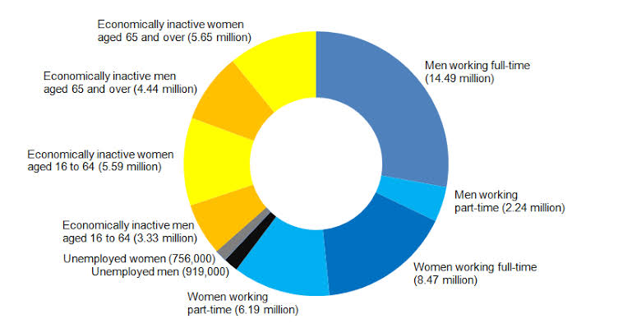
Figure 1: UK Labour Market
(Source: Clegg, 2018)
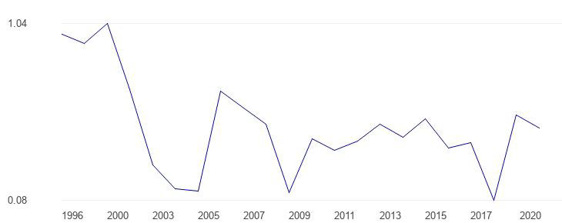
Appendix 2: Political Stability in the UK
Figure 2: Political Stability of the UK
(Source: United Kingdom political stability - data, 2022)
Appendix 3: Human Capital Theory
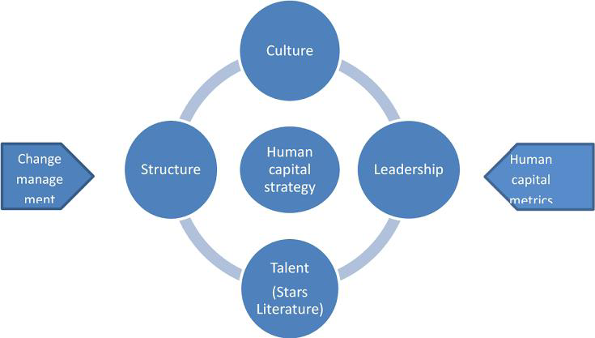
Figure 3: Human Capital Theory
(Source: [PDF] Human Capital Theory: Assessing the evidence for the value and importance of people to organisational success: Semantic scholar, 2022)

