

University of Wales Trinity Saint David
School of Engineering

Lean and Six Sigma Methodologies for Process Improvement

Quality and Business Improvements (ACMA4004)

Izzy Southway
2115802
07/02/2022

Table of Contents

List of Figures………………………………………………………..Page 3
Introduction………………………………………………………….Page 4
Main Body
- Six Sigma Methodologies……………………………. Page 5
- DMAIC Principles………………………………………… Page 8
- DMAIC Vs DMVAD………………………………………. Page 11
- Lean Principles/Implementation…………………..Page 12
Comparison……………………………………………………………Page 15
Conclusion……………………………………………………………..Page 16
List of References…………………………………………………..Page 17
Appendices……………………………………………………………Page 18

List of figures
Figure 1 …………………………………………………………………………………………..………Page 6
https://sixsigmastudyguide.com/project-baseline-sigma/ (p1)

Figure 2……………………………………………………………………………………………………Page 7
Evans, J.R. and Henderson, K.M. 2000. Successful implementation of Six Sigma: benchmarking General Electric Company. Benchmarking: An International Journal 7(4) 260-282. (p5).

Figure 3 ……………………………………………………………………………………….………..Page 11

Tenera, A. and Pinto, L.C. 2014. A Lean Six Sigma (LSS) Project Management Improvement Model. (p3)

Figure 4……………………………………………………………………………………………….Page 15

Roy Andersson, Henrik Eriksson, Håkan Torstensson, (2006) Similarities and differencesbetween TQM, six sigma and lean. (p282-296)

Introduction
The global business market is in constant pursuit of process/ product perfection, alongside aiming for complete customer satisfaction with maximum financial gain, with minimum time and resource costs. Companies within this market compete vehemently to strive for perfection, make continuous sustainable improvements, with an end goal of obtaining significant financial growth.
This drives the need for companies to adapt, provide consistent levels of quality and find ways to continuously improve their processes products and services. Thus, giving birth to a global market in which has become increasingly quality conscious.
Therefore, this document aims to explore 2 of the main quality improvement methodologies, lean manufacturing/implementation, and Six Sigma and their fundamental principles.

Six Sigma Methodologies
In order to satisfy customer needs (VoC), demands and expectations many companies within industry have come to the realisation that implementation of 6 sigma methodologies and philosophies are fundamental to contemporary quality management.
Brady, J.E; Allen, T.T. 2006. (p2)
“Like quality management in general, Six Sigma has penetrated into most sectors of today’s business world”.
Brady, J.E; Allen, T.T. 2006. (p2) refer to Lindermanet al.3(p. 195) for the definition of the term ‘six sigma’. Both suggest that Lindermanet al.3(p. 195) called for a push in developing a standardised definition of 6 sigma and therefore produced the following:
“Six Sigma is an organized and systematic method for strategic process improvement and new product and service development that relies on statistical methods and the scientific method to make dramatic reductions in customer defined defect rates”.
Simplification of this extract suggests that 6 sigma is a systematic methodology that focuses predominantly on statistical analysis where the desired outcome is to eradicate variation and errors by decreasing the variation within a service, product, or process.
Implementing a methodology such as that of 6 sigma, therefore results in strategic decisions being made based purely on given data, in contrary to relying on intuition where decisions stem from ‘I think’ and ‘I feel’.
The of 6 sigma include:

- Statistical Analysis of variation.
- Data Driven Decision making.
- Customer Defined Quality (VoC).
- Continuous Improvement.

Moreover, 6 sigma can also be represented graphically, as a way showing how far spread a data set is from the given mean. Its seen to be derived from the ‘normal’ bell shaped curve often observed in stats.
As illustrated below in figure 1, each interval on the graph represents a level of sigma. For example, +/- 3σ equates to 99.73% of where the data will fall within. On the other hand, as seen below, +/-6σ is a representation of 99.99% of where the data lies.
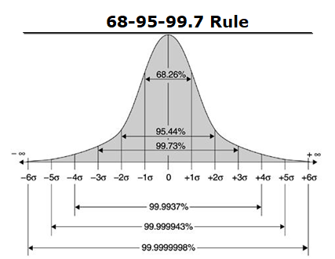

Figure 1
https://sixsigmastudyguide.com/project-baseline-sigma/ (p1)
Furthermore, it should also be noted that these ‘defects’ are customer defined, and that 6 sigma refers to “a goal of less than 3.4 defects per million opportunities”. This being within the observed process. Brady, J.E; Allen, T.T. 2006. (p2).
Exploring this quote from a statistical vantage point, 6 sigma is essentially a measurement of the variability and spread of a given data set.
Simplification:
Area under a normal curve represents 1 million. Therefore, 3.4 product defects are found to be outside of the given customer spec. The greater the sigma level, the fewer defects are observed within the process.

An example of this can be seen in figure 2 below.
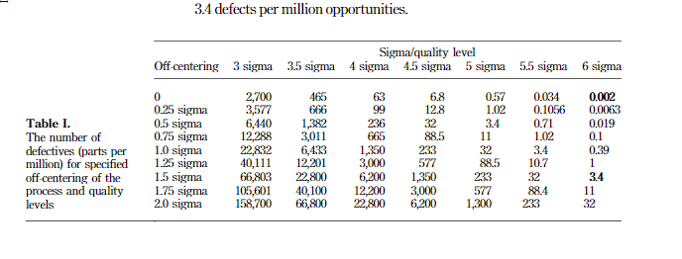

Figure 2

Evans, J.R. and Henderson, K.M. 2000. Successful implementation of Six Sigma: benchmarking General Electric Company. Benchmarking: An International Journal 7(4) 260-282. (p5).

DPMO can be defined as the predicted performance behaviour or long-term process goal. However, within a 6 sigma process a shift of 1.5 sigma can be observed. A shift as such (+/-1.5) is typically seen in the average performance of a process over a longer period. It represents a theory that over an extended time period any given process will shift or deviate from its set target value by approximately 1.5 standard deviations.
As a result of this shift and according to Evans, J.R. and Henderson, K.M .(p4), the DPMO now becomes accepted at 3.4 as a 6 sigma value. However, neglecting this would result in a value now equating to 2 defects per billion opportunities.

DMAIC Principles
This second part of this section will aim define and explore both the DMAIC and DMADV 6 sigma methodologies.
In accordance with Brady, J.E. and Allen, T.T.(p2), their article outlines the 2 pre-eminent 6 sigma methodologies for completed projects. DMAIC for process improvement or DMADV for new product and service development.
First and foremost, DMAIC is an acronym for Define, Measure, Analyse, Improve and Control.
It can be seen as a substantiative problem-solving process that provides businesses with an approach to process improvement in which is both structured and dependent on collated data, facts, and metrics from the given process.
Put simply, the DMAIC process allows variation in a product or service within an existing process to be identified and tackled. It is deemed as a short-term process, with a definitive end, that is dependent on the ‘project scope’ defined at the beginning of the process.
Evans, J.R. and Henderson (p11), begin defining each step of the DMAIC process:

Define.

This step is used to outline the problem with the current process and develop an overall scope for the project. In summary, the targeted customer and their priorities are established.

Furthermore, according Evans, J.R. and Henderson (p15 ), this preliminary stage allows businesses to draw up a problem statement and identify which customers are affected by the current issues, how they are impacted what their priorities are.

Following this, Evans, J.R. and Henderson (p11) suggest that critical to Quality attributes are also defined based on the Voice Of the Customer (VoC). This refers to how the customer perceives the quality of either a product or service. It also allows for businesses highlight what characteristics the customer sees as important, and therefore provides a means of understanding what sections in the current process add value.

Within this initial stage of the DMAIC process, various tools such as SIPOC diagrams and process mapping can be utalised to either highlight the elemets of the given process that are relevant prior to intiation, or to illustrate graphically the flow in which tasks are going to be completed.

Finally, implimentation of a project charter is often seen. This allows the business to document the define stage and develop a business.

Measure.

Evans, J.R. and Henderson (p11) define this stage by asking the questions ‘How is the process measured and how is it perfomring?’

Initally, this phase of the process incorpartes the study of the process currently in place, identify the variation within the process or product, and more crucially outline a basline perfomance for the process at hand.

Furthermore, additonal key factors for carrying out the measure phase include:

- Performance indicators – Identifying they key attributes that directly affect the perfomance of the process.

- Data collection – Devising a plan to collate the data and then poceeding to do so.

- Measurement and system analysis – this invovles implimenting a method that validates the way in which factors of the process are being measured and also validates the data that has been collected.

- Machine Capabilities – understand both the machine and process capabilities.

Similary, as adressed in the define stage, there are a number of different tools that can be utalised. This could include thise such as histograms, pareto charts, MSA, and control charts.

Analyse.

Once again Evans, J.R. and Henderson (p11) suggest that asking the question ‘What are the most important causes of defects?’, is crutial to the analysis phase of the project. Futhermore, the article suggests that the company can begin identifying what defects are occuring consistently, the root cause of these defects, and what variables in the process are causing the resulting variation.

Addiontally, it should be noted that the ‘root casue’ of the problem is a data led investigation. It relies on statistical and qualitive analysis to examin the current perfomance of the process and thefore pin point the problem. Neglecting the true root cause of variation can result in the failure to impliment the appropriate corrective actions, and therefore the desired improvements cannot be obtained.

In continuation, there is potential for a number of root cuases to be observed. However, businesses should aim to choose the root cause with the most impact to improve CTQ.

Finally, Evans, J.R. and Henderson (p15/16) suggest the use of tools such as affinity diagrams, brainstorming, cause and effects analysis, hypothesis testing etc can be used throughout this phase.

Improve.

In this stage of the process bisunesses start asking questions such as ‘How do we remove the causes of the defects?’. Evans, J.R. and Henderson (p11). Initially, this stage would begin by developing a number of possible solutions to combat the root cause of the problem.

Following this, each of the possible solutions are assessed for effectivenss, and where the best suited solution is implimented for improvement. Moreover, a future state process map is developed as way of visually representing the steps in the process potentially following 2 or 3 months of improvements.

Finally, an evaluation comparing the observed improvements and the intial problem should be conducted. The bisunesses project charter shoud then be updated accordingly.

Control.
This is the final stage of the DMAIC process and asks the question ‘How can we maintain the improvements?’. Evans, J.R. and Henderson (p11).
An article written by Roy Andersson, Henrik Eriksson, Håkan Torstensson, (2006) (P8) explores the control phase further, suggesting that businesses should begin to look at how the implemented improvements can be maintained in order to continuously meet the set targets and how a specific control plan can be developed in order to prevent these issues from reoccurring in the future.
Additionally, this phase focuses on educating and training employees on the process changes and the new implementations. Documentation and tracking of the improved process should also be conducted.

The below diagram has been extracted from an article by Tenera, A. and Pinto (p3) , and provides a visual summary of the infromation relating to the DMAIC process provided above.
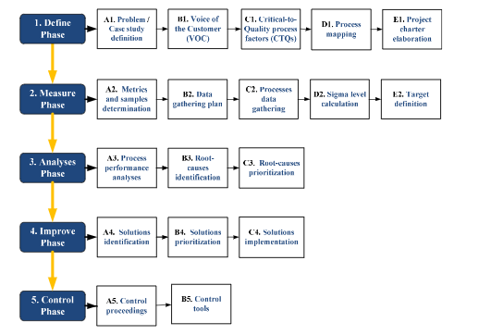

Figure 3
Tenera, A. and Pinto, L.C. 2014. A Lean Six Sigma (LSS) Project Management Improvement Model. (p3)

DMAIC Vs DMADV

J. Jenkins Introduction to Six Sigma 2022 (p34) compares both DMAIC and DMADV.
The DMAIC approach to problem solving is utilised when the quality of a product or process does not meet customer expectations or demands and therefore requires improvements to be made.
In contrast to DMAIC, DMADV stands for Define, Measure, Analyse, Design, Verify.
This framework is used and implemented when a new process or product is required to be developed. DMADV is often incorporated when the DMAIC process has been exhausted or ‘Optimised’ and no longer satisfies the customer demands. Businesses are therefore forced to embark on a complete re-design and re-focus of the current process.

Lean principles/implementation
Roy Andersson, Henrik Eriksson, Håkan Torstensson, (2006) (p282-296) begin defining lean manufacturing as method in how to control ‘resources in accordance with the customers’, whilst decreasing the amount of ‘unnecessary waste (including waste of time)’.
Simplified, lean manufacturing can therefore be described as a systematic way of optimising productivity whilst eliminating waste within a manufacturing process. This form of waste can be referred to as ‘MUDA’ and is anything that does not add value to the process or product. Additionally, there is also MURA (waste by variation in process) and MURI (waste by overloading) that lean also aims to eliminate.
Lean manufacturing strives for continuous and sustainable improvements to the manufacturing process and is often know as Kaizen (change/good). It’s important to note that perfecting is unattainable. However, in its pursuit continuous improvements are made.

According to Roy Andersson, Henrik Eriksson, Håkan Torstensson, (2006) (p282-296), Toyota implemented the lean manufacturing concept on a large scale in the 1950’s. The article also outlines the 5 main principles of lean manufacturing:

- Only the customer’s perception of value is important. This is vital for understanding what does or does not add value to the process.
- Value stream analysis. Determining which processes add value and those that do not. This provides a visual representation of all activities.
- Continuous flow of production in contrast to moving large batches.
- Pull. Production does not occur unless there is need for it downstream. Begins with customer demand.
- Continuous improvement. Always striving for perfection therefore there should be no end to improvements.

Furthermore, Roy Andersson, Henrik Eriksson, Håkan Torstensson, (2006) (p282-296) also explore the fact that customer demand is unstable and therefore it’s often difficult to apply these lean methodologies. Factors such as over production, over processing, inventory, defects, and movement are some of the biggest contributors the elimination of non-value-added activities.

Roy Andersson, Henrik Eriksson, Håkan Torstensson, (2006) (p282-296) noted that there a variety of different tools that can be used to eliminate such waste. This includes, value stream analysis, total productive maintenance, Kaizen costing and cost analysis etc. In addition to this, it is also recommended that utilising tools such as Kanban to improve the supply chain and JIT (Just in Time) systems to eliminate excess inventory can be essential to lean manufacturing.

Moreover, there are a number of key principles that are utilised in lean manufacturing:

Kaizen.
This term translates to ‘improvement’, especially those that are simple, sustainable and do not require substantial financial expenditure. However, implementing this methodology requires complete commitment to making these continuous improvements.
There are 3 main principles associated with the Kaizen methodology:
- 5s (Good housekeeping)
- Eliminate unnecessary factors that are not required for performance.
- Maintain orderliness by labelling and arranging items in order.
- Maintaining a clean and tidy workspace.
- Produce a standardised level of cleanliness.
- Back good work regarding the 5s’ with rewards, training and communication.

- Waste Elimination
- Standardisation

Heijunka.
This methodology is a way in which the correct amount of product type and value is determined in order to level and optimise production, whilst reducing the risk of losing inventory and being unable to move product. The upstream is balanced as it creates demand within each part of the process. This also ensures that the customer receives their order when demanded.

Standard work.
This is a methodology that promotes the standardisation of working processes within a businesses. This encourages stability and helps to reduce variability in production. The promotion of stability is essential in order to being implementing of lean manufacturing.
Furthermore, tools such as standard work charts can be used to achieve process standardisation. It outlines the specific work procedures and tasks delegated to each of the operators.

Jidoka.
This term refers to how there is an automatic halt in production if there are any inconsistencies or anomalies occurring within the production process, therefore eliminating products with poor quality or defects. It often relies on developing methods of removing the root cause of the production halt.
This system works as following:
Identification of error
- Stop production
- Rectify error
- Remove root cause

Poka-yoke.
This term refers to the removal of human error production. This is achieved by making production methods ‘fool proof’. This system regards the design of the product, the tools required and the process, and makes it physically impossible for tasks to be performed incorrectly.

Comparison
Roy Andersson, Henrik Eriksson, Håkan Torstensson, (2006) (p282-296) present a section of the article comparing both six sigma and lean manufacturing.
Firstly, the article addresses the main difference between 6 sigma and lean, stating that 6 sigma ‘focuses more on accomplishing no defects, while the latter is a better choice when one wants to improve process flow and eliminate waste’.
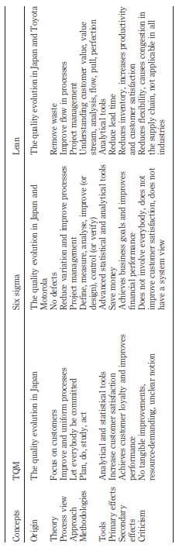
Expanding on this extract, we can therefore say that lean manufacturing begins by analyse the flow of production and establishing what ‘value’ is based on the customers wants, needs and perceptions. There is rapid improvement other than projects.
On the other hand, 6 sigma looks at reducing variation, defects and waste in services, processes, and products in order to achieve an increased customer satisfaction.
It should be noted each method has its own approach, and neither is used to replace each other.

Roy Andersson, Henrik Eriksson, Håkan Torstensson, (2006) (p282-296) also show provide a table comparing both methodologies.

Figure 4
Roy Andersson, Henrik Eriksson, Håkan Torstensson, (2006) (p282-296)

Conclusion
Finally, Roy Andersson, Henrik Eriksson, Håkan Torstensson, (2006) (p282-296) conclude that there are some similarities between both 6 sigma and lean manufacturing. Each have tools, systems, and approaches to making improvements. The authors’ also summarise in saying that 6 sigma and lean are vices used to achieve continuous improvement and significant success within a business.
Finally, this document, with the aid of research, has aimed to identified and explore the key principles of six sigma and lean manufacturing, whilst highlighting some of their overall key similarities and differences.

Reference list
Reference 1
https://sixsigmastudyguide.com/project-baseline-sigma/ (p1)
Reference 2
Evans, J.R. and Henderson, K.M. 2000. Successful implementation of Six Sigma: benchmarking General Electric Company. Benchmarking: An International Journal 7(4) 260-282. (p5).
Reference 3
Tenera, A. and Pinto, L.C. 2014. A Lean Six Sigma (LSS) Project Management Improvement Model. (p3)
Reference 4
Roy Andersson, Henrik Eriksson, Håkan Torstensson, (2006) Similarities and differences between TQM, six sigma and lean. (p282-296)
Reference 5
J. Jenkins Introduction to Six Sigma 2022 (p34)

WC : 2787

