ZARRAR ZAFAR
1605825
Researching and analysing
EMPL4012_LON
Lecturer: Isaiah Oino

Working From home
Is working from home a better option than working a salary job?
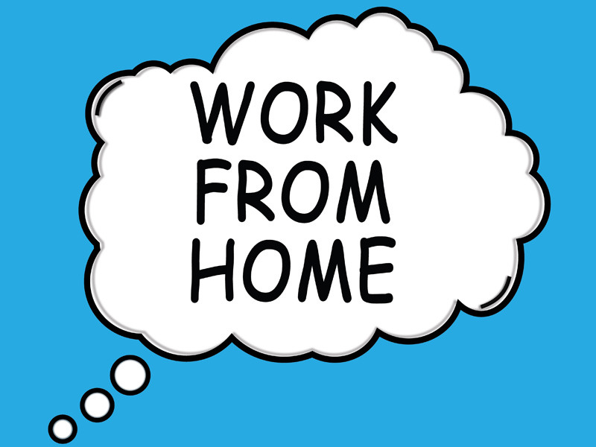
Zarrar Zafar
14.12.2017
Researching and analysing data

INTRODUCTION
There have been many questions surrounding the idea of working from home and whether it is a better option than doing a salary job. However there is research evidence to suggest that working from home can have many perks that make it easier and more useful to work at home rather than doing a salary job with fixed working hours. There are many reasons why people prefer to work from home and this report will examine why that is.

REASONS FOR WORKING AT HOME
There are several reasons as to why people would rather work at home and some of these can vary from things such as personal circumstances at home as well as not having the pressure of working for someone else. However it can be argued that one of the main reasons that people choose to work at home is due to the flexibility that it provides. It allows them to balance their schedule considering their personal life and the timings that suit them best personally unlike an office job where there is a less likelihood of his happening. Jobs have taken a new shape as there are now more than a million different types of jobs to choose from and some have been moved onto making these current jobs more flexible to work with.

RESEARCH SUPPORT
An article on POWWOWNOW suggest that flexibility to workers is very important but very few are able to actually get flexible hours that suit them. For example:
- 47% of full time employees do not have flexible working encouraged at their workplace
- 67% of employees wish they were offered flexible working
- 58% of people believe that working away from the office would help them become more motivated
- 45% of people surveyed spend over an hour commuting a day
- 56% of commuters feel stressed or flustered at least once a month, 66% of which suffer this at least once a week
- 53% of people feel that they would be more productive if they could work outside the office
- 70% of workers feel that offering flexible working makes a job more attractive to them
- 6% more men than women are offered flexible working
- Women (34%) are more likely to ask for flexible working over a pay rise compared to men (26%)
Using these statistics it can be suggested that one of the main reason that people prefer to work at home is because they require flexibility with their worker so that it can suit their personal life style.
Also it can be suggested that working from home may often vary as it could be argued that women who traditionally are left with household work may be more likely to work from home. This would allow them balance both their work at home with their actual job related work. However the assumption isn't solely based on stereotypes it may also be because women are less likely to receive flexible hours at work compared to men making them more likely to want to work from home. This means that because they aren't under a strict schedule they are able to make plan that fit with their timing well. This enables them work with less stress and with more control of their own life they have the power to make decisions without needing permission from employers.
Moreover working from home removes the need of commuting which 56% of workers found very stressful with 66% having to experience it every week. This could lead to workers becoming less motivated and very apathetic because even getting to work causes them stress and combined with actual work; workers may feel overworked with stress level rising very quickly. However working from home acts as a better option because people are able to work in less stressful environment, and environment they are used to and comfortable with. This allows them to feel at ease while they are working reducing the stress and increasing the quality of their work because they are working in an environment that suits their needs best.

PROBLEMS
Although there are many reason as to why working from home can be very beneficial there are also factors that contribute to making it difficult for people. British Vogue editor Alexandra Shulman, in the guardian newspaper, suggests that she believes that working at home isn't an adequate alternative. The article states that work is best done in an office environment at a desk rather than at home to ensure a worker's productivity. Also working at home, unless it's a self-owned business that does not require interactions with a company, co-workers and an employer, it can cause trouble for others. This is because an employer or a co-worker isn't able to communicate with a person working from home directly, it means having to communicate through emails. This can be very annoying to deal with because it means having to constantly be on a phone or a computer to make sure you have access to the emails you may receive. Also it can be tedious because it means that when corrections need to be made it increases the amount of emails because it's harder to explain such problems through email than it is directly to someone face to face.
Another person who seems to agree to the idea of working from home being a problem is Yahoo CEO Marissa Mayer. Mayer suggests that it is better for employees to work in an office environment because it allows there to be more effective communication between staff and gets rid of the problem of having to only communicate through a series of emails. It allows direct communication where problems can be fixed with feedback much easily and quickly.
Even if a person has their own personal business it can still cause problems and these can be to themselves as individuals. The way they work at home could potentially change their work ethic for the better or worse and if it is the latter it could make them unable to get a job or keep a job in the future. When people are away from a work environment they may get too comfortable, perceiving their work more like a holiday. This is why it can be suggested that working from home may not be such as great idea especially for people that get easily distracted or dismayed.

DATA
Problems with working at home | Why these are major problems
The cost | Working from home can actually be more costly than working in an office. This is because on top of normal bills a home worker has to ensure that the initial costs of training and providing suitable equipment, including adaptations to meet health and safety standards and the needs of disabled employees has been met by them
Lack of communication | Working from home could increase the feeling of isolation from a home worker as they feel lonely working by themselves at home. Also it may lead to stress and depression because working from home may lower the amount of support they receive making it harder to ratify mistakes
Low reliability | Workers may not be as productive as they need to be because they aren't being monitored by an authoritative figure which leads to lower reliability because companies aren't sure that projects will actually be completed effectively on time at home. It can cause workers to become lazy and with the possibility of discarding work half way through
Decreased staff morale | Staff working at different location s may make it difficult to manage staff and have good communication between everyone. This could make it difficult to improve teamwork skills smoking it harder to make sure that employees remain motivated and productive
Performance issues | It could lead to a possible deterioration in employees' skills and work quality. This is because without having a skilled and experienced team to overlook your performance, it becomes difficult to determine whether your work is going well or not. Also it's difficult to manage the work from home while also having to ensure that the employees skills are being used and upgraded
Not all jobs are suitable for working at home | Although there are high paid jobs that can be done from home, it isn't the case for all jobs. This means than having to work from home it is useful to get a job that allows for flexibility

RESULTS
Even though there are a lot of problems that may arise when working at home there are also advantages that may outweigh the disadvantages.

Benefits for working at home | Why these are important
Improved employee retention | Home working can help working parents who have childcare responsibilities. This allows them to do both without the need for a constant back and forth of having to prioritise one over the other
Access to a wider pool of applicants | For example, disabled people who may prefer to work from home. This allows them to avoid travelling and the stress of doing so to work in a place that is most suitable to their needs
Possible productivity gains | Due to fewer interruptions and less commuting time. This means that there is more time to get work done because this avoids commuting which usually takes up a good amount of time for workers everyday
Increased staff motivation | With reduced stress and sickness levels because staff is doing work where they feel comfortable without an office environment where they have behave a particular way
Financial benefits | Savings on office space and other facilities. It can allow home workers and even employers to save money as there is not as much of a need to have multiple facilities that they might have to pay for. Travelling is also another way most people end up saving money, if an individual rides to work every day it can be quite costly depending on the travel it can be even expensive.
Convenience | Ability to locate sales staff near clients rather than in your premises.
Better work/life balance | Employees working from home can lead to improvements in health and well-being. They have more time to do extra activities and indulge in their hobbies which gives them more job satisfaction, they will know that they are living their lives to the fullest and be able to work even harder.

CONCLUSION
It can be suggested that working from home can be harmful to a business because employers aren’t able to directly monitor the performance of their employees. Due to this there are employees who end up wasting their time and can even end up being costly to their employers ultimately damaging the company they work for. However all is not bad as people that work hard and earnest towards their work can be extremely beneficial to the company. They are able to spread their work and this spread of working from home has opened up a range of possibilities for the way businesses can operate and structure them. This is because employees working from home are able to decide on timing and the amount of work they take on according to their own personal life. This allows them to balance out the two, their personal life and work, for more effective and healthier style of working.
Working from home allows workers with many opportunities and benefits which not only brings about new responsibilities for the employee but also an employer. For example the employer is left with the decisions on as to whether they can offer working from home to their employees or not. In the end it is the employer’s responsibility to make sure that their employee is trustworthy and hardworking enough to be allowed the chance to be able to work from home.
It is clear that there are number of benefits to working from home or using your own home as a work base which is why it can be suggested that although there may be problems with it, it is a more comfortable and stress free option which workers prefer. However if salary jobs could be more flexible this number could possibly decrease.

REFERENCES

Shulman, A. (2018). Alexandra Shulman on working from home: it's not an adequate alternative. [online] the Guardian. Available at: https://www.theguardian.com/money/2013/mar/02/alexandra-shulman-working-from-home [Accessed 11 Jan. 2018].
McGregor, H. (2018). Heather McGregor: 'Working from home is the future'. [online] the Guardian. Available at: https://www.theguardian.com/money/2013/mar/02/working-from-home-heather-mcgregor [Accessed 11 Jan. 2018].
BBC News. (2018). The myth of working from home. [online] Available at: http://www.bbc.co.uk/news/magazine-21588760 [Accessed 11 Jan. 2018].
Keller, E. (2018). Yahoo CEO Marissa Mayer's work-from-home memo is from bygone era | Emma G Keller. [online] the Guardian. Available at: https://www.theguardian.com/commentisfree/2013/feb/26/yahoo-ceo-marissa-mayer-memo-telecomute [Accessed 11 Jan. 2018].
nibusinessinfo.co.uk. (2018). nibusinessinfo.co.uk. [online] Available at: http://www.nibusinessinfo.co.uk [Accessed 11 Jan. 2018].
Blackman, A. (2018). Freelance Work Versus a Salary Job: The Pros and Cons. [online] Business Envato Tuts+. Available at: https://business.tutsplus.com/tutorials/freelance-work-versus-a-salary-job-the-pros-and-cons--cms-25052 [Accessed 11 Jan. 2018].
Powwownow.co.uk. (2018). Flexible Working Statistics - 2017. [online] Available at: https://www.powwownow.co.uk/smarter-working/flexible-working-statistics-2017 [Accessed 11 Jan. 2018].

