strategic analysis of Lego



UNIVERSITY OF WALES TRINITY ST DAVID
SWANSEA

MBA

BMMB7013
Strategic Management
for
Dr Muhammad Tahir Mushtaq
STRATEGIC ANALYSIS OF LEGO

Contents
The executive summary 2
Introduction 4
the report main body 4
Result 5
Conclusion 5
Recommendation 5
Refence list 5
Appendixes 5

The executive summary
the report will explor stategy for Lego by identifing Lego's present position, that will be achieved through useing Pestle framewok, to analyse Lego's macro-environment. the report will also use the value of chain framework to examine Lego's startegic capabilities .
the report as second stage will identify Leg's startegic choice, and then hhhhhhhh will be use to put the strategic managemnt in action.
The report’s aim and objectives.

The aim of the report is to conduct strategic analysis reshape Lego's strategic direction to meet rising customer expectations and to ensure a sustainable competitive advantage. The report also will provide recommendations for the implementation of innovative strategies taking into consideration the wider implications on different areas of the organisation. These aims will be achieved by:
Objectives of the report

introduction
Strategy is defined as the long term goal of an organization. As outlined in section 1.2 there
exist a number of different levels of strategy in an organisation. The levels can be basically
divided into three categories. Above everything stands the corporate level strategy, which is
responsible for the overall purpose of the organisation. In the case of the LEGO Group the
corporate level strategy directed the company into the manufacture of the todays famous
plastic LEGO Brick, the development of LEGOLAND and the international growth of the
company. The second level is the business level strategy, which is also sometimes called the
competitive strategy, because it is about how the different businesses of the organisation
compete successfully in their markets. For the LEGO Group the Business level strategy is
reflected in the development and introduction of new innovative products like LEGO
TECHNIC, LEGO Castle, LEGO DUPLO and many other products to compete in the
competitive toy market. The third level of strategy are the operational strategies, which are
concerned with the delivery of the corporate and business strategy. The operational strategies
cover for example processes, designs and people. Operational strategies provoked the
introduction and re-organization of management to the LEGO Group. As well as the review
of the procurement process and the outsourcing strategies. The development of strategy at the
LEGO Group reflects the exploring strategy model (1.4). The model includes understanding
the strategic position of the company, analysing the strategic choices for the future and
managing the process of strategy in action.

This section of the report will define what is Strategic management/an overview of the chosen company /discuss the strategic position of the organisation.

The definition of strategic management.

Strategic management is to identify, select and implement a long-term goal and objectives for an organisation. According to this definition, strategic management includes understanding the strategic position for an organisation, making strategic choices for the future and implementing the strategy by putting it in action. Figure 1(the Exploring corporate strategy model) shows the elements of the strategic management. However, in practice the three elements of strategic management do not follow this order, they are interlinking on each other ( (Johnson, et al., 2008).
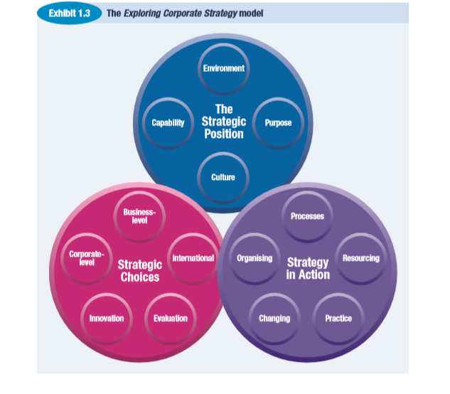
Figure 1(the Exploring corporate strategy model)

an overview of lego group

Lego is a privately held consumer product company, which designs, manufactures and markets a wide range of toys, and play materials. The company offers creativity development products, and teaching materials for children. Lego’s products are focused on the concept of learning and development through play. Its product line includes traditional toys, brick building sets, education products, robots, video games and online games. The company markets its products under the brand name LEGO. Along with its subsidiaries, the company has presence across Europe, Americas, Africa, and Asia-pacific. Lego is headquartered in Billund, Denmark (MarketLine, 2018).

Identifying the Level and the horizons of strategy

identifying the strategic management for lego.

To reshape Lego's strategic direction to meet rising customer expectations and to ensure a sustainable competitive advantage there are need to identify strategic management for Lego, by answering the questions in the diagram figure 2.
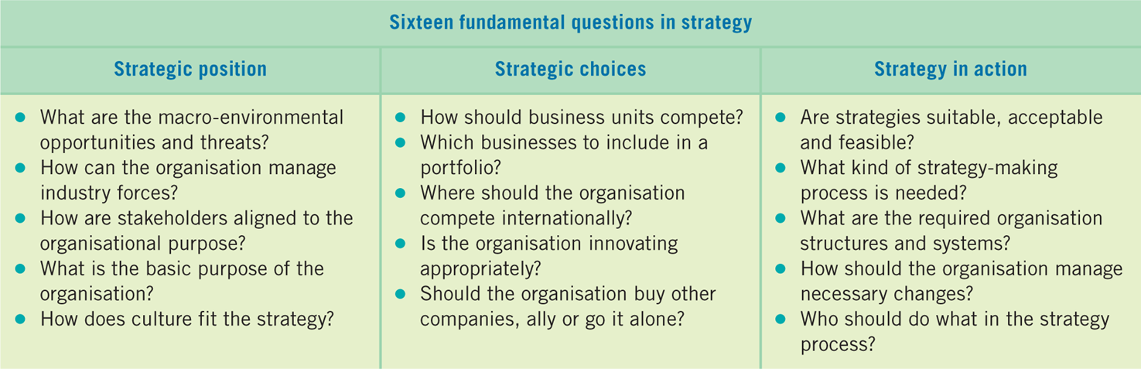

understand the strategic position of lego.

To understand the strategy position for an organisation there is a need to find out about the environmental opportunities and threats, the organisation’s strengths and weaknesses, the basic purpose of the organisation and the effects of culture on the strategy ().
Applying this in Lego case there are need to identify the internal and the external environment analysis, the external environment analysis.

internal environment analysis.

To analysi the internal factor of Lego ,

to ana

External environment analysis

Stated by Singh & Srivastava (2019), PESTLE analysis is an important measure to study about the macro environmental factors affecting the business. Founded by Francis J. Aguilar (1967) and stands for Political, Economic, Social, Technological, Environmental and Legal influences. Applying the framework on Lego to the external influences on company.
Regarding the Political factor, Lego has political neutrality to be involved in any event, program or movement with political connection to avoid risks such breaking the laws in local or international markets (Berg, 2015) . However this political neutrality was criticed in 2015 when it refused to supply leg bricks to Chinese artist to used them in an exhibition related to freedom of speech and political art (Lowe, et al., 2015).
Regarding the Economic factor, Lego operates through an extensive network of subsidiaries in Americas, Europe, Africa and Asia-Pacific region. enter new markets through production units as well as enhance its position in existing markets, Lego emphasizes on new product development, as new products account for approximately 60% its total sales every year (MarketLine, 2018).
Regarding the environmental factor: Lego emphasises on manufacturing products with sustainable and environmentally friendly materials ( (MarketLine, 2018). Howevr, the alternative options Lego is trying to move toward from sugar cane still hard-wearing plastic (Espiner, 2018).
Regarding the Social factor: as Lego operates in more than 100 countries the company announced a partnership with Unicef to promote the agency’s program for ensuring businesses respect and support children’s rights beside, is protecting children online by working to ensure that it markets to children responsibly (Confino, 2015).In addition, Lego operates in collaboration with several education institutions covering various research projects such as children’s play area and new technologies. In FY2017, the company spent DKK550 million on its R&D activities, which stood at 1.6% of the company’s revenue (MarketLine, 2018).
Regarding the Technological factored, for Lego to build on the strength of an enterprise platform and to develop the company, Lego had transformed itself to become a digital company. However, the digitals transformation posed some challenges, such as the risk of failing to respond quickly enough to the opportunities and the threat of the digital economy posed ( (Andersen & Ross, 2016).
Regarding the Legal factors, stated by Bason (2012) Lego has delayed filing its lawsuit against its other companies that imitate Lego miniature figures. Furthermore, courts rejected some of Lego’s allegation as the court argue that Lego's miniature figures are functional and thus not subject to copyright. also, some elements such the arm and legs of the toys are functional. However, other elements, such as the cylindrical shape of the head and the trapezoidal shape of the body are sculptural elements subject to copyright protection. Therefore, Lego must be vigilant and cautious about its designs and make use of patents and copyrights Law.
According to Lage Pestel analysis the table below Summarise the factors on the organisation.

Political  One of Lego core value is to maintain political neutrality | Economical  Expanding geographically and introducing a new product continuously. | Social  partnership with UNICEF to promote and support children’ rights.  Ensure its children online game markets responsibly.
Technological  The digital transformation. | Legal  poor copyright laws in many subsidiaries.  involvement in multiple lawsuits against other rivals of imitations. | Environmental  Use a friendly material.
I need to draw sociogram of Lego’s network, to analyse the stakeholders .after pestle.
To identify the organisation position there are need to analyse the determinants of strategic
capability, resources, competences and the linkages between them.
The main core of the internal analysis is to identify the strengths and weaknesses for the organisation in order to build on the strengths and overcome the weaknesses when implementing the strategic strategy (Johnson, et al., 2008). stated by ( (Sheehan & Foss, 2009) organisations engage in several activities in the process of converting inputs to outputs. These activities classified by Porter (1985) as primary activities such as inbound and outbound logistics, operation, marketing and sales, and service. The support activities that all businesses must undertake in some form such as, human resource management, technological development and infrastructure. Applying the value chain on Lego case will identify the resources and competences LEGO have enabled them to regain their successful position in the global toy market.

Resources
Lego in one of the leading toy manufacturers in the world and has both tangible and intangible resources, such as, positive brand, associated with learning and quality; and the bricks are as iconic in some parts of the world , design, develop, produce and market of toy and play materials. the company produces a wide range of learning toys, produce video games and online game for different ag groups. The company also has attractive productions such as LEGOLAND (MarketLine, 2018).

Lego’s capabilities.
In inbound logistics part, Most Lego pieces are made from high-quality plastic called ABS, meets safety, durability and quality rules and provides good connective grip, high gloss with the suitable colour (LEGO, 2019).However, Lego criticise of being very expensive (Espiner, 2018).

In operations part.

In outbound logistics par

LEGO developed its supply chain by building good relations with its suppliers in order to collect expectations to enhance market feedback, therefore, improve innovation capability; obtain market information to improve fast adjustments of sales in both the short and the long run.

In marketing and sales part:

Lego tend to create animated series such as Lego Ninjago, Lago predect that the more children will watch such series the more they will be emotionally attached to the charactor thus will demand that chacracter specific toy . (Brook, 2013) However, Lego citicise of its expensive compare with their competitors, as it pays licensing that are linked to blockbuster brand , so the cost directly passed to the consumer (Espiner, 2018).

In technology development part

In firm infrastructure part

Lego has been shifting its production to low-cost countries and is building a new factory in Hungary ( (Harrington, 2013).

services

SWOT ANALYSIS,

SWOT FRAME WORK WILL BE ALSO USED
According to (Espiner, 2018) Lego state that lego products are unique, meet the highest safety and quality standred .Howevr, Lego citicise of its expensive compare with their competitors, as it pays licensing that are linked to blockbuster brand , so the cost directly passed to the consumer.

Threats: the industry has suffered due the growing emergence of games on mobile devices. As children and their parents spend more time using smartphones and tablets, they spend less time with physical toys and weakness in Europe due to the eurozone crisis ( (Harrington, 2013)

Lego says its consumer sales in 2017 were flat,Lego lost its imagination, and it could be the (Espiner, 2018).
The cheap iitation ( (Bason, 2012)) However, but inferior imitations are able to threat the brand, because inferior imitations with lower cost to attract customers, whereas, customers buy inferior imitations for LEGO products. Therefore, to create greater products’ value is very important operation for the ELGO to remain and protect its brand power.
The Lego group was founded in 1932 by the Kristiansen family, is the world’s third largest manufacturer of play materials and provides toys and teaching materials in more than 130 countries.
The strategic drift

alternative strategies available for lego

Analysing LEGO's position identified several internal as well as external factors which resulted in certain issues like there are the brick material and how is non recyclable. The other material which were planning to use but it has the same problem. there were major strategic development which LEGO witnessed.

the diversivication startegy.
Lego is main customer are boys, lego has been diversfying towards trying to attract more girls but boys remain the core customers .leo also tried to attract adult but fail because the adult product are very niche. (Espiner, 2018).
Innovation Stragy
realising the important of the involving supply chain partner, lego change it stategy from closed product development with confidentially to involve the customer and suppliers in early product development processes. his effort has enabled LEGO to gain new perspectives on issues such as packaging, price, and other key selling points that will work in the retail outlets. Then, LEGO does what it is best at -focus on the play experience, the marketing efforts, and the story telling. However, There are cultural challenges with relying more on innovations from the supply chain networks ( (Arlbjorn & Paulraj, 2013).

Result
This section of the report will discuss how to manage the strategy chosen for Lego Group in Action. to secure successful implementation, the strategy should be-be based on a realistic assessment of the organisation' internal resources an capabilities,.

Conclusion

Recommendation

Refence list

Appendixes

External environment analysis

Porter five forces

Porter (2004) outlines five forces which have an impact upon a business coming from the external environment and include the following elements which will now be considered individually: Level of rivalry, Power of buyers, Power of suppliers, Threat of substitutes, Threat of entrants, Level of rivalry.
The overall level of rivalry may be seen as relatively intense for the Lego group in the run up until the end of 2004. Whilst Lego occupies a strong position in the market for construction toys with relatively few rivals one must consider that Lego is now competing in boarder market of children’s entertainment which in the lead up to 2004 began in include large incumbents from the electronics sector such as Sega and Nintendo.
Power of buys
The power of the buyer in the case of Lego may be seen as relatively high with low switching costs between alternative toys and even substitute products such as video games and television.
Power of suppliers
The power of suppliers may be seen as average, Lego’s products on the whole may be seen as largely based upon standardised inputs such as plastics and chemicals. There is the consideration that were Lego chooses to move into non-traditional areas such as sets associated with films or games the power of suppliers will increase as a key input becomes that of licences which is a form of intellectual property.
Threat of substitutes
This may be seen as the largest threat to the Lego group in the run up to the end of 2004. Although it is difficult to define what market a company occupies (Grant 2008, Porter 2004) for the purpose of considering the impact of substitution one must consider Lego to be a provider of children’s entertainment. In this case the threat from substitutes are rather high given that consumers may substitute between alternative traditional toys such as action figures or toy cars through to electronic products such as video games and television.
Threat of new entrants
The threat of new entrants into both the smaller traditional toys market and the wider children’s entrainments market may be seen as relatively low in the run up until 2004 largely for similar reasons. In order to enter these markets there is the requirement for significantly high levels of investment in both the form of capital investments and research and development costs both of which act as barriers to entry and thus restrict the number of new entrants (Porter 2004).

Pestle analysis

PEST analysis:
Economic:
The Toy educational industry is developing and can be seen to be economically stable in the past few years. The economy is improving well so the LEGO also improve their products to gain the best for their customers. The business not only improves economic of the domestic market but also the external market in all over the world. For example, the US market has big opportunities to LEGO and other toy companies.
Technological:
This is one important force in the Toy industry. In order to have new innovations and good product, LEGO Company also has and improving new technologies, also this is the way to compete with many other strong competitors in the market. LEGO Company makes sure they are updated to what happening in case to adjust the changes.
Eenvironmental:
Lego company is trying to make their products that they sell are proven to cause minimal problems to the environment. The company also introduced some strategies that aim to decline pollutants and create a good environment. The company also invested a huge amount of money in waste system to protect the environment near company’s factories.

Internal environment analysis

Value of chain

Lego have a quite large in toy market share in this industry. The company has enough strength to continue increase sale revenue in next period. Organization of LEGO has a long history and many different kinds of toy. Moreover, LEGO’ toys are suitable with children and bring education meaning. In addition, the business has good website which are colourful, clearly, attractive, and helpful for customers when they have arrived.
LEGO products are always new and popular material offers to improve their toys. Especially, the company is often focus on famous characters or superheroes in films and comic books such as Star War, Spider man, Pirate of the Caribbean, ninja, or Sorted activity programs by ages. This strategic becoming very successful to target children, it makes their products is more attractive with their customers. However, LEGO was focus on children, but they realized adults had created their big users who spent more money on their product than children. In fact, the price of LEGO is not cheap, therefore they need the satisfied of presents who pay money for their child’ toys. Then, they started connecting them; improve the relative with them and becoming successful by this plan. Following Jake McKee (formallyÂ Lego’s Global Community Relations Specialist) said about strong social media strategy what made the high successful of LEGO Company nowadays. He suggests three incredibly simple points in this strategy:
– Look beyond your target customers
– Support existing fans
– Find what works and replicate
LEGO’s strategic is trying to open their market in all over the work. The company wants to more increase number of sale in the United States because they realize there are potential growth opportunities in this market. In addition, Eastern Europe and Asia are also two places where the market growing very rapidly; so LEGO want to make more revenue from here.
Moreover, LEGO organization is wanting to open and expand more activities that direct to customer – kids and their presents, to help more close and understand what their litter customers want. also, realize the important of understanding customers because their target customers are children with variable ages, who easy to attractive and persuade; but also, easy to change their mind when they see other toys that new, beautiful or maybe colorful than their own toys. On the other hand, LEGO are improving online strategy. They built new website with attractive design, colorful for children; developing online stores, and online activities, for example children online games

Lego’s core competence and the strategic capability

Lego has three strategic capabilities:

Customer focused innovation:
By involving customer to get ideas,,,,,,,

Core brand identity:
Consumer value a Lego version of a particular movie themed toy more than they would value a similar toy made by a competing manufacturer and that because of their previous positive experiences with Lego products.

Efficient operation:
Lego can make a toy more cheaply than another toy manufacturer, because they can utilise parts that they have already designed and already have the equipment to produce for another toy.

Market analysis and forecasting
enter new markets through production units as well as enhance its position in existing markets, Lego emphasizes on new product development, as new products account for approximately 60% its total sales every year.
Globalisation.
The company focuses on globalizing its operations. It intends to enter new markets through production units as well as enhance its position in existing markets. In line with this, the company-initiated expansion projects in Mexico and Hungary. It also started new plant in Jiaxing, China.
New Products
Lego emphasizes on new product development, as new products account for approximately 60% its total sales every year.
Digitalization
The company also focuses on digitization through integrating physical and digital play, e-commerce, marketing and business/enterprise system. Lego also
Restructure
Plans to restructure its operations in order to meet challenges, gain competitive advantage against intensifying competition and fulfil environment,

- the company offers play themes based on movies or books.
- It provides toys and games for kindergarten toddlers, school children and teenagers and others.
- Lego offers an array of pre-school products for children who have not started attending school. The products are specially developed to sharpen the capabilities of young children through creative play.
- The company’s LEGO Education products category caters specially to the educational sector. Lego provides learning solutions based on LEGO brick, curriculumrelevant material, and physical and digital resources for children at preschool, elementary, middle school, and after school.
- It also offers online games covering action, strategy, adventure, creative and preschool categorie.
- It also operates Legoland parks that comprise kid-powered rides, building challenges, coasters and interactive attractions.
- The company reached nearly 100 million children through joint activities of LEGO Group, LEGO Education and the LEGO Foundatio.

Strategic choices
Generating Strategic Options out of the internal and the external analysis.
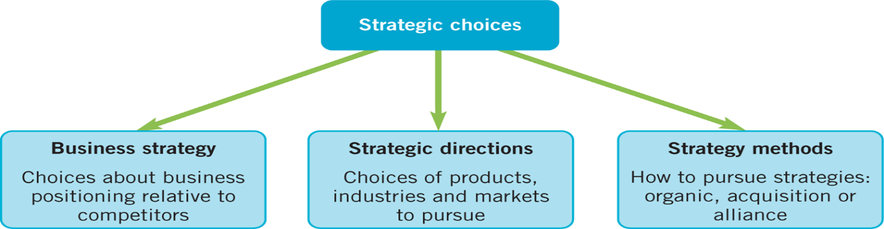

Business strategy
Business position map
Where is Lego position in the market?

1: Cost leadership strategy

Innovative design.

2: Differentiative strategy
Marketing position
Product design
Operating concept.

3: Corpora strategy
Diversification
Vertical integration

Main findings

Conclusion

Recommendations

References

Appendix

