BMSW4003
DIGITAL SKILLS AND RESEARCH METHODS

Research report on the impact of Virtual Learning Environment (VLE) – Moodle on
students’ learning experience in the University of Wales Trinity Saint David London Campus.
Table of Contents
Introduction 3
Rationale of the study 3
Aims and objectives 3
Literature review 4
Methodology 5
Results 6
Discussion 13
Conclusion 13
References 15

Introduction
Virtual learning environment is a method where learning is delivered to the students through the web. It is a web-based software system which allows the students to learn and to be taught using a range of tools and activities. The VLE is a very important learning resource especially for distant learners, part time learners and the virtual learners (Becta, 2003). Through the VLE, students can be provided with tasks from their class and they can complete them in their own pace as well as time based on their location and they can also contribute to many class discussions to support them in their learning. Reports have suggested that the use of VLE has great positive impact on the student’s academic performance, boosts the motivation of students and support independent learning (Arbaugh, 2000). This report will provide a research on the impact of VLE-Moodle on the learning experience of University of Wales Trinity Saint David London Campus.

With the current trends in the education world, many people have resorted to studying online. VLE has been majorly used in many Campuses in the UK basing on its known benefits but what is really the impact of VLE on the learning experience of the students using it. Data on the impact of VLE on the learning experience of students is still limited and further research is therefore needed to be done to understand this impact very well and this responses, data and analysis can be used to make VLE better for learning experience and towards better outcomes of learning (Boling et al., 2012). This research will therefore provide great benefits to the in the University of Wales towards making Moodle better towards improvement of learning experience. The findings shall be of great interest to University of Wales teachers towards understanding the areas of attention in the promotion of VLE-Moodle in learning.

Aims and objectives
The aim of this study is to find out on the general impact of the Virtual learning Environment-Moodle on the general learning experience of students in UWSTD London campus. It aims at making use of both primary and secondary data as well as analysis of published information on this topic to draw conclusions.
The major objectives of this study shall be:
- How virtual learning has been used in UWSTD London campus
- To provide insights on how the various students feel on the benefits of VLE on their studies
- To understand the negative implication of VLE-Moodle on the students learning experience
- To provide insights on the areas of Moodle which needs improvement.

Literature review
Many literatures have been published in relation to this topic, one of the literatures in this topic aimed at exploring the positive impact of VLEs on the learning of students. The study on the use of VLEs by students and teachers for online learning and teaching, under this study showed that most students who uses VLEs for learning for learning measurements of depth, vocabulary skills, language skills and other perspectives did well as compared to students who did not learn through the VLEs. The study found concluded that students who studies using the VLEs for studying not only encourage independent thinking as well as progressive thoughts but also maximise reflection by the students. The research further concluded that students who have access to integrated learning systems, programming and design technologies, simulation software and computer assisted technologies gains positively in national tests, standardised tests and tests developed by researchers (Barker, 2013).
Another literature by Mirandanet on the impact of VLEs on learning and teaching provides that VLEs are still new in the learning system and it is already bringing about great impact on higher learning and teaching in schools and is projected to bring great benefits on the learning experience of students. Under this literature, it is provided that a higher learning institution will not be sustainable in the 21st century if it does not have the VLE platform. Besides that, the VLEs bring about great benefits for the students using it ranging from flexibility in studies since the VLE can be accessed anywhere and at any time they want learn. Using the VLEs also enhances engagement as well as motivation among the students using it. The VLEs also provide an opportunity to learn and apply various approaches to learning from the forums of online discussions. Using the VLEs also improves technical skills in the use of technology, writing skills, presentation skills and other ICT gains. It also provides that parents can be engaged in the learning of their children (Mirandanet, 2014).
Another research paper by Emerson provides that technology is taking the centre stage of higher learning in the UK. The outcomes of the research paper provide that Moodle has brought about great positive impact in learning ranging from promoting flexible learning and supporting teachers to produce flexible learning materials towards learning and outcomes assessment on the students. The paper proposes some of the ways in which Moodle can be made more effective towards promoting great learning experience among students, it recommends that colleges should make VLEs a priority by incorporating the use of Moodle into the school’s strategic plan and that induction should be provided to all students in every academic year so that they can be familiar with it on the various features of the platform and the interactive tools available in the platform for use by students (Jackson, 2017)
Another publication by Ethink provides that Moodle has greatly improved the learning experience of students. It provides that there are many reasons why students pick Moodle for learning today. Some of the benefits of using Moodle provided under this publication include an organized learning platform which easily integrates with the current learning system and enables the institution to easily manage learning through a centralized management. This streamlines all the roles of the administration since all the information are managed from one place. It also promotes flexible learning since students can access learning materials anywhere and anytime, this feature has been enhanced by Moodle app which means that they don’t need to be physically present in the classroom in order to learn. It also provides teachers with an option to provide feedback to the students through the various plugins in which the students can acquire feedback for their work. Besides that, it saves on time in which learners access learning and in which teachers teach, record, assess attendance as well as enrolment of learners (Ethink, 2019).

Methodology
The research on the impact of VLE-Moodle on the learning experience in UWSTD London campus made use of various methods to obtain data. Both primary and secondary data from primary and secondary research were used to obtain answers for this research. The secondary data used for this research included publications, past researches, journals, web-based resources and other sources of information relevant to the research most of which have been discussed on the literature review of this research. Collection of secondary data came first where I did a lot of online and offline research on what other people have published on the same topic so that I can analyse the data and draw conclusions from the various sources.
Collection of primary data came as the second step of the research where I used a questionnaire to collect data from students both online and one on one meetings with various students both who have used the University Moodle for studies and those who haven't used it. The questionnaire had 8 questions which every participant was supposed to fill. Reaching to every student in the university would have been a very hectic and time-consuming practice and I therefore decided to only use online platforms for survey. Using a small number was also a way of making it easy to analyse the data. I made use of the online survey tool survey monkey to obtain responses from the students through a link which was available on our students WhatsApp group, students’ Facebook group and I also shared to individuals' inboxes. The total responses from the survey monkey survey tool on the was 16. The current Covid-19 protocols made it very hard to collect data offline.
I then analysed the primary data using the available online analysis tools while I analysed the secondary data thematically based on my own understanding.

Results
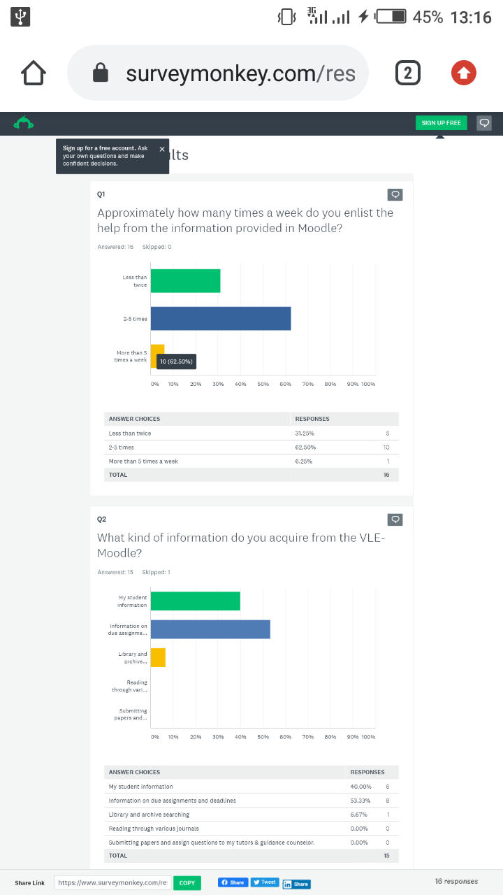
From this question, we find that many students in the campus access help from Moodle 2-5 times per week while very few of them access more than 5 times as compared to those who enlist help less than twice a week.

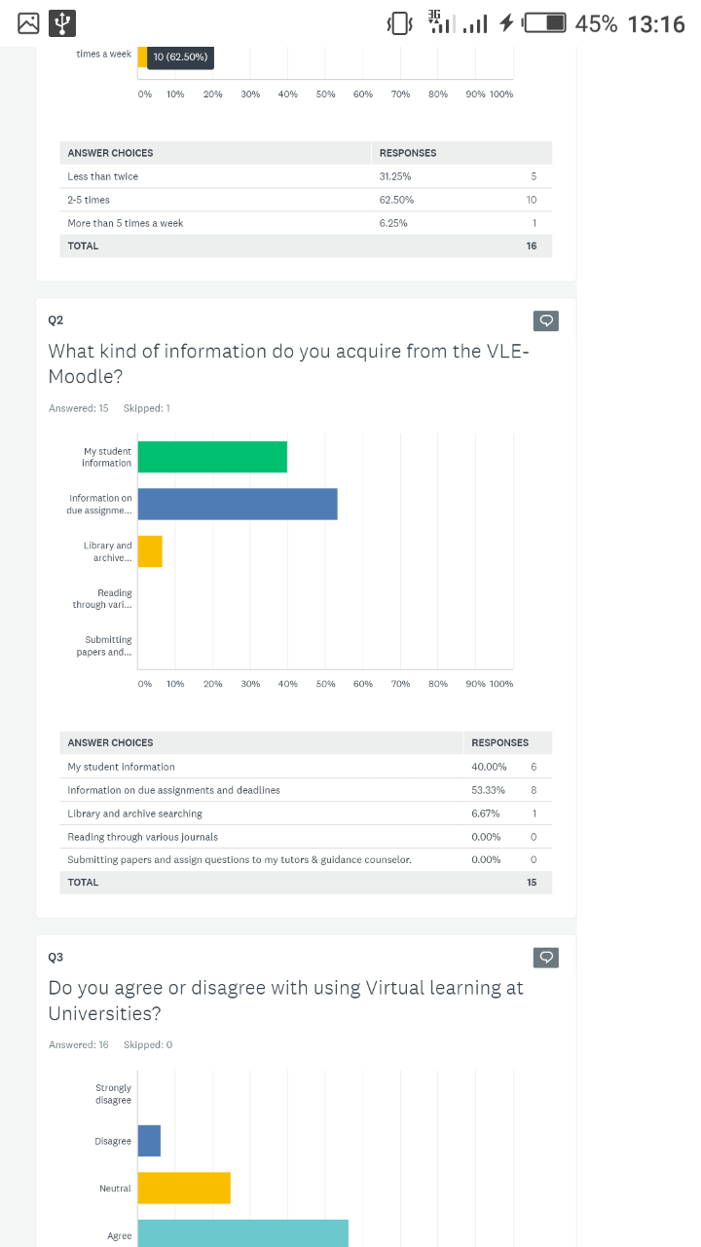
In the second question, I found out that most students mostly use the Moodle to acquire information on due assignments, followed by the students who us the platform to check on their student information and the third placed are the students who use UWTSD London Campus Moodle to access library and archive. No participant uses the VLE to read journals or to submit assign questions or submit papers to the tutors

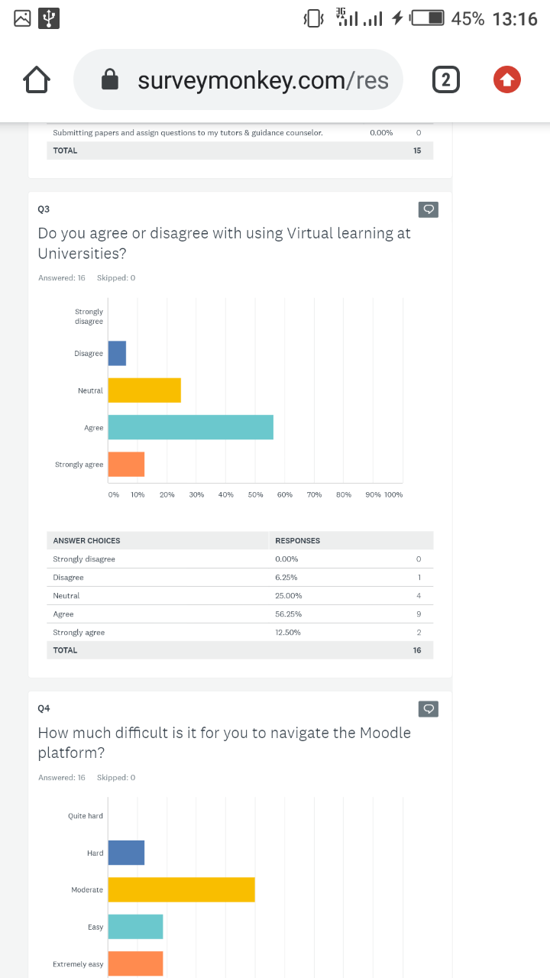
According to this question, most participants agree with the use of virtual learning in the Universities, while some are neutral about the usage of virtual learning, followed by a number of participants who strongly agree and in the last position were a very dismal number who does not agree with the use of virtual learning in Universities.

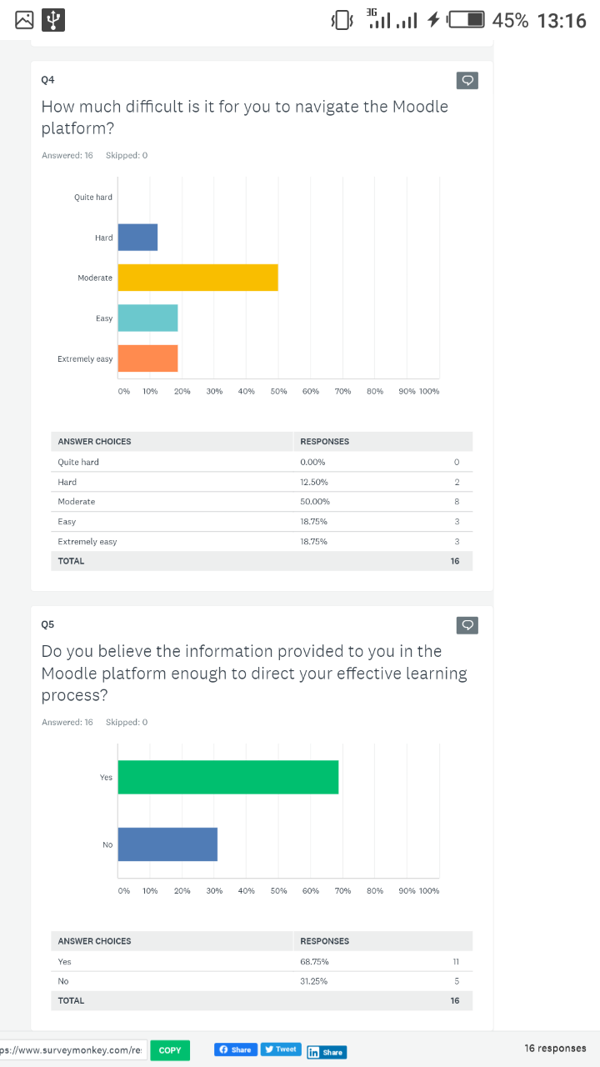
Under this part students face moderate difficulty when navigating the Moodle platform. Equal number of participants finds it easy and extremely easy to navigate through the platform while a dismal number find it hard to navigate through the campus Moodle.

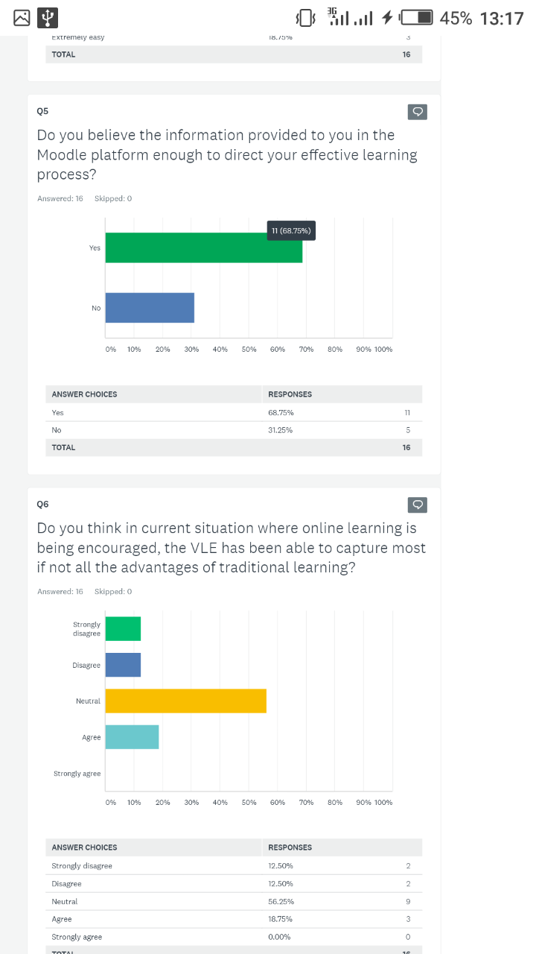
A big number of participants (68.75%) believe that the information provided to them in the Moodle platform promotes effective process of learning. While 31.25% believe that the information does not defectively promote effective learning.

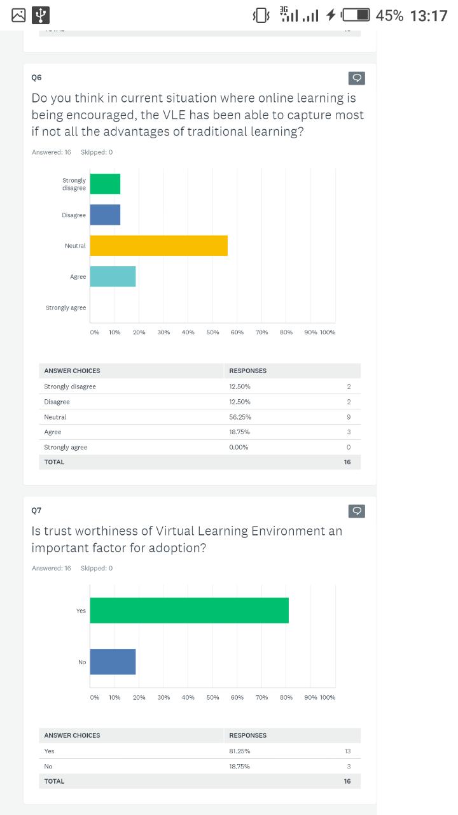
Most of the participants were neutral about the extend in which the VLE has captured most of the advantages of traditional learning. 16.7% agree that it has captured the advantages of traditional learning while the same number of participants disagree and strongly disagree on the VLE capturing the advantages of traditional learning.

Most of the participants provides that trustworthiness of the Moodle platform is an important factor towards adoption of the VLE while a very small number does not consider trustworthiness as important towards VLE adoption.
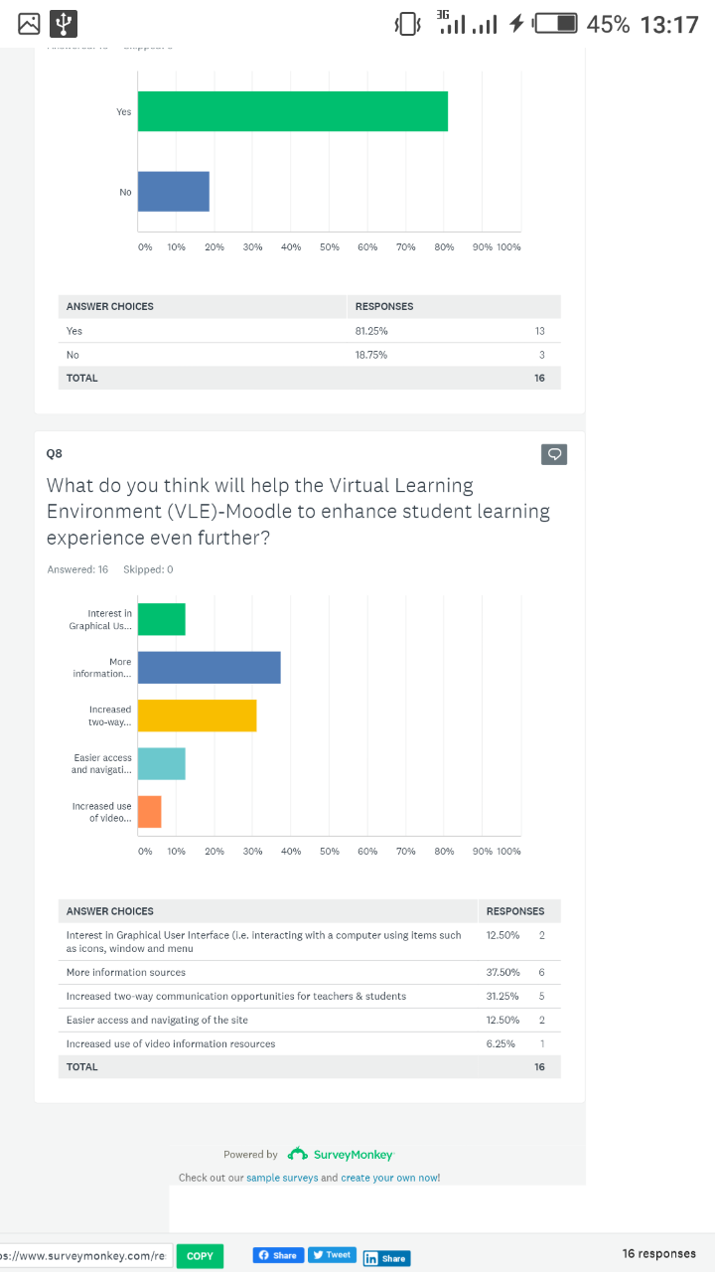
According to most of the participants, more sources of information should be used in order to enhance the learning experience through the VLE-Moodle: this should be made a priority followed by increasing a two way communication opportunities for the students and teachers followed by improvement in graphical user interface which stood in the same place with making it easy to access and navigating the platform and finally increasing use of videos for sources of information.

Discussion
Many arguments from the primary data shows that the learning experience of UWTSD students have been enhanced through the application of VLE-Moodle in virtual learning. Many students access the Moodle between 2-5 times a week which is almost every school day with most of them checking on the assignments. Besides that, many learners agree with the usage of Moodle for learning in the University. Most learners also find that the information on the Moodle to be good in promoting effective learning. Besides that, many learners think that Moodle has covered much of the percentage brought about by traditional learning especially during this period when online learning is being encouraged. However, most of the students face moderate difficulty while navigating through the platform and they most also think that adding sources of information should be made a priority towards making the platform effective towards making the experience of learners using it better.
Most of the data from the secondary research also provide that VLE- Moodle has enhanced the learning experience of learners in UWTSD London campus and all-over the UK especially during this time. Mirandanet provides that the use of VLE-Moodle in higher learning brings about flexibility in learning and provided learners with new approached towards learning. Ethink (2019) on the other hand explains that Moodle has not only promoted flexibility in learning but also saves on time, made it easy to manage learning, made learning more organized and made it easy for lecture and student to communicate and obtain feedback on the right time.

Conclusion
Generally, Virtual learning environment (VLE)-Moodle has promoted the learning experience in UWTSD London Campus. It has made learning flexible for students using it, made it easy to access academic resources from anywhere at any time. The UWTSD Moodle has also made it easy for lectures to manage learning and to provide feedback for students on assignments and any other aspect of learning. Especially under this period where online learning is being encouraged, Moodle has taken over most of the advantages of traditional learning and many students are embracing it. However, there is still much to be done towards further improvement of learning through the platform. Some of the recommendations include;
- Making it easier to access and navigate through the VLE-Moodle used by UWTSD London Campus
- Increasing the sources of information available in the Moodle for students
- A means to make the Moodle interactive should be developed to promote two-way communication
- The VLE should be designed in a way that the students are in control of design of learning
- Non-directed use of the Moodle should be encouraged

References
- Arbaugh J. B. (2000) Virtual classroom characteristics and student satisfaction Journal of Management Education, 24, 32-55
- Barker, J., Gossman, P. (2013) ‘The learning impact of a virtual learning environment: students’ views ‘ Tean Journal 5 (2) July [Online] Available at: http://bit.ly/AtMwtr [Accessed 12th August 2020]
- Becta. 2003. Virtual Learning Environments in education: a review of the literature. [Online] Available at: http://www.becta.org.uk/page_documents/ research/VLE_report.pdf [Accessed 12th August 2020]
- Boling, E.C., Hough, M., Krinsky, H., Saleem, H., & Stevens, M. 2012. Cutting the distance in distance education: Perspectives on what promotes positive, online learning experiences. Internet and Higher Education, 15, 118– 126.
- Ethink. 2019. How Moodle improves outcomes of learning [Online] Available at: https://ethinkeducation.com/blog/moodle-in-higher-education-improved-learning-outcomes/ [Accessed 12th August 2020]
- Jackson, E.A. Impact of MOODLE platform on the pedagogy of students and staff: Cross-curricular comparison. Educ Inf Technol 22, 177–193 (2017). https://doi.org/10.1007/s10639-015-9438-9
- Mirandanet. 2014. What research says about virtual learning environments [Online] Available at: https://mirandanet.ac.uk/wp-content/uploads/2019/06/wtrs_04_vles.pdf [Accessed 11th August 2020]

Appendices
Appendix 1; Questionnaire (source: https://www.surveymonkey.com/results/SM-PYSTHP5M7/)


