Modern & Traditional Assignment

Sean Hazelby

Level 5

Contents
Introduction 3
Foundation 3
Steel frame 3
Grid system 4
Flat roof 4
Cladding 5
System of enclosure 5
Curtain Wall 5
Referencing 6
Appendixes 6

Introduction
The project is going to consist of a multi-story office building located on SA1, Swansea. The site has historical context as this was the site for the old Swansea docks. It is known that the ground conditions are of poor quality in the area and may be contaminated. Weather and local climate will need to be considered. The elements of the primary structure should be chosen with great care and thoughtfulness of the local climate as this is going to be the main factor to whether the building will be successful or not in terms of construction.

Foundation
The area of site is one of historic context. SA1 is located on the old docks of Swansea. Most of SA1 wasn’t even there years ago meaning that most of SA1 is indeed made ground. Made ground consists of ground that is contaminated and made up of non-natural elements for the area. You will find things like rubbish, metal, coal debris and bits and bobs scattered within the ground. This is not adequate ground to build upon. As a solution we must have a deep foundation to make sure that the building can stand as strong as possible without relying on the poor ground conditions. We need the foundation to stand on solid ground meaning that we will have to go down deep. The borehole records suggest a strong presents of made ground which supports the historic action of the area. We have made ground consisting of sand, shale, broken bricks, rubbish and much more down to depth of up to 4.55m deep. Past this is consist of clay soil which is still not adequate. At a depth of 18.6m we have soil that is appropriate which is grey mudstone.
As a foundation type I will suggest a piled foundation. Piles offer great strength and is suitable for our site. It gives us the ability to bypass the poor soil. It will consist of concrete which is very strong under compression and some reinforced steel to make it stronger. SA1 and Swansea is known as one of the worst weather cities in the UK meaning high winds and rain will batter the faces of the building meaning that our foundation needs to be solid and secure and avoid any movement from foreign elements. A Piled foundation typically goes down to a depth of 18-20m. This applies to our site. This ensures strength and stability to build our superstructure.
(Anon, 2021)

Steel frame
The framing material of the building is set out in a grid system meaning that the columns of our frame will divide the building into different sections. I would assume that the steel is going to be an 8inch I beam which has a span of 4m/4.1m including the bracket (Tapfenhart, 2022). The columns will be drilled down into our foundation ensuring a trusty sand safe base. Having a grid system ensures there is strength and stability for the building. The frame is the skeleton and backbone of the building ensuring that everything built upon it is stable and able to last for years on end. In the building, a steel frame is used which is a suitable style of frame for the project for many reasons. Steel is good for this example due to its high level of strength within a small cubic area. Taking up less space means that the building is cheaper as it doesn’t have to increase in size for the rooms to meet their required size. This means all rooms and corridors can flow effortlessly into one another without having interruption on a frame point and that you can have room sizes that are adequate without the building being larger making it very efficient for saving space. Steel is a great option as a frame as it is very strong, durable, and very secure.
Our building needs to be able to withstand the elements of the coastline. The SA1 area is known for its high volume in rain and devastatingly high winds. Our framing material needs to able to withstand these elements or it could lead to awful results. Steel is a great choice for this as it offers flexibility which is great for windy days as it allows the building to move. IF a building doesn’t move is means it’s under more stress to avoid movement. Steel is a great choice for this project because it offers the ability to withstand the wind due to its flexible nature meaning that this is the best choice of frame. Wind loading is going to be a massive part of this project.
Steel is a very strong framing material. Steel can support massive buildings, allowing them to move under forces like wind. The strength not only lasts a couple of years but indeed it last a very long time making it a long-term frame material and usually is 2-3% cheaper than projects that don’t use steel framing (David, 2018). Steel is very diverse and is not vulnerable to biological attacks. Steel does not rot, obtain mould, in danger of termite damage or any kind of insect attacks. The only thing steel is not up to scratch in is defence against rust. The more salt in the air the more chance steel has got of rusting. This is a problem for obvious reasons. We see this mostly in coastal projects. When salt and oxygen react with steel is causes the steel to rust on the outside. This makes the frame weaker and leads to weak points in the frame making it less safe. In terms of fire resistance, steel is very effective due to the fire retardant coating on the outside of the steel. This offers a very safe atmosphere giving confidence to people that the fire will not destroy the frame. There is a big misconception when it comes to steel as it was thought that steel was not good under fire due to disasters like 9/11. This is true when there is no fire retardant coating. Therefore, it is imperative that the steel is done correctly with the adequate coating applied to the outer skin to prevent disasters like the above. Steel is suitable for several weather conditions such as hurricanes, snow, rain, wind, and heat waves.

Grid system
Our building is structured in a grid system. Grids offer structure and support and helps easily differentiate the rooms before they are even implemented. This gives good foresight to how rooms will fit within the frame thus causing less confusion. A Grid system helps make sure that the building is done in a way that’s organized and easier to follow than other methods. It is easy to locate issues and is much easier to access them when maintenance needs to be done (Soegaard, 2021).

Flat roof
The building has been designed with a flat roof in mind. This is cheaper then a pitched or hipped roof and is effective when done correctly. Unfortunately, your almost guaranteed to get a leak with a flat roof. A flat roof is not exactly flat as it has a pitch fall of 1.5 degrees. This in theory is mean to let the water run away down and of the building into the gutters. Unfortunately, when there is heavy rain, it struggles to cope and as a result water collect at the top of the building causing leaks and possibly mould on the ceiling of your house which is a problem for obvious reasons.
Flat roofs are generally cheaper than other roofs due to the lower area needed. This is a massive factor when designing an office block that is large in scale. The cost for a pitched roof would be massive. Flat roof is more suitable due to the cost effectiveness for this project. It would be more suitable to use a flat roof and concentrate on making sure it’s done correctly however this will be difficult as any weakness in the roof will be exploited due to the high rain and winds in the area. Repairs are very cheap also and easy to complete, making it more cost effective (FORMISANO, 2020). The roof will be fitted on to the steel RSJ’s going across the building. The RSJ’s will be fitted into all the walls to give the building strength. It gives the roof mote structure thus making it safer. The joists will be laid on top of the steel along with an OSB board underneath. It is paramount that the OSB is waterproofed, or it will cause the wood to rot.

Cladding
Our cladding needs to be well made and ensures that it will not blow off in high winds. It will need to be coated to pass fire safety also to stop salt from rotting the timber cladding. I have seen many buildings located near the site where the cladding hasn’t been coated and has therefore started to rot and loose it colour making it look awful. It is important for this office block to function but also to be ethically pleasing on the eye. The cladding will help us combat our wind loads by deflecting it away from the building. I will not deflect it up because it will leave our flat roof vulnerable.

System of enclosure
A system of enclosure is what will separate the exterior structure to the interior structure. We want the interior to be enclosed to keep the comfort levels inside in a state that is safe and pleasant. We do not want outside elements breaking through and effecting interior life. Therefore, our primary structure is so important. It is the defence against the elements, which is why it needs to be done in a methodical way to ensure errors are minimised.

Curtain Wall
As a system of enclosure, I am going to suggest a curtain wall system. In this case it is important to enclose our interior due to the site area being prone to bad weather – more so than in other places on Wales. The purpose of curtain walling is to keep the weather out in a way that’s effective and is aesthetically pleasing to see. I feel this is a good way to ensure that the harsh climate will not penetrate the building fabric and cause problems for those on the inside. The curtain walls will have an aluminium frame in between the sheets of glass which will not carry any loads. Due to the use of thinner materials like glass and aluminium it will be cheaper than load bearing options and will save vital amounts of money.
Curtain walls are non-load bearing which will mean the loads will be spread from our flat roof down through the steel I beams throughout our steel frame and down into our piled foundation. This means when we have things like snow on our roof, the weight will not be spread on to the curtain wall but instead down through the columns and I beam and down into the foundation. The curtain walls will also offer not only protection against snow, rain, and wind, but it also has a way of utilizing sunlight. The curtain wall panels will dim the sunlight to a point where it won’t dazzle people on the inside. Working in an office is every hard when sunlight is reflecting everywhere which is why curtain walls are less reflective and less bright ensuring a comfortable working environment on the inside of the building to increase productiveness. The curtain wall panels of glass ensure that we can use natural light on sunny day which will drastically lower our energy consumption. It is important to lower our energy consumption as time goes on – this will save money and not waste valuable resources.
(Patil, 2021)
Curtain Walling is going to be one of our protections against wind loads in the area. Our large pane of glass is suitable to deflect the wind forces. Due to the smother surface of the glass the wind is unable to grab onto parts of the curtain wall making it very suitable for the area.

Referencing
Citation | URL | Last Opened
(Anon, 2021) | https://www.designingbuildings.co.uk/wiki/Pile_foundations | 4/2/2022
(David, 2018) | https://www.canamsteelbuildings.com/the-advantages-of-steel-frame-buildings/ | 5/2/2022
(FORMISANO, 2020) | https://www.thespruce.com/pros-and-cons-flat-roofing-systems-1824698 | 2/2/2022
(Patil, 2021) | https://constructionor.com/curtain-wall/ | 6/2/2022
(Soegaard, 2021) | https://www.interaction-design.org/literature/article/the-grid-system-building-a-solid-design-layout#:~:text=The%20grid%20system%20helps%20align%20page%20elements%20based,elsewhere.%20Consider%20the%20grids%20we%20find%20in%20maps | 6/2/2022
(Tapfenhart, 2022) | https://upgradedhome.com/how-far-can-a-steel-i-beam-span/ | 3/2/2022

Appendixes

Appendix 1
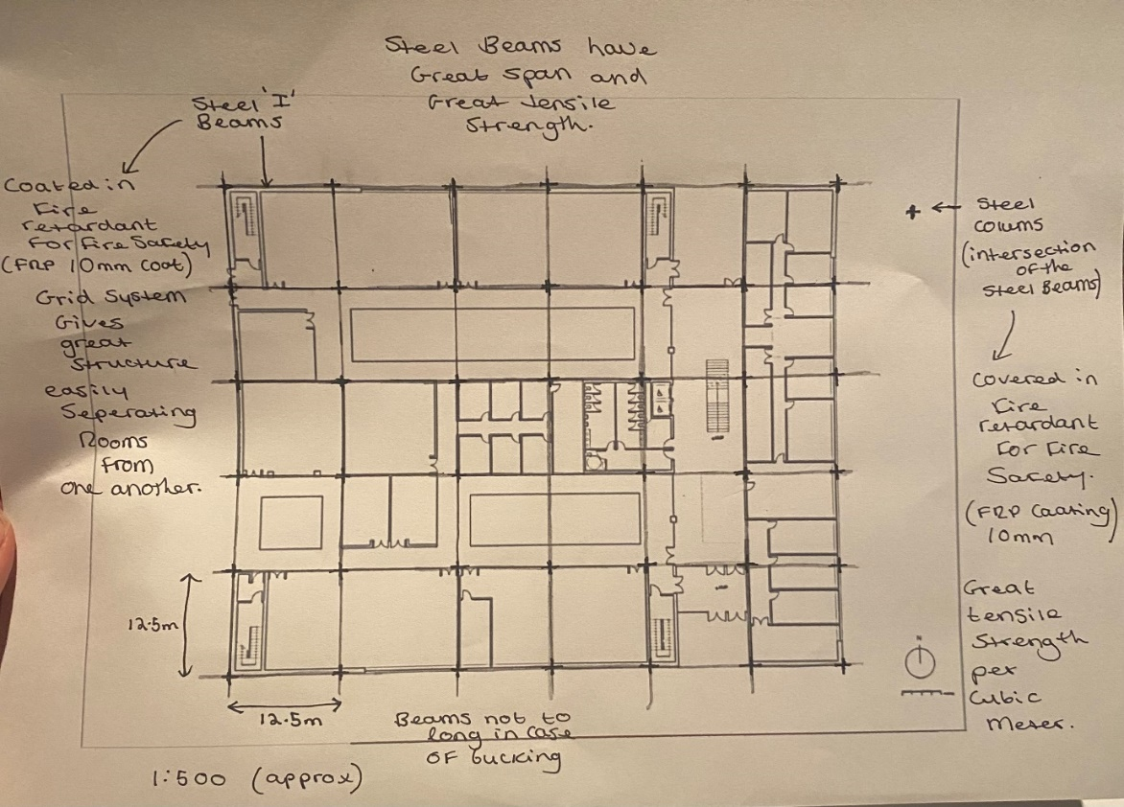
Appendix 2
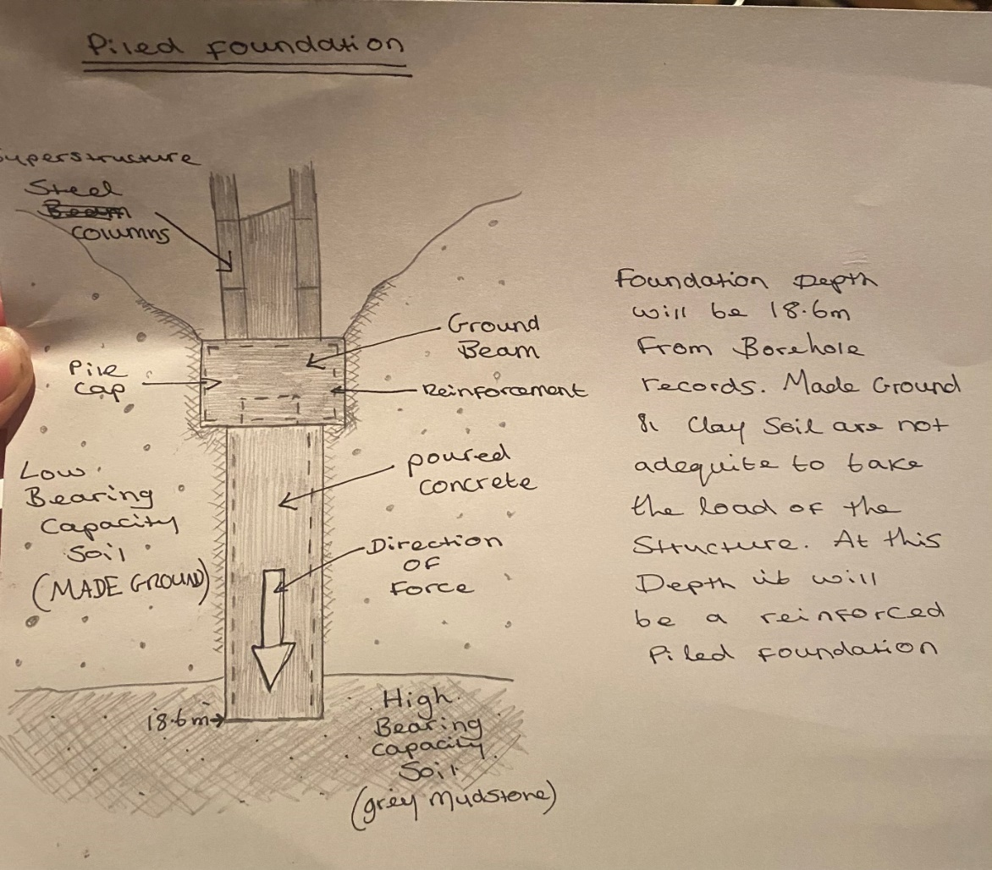
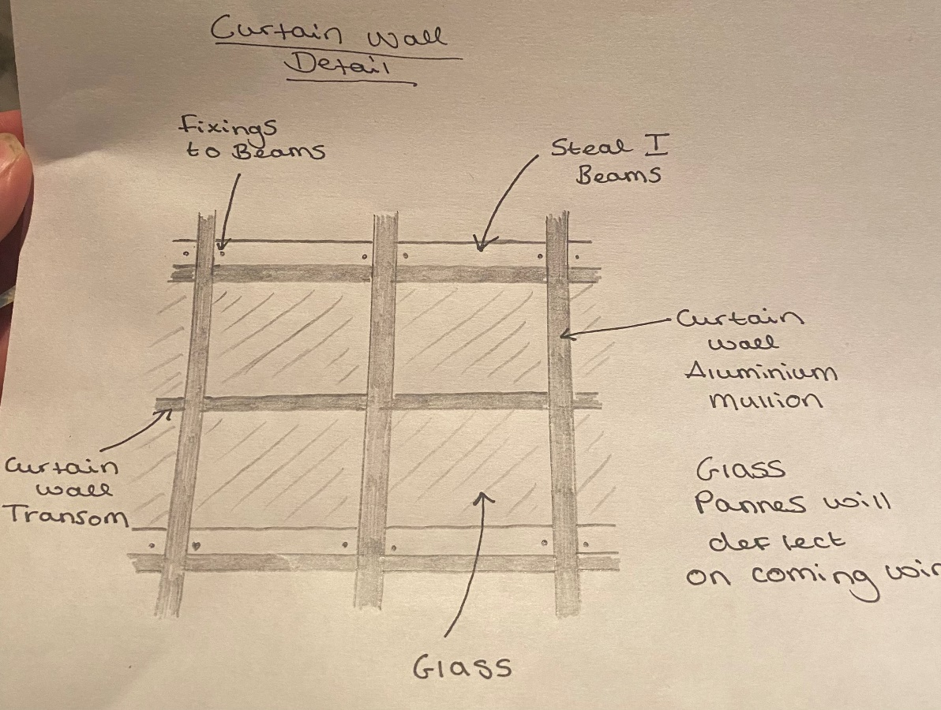
Appendix 3

Appendix 4


