
Skills for the Workplace
Module Assignment Submission
Student Name: | Renee kennedy
Student Number: | 2010989
Module No: | BMSK4007
Module Title: | Digital Skills and Personal Branding

Statement of Confirmation of Authenticity
By the act of making this submission, the student declares that this is the work of the student named above. The work has not, in whole or in part, been knowingly presented elsewhere for assessment, or where assessment has been built on a previous assessment, this has been identified. Where materials have been used from other sources it has been properly acknowledged. If this statement is untrue, the student acknowledges that an assessment offence has been committed.
Attention is drawn to the plagiarism and unfair practice policies of both the University and of ILM.
Permission for ILM to use this script
ILM uses learners’ submissions – on an anonymous basis – for assessment standardisation. By submitting, both the centre and the learner agree that ILM may use this script on condition that identifying information is removed. However, if you are unwilling to allow ILM use this script, please refuse by ticking the box: □

Table of Contents
What has been the impact of 21st Century Technologies on the modern workplace? 3
Evaluate the appropriate use of modern technologies and social media in the workplace generally 3
Explore the use of modern technologies and social media in own workplace 3
How can Personal branding help YOU? 4
Your LinkedIn Profile to promote your Personal Brand 4
Evaluate the value of other social media platforms to enhance networking and career prospects 4
Examine the impact of Personal Branding on your own employability 4
Discuss personal and professional security and safety online. 4
References 6
Appendix 1 7
Appendix 2 8

What has been the impact of 21st Century Technologies on the modern workplace?

Evaluate the appropriate use of modern technologies and social media in the workplace generally

According to A Prasad (2018) Technological advancements have entirely reshaped the organizations by making their business processes highly integrated, and more streamlined. Technological advancements have facilitated businesses in running their tasks smoothly and performing well than ever before.
Technology has changed the way people used to communicate in the modern workplace. The arrival of smartphones, social networking sites, chat apps has brought communication to a new level. Communication among the employees, or management to subordinates, or management to management has become fast, instantaneous, more deliberate, collaborative, and unified.
You can send emails, text or video chat or even video conference with subordinates or superiors through social networking apps like WhatsApp, Skype, etc. With the help of technology, you no longer need to be present at your workplace every time. You can engage in other important works outside the office, and keep in touch even face-to-face with your colleagues at the office through video chats and conference.
New technology has enabled remote working, teleconferencing and co-working space which has completely reshaped the modern workplace.
Ian Bailey (2019) states Let's say it's 2029, and your new smartphone has detected a pattern in the use of your Starbucks app.
Every time you have a meeting with your boss, you immediately stress-drink a Venti extra sweet, double shot caramel macchiato with whipped cream. The phone might just start pre ordering that drink for you (and paying for it with your credit card) after every meeting with your boss in your calendar.

In my opinion smartphones are having a positive impact making communication in the workplace so much easier and quicker for members of staff.

In my workplace meetings can be set up remotely from a smart phone and the meeting can also go ahead through smart phones which allows me to work and communicate away from my desk. This is a process I have experienced whilst working from home due to Covid-19 and it has helped me massively.
I travel with work so having maps available from my smartphone so its all in one place no need for a separate sat nav system makes travelling on the go so much easier for myself.
Online banking at the touch of a button with the ability of being able to do everything without calling a call centre and speaking to a person this is one that I use on a daily basis.
Matthew Boyle (2020) states that Research suggests 84% of UK adults (16+) own a smartphone in 2020. However, the breakdown across age categories reveals a more detailed insight.
Those aged 16-24 were most likely to have mobile Internet access, with 98% owning a smartphone. In comparison, just 53% of those aged 65+ have internet access via smartphone ownership, the lowest use out of any age group.
My conclusion from the Graph is that mobile internet access via smartphones is most popular in the younger generation between age 16 right up to age 44. Showing that age 45+ would rather use the internet via desktop or not at all
See Appendix 1
A negative of a smart phone for me is that people have become reliant on them in the personal and professional world. Having smart phones in the workplace could cause distraction as you can easily access your personal social media also whilst working so you may look like you are being efficient when actually you’re just keeping up to date on your personal life during working hours.
Also, me having a smart work phone makes me available at all times I can be contacted on holiday which is inconvenient.

People like myself now store a lot of personal information on their smart phones which could be open to fraud. Keeping your data all in one place could cause you to lose it all.
If you don’t save your contacts to your sim card and your phone breaks that means when you transfer your sim over to a new phone you have lost all that data.
Smartphones are not cheap and come at a cost which can be quite expensive I think the average smart phone would be around £150.00.

Jason Brain (2020) advises Using social media in the workplace has been correlated with improved competencies in engagement, communications, innovation & entrepreneurship, and employer branding.
If I am looking for a product within a company the first place, I go to is social media as its quick and easy to access the latest deals etc.
More than half of the world now uses social media states Dave C 2020 (see appendix 2)
I can see from Dave’s figures that the total Social media users across the world is 3.96 billion and the total amount accessing it through mobile phones is 3.91 billion leaving a small amount compared to these high figures of 50 million users accessing social media through other channels.
The 3 main social media platform used for business are Facebook Twitter and Instagram states Nathan Thompson 2020.
He stats that though Mark Zuckerberg has gotten a lot of bad press over the last couple of years, there’s no denying that he built the (overall) best social media platform for business currently available. In its third quarter of 2019 it was reported to have earned $17.652 billion and a total of $66.529 billion from 12 months prior.
Bob Wilson (2020) explains Cloud-based programs can be used at any time on almost any device with an internet connection, a benefit that leads to greater collaboration, particularly for businesses with remote employees.

Martyn Casserly (2020) states that Storing them online means you never have to worry about where you put a document: just sign into your account on any device and your files are there.
Most cloud storage works so that there's a local copy of all the files on your laptop, PC or Mac as well for convenience, but on phones and devices with limited storage, they're available on demand without taking up precious space.
Martyn’s conclusion is that Google drive is the best overall.
Positives of the cloud
-Having documents, photos and other files online makes it simple to share them with friends, family and colleagues. The storage space is huge.
-You can also access it anywhere from any device.
-There’s a backup option for extra security
Negatives of the cloud-
-It could get hacked and lose all the data.
-It could run slow if a lot of users are accessing it at the same time.
-You have to have internet connect to access it so if you were in a remote spot you would not have access.

I did a craap analysis on all my sources an example of one is in (Appendix 3)

Explore the use of modern technologies and social media in own workplace

Social media in my workplace is a quick and free way to promote products and services without the costs of advertisement like for example newspapers or on billboards.
It’s a quick way for marketing to get a message across to customers all over the world at the same time.
It is also used as a recruitment tool to advertise positions within the company.
Although it has a lot of benefits, I think there are also downsides.
Social media allows customers to comment complaints and negative opinions open to everyone to see and in my opinion, these can give a company a bad name.
It’s like anything before I purchase it, I will check the reviews and if they are all negative it will put me off buying that item.
A lot of the negative comments on my workplace website don’t have any comments to say the customers complaint has now been resolved and the customers is now happy with the resolution.
For me this is not good for marketing as everybody likes to see that when a problem arises that it is dealt with and resolved in a timely manner
See appendix 5 Examples in from British Gas Facebook and Twitter page.

The technologies we use in my workplace now compared to 10 years ago have massively changed more for the best.
We have introduced smart meters. Matthew B (2020) states the rollout of the programme began eight years ago in 2011 a scheme that pledged to provide a total of 53 million smart meters to over 26 million homes, smaller businesses and public sector premises. The government’s original target was to have them installed in all homes by 2019, a goal that was later postponed to 2020.
15.3 million operational smart meters have been installed as part of the scheme, according to data recorded in March 2019. This equates to an average of 564,474 meters installed per quarter across the UK.
Smart meters have had a positive on energy usage (See appendix 1)

I can see by looking at the results of the graph that 55% more people are turning lights off that are not in use alongside turning the heating down when not needed to save energy which is a positive. This shows that people are more aware of their energy usage.
A positive during this time of a pandemic is that smart meters are read remotely so customer’s meters can still be read without having to physically visit properties
The downside of the smart meter is that since the release the employment of meter readers have plummeted by 80%. The number of redundancies is going to keep rising as more and more smart meters get installed Says Colleague A

In 2020 we introduced a system called ‘Streem’ into British Gas Business which now allows us to see the customers setup instead of them having to send in a photo of it or us to take the time to send out an engineer to do a site visit prior to the works going ahead.

This is a huge benefit for us as a company we are getting jobs completed quicker and the result of the work carried out more accurate.
Like any new technology this was very awkward for ourselves and the customers to use and get used to.
I asked 5 employees and 5 customers what they thought of this new technology and documented their responses (see appendix 6).

The results show me that my colleagues enjoy this a slightly more than the customers as it’s our job and it makes the process easier. Some customers are not technical so this takes them out of their comfort zone and prefer what they are used to. Overall, this technology is a positive.

The negative side of this is the customer not being able to use this tool along with instruction from ourselves as our customer can be of the older generation that only use phones to call and text.
Some customers don’t want you to film the inside of their properties.

How can Personal branding help YOU?

Your LinkedIn Profile to promote your Personal Brand

I have set up a LinkedIn profile to widen my job opportunities especially within the pandemic we are currently facing.
It will benefit me by allowing companies to head hunt me and contact me with job opportunities.
Giving me great career opportunities.
A negative it could bring is that my profile doesn’t give off a first good impression so recruiters will be put off straight away.
I may not stand out from a crowd even though I think my profile will in a good way.
Another negative is I find it really open so anyone can search you on there its not like other social media where you can be private and only accept requests that you want to.
LinkedIn is not going to in my opinion benefit you unless your profile is open for all to see.

https://www.linkedin.com/in/renee-kennedy-682509203/
Please find front page of LinkedIn profile in Appendix 4

Evaluate the value of other social media platforms to enhance networking and career prospects

Facebook is a good platform to enhance career prospects. James Everett (2020) suggests Facebook is the largest social media platform in the world. It was founded in 2004 and has 2.603 billion active users.
Standout features for fakebook-
- Audience Insights gives small businesses the power to leverage Facebook’s massive pool of aggregated data to help them reach their ideal audience.
- Facebook 360 allows businesses to upload panoramic style photos from a smartphone, creating immersive, interactive experiences for their followers.

Facebook’s massive reach and powerful social media marketing capabilities make it a no-brainer for most businesses.

The negative for using Facebook to promote your business is you cannot control what is being said about you and once a mistake has been made public its hard to erase that image.

In my opinion the good thing about Facebook is everyone knows about it its probably the first social media platform to start the trend so it is well established. Its easy to spread the word with your followers tagging their followers in your post.

Christina Newberry (2021) suggests LinkedIn statistics look a little different than they do for some of the other social networks. It’s not the biggest social network, or the one with the largest reach. Some of the numbers are smaller. At first glance, they may not seem as impressive for marketers looking to make a big impression.
The network officially launched on May 5, 2003: nine months before Facebook launched at Harvard. LinkedIn is the oldest of the major social networks still in use today.

LinkedIn has 722 million members. It’s not the largest of the social networks, but with a specific business focus, it’s an audience worth noticing.

My conclusion is LinkedIn is good to have if you are looking for employment. I think out of the 3 social media platforms (Facebook Twitter and LinkedIn) it’s the best for employment.
If you do not set your profile correctly this could have a negative impact. For example, if you are looking for a job in catering but you put your current job role as a van driver in the header then when people narrow their search down looking for a van driver you will come up and be contacted for a job position you are not looking for.

Ting Lin (2020) suggests of the social media platforms, Twitter marketing can be particularly complex, given its short life span and challenging character limit.

Twitter boasts 330 million active users making it the smallest out of the 3 I have researched.

My conclusion is a negative that comes with twitter as well as other social media is that fake accounts can be set up posing as yourself but Twitter has acted in response, with its cleansing of up to 70 million fake accounts last year as suggested by Ting Lin (2020).

Examine the impact of Personal Branding on your own employability

I think personal branding is the most important first impression people get of you.
It separates you from any competition you have regarding employment and its free.
The first impression is hard to shift if it’s not a good one.
For example, if your social media profiles are of you partying getting drunk all the time and posting things that contain anything for example racist or homophobic then you are not off to a good start when it comes to personal branding and career development.
Social media is a go to when trying to find out something about someone whether that be in general or for career purposes.
My conclusion on personal branding is if you invest in it you could be well on your way to a successful career.
I

Discuss personal and professional security and safety online.

Online payments come with a big security risk. When you make payments online how do you know you are making the payments to the people who they say they are? Where are your card details going when you type then into the screen? Do your card details get deleted by the receiver or stored for future non authorised use? These are questions I ask myself every time I make an online payment.

Qing Yang (2015) states that the uncertainties of transaction handling and consumer perception toward risk have been identified as some of the major problems causing consumers’ hesitance toward taking advantage of online payments. With the ever-growing implementation of trusting mechanisms for online payments, consumer confidence has greatly increased. This research explores the elements of perceived risk and trust – the two most vital factors influencing consumer behaviour of online payment.
Types of perceived risks are (1) system dependent uncertainty risk caused by functional defects, deposit costs or security problems in online payments and (2) transaction specific uncertainty risk caused by the conduct of different parties who are involved in the online transaction.
Basically, system dependent uncertainty risk is characterized as an exogenous variable because it is related to environmental uncertainty of the transaction and its unpredictable nature associated with unpredictable online payment technology, such as potential technological sources of errors, current limited functions, necessary time input and security gaps, which are all beyond the control of online payments servers or consumers. However, transaction specific uncertainty is regarded as an endogenous variable, namely market uncertainty resulting from decisions of different parties caused by asymmetric information and an opportunistic manner among them by taking advantage of a distant and impersonal internet environment.
Generally speaking, in the early stage of online payments, consumers may not trust this new way of payment without the protection of regulation and modern technology, such as online identification and public key encryption. As a result, initial institution-based trusting belief mechanisms are needed to facilitate service success, such as the third-party payment platform or Certificate Authority (CA). Consumers trust the servers if they visit an unknown e-server at first, and then they take risk in the transaction.

I have had my credit card used for an unauthorised payment previously in which the fraud team at the bank noticed the payment and contacted me straight away to confirm if I had made that payment which they had already blocked.
The positive of this is that they made me feel comfortable that their fraud security is at a high level. The negative of this is if it was myself that had made that transaction, they had already declined based on their definition of suspicious behaviour which would of caused me a delay in receiving my item.

I asked my boss how my personal data was stored and she confirmed that it is stored in a secure file on the computer that no one apart from HR have access to.
She advised that I can request copy of the personal data they hold for me and it will take up to 30 days for this to be produced to me.
She confirmed that some data can be kept by my employer without my permission for example my name, address, age, national insurance number and any disciplinary action.
The information they do need my permission to keep would be for example health and medical conditions, race or religion.
She has confirmed that as my boss she can request this information also but she would be questioned in more depth as to why she required the information on me that has to have my permission to be kept.
My company is audited by the FCA (Financial Conduct Authority). When it comes to GDPR we request to be audited unless there has been a significant number of complaints against the company then the FCA will request to audit you. They can also carry out random checks on companies to make sure that they meet the standards.
A good thing about an audit is that the company is then aware that they are flowing all processes correctly and are up to date with the regulations. But it can also raise awareness that the processes are not being followed as Dr Paul Voigt (2020) explains-
- On the one hand, the audit evaluates the internal implementation of the GDPR requirements and documents it accordingly. In the best case, this documentation can serve as proof of GDPR compliance to the supervisory authority. Even if the audit does not provide complete proof of compliance, the audit documents the corresponding efforts and will generally need to be considered in favour of the company when calculating a fine.
- On the other hand, an audit can uncover internal errors and deficiencies of the GDPR implementation and thereby show companies their need to adapt to ensure full compliance. Even two years after the GDPR came into force, many companies have still not succeeded in fully implementing it, as is evidenced by high fines in the EU.

References

Prasad, A. (2018) 10 Ways Technology Has Reshaped the Modern Workplace.
Available at : https://www.quickfms.com/blog/how-technology-has-reshaped-the-workplace
[Accessed: 19th January 2021].

Bailey, Ian. (2019) ‘How smart will phones get?:’ Smartphones of the Future may be Capable Not Only of Storing and Presenting Information, Ian Bailey writes, but Using It Intuitively To Make Decisions On Behalf of Its Owner
P.6.

Matthew, B. (2020) Smart Meter Statistics. Available at: https://www.finder.com/uk/smart-meter [Accessed 22nd January 2021]

Dave, C. (2020) Global social media research summary August 2020.
Available at: https://www.smartinsights.com/social-media-marketing/social-media-strategy/new-global-social-media-research/
[Accessed: 24th January 2021].

Matthew, B. (2020) Mobile internet Statistics. Available at: https://www.finder.com/uk/mobile-internet--statistics [Accessed: 27th January 2021]

Jason, B. (2020) Social Media in The Workplace: What Every Executive Should Know. Available at: https://everyonesocial.com/blog/social-media-in-the-workplace/ [Accessed 27th January 2021]

Wilson, B. (2020) Lecture 1: Digital skills and personal Branding, [TSD Carmarthen Lectures 2014: Cert HE Programme]. 8th Dec

Martyn, C. (2020) Best Cloud Storage 2020. Available at: https://www.techadvisor.co.uk/test-centre/internet/best-cloud-storage-3614269/ [Accessed 27th January 2021]

Nathan, T. (2020) The Best Social Media Platforms for Business: Your Ultimate Guide. Available at: https://optinmonster.com/best-social-media-platforms-for-business/ [Accessed 29th January 2021]

Qing, Y. (2015) ‘Exploring consumer perceived risk and trust for online payments’
: An empirical study in China’s younger generation’ Computers in Human Behaviour Volume 50 (September 2015, Pages 9-24)

Dr Paul, V. (2020) Compliant or non-compliant? GDPR audits as a self-control tool. Available at: https://www.taylorwessing.com/en/insights-and-events/insights/2020/08/compliant-or-non-compliant---gdpr-audits-as-a-self-control-tool [Accessed 30th January 2021]

James, E. (2020) 15 Top Social Media Sites & Platforms (A Handy 2021 Guide). Available at: https://smartblogger.com/social-media-sites/ [Accessed 30th January 2021]

BIBLIOGRAPHY

Ben, S. (2021) How Does Cloud Storage Work? A 2021 Guide for the Uninitiated. Available at: https://www.cloudwards.net/how-cloud-storage-works/ [Accessed 27th January 2021]

Minneapolis, M. (2018) ‘2018 TOP WORKPLACES: CAREER GUIDE; Social media and the job search; Popular platforms, including LinkedIn, can help you develop your career.’(6)

Pam, L. (2019) WhatsApp in the workplace. Available at: https://www.hrmagazine.co.uk/article-details/whatsapp-in-the-workplace [Accessed 26th January 2021]

Appendix 1

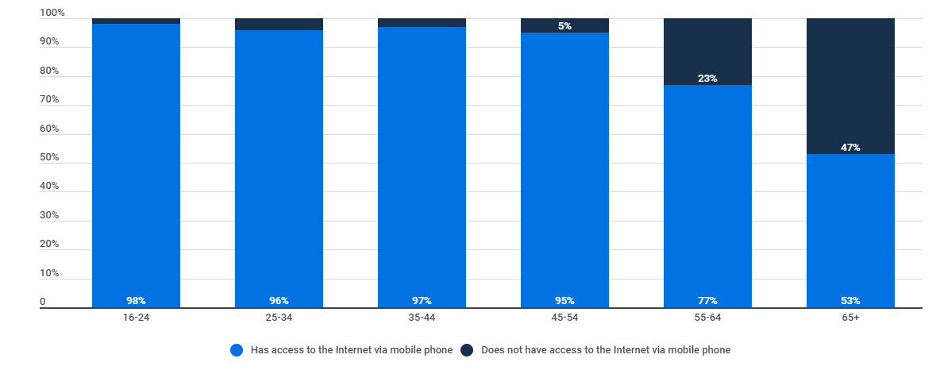

Appendix 2
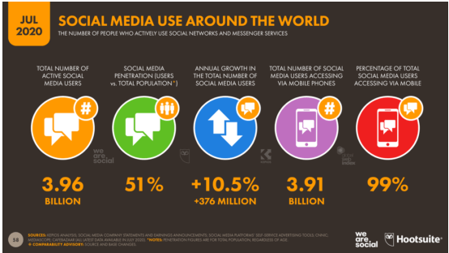

Appendix 3
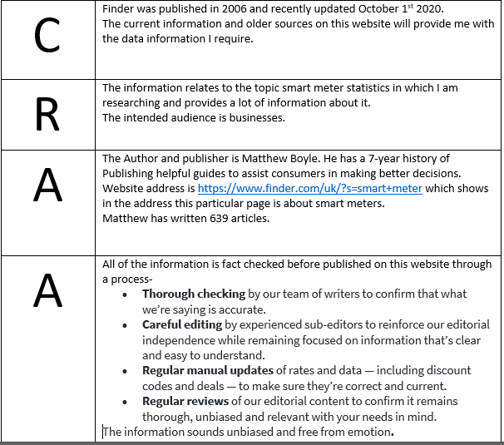

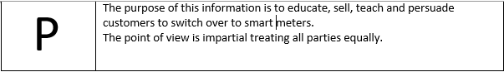

Appendix 4
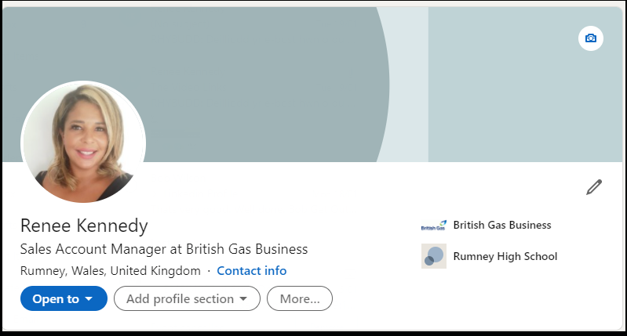

Appendix 5
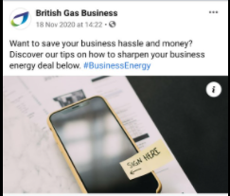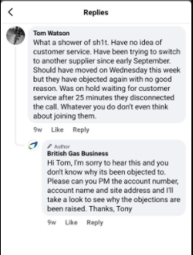

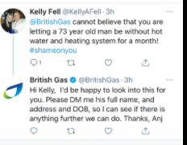

Appendix 6
Employee 1 | “Absolutely love it, it makes my job so much easier “
Employee 2 | “whoever designed this tool is genius “
Employee 3 | “This has made my job quicker and easier by far”
Employee 4 | “ So much easier to explain to a customer what they require at site at the click of a button”
Employee 5 | “This should have been brought in 10 years ago we now realise how much work we made for ourselves by not having this tool”

Customer 1 | “Too technical for me I just about know how to use my phone to send a text”
Customer 2 | “As a repeat customer of British Gas Business this is going to make my life a lot easier”
Customer 3 | “This is great as I am not technical when it comes to electricity at all so I can leave it to the experts to see without attending my property”
Customer 4 | “ This process was quick and easy I am very impressed with it “
Customer 5 | “I will defiantly be back to use this process “

