Elliott Chapman
Major Written Project – Dissertation
Student Number: P146287
Module: M6X01791
Course: Fine Art BA (Hons)
Submission Date: 13.12.17
Lecturer: Gwen Beynon
Word Count: 6845

Introduction
The basis of this paper is to critically analyse the zeitgeist of Abstract Expressionism and the socio-cultural factors that influenced the development of this artistic movement. This will include how WWI and WWII, Modernism including Technical Development, affected the Movement through the investigation of the artists: Mark Rothko and Jackson Pollack and works that are representational of their style and associated Abstract Expressionism artistic theory. Primary research will include viewing Mark Rothko’s works displayed the Tate Modern, reflection of Jackson Pollock’s artwork at the Seattle Art Museum (historical) and watching a recording of an interview with Pollock. Secondary research will include viewing Dr James Fox, Art Historian, ‘Bright Lights, Brilliant Minds; A Tale of Three Cities’ (BBC, 2014) featuring ‘New York School’, biographies and reference books. Within the paper the artist’s lives are discussed in chronological order and embed a review of a selection of their crucial works.

Abstract Expressionism
The Tate Modern (Tate, 2017) describes Abstract Expressionism as a term which is applied to new forms of abstract art, this is a vague description, Ducksters (2017) goes part way to categorise this style of art in describing it as ‘having no recognizable subject’. Conversely, according to (MoMA, 2017) it is mostly characterised by lines, shapes and colours from the use of gestural brush strokes and mark making. The term ‘New York School’ came into use in the 1940s to describe the radical art scene that emerged in New York after the Second World War. The School gave birth to the profound new style of painting known as Abstract Expressionism (Breslin, 1993).

The zeitgeist of Abstract Expressionism is in the capturing of the “spirit of the time” (Funk and Wagnalls 1952). According to Funk and Wagnalls (1925) “The spirit of the time; the intellectual and moral tendencies that characterize any age or epoch”, from the German word Zeit meaning “time,” and Geist, meaning “spirit” or “ghost”. To identify the zeitgeist of this art period it is necessary to carry out a critical analysis which involves evaluating eminent artists, their work and the arguments, evidence of writers to provide a considered opinion based on various conclusions. It is important to recognize the social and cultural factors which were prevalent during this epoch, as these are influences that, fundamentally, shape, change and develop the lives of individuals and create structural changes to society; cultural factors are sets of values, customs and attitudes which have been established over many years and are often historic. Social factors do not directly affect culture however, they do, inadvertently, have an impact and will form part of the critical analysis.

Jackson Pollock
Paul Jackson Pollock (January 28, 1912 – August 11, 1956) was an American painter who played a major role in the Abstract Expressionist Movement. Born to LeRoy Pollock and Stella May McClure – a traumatic and difficult delivery in Cody Wyoming, Pollock was the youngest of five children. Intensely self-conscious, the young Jackson Pollock was described by his friends and family as childish, troubled, insecure, restive and driven, traits he never outgrew (Landau, 1989, P.12). LeRoy came from a farming background and Stella enjoyed weaving, crocheting, and quilting - she often made shirts for the whole family. Although LeRoy constantly worked, he found it hard economically to support his wife and sons. What are the outside versions of success and failure? Do these intrude on an artist’s work? Did this have effect on Pollock? Friedman, (1972, P.3-15) provides an intimate insight of the social and cultural environment of Pollock’s childhood. Pollock came from a stern background; in family photographs Stella’s kind qualities often seem supressed, giving stern impressions whereas LeRoy looks pleasantly relaxed. Stella’s aggression and outward demeanour in union with LeRoy’s tenderness and inwardness would exist in Pollock throughout his life. The family constantly moved during Pollock’s childhood and by the age of ten, Pollock had lived in six homes in three states.

As noted by Friedman (1972) at the age of fifteen Pollock and his brother Sandy were employed to carry out surveys (LeRoy’s current field of employment). This involved travelling to remote areas where they would sleep in log cabins, eat large breakfasts and drink in the evenings with the other workers. It is at this time Pollock was introduced to alcohol and his personality began to change; to compensate for his youth Pollock would behave more aggressively, although alcohol seemed to diffuse this aggression, rendering him calm and more at ease with society. At the time, Prohibition (1920 – 1933) was in force, this was a nationwide constitutional ban on the production, importation, transportation, and sale of alcoholic beverage. The alcohol Pollock drunk was in all probability ‘bootleg’ – homemade (History, 2017). It is well documented that Pollock had difficulties with alcoholism throughout his life and this would ultimately be the cause of his death, he died in August 1956 in a car crash driving whilst intoxicated. He would later undergo psychiatric therapy to try and cure this addiction which resulted in brief periods of abstinence and occasions of sobriety, these times were ultimately productive periods of his life. Pollock became drunk on moderately small amounts of wine and beer, often passing out. This induced both physiological and psychological problems for him. Emmerling (2003, P.17-34) remarks that on one such occasion during 1937 due to his alcoholism Pollock was admitted for a period of four months to a psychiatric hospital under the care of Joseph L. Henderson. Psychiatrist. Pollock began to bring sketches to give to Henderson as means of communicating because he had trouble vocalising his personal life. This would help Pollock convey his thoughts and feelings, these sketches would become his famous ‘Psychoanalytic Drawings’, although the works were done independently to their sessions. Jose Clemente Orozco (1883-1949) a Mexican painter whose works include ‘Gods of the Modern World’ (1932-1934) where several skeletons in academic gowns are performing what appears to be a ritual, was a dominating influence on Pollock. This hospitalisation was the first of many admissions and therapies throughout his life.

Later that same year Pollock attended Riverside High School and after academic and emotional struggle, he dropped out. It was at this time the Pollock family moved to Los Angeles where Pollock enrolled at the Manual Arts High School where his main engagement in studies consisted of art. There he would meet Frederick John de St. Vrain Schwankovsky, Head of the Art Department, who would introduce Pollock to Abstract Art and Buddhism. Schwankovsky teachings of complete openness to all kinds of religious, aesthetical and political experiences seemed to satisfy a need in Pollock. The field of Architecture interested Pollock, however, art was his main pursuit; in 1929 Pollock indicated in a letter to his brothers Charles and Frank, that he wanted to become “an Artist of some kind”. His family had no way of knowing Pollock would become the most famous painter of his generation.

Landau (1989, P.24) discusses the challenges and psychological issues faced by Pollock on his relocation to New York in 1930 when he joined the Art Students League, the largest Art School in the United States, studying with Thomas Hart Benton, one of the most acclaimed and provocative artist of the Depression Decade. This relocation was the result of Pollock’s brothers’ encouragement to join them there, as they were in pursuit of a career in art and had moved to New York to expand their training. New York at that time was becoming a hub for new artists and progressive artistic styles. It seems that the first psychological issue was that of identity, when he began using his middle name as he preferred to go with the manly Jackson rather than the saintly Paul. This decision echoes the sentiments of his fellow class students who were astonished that he alternated between a sweet shy person and an aggressive quarrelsome one. It is here Pollock found that he enjoyed drawing and that it led to a temporary outlet that drinking only dulled. Very few of his works of this period survived, making it difficult to identify what emotions he experienced at that time. Friedman (1972) infers that the 1930’s were the most difficult period for Pollock, affected by both the dire economic condition of the country and demise of the art market. Life’s difficulties may have fallen more readily on the sketchpad and may have made things calmer for Pollock. Drawing would also become his greatest salvation and worst fear, existing together on paper, according to Landau (1989, P.24) reflecting his personality trait of confusion and single mindedness. During this period Pollock was forced to take somewhat demeaning jobs; janitorial, stone cutter and at the Works Project Administration (a government initiative to provide and generate employment opportunities) where he was required to produce paintings for allocation to public buildings, a position he held until 1943. This enabled Pollock to finance his painting but little else. Again, not many of these paintings can be found.

Pollock began to embrace moments of his life within his art, representational of this is ‘Male and Female’ (1942) where Pollock’s mother and father have been emphasised, he also started to fight tradition and the styles or principals he had been taught. Friedman (1972, P.150-169) identifies the correlation between Pollock initially giving his work conventional titles; later numbering them and the evolvement of his unique art style. This was, in Pollock’s own opinion, because it made people look at the painting for what it was ‘pure painting’ and as his work seemed not to have a beginning nor end, would avoid adding confusion to the viewer. Examples of these would be; ‘Naked Man with Knife’ (1938 – 1940) and then the later ‘Number 23’ (1948) which was a characteristic Drip Painting.
In 1950, Pollock, along with seventeen other ‘irascible’ painters refused to partake in a National Competitive Exhibition because the award juries were notoriously hostile toward advanced art. The National Exhibition included an entry of 6,248 paintings, 761 to be accepted and 307 to be exhibited. Most of these paintings were however Cubistic and none would represent post-World War II developments in art. Indeed, the first two prizes were Cubist paintings and the first prize was $3,500 and the fourth $1,000. This attitude was reflected overseas. Pollock’s Artwork (Number 1, 1948) was exhibited in Venice’s Biennale. Italian Art Critic, Bruno Alfieri, annoyed Pollock as very little time was spent looking at work from Gorky, de Kooning and especially Pollock - The American Artists were given the silent treatment. During this period Pollock painted thirty-two (32) pieces of art, four (4) of which are recognised as his greatest - including size. American Art dealers were slowly recognising that the works of Expressionist painters; such as Pollock, Still, Rothko and Newman were best exhibited in large spaces due the enormous scale of their artworks.

Conversely in the early 1950’s Pollock barely survived financially, although artistically successful, it did not provide any substantial income. He began to drink again out of despair, which was catastrophic (Abstract Expressionism, 2016). He had done so much and so little had come out of it. In 1952 Pollock sold three paintings in his exhibition in Paris at Studio Paul Facchetti; Number 19, (1951) Number 17, (1949) and Number 8, (1951). However, considering discounts, reimbursements for crafting, shipping, and catalogue publication Pollock would have only earned about $1,300 that year. Betty Parsons, Pollock’s art dealer, struggled to sell his paintings and he argued she needed to be more aggressive. Pollock would hear the propositions of other more tougher art dealers who spoke of art as merchandise and no doubt contemplated substituting Ms. Parsons. Pollock had no other audiences other than other artists. It is only later in 1954, European art dealers would begin to show more interest in seeing and buying American paintings such as that of Pollock (Emmerling, 2003).
Having studied Pollock’s early life, his developmental journey, one gains an appreciation of the impact that certain events, situations and encounters had upon his art. In 1923 the family moved back to Arizona and it is here Pollock explored the Indian ruins and visited the Reservations where ceremonial dances and sand paintings took place. According to the Encyclopaedia Britannica (2017); Sand painting, also known as ‘dry painting’ is an art where stylized, symbolic pictures are formed from crushed, coloured sandstone, charcoal, pollen, or other dry materials of various colours such as white, red, black, yellow and blue placed on a background of smooth sand. Navajo people explain that these figures in sand paintings depict objects like sacred mountains where the gods live, legendary visions, or they illustrate dances or chants performed in rituals. It is evident when you consider his works; Mural (1943-1944), The Moon-Woman (1942), Birth (1938-1941), Male and Female (1942), Guardians of the Secret (1943) and those of Navajo artworks that certain traits have been channelled into some of Pollock’s bold abstract paintings.

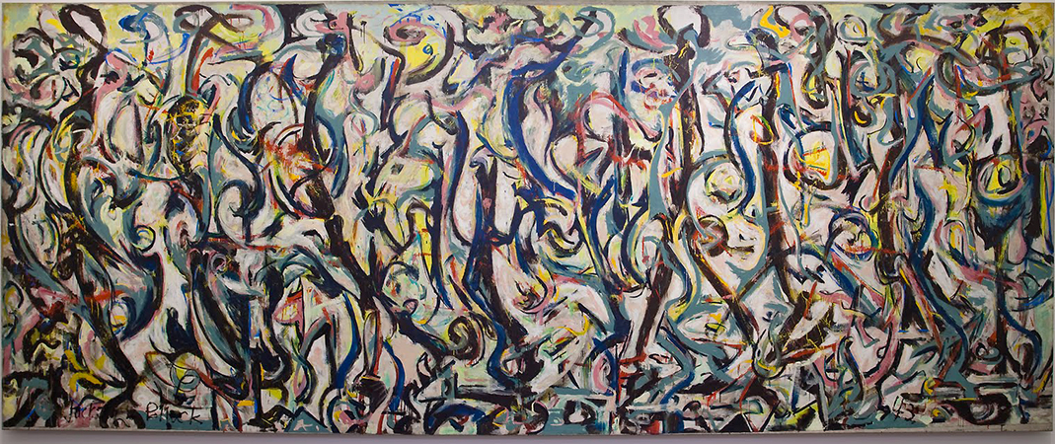
Mural (1943-1944) by Jackson Pollock
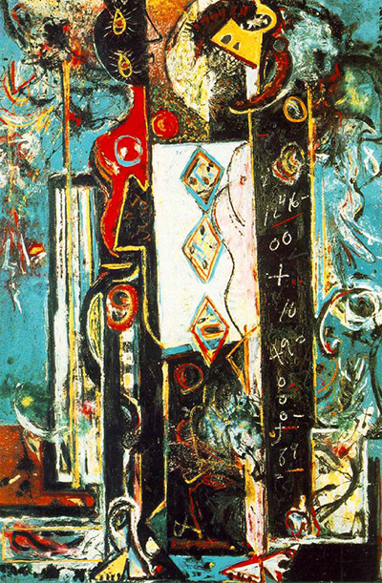
Male and Female (1942) by Jackson Pollock

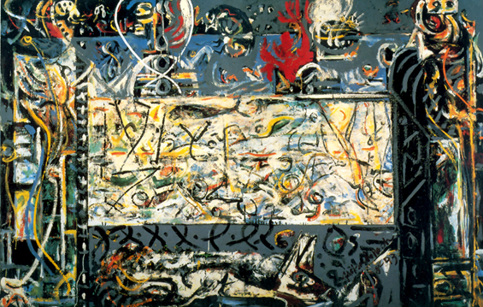
Guardians of the Secret (1943) by Jackson Pollock


Navajo Sand Painting (2017)
https://room226.weebly.com/navajo-sandpainting-gallery.html

Under the tutelage of Benton and Regionalism; The Moon Woman (1942) demonstrates a digression from this style and the exploration into Abstract Expressionism. Instrumental of this was Pollock’s exposure to Joan Miro (1893 – 1983), surrealist artist, retrospective and works of Picasso (1881 – 1973), cubist artist, who Pollock held in reverence and was obsessed with. Within this artwork cubism became far less structured and more fluid. Pollock and Lee Krasner became a couple after collaborating on the exhibition ‘American and French Painting’, they married in 1945. Furthermore, Krasner confirmed the tremendous effect that the moon had on Pollock perhaps reflects the bipolar elements of his nature and is substantiated by friends of his preoccupation with the moon. The ‘The Moon Woman’ depicts imagery based on totemic or mythic figures, ideographic signs and ritualistic events which have been construed as relating buried experiences and cultural memories of the psyche (Guggenheim, 2017). The image confronts the viewer, the star contrast between the fiery sensuality of the background and the calmness of the female form reflects the fight between the public ego and the private id seen within the painting (Jackson Pollock Biographies, 2011).

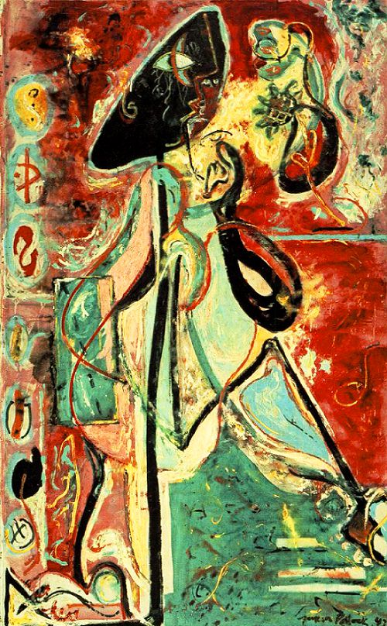
The Moon Woman (1942) by Jackson Pollock

The ‘The Moon Woman’ is not an archetypal Pollock ‘Jack the Dripper Painting’, in fact within this artwork Pollock uses a similar palette to that of Picasso. His brush strokes convey the curved lines of her body which emanate from the bold black line of her backbone that prevails a sense of power and purposefulness, equally, that of isolation and other worldliness - reinforced as the face is illustrated in profile and frontal view, suggesting a public and private persona. It should be noted that during this period Pollock had undergone Jungian analysis with Dr Joseph L Henderson and many art historians link this work to this psychological theory.

Differing from the imagery of ‘The Moon Woman (1942)’, another climatic event in Pollock’s life was the short film made by, German Photographer Hans Namuth, of him working in real time on glass. Namuth believed to know Pollock and his works and thought it best to capture his creativity in motion to realise the event itself as art in addition to the artwork created. Pollock was often reluctant for anyone to watch him or be present when he was working and never communicated much verbally, again an area that Pollock found increasingly difficult to do. Filming Pollock would no doubt have been intrusive. However, Namuth believed Pollock was at ease and felt no tension in connection to the film. Namuth, having watched Pollock create artworks described it to be “great drama”. Pollock created and developed his own unique style of painting where he would splash and dribble paint onto canvas straight from the container, very rarely would he use brushstrokes within his work and is often on un-stretched canvas placed on the floor as this enabled him to easily manoeuvre about the artwork. Pollock’s technique involved very thin paint enabling, using his unique methods, a controllable medium to apply to canvas. His unique style of painting was said to have derived from when he was a student of Siqueiros (1896-1974). He was introduced to enamel paint for the first time and encouraged to use unorthodox techniques such as pouring and flinging paint to achieve spontaneous effects.

Siqueiros’s primary influence was to be technical rather than stylistic. Siqueiros wanted to revitalize North American art as a tool for political change and to form a new artistic language to the working class by experimenting with current, primary industrial materials and technology. Landau (1989, P.66) observes that Pollock used paint pouring as one of several techniques in canvas painting, producing works in the early 1940s, such as "Male and Female" and "Composition with Pouring I.” Pollock’s most famous paintings were those from the ‘drip period’ between 1947 and 1950. Harrison (2015) recounts that Pollock modestly put the painstakingly accomplished method down to ‘… a natural growth out of a need’, explaining that: ‘I want to express my feelings rather than illustrate them. Technique is just a means of arriving at a statement.’

Namuth would learn that the impact of Pollock’s personality had a great deal to do with the relationship to his art. No artist of Pollock’s generation had yet become part of a major film. Number 29, painting on glass itself was reversible and would no doubt generate ideas for the future. Yet, Number 29 (Film Documentation on Glass) would be the final reduction of Pollock to subject matter - to become a thing, a commodity, an entertainment. Engaged in his work Pollock would channel and exert intense energy through his body and face which would no doubt have affected his career; was he a performance artist aswell as a painter? His widow, Krasner, said “Whatever Jackson felt, he felt more intensely than anyone I’ve known; when he was angry. He was angrier; when he was happy, he was happier; when he was quiet, he was quieter…” Pollock’s publicity may well have intensified after filming and Pollock would struggle under the constant attention he was to receive. In 1951, Robert Goodnough (1917 – 2010), abstract painter describes (from photographs from Hans Namuth) Pollock’s process as a ‘ritual dance’ and ‘gradual rhythms’ of movement around the canvas.

The Art Critic, Harold Rosenberg validates this theory in his essay “The American Action Painter” December 1952 concerning Action Painting; “That what was to go on the canvas was not a picture but an event. The painter no longer approaches his easel with an image in mind. The image would be the result of his encounter. Action Painting breaks down the distinction between art and life; It’s not a picture of a thing, it’s the thing itself. It doesn’t reproduce nature, it is nature. Language has not accustomed itself to a situation in which the act itself is the ‘object’. An artist may be old however the painter young.” (B. H. Friedman, 1972) He stated that the ‘figure 4’ establishes tension on a canvas and that Pollock evidently used it in; Stenographic Figure, Male and Female and Wounded Animal.

According to Anfam (1990), The Drip Period 1947-1950 is recognised as the time when Pollock produced his most famous paintings. Late in 1946 Pollock began to pour, drip and dribble oil, enamel and aluminium paint onto sized but un-primed canvas stretched on the studio floor. He used numerous utensils to apply the medium and when pouring directly from the tin of paint he used his arms and entire body to create large and energetic abstract works. Pollock used domestic and industrial paints to create his paintings as this was in part because he could not afford traditional mediums. Lee Krasner (1908 – 1984) described his palette as "typically a can or two of … enamel, thinned to the point he wanted it, standing on the floor besides the rolled-out canvas" His gestural lines create a unified overall pattern that allows the eye to travel from one of the canvases to the other and back again. Sources for the drip technique include the Navajo sand paintings. Pollock often spent weeks of painting and then weeks of contemplation before finishing a canvas. At the peak of fame, Pollock abruptly abandoned the drip style and after 1951 Pollock’s paintings became dull in colour, such works would include ‘Black on White painting III’ (1951) and they would be referred to as his 'Black pouring'. The departure from his earlier style was not what his collectors wanted and were difficult to sell. However, these works show Pollock attempting to find a balance between abstraction and depictions of the figure.

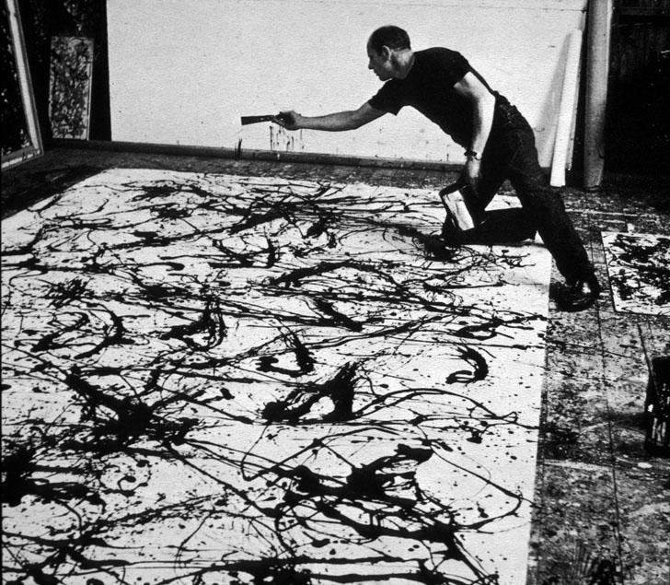
Jackson Pollock (1912 – 1956) Action Painting

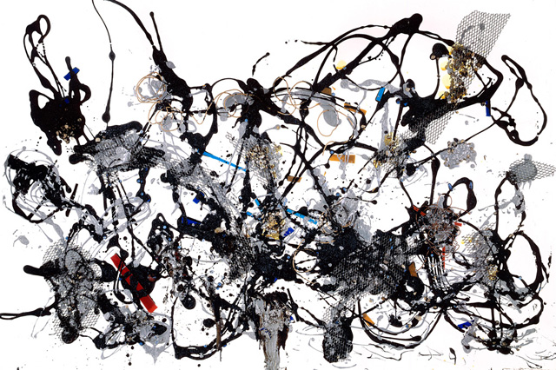
Number 29 (1950) by Jackson Pollock

Anfam (1990) supports the principle that ‘Birth’ is an actualisation of the trauma Pollock experienced during his perilous birth, when he was nearly strangled by the umbilical cord and exposes his later insecurities. He advocates that Pollock stares from a Lilliputian self-portrait looking almost childlike, already meditating from the present standpoint on his troubled past. Should there be any doubt about his mindset? The Tate Modern (2017) interprets ‘Birth’ as being full of primeval energy and portrays birthing as a desperate struggle that Landau (1989), concurs with. Each describing the painting of mask like faces (not unlike Inuit Native American Art) in oil on canvas encompassing a pallet of strong colours which include; reds, blues, blacks and white. Although one can see two parts of the human body within the works, specifically a stretched arm and a leg bent at the knee, the figures are not necessarily defined. Furthermore, Landau (1989), infers that Pollock communicates frenzied emotions through the application of brush, energetic strokes and mark-making. The Tate (2017) argues that Pollock was fascinated by primitive art because of its ability to express human fears and desires as conveyed through the channelled sexuality in the position of the lower part of a figure, the ejaculating penis under the mask aswell as several tubular appendages attached to the bent leg that can be perceived as both exterior and interior anatomical forms – male or female.

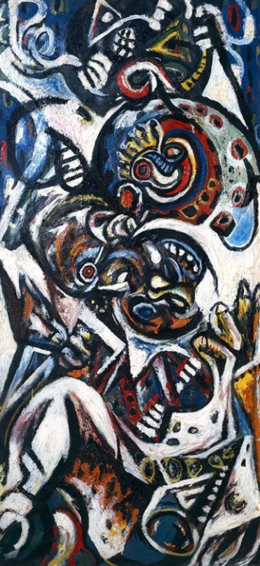
Birth (1941) by Jackson Pollock
Mark Rothko
Phaydon (1996) concludes that a form of abstract expressionist painting which focuses on colour rather than gesture as the focus of expression is that of ‘colour field painting’ and Mark Rothko is primarily recognised as the foremost exponent of this style of art. A key member of the New York School, unlike Pollock - an American, Marcus Rothkowitz was born in Dvinsk, Latvia to a Jewish, Russian as oppose to Yiddish speaking family.

He was a fragile, sensitive and sickly child and according to his brother he became a hypochondriac adult. His family environment was one in which education, politics and literature were extremely important (Breslin, 1993). His early childhood was affected by World War II, communism and anti-Semitism. His father was of a generation of Russian Jewish intellectuals who had conflicting views of the effects of modernisation.

Living in Pale where the town was mainly agricultural – farming. It had a severe climate; winters were very long with below freezing temperatures, summers were wet and because it is so far north the days are long and few hours of darkness. His childhood activities included skating on the river, swimming during the summer an active social life, walks in the country-side (it was heavily forested) and family picnics. Breslin (1993) discusses the consequences of political and economic changes and the uncertainty of personal safety which led to the Rothkowitz being forced like so many others, to emigrate to the United States to avoid being killed during the First World War or exterminated by the Nazis in the Second World War. This was a staggered migration, the last members of the family were Marcus, his sister Sonia and mother, arriving in August 1913. Rothko remembered this journey as “exhausting and unforgettable”. He felt a strong sense of displacement which inspires the artwork entitled, Street Scene (1936), painted during the Depression. The title suggests a representation of everyday activities. Yet Rothko’s people are still, almost frozen, caught between two juxtaposed environments that are symbolic. The three human figures, (an adult and two children), appropriately dressed to combat the dark coldness that pervades. They are arranged formally atop four grey steps much the same as a pedestal and look like public statues. The adult dependant on the viewer can be perceived as male or female, combining a joint parental role in respect of the children. The children on the other hand look grim and worried. Within the painting are a series of vertical and horizontal rectangles, giving the appearance of a classical façade. The structure appears one-dimensional, like a stage set and is imposing, almost eclipsing the figures. The building is austere and is symbolic of a tomb, additionally there is a darkness behind the figures suggestive of a void. Both aspects of the painting evoke environments that are anonymous and alien to human feelings although there are interests and softened areas that provide warmth, soothing regularity and uncertainty. Breslin (1993) argues that each side highlights what the other lacks; “the structure’s rigid formality offers peace without vigour; the thick grey creates a force without order or clarity. As a result, the family, haunted by what is behind them, shadowed by what is to come, is radically displaced, caught between two worlds, neither of which is comfortable, familiar, homelike.” Art historian, Anna C. Chave (1989) states that Street Scene (1936) epitomises this.

Having family in Portland, Oregon, it was a natural place to settle and they moved to a house in the Jewish ghetto nicknamed ‘little Russia’ the euphoria of leaving the insecurities and terrors of life in Pale were dashed as Marcus’ father Jacob became seriously ill and died seven months later of cancer. Although Rothko was aware of the issues that resulted in the family emigrating, the relocation had a lasting detrimental affect and he never felt entirely at home, he indeed felt like he had been exiled. Chave (1989), offers this as the bases for Rothko’s resistance to assimilation and Street Scene (1936) shows him frozen, hanging between two worlds not fitting into either. The impact of the family’s poverty and the death of his father were very painful for him.

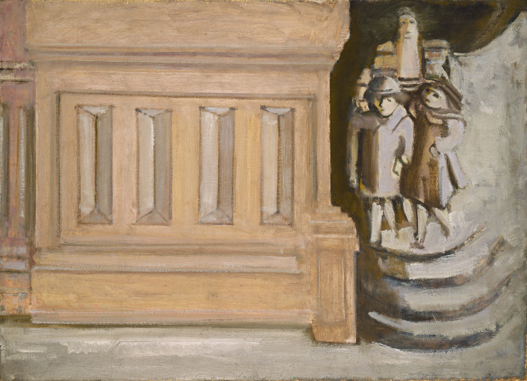
Street Scene (1937) by Mark Rothko

Rothko was conspicuously different from other boys of his age. He began high school in 1918 and being the youngest he was bullied for his lack of conformity and language. He excelled at school and in 1921 he left Portland to attend Yale University where he studied English, French, European History, Elementary Mathematics, Physics, Biology, Economics, the History of Philosophy and Psychology. This new environment fell short of his ideals, he was exposed to direct anti-Semitism which was institutional, because of the increase in Eastern Europeans entering higher education and Ivy League schools causing resentment. Ethnic prejudice by privileged higher echelons of society excluded Jews from many of the fraternities, athletic teams and social activities. Whilst there, Rothko lived off campus to save on expenses which made him even more ostracized. He often visited family who lived nearby and met through them people who enjoyed art, music and literature. By his Yale friends (other Jews) he was regarded as ‘brilliant’, ‘well read’ and ‘destined for great things’. He continued to draw and sketch but considered Law and Engineering as a profession. In addition, his scholarship converted into a loan and he was forced to work. He later moved into the university, but this did not improve his situation, he became increasingly disillusioned with education and antagonistic towards Yale and his fellow students, as a consequence, he was involved in producing an underground paper with other likeminded students. Towards the end of 1923 Rothko, totally disillusioned, left Yale. This was a turning point in his life and his decision disappointed and angered his family, even more so, when he decided to move to New York and pursue a career in the arts. He was attracted to painting when he went along with a friend to the Arts Student League and saw the work produced there. He was unsure whether the theatre or painting was his calling and after a short time returned to Portland to study acting and he later returned to New York after he was unsuccessful in winning the scholarship to the American Laboratory Theatre. He often spoke of his paintings as ‘dramas’ and his shapes as ‘performers’. He then enrolled in the new school of design, this was short lived, and he later enrolled at the Arts Student League. The Expressionist Painter, Max Weber (1881 – 1961) taught Rothko for a short period of time and the importance of seeking a universal, spiritual basis for art. (Breslin, 1993) However, Rothko was largely self-taught as a painter and his works showed no direct reflection of paintings of the past; they were not precedent with any traditional paintings and his work has been highly individualistic from the very outset.

The main attraction and inspiration for his art was the female body, which became a kind of mirror in which he explored his own emotions and thus a representation of what blocked and confined him, his own psyche. He lived like most young artists, on very little. He claimed that had he gone back to Portland “he would have been a bum” whereas in New York he found the “freedom to develop”.

Rothko was quite introverted and conducted himself with singlemindedness, perhaps, as a consequence of seeing himself as an outsider to hostile societies. Although his family fled the Tzarist pogroms Rothko continued to experience oppression, as well as the more local activities of the Ku Klux Klan and other traumas in the Los Angeles of his youth, the flagrantly corrupt WASP – controlled metropolis that is the setting of Raymond Chandler’s novels. (Breslin, 1993)

In his youth, Rothko recounts that art was non-existent, he was not aware of museums and art galleries until later, when in his twenties. Conversely one of Rothko’s first loves was the theatre.

Rothko remained in New York throughout the war, saved from the draft by his bad eyesight. The war imposed rationing and shortages for those at home. It also later stimulated the economy, ending the Depression and giving people the money with which to buy such luxuries as Jewellery and paintings.

Rothko was a melancholy, solitary person, preoccupied with his artistic productions. As a man he was physically large and heavy a complete contradiction to the sickly calcium deficient child he was. Rothko met Edith Sachar (1912-1981), a Jewellery designer, in 1932 and would marry her later that year. According to Edith, Rothko was a very moody person, very careless and not concerned about his personal appearance. As a struggling artist his financial situation was dire, even with the two of them at work, it was Edith’s salary that kept them from going under. Edith was not an artist and Rothko found it often difficult to discuss his art with his wife, she became frustrated by his lack of success and started to pressure him to join her in her business. His marriage to Edith began to fall apart and Rothko divorced Edith in 1945.

When Rothko first started to paint, hardly anyone in New York was creating abstract art. In his early career he was deeply wedded to pictorial tradition, Rothko’s later work has been classed as ‘Action Painting’ yet without evidence of his approach towards working (as with Pollock and Number 29) it is difficult to rectify (MoMA, 1972). Rothko’s large surfaces of rectangular configurations absorb and envelope the viewer, as if he or she were to enter it, to sink into its atmosphere of mist and light or to draw it around themselves like a coat or skin. Furthermore (MoMA, 1972) states that these silent paintings with their enormous opaque surfaces are mirrors, reflecting what the viewer brings with him. In this sense it can be said they deal directly with human emotions, desires, relationships, for they are mirrors of our fantasy and serve as echoes of our experience. In these vast canvases he abandoned solid colour areas for rectangular frames of single hue set in a field of solid colour. There is the constant stripping-down of his pictures to their barest essentials. It is disconcerting how extremely simplistic the work is.

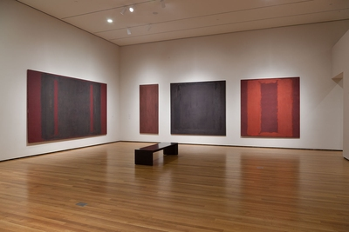
The Four Seasons (circa. 1958) by Mark Rothko
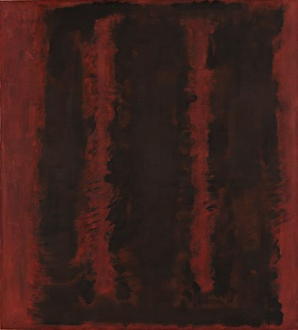
Black on Maroon (1958) by Mark Rothko

Rothko would consistently aim to channel human emotions through his art by means of colour; the colours serve as a vessel that holds the content and sets the general tenor of the mood. Such feelings are of haunting suggestions of emptiness and absence. Nevertheless, critics paid scarce attention to his own perspective on his art. Rothko wanted viewers to be allowed to approach his paintings “as a pure and unique experience, for which they should not be prepared.” No words could take from Rothko’s paintings entirely of their indeterminacy, their illegibility, or their difficulty. Rothko believed “painting, like every other art, is a language by which you communicate something about the world”. Rothko at first rejected the notion his paintings were abstract and were instead “realistic” and having “real and specific meaning”. He would also protest on the conception of colour; “I’m not interested in colour and I’m not a colourist… colour is nothing but an instrument for expressing something larger”. Only until 1938 was Rothko willing to forego the conventions of local colour and mimetic form. He also stated; “Abstract art never interested me.” “I am not an abstractionist.”
- What was obvious to the viewer was by no means obvious to the artist.
- Throughout the 1940’s Rothko’s work became unmistakably abstract.
- Rothko eventually reconciled himself to abstraction.
Rothko was a lonely man who chose a profession that cut him off from his family and which was itself solitary. In the second half of the 1950’s Rothko’s work turned towards the tragic. The paintings appeared to harden, their spectra narrowed, growing either dim or polarized, and the atmosphere was overcast in the commanding, even operatic Four Darks in Red (1958). He was deeply depressed and committed suicide at his studio in New York on 25th February 1970, he was sixty-seven years old. Having scythed deeply into his arms with his paint knife he was found dead in his own pool of blood on the floor of his studio in Bowery. The sombre, dark red pool of blood was said in some way akin to his rectangular canvases of the Four Seasons, a colour field painting; perhaps his last work of art? Like most American artists of his generation, Rothko's early career was marked by struggle and little recognition. The paintings Rothko did for the Four Seasons now hang in London’s Tate Modern, having arrived, disconcertingly, on the day of his suicide.

Conclusion
Rothko and Pollock stood for a common search for an absolute, either of compulsive movement or colour, creating a powerful, immediate impact. Pollock and Rothko were aware of the dangers of becoming prisoners of their own originality. According to Anfam (1990) the inner hinterland, the so called ‘collective unconscious’, was supposedly common to all human beings, whether primitive or ‘civilized’. Hence the ‘archaic’ look about the pictures of Rothko and Pollock which cut through to inner truths. Moreover, the collective unconscious could only be known via mediator’s or ‘archetypes’; primal figures, symbols and the groupings associated with them that populate dreams and myths which resembled signs pointing towards things hidden and complex. Philosopher, Friedrich Nietzsche (1844 – 1900), stated that Rothko’s art counters chaos and springs from primal roots. Rothko was recognised as one of the leading players in the New York School as was Pollock, however, Rothko remained aloof and distanced from Pollock, who he resented and would later avoid exhibiting his works in the same vicinity as the ‘Westerner’. Critics state that after Rothko’s suicide his works became magically timeless; Dore Ashton, an art critic, wrote that his work is now of “magic and mystery” on their “ineffable and enigmatic” qualities. While Pollock was alive, some reviewers – unsympathetic in the extreme – accused Pollock of running a wrecking enterprise. His work, they complained, ruthlessly shattered the accepted conventions of picture making. Looking back, we can see that these critics were not wrong in what they were saying; what they could not know, however, was just how profoundly Abrstract Expressionism’s challenge to tradition was to change the course of art. (Landau 1989, P.21)

Abstract Expressionism Revitalised North America and became a tool for Political change and a new artistic language to the working class. The artistic style allowed the viewer to experience intimate sensations which in turn enabled access to deep emotions through tapping into to subconscious mind. The work through its vast scale and colourful fields would envelope the viewer and help alleviate the cultural influences of that time. As oppose to confining feelings artists decided to express them in outwardly fashion, although by certain sections of society this style was viewed as not being ‘artistic’ (Abstract Expressionism Royal Academy, 2016). People are now more acceptive of the style which has gained wide acclaim and acceptance, demonstrating that we appreciate the importance of Abstract Expressionism as a conduit for the crucial coping aspect it provides in our lives. In 2006 Pollock artwork ‘Number 5 (1948)’ was bought for $164.4 million, this was of the Drip Period. The following year in 2007 Rothko’s ‘White Centre (1950)’, his signature and multiform styles sold for $32.645 million. Both are synonymous with crucial periods of these artists.

Through the research it is apparent that as adults Pollock and Rothko had nothing in common other than they were Abstract Expressionist painters who are recognised as foremost within their fields. Both possessed a determination to produce art, for arts’ sake and made huge sacrifices to pursue this, enduring personal and professional criticism, yet not necessarily of self-doubt. Not only were they consumed by art, they used art as a conduit for their emotions. It can be viewed each experienced trauma and difficulties whilst growing up, during the early stages of their profession and both developed issues which led to Pollock becoming an alcoholic and Rothko suffering from bouts of depression. Conversely their suffering provided a foundation of creativity in which to channel their emotions, opinions, angsts, psyche and art. Due to the limitations of the word count it is difficult to discuss in depth the nexus of their troubled personalities and that of causal effects. It is, however, apparent that both areas are integrated and represented within the paintings these artists produced. Nonetheless it is evident that their art was a manifestation of both of their inner struggles. Due to their early and untimely deaths, it is difficult to foresee whether their styles would alter in line with their personal development and changes within the world.

Bibliography

Anfam, D. (1990). Abstract Expressionism. In D. Anfam, Jackson Pollock - Drip Painting (p. Page 120). London.
Anfam, R. A.-D. (2016). Abstract Expressionism . London: The Department for Culture, Media and Sport.
Birth by Jackson Pollock. (2014). Retrieved from Jackson Pollock Prints : http://pollockprints.org/birth/
Breslin, J. E. (1993). Mark Rothko - A Biography . Chicago and London: The Univeristy of Chicago Press.
Chave, A. C. (1989). Mark Rothko - Subjects in Abstraction . New Haven and London: Yale University Press.
Ducksters. (n.d.). Retrieved April 10, 2017, from http://www.ducksters.com/history/art/abstract_art.php
Emmerling, L. (2003). Pollock. Germany : TASCHEN.
Friedman, B. H. (1972). Jackso Pollock: Energy Made VIsible. New York: McGraw-Hill.
Guggenheim. (2017). Guggenheim. Retrieved from www.guggenheim.org/artwork/34733
Jackson Pollock - Biography, Paintings and Quotes. (2011, November 25). Retrieved from Jackson Pollock: https://www.jackson-pollock.org/moon-woman.jsp
Jackson Pollock - Birth 1941. (2017). Retrieved from Tate: http://www.tate.org.uk/art/artworks/pollock-birth-t03979
Jackson Pollock Prints. (2016). Retrieved from http://pollockprints.org/moon-woman/
Jackson Pollock Prints. (2017, December 01). Retrieved from Pollock Prints - Birth: http://pollockprints.org/birth/
James C. Fernald, L. (1925). The Desk Standard Dictionary. New York and London: Funk and Wagnalls .
Landau, E. G. (1989). Jackson Pollock. In Jackson Pollock (pp. 44 - 46). London: Thames and Hudson.
Navajo Sandpaintings. (1994-2011). Retrieved from http://navajopeople.org/navajo-sand-painting.htm
Phaidon. (1996). The 20th Century Art Book. London: Phaidon.
Pollock, J. (n.d.). Guardians of the Secret (1943). Artsy Press 2017, New York.
Pollock, J. (n.d.). Mural (1943-1944). Christies , London.
Pollock, J. (n.d.). Number 29 (1950). Pinterest, New York.
Pollock, J. (n.d.). The Moon Woman. The Moon Woman. New York.
Prohibition . (2017, December 08). Retrieved from History : http://www.history.com/topics/prohibition
Sand Painting. (2017). Retrieved from Encyclopaedia Britannica: https://www.britannica.com/art/sand-painting
Selz, P. (1972). Mark Rothko. New York: Arno Press.
SF MO MA. (n.d.). Retrieved April 14, 2017, from https://www.sfmoma.org/watch/jackson-pollock-paintings-have-a-life-of-their-own/
Tate. (n.d.). Retrieved April 10, 2017, from http://www.tate.org.uk/art/art-terms/a/abstract-expressionism
TATE. (2017, November 19). Retrieved from TATE: http://www.tate.org.uk/art/artworks/rothko-red-on-maroon-t01165
TATE. (2017, December 01). Retrieved from Jackson Pollock - Birth: http://www.tate.org.uk/art/artworks/pollock-birth-t03979
The Culture Trip. (2016). Retrieved April 30, 2017, from https://theculturetrip.com/north-america/usa/wyoming/articles/jackson-pollock-recording-the-unconscious/
Unknown. (n.d.). Jackson Pollock - Action Painting. Action Painting. New York.

