Adam Evans (0450685)

APCA7001
Lecturer: Mahesh Kannath
Reflective Essasy
Design for Industry 4.0

Contents
Introduction 2
Diamond Centre Wales 3
Design Process 4
Augmented Reality 6
Additive Manufacture 7
Automation of Finishing Techniques 7
Design for Recycling and re-use 9
Conclusion 10
References 11

Introduction
Within this reflective essay the focus will be looking at the way I4 technologies have affected the bespoke Jewellery Industry. Primarily with a focus on the organisation Diamond Centre Wales.
Traditionally a manufacturing model with hands and tried and tested tools, Industry 4.0 has brought new options to not only Goldsmiths but also to the designers. It has allowed for greater communication between manufactures and consumers to accommodate how the culture has changed for mass customisation and personalisation.
Direct Metal Printing in combination with automated finishing processes would allow for automated assembly and reclamation of materials.
Automated processes combined with machine learning so as not relying on specialists who may not always be available to manufacture, Machines can run continuously. The use of the IIOT allowing automated maintenance to be developed from a sensors and connectivity of operations in factory.
Augmented Reality and Virtual Reality to visualise before creation of physical pieces so ensuring only what needs to be created is. Also, a look at circular economy for different business models that may suit the societal changes towards environmentally friendly and sustainable practices.

Diamond Centre Wales
Manufacture is currently in the age of Industry 4.0, enabled by its nine central pillars the Internet of things, Cloud Computing, Big Data Analytics, Augmented Reality, Cyber Security, Simulation, Systems Integration, Additive Manufacture and Autonomous Robotics (Vaidya et al. 2018).
This essay will reflect upon Diamond Centre Wales, a small enterprise based in South Wales that creates and manufactures primarily bespoke pieces of Jewellery. This design process is accomplished as a cocreation with their customers. Diamond Centre Wales is working towards the Demand Chain management system that suits a bespoke jeweller’s operation (Ganji, Coutroubis and Shah, 2018).
The current process is such as, an Initial design consultation is organised to agree the specifications and materials to be used for the piece. The CAD/CAM department will then draw up the design using parametric software, this 3D model can then be utilised, firstly to create a photo realistic render, this is sent to the customer who is then able to consider their satisfaction with the design and if they would like to move on to the next stage of manufacture. If the customer is not yet fully satisfied, various iterations created via feedback from the customer can be designed until ready to move to the next stage.
The second use for this 3D software model is that it can be used to create a real-world model, using a 3D wax printer. This itself has two main uses at DCW. The first being to provide a 1:1 scale model for viewing for customers who would like to see the ‘finished piece’ on their hand. The second, though primary use for these wax models is for the Lost Wax casting process.
Once casting has been completed, Goldsmiths at the DCW will then clean, polish and set the piece using traditional methods and tools. At this point the piece is delivered to the customer.
This current process allows a great deal of flexibility when designing pieces of jewellery, before embracing I4 technologies, DCW would use prefabricated parts and or create components from raw materials. This process would limit availability of design and each iteration was costly and time consuming.

Design Process
DCW employ a CAD/CAM department that uses parametric software to design pieces of Jewellery, the benefits of this type of software is various versions of a design can be made simply by editing a few parameters. With the advent of cloud computing to process these models it means the days of having high end computers aren’t as important allowing more people to utilise this technology.
Algorithmic software can be used to further enhance designs to cut down on repetitive tasks, where a premade primitive design such a sphere could be transformed into a hollowed pattern with Voronoi patterns described by a few parameters such as thickness, number of sections or distant methods between points such as Manhattan or Euclidian. This technology enables designers to reach greater levels of complexity with the designs.
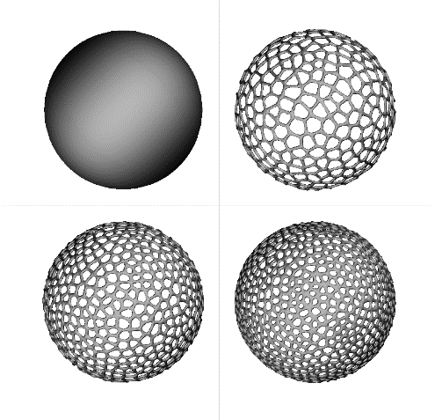
(Evans, 2021)
Cocreation of designs is something integral to the DCW business model, and with the rise of businesses now offering direct control of their design from predefined parameters, meaning that once a company has set up the parameters, tolerances and material choices, a consumer can design their ring essentially independently from a sales person, real time data of material weights and associated costs can be presented to the user as they create their amendments (Bertacchini et al., 2021).
The want for mass customisation has become more important in recent years for consumers who want personalisation to their products. Parametric software to allow small changes to already existing designs allow this, whereas previously, using hand crafter methods this would not have been viable.
X-ray scans combined with 3D scanning and algorithms have been used by Cortex to create bespoke casts, firstly by scanning the break, then scanning the area around the injury, in this case the arm, to which the cast is then custom made using Voronoi like structures to ensure a specifically made solution for that particular break and also as light and as robust as possible. 3D scanning could then be applied to CAD software to create custom finger sizes, neck sizes, so Jewellery can be adapted to the wearer of the item. (Deezen, 2013)

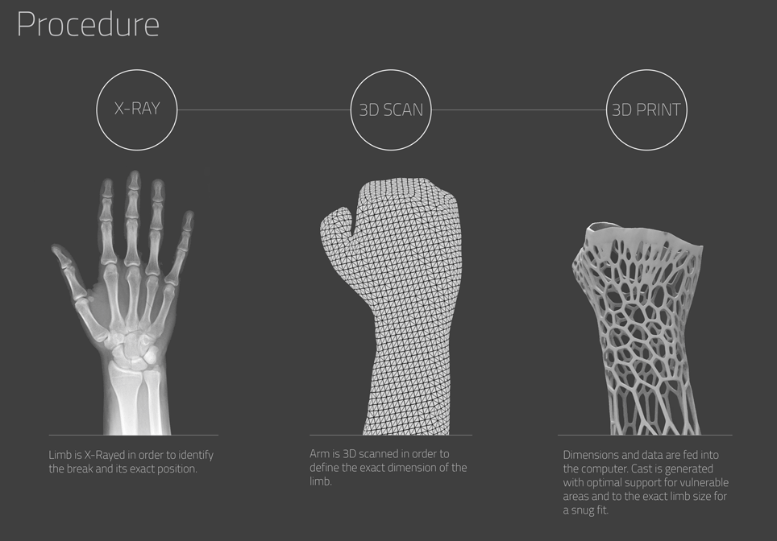
(Deezen, 2013)

Generative design uses a design approach where the designer sets out goals via parameters for software, so rather than creating the end design, the designer receives several solutions that meet these goals and then the designer is able to curate best fit, using their expertise.
A similar concept is used with generative art such as ‘Obvious’ They use two algorithms a Generator and a Discriminator, in this example the Generator creates a portrait from a fictional family. This portrait is then sent to the Discriminator whose role is to decide if any portrait it is presented with is real or AI. AI is currently viewed as the medium of the product rather than the creator of the product as any design is created in collaboration between designer and the rules defined to the algorithm (Christie's, 2018). This could be applied to new ranges of jewellery as well as parameters could be set for new pieces to be created in exactly the same way a portrait is created.
Currently the Stereolithography file .Stl is the standard file type used for AM. It slices 3D software models into sections to be printed by appropriate machines. Butt,2020, noted that the .3mf file is a contender to replace the Stl as the standard due to the additional information that is able to be stored on the file. For example, a Stl will only create a record of the boundaries of the slices it creates whereas a .3mf file will be able to store, render details, materials to print, parameters associated and so on. This means there will be added reliability in manufacture processes due to the design rules and parameters being locked to the specific file.
Other methods moving away from the standard Stl file are being used to take advantage of the new manufacturing processes, like Full Controls nozzle path code that does not need to tesselate a 3D model due to its non-traditional building process, allowing for robust and complex designs including lattices, filigrees and gyroids (Gleadall 2021).
Augmented Reality
Augmented reality and virtual reality can be used as a viable means to decrease the number of prototypes that would need to be created for the creation of a final piece, the user would be able to see a virtual but life size model placed upon themselves before any manufacture would need to take place.
An organisation could look at reducing their overall physical stock and move to a virtual layout, where people could attend the shop online and see available products, this would reduce insurance, maintenance and production cost for a Jewellers who may have these stock options as jumping off points for design anyway. This method would increase a particular organisations catchment area for potential customers from its current geographical limitations to anywhere the internet can be connected.
Augmented and mixed reality provides a positive to the sales of business that take advantage of it (Tan, Chandukala and Reddy, 2021), with new breakthroughs in the technology Vovk et al., 2018, has shown previous issues such as simulator sickness tends to no longer be an issue with the users. This technology could be used to show real time changes to iterations whilst positioned on the user’s hand or body. In effect the user can make radical design changes from the parameters provided and see the changes on their person. This would in effect
Additive Manufacture and Investment Casting.
Additive Manufacture is the technique of layer-by-layer automated construction using a range of materials such as polymers and metals, it enables mass customisations and personalisation whilst allowing the automation of traditional process (Wujec, T 2017).
As Described above, DCW currently uses lost wax casting, wherein a wax model is created to be burnt out to create a temporary mould for molten metal to fill. Additive manufacture has been celebrated as a greener option to the industry standard methods currently employed in the jewellery industry (Ahn, 2016). Investment casting is currently utilised in around 80% of Jewellery production across the globe (Cooper, 2015) having been established in the industry for thousands of years (Pattnaik, Karunakar and Jha, 2012). Now AM allows a piece to be printed using direct metal, thus removing the energy inefficient lost wax casting method.
AM enables the ability to create consistent complex geometries and iterations that would be too expensive and time consuming to be created with traditional hand tooling methods (Wang et al., 2019). This expands the library of available designs and techniques that can be utilised to create unique products. Heat sensitive stones could be place halfway through builds to allow for automatic setting.
The direct metal additive manufacturing process can reduce supply chain requirements and allows organisations to be more agile, allowing designs not achievable using lost wax casting to be employed.
New metal alloys are currently being designed along with the parameters for their associated machines and processes, due to the balance between particle size, melting points and the resulting effects on the microstructure’s density and porosity (Yakout et al., 2017).

Automation of Finishing Techniques
Automating the finishing process to remove labour intensive practices and removing goldsmiths from harmful environmental factors involved within these processes allow quality of life to improve whilst also allowing more meaningful work to be completed by the goldsmith.
When creating new designs with new complex geometries the ideas and processes behind preparing finished pieces will need to addressed. Polishing, in its simplest of terms is removing peaks and troughs from a surface to provide an even surface that will produce a greater lustre (Fletcher 2019).
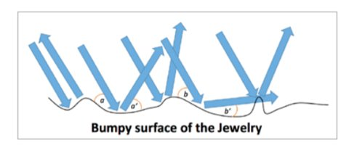
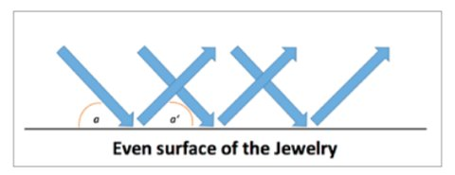
(Fletcher 2019)
Electro polishing or Plasma electropolishing are able to significantly reduce the process time for the clean-up, provide greater lustres and allow for greater reclamation of precious metal materials that can then be used again without refining – a costly and environmentally unfriendly procedure.
Instead of using traditional hand polishing methods or polishing techniques such as drag, centrifugal finishing, barrelling, or laser polishing. Other techniques such as micro selective melting are being reviewed for AM products though this is not currently suitable for the design processes involved with Jewellery production (Nagarajan et al. 2019).
This style of technique lends itself to the more complex geometries that new technologies enable, as the more complex a design the longer a goldsmith would have had to perform post processing duties
Plasma Electro polishing has been proposed for the jewellery industry as electropolishing is not a viable option due to its use of potassium chloride heated to 950°C (Kushner, 2008) with the associated health affects being a carcinogenic alongside with the vapours creating eye damage and respiratory and skin irritation and corrosion (Danilov et al.2019).
The high levels of reclamation from plasma electrolytic polishing also lends this automation process - that enables greater design complexity by industry 4.0 – a strong advantage as currently reclamation of precious metals is the second primary source of precious metal acquisition. Meaning between the new design process and automation process a business such of DCW would be able to retain more material to use in future designs (Granados-Fernández et al.2021) This will allow the environmentally beneficial process of re-atomisation of the precious metal powder used in the manufacturing process.

Design for Recycling and re-use
The Jewellery industry has always steered towards aspects of a circular economy due to the precious and rare metals used but as the Circular economy model replaces the current prevalent linear economy the is going to be a need for a societal mindset revolution (Lieder and Rashid, 2016).
This won’t just apply to the finished product but the tools used to create the end product. It will be for manufacturing organisations such as DCW to diminish the negative effects of using raw earth materials and manufacture that directly and have lasting impacts on the environment (Gurung, P. 2019). The circular economy also aligns itself with the United Nations standard development goal 12 (UN, 2015) and the future generations 2020 Wales act by utilising the efficient processing of materials (www.futuregenerations2020.wales, 2020.)
Witjes and Lozano, 2016 have noted manufacturers and consumers have already began moving towards sustainable style models. This is evident in the rise of product-service models that lessen negative ecological effects (Mont, 2002). Outside of the jewellery industry the lighting as a service model exemplifies what can be achieved, wherein the organisation supplies light bulbs to the consumer for a periodic rate, any time the bulb is replaced or repaired it is sent back to the original manufacturer who has designed its product for easy dissembling to its raw elements, meaning that in this closed loop no materials are lost in inefficient recycling processes (Dzombak, Kasikaralar and Dillon, 2020).
This could be applied to the Jewellery industry, where instead of purchasing a jewellery piece the user buys the design then when they change designs Materials could be reduced to raw materials back at the original sales point (Vanegas et al., 2018). Sentimental items are already remade across the jewellery industry, this would provide an option for fast fashion items to be dealt with in a similar manner.
Systems can be set up to manage their own processes via maintenance schedule using big Data analytics, this would allow for mass customisation as past runs and usage can be used to plan new customisable runs, compiled with the faster cycle times for new iterations that AM empowers then Mass-individualisation is viable for organisations with their bespoke batch orders of 1 (Leng et al.2020).

Conclusion
Industry 4.0s automation of repetitive but vital tasks is able to improve quality of life and working conditions that can be expected for Goldsmiths and skilled workers, as they can be removed from harmful and repetitive operations. Allowing focus to be on the designs and manufacture.
A major change within Industry 4.0 as compared to previous relationships between manufacture and consumer is the movement towards co creation with consumers, even to the point of creating parameters a consumer can exploit to create a personal product without the need for traditional channels such as talk to a sales person or designer. This empowering of design freedom is enabled by the use of parametric and generative software. This presents the user with a selection of choices whilst still staying within design parameters that are dictated by the manufacture, either to suit branding or practical manufacturing needs.
Augmented reality and Virtual reality will allow for various iterations to be created without the need for actual manufacture, consumers will be able to place virtual representations of their designs upon themselves in virtual space before committing to a product being created, allowing there to be no need for needless physical pieces being created. This will also mean that organisations will now need to created endless stock that has to be maintained and insured and stored, instead focusing on pieces customers actually want.
DCW continues to embrace new technologies, from its development of CAD and CAM departments, the use of rapid prototyping for lost wax casting and 3D Scanning. All of these technologies have allowed DCW to continue its development of design, for aesthetic reason and for allowing its compatibility with the choosing technology. It has also enabled DCW
References
Ahn, D.-G. (2016). Direct metal additive manufacturing processes and their sustainable applications for green technology: A review. International Journal of Precision Engineering and Manufacturing-Green Technology, 3(4), pp.381–395.
Bertacchini, F., Bilotta, E., Demarco, F., Pantano, P. and Scuro, C. (2021). Multi-objective optimization and rapid prototyping for jewelry industry: methodologies and case studies. The International Journal of Advanced Manufacturing Technology, 112(9-10), pp.2943–2959.
Butt, J. (2020). Exploring the Interrelationship between Additive Manufacturing and Industry 4.0. Designs, 4(2), p.13.Christie's (2018). Is artificial intelligence set to become art’s next medium. [online] Christies.com. Available at: https://www.christies.com/features/A-collaboration-between two-artists-one-human-one-a-machine-9332-1.aspx.
Danilov, Igor, et al. “Process Understanding of Plasma Electrolytic Polishing through Multiphysics Simulation and Inline Metrology.” Micromachines, vol. 10, no. 3, 26 Mar. 2019, p. 214, 10.3390/mi10030214. Accessed 5 Aug. 2021.
Dzombak, R., Kasikaralar, E. and Dillon, H.E. (2020). Exploring Cost and Environmental Implications of Optimal Technology Management Strategies in the Street Lighting Industry. Resources, Conservation & Recycling: X, 6(6), p.100022.
fletcher, and frank cooper. “2018 - Precious Project: Polishing and Finishing Additive Manufacturing (AM) Jewelry.” The Santa Fe Symposium, 2018, www.santafesymposium.org/2018-santa-fe-symposium-papers/2018-precious-project-polishing-and-finishing-additive-manufacturing-am-jewelry.
Ganji, E.N., Coutroubis, A. and Shah, S. (2018). DCM 4.0: Integration of Industry 4.0 and Demand Chain in Global Manufacturing. 2018 IEEE International Conference on Engineering, Technology and Innovation (ICE/ITMC). [online] doi:10.1109/ICE.2018.8436383.
Gleadall, Andrew. “FullControl GCode Designer - Open-Source Software for Unconstrained Design in Additive Manufacturing.” Additive Manufacturing, June 2021, p. 102109, 10.1016/j.addma.2021.102109. Accessed 29 June 2021.
www.futuregenerations2020.wales. (n.d.). Future Generations. [online] Available at: https://www.futuregenerations2020.wales/ [Accessed 31 May 2021].
Gurung, P. (2019) Business Case: X – Jewelers- Master’s Thesis International Business Management: Integrating Sustainability Into Jewelry
Leng, Jiewu, et al. “A Loosely-Coupled Deep Reinforcement Learning Approach for Order Acceptance Decision of Mass-Individualized Printed Circuit Board Manufacturing in Industry 4.0.” Journal of Cleaner Production, vol. 280, Jan. 2021, p. 124405, 10.1016/j.jclepro.2020.124405. Accessed 2 Dec. 2021.
Lieder, M. and Rashid, A. (2016). Towards circular economy implementation: a comprehensive review in context of manufacturing industry. Journal of Cleaner Production, 115(115), pp.36–51.
Nagarajan, Balasubramanian, et al. “Development of Micro Selective Laser Melting: The State of the Art and Future Perspectives.” Engineering, vol. 5, no. 4, Aug. 2019, pp. 702–720, 10.1016/j.eng.2019.07.002. Accessed 20 Sept. 2021.
Pattnaik, S., Karunakar, D.B. and Jha, P.K. (2012). Developments in investment casting process—A review. Journal of Materials Processing Technology, [online] 212(11), pp.2332–2348. Available at: https://www.sciencedirect.com/science/article/abs/pii/S0924013612001823 [Accessed 25 Jan. 2021].
Tan, Y.-C., Chandukala, S.R. and Reddy, S.K. (2021). EXPRESS: Augmented Reality in Retail and Its Impact on Sales. Journal of Marketing, [online] p.002224292199544. Available at: https://doi.org/10.1177%2F0022242921995449 [Accessed 19 Feb. 2021].
United Nations (2015). #Envision2030: 17 goals to transform the world for persons with disabilities | United Nations Enable. [online] Un.org. Available at: https://www.un.org/development/desa/disabilities/envision2030.html.
Vovk, Alla, et al. “Simulator Sickness in Augmented Reality Training Using the Microsoft HoloLens.” Proceedings of the 2018 CHI Conference on Human Factors in Computing Systems - CHI ’18, 2018, 10.1145/3173574.3173783.
‌Wujec, T. THE FUTURE OF MAKING. (2017). [online] Available at: https://damassets.autodesk.net/content/dam/autodesk/docs/pdfs/futureofmakingthings/FutureOfMaking_ADSK_v3.pdf.
Witjes, S. and Lozano, R. (2016). Towards a more Circular Economy: Proposing a framework linking sustainable public procurement and sustainable business models. Resources, Conservation and Recycling, 112(112), pp.37–44.
Deezen (2013). Cortex 3D-printed cast for fractured bones by Jake Evill. [online] Dezeen. Available at: https://www.dezeen.com/2013/06/28/cortex-3d-printed-cast-for-bone-fractures-jake-evill/.Vanegas, P., Peeters, J.R., Cattrysse, D., Tecchio, P., Ardente, F., Mathieux, F., Dewulf, W. and Duflou, J.R. (2018). Ease of disassembly of products to support circular economy strategies. Resources, Conservation and Recycling, [online] 135(135), pp.323–334. doi:10.1016/j.resconrec.2017.06.022.
Wang, J., Sama, S.R., Lynch, P.C. and Manogharan, G. (2019). Design and Topology Optimization of 3D-Printed Wax Patterns for Rapid Investment Casting. Procedia Manufacturing, 34(34), pp.683–694. doi:10.1016/j.promfg.2019.06.224.
Yakout, M., Cadamuro, A., Elbestawi, M.A. and Veldhuis, S.C. (2017). The selection of process parameters in additive manufacturing for aerospace alloys. The International Journal of Advanced Manufacturing Technology, 92(5-8), pp.2081–2098. doi:10.1007/s00170-017-0280-7.

