

Design of a Pollution Monitoring Station

Final Report

By Matthew Taylor

Supervisor: Dr Stephen Mosey
Second Marker: Dr Gary Jones

Project submitted as part of the requirements for the award of
BEng (Hons) Electrical and Electronics Engineering

Table of Contents

Table of Figures 3
Abstract 4
Introduction 4
Aims and Objectives 4
Literature Review 5
Literature on Pollution 5
Literature on Low-Cost Pollution Sensors 7
Current Market 8
Methodology 9
My Design 10
My Features 10
The Sensors 10
The Technology 11
The Hardware 13
The Software 14
Results & Discussions 19
Conclusion 24
reflection 24
References 25
Appendix 27

Table of Figures

Figure 1 - UK mean concentration of PM2.5 6
Figure 2 - OPC Sensor 11
Figure 3 - MOX Sensor 12
Figure 4 - Proteus Schematic 13
Figure 5 - Price of prototype 13
Figure 6 - Initialising flowchart 14
Figure 7 - BME680 getting ID 14
Figure 8 - SEN55 getting ID 14
Figure 9 - BME initialisation 15
Figure 10 - Proteus log 15
Figure 11 - Register addresses 16
Figure 12 – Combining bytes 16
Figure 13 - Setting heat plate 16
Figure 14 - Operational flowchart 17
Figure 15 - Getting the time and measurements 17
Figure 16 - Storing data to EEPROM 17
Figure 17 - PC terminal Figure 18 - setting the terminal 18
Figure 19 - Temperature and Relative Humidity Baseline Comparison 19
Figure 20 - BME680 VOC Baseline Comparison 20
Figure 21 - SEN55 Baseline Comparison 20
Figure 22 – Dr Salimifard’s experiment 21
Figure 23 - Acetone BME680 22
Figure 24 - Acetone SEN55 22
Figure 25 - Particulate Matter 23

Abstract

I aimed to create a pollution monitoring station, which I completed, using a Microchip microcontroller, Bosch’s BME680, and sensirion’s SEN55. I found that there is an existing market for devices similar to my design, and that there is academic literature on the viability of low cost sensors as well as examples of them being deployed in government projects. I conclude my report with an evaluation of my implementation and a discussion on possible future iterations.

Introduction

There is a pressing need for pollution monitoring to become more readily available at a more affordable price point. People’s health is adversely affected by pollution, increasing the risk to health complications and is also attributed to a sizable number of deaths in the UK and worldwide each year.

I propose to design a pollution monitoring station using low-cost sensors. There is an increasing discussion about the viability of using low-cost sensors instead of reference method devices, due to the large price difference between the two. My original intention for the product was that it could have a place in the museum and heritage sector, where I currently work. I could see museums with outdoor aspects or heritage sites with large outdoor estates having an interest in the conditions of their environment. During my literature review I also \found that there is a market demand for low-cost sensors for both citizen science and government projects.

In this report I have discussed previous works on the topic to determine the viability of my proposed product. I found that there will be limitations on the conditions in which the product will work, and I would need to additionally monitor the conditions of temperature and relative humidity to know when the unit can accurately record data. I also found that the sensors accuracy, without further calibration, degrades after a year.

Aims and Objectives

My aim is to design a pollution monitoring Station, including its sensors, components, software and enclosure and I will finish with producing a prototype.

My objectives are;

- I will research the viability of low-cost sensors, and if they would be appropriate for my product.
- This will include their accuracy and their longevity without further calibration.
- Discuss the reasoning for designing such a product, its use case and its limitations.
- Produce a prototype of the pollution monitoring station and rigorously test its functionality.

Literature Review

Literature on Pollution

Around 40,000 deaths were attributed to exposure to outdoor air pollution in the UK in 2016 [1]. Ambient pollution was shown to be detrimental to people’s health, with particulate matter causing the death of over 3 million people worldwide in 2010. [2]

Pope and his co-authors [3] set out to compare exposure–response relationships of particulate matter smaller than 2.5 µm (PM2.5) with lung cancer and cardiovascular mortality and discussed the implications of exposure to PM2.5 through smoking, second-hand smoke and ambient PM2.5 pollution. The study was a prospective cohort with 1.2 million US adults collected by the American Cancer Society. They were able to plot the relative risk (RR) of the estimated daily dose of PM2.5 from smoking, second hand smoke and ambient air pollution. The RR of lung cancer from 10 μg/m³ of PM2.5 exposure was 1.21, the same as living with a smoking partner.

Brook and his co-authors [4] including Pope, in their 2010 study concluded “Exposure to PM2.5 over a few hours to weeks can trigger cardiovascular disease-related mortality and nonfatal events.” and “longer-term exposure (e.g. a few years) increases the risk for cardiovascular mortality to an even greater extent and reduces life expectancy within more highly exposed segments of the population by several months to a few years.” They went on to state that “reductions in PM levels are associated with decreases in cardiovascular mortality within a time frame as short as a few years.”

Dockery [5] conducted a study with his co-authors of the data of 8,111 adults in six U.S. cities with a 14-to-16-year mortality follow-up. They found the adjusted mortality-rate ratio for the most polluted of the cities as compared with the least polluted was 1.26. This demonstrates that even a reduction in PM2.5 ambient pollution to match a lesser polluted US city, could reduce PM2.5 mortality by 23 percent. They did control for smoking which is a major source of PM2.5 although they stated that “the effects of other, unmeasured risk factors cannot be excluded with certainty.”

Laden and her co-authors [6] also found the link between PM2.5 ambient pollution exposure and acute and chronic mortality. Using the same dataset as Dockery, they found that “PM2.5 exposure was associated with lung cancer (RR 1.27) and cardiovascular deaths (RR 1.28)”. They also found that a reduction of the mean PM2.5 by 10 μg/m³ improved the health outcome over an 8 year period (RR 0.73).

Miller studied 65,893 postmenopausal women without previous cardiovascular disease in 36 U.S. metropolitan areas from 1994 to 1998 with a median follow-up of 6 years and their PM2.5 exposure by taking the measurements from a monitor located nearest to each woman's residence [7]. They found that “each increase of 10 μg/m³ was associated with a 24% increase in the risk of a cardiovascular event and a 76% increase in the risk of death from cardiovascular disease.”

These studies show a strong and consistent link between exposure to ambient PM2.5 pollution and lung and cardiovascular disease. They have controlled well for smoking, second hand smoke, and other factors, with Miller stating that they adjusted for age, race or ethnic group, smoking status, educational level, household income, body-mass index, and presence or absence of diabetes, hypertension, or hypercholesterolemia. [7]

By the nature of these longitudinal studies with follow-up periods of several years, these studies and more-so their data-sets are aged, although the UK government has published the annual mean concentrations of PM2.5 from 2009 to 2021 showing that roadside and urban environments still experience levels as seen in Millers study (3.4 to 28.3 μg/m³ with a mean of 13.5 [7]). Additionally, some of them use the same data-set. For example Pope [3] and Brook [4], from the American Cancer Society Cancer Prevention Study II cohort, but Dockery [5] and Laden [6] used the data from the ‘Harvard Six Cities study’ and Miller [7] used data from The Women's Health Initiative Observational Study.

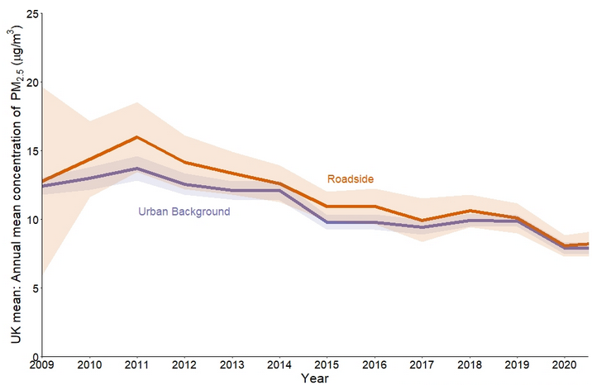
Figure 1 - UK mean concentration of PM2.5 [8]

Literature on Low-Cost Pollution Sensors

Venkatraman Jagatha and her co-authors wrote [9] a review into low-cost pollution sensors and highlighted that the current spatial measurements of outdoor air pollution is limited by the high cost of reference devices. She argues that there is a paradigm shift towards using low cost sensors due to the high price as well as advancements in micro-sensing technologies. She points to Purple-Air, a company who manufacture low-cost devices working together with the Environmental Protection Agency of the USA (EPA) in its projects[10]; and the draft roadmap of the EPA’s next generation of air quality monitoring includes low-cost sensors. In Germany, Breeze Technologies are working on projects together with different state governments [11], and the Sense-Box project is supported by the German Federal Ministry of Education and Research. Expanding to the European Union, the Joint Research Centre (JRC) “welcomes the frequent use of low-cost sensors by citizens, researchers, and institutions despite their drawbacks.”[9] The JRC used low-cost sensors in their AirSensEUR project and are testing low-cost sensors to classify them according to their probable applications [12].

Jiří Bílek and his co-Authors [13] ran a study for over 2 years near an ironworks in the Czech Republic, using a network of particulate matter (PMx), nitrogen dioxide (NO₂) and ozone sensors to evaluate the use of low-cost optical and electrochemical sensors over a continuous year-long operation. They found that the PMx measurements corresponded well with the reference method, and that the sensor they used, the Alphasense OPC-N3, could be used accurately individually or as part of a cluster. They found that the NO₂’s sensory measurements were poor when using linear regression methods, although the data could be improved with corrective functions, and more advanced data analysis methods. The authors concluded that the sensors are not suitable replacements for reference method devices, but are suitable for monitoring trends and concentration, and when deployed in a cluster have a high spatial and temporal resolution. They also concluded that they had proved the long term usability with their annual measurements.

The Breathe London Project [14] is a great example of lower-cost pollution monitoring stations being deployed. They deployed 100 sensors around London measuring fine particulate matter PM10, and PM2.5, as well as nitrogen oxide, nitrogen dioxide, and carbon dioxide. They concluded that their pilot project “successfully demonstrated that lower-cost sensors and mobile monitoring can be a useful tool for your city to tackle local air pollution and protect people’s health.”[14]

The literature is generally positive about the use of low cost sensors, although their limitations would need to be considered when planning a monitoring project, but Breathe London demonstrates their feasibility.

Current Market

I extensively compared six products on the market ranging from under £200 and increasing into the thousands (Appendix 1). At their core they will measure a selection of particulate matter diameters and some environmental conditions, and as the cost increases the number of size classifications of PM and number of environmental conditions generally increase as well as the inclusion of sensors for gaseous pollutants.

Starting with the Gaia A12 (Appendix 2) which retails for £162 and includes the most limited suite of sensors. The A12 only measures PM2.5 and PM10, and like all the following devices also temperature and relative humidity. It requires a Wi-Fi connection, and the data can be freely accessed via their web app or an API. [15]

PurpleAir’s Flex (Appendix 3) costs £217 and includes additional features than the A12, like PM1, and a gaseous sensor that measures total volatile organic compounds (VOCs), but this VOC measurement is only an index from 0 – 50, representing Excellent to Extremely polluted, not the standard unit of ‘parts per million’. This device also requires Wi-Fi and the data is made available from their web app. [16]

The Clarity Node-S (Appendix 4) includes the common PM2.5 and PM10, and a sensor for nitrogen dioxide. Clarity also sell an add-on module that adds a range of environmental sensors as well as sensors for the pollutants ozone and VOC. Unlike the previous two units which were powered by a DC transformer, this unit is powered by a solar panel and an internal battery. This unit also includes a sim card and cellular for data access through a web app or API. This is the device now deployed in the Breathe London Project and can be bought in the UK for £2400 from Imperial College London. [17]

The Pod by AQ Mesh (Appendix 5) includes the greatest range of pollution sensors including the sizing of PM 1, 2.5, 4 and 10, and seven gaseous pollutants including, nitrogen oxide, nitrogen dioxide, and general nitrogen oxides, cardon oxide, cardon dioxide, sulphur dioxide, O-zone, and Hydrogen sulphide. This is the only device I have compared that measures VOCs in parts per million. The Pod is manufactured to order in the UK and the number of sensors can be customised. This was the device originally deployed in the Breathe London Project with a selection of the total sensors they offer. [18]

Methodology

I have chosen to design my product using a microcontroller manufactured by Microchip. I chose to use the Microchip hardware and environment as the programming and debugging hardware could be made available to me through the university. I used microchip’s MPLAB X IDE and XC8 compiler as they are freely available and sufficiently documented by the manufacturer. Importantly MPLAB X includes a suite of debugging features, like hardware breakpoints, single stepping through code, access to the current register values and variables in memory, as well as GIT integration for version control.

Other brands of microcontrollers are available, like NXP and ST microelectronics who both licence an ARM core[19][20]. They can offer better unit prices when buying in bulk but are more costly individually. I would also need to invest in the debugging tools, and they do not manufacture any of their processors in DIP packaging.

I specifically chose the PIC18F26K80 as it has the largest EEPROM from the range, and is reasonably priced at £4.40 [21] in a DIP package which is convenient for prototyping. For future iterations, a surface mount microcontroller like the PIC16F15214 with a smaller number of pins would be more appropriate as well as cheaper at £0.65 per unit [22].

My Design

My Features

I formulated a plan for my design, using the knowledge I gained through my research into the current market as well as my reading of the current literature. Pope stated that Particulate matter smaller than 2.5μm is a good proxy for overall pollution levels, including ambient particulate matter pollution from transportation, wind-blown dust, burning of biomass, and industrial sources [3]. PM2.5 and PM10 are both regulated by the UK government, and PM10 is often included in PM sensors, so I chose to specify a sensor that covers both as a minimum. All but the cheapest device in my market research included some level of gaseous pollutant sensing, and I found accessibly priced sensors for VOCs and nitrogen dioxide, but due to the conclusion in Jiří Bílek’s study [13], I have specified for VOCs which are often a component of petroleum fuels, paint thinners, and are common ground-water contaminants.

I also tracked temperature and relative humidity, as these variables can affect the efficacy of the sensor, and if either of these variables go out of the sensor’s range of operation, then the data needs to be disregarded during those events. I have also specified to include local storage like Purple Air’s unit, which can store up to two years of data or Aeroqual’s AQY R, which can store up to five years of data. For the prototype I will use the internal EEPROM, but for a full product it would need to include a larger capacity such as an SD card or flash storage.

All of the devices that I compared include live data transmission over Wi-Fi or cellular, so I have specified for the data to be transmitted live with a wired connection and using the UART protocol and RS232 to increase the range. I have also specified that the device is low powered so that future iterations can incorporate solar charging and an internal battery.

The Sensors

The Sensirion SEN55-SDN-T (£28.90) measures PM1, PM2.5, PM4 and PM10 as well as nitrogen oxides and VOCs. The SEN55’s measurement of nitrogen oxides and VOCs is very limited as the unit does not output an absolute value and only an index calculated from a running average. I will also use Bosch’s BME680 (£9.07) which measures total VOCs as an index. Both of these sensors also measure temperature and humidity.

The Technology

Electronic particulate matter sensors are ‘optical particle counters’(OPCs) and they utilise a laser and photo diode and operate on either the scattering or obscuration principle but all optical particle counters operate by guiding the ambient air and particulate through the laser. The internal microcontroller then reads the output from a photo diode and measures the quantity and diameter of the particulate matter, and the mass per volume (μg/m³) can be calculated.

Sensirion state that “Although OPCs are fairly comparable in performance when counting particles, the algorithm converting the measured signal into a mass concentration is a real performance differentiator among different sensor manufacturers.” This becomes more apparent when digging deeper at how manufacturers design their sensors and algorithms. For example, Sensirion state their sensor is only able to measure 3-5% of aerosol particles and rely on statistics and extrapolation to calculate the mass concentration of PM0.5, PM1.0 and PM2.5. Because the OPC sensors estimate the mass concentration by counting the number of particles, and far fewer number of particles are required to have the same mass concentration, manufactures may choose to estimate larger particle sizes like Sensirion has with their PM4, and PM10 output. This is a limitation of low-cost sensors, as Alphasense produce two sensors which measures up to PM10, but cost from £185 to £365.

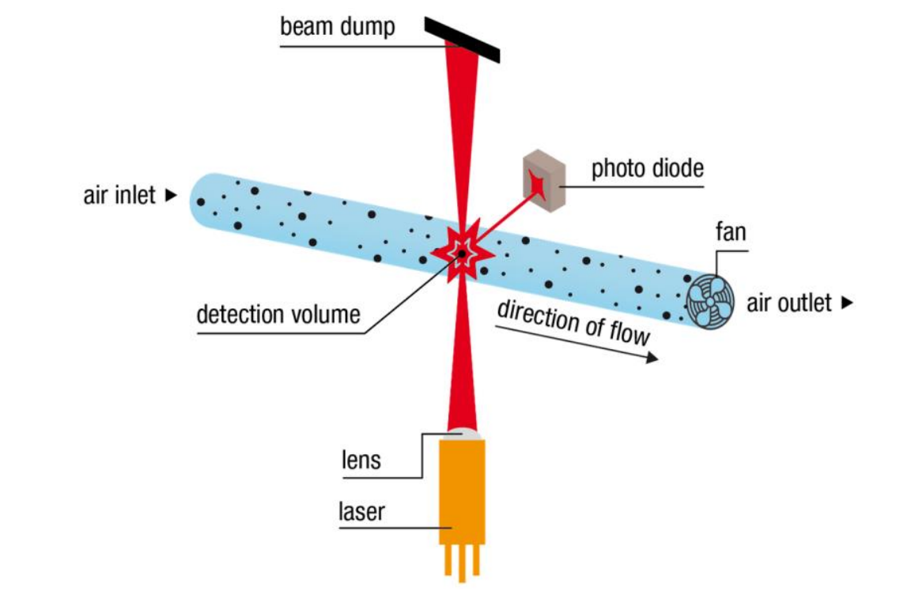
Figure 2 - OPC Sensor [23]

The Metal Oxide (MOX) Sensor is an electrochemical sensor, and it is constructed of a metal oxide surface that can be heated by a hotplate. The resistance of the metal oxide layer can be measured to determine a change in surrounding concentration in oxidising or reducing gases. The metal oxide surface can be designed to be selective to oxidising or reducing gases and even selective to specific compounds, but they are more generally broadband-sensitive, leaving them affected by a range of either oxidising or reducing gases.

Oxidising gases include gases like nitrogen oxides (NOx) and ozone. Nitrogen oxides are mostly formed from the combustion of fossil fuels and the UK department for Environment, Food & Rural Affairs stated that an estimated average of 70% of NOx concentrations at the roadside originate from road transport emissions [24]. Ozone doesn’t have any major emission source but is rather generated by a reaction between ultraviolet radiation from the sun and nitrogen oxides, or also from non-methane organic volatile compounds[25], [26]. oxidising gases are highly reactive which means they are powerful irritants and are harmful to the lungs even at low concentrations [27].

The SEN55 includes two MOX sensors, one selective to oxidising gases like nitrogen oxides and ozone and the other selective to reducing gases like VOCs and hydrogen.

MOX sensors have several drawbacks compared to reference method devices, for example, they are inadequate at taking absolute measurements as they require a well-defined baseline and the measurement from MOX sensors drifts over time. They are also hampered by the fact they are broadband-sensitive.

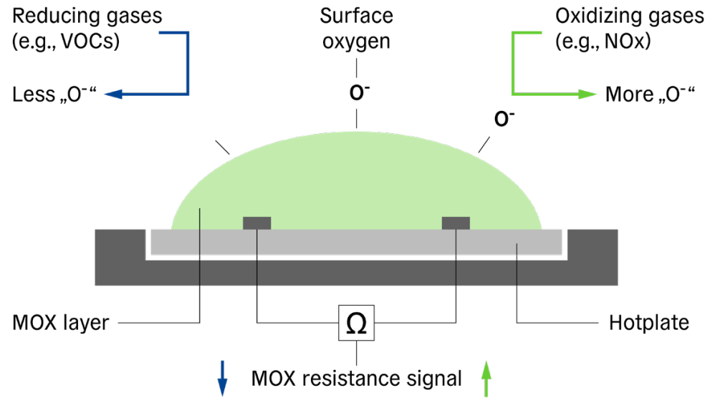
Figure 3 - MOX Sensor [28]

The Hardware

I started the development process by drawing the schematic with the software Proteus-8. For the purpose of simulation, I included the BME280, which is similar to the BME680, including temperature, humidity, and pressure but excludes the VOC sensor. I also included the DS3231 real time clock.

I connected the LEDs to PORTA through current limiting resistors, and I connected pull-up resistors to the two I2C lines. I also included Proteus’ visual instruments, the oscilloscope, I2C debugger, and UART terminal for debugging. Not included in the schematic is the decoupling capacitor on the DC power pins.

After getting the basics of the system operating in the simulation I assembled it on a breadboard.

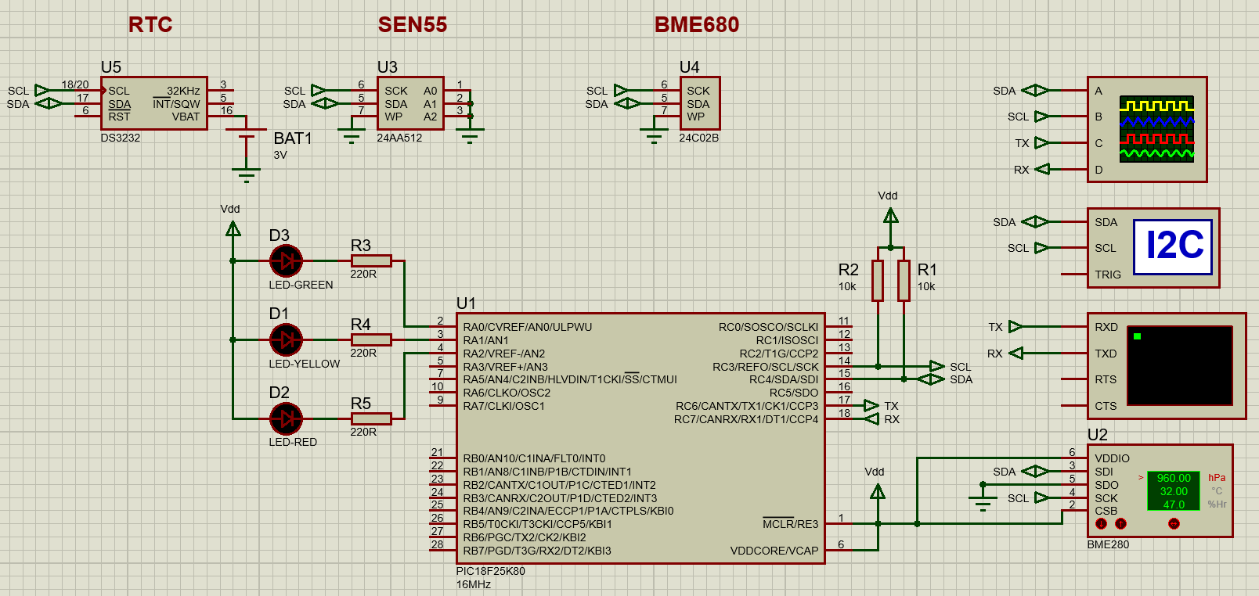
Figure 4 - Proteus Schematic

PIC18F26K80 | £ 4.40
BME680 module | £ 9.09
SEN55 | £ 28.90
DS3231 module | £ 9.64
LED x3 | £ 2.40
10K Resistor x2 | £0.96
1µF Capacitor | £0.18
Total: | £ 55.57
Figure 5 - Price of prototype

The Software

I firstly laid out the operational process in a flow diagram for my reference during writing the program. The flow chart can be split into two parts. On power up the system is initialised, Firstly the microprocessor (PIC) and its internal peripherals, followed by the sensors via I2C instructions.

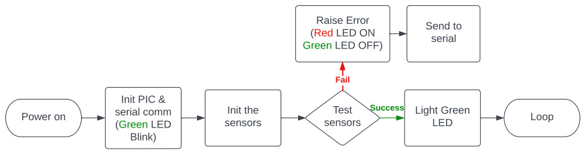
Figure 6 - Initialising flowchart

To check the sensors are connected, I request the ID number from the BME680 (figure 7) and the firmware number from the SEN55 (figure 8) and compare it to the expected value. If the sensors return the expected value, I set them to their measurement mode with their respective methods laid out in their data sheets.

1. uint8_t get_BME680_ID(void){ // returns ID
2. i2c_start();
3. i2c_write(BME680_WRITE_ADDR); // send slave address (write mode)
4. i2c_write(BME680_CHIP_ID); // send reg i want to read
5. i2c_rep_start(); // send repeated start as specified in datasheet
6. i2c_write(BME680_READ_ADDR); // send slave address (read mode)
7. uint8_t data = i2c_read(0); // store ID in data
8. i2c_stop(); // send stop condition
9. return data; // return the ID
10. }
Figure 7 - BME680 getting ID
1. uint8_t get_SEN55_Firmware(void){ // returns ID.
2. i2c_start();
3. i2c_write(SEN55_WRITE_ADDR); // send slave address (write mode)
4. i2c_write(0xD1); // send reg
5. i2c_write(0x00); //
6. i2c_rep_start(); // send repeated start
7. i2c_write(SEN55_READ_ADDR); // send slave address (read mode)
8. uint8_t data1 = i2c_read(1); // firmware number
9. uint8_t data2 = i2c_read(1); // reserved
10. uint8_t CRC = i2c_read(0); // CRC
11. i2c_stop(); // send stop condition
12.
13. uint8_t data[2] = {data1, data2};// verify CRC
14. if (CRC != CalcCrc(data)) {
15. printf("CRC ERROR");
16. return 0xFF;
17. } else {
18. return data1; // return the ID
19. }
20. }
Figure 8 - SEN55 getting ID
The BME680 includes a large range of configurations including mandatory and optional settings. I chose to use an oversampling of 1x for temperature and humidity as this will allow for the highest accuracy, but also makes the measurements susceptible to noise (Figure 9). The BME680 also has a built in IIR filter which can be applied to the temperature and pressure measurement, which is designed to filter out any transient spikes. I opted out of passing the temperature data through the IIR filter as it affects the bandwidth and resolution, and due to the limited thermal coupling to an enclosure, I don’t expect transient readings from the temperature sensor.

1. void BME680_init(void){ // sets oversampling to 1x for t/rh/p
2. i2c_start(); // reg is only implemented after write to ctrl reg.
3. i2c_write(BME680_WRITE_ADDR); // send slave address (write mode)
4. i2c_write(BME680_CTRL_HUM); // send slave register
5. i2c_write(0x01); // set humidity oversampling to x1
6. i2c_stop();
7.
8. i2c_start();
9. i2c_write(BME680_WRITE_ADDR); // send slave address (write mode)
10. i2c_write(BME680_CTRL_MEAS); // send slave register
11. i2c_write(0x24); // set temp and pressure oversampling to x1
12. i2c_stop();
13. }
Figure 9 - BME initialisation

Before I wrote the code for the BME680 for the hardware, I simulated in Proteus using the BME280 as both units are initialised with the same method and the temperature and humidity is also accessed through the same method. Simulating the process first was very important to being able to get it working on the hardware as I had access to additional information, such as what instruction the sensor received. One example was that the PIC was attaching an acknowledgment onto the last I2C byte, which caused the BME280 to load the incremented register value into the buffer, so that when the next instruction was received, it would firstly send the byte left in the buffer before sending part of the requested data. Figure 10 shows the simulation log and that a calibration data byte (DIG_H1) was sent, but the I2C debugger did not show the byte had been pushed onto the wire. This indicted an issue with the PIC’s instruction, and I was able to locate the bug in the code where a byte was always acknowledged regardless of the argument passed to the function.

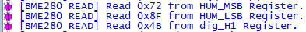
Figure 10 - Proteus log

The simulation log also gave the hex value in that register so that I could verify the value in the PIC’s memory, which was especially helpful as the registers are a mix of unsigned and signed integers as well as some of the values are greater then 8 bits so some registers contain data for separate purposes, for example, the register 0xE5 stores the four least significant bits for DIG_H4 as well as the four least significant bits of DIG_H5 (Figure11). This required some bitwise operations to remove the unwanted data and position the bits before combining them with their respective most significant bits, which can be seen in figure 12.

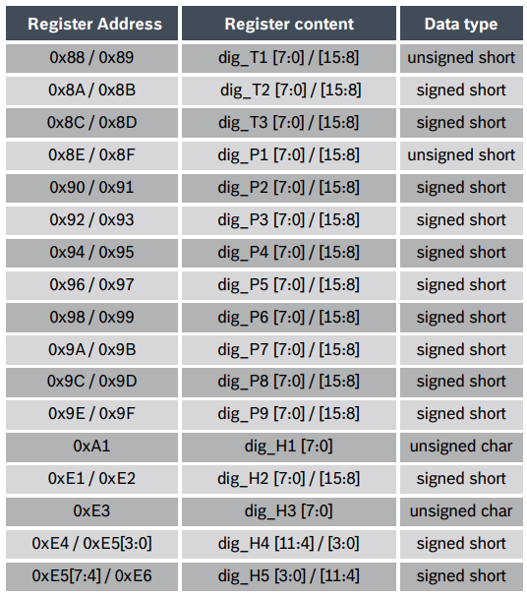
Figure 11 - Register addresses

1. DIG_H4 = (DIGH4_MSB << 4) + (DIGH4_5_LSB & 0x0F);
2. DIG_H5 = (DIGH5_MSB << 4) + ((DIGH4_5_LSB >> 4) & 0x0F);
Figure 12 – Combining bytes
The VOC sensor requires several registers to be set for operation, including the hot plate temperature and duration of heating, but as the hot plate temperature must be compensated for with the ambient temperature this is adjusted on every loop. Figure 13 shows the temperature being set to 300°C for 100ms.

1. void start_gas(void) {
2. uint8_t res_heat = calc_res_heat();
3.
4. i2c_start();
5. i2c_write(BME680_WRITE_ADDR);
6. i2c_write(BME680_GAS_WAIT_0);
7. i2c_write(0x59); // set heat up duration to 100ms
8. i2c_stop();
9.
10. i2c_start();
11. i2c_write(BME680_WRITE_ADDR);
12. i2c_write(BME680_RES_HEAT_0);
13. i2c_write(res_heat); // set heater set point to 300*C
14. i2c_stop();
15.
16. i2c_start();
17. i2c_write(BME680_WRITE_ADDR);
18. i2c_write(BME680_CTRL_GAS_1);
19. i2c_write(0x10); // enable GAS read
20. i2c_stop();
21. }
Figure 13 - Setting heat plate

The program has a simple operation which loops for as long as there is still space for the collected data, shown in the flow diagram (figure 14).

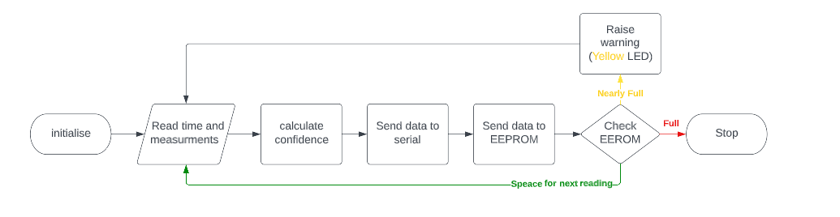
Figure 14 - Operational flowchart
The process of getting the time is done at the top of the loop and calls the related functions. During the readings the green light is turned off, which has an effect of blinking the LED, which confirms the device is running.

1. while(1){
2.
3. // take measurements
4. set_green_LED(0);
5.
6. BME680_forced(); // force BME to take T/RH/VOC measurement
7. temperature = calc_temp(); // store temp
8. humidity = calc_hum(); // store RH
9. VOC_res = calc_voc(); // store VOC
10. get_SEN55_Values();
11. get_time();
12.
13. set_green_LED(1);
Figure 15 - Getting the time and measurements
To store the data to the EEPROM I used the included memory library to write the data to incrementing addresses. On each loop, I confirm there is space, and once the capacity is at 75%, I light the yellow LED as a warning. With the current EEPROM of 1024 byes, 30 readings can be stored.
1. if (eeprom_address < 0x3FF) {
2. // store measurements
3. DATAEE_WriteByte(eeprom_address, (temperature & 0xFF00) >> 8);
4. eeprom_address += 1;
5. DATAEE_WriteByte(eeprom_address, temperature & 0x00FF);
6. eeprom_address += 1;

...

24. // store current EEPROM address case of power loss.
25. DATAEE_WriteByte(0x01, (eeprom_address & 0xFF00) >> 8);
26. eeprom_address += 1;
27. DATAEE_WriteByte(0x00, eeprom_address & 0x00FF);
28. eeprom_address += 1;
29.
30. } else { // EEPROM full
31. set_green_LED(0);
32. set_red_LED(1);
33. }
34.
35. if (eeprom_address > 0x300) { // 25% memory left
36. set_yellow_LED(1);
37. }
Figure 16 - Storing data to EEPROM
Once the data has been collected, it is transmitted by the UART peripheral of the PIC. For good signal integrity, I converted the TTL logic level to RS232 with a ‘MAX232’ then a RS232 to USB adapter to connect to a PC. This would allow for a greater wire length than TTL and USB alone. When the PC recieves the information, it has already been converted to the HEX form of ASCII, so PC only needs to print the characters received.

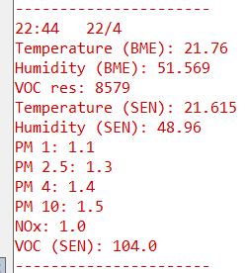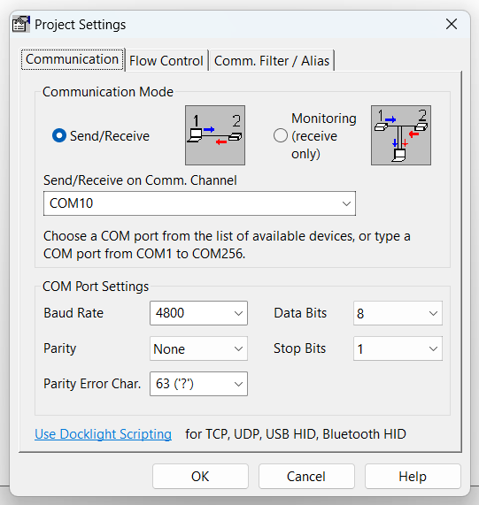
Figure 17 - PC terminal Figure 18 - setting the terminal

Results & Discussions

I first ran the system for two hours to compare the sensor readings with a “UMI” temperature and humidity sensor as well as a “Life Basis” air quality monitor, which measured temperature, humidity, total VOCs (tVOC), formaldehyde (CH₂O), PM 1, PM 2.5, and PM 10. The first chart shows that the BME and SEN humidity tracks well with my reference devices. The temperature measured by the Life Basis unit was comparatively lower than the other devices, this is partly due to the unit only measuring in whole degrees. The temperature and humidity measurements are important for the sensors as the values are fed back as compensation parameters.

Figure 19 - Temperature and Relative Humidity Baseline Comparison

I then plotted the VOC reading from the BME680 and the tVOC and CH₂O from my reference device. The reference device’s readings from the first 30 minutes were sporadic and did not correlate with the BME680 readings so I would surmise that it requires a burn-in time before stabilising. Despite my efforts, at 2:45 all the sensors experienced a drop in VOC levels, likely from a gust of fresh air, which indicates that the BME680 is equally as quick to respond as my reference unit but the BME680 response afterwards was muted compared to the tVOC of the reference device.

Figure 20 - BME680 VOC Baseline Comparison

I also plotted the two indexes that the SEN55 generates from its’ two MOX sensors. The nitrogen oxides (NOx) index remained 1 for the duration of the test, which means that the level of NOx and ozone did not change. The VOC index is designed to rest at 100, and increases when the current reading is higher than the 24 hour average, and drops below 100, when the current air quality is better then the 24 hour average. The VOC index dropped from 100 to 98 while the reference unit measured a drop in tVOC and CH₂O and returned to 100 after the event. The index read 147 then 178 before settling at 100, at the same time as the tVOC raised from 0.214 μg/m³ to 0.394 μg/m³, which is a 84.1% raise, compared to the index raising 78%.

Figure 21 - SEN55 Baseline Comparison

I also ran some tests where I would aerosolise a pollutant and measure the effect. I was inspired by the experiments done by Dr Salimifard and her co-authors [29], where they placed a number of sensors in an airtight chamber and inserted a set amount of a compound shown in figure 22. As they knew the size and weight of their chosen compounds and the volume of the chamber, they were able to calculate the expected results. For my method I created two events with different mixtures, acetone and antiperspirant. Acetone is organic and highly volatile, so would be suitable to test the VOC sensors. The antiperspirant contains aluminium chloralhydrate which has a particle size of between 10μm and 15μm as well as other compounds of smaller diameters so is a suitable compound to test the particulate sensor.

.
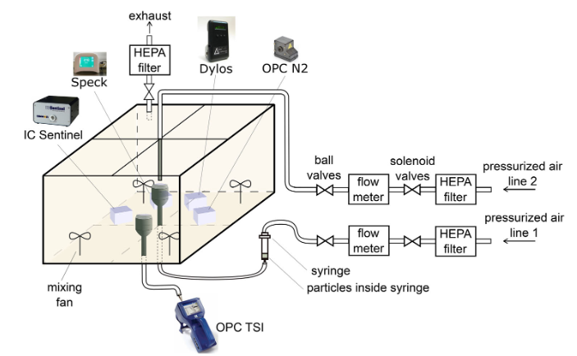
Figure 22 – Dr Salimifard’s experiment

I plotted the BME680 VOC reading and the SEN55 VOC index reading on separate charts against my reference device. The reference device went out of range at 9.999 μg/m³ and 1.999 μg/m³ of tVOC and CH₂O respectively within 2 seconds of the event, and the BME680 peaked at 665 Ω after 12 seconds. The SEN55 took 28 seconds from the event to reach the peak VOC index. The CH₂O stayed out of range for 38 seconds and tVOC stayed out of range for 1 minute and 6 seconds.

Figure 23 - Acetone BME680

Figure 24 - Acetone SEN55

To test the PM sensors, I sprayed an aerosol containing aluminium chloralhydrate which due to its particle size of between 10μm and 15μm, should be detectable by the PM10 sensor. There are also other compounds of various sizes as well as butane and propane which are volatile organic compounds (VOCs). The SEN55 responded faster than the reference device peaking after 4 seconds from the event, whereas the reference device took 6 seconds to peak. The reference device also didn’t peak as high with 526 μg/m³ of PM10 whereas the SEN55 measured 1252.6 526 μg/m³ of PM10 at its peak. After 10 seconds from the event, the SEN55 and reference readings started to converge on one another to the point when PM 2.5 is 166 μg/m³, SEN55 is only reading 3 μg/m³ higher.

Figure 25 - Particulate Matter

The index the SEN55 generates is an average of past readings which can be seen by the latency in the rise after the event. This is advantageous to avoid spurious readings but prevents a quick response from a spike in contaminants.
The quality of my tests fell short of the experiments I was inspired by, as I was unable control the quality of the air during my baseline test, and I was unable to determine the quantity of the pollutant that I dispersed in the air as the tests weren’t self-contained and I didn’t know the exact make-up of the compounds. However, the corelation between my device and the reference device were encouraging.

Conclusion

In conclusion, I was able to produce a prototype of the device I set out to design in my proposal. I was able to use the two sensors I proposed and collect their data. I also met my objectives in the literature review of researching the viability of low cost sensors by covering the work of Venkatraman Jagatha [9], Jiří Bílek [13], and the Breathe London Project [14]. I also tested my implementation, although not to the extent of Dr Salimifard’s experiments. A part of my design objective was to design an enclosure for the device. This is something that I did not do. As the process went on, I felt like this became outside the scope of the project of designing an electronic system.

I was disappointed that more advanced functions of the BME680 were locked behind a closed source binary firmware provided by the manufacturer Bosch. I wanted to utilise the air quality index (AQI) that it can calculate, but they have kept the equation proprietary, and can not be utilised without implementing their memory heavy firmware.

The device has room for improvement with some of the proposed features still to add. Namely calculating the confidence of the measurements by using the second sensor. An additional function where the EEPROM data is transmitted en masse to the terminal is also required as the current version does not support recalling the stored data. There are still some rough edges with error handling, the software can hang if an I2C message is incomplete, and the CRC bytes from the SEN55 are not always checked. If a CRC byte is incorrect or a byte is not acknowledged then the data should be requested again.

The design of the hardware could be revisited too, for example, as suggested in my discussion of my features, the design could implement a battery and solar charging circuit. This was a feature of the majority of the products I compared on the current market.

Reflection

I started this project with no knowledge of the C programming language, so this has been a great opportunity for me to familiarise myself with it and test my understanding. I have greatly benefited from working on the electronics rather than a simulation as it introduced additional challenges. For example, the datasheet for the SEN55 improperly described how to communicate with it leading to much head scratching, which is where I learned the most about the I2C protocol.

References

[1] ‘Every breath we take: the lifelong impact of air pollution’, RCP London, Feb. 23, 2016. https://www.rcplondon.ac.uk/projects/outputs/every-breath-we-take-lifelong-impact-air-pollution (accessed Oct. 30, 2022).
[2] S. S. Lim et al., ‘A comparative risk assessment of burden of disease and injury attributable to 67 risk factors and risk factor clusters in 21 regions, 1990–2010: a systematic analysis for the Global Burden of Disease Study 2010’, The Lancet, vol. 380, no. 9859, pp. 2224–2260, Dec. 2012, doi: 10.1016/S0140-6736(12)61766-8.
[3] C. A. Pope et al., ‘Lung cancer and cardiovascular disease mortality associated with ambient air pollution and cigarette smoke: shape of the exposure-response relationships’, Environ. Health Perspect., vol. 119, no. 11, pp. 1616–1621, Nov. 2011, doi: 10.1289/ehp.1103639.
[4] R. D. Brook et al., ‘Particulate matter air pollution and cardiovascular disease: An update to the scientific statement from the American Heart Association’, Circulation, vol. 121, no. 21, pp. 2331–2378, Jun. 2010, doi: 10.1161/CIR.0b013e3181dbece1.
[5] D. W. Dockery et al., ‘An association between air pollution and mortality in six U.S. cities’, N. Engl. J. Med., vol. 329, no. 24, pp. 1753–1759, Dec. 1993, doi: 10.1056/NEJM199312093292401.
[6] F. Laden, J. Schwartz, F. E. Speizer, and D. W. Dockery, ‘Reduction in fine particulate air pollution and mortality: Extended follow-up of the Harvard Six Cities study’, Am. J. Respir. Crit. Care Med., vol. 173, no. 6, pp. 667–672, Mar. 2006, doi: 10.1164/rccm.200503-443OC.
[7] K. A. Miller et al., ‘Long-term exposure to air pollution and incidence of cardiovascular events in women’, N. Engl. J. Med., vol. 356, no. 5, pp. 447–458, Feb. 2007, doi: 10.1056/NEJMoa054409.
[8] ‘Concentrations of particulate matter (PM10 and PM2.5)’, GOV.UK. https://www.gov.uk/government/statistics/air-quality-statistics/concentrations-of-particulate-matter-pm10-and-pm25 (accessed Dec. 29, 2022).
[9] J. Venkatraman Jagatha et al., ‘Calibration Method for Particulate Matter Low-Cost Sensors Used in Ambient Air Quality Monitoring and Research’, Sensors, vol. 21, no. 12, p. 3960, Jun. 2021, doi: 10.3390/s21123960.
[10] Karoline Johnson, Brett Gantt, Ian VonWald, and Andrea L. Clements, ‘PurpleAir PM2.5 performance across the U.S.#2’. https://cfpub.epa.gov/si/si_public_record_Report.cfm?Lab=CEMM&dirEntryId=348236 (accessed Nov. 06, 2022).
[11] ‘Urbane Luftqualitätsüberwachung: Luftqualitätssensoren, -daten und -analysen’, Breeze Technologies. https://www.breeze-technologies.de/de/loesungen/urbane-luftqualitaet/ (accessed Nov. 06, 2022).
[12] M. Gerboles, L. Spinelle, and M. Signorini, ‘AirSensEUR: an open data/software/hardware multi-sensor platform for air quality monitoring. Part A: sensor shield’, JRC Publications Repository, Oct. 21, 2015. https://publications.jrc.ec.europa.eu/repository/handle/JRC97581 (accessed Nov. 06, 2022).
[13] J. Bílek, O. Bílek, P. Maršolek, and P. Buček, ‘Ambient Air Quality Measurement with Low-Cost Optical and Electrochemical Sensors: An Evaluation of Continuous Year-Long Operation’, Environments, vol. 8, no. 11, p. 114, Oct. 2021, doi: 10.3390/environments8110114.
[14] ‘Breathe London Map’, Breathe London. https://breathelondon.edf.org/ (accessed Jan. 31, 2023).
[15] T. W. A. Q. I. project, ‘Chất lượng không khí trên toàn thế giới: AirNet Sensor Network’, aqicn.org. https://aqicn.org/gaia/ (accessed Nov. 09, 2022).
[16] ‘PurpleAir Flex Air Quality Monitor’, PurpleAir, Inc. https://www2.purpleair.com/products/purpleair-flex (accessed Feb. 05, 2023).
[17] ‘Breathe London Node | Imperial College London Online Store’. https://estore.imperial.ac.uk/product-catalogue/faculty-of-medicine/school-of-public-health/breathe-london-node (accessed Mar. 05, 2023).
[18] ‘AQMesh’, AQMesh. https://www.aqmesh.com/products/aqmesh/ (accessed Feb. 05, 2023).
[19] ‘Arm Microcontrollers’. https://www.nxp.com/products/processors-and-microcontrollers/arm-microcontrollers:ARM-MICROCONTROLLERS (accessed Apr. 25, 2023).
[20] ‘Arm Microcontrollers - 32-bit MCUs - STMicroelectronics’. https://www.st.com/content/st_com/en/arm-32-bit-microcontrollers.html (accessed Apr. 25, 2023).
[21] ‘PIC18F26K80-I/SP - 8 Bit MCU, Flash, PIC18 Family PIC18F K8x Series Microcontrollers, PIC18, 64 MHz, 64 KB, 28 Pins’. https://uk.farnell.com/microchip/pic18f26k80-i-sp/mcu-8bit-pic18-64mhz-dip-28/dp/1823165 (accessed Apr. 07, 2023).
[22] ‘PIC16F15214-I/SN - 8 Bit MCU, PIC16 Family PIC16F152xx Series Microcontrollers, PIC16, 32 MHz, 7 KB, 8 Pins, NSOIC’. https://uk.farnell.com/microchip/pic16f15214-i-sn/mcu-8bit-32mhz-nsoic-8/dp/3628081 (accessed Apr. 07, 2023).
[23] ‘Particulate matter sensing for air quality measurements’. https://sensirion.com/products/product-insights/specialist-articles/particulate-matter-sensing-for-air-quality-measurements/ (accessed Dec. 30, 2022).
[24] ‘Emissions of air pollutants in the UK – Nitrogen oxides (NOx)’, GOV.UK. https://www.gov.uk/government/statistics/emissions-of-air-pollutants/emissions-of-air-pollutants-in-the-uk-nitrogen-oxides-nox (accessed Apr. 02, 2023).
[25] Cluster of Water and Environment, Department of Civil Engineering, Faculty of Civil Engineering and Built Environment, Universiti Tun Hussein Onn, 86400 Batu Pahat, Johor, Malaysia. et al., ‘The cause-and-effect analysis of ground level ozone (O3), air pollutants and meteorological parameters using the causal relationship approach’, J. Eng. Res., May 2022, doi: 10.36909/jer.17233.
[26] ‘Concentrations of ozone’, GOV.UK. https://www.gov.uk/government/statistics/air-quality-statistics/concentrations-of-ozone (accessed Mar. 28, 2023).
[27] S. Cakmak et al., ‘Associations between long-term PM2.5 and ozone exposure and mortality in the Canadian Census Health and Environment Cohort (CANCHEC), by spatial synoptic classification zone’, Environ. Int., vol. 111, pp. 200–211, Feb. 2018, doi: 10.1016/j.envint.2017.11.030.
[28] ‘Smart sensor solutions’. https://sensirion.com/products/catalog/SGP41/ (accessed Apr. 23, 2023).
[29] P. Salimifard, D. Rim, and J. D. Freihaut, ‘Evaluation of low-cost optical particle counters for monitoring individual indoor aerosol sources’, Aerosol Sci. Technol., vol. 54, no. 2, pp. 217–231, Feb. 2020, doi: 10.1080/02786826.2019.1697423.

Appendix

Appendix 1
Spreadsheet of current market - [EXTERNAL]

Appendix 2
GAIA A12
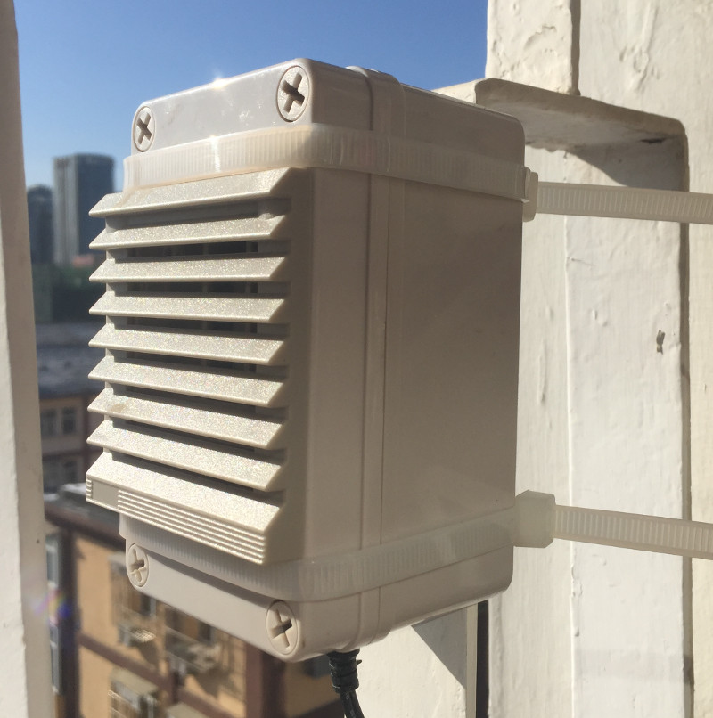

Appendix 3
PurpleAir
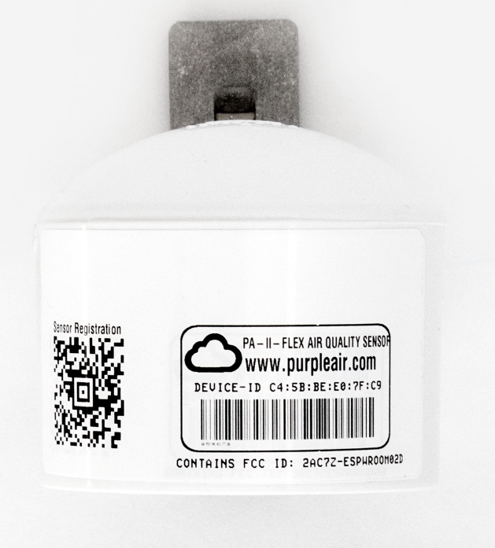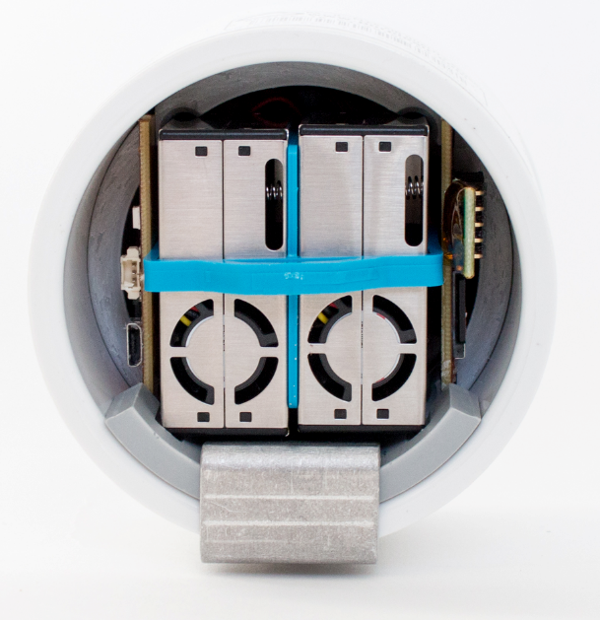

Appendix 4
Clarity Node-S
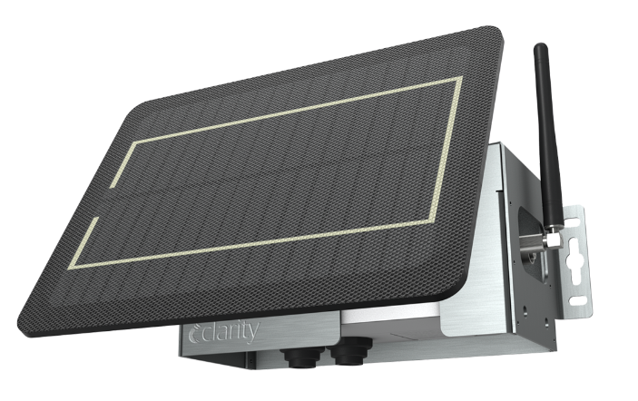

Appendix 5

AQ-Pod Mesh
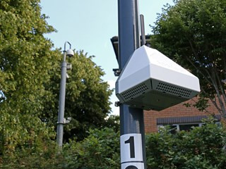

Appendix 6
TSI Bluesky
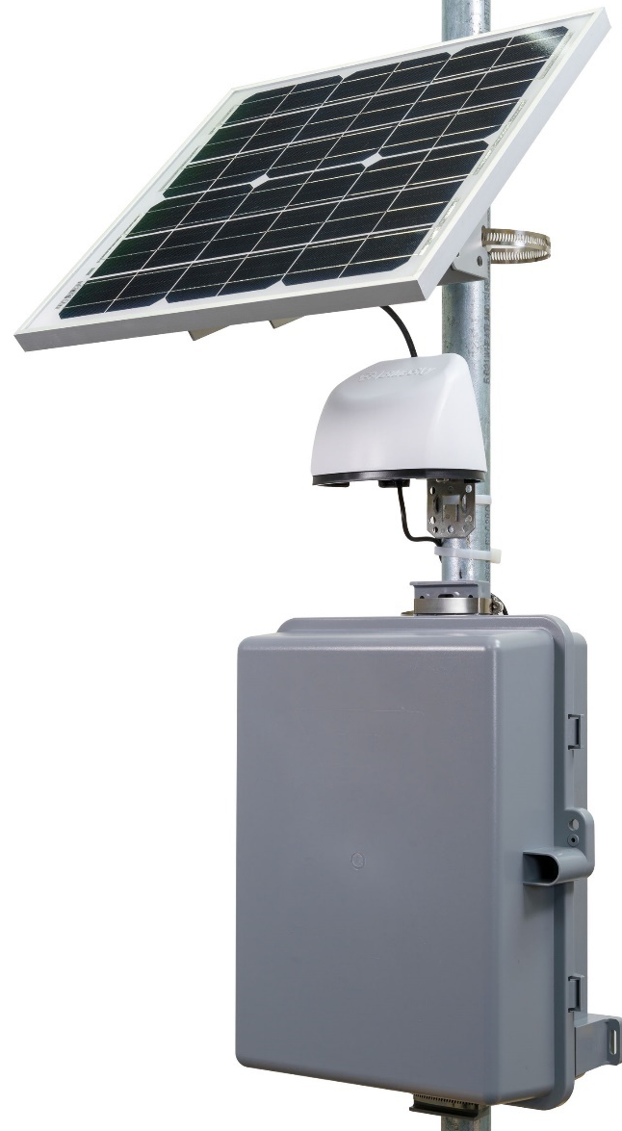

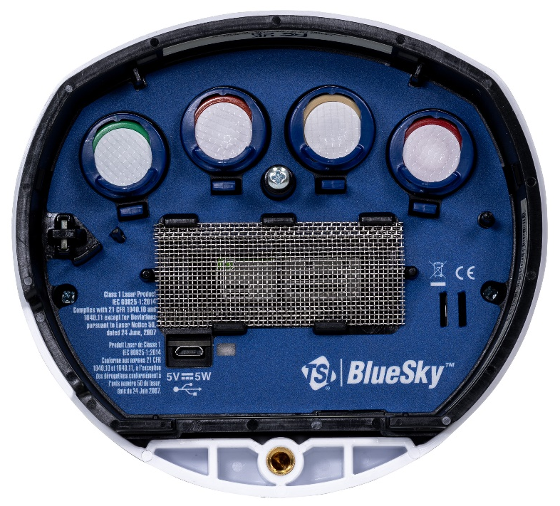

Appendix 7
Areoqual - R
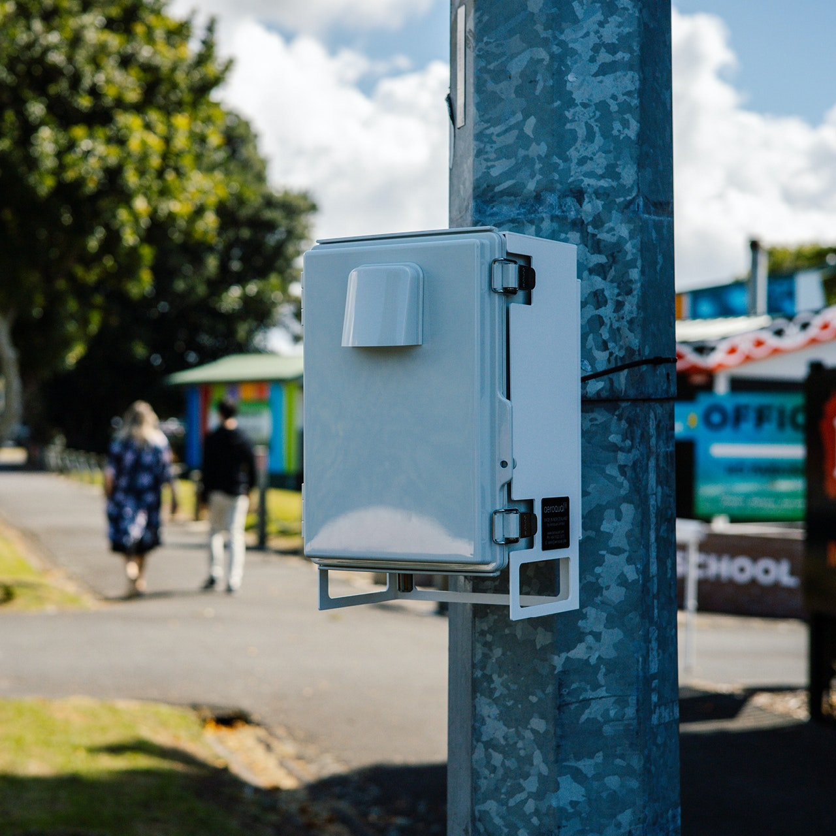

Appendix 8
Proteus files - [EXTERNAL]

Appendix 9
MPLABX files - [EXTERNAL]

