Revised word count- 4284

AC 1.1
The use of evidence based practice (EBP) has increased immensely over the last decade or more, people professionals are encouraged to adopt an evidence based approach when developing new practices, strategies or policies (Armstrong and Taylor, 2020). Practitioners now subconsciously base most of their decisions on EBP. Barends et al (2014) defines evidence based practice EBP as a combination of critical thinking and the conscientious explicit use of the best available evidence from multiple credible sources.
EBP is a decision making process used by HR practitioners based on the principle that organisational decisions should be made after considering the multiple available sources of evidence to come to a high quality decision (Armstrong and Taylor, 2023). To ensure decisions are being made conscientiously practitioners must use a variety of critically appraised sources (Rousseau, D.M. and Barends, 2011), for example, scientific literature, work-based research, internal/external feedback and practitioner expertise. This approach is a radical change from the typical decision making methods used by management in prior years, as it allows scope for management to develop critical thinking rather than using only personal judgement and experiences (Young, 2023).
EBP is a decision-making process used by practitioners based on the principle that organisation’s high-quality decisions should be made after considering multiple available sources of evidence (Armstrong and Taylor, 2023). To make conscientious decisions, a variety of critically appraised sources needs to be considered (Rousseau and Barends, 2011) e.g. scientific literature, work-based research, internal/external feedback, and expertise. This type of process allows scope to develop critical thinking and not rely on personal judgement and experiences (Young, 2023).
Practitioners should focus on the four 4 fundamental sources of evidence when making decisions; scientific, organisational, experimental and stakeholder based. Breaking each of these sources down Each of these allows practitioners to achieve a better understanding of why evidence based practice EBP is argued to be the most beneficial approach when it comes to business decisions.
Scientific evidence allows practitioners to gather academic findings through published scientific research and analysis. This type of evidence is considered to be the 'best available evidence' as the research is vetted accordingly to the standards of measurement of reliability and internal validation (Rousseau, D.M. and Barends, 2011).
Organisational evidence can be gathered from the data readily available from within an organisation (Waite, K. et al, 2021). This evidence is easily accessible and depicts an accurate picture of the organisation’s current situation. Examples of this data would be employee turnover data, sickness absence data, learning and development L&D metrics.
Experimental evidence is made up of the knowledge and experience of those within the organisation. Decisions are influenced by experienced professionals that have faced a similar situations (Waite, K. et al, 2021). This source of evidence is a subconscious way of decision making as most managers tend to depend on on personal experiences in the first instance.
Stakeholder evidence takes into account considers the views and values of internal and external stakeholders before making a decision (Young, 2023). This type of evidence could includes the customer feedback and complaints.
Before considering the above 4 sources of evidence Barends et al (2014) recommends that people practitioners use a six- 6 step approach before reaching a high quality decision.
The six 6 steps are:
1. Asking- This involves translating a practical issue into an answerable question.
2. Acquiring- Systematically researching and gathering relevant evidence.
3. Appraising- Critically evaluating the validity and relevance of the evidence.
4. Aggregating- Weighing up and putting together all relevant evidence.
5. Applying- Incorporating the evidence into the decision-making process.
6. Assessing- Evaluating the outcome of the decision made.
(Armstrong, 2016)
EDP should contribute to practitioners in achieving a sound unbiased decision, however there are some limitations. One being One limitation of this would be the lack of skills required to critically evaluate the validity of the available evidence (Rousseu and Briner, 2014), if practitioners do not posses have the skills to underpin the trustworthiness and quality of the evidence they may be tempted to base their decisions on personal judgement from past experiences and this can lead to bias conclusions (Barends and Rousseau, 2018).

AC1.2
For people practitioners to overcome and identify issues, there are a range of analysis tools that can be used (Armstrong and Taylor, 2020). These tools allow practitioners to diagnose organisational challenges, issues, and opportunities. Examples include environmental analysis tools, strategic reviews, Porter’s five forces, fishbone analysis etc. just to name a few.
The most commonly used environmental analysis tools within people practice are PESTLE and SWOT. PESTLE analysis aids in identifying the external factors that may impact an on organsation’s decisions whereas SWOT focuses on the appropriate internal actions to tackle any external factors. (Perera, 2017).
PESTLE analysis is a management tool used to identify external factors that may affect an organisation by influencing the business decisions (CMI, 2014). It focuses on the 6 key external factors; Political, Economic, Sociological, Technological, Legal and Environmental (CIPD, 2022a).
Political factors take into account considers government policies and how this may impact an organisation. For example, tax implications, industry regulations and global trade agreements and restrictions (CIPD, 2022a).
Economic factors include changes within our economy e.g. unemployment, inflation, exchange/interest rates and wage changes (CMI, 2014). A recent example of how economic factors influence business decisions is the recent Real Living Wage changes. In October 2023 the new rate of Real Living Wage was announced, the national living wage increased by 9.7% having an impact on organisations' pay policies (GOV.UK, 2013) this consequently forced organisations to evaluate and review their current pay policies and implement the appropriate changes.
Sociological factors are cultural factors that impact an organisations decisions and are argued to be the most difficult to predict as it involves the ideals and behaviour of the public (Perera, 2017). An example of these factors would be life expectancy, population growth and birth rates (Marmol and Feys, 2015). Organisations need to adapt to the every changing sociological factors to ensure strategies reflect the current sociological environment (Perera, 2017).
Technological factors include the ever-changing new technologies that are continuing to be introduced and how this will impact an impacts organisations’ way of working (CIPD, 2023). Gen AI is an example of a recent new technological factor this that has a huge impact on work methods. This tool can be used to elevate HR processes such as recruitment and onboarding (Horton, 2023a). For example, Gen AI has the ability to can generate job adverts and interview questions based on job descriptions and this could aids in reducing bias and ensures consistency throughout the recruitment process (Horton, 2023b), However this tool comes with trial and error and should be tested sufficiently. before releasing to the public.
Legal factors take into account considers any legislation that may have an impact on organisations, such as e.g. employment laws and regulations, imports/exports etc. (CIPD, 2023). Organisations must ensure that they operate within a the framework of the law (Worthington, I. et al, 2018) and pay close attention to employment laws such as the Equality Act 2020.
Environmental factors include issues such as global warming and sustainable development (Marmol and Feys, 2015) and how this impacts an organisations operation.
Both of these environmental analysis tools work hand in hand within EBP, PESTLE evaluates the available external evidence and SWOT takes the appropriate internal actions to prevent any avoidable challenges.
In addition to the available analysis tools, there are a range of analysis methods used within people practice, these include including people analytics, benchmarking, metrics, job analysis, observations (Armstrong and Taylor, 2023). People analytics focuses primarily on analysing staff data such as performance, wellbeing, and productivity (Armstrong and Taylor, 2023) to recoginses and improve business operations, thus enabling practitioners to demonstrate a more effective evidence-based approach.

AC1.3
Critical thinking is a vital component when adopting an evidence-based approach as it encourages the use of rational thinking. Critical thinkers must first have the ability to reflect and analyse any situation (Howlett and Coburn, 2019), whether it is considered to be challenging or not. Secondly, they must have the ability to construct appropriate arguments and relay this in an appropriate manner to peers (Harber, 2020) and thirdly, having the ability to recognise when others are using critical thinking techniques how this may impact the organisation’s strategies (Howlett and Coburn, 2019).
Paul and Elder (2019) argues that without critical thinking, decisions made are biased, uninformed and lack quality. The ability to think critically critically think underpins the quality of good management and leadership (Eales-Reynolds, et al 2013). Before any business decision can be made, practitioners must analyse each source of evidence and asses the validity (Harber, 2020). Personal biases can hinder the ability for this, it is important to eliminate bias by considering a more evidence-based approach. Biases come from past experiences, emotions, and social and cultural influences. Many practitioners may be subject to bias to save time on making decisions, but this could result in decisions being made irrationally and faulty thought out (Scott and Lamb, 2018). To avoid decisions being made purely on bias, practitioners should question and evaluate all evidence before coming to a decision. Unconscious bias can have a big impact on recruitment and selection. To avoid this, organisations should select candidates via blind CVs, meaning excluding any personal information which will take away any characteristics that could be judged on. This allows practitioners to increase diversity and focus on the skills and attributes of the candidate rather than personal information (Scott and Lamb, 2018).

AC1.4
Decision making and problem solving go hand in hand when discussing EBP, the process of the two combined supports the best course of action. There are 3 main types of decision making: strategic, tactical and operational (MindTools, no date). Practitioners need to poses have the right decision making skills to support sound decisions and determine which will be the best course of action to take (MindTools, no date).
In order for practitioners to For practitioners to make effective decisions it’s important to consider the many available decision making tools (CMI, 2020), these are:
- Kepner and Tregoe's model
- De Bono’s six thinking hats
- Tannenbaum and Schmidt leadership continuum
- Stakeholder analysis
- Force field analysis
(CMI, 2020)
The theory behind De Bono’s six thinking hats is that it aims to solve organisations problems by incorporating all 6 basic instincts when making decisions (Bono, 2017). The six hats represent 6 instincts of thinking and thus each have their own role. The white hat considers the facts and statistics, the red hat takes into account considers feelings and emotion, the black hat highlights the risks and issues, the yellow hat highlights the benefits and values, the green hat takes a creative approach and finally the blue hat is responsible for the organisation and planning (Bono, 2017). By using these 6 collaboratively it supports the effectiveness of decision making.
Another commonly used decision-making tool is stakeholder analysis. This involves organisations identifying stakeholders and evaluating how their needs have an impact on business decisions. This tool allows practitioners to constantly improve the way of working and ideally anticipate problems well in advance (CMI, 2023). In order to To have successful stakeholder analysis people managers need to consider:
- Gathering the relevant information
- Identifying the different stakeholders
- Map out the stakeholders
- Having specific goals
- Prioritising the stakeholders
- Cultivating an action plan
- Building a rapport with stakeholders
- Monitoring and reviewing decisions
(CMI, 2023).
These considerations enable people managers to effectively achieve goals and manage any conflict.
Developed Force field analysis developed by Kurt Lewin in 1951, it is a tool used to identify and analyse two sets of factors: the forces driving change and the forces resisting change (McGrath and Bates 2017). Lewin had the idea that if If we as practitioners analysed the strengths and weaknesses of each of the two factors in detail it would be possible to determine if whether the change would be a success or not, thus establishing if there is a need for change (McGrath and Bates, 2017). An example of this would be to introduce hybrid working within an organisation. The driving force for this would include improving employee engagement, increased productivity, lower costs etc. The restraining forces could include communication issues, the cost of issuing staff with additional office equipment, the feeling of isolation etc.
The of use decision making tools along with critical thinking and analysis tools and methods are vital when it comes to people managers demonstrating effective policies and strategies.
These tools, along with critical thinking are vital when developing effective policies and strategies.

AC1.5
Ethical practice ensures that organisations adhere to ethical values and standards in the day to day running of the organisation and in turn creates a positive ‘ethical culture’ (Bosley, 2023).
Jones (1991: 367) defines ethical decisions as those that are morally acceptable to its peers (Armstrong and Taylor, 2020), thus meaning every decision must be taken carefully and take into account considers the consequences it may have for others involved such as internal or external stakeholders.
Ethical perspectives of utilitarianism, deontology discourse theory and stakeholder theory are all frameworks that assist in EBP. Although utilitarianism is a less dominant method of ethical thinking, it still remains prominent in some ways (Mill, 2014). It is based on the principle that decision outcomes work best when they result in the greatest good of its peers (Armstrong and Taylor, 2020). This method has many benefits when it comes to decision making, one being it is primarily people orientated and promotes a positive work ethic. This however could be a difficult and unrealistic approach when it comes to certain decisions as although organisations aim to a positive outcome, this may not be feasible if they are considering the needs of the business.
Ethical perspectives of utilitarianism, deontology and stakeholder theory are frameworks within EBP. Utilitarianism is based on the principle that decision outcomes work best when they result in the greatest good of its peers (Armstrong and Taylor, 2020) and has many benefits when it comes to decision making, one being it is primarily people orientated and promotes a positive work ethic. This however could be a difficult and unrealistic approach when it comes to certain decisions as although organisations aim to a positive outcome, this may not be feasible if they are considering the needs of the business.
Unlike utilitarianism, Deontological theory is the belief that decisions cannot be labelled as right or wrong regardless of the consequences, whether this is positive or negative (Armstrong, 2016). This theory is more realistic when it comes to EBP as not all decisions will have a positive impact and not peers will agree with the business decisions. These decisions focus on rules and regulations and are morally good based on the actions rather than a positive outcome.
Stakeholder theory is based on the principle that the goal of the organisation is to maximise returns to shareholders, typically through payments or increased share value (Gibson, 2012). Unlike utilitarianism and deontological theory, this theory is based purely on profits and all decisions are based around either lowering costs or raising prices rather than morally good actions or outcomes. This type of theory may not consider ethical values as part of the main objective but instead focuses on the interests of its owners and stakeholders. This financial objective approach provides a framework and shapes decisions on the basis that resources are allocated and managed as effectively as possible with limited cost (Bonnafous-Boucer and Rendtorff, 2016).
Regardless of whether a practitioner follows a utilitarianism or deontological or stakeholder theory approach, every business decision needs to should abide by the strict ethical standards set and ethical decisions are a necessary part of professionalism (Armstrong, 2016). An organisation’s core principles and values must adhere to the fair treatment of others, irrespective of own opinions and views. and this is done best by leading by example in both a practitioners professional and personal life.
CIPD (2015) released a research report analysing ethical standards and gives an insight into the 8 ethical lenses organisations should take into account when making decisions and developing strategies. These are fairness, merit, markets, democracy, wellbeing, rights and duties, character, and handling down (CIPD, 2015). All 8 of these lenses need to be considered when making decisions, especially in terms of values and principles.
This however is not always that simple, ethical dilemmas may arise in situations and professionals are forced to think about decisions more conscientiously. These dilemmas may include discrimination, bullying and harassment, conflicting goals etc. To resolve ethical dilemmas all relevant facts need to be gathered, professionals must firstly gather all the relevant facts, assess if the organisational policies organisations’ policies should be assessed and guidelines are should be being followed correctly, gather the views and opinion of others not directly linked for alternative perspectives, evaluate if the facts justify the proposed action and finally question if the proposed action will benefit or risks the organisation with the proposed action (Armstrong and Taylor, 2020).
Ethical dilemmas are an unpredicted possibility that may arise, and this forces practitioners to make decisions more conscientiously. These dilemmas may include discrimination, bullying and harassment, conflicting goals and should be solved by gathering all facts, assessing if the organisational polices need to be considered, implementing strict guidelines, creating an action plan and evaluating if the proposed action will benefit or risk the organisation (Armstrong and Taylor, 2020).

AC3.1
There are many ways organisations measure financial and non-financial performance.
Financial KPIs are used to monitor, measure, and analyse an organisation’s financial situation (Stobierski, 2020). Financial KPI’s use metrics to present these findings and allows people managers to get obtain a clear picture of how an organisation is operating financially. An advantage of this is that managers can compare the current financial situation to the previous year, and this allows managers to establish whether the current year has improved financially or not. Understanding these performance indicators allows the organisation to reevaluate the goals and strategic objectives (Stobierski, 2020). It does however have its disadvantages, one being the majority of financial KPIs are issued a month behind, thus not giving a clear picture of the current months’ financial situation. It could also be argued that external stakeholder such as investors may solely focus on financial KPIs, and this may cloud judgement on the organisation’s other objectives.
Non-financial performance can be measured by evaluating customer satisfaction. This method measures the satisfaction levels of the services and goods available to external stakeholders. For this to succeed, organisations must make informed decisions that will be in favour of their customers by implementing customer satisfaction as an key organisational goal (Hill, N. et al, 2007). This method is extremely beneficial as if needs are met or exceeded, customers tend to stay loyal (Hill, N. et al, 2007) and loyal customers have a direct link to increased profitability and high staff morale. If measured correctly, this method of evaluation provides management with insight into how strategies can be improved and adapted to meet the needs of customers.
Customer satisfaction can be measured by the use of using surveys, focus groups, online reviews/complaints etc. These tools will enable managers to understand customer’s needs, identify areas of improvement, benchmark performance against other organisations and increase profits (Hill, N. et al, 2017). There are however some disadvantages that should be considered, one being the likelihood of every customer taking park in a survey or attending a focus group is not guaranteed and if customer satisfaction is not measured often, this again may not give a true reflection. Another limitation could be that less people are more likely to complain about a good or service than leave a positive review.

AC3.2
People analytics is a method used by organisations to recognise workforce value (Hill, 2021). Adding value is the aim of any manager as it poses a direct link to the success of the business and high staff morale. Before something can be seen as ‘valuable’ the following should be considered; will it be insightful? Will it be relevant? And will it be actionable? (Hill, 2021). In addition to adding value to internal work processes, creating value for customers will increase profits and in turn benefit stakeholders (Waite, K. et al 2021).
Job evaluation is an well-known example of measuring the impact and value of people practice. Job evaluation is the process of gathering internal and external data on job roles (Cotton, 2023) and pays particular attention to equal pay and value (Armstrong, 2018). This can be done through job ranking and job classification.
This method has its disadvantages, one being it does not depict an exact measurement of the job duties, it also could highlight pay gaps between similar roles in other organisations and this could encourage staff members to look for employment elsewhere.
Cost-benefit analysis is a method used to measure the cost behind a strategy and determining determines if it is worth the risk. The concept behind this method is weighing up the benefits of a strategic plan and comparing the costs or benefits associated (MindTools, no date). The costs are measures measured through financial metrics such as revenue earned, or cost saved and also considers the intangible positives such as customer satisfaction and staff morale (Hayes, 2023). A limitation with this type of analysis is that it is not possible to measure every single cost for every strategy, especially in a fast-paced environment where strategies are continually being introduced. Another limitation would be that even if the cost or benefit is identified, this may not depict a true representation as predictions could be incorrect.

Task 2

AC2.1, AC2.2 and AC2.3

Table 1
People analytics assists people managers in gathering vital information through the use of by using quantitative and qualitative data. This data allows managers to develop strategies and draw conclusions and can be gathered from HR systems and external sources such as staff surveys (CIPD, 2022a).
Quantitative data focuses on numbers and statistics. This data enables managers to compare outcomes such as performance, productivity, well-being, and turnover etc. (Armstrong and Taylor, 2020). Whereas qualitative data focuses on observations, images, and narratives the qualities observed (LinkedIn, no date). Qualitative data can be used to develop strategies based around organisational cultures.
The analysis of factors such as gender, ethnicity, disability, and salary can provide insight into the organisation and identify areas for improvement through recommendations.

Chart 1: Percentage of each gender by type

The above pie chart outlines the percentage of gender by type across the whole organisation with 140 being male (54%), 118 being female (45%) and only 2 non-binary (1%).

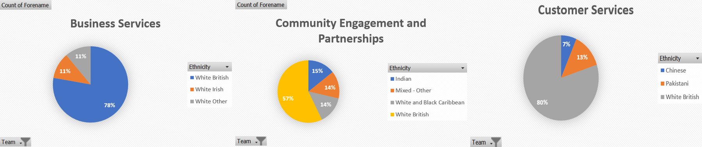
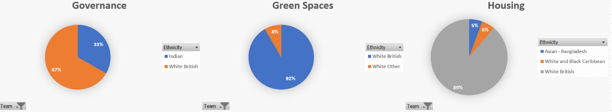
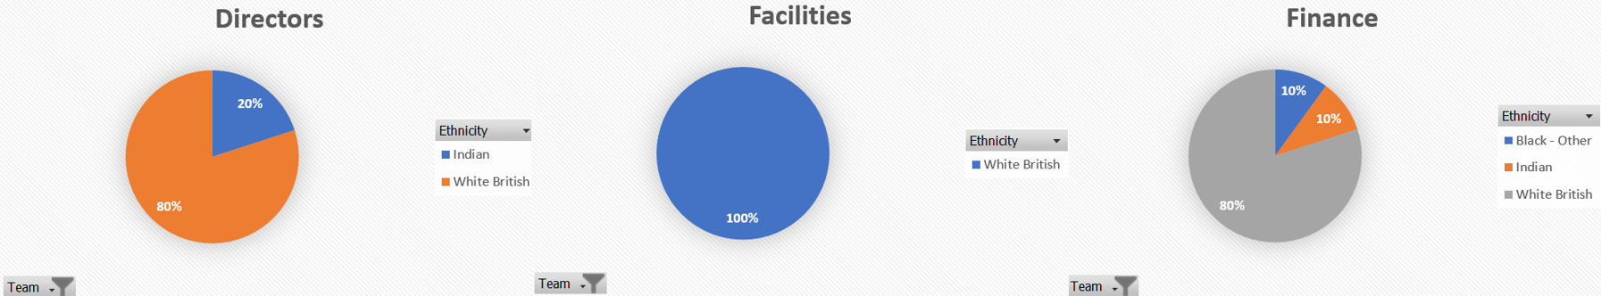
Charts 2-19: Ethnicity as a percentage per team

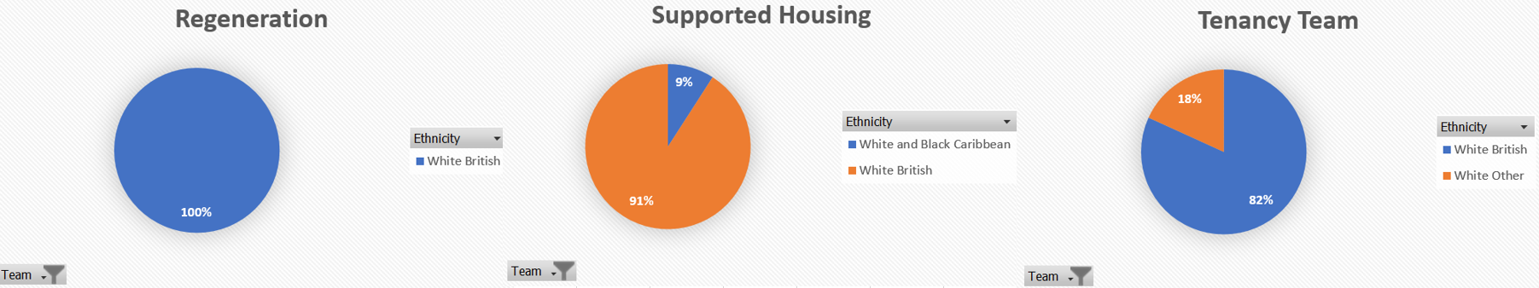
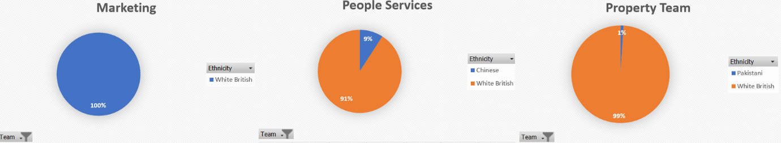
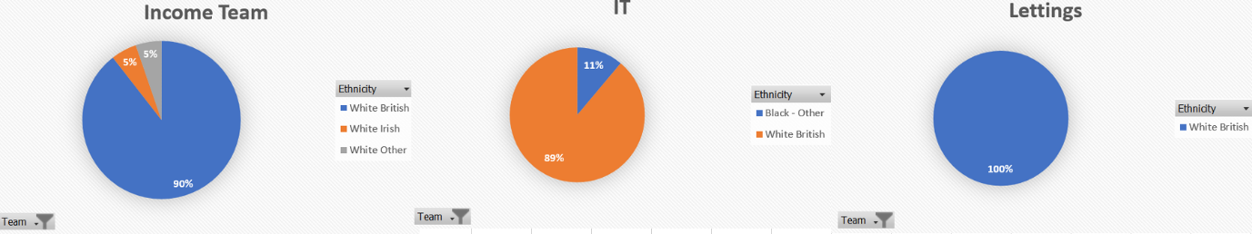
Charts 2-19: Ethnicity as a percentage per team

As shown in the charts above, the dominate ethnicity across the whole organisation is White British with a total of 237 staff members (91%). Ethnic minorities total to only 16 (6%).

Chart 20: Ethnic minorities per team

Chart 20 outlines that staff members of an ethnic minority are spread across 10 teams but the highest number of staff members is only 3 and only across two teams- Community Engagement and Partnerships and Customer Service.

Chart 21: Disability percentage as an organisational whole.

The bar chart above outlines that 239 (92%) staff members of the whole organisation are not disabled and only 21 (8%) are disabled.

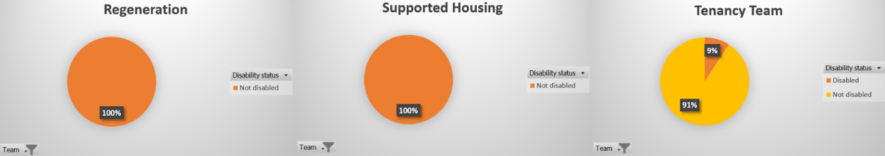
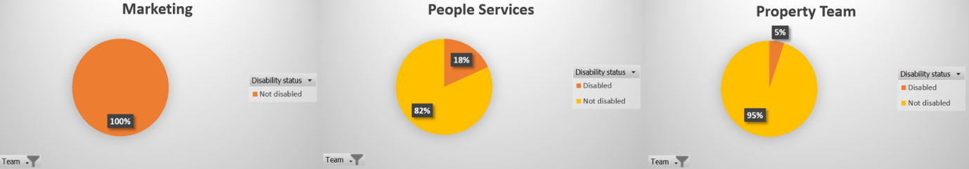
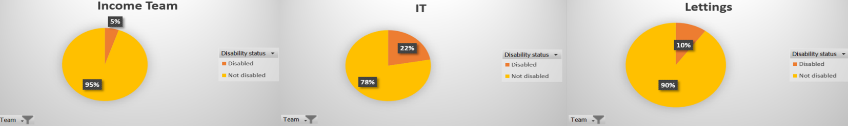
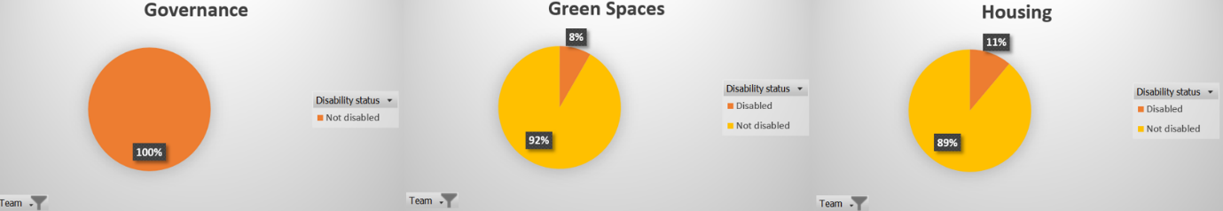
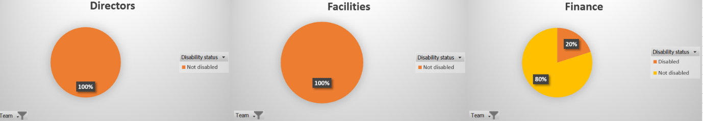
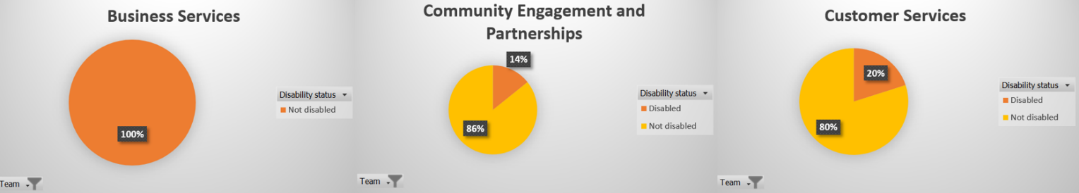
Charts 22-39: Disability percentage per team

Charts 22 to 39 breaks down the percentage of disabled and not disabled into teams, the charts show that out of 18 teams, 11 of those include at least one person that has a disability with the highest number being 5 disabled people within the Property Team.

Chart 40: Average salary across genders

Chart 41- Female and male at manager level or above

The total average salary across the whole organisation is £31,757. Chart 40 provides an insight into the salary differences across genders. Females have the highest average salary at £31,900, males following with £31,812 and non-binary at the lowest at £19,500. Non-binary may have low average salary but as shown in chart 1, non-binary only equates to 1% of the organisation.
Chart 41 shows that 19 females are at manager level or higher within the organisation as opposed to only 14 males and 0 non-binary, which could justify the reasons for females having a higher average salary than males and non-binary.

Recommendations
As outlined in charts 20 and 21, it is clear to see that diversity is a big problem within the organisation, to change this managers could incorporate a better business case for increasing diversity and inclusion in the workplace. McKinsey outlines in his research on diversity and inclusion that the more diverse a company is the more likely than ever it will be to outperform (McKinsey&Company, 2020). Diversity within the workplace can result in better productivity and team morale which in turn will result in higher profitability. This could be done by performing an in-depth audit to identify pay gaps (Indeed, nodate). The limitations with this would be that it could be time consuming and it could take time away from the day to day operations.
Another recommendation could be to update the current recruitment strategy by offering apprenticeships and internships to underrepresented groups, highlighting diversity and inclusion on job adverts, on the company websites and incorporating in the organisation’s values (Indeed, nodate). This would ensure that when recruiting for new roles, it will attract a diverse audience. The limitations for this would be that managers may require further training on diversity and inclusion for them to make better unbiased hiring decisions and this could come at cost.
As outlined in charts 20 and 21, it is clear to see that diversity is a big problem within the organisation. McKinsey outlines in his research on diversity and inclusion that the more diverse an organisation is the more likely it will be to outperform (McKinsey&Company, 2020). Diversity within the workplace can result in better productivity and boost team morale which in turn will result in higher profitability and inclusion.
The first recommendation to tackle this issue could be to implement an equality, diversity, and inclusion (EDI) strategy by taking a systematic approach by incorporating EDI into the organisation’s values. Managers and leaders need to champion these behaviours and guidelines should be issued to all employees to ensure they adhere to the EDI strategy. Another way could be implementing throughout the employees lifecycle via mandatory unconscious bias training to all staff, especially those who are involved in recruitment. This will enable employees to develop an awareness of how unconscious bias could impact EDI in the workplace. The risks with this recommendation would be that it could come at a cost to the organisation to implement mandatory EDI training to all staff, another risk would be if this was a new implementation and not part of the organisation’s culture, some may be reluctant to change, and this could cause conflict.
Another recommendation would be to implement EDI initiatives within recruitment, by ensuring job descriptions include gender-neutral language, anonymising applicants to minimise unconscious biases. setting diversity targets (CIPD, 2022b). This would provide an unbiased approach to recruitment; it also allows organisations to collect and analyse data on EDI within recruitment which can be used to identify gaps and prioritise implementing inclusion within their strategies.

Table 2
Table 2 Findings from the survey:
- 37% strongly agree that they enjoy working from home on some days of the week and 31% disagree.
- 54% strongly agree that hybrid working practices supports the work-life balance and well-being, only 11% disagree.
- 34% strongly disagree and 46% disagree that they feel fully supported when working at home.
- 23% strongly agree and 26% agree that hybrid working practices make them more productive, however 27% disagree and 22% strongly disagree with this statement.
- 34% strongly disagree and 21% strongly agree that working from home does not affect their cross functional communication and collaboration with their team.
- Only 3% strongly agree that since hybrid working has been in place, they feel more connected to the company culture, however 24% strongly disagree with this.
- 47% strongly disagree that working from home allows them to meet their targets.
- 37% strongly disagree that they can easily access resources at home, however 33% agree with this.
- 30% strongly agree that working from home removes conflict and 30% strongly disagree with this statement.
- 83% strongly disagree that they feel less stressed when away from the workplace.
- 23% strongly agree that they get the recognition about their work when working from home but 29% strongly disagree.
- 52% disagree and 31% strongly disagree that they miss engaging with colleagues in the workplace.
- 18% disagree and 24% strongly disagree that they find working remotely a challenge.
- 33% strongly agree and 32% agree that they find it difficult to separate work from their personal life.
Overall, it is clear to see that out of the 300 staff members that filled out the survey on hybrid working practices, the result is almost a 50/50 split although some do agree that it is a positive practice and that those , it seems that those who do that enjoy hybrid working seem to have higher productivity. It is clear that the obvious that the need for more support is paramount across the 300 staff members.

Recommendations
A key recommendation would be to look into investigate the current support offered to staff that opt for hybrid working and put in better measures to check in and monitor the practice, for example regular one to one sessions and monthly reviews of productivity and well-being could be an option. Staff will then feel more valued and supported whilst home working. Although this would be a positive approach to monitor hybrid working this may not benefit all employees, some may feel that the sessions are unproductive and could take up too much valuable working time. Other employees may feel that the regular monitoring could be an indication that there is a lack of trust between the manager and the employee.
To capture fully where support is lacking, a smaller staff survey could be issued to each department to identify if this is a whole organisational issue or if the lack of support is only affecting certain departments. Support training could then be offered to managers in those departments to upskill them. Support training could be offered to all managers across the organisation to upskill them in staff supporting measures, this would promote a more positive and open working environment but could also come at a cost and could take away time from manager’s day to day tasks.
Another recommendation could be to offer hybrid working to the staff members who wanted it, firstly on a trial basis for 1 or 2 days a week and analyse the results of the trail in the coming weeks, looking at the positives and negatives, ensuring to consider the opinions of those who are hybrid working and those who are not. This will ensure that the full picture is being captured and this could provide managers to come up with improvements to ensure efficiency of this way of working. A risk of this could be that it may come at a cost to the organisation as IT equipment may need to provided to hybrid workers. Another risk could be that if the team only contains for example 5 staff members and 3 of those are hybrid working it may cause isolation to those who are not or vice versa and this may develop into a toxic working environment.

Bibliography

- Adair, J. (2019) Decision Making and Problem Solving. Break Through Barriers and Banish Uncertainty at Work. Switzerland: Springer Nature.
- Bonnafous-Boucher, M. and Rendtorff, J. (2016) Stakeholder Theory: A Model for Strategic Management. 4th edn. London: Kogan Page
- Gibson, K. (2012) Ethics and Business: An Introduction. London: Cambridge University Press.
- Armstrong, M. (2016) Armstrong’s handbook of management and leadership for HR : developing effective people skills for better leadership and management. 4th edn. London: Kogan Page.
- Armstrong, M. (2018) Armstrong’s Job Evaluation Handbook. A guide to achieving fairness and transparency in pay and reward. London: Kogan Page.
- Armstrong, M. and Taylor, S. (2020) Armstrong’s Handbook of Human Resource Management Practice. 15th edn. London: Kogan Page.
- Armstrong, M. and Taylor, S. (2023) Armstrong's Handbook of Human Resource Management Practice. A Guide to the Theory and Practice of People Management. London: Kogan Page.
- Barends, E. & Rousseau, D. (2018). Evidence- Based Management: How to Use Evidence to Make Better Organizational Decisions. London. Kogan Page.
- Barends, E., Rousseau, D.M., & Briner, R.B. (2014). Evidence-based Management: The Basic Principles. Amsterdam: Centre for Evidence-Based Management.
- Battista, M (2023) CIPD. Available at: https://www.cipd.org/uk/knowledge/factsheets/pestle-analysis-factsheet/ (Accessed: 10 October 2023).
- Bono, E. (2017) Six Thinking Hats. The Multi-million Bestselling Guide to Running Better Meetings and Making Faster Decisions. United Kingdom: Penguin Books Limited.
- Bosley, A. (2023) CIPD. Available at: https://www.cipd.org/uk/knowledge/factsheets/ethics-role-hr-factsheet/ (Accessed: 30 November 2023).
- CIPD (2015) Ethical decision-making: Eight perspectives on workplace dilemmas. London: Available at: https://www.cipd.org/globalassets/media/comms/the-people-profession/profession-map-pdfs/ethical-decision-making-2015-eight-perspectives-on-workplace-dilemmas_tcm29-9564.pdf (Accessed: 21 November 2023).
- CIPD (2022a). Available at: https://www.cipd.org/uk/knowledge/factsheets/analytics-factsheet/ (Accessed: 10 October 2023).
- CIPD (2022b). Available at: Inclusive recruitment: Guide for employers | CIPD (Accessed: 11 February 2024).
- CIPD (2016) Available at: https://www.cipd.org/uk/learning/support-for-students/currently-studying/critical-review-writing/ (Accessed: 15 November 2023).
- CIPD (2021). Available at: https://www.cipd.org/uk/knowledge/guides/effective-hybrid-working/ (Accessed 04 December 2023).
- CMI (2023) Stakeholder Analysis and Management. Available at: https://www.managers.org.uk/knowledge-and-insights/resource/stakeholder-analysis-and-management/#:~:text=The%20aim%20of%20stakeholder%20analysis,or%20otherwise%20of%20their%20goals (Accessed: 22 November 2023).
- CMI (2020) Available at: https://www.managers.org.uk/knowledge-and-insights/resource/decision-making/ (Accessed: 15 November 2023).
- CMI. (2014) Managing Strategy. Your Guide to Getting it Right. United Kingdom: Profile Books.
- Coburn, T. and Howlett, W. (2019) Critical Thinking [Podcast]. 05/11 of posted message. Available at: https://www.cipd.org/uk/knowledge/podcasts/critical-thinking/ (Accessed: 11 November 2023).
- Cotton, C. (2023) CIPD. Available at: https://www.cipd.org/uk/knowledge/factsheets/market-pricing-factsheet/#:~:text=Methods%20used%20by%20employers%20include,with%20another%20in%20a%20workplace (Accessed: 02 December 2023).
- Cottrell, S. (2017). Critical Thinking Skills. Effective Analysis, Argument and Reflection. 3rd edn. London: Bloomsbury.
- De Mast, J. (2013) ‘Diagnostic Quality Problem Solving: A Conceptual Framework and Six Strategies’, The Quality Management Journal, 20(4), pp. 21–36. https://doi.org/10.1080/10686967.2013.11918362
- Eales Reynolds, L. Judge, B. McCreery, E. and Jones, P. (2013) Critical Thinking Skills for Education Students. 2nd edn. London: Sage.
- Falletta, S.V. and Combs, W.L. (2021) ‘The HR analytics cycle: a seven-step process for building evidence-based and ethical HR analytics capabilities’, Journal of work-applied management, 13(1), pp. 51–68. Available at: https://doi.org/10.1108/JWAM-03-2020-0020
- Ferrar, J. and Green, D. (2021) Excellence in People Analytics: How To Use Workforce Data To Create Business Value. London: Kogan Page.
- GOV.UK (2023) Available at: The National Minimum Wage in 2023 - GOV.UK (www.gov.uk) (Accessed: 11 October 2023).
- Haan, S. (2023) CIPD. Available at: SWOT Analysis | Factsheets | CIPD. (Accessed: 13 November 2023).
- Haber, J. (2020) Critical thinking. Cambridge: The MIT Press.
- Hayes, A. (2023) Investopedia. Available at: https://www.investopedia.com/terms/c/cost-benefitanalysis.asp (Accessed: 02 December 2023).
- Hill, N. Brierley, J. and Macdougall, R. (2017) How To Measure Customer Satisfaction. 2nd edn. London: Routledge.
- Hill, N. Roche, G. and Allen, R. (2007) Customer Satisfaction. The Customer Experience Through The Customer’s Eyes. London: Cogent Publishing Ltd.
- Hill, S. (2021) CIPD. Available at: https://www.cipd.org/uk/knowledge/guides/analytics-practitioner-guide/ (Accessed: 01 December 2023).
- Horn, R. (2009) The Business Skills Handbook. London: CIPD.
- Horton, T. (2023a) Generative AI in HR. Generative AI and the transformation of HR. 9 November. Available at: https://www.linkedin.com/learning/generative-ai-in-hr/generative-ai-and-the-transformation-of-hr?u=77966930 (Accessed: 10 November 2023).
- Horton, T. (2023b) Generative AI in HR. Talent acquisition and onboarding. 9 November. Available at: https://www.linkedin.com/learning/generative-ai-in-hr/generative-ai-and-the-transformation-of-hr?u=77966930 (Accessed: 10 November 2023).
- Indeed. (nodate). Available at: https://www.indeed.com/hire/c/info/benefits-of-diversity (Accessed: 06 December 2023).
- Ingham, J. (2007) Strategic Human Capital Management. Creating Value through People. London: Elsevier Ltd.
- Khan, N. and Millner, D. (2020) Introduction to People Analytics. London: Kogan Page.
- Lewis, G and Rowsell, J. (2023) People Management. Available at: https://www.peoplemanagement.co.uk/article/1839351/national-living-wage-rise-least-11-provides-nice-balance-firms-affordability-employee-need-say-experts (Accessed: 10 October 2023).
- Linkedin. (no date). Available at: https://www.linkedin.com/advice/0/how-do-you-balance-quantitative-qualitative-4e#quantitative-data-and-methods (Accessed: 04 December 2023).
- Marchington, M. Wilkinson, A. Donnelly, R. and Kynighou, A. (2020) Human Resource Management at Work. 7th edn. London: CIPD.
- Marler, J. and Boudreau, J. (2016) 'An evidence-based review of HR Analytics', The International Journal of Human Resource Management, Volume 28,Issue 1: Annual Review.
- Marmol, T. del and Feys, B. (2015) PESTLE Analysis. Translated by C. Probert. Namur: Lemaitre Publishing.
- McGrath, J. and Bates, B. (2017) The Little Book of Big Management Theories…And How To Use Them. 2nd edn. London: Pearson Education Limited.
- Mckinsey&Company (2020) Diversity Wins How inclusion matters. London: Available at: https://www.mckinsey.com/~/media/mckinsey/featured%20insights/diversity%20and%20inclusion/diversity%20wins%20how%20inclusion%20matters/diversity-wins-how-inclusion-matters-vf.pdf (Accessed: 05 December 2023).
- Mill, J. (2014) Utilitarianism. London: Cambridge University Press.
- MindTools (no date) Available at: https://www.mindtools.com/aiplsat/how-to-make-decisions (Accessed: 11 November 2023).
- Paul, R. and Elder, L. (2019) The Miniature Guide to Critical Thinking. Concepts and Tools. 8th edn. London: Rowman & Littlefield.
- Perera, R. (2017) The Pestle Analysis. Nerdynaut.
- Porter, K. and Smith, P. and Fagg, R. (2011) Leadership and Management for HR Professionals. London: Taylor & Francis.
- Rousseau, D.M. and Barends, E.G.R. (2011) ‘Becoming an evidence-based HR practitioner’, Human resource management journal, 21(3), pp. 221–235. Available at: https://doi.org/10.1111/j.1748-8583.2011.00173.x.
- Stobierski, T. (2020) 13 FINANCIAL PERFORMANCE MEASURES MANAGERS SHOULD MONITOR. Available at: https://online.hbs.edu/blog/post/financial-performance-measures (Accessed: 29 November 2023).
- Taylor, S., & Woodhams, C. (2022) Human Resource Management: People and Organisations. 3rd edn. London: CIPD.
- Waite, K. et al (2021) People Practice: A Complete Guide. London: Kogan Page.
- Wild, S. (2023). CIPD. Available at: https://www.cipd.org/uk/knowledge/guides/gender-pay-gap-reporting-guide?_gl=1*1nyxe64*_ga*MTYyOTA5MDQzNi4xNjc4MzcwNzg0*_ga_D9HN5GYHYY*MTY5NjI2NDI0Ni43MC4xLjE2OTYyMzY1MjMuNjAuMC4w (Accessed: 05 December 2023).
- Worthington, I. Britton, C. and Thompson, E. (2018) The Business Environment: A Global Perspective. 8th edn. London: Pearson.
- Young, J. (2023) CIPD. Available at: https://www.cipd.org/uk/knowledge/factsheets/evidence-based-practice-factsheet/ (Accessed: 10 October 2023).
- Scott, A and Lamb, P. (2018) Unconscious bias [Podcast]. 01 May. Available at: Unconscious bias | CIPD (Accessed: 9 February 2024).

