Llwybr Datblygu’r Gymraeg
Darlith 1
3ydd o Hydref 2023 - Grŵp 1 Cyfrwng Cymraeg

Dolenni Defnyddiol:

- Forms – Adfyfyrio
- https://forms.office.com/Pages/ResponsePage.aspx?id=-REPTm4EBUWcuNshUjEeITJotDVOBN1FulHGsjRdpKtUNzBYRlRQM1ZSUEdDNVZMOVY5QUJMUDFOVS4u
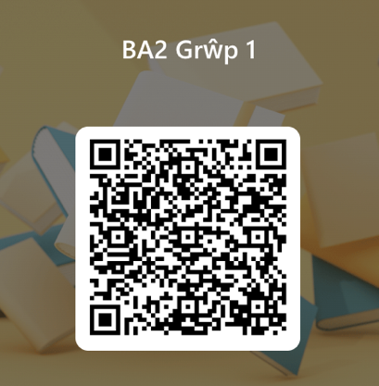

Darllen Cefndirol
Canllaw Cwricwlwm i Gymru
https://hwb.gov.wales/api/storage/b0e91f7c-0050-47b6-9b23-0273d39df9f3/canllawiau-cwricwlwm-i-gymru-070220.pdf

Y Gymraeg Mewn Addysg
https://llyw.cymru/sites/default/files/publications/2018-02/y-gymraeg-mewn-addysg-cynllun-gweithredu-2017%E2%80%9321.pdf

Cymraeg 2050
https://senedd.wales/laid%20documents/gen-ld11108/gen-ld11108-w.pdf

Siarter Iaith
https://hwb.gov.wales/api/storage/3f5e1bb0-f99a-444f-a82c-ab8d22cac3fd/48543_siarter_w_merged.pdf
Hanes yr Iaith
https://www.youtube.com/watch?v=lMsbMY2B6RY

