
Website and Database Concepts
Assignment 1 – Due 03/05/2022

Peter Siow
Student Number – 2104217
Course Title – Computer Networks and Cybersecurity

Table of Contents
Introduction 3
Requirements for the website 3
Site Diagram 3
Wireframe diagram 3
Home page wireframe 4
History of Swansea wireframe 4
Why come to Swansea? Wireframe 4
Places to visit in Swansea wireframe 5
Swansea FC wireframe 6
Implementation 6
Validation 8
HTML Errors 9
Error 1 9
Error 2 9
Error 3 and 4 9
Error 5, 6, 7 and 8 9
Error 9 10
Error 10 10
Error 11 10
CSS Errors 10
Evaluation 10
Part A 10
Usability 10
Accessibility 11
Search Engine Optimisation – SEO 11
Part B 11
Usability 11
Search Engine Optimisation 11
Accessibility 12
Accessibility For my Website 12
References 13
Appendices 13
Home page 13
History of Swansea 15
Why come to Swansea? 19
Places to visit in Swansea 23
Swansea FC 26
Stylesheet 27

Introduction
This report is going to cover my implementation of my website which I created in which was about Swansea as a city and attempting to persuade tourists and students to visit as well as educating locals about the city. As well in this report I will covering the implementation, checking for errors within html documents. Finally in the report I will discussing the terms of usability, accessibility and search engine optimisation for websites and discussing how I implemented these techniques into my website.

Requirements for the website
The purpose of the website in which I created was the subject of Swansea as a city and the information was to target locals, tourists, and students in which were looking to explore Swansea as a city or even learn about the history of the city, any ages can use this website to learn about Swansea, as the GUI Is simple and easy to navigate around the website. The sole purpose for the website was to educate or remind others about Swansea as well to help others find interesting attractions to visit. The website is important to students as I also intended to guide students to choose Swansea as a city to study in, as there are different universities to choose from and many attractions to visit as a student.

Site Diagram

Wireframe diagram

Home page wireframe

History of Swansea wireframe

Why come to Swansea? Wireframe

Places to visit in Swansea wireframe

Swansea FC wireframe

Implementation
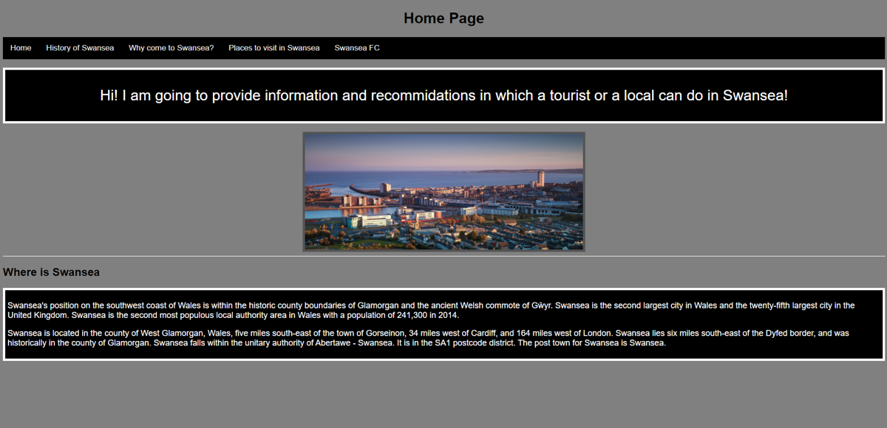

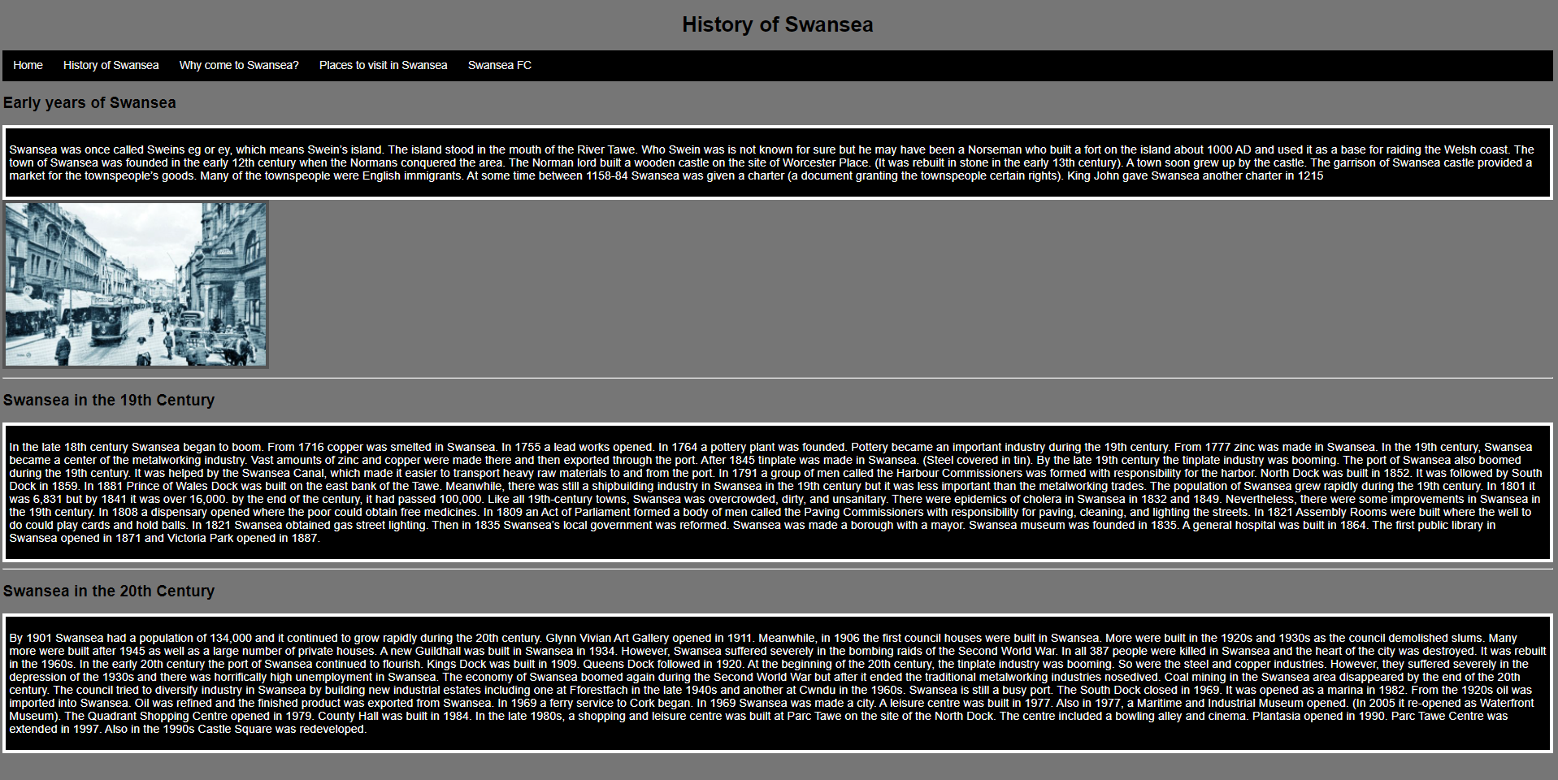

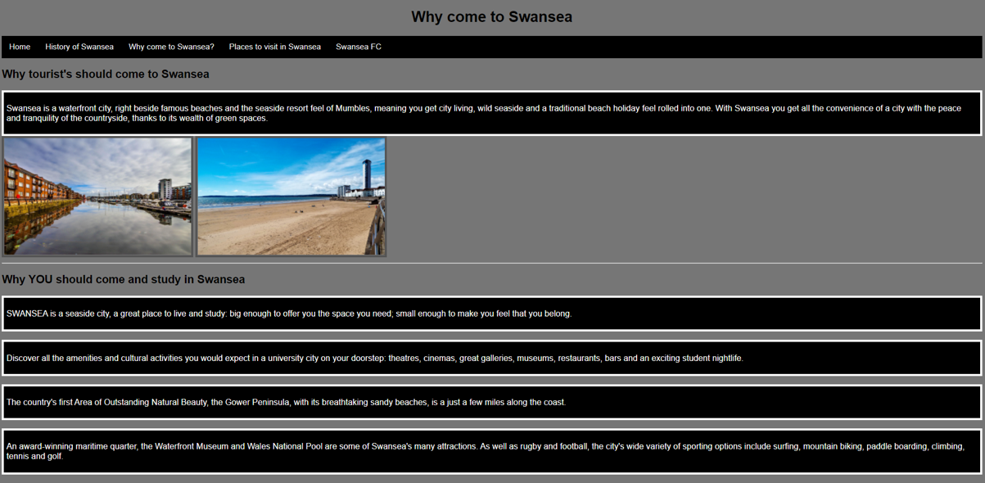
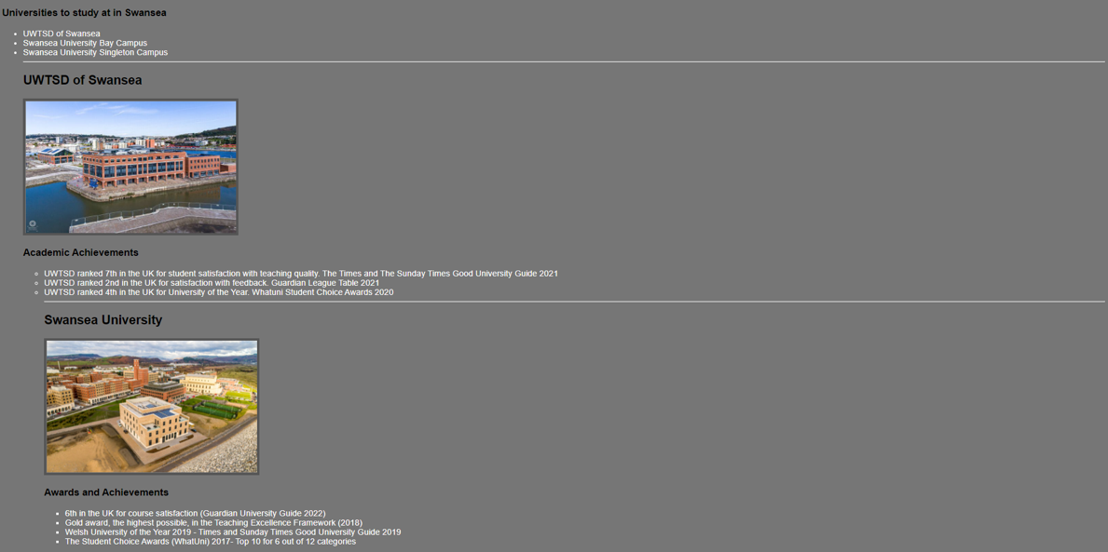
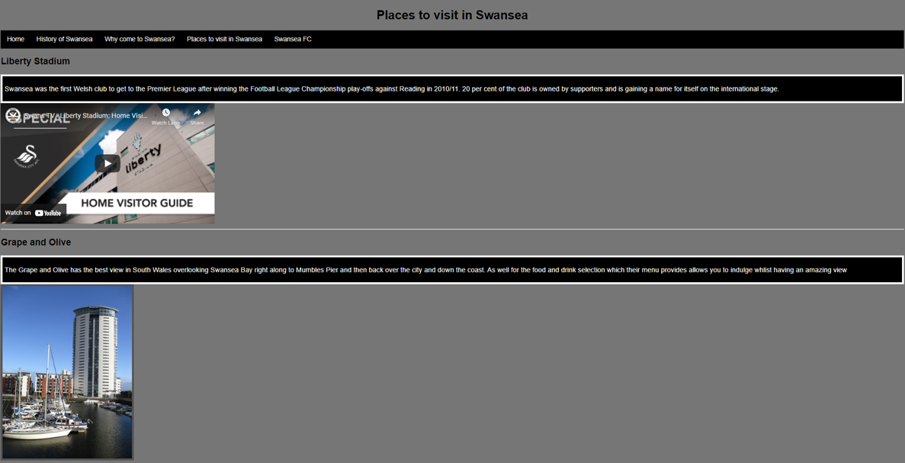
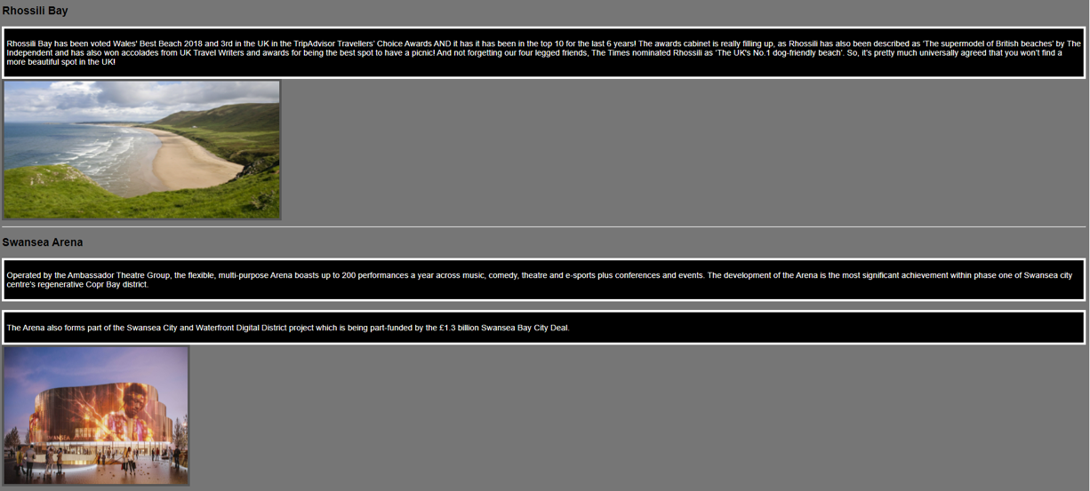

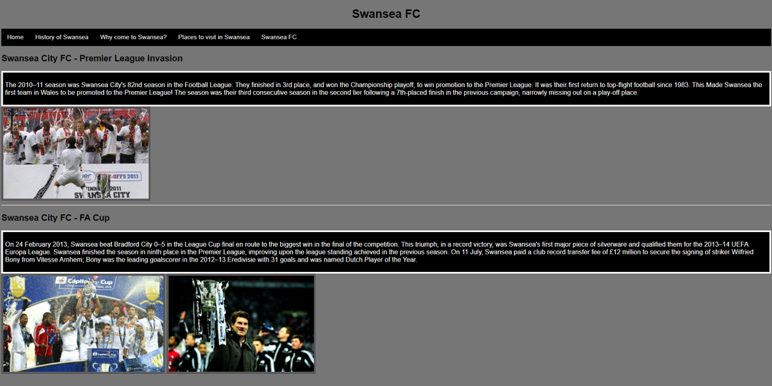

Validation

HTML Errors
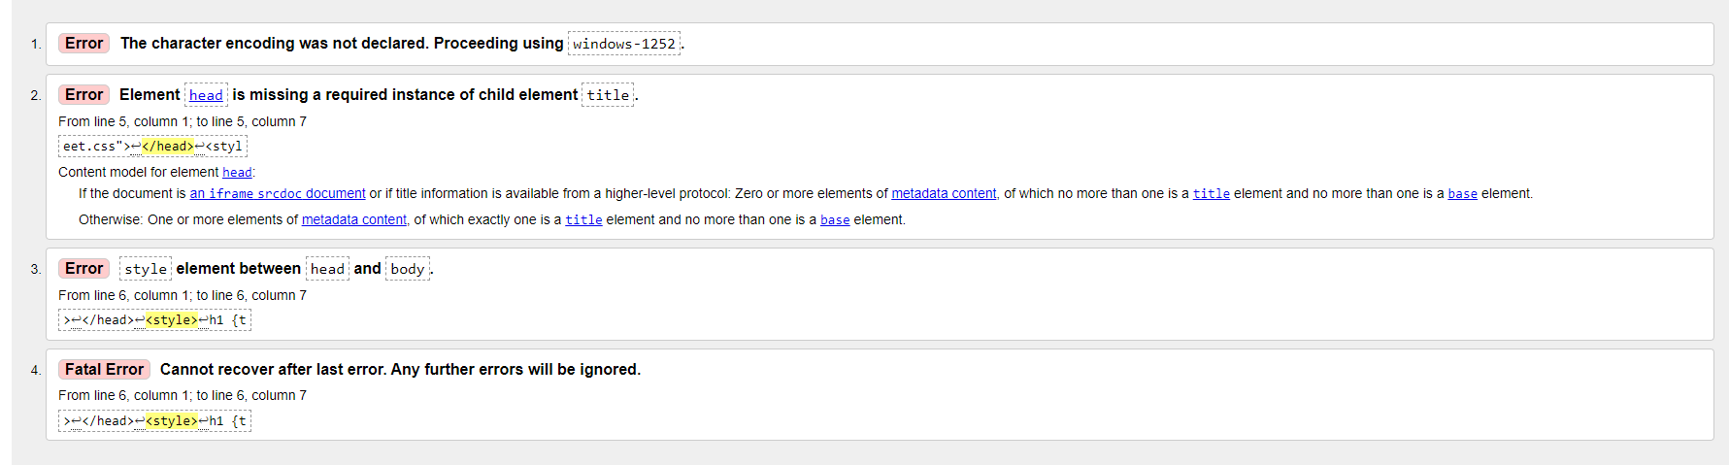
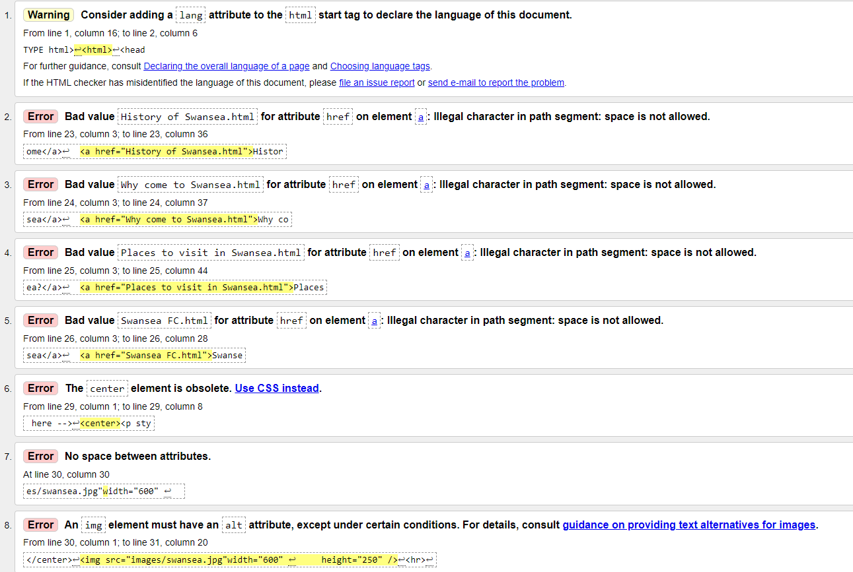

Error 1
The first error which occurred when uploading the home page to the validator was “The character encoding was not declared. Proceeding using Windows1252”. Which means that in the original document I did not declare any type of character set to be used on the website, so when I uploaded the file to the validator it proceeded to use the Windows-1252 character set. So, to avoid this error I would need to input this code into the file <meta charset="UTF-8">. Using this code will declare the character set being on the website when being run.

Error 2
The second error which occurred in the validator is that when in-between <head> </head> I did not give the webpage a title. So, when I did not include a title, it would show the path from my documents where the file is stored. So, to prevent the error from happening and to give a title to the webpage when opened in a browser I had to use the code <title>Home Page</title>.

Error 3 and 4
The error is linked to each other in which I had to replace the styling which i used in the file and move it in the <head> </head> as it was originally in the <body>.

Error 5, 6, 7 and 8
The errors which occurred in 5,6,7 and 8 are all linked together as they have the same error as in the navigation bar when I linked web pages to each the original file names had spaces in the file name in which the validator did not approve of, so to avoid the errors I had to change the file names in which they do not have spaces and as well for the code for each web page I had to change it to the accordingly new file names.

Error 9
This error shows that one of the paragraphs in the home page for the website is that when I centred the paragraph it was in the home page file rather than in the stylesheet of the website, so I created a class within the style for that specific paragraph and used text-align center to center the paragraph and avoid this error.

Error 10
In error 10 the error was that the sizing of the image which I included in the code was not spaced out in the quotation marks which detected as an error in the validator and all I had to do to prevent this was to space the start of the quotation marks from the styling of how the image will resize on the web page.

Error 11
Error 11 is the same code error in error 10 as for the image which I used I did not include an alt in the code which means if the image cannot be viewed to the user it will then show the alt. So, for this example, it would be that I named the alt “overview of Swansea” as this can be useful to give the user an example of what the image is and context to the webpage.

CSS Errors
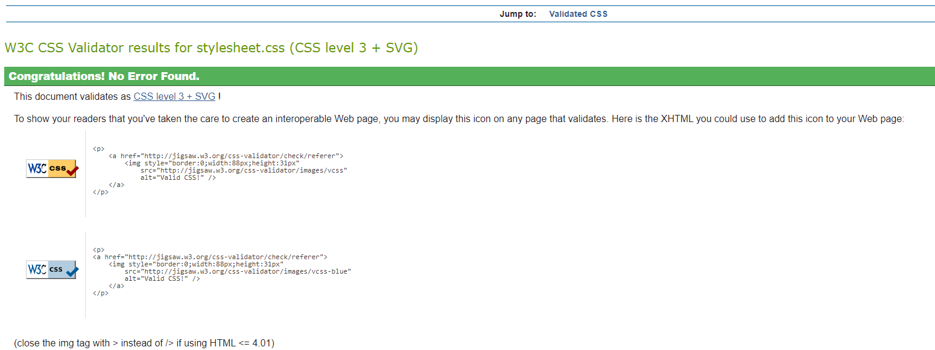
The CSS stylesheet linked to my website did not record any errors when uploading the stylesheet to the CSS validator.

Evaluation

Part A

Usability
The term usability for a website is in other words “ease of use” and this means how simple it is for a user to use the website and this can depend on several factors with font size being too small, colours on the website are not working together, inconsistent sizes of images etc. When designing a website, it is crucial to consider the user roles which may use the website and the three user roles to consider are casual, expert and power users. As casual users may visit the website on separate occasions, so having a design of bigger and more distinctive colours may more eye catching to the user and allow them to navigate around the website easier due to the distinctive features. For expert users, these users may use the website all day, so considering using less bright colours, images and buttons downscaled as these features may annoying and cause more harm than good for the users. Lastly, power users tend not to care about graphics too much but adding a distinctive feature on the website to allow them to know if they are in the correct destination for their use.

Accessibility
The term accessibility related to website’s is when people with disabilities can use the web. As this allows them to interact without an issue occurring with their disability hindering their experience. There are many different disabilities when considering when creating a website, such as visual, auditory, speech, neurological disabilities etc. Web accessibility is essential when designing a website as web usage is becoming an essential in daily life due to ease of access, so implementing or thinking of ways to implement web accessibility allows for equal opportunities for everyone.

Search Engine Optimisation – SEO
The term SEO known as search engine optimisation is a tactic in which a website pushes through traffic to achieve the top result on a search engine in which can be Microsoft edge, google and Firefox etc. Search engine optimisation is important as retrieving information online is commonly used now due to how easy it is to find and retrieve and for businesses it is incredibly important for them to get the top result on a search engine as there are many other competitors trying to achieve the top result on a search engine as this can increase sales.

Part B

Usability
For my design of my website did achieve usability as the colours which I used make it easier for the user to view the website as well as reading the information on the website due to the colours working with each other and not clashing harshly. But due to the simple colours used does make the website appear boring and not eye catching due to the colours not being bright and vibrant, but I wanted to achieve the result of easy on the eye for the user. Another reason the website is easy for the user is that in the web pages I made sure to adjust the size of the images which I implemented on the website as, most of the original size of the images were too big and did not fit within the web page aesthetically, but I do think that for paragraphs I could have been more creative with implementing a style for the paragraph in adding a border to all paragraphs to separate the text from the core background. For the functionality of the website everything which was added works when interacting, such as the video which I added works only when the user manually plays the video as well for the navigation bar it will direct the user to the desired web page that they choose. Recommendations which I could include in the future of the website would be implementing an option of light mode and dark mode as user’s may prefer light mode rather than dark mode and by doing this I would need to consider where I would I place the buttons to allow the user to choose between the both as well of the colour of the text being converted when the user switched between light and dark mode.

Search Engine Optimisation
One of the SEO techniques which I implemented onto my website was to add alt text on images on the website as, search engines cannot interpret what an image is, so implementing alt text allows the search engine to relate the image to what a user is searching on a search engine which may lead a user to click on the image and direct them to my website.
Another technique which I used on my website is using descriptive text on my webpages which are meaningful to what a user may search on a search engine, as a user may search “History of Swansea” as I have a whole page dedicated to the topic, I have information which is strictly about the history of Swansea which can increase the ranking on my website.
A third technique which I used in enhanced the ranking was implementing many title and meta description within my website as implementing these features on a website as firstly title tags are displayed on top of a tab when opened, but the key positive on why title tags are effective is because when a user searches for a topic related to my website or specifically the topic which the user searched for their first instinct is to click on the first result they see that is specified to their needs. The meta description is like a snippet of what content the website contains when a user searches for the topic on a search engine they can read the meta description and it may attract a user to visit the website if it fits their needs.
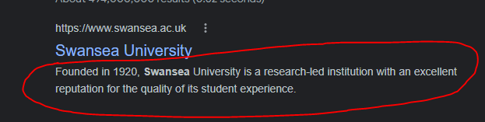

Accessibility
Web content accessibility guidelines which are also known as WCAG 2.1 is important as it provides recommendations on what can be implemented in a website to provide access to a website or app to everyone which can include users with disabilities. As for the WCAG 2.1 it requires four design principles in which creators should always consider when designing their website to improve the accessibility in which are perceivable, operable, understandable, and robust. Perceivable means the content within a website is presentable to all users with their senses e.g. captions for videos. Operable meaning several ways which a user can find and use the content within a website e.g. being able to play, pause, mute, or skip a video. Understandable meaning the using and finding the content is universal for everyone e.g. all content on the website is in English. Robust meaning the compatibility with the current and future users which visit the website using assistive technologies or anticipated browsers e.g. implementing code which allow assistive technologies like screen readers to be used.

Accessibility For my Website
For my website, the perceivability which I included was alt text with images on my website, as well for the video on the website as it was a YouTube link a user would be able to turn on subtitles if there is a hearing problem, also with the colour combination within the website I used a contrast ratio to test if they mixed well with each other and it passed all the tests and this infers to me users are able to read the information clearly with no problems. The website is operable as users can adjust the video to their liking such as full screen, volume adjustment etc and I used meaningful titles and headings within the website to make sure users are able to identify what part of the website they are viewing. My website is understandable as the only language is English, as Swansea is in the UK and one of the purposes of the website is to attract tourists and students to visit Swansea, as well as not using slang or phrases which users might not understand. But I could have kept some of the information shorter.
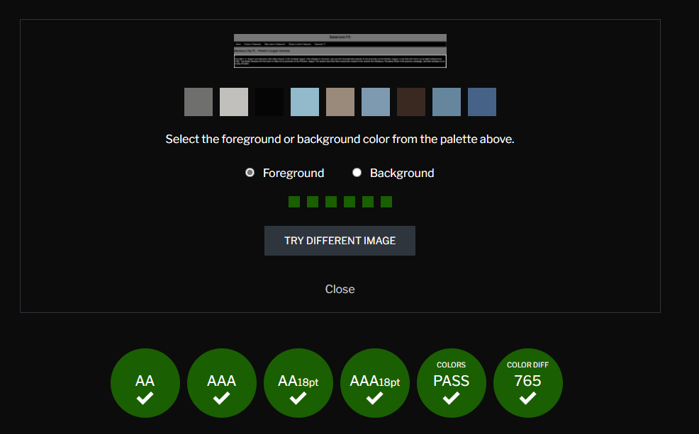

References
[1]S. L. Fowler and V. R. Stanwick, Web application design handbook best practices for web-based software, 1st edition. Amsterdam ;: Elsevier/Morgan Kaufmann, 2004.
[2]R. Rutter et al., Web Accessibility Web Standards and Regulatory Compliance, 1st ed. 2006. Berkeley, CA: Apress, 2006. doi: 10.1007/978-1-4302-0188-5.
[3] Egri Gokhan, Bayrak Coskun, “The Role of Search Engine Optimization on Keeping the user on the site. 2014
[4] Ben Caldwell, Loretta Guarino Reid, Gregg Vanderheiden, Wendy Chisholm, John Slatin, Jason White. “Web Content Accessibility Guidelines (WCAG) 2.1”. 05 June 2018

Appendices

Home page
<!DOCTYPE html>
<html>
<head>
<title>Home Page</title>
<meta name="home" content="Home page of Swansea as a city and this website contains the History of Swansea, Attractions and the Football club.">
<meta charset="UTF-8">
<link rel="stylesheet" href="stylesheet.css">
<style>
h1 {text-align: center;}
img {
border: 5px solid #555;
display: block;
margin-left: auto;
margin-right: auto;
}
</style>
</head>

<body style="background-color:gray;#767676">
<h1>Home Page</h1>

<div class="topnav">
<a class="active" href="Home.html">Home</a>
<a href="History_of_Swansea.html">History of Swansea</a>
<a href="WhyComeToSwansea.html">Why come to Swansea?</a>
<a href="Places_to_visit_in_Swansea.html">Places to visit in Swansea</a>
<a href="Swansea_FC.html">Swansea FC</a>
</div>
&nbsp;&nbsp
&nbsp;&nbsp
&nbsp;&nbsp
&nbsp;&nbsp
&nbsp;&nbsp
&nbsp;&nbsp
&nbsp;&nbsp
&nbsp;&nbsp
&nbsp;&nbsp
<!-- Content -->
<div class="para">
<p>Hi! I am going to provide information and recommidations in which a tourist or a local can do in Swansea!</p>
</div>
&nbsp;&nbsp
&nbsp;&nbsp
&nbsp;&nbsp
&nbsp;&nbsp
&nbsp;&nbsp
&nbsp;&nbsp
&nbsp;&nbsp
&nbsp;&nbsp
&nbsp;&nbsp
<img src="images/swansea.jpg" alt="Overview of Swansea" width="600" height="250" />
<hr>
<h2>Where is Swansea</h2>
<div class="allpara">
<p>Swansea's position on the southwest coast of Wales is within the historic county boundaries of Glamorgan and the ancient Welsh commote of Gŵyr. Swansea is the second largest city in Wales and the twenty-fifth largest city in the United Kingdom. Swansea is the second most populous local authority area in Wales with a population of 241,300 in 2014.</p>
<p>Swansea is located in the county of West Glamorgan, Wales, five miles south-east of the town of Gorseinon, 34 miles west of Cardiff, and 164 miles west of London. Swansea lies six miles south-east of the Dyfed border, and was historically in the county of Glamorgan. Swansea falls within the unitary authority of Abertawe - Swansea. It is in the SA1 postcode district. The post town for Swansea is Swansea.</p>
</div>

</body>
</html>

History of Swansea
<!DOCTYPE html>
<html>
<head>
<title>History Of Swansea</title>
<meta name="History Of Swansea" content="The historic past of Swansea and how to develop into the city as it is today!">
<meta charset="UTF-8">
<link rel="stylesheet" href="stylesheet.css">
</head>
<style>
img {
border: 5px solid #555;
}
h1 {text-align: center;}
</style>
<body style="background-color:#767676;">
<h1>History of Swansea</h1>

<div class="topnav">
<a class="active" href="Home.html">Home</a>
<a href="History_of_Swansea.html">History of Swansea</a>
<a href="WhyComeToSwansea.html">Why come to Swansea?</a>
<a href="Places_to_visit_in_Swansea.html">Places to visit in Swansea</a>
<a href="Swansea_FC.html">Swansea FC</a>

</div>
<!-- Content -->

<h2>Early years of Swansea</h2>
<div class="allpara">
<p>Swansea was once called Sweins eg or ey, which means Swein’s island. The island stood in the mouth of the River Tawe. Who Swein was is not known for sure but he may have been a Norseman who built a fort on the island about 1000 AD and used it as a base for raiding the Welsh coast.

The town of Swansea was founded in the early 12th century when the Normans conquered the area. The Norman lord built a wooden castle on the site of Worcester Place. (It was rebuilt in stone in the early 13th century). A town soon grew up by the castle. The garrison of Swansea castle provided a market for the townspeople’s goods. Many of the townspeople were English immigrants.

At some time between 1158-84 Swansea was given a charter (a document granting the townspeople certain rights). King John gave Swansea another charter in 1215</p>
</div>

<img src="images/highstreet.jpg" alt="Swansea High Street" width="400"
height="250" />
<hr>
<h2>Swansea in the 19th Century</h2>
<div class="allpara">
<p>In the late 18th century Swansea began to boom. From 1716 copper was smelted in Swansea. In 1755 a lead works opened. In 1764 a pottery plant was founded. Pottery became an important industry during the 19th century. From 1777 zinc was made in Swansea.

In the 19th century, Swansea became a center of the metalworking industry. Vast amounts of zinc and copper were made there and then exported through the port. After 1845 tinplate was made in Swansea. (Steel covered in tin). By the late 19th century the tinplate industry was booming.

The port of Swansea also boomed during the 19th century. It was helped by the Swansea Canal, which made it easier to transport heavy raw materials to and from the port.

In 1791 a group of men called the Harbour Commissioners was formed with responsibility for the harbor. North Dock was built in 1852. It was followed by South Dock in 1859. In 1881 Prince of Wales Dock was built on the east bank of the Tawe.

Meanwhile, there was still a shipbuilding industry in Swansea in the 19th century but it was less important than the metalworking trades.

The population of Swansea grew rapidly during the 19th century. In 1801 it was 6,831 but by 1841 it was over 16,000. by the end of the century, it had passed 100,000. Like all 19th-century towns, Swansea was overcrowded, dirty, and unsanitary. There were epidemics of cholera in Swansea in 1832 and 1849.

Nevertheless, there were some improvements in Swansea in the 19th century. In 1808 a dispensary opened where the poor could obtain free medicines. In 1809 an Act of Parliament formed a body of men called the Paving Commissioners with responsibility for paving, cleaning, and lighting the streets.

In 1821 Assembly Rooms were built where the well to do could play cards and hold balls. In 1821 Swansea obtained gas street lighting.

Then in 1835 Swansea’s local government was reformed. Swansea was made a borough with a mayor. Swansea museum was founded in 1835. A general hospital was built in 1864. The first public library in Swansea opened in 1871 and Victoria Park opened in 1887.</p>
</div>

<hr>
<h2>Swansea in the 20th Century</h2>
<div class="allpara">
<p style="color:#FFFFFF;">By 1901 Swansea had a population of 134,000 and it continued to grow rapidly during the 20th century.

Glynn Vivian Art Gallery opened in 1911. Meanwhile, in 1906 the first council houses were built in Swansea. More were built in the 1920s and 1930s as the council demolished slums. Many more were built after 1945 as well as a large number of private houses.

A new Guildhall was built in Swansea in 1934. However, Swansea suffered severely in the bombing raids of the Second World War. In all 387 people were killed in Swansea and the heart of the city was destroyed. It was rebuilt in the 1960s.

In the early 20th century the port of Swansea continued to flourish. Kings Dock was built in 1909. Queens Dock followed in 1920. At the beginning of the 20th century, the tinplate industry was booming. So were the steel and copper industries. However, they suffered severely in the depression of the 1930s and there was horrifically high unemployment in Swansea.

The economy of Swansea boomed again during the Second World War but after it ended the traditional metalworking industries nosedived. Coal mining in the Swansea area disappeared by the end of the 20th century. The council tried to diversify industry in Swansea by building new industrial estates including one at Fforestfach in the late 1940s and another at Cwndu in the 1960s.

Swansea is still a busy port. The South Dock closed in 1969. It was opened as a marina in 1982. From the 1920s oil was imported into Swansea. Oil was refined and the finished product was exported from Swansea. In 1969 a ferry service to Cork began.

In 1969 Swansea was made a city. A leisure centre was built in 1977. Also in 1977, a Maritime and Industrial Museum opened. (In 2005 it re-opened as Waterfront Museum). The Quadrant Shopping Centre opened in 1979. County Hall was built in 1984.

In the late 1980s, a shopping and leisure centre was built at Parc Tawe on the site of the North Dock. The centre included a bowling alley and cinema. Plantasia opened in 1990. Parc Tawe Centre was extended in 1997. Also in the 1990s Castle Square was redeveloped.</p>
</div>
</body>
</html>

Why come to Swansea?
<!DOCTYPE html>
<html>
<head>
<title>Why come to Swansea</title>
<meta name="Why come to Swansea?" content="Why you should come to Swansea and stay in the beautiful city">
<meta charset="UTF-8">
<link rel="stylesheet" href="stylesheet.css">
</head>
<style>
h1 {text-align: center;}
img {
border: 5px solid #555;
}
</style>
<body style="background-color:#767676;">
<h1>Why come to Swansea</h1>

<div class="topnav">
<a class="active" href="Home.html">Home</a>
<a href="History_of_Swansea.html">History of Swansea</a>
<a href="WhyComeToSwansea.html">Why come to Swansea?</a>
<a href="Places_to_visit_in_Swansea.html">Places to visit in Swansea</a>
<a href="Swansea_FC.html">Swansea FC</a>
</div>
<!-- Content -->

<h2>Why tourist's should come to Swansea</h2>
<div class="allpara">
<p>Swansea is a waterfront city, right beside famous beaches and the seaside resort feel of Mumbles, meaning you get city living, wild seaside and a traditional beach holiday feel rolled into one. With Swansea you get all the convenience of a city with the peace and tranquility of the countryside, thanks to its wealth of green spaces.</p>
</div>
<img src="images/marina.jpg" alt="Swansea Marina" width="400"
height="250" />

<img src="images/beach.jpg" alt="Swansea Beach" width="400"
height="250" />
<hr>

<h2>Why YOU should come and study in Swansea</h2>
<div class="allpara">
<p>SWANSEA is a seaside city, a great place to live and study: big enough to offer you the space you need; small enough to make you feel that you belong.</p>
</div>
&nbsp;&nbsp
&nbsp;&nbsp
&nbsp;&nbsp
&nbsp;&nbsp
&nbsp;&nbsp
&nbsp;&nbsp
&nbsp;&nbsp
&nbsp;&nbsp
&nbsp;&nbsp
<div class="allpara">
<p>Discover all the amenities and cultural activities you would expect in a university city on your doorstep: theatres, cinemas, great galleries, museums, restaurants, bars and an exciting student nightlife.</p>
</div>
&nbsp;&nbsp
&nbsp;&nbsp
&nbsp;&nbsp
&nbsp;&nbsp
&nbsp;&nbsp
&nbsp;&nbsp
&nbsp;&nbsp
&nbsp;&nbsp
&nbsp;&nbsp
<div class="allpara">
<p>The country's first Area of Outstanding Natural Beauty, the Gower Peninsula, with its breathtaking sandy beaches, is a just a few miles along the coast.</p>
</div>
&nbsp;&nbsp
&nbsp;&nbsp
&nbsp;&nbsp
&nbsp;&nbsp
&nbsp;&nbsp
&nbsp;&nbsp
&nbsp;&nbsp
&nbsp;&nbsp
&nbsp;&nbsp
<div class="allpara">
<p>An award-winning maritime quarter, the Waterfront Museum and Wales National Pool are some of Swansea's many attractions. As well as rugby and football, the city's wide variety of sporting options include surfing, mountain biking, paddle boarding, climbing, tennis and golf.</p>
</div>

<h3>Universities to study at in Swansea</h3>
<ul>
<li style="color:#FFFFFF;">UWTSD of Swansea</li>
<li style="color:#FFFFFF;">Swansea University Bay Campus</li>
<li style="color:#FFFFFF;">Swansea University Singleton Campus</li>
<hr>
<h2>UWTSD of Swansea</h2>
<img src="images/UWTSD.jpg" alt="UWTSD" width="400"
height="250" />

<h3>Academic Achievements</h3>
<ul>
<li style="color:#FFFFFF;">UWTSD ranked 7th in the UK for student satisfaction with teaching quality.
The Times and The Sunday Times Good University Guide 2021</li>
<li style="color:#FFFFFF;">UWTSD ranked 2nd in the UK for satisfaction with feedback.
Guardian League Table 2021</li>
<li style="color:#FFFFFF;">UWTSD ranked 4th in the UK for University of the Year.
Whatuni Student Choice Awards 2020</li>

<hr>
<h2>Swansea University</h2>
<img src="images/baycampus.jpg" alt="Bay Campus" width="400"
height="250" />

<h3>Awards and Achievements</h3>
<ul>
<li style="color:#FFFFFF;">6th in the UK for course satisfaction (Guardian University Guide 2022)</li>
<li style="color:#FFFFFF;">Gold award, the highest possible, in the Teaching Excellence Framework (2018)</li>
<li style="color:#FFFFFF;">Welsh University of the Year 2019 - Times and Sunday Times Good University Guide 2019</li>
<li style="color:#FFFFFF;">The Student Choice Awards (WhatUni) 2017- Top 10 for 6 out of 12 categories</li>

</body>
</html>

Places to visit in Swansea
<!DOCTYPE html>
<html>
<head>
<title>Places to Visit in Swansea</title>
<meta name="Attractions" content="Attractions in Swansea which are essential to visit when in Swansea!">
<meta charset="UTF-8">
<link rel="stylesheet" href="stylesheet.css">
</head>
<style>
h1 {text-align: center;}
img {
border: 5px solid #555;
}
</style>
<body style="background-color:#767676;">
<h1>Places to visit in Swansea</h1>

<div class="topnav">
<a class="active" href="Home.html">Home</a>
<a href="History_of_Swansea.html">History of Swansea</a>
<a href="WhyComeToSwansea.html">Why come to Swansea?</a>
<a href="Places_to_visit_in_Swansea.html">Places to visit in Swansea</a>
<a href="Swansea_FC.html">Swansea FC</a>
</div>

<!-- Content -->

<h2>Liberty Stadium</h2>
<div class="allpara">
<p>Swansea was the first Welsh club to get to the Premier League after winning the Football League Championship play-offs against Reading in 2010/11. 20 per cent of the club is owned by supporters and is gaining a name for itself on the international stage.</p>
</div>
<iframe width="560" height="315" src="https://www.youtube.com/embed/9NSuaM0m2kc?start=1" title="YouTube video player" frameborder="0" allow="accelerometer; autoplay; clipboard-write; encrypted-media; gyroscope; picture-in-picture" allowfullscreen></iframe>
<hr>
<h2>Grape and Olive</h2>
<div class="allpara">
<p>The Grape and Olive has the best view in South Wales overlooking Swansea Bay right along to Mumbles Pier and then back over the city and down the coast. As well for the food and drink selection which their menu provides allows you to indulge whlist having an amazing view</p>
</div>
<img src="images/grapeandolive.jpg" alt="Grape and Olive">
<hr>
<h2>Rhossili Bay</h2>
<div class="allpara">
<p>Rhossili Bay has been voted Wales' Best Beach 2018 and 3rd in the UK in the TripAdvisor Travellers’ Choice Awards AND it has it has been in the top 10 for the last 6 years! The awards cabinet is really filling up, as Rhossili has also been described as ‘The supermodel of British beaches’ by The Independent and has also won accolades from UK Travel Writers and awards for being the best spot to have a picnic! And not forgetting our four legged friends, The Times nominated Rhossili as ‘The UK's No.1 dog-friendly beach’. So, it’s pretty much universally agreed that you won’t find a more beautiful spot in the UK!</p>
</div>
<img src="images/rhossilibeach.jpg" alt="Rhossili Beach" width="600"
height="300" />
<hr>
<h2>Swansea Arena</h2>
<div class="allpara">
<p>Operated by the Ambassador Theatre Group, the flexible, multi-purpose Arena boasts up to 200 performances a year across music, comedy, theatre and e-sports plus conferences and events. The development of the Arena is the most significant achievement within phase one of Swansea city centre’s regenerative Copr Bay district.</p>
</div>

&nbsp;&nbsp
&nbsp;&nbsp
&nbsp;&nbsp
&nbsp;&nbsp
&nbsp;&nbsp
&nbsp;&nbsp
&nbsp;&nbsp
&nbsp;&nbsp
&nbsp;&nbsp

<div class="allpara">
<p>The Arena also forms part of the Swansea City and Waterfront Digital District project which is being part-funded by the £1.3 billion Swansea Bay City Deal.</p>
</div>
<img src="images/swanseaarena.jpg" alt="Swansea Arena" width="400"
height="300" />

</body>
</html>

Swansea FC
<!DOCTYPE html>
<html>
<head>
<title>Swansea FC</title>
<meta name="Swansea FC" content="Swansea Football club in the championship and first Welsh team to reach promotion to the premier leauge">
<meta charset="UTF-8">
<link rel="stylesheet" href="stylesheet.css">
</head>
<style>
img {
border: 5px solid #555;
}
h1 {text-align: center;}
</style>
<body style="background-color:#767676;">
<h1>Swansea FC</h1>

<div class="topnav">
<a class="active" href="Home.html">Home</a>
<a href="History_of_Swansea.html">History of Swansea</a>
<a href="WhyComeToSwansea.html">Why come to Swansea?</a>
<a href="Places_to_visit_in_Swansea.html">Places to visit in Swansea</a>
<a href="Swansea_FC.html">Swansea FC</a>
</div>
<!-- Content -->
<h2>Swansea City FC - Premier League Invasion</h2>
<div class="allpara">
<p> The 2010–11 season was Swansea City's 82nd season in the Football League. They finished in 3rd place, and won the Championship playoff, to win promotion to the Premier League. It was their first return to top-flight football since 1983.
This Made Swansea the first team in Wales to be promoted to the Premier League!
The season was their third consecutive season in the second tier following a 7th-placed finish in the previous campaign, narrowly missing out on a play-off place.
</div>

<img src="images/playofffinals.jpg" alt="Swansea Playoff Finals" width="400"
height="250" />
<hr>

<h2>Swansea City FC - FA Cup</h2>
<div class="allpara">
<p>On 24 February 2013, Swansea beat Bradford City 0–5 in the League Cup final en route to the biggest win in the final of the competition. This triumph, in a record victory, was Swansea's first major piece of silverware and qualified them for the 2013–14 UEFA Europa League. Swansea finished the season in ninth place in the Premier League, improving upon the league standing achieved in the previous season. On 11 July, Swansea paid a club record transfer fee of £12 million to secure the signing of striker Wilfried Bony from Vitesse Arnhem; Bony was the leading goalscorer in the 2012–13 Eredivisie with 31 goals and was named Dutch Player of the Year.</p>
</div>

<img src="images/facup1.jpg" alt="Swansea FA Cup Trophy Lift" width="440" height="265">

<img src="images/facup2.jpg" alt="Swansea FA Cup Manager"width="400" >

</body>
</html>

Stylesheet
/* Add a black background color to the top navigation */
.topnav {
background-color: black;
overflow: hidden;
}

/* Style the links inside the navigation bar */
.topnav a {
float: left;
color: #f2f2f2;
text-align: center;
padding: 14px 16px;
text-decoration: none;
font-size: 17px;
}

/* Change the color of links on hover */
.topnav a:hover {
background-color: white;
color: black;
}

.para {
text-align: center;
color: #FFFFFF;
padding: 5px;
border:#FFFFFF; border-width:5px; border-style:solid;
font-size: 32px;
background-color: #000000;
}

.allpara {
background-color: #000000;
color: #FFFFFF;
padding: 5px;
border:#FFFFFF; border-width:5px; border-style:solid;
font-size: 18px;
}

@font-face {
font-family: "arial";

}
* {
font-family: "arial";
}

