Student Name: Ashleigh Simons

Student Number: 2003948

Course Name: Computing

Module Name: Introduction to Web and Database Concepts

Contents

Page 3 – Introduction Page

Page 4 – Database Designs / Context Diagram

Page 5 – Level 0 DFD

Page 6 – Entity Relationship Diagram

Page 7 – 16 Documentation of Tables

Page 17 – Verification of Designs

Introduction Page

Within this assignment I will be developing a suitable solution to the Celtic Caterers brief. I will firstly have to create a context diagram on what the system is required to do. Next, I will be creating a Level 0 DFD to show the data flow throughout the database and how it will be used. After that I will be creating an entity relationship diagram to show the entities, relationships, degree of relationships, membership classes and annotated descriptions for the relationships. Then I will document the created database showing the tables, fields, foreign keys, and relationships that I create within the database. Also, I will show how the tables relate to each other, verifying that the database meets user requirements, and that the table design meets the rules of third normal form. Finally, I will document the use of additional Microsoft Access functionality.

Database Designs

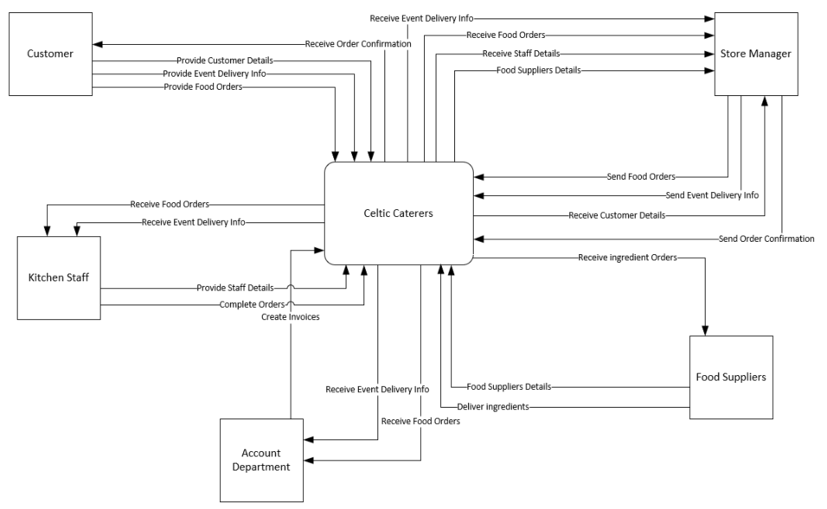
Context Diagram

This is the context diagram for the Celtic Caterers System. Please zoom in if there is any information not clearly visible. Shown above, there are five areas that have information involved with them and this diagram shows a flow of where this information might go. We have the customer that is providing all their personal details, orders, and event delivery information. The Store Manager then uses this information to tell the kitchen staff what is required and sends an order to the Food Suppliers so that the ingredients are ordered for the kitchen staff to make the food for the event. The account department receive information about the event and the food orders to make sure that everything is stored about the orders. Now we know all of the context behind the system we can create a Level 0 DFD.

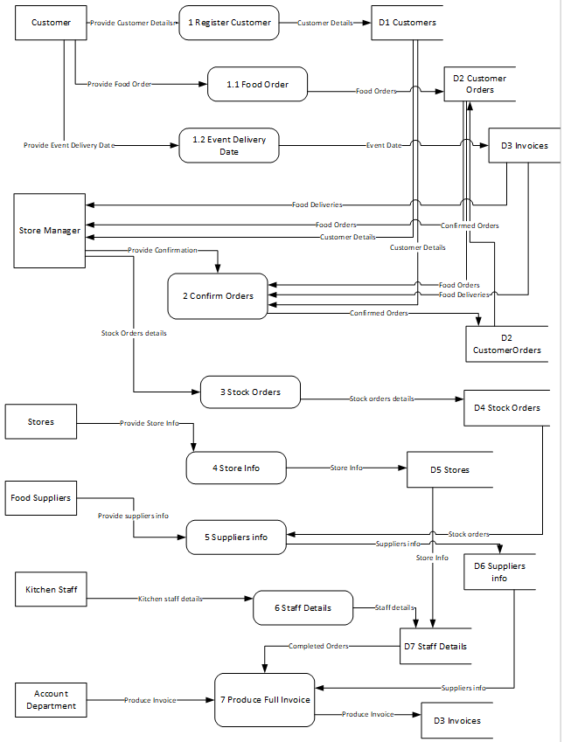
Level 0 DFD
This level 0 DFD is a Data Flow Diagram, and this shows how the information will be gained and where it will be stored. Please zoom in if you want to see the level 0 DFD more clearly.
We see the Customer at the top providing all the personal details, food orders and event delivery information and this being stored in the D1 Customers, D2 Customer Orders and D3 Invoices on the right-hand side.
Then we see the store Manager providing information about the confirmed orders and the stock orders and the confirmed orders information will go to D2 Customers and the stock orders will be stored in D4 Stock orders.
The stores will then provide the store information, and this will be stored in D5 Stores.
We then have nearing the bottom Food Suppliers, and kitchen staff, the information that is collected from these two will go into D6 Suppliers and D7 Staff Details.
At the very bottom we finally have Account Department, and this will be where the invoice is collected, and this is stored in the D3 Invoices that also has the event delivery date.
I have created this DFD as it helps to organize where data will be kept and stored within the database, it also helps us find the flows between information and figure out what will be required within each of the tables within the database. From doing this we can see that there will be 7 tables with different pieces of information in them and ways that we can link the information.

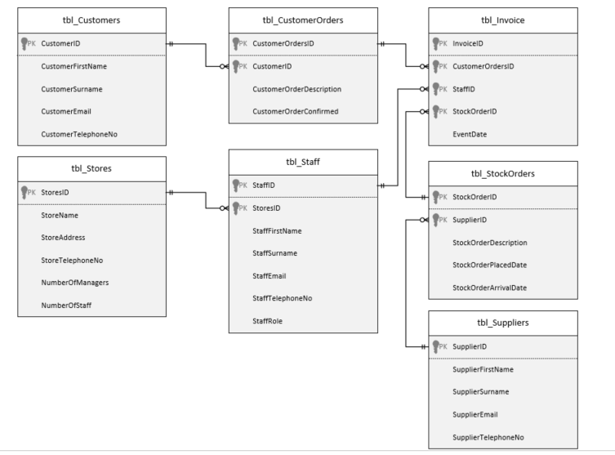
Entity Relationship Diagram

This is the entity relationship diagram that produced based on the DFD (Data Flow Diagram). There are 7 tables that have been created to store various information found in the context diagram and the DFD. There are also relationships within the entity relationship diagram, and this is to show where the information will be used. There are also primary and foreign keys within the tables as some of them will need information from other tables to be able to work as well as it can and so that information is not being duplicated as we do not want repeated data if it is not necessary. The relationships that have been created are one-to-many relationships and the table with one will have records including for example StoreID where the tbl_Staff will have many StoreID’s as there will be many StoreID’s within it for each record of staff members.

Documentation of Tables

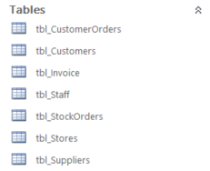
Tables Created
These are what the tables look like after creating them in Microsoft Access. There are screen snippets of what these tables would look like after Celtic Caterers have entered in information and data within the tables. For an example of how they would work and look I have created records of data so that the tables are clear to understand and clear to what the users would have to enter within the database. Please zoom in to any of the screen snippets if any data is unreadable or unclear.

Tables when viewed
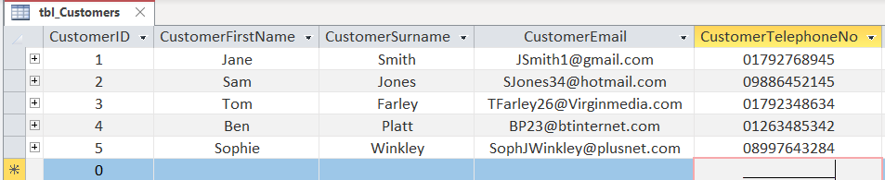
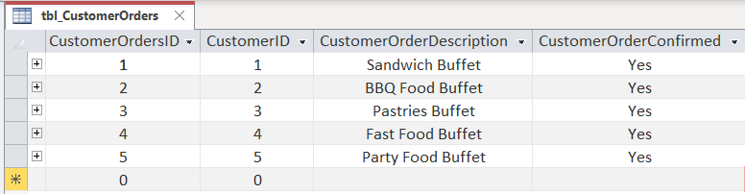
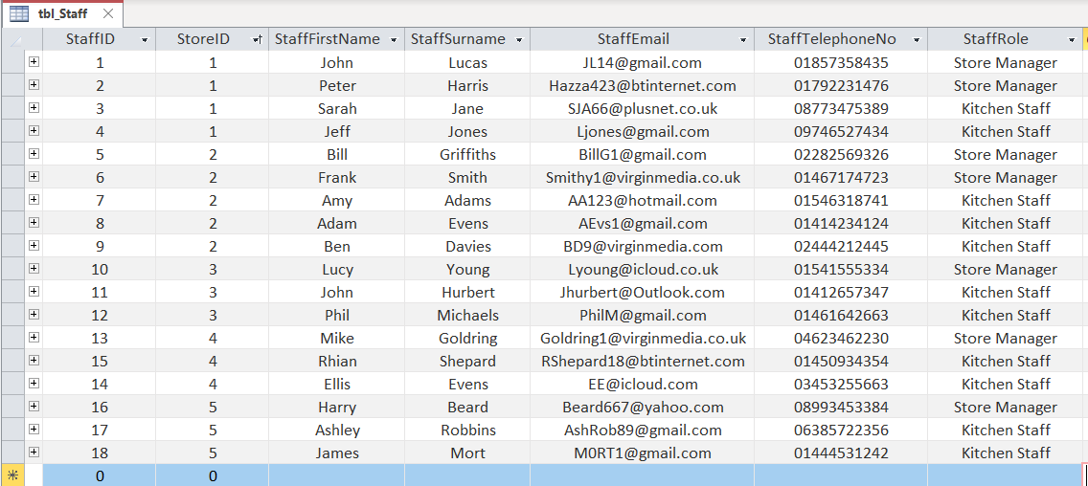
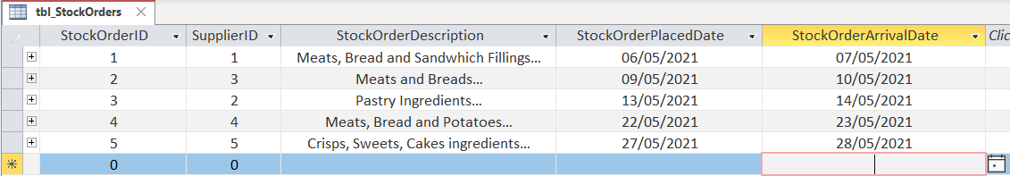
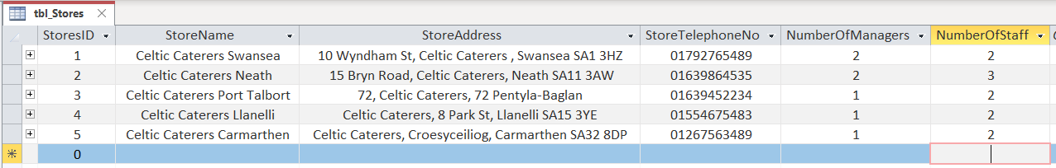
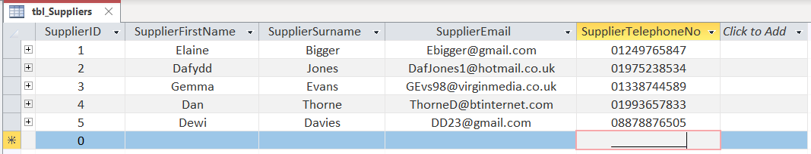
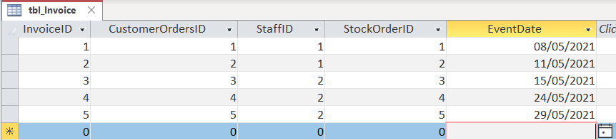
Above is how all the table would be presented when data from Celtic Caterers has been entered. The tables have custom field sizes, validation rules, validation text, input masks and indexes as seen necessary to the information that is being entered into each of the fields. This has been done to make sure that the information being entered is sensible and accurate. If the data is not sensible then there could be instances where an email address does not have an @ sign or there could be a telephone number with 6 digits where all UK telephone numbers have 11 digits. Having all of these put in place just removed the chances of the users entering something that should not be there so this is good to have on the fields.

Fields Created & Foreign Keys

There are many different fields within the tables and each of them have been created to get information either of the customer, staff, supplier, stores, orders, or stock. The fields are them chosen based off the best suitable data entry. There are also primary and foreign keys within these tables created and these are the identifier fields making the records in these tables unique and the fields that have been linked through another table so that there is no data duplication and so that the tables can be linked with information to make more sense and connection.
Invoice and Customer Orders Tables
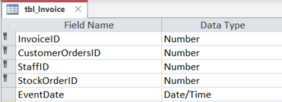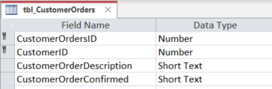
Customers and Staff Tables
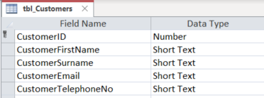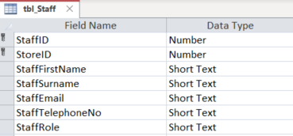
Stores and Stock Orders Tables
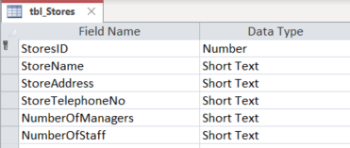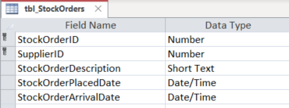
Suppliers Table
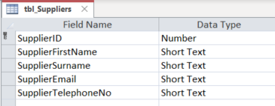
Above you can see all the tables, fields, primary keys and foreign keys that have been created. Each of the fields has a data type that best suits the data that will be inputted into the database. As previously stated within the tables created section there are custom input masks, field sizes, validation rules and validation text based on what the information is required and what the database is expecting of the user to enter. These all make the data more accurate when it is being entered and reduces the chance of errors to be made my accident by the user. There are also as mentioned field that cannot be duplicated and some that are able to as some fields like primary felids should not be available for multiple records in some cases however in other tables this is okay so from fields to fields this is different for each one.

Relationships

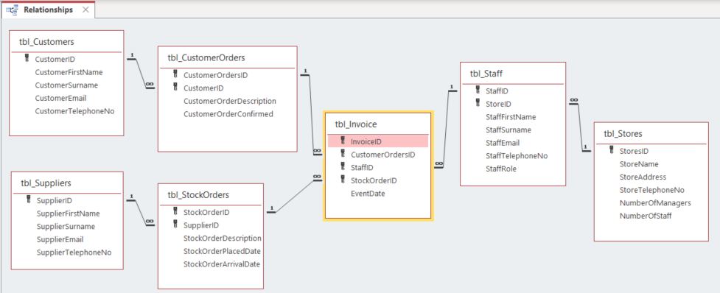

Above is a screen snippet of the relationships of the database. It shows the different tables, the fields, the primary and foreign keys, and the relationships between the tables that have them. There are 6 different relationships that are all one-to-many relationships and they have enforced referential integrity. Having this enforced referential integrity stops the users from editing something in a table where it should not be edited. If the user wants to make a change to a record they need to go to that table and change the record and then go back to the table to enter the new data. These stop records from being orphaned and becoming useless making the system more useful as there will be no mistakes in leaving a record not used or missed within the relationships of the tables involved.

Forms
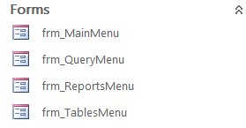
These are the form names that have been created to help with the user accessing the Queries, Reports and Tables on the database. On each of the menu’s there are several buttons that have had macros created so that when the buttons are clicked the desired query, report or table opens.

Main Menu
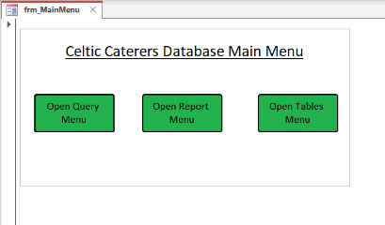
This is what the Main Menu looks like and you can see the three buttons being the three options of where the users can navigate to.

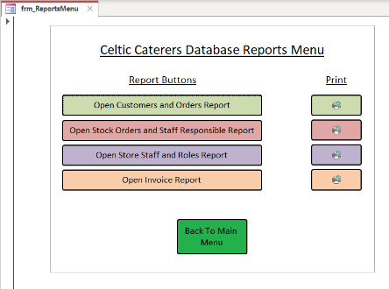
Secondary Menus
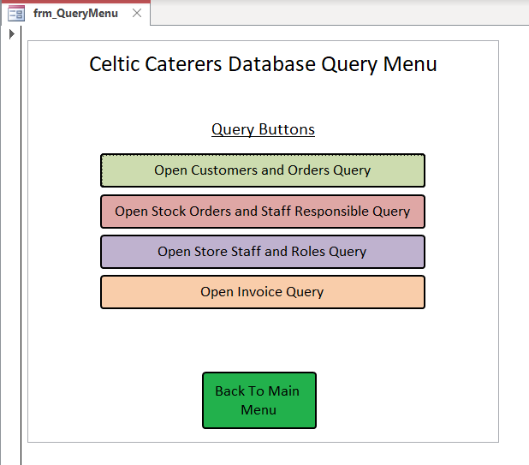
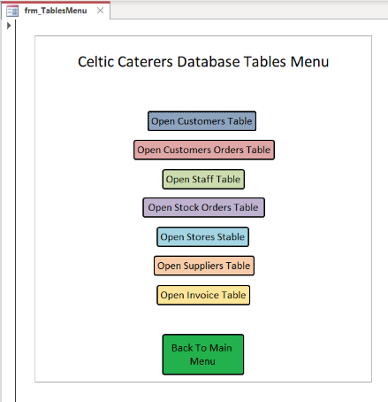

Above you can see the three menus, and these are for the tables, queries, and reports. On each of these menus there is a button that allows the users to go back to the main menu. This is done just in case a user clicks on the wrong menu and needs to go back.

Queries

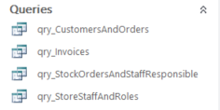
These are the name of the different queries that have been created. There is CustomersAndOrders, Invoices, StockOrderAndStaffResponsible and StoreStaffAndRoles.

Query Results when Runned
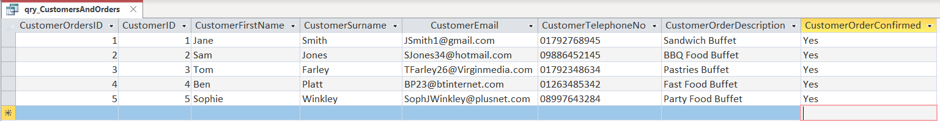
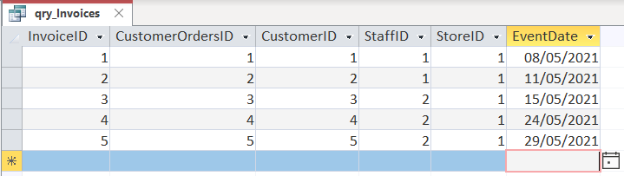
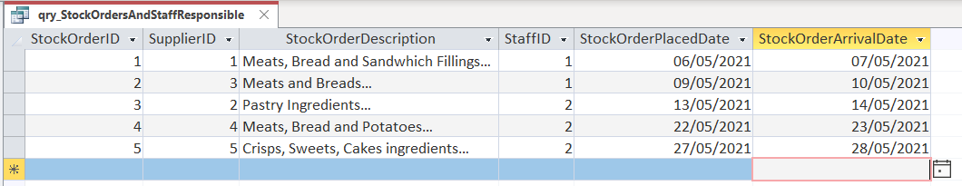
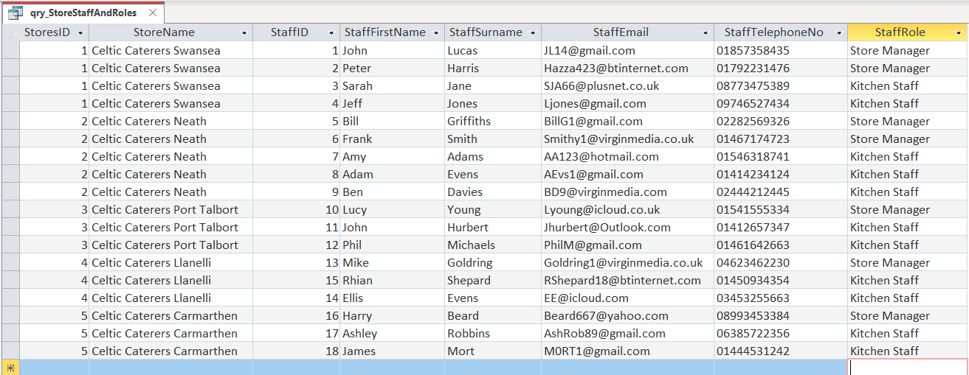
Above shows all of the results that you would find by running the queries, the queries were created using the design query to be able to select the tables and fields required to create tables that the users can use to get information easily that relate to orders, stock and suppliers. The invoice query shows all the data relating to where each order was made and by who and for when which is all important for the Store Managers and Account Department to keep track of what is being done and what needs to be done.

Reports
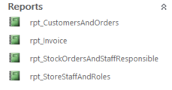

These are the report that have been created so that the users have the query information in a report style. Having this information presented that it is clearer to read and more understandable than a table will give users more benefit than just having a table or query presented to them. They are also able to then print these reports out to have them on paper so that they can be kept, stored, or given to the Store Managers, Account Department to have this information recorded and easy to access.
Report Layouts when Opened
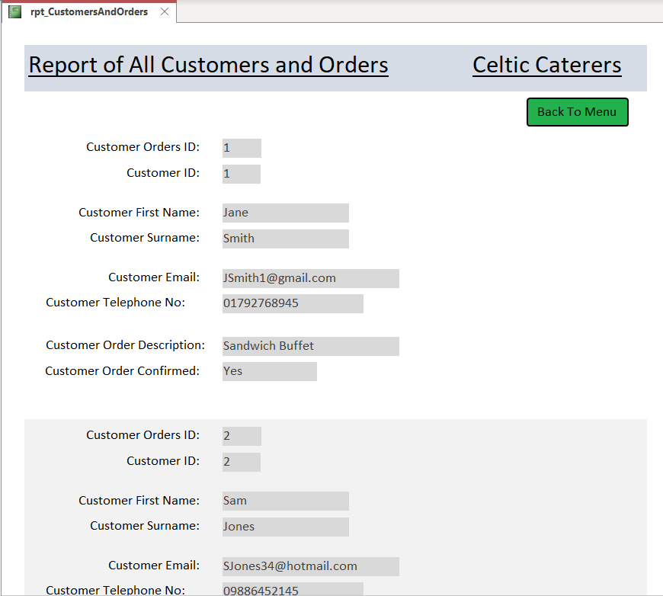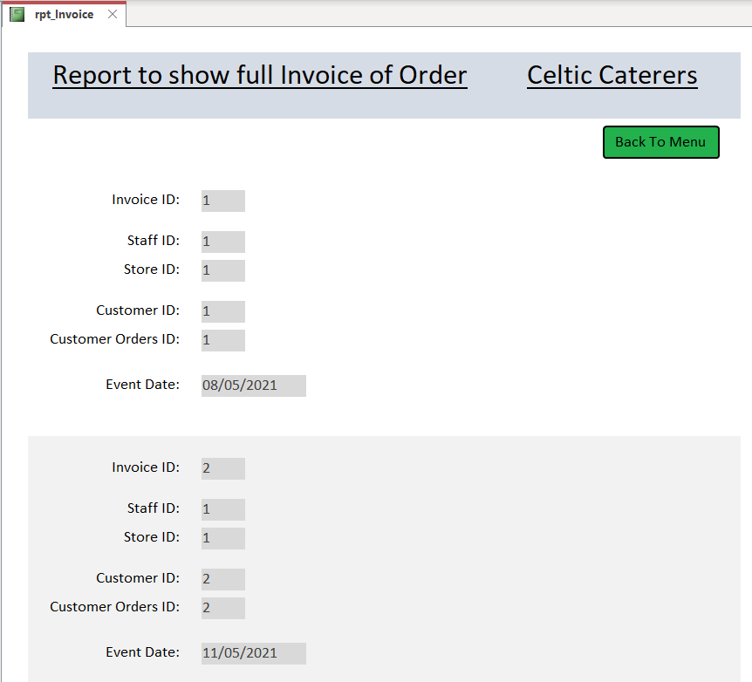

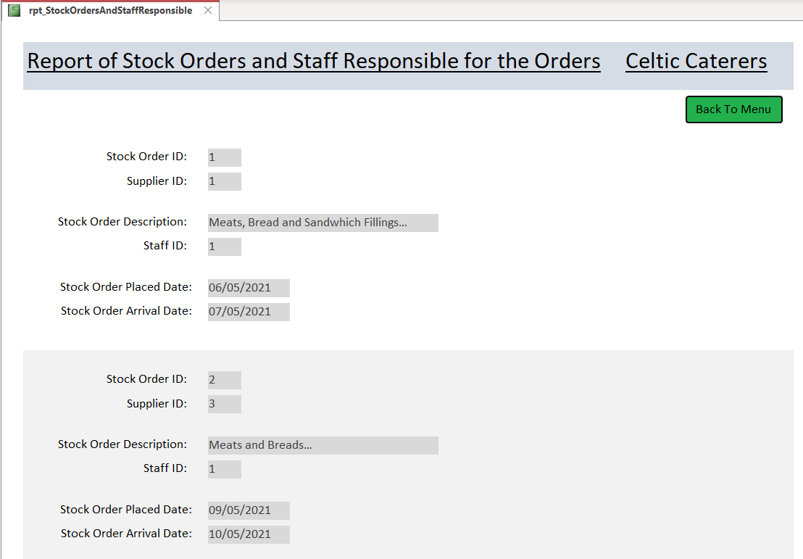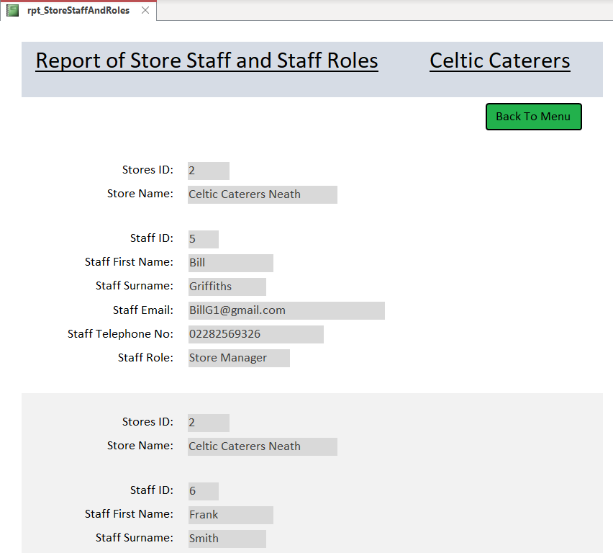
Above are all the reports and how they would be viewed if opened in Microsoft Access. Please zoom in if any data or information is unclear to read.

Macros

Macros Using Macro Builder
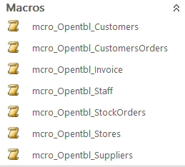
These are the macros that have been created for the functionality of the buttons of the Tables Menu. Theses were created using the macro builder and there are also many actions and embedded macros that have also been created within buttons that are shown below in All Actions.

All Actions
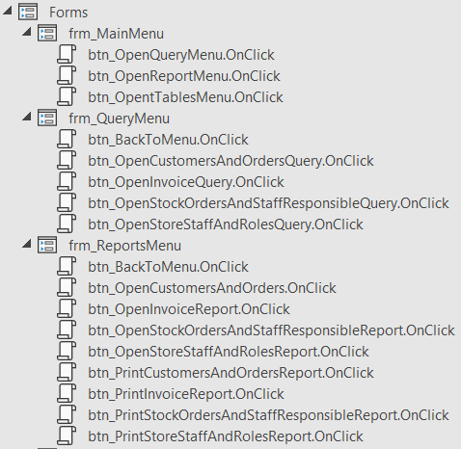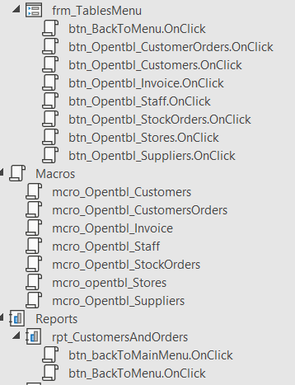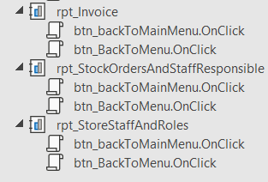
These have been created to Open tables, queries, forms, and reports. Also, to print out the reports from the reports’ menu. The macros can be accessed by clicking on a button in design view and looking at the On Click: Embedded Macro, within the Events tab of the Property sheets. Here you can see all the macros’ instructions and navigation.

User Guide

When opening the database, the user should click on frm_MainMenu on the left-hand side and this gives them a menu navigation that they can use to access anything that they need to from here.
Accessing Invoice to View or Print
1. Click on the ‘Open Report Menu’ button.

2. Then click the Orange Printer Button to print. Or click the ‘Open invoice Report’ to view the report of the invoice.
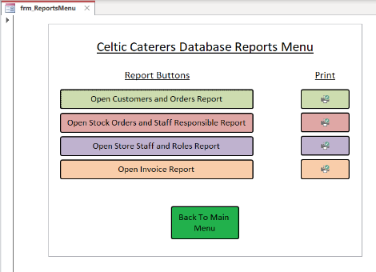

Seeing a Record of Transaction
1. Click on the ‘Open Report Menu’ button.

Verification of Designs

2. Click on the ‘Open Customers and Orders Report’ button.
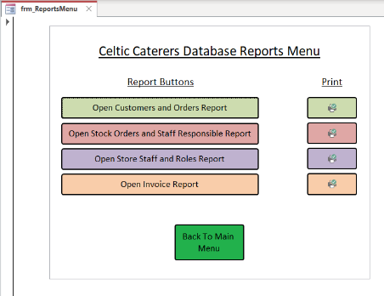
Query information about catering events
1. Click on the ‘Open Query Menu’ button.

2. Click on the ‘Open Customers and Orders Query’ button.
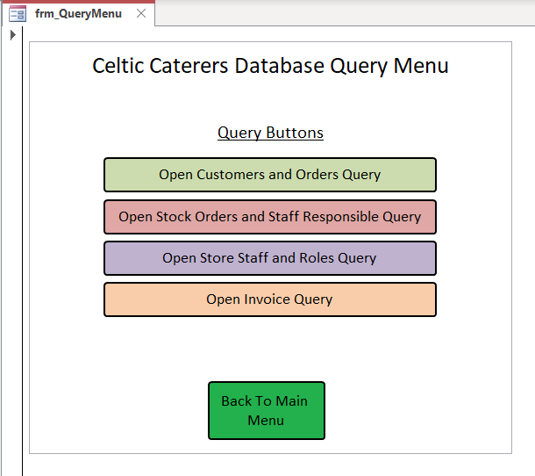

Verification of Designs

Firstly, I believe that the database that has been produced has been created through many stages of design that have been looked at such as a Context Diagram showing the scenario and aspects involved that would need to be considered when making the database. A Level 0 DFD to show the data flow of the database and what is required for data entry and where the information gained will be stored. Also, an Entity Relationship Diagram that shows the proposed tables, primary keys, foreign keys, attributes, and relationships between tables so that the information can be used most effectively whilst thinking about the accuracy of data and not producing duplicates or orphaning records.
I believe that I have successfully created a database that is suitable to the brief and what the users are requiring of the system and the data that they would like to access and have produced into reports and queries that they can use to gain information about invoices, transactions and booked catering events. In addition, I also believe that I have created a database that Celtic Caterers can in the future develop further to calculate quarterly and yearly profits.

