


﻿Improving Performance and Productivity Proposal

Gareth Siddell P151361
MSc Networks & IT Security
Leadership & Management (M7X01697) – Research Proposal
Lecturer: Professor John Rees

Contents

1. Executive Summery 4

2. Introduction 5

3. Options for addressing the motivation issues 6

4. Accelerate the development 10

5. Appraise options for evaluating staff 13

6. Analysis of leadership approaches 17

7. Reference List 22
Figures
1. Maslow hierarchy of needs [1]
2 McGregor’s Theory X and Y [2]
3 Belbin Team Roles [3]
4 Myers Briggs Type Indicator Grid [4]
5 Situational Leadership [5]

1. Executive Summery

Swansea Knowledge Factors Ltd is a software development company in Swansea South Wales. Swansea Knowledge Factors Ltd specialises in AI (Artificial Intelligence) and big data analysis. This paper has been written to address the issues highlighted by senior management around the performance of the development team. The paper looks at motivational techniques, Maslow’s Hierarchy of Needs understanding the needs of a person, by identifying and meeting these needs giving the individual a feeling of belonging to get them to the next stage of self-esteem and self-actualisation to improve performance. Utilising McGregor’s Theory X and Y on developers will enable the manager to map the employee to Maslow’s Hierarchy of Needs to identify where they are in their career to target the next steps to be taken. To help build self-confidence and a sense of belonging Edwin Locke’s goal setting theory should be used. Locke’s research evidences that setting difficult goals and getting them to agree to that goal builds confidence and improves performance. The recommendation should be to use all three theories’ together taking the best parts of each.

To help accelerate the development of the team two approaches are discussed, BELBIN for teams and Myers Briggs type indicator. These instruments through psychometric and psychological type testing can identify the characteristics of the team members. BELBIN and Myers Briggs instruments can identify the personality and using these instruments the team can be balanced to improve performance. Placing the developers in the correct role on a project will improve quality and performance. The use of both tools is recommended as BELBIN will identify the role of the individual in the team while Myers Briggs will identify the individual’s traits, this will aid in development of the individual.

The options for evaluating the staff would be a continuation of the development section, BELBIN and Myers Briggs evaluations will be used with a staff appraisal. Appraisals fit in with Goal setting theory by Locke. An effective appraisal system can be a positive experience for the individual and discussions about performance and training needs will give the person a feeling of belonging within the organisation. Individuals that have feedback and goals has been shown by Edwin Locke to have a positive effect. Targets KPI’s and compliance will also be measured to ensure legal compliance.

The leadership approaches to be taken would include an element of situational leadership. Taking parts of this theory best suits a development team. The original theory is based around level of competence in a task, as we require the team to be operating at high performance adapting the theory to work on the team development will aid the turnaround of projects. Coaching and mentoring has also been recommended, but not just as a team development but for the whole organisation. Coaching of individuals from senior managers will help them realise there personal and professional goals. Mentoring from senior employees sharing their skills and knowledge with less experienced individuals helps create a team ethos and ensures development of junior staff.

We should start to see an improvement in performance after three months of implementation full results should be seen between six months to one year.

2. Introduction

Swansea Knowledge Factors Ltd is a software development company in Swansea South Wales. Swansea Knowledge Factors Ltd specialises in AI (Artificial Intelligence) and big data analysis. Senior management have concerns around the performance of the software development team. It is believed that the team are under preforming and a new team manager has been employed to improve team performance. This proposal paper has been written for the senior management team, to propose methods of improving team performance. The paper has been broken down in four sections where options have been discussed the sections are: -

  - Options for addressing the motivation issues, this discusses Abraham Maslow’s Theory of Human Motivation, McGregor’s Theory X and Y theory and Edwin Locke Goal-Setting Theory as ways to address motivation.
  - Accelerate the development of the team by identifying team member personality traits through the use of BELBIN of teams and Myers Briggs type indicator.
  - Appraise options for evaluating staff with BELBIN of teams, Myers Briggs type indicator, appraisals and measuring performance with targets and KPI’s.
  - Analysis of leadership approaches, discussing Autocratic leadership, Transformational leadership, Situational leadership and coaching and mentoring.

3. Options for addressing the motivation issues

Introduction
In this section we’ll discuss various theories of motivations, understanding what people needs are, to help improve team performance. We will start with Abraham Maslow’s paper “A Theory of Human Motivation”[6] discussing the relevance of McGregor’s Theory X and Y [7] people types and end with Edwin Locke “Goal-Setting Theory” [8] that will give an understanding of people and how to get the best out of them.

“A Theory of Human Motivation”
Abraham Maslow [9] a psychologist from America studied human needs from the most basic and published them “A Theory of Human Motivation” that looks at the needs of an individual. Maslow broke these down to 5 sections that he organised in a hierarchy, the most basic needs from the bottom up.
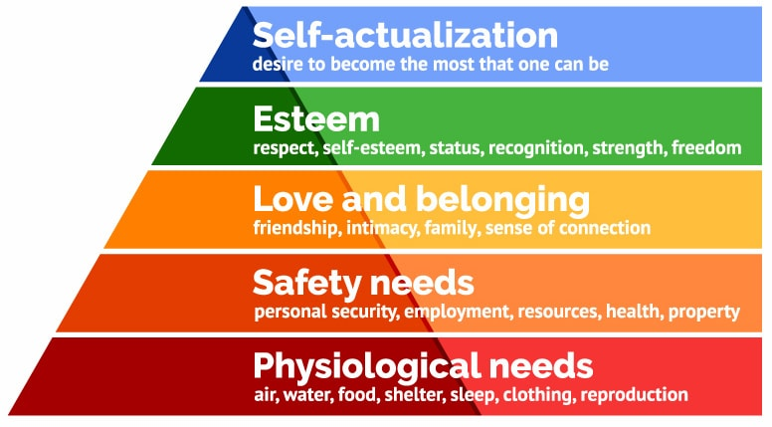
Figure 1 Maslow hierarchy of needs [1]

Figure 1, Maslow’s hierarchy of needs shows the 5 sections of needs that a person requires to reach their full potential. At the bottom the most basic of needs Physiological, air, water, food, shelter, sleep, clothing, reproduction and survival needs.
Next level are the safety needs, people need to feel safe, secure and be in good health.
The next three needs are what we should be focusing on as a company to get the best from the team. Love and belonging, staff feeling like they belong in a team is a part of high performance, staff need to feel accepted and part of the group to give their best. This needs to be part of the company culture reflected in its behaviour and values. A section of Acceptance and Belonging in “make a dent leadership” [10] states that to make people feel they belong by:
  - No negative self-talk, no put downs
  - Practicing respect all of the time
  - Staff should not compete for rewards
  - Value the diversity of the staff
  - Provide opportunities to develop capabilities, interests of each individual
  - Promote inclusion and acceptance – do not allow cliques to develop
  - Encourage and promote co-operation
  - Do not compare people
  - Allow people freedom to contribute and control their destiny

The author would agree with all the points for a software development team, “Staff should not compete for reward” this may not work so well in a sales environment but in a software development environment the code will be better if it is not rushed. This would not mean there would be no targets, just not micro managing staff to write X amount of lines of code a day. “Don’t allow cliques to develop” from experience that is very damaging to moral, people do not feel like they belong when cliques form. Cliques are also usually the source of negative feeling/comments towards other staff members.
Esteem, can link into the same thread as belonging, giving staff confidence, respect, positive comments, recognising good work and giving praise, everyone wants to be praised as it makes them feel good, feel like they belong.
Maslow first states in his first publication in 1943 that a person must meet the lower levels 100% before moving on to the next level, but later clarified in 1987 that a person can sometime move to the next level once they more or less satisfied it. Self-actualisation the top level can therefore be reached without fully satisfying the lower levels, staff that reach this level to realise their personal potential and have a desire to become everything they are capable of becoming. As a manager coaching and encouraging staff through the levels to reach Self-actualisation will enable them to be a high performer.

McGregor’s Theory X and Y
Douglas McGregor was a management professor who in 1960 published a book “The human side of enterprise” following on from the works of Maslow, McGregor developed the Theory X and Y to categorise managers. Theory X managers can be linked to Maslow’s bottom two layers while theory Y managers can be linked to the top three.

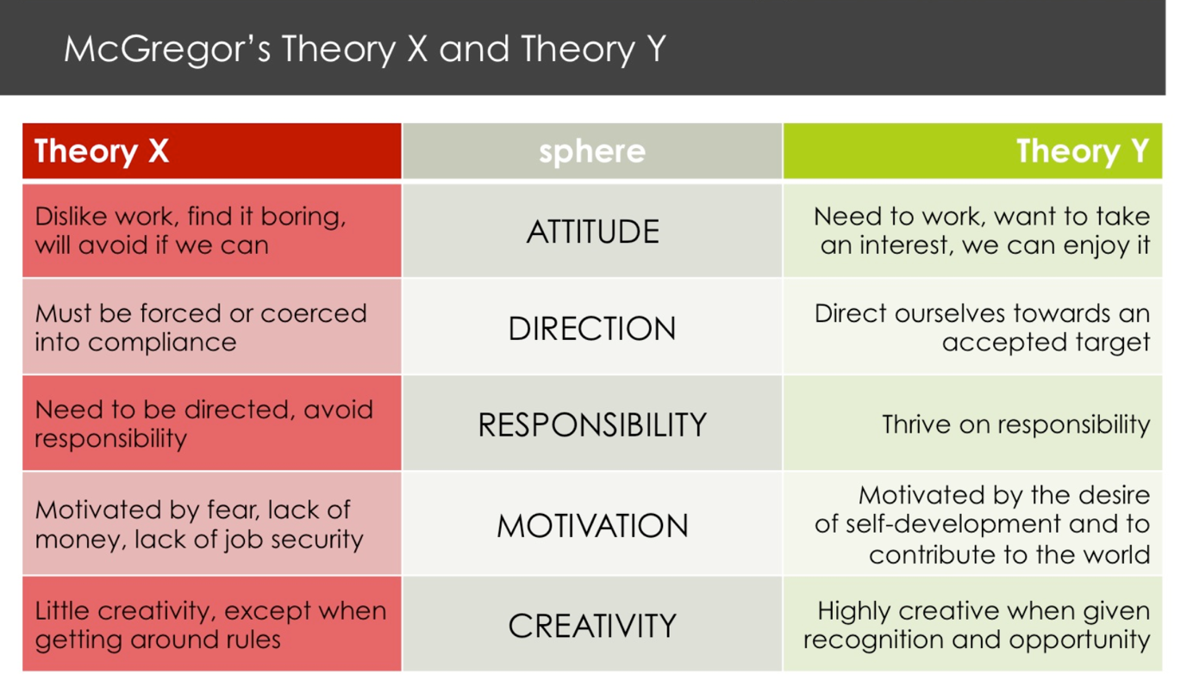
Figure 2 McGregor’s Theory X and Y [2]
The author believes the same can be used to categorise staff. In a team of developers, staff with a low level of belonging and self-esteem will tend to fall into Theory X. While you can have other developers in the same team who are self-motivated, want to self-develop and contribute who will fall into Theory Y.
Theory X workers are only there to satisfy the bottom two layers of Maslow’s hierarchy of needs, they do not feel a sense of belonging, dislike work, must be forced into compliance, need constant direction, only motivated by fear/money/lack of job security, little creativity. While on the contrast theory Y workers fit into the top three layers of Maslow’s hierarchy of needs, need to work, feel part of something, self-motivated, thrive on responsibility, self-development and highly creative. Strong leadership for Theory X workers, praise, making them feel like they belong in the team, motivating them to become theory Y workers will improve team and worker performance.

Edwin Locke "Goal-Setting Theory"
Edwin Locke is a psychologist from America and pioneer in goal setting theory. Locke developed the theory in 1968 and works around improving the theory have continued with Gary Latham up to 2006. [8][11] Locke and Latham research has demonstrated that setting goals and targets improve productivity. They also learned that the harder the goal the more focused someone will be and try harder to achieve it. They have identified five goal principles to improve success: -

- Clarity.
- Challenge.
- Commitment.
- Feedback.
- Task complexity.

Setting clear goal gives the employee clarity of what they are trying to achieve. Setting a clear goal also enables measuring the results to be more accurate.
The goals set must be challenging, but not too challenging that they are impossible to achieve.
For the goal to be a success the team/individual must accept the goal and believe they can achieve it. The theory also works better if the team or individual are involved in setting the goal has input.
Feedback needs to be two-way, between manager and team. The team should be feeding back the progress to the manager. The manager also needs to be providing support, in the way of praise if the task is going well or leadership and guidance if the task is behind.
Ensure the task is not too complex, if the task becomes too complex for the team or individual to handle they can get overwhelmed and could push themselves too hard.

The aim of this is for the team or individual to succeed, success leads to more success and higher performance. Goals need to be flexible but not too flexible that the goal does not become too easy. The author has had experience with this theory and has found it works well and motivates people to perform at a higher level on the next task.

Conclusion
The three theories have been chosen as they work well together. McGregor X Y used on the worker, can help the manager identify team members who need extra leadership and mentoring. To help them achieve a McGregor Y developer. Maslow hierarchy of needs helps identify where a developer is in their career so the manager can help them reach Self-actualisation through the use of Locke’s goal setting. Goal setting can build confidence to someone at any level of the hierarchy of needs. Ensuring everyone feels like they belong in the team will no doubt improve performance.

4. Accelerate the development

Introduction
In this section we will look at and discuss methods to identify the team member types and how to accelerate the team development. We will discuss instruments such as BELBIN for teams [12] to identify what types of team member personality traits exist within the development team. Another test to preform to identify personality traits within a team would be Myers-Briggs Type Indicator MBTI [13] this is the most widely used personality assessment tool. Knowing your team personality traits can aid in getting the right people involved at the right time in a project.

BELBIN for Teams
Belbin for teams is based on psychometric testing, the difference with the Belbin model is that most test rely on self-reporting. Belbin uses multiple questions as evidence to draw the conclusion. [14] The Belbin model identifies individuals from testing using High level reasoning ability (the Critical Thinking Appraisal), Personality (16PF 16 scales of the Cattell Personality Inventory) and outlook (PPQ Personal Preference Questionnaire) [15] for nine team roles. The nine team roles are broken down into the following: -
  - Resource Investigator
  - Team worker
  - Co-ordinator
  - Plant
  - Monitor Evaluator
  - Specialist
  - Shaper
  - Implementer
  - Completer Finisher

Resource Investigators are inquisitive people who are meant to bring back new ideas to a team
Team workers are the gel that holds a team together, they are versatile, identify work required and complete for the team.
Co-ordinators are confident, they identify the team’s objectives and delegate the work to the team members appropriately.
Plants are highly creative problem solvers, they think unconventionally to solve issues.
Monitor Evaluator are logical thinking, impartial, they identify the teams options in a dispassionate way.
Specialists are experts in key areas bringing in-depth knowledge to the team.
Shapers are the driving force, they keep the team moving, do not lose focus and keep the team moving forward.
Implementers are planners and strategists, they implement the work as efficiently as possible.
Completer Finishers are the quality control, best used at the end of a task to ensure its to the highest possible standard.
Figure 3 in the next section shows the Belbin for teams roles.

Belbin’s research has shown that a combination of the team role out preformed all other combinations [16] the ideal team should have all roles. In the authors view finding a team with all members is very remote, having too many of one role in a team would also be damaging. Having multiple co-ordinators or implementers, not enough team workers or plants and not having a completer finisher will leave projects incomplete before the team moves on to the next task. The original research had 8 roles, but it was found that 30% of people didn’t have a clear team, so a ninth role was created that of specialist. [17]

The view of the author would be that some roles are more important than others, the author has worked on many projects without some of the roles. A completer finisher can act as other roles thorough the project, implementer for example, both are roles where details are important. A plant can also be the specialist or the monitor evaluator [18]. It is very rare to get all types in a team but some team member can take on multiple roles to fill the gaps, this is also backed up by Belbin studies. [17][19]

Myers-Briggs Type Indicator
Myers-Briggs Type Indicator is a tool that looks at psychological type. The tool is based on work done by Carl Jung to explore cognitive styles. [20] MBTI looks at the type of person following on from cognitive styles identified by Jung: How people look at life, how people look at the world and how people reach conclusions about the world. MBTI identifies 16 personality type based on questions answered by the individual, these are broken down into 4 sections: -
  - Favourite world
  - Information
  - Decisions
  - Structure

Favourite world questions are to find out if a person is inward or outward focusing. Extraversion or Introversion E Or I.
Information questions are to find out how a person views information, do they focus on the information or try to add meaning, sensing or intuition S or N
Decision questions are to find out if a person uses logic or considers if there are special circumstances, Thinking or Feeling T or F.
Structure questions are to find out if a person in dealing with the outside world prefers things decided or are open to new ideas or information, Judging or Perceiving J or P.

Figure 4 in the next section shows the Myers Briggs Type Indicator Grid.
Adding all the letters together will come out as the type of person MBTI thinks you are. A list of meanings can be found on the Myers-Briggs Type indicator web site. [21] As with the Belbin model having a team with all members having a similar type could cause the team to be ineffective. Having a balanced spread of types within the team provided better out comes. MBTI has undergone many studies of validity, it been concluded that the instrument yielded lower scores of reliability on persons under the age of 20 than adults. [22] It has also been found that the test re-test score in MBTI in a 1 week to 2.5 year period were high. [22][23] The author having done the test found it to be accurate and a useful tool for personal development.

Conclusion
The instruments selected for team development are the two biggest one for evaluating staff personality types and how they would work in a team. The instruments will help evaluate the team members and help with finding out what team member is better suited for a task within the overall project. The instruments can also aid the individuals with their personal development, using the tool someone might score high and be suited in management position. Both instruments are helpful in their own way, the author believes Belbin for teams has a better interface for understanding a role within a team, while MBTI will give the individual an insight into their personality and from this they can be aware of their own traits and use this in there day to day life as well as working life. From a team development the author would recommend the development team do both tests and get both results. These tests can be used as a team building exercise as well as the team members learning more about their team mates. Knowing someone’s personality traits and strengths will help the team understand each other better. It must be added these are instruments and the results are not exact, answering these questions can be influenced by how that person is feeling that day as these tests are self-reporting tests.

5. Appraise options for evaluating staff

Introduction
In this section we will look at methods for evaluating staff, this follows on from the works in the last section. The information gained from the Belbin for teams and Myers Briggs Type Indicator fit in with understanding of what staff types are in the team. How the staff will work as a team and their personality traits. We will discuss staff appraisals and how that can aid the development of the individual. We will also look at more rigid methods of evaluating staff, measuring them against targets, KPI Key Performance Indicators. Competency frameworks to ensure staff are up to date with essential training, information governance to avoid data breaches and job competency.

Belbin and Myers Briggs
As discussed in the last section these instruments will give the manager an understanding of what people they have in the team. This information can be used to put the right person in the correct role within that team to get the best from that group. Ensuring that the right roles are present within the team has been proven to be essential if you want high performance from that team.
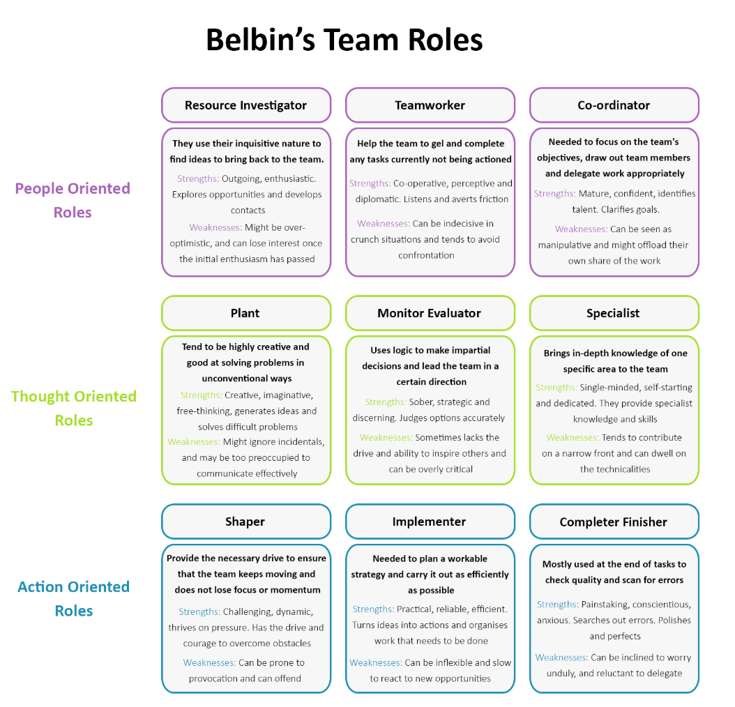
Figure 3 Belbin Team Roles [3]
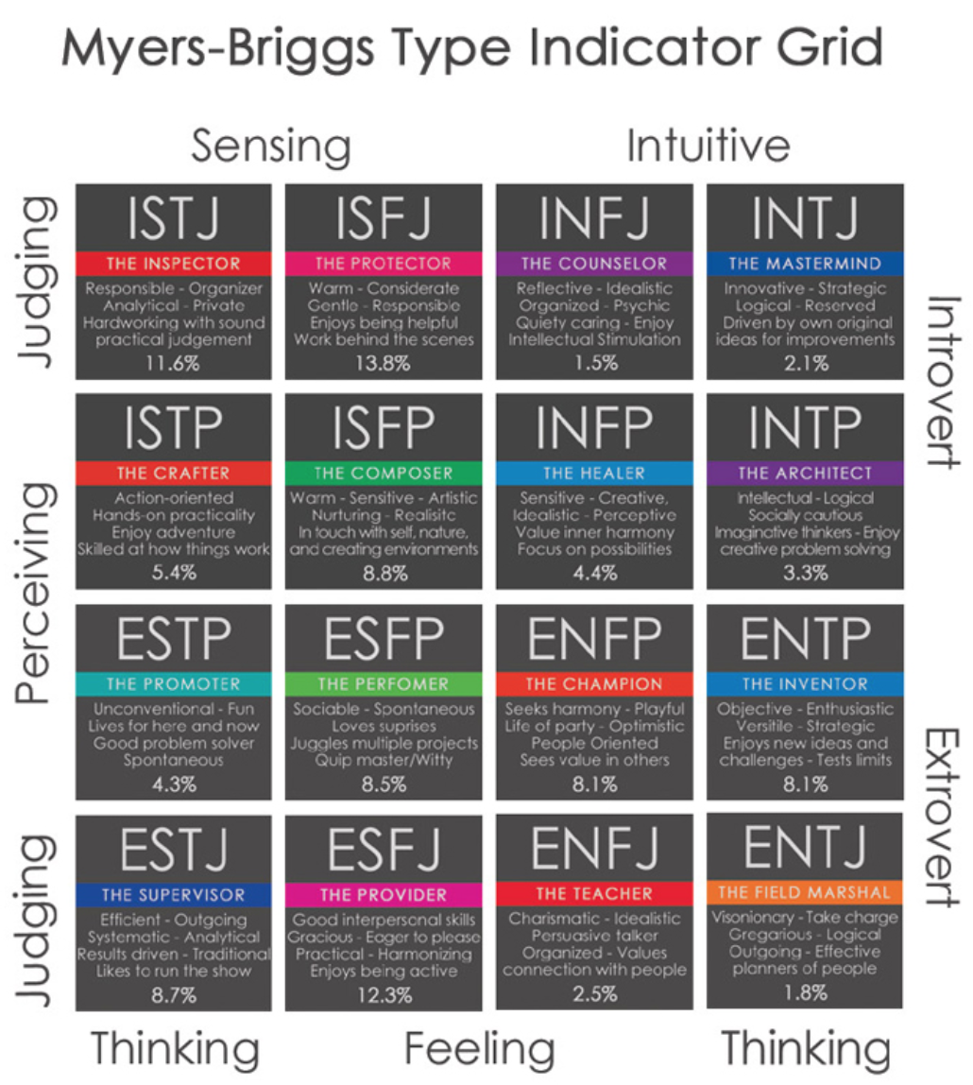
Figure 4 Myers Briggs Type Indicator Grid [4]

As you can see from figure 3 and 4 Belbin for teams and Myers Briggs Type Indicator grid once you have identified the individual’s role they can be placed in the team, assigned the role that best suits them and will give the best outcome for that team. The author would highlight that the tests are self-reporting and dependant on how that person was feeling that day, so monitoring of the new team would be essential.

Appraisal
Appraisal is normally a one to one meeting with a manager or supervisor where the performance of a staff member is discussed. An appraisal normally happens on a yearly cycle, (but can be more frequent) in the appraisal objectives/goals are set to be completed throughout the year and to be discussed in the next appraisal. Normally an appraisal document is given out to the staff member to complete before they come to the appraisal, this will include past objectives and dependant on the organisation may include a section for the staff to set their own objectives for the following year, this can be linked to Edwin Locke goal setting theory [8]
The appraisals tends to have common elements
  - Past objectives/performance
  - Setting objectives and goals for the next year
  - Evaluating based on company/department predetermined standards
  - Formal feedback
  - Future training/performance
  - Salary enhancements

Appraisals should be a positive experience, appraisals should not be used to address poor performance, if an employee is performing poorly this should have already been addressed as part of the manager’s responsibilities. Appraisals are about the employee, they should be used as development tool and to get the opinions of the employee on how they feel about working in the organisation. According to small business recommendations appraisals should not last longer than 30 minutes [24] but the author thinks for professional staff that would not be enough time, but feels the appraisal should not go on longer than 60 minutes. 30 minutes is not enough time to discuss how the employee felt the previous objectives went, good/bad points, what the employee thinks they could have done better, what they learned from the objective and to give feedback. There are critics to the appraisal process, Redman and Wilkinson believe appraisals are an expensive process that can cause conflict between the appraiser and appraisee [25] Grint goes further and stated that “Rarely in the history of business can such a system have promised so much and delivered so little”[26] The authors view would be, appraisals can have a positive outcome on performance, employees have feedback and goals and this has been shown by Edwin Locke to have a positive effect. [11] Negative appraisals will have a negative effect, but appraisals should positive any issues about performance should be addressed as they are happening.

Targets, KPI’s, Competency
Targets/KPI’s are a way of measuring performance. Each employee is given a target of producing X amount of goods, writing X amount of code in a set time. This is a good way for managers to measure performance but the question has always been “Does the quality suffer” because employees are rushing their work. The authors past experience of monitoring staff performance against other team members based on service desk calls closed, shown that staff started “cherry picking” easy calls to get good statistics, or even creating calls to close. Targets where employees can pick what work they preform will cause employees to choose the easy tasks, if targets are used work needs to be assigned to employees. Competencies are essential in some roles, for example a gas engineer or electrician need to keep their qualifications up to date to be able to perform their role. To maintain accreditations, they need to be refreshed every few years. With the General Data Protection Regulation GDPR coming in to effect in May 2018, companies have an obligation to give staff data protection governance training and can be heavily fined if there is a data breach due to someone not having that training. Employers have a legal duty to give health and safety, first aid training to some staff, this needs to be refreshed every few years. Staff need to be measured on this.

Conclusion
A manager needs to be able to evaluate staff, from performance to compliance with the law. Managing staff performance and improving that performance can be performed with a number of tools, from evaluating employee performance and what role in the team best suits their personality type to what to expect from their traits. Using tools like Belbin and MBTI can help the manage and employee identify where they best fit in a team. Evaluating performance can be gained via goal setting and objectives in an appraisal. Care needs to be taken when setting KPI style targets and there is a legal duty on the employer to ensure the staff meet the correct compliance levels. Employees need targets, but the targets need to be achievable and meaningful. Appraisals can be positive for the employee, this can improve performance. Following Edwin Locke goal setting theory his works have shown getting the employee to agree and set their own goals and complete them will improve both confidence and performance.

6. Analysis of leadership approaches

Introduction
In this section we will discuss leadership and the different approaches to leadership. I found a good example of the differences between a leader and manager from management consulting courses [27]
“There is an interesting story, which nicely illustrates the difference between a manager and a leader.

Newly appointed to the position of supervisor in a large industrial plant, a manager decided to impress his subordinates with his authority. Striding purposefully onto the plant floor, the manager carefully chose the subject of his well-rehearsed address. Once he had arrived at the workstation manned by the union shop steward, he announced, in words loud enough for most workers to hear, "I want to make one thing perfectly clear: I RUN THIS PLANT!"

Unimpressed, the shop steward held up his hand. On seeing his signal, all the workers shut off their equipment. Then, in the eerie silence of the large plant, the shop steward challenged the manager: "OK. So, let's see you run it." Clearly, by virtue of his appointment to the position of manager, the supervisor had authority. However, without followers, he was no leader. In this scenario, the union shop steward is the leader. In spite of the authority inherent in the position of supervisor, the workers chose to follow the directives of the shop steward.”

Above is a good example of the difference between a manager and leader, leaders need followers. Within leadership there are styles of leadership. In this section we will discuss a few and their suitability for a development team. We will discuss the extreme “Autocratic leadership” and will discuss “Transformational leadership” we will also discuss “Situational leadership” and end with coaching and mentoring as an approach.

Autocratic leadership
Autocratic leadership approach is a “command and rule” approach, the boss makes all the decisions and expects subordinates to promptly implement. The leader holds all the authority and responsibility, they make all the decisions on their own without any consolation from subordinates. There are normally strict procedures, guidelines and policies in place and the work environment has little to no flexibility. This approach can discourage group input, people tend to feel happier and perform better when they are contributing with the decision making. [28] Building a team environment where developers are working on different sections of a program participation and group decision making are essential. Creating that environment can aid in problem solving. Stifling group input from an autocratic approach will lead to projects failing.

Transformational leadership
Transformational leadership is an approach that causes change in individuals, transformational leaders use motivational techniques to get individuals to accept the change and to do more than they thought possible.[29] Followers of transformational leaders feel a sense of loyalty, admiration and trust for the leader, this is due to the leader offering something more than just personal gain. They create an inspiring mission with vison to give the followers an identity. They encourage followers to come up with new ideas and to challenge the status quo “we have always done it that way” people. Critics of transformational leadership style argue that transformational leaders have the potential to abuse the power. Some leaders have been known to have narcissistic tendencies thriving from manipulation. [30] Transformational leadership would be hard to train, charisma, intellectual stimulation, inspirational motivation and individualised consideration are not something that can be trained to some managers. People are either transformational leaders or not, a good publicised example of a transformational leader would be Sir Richard Branson and Christine Nixon who transformed the culture of the Australian state of Victoria police department. [31] Transformational leadership can be used for good as the examples have shown, but with every approach is has good elements and bad.

Situational leadership
Situational leadership is an approach from Paul Hersey and Ken Blanchard, based on an individual’s competency in that role. The theory is characterised on the amount of support given by the leader to the follower. The supportive behaviours are named: -
S1: Directing
S2: Coaching
S3: Supporting
S4: Delegating

S1, directing: leaders provide clear guidance and supervise them closely, decision making is made by the leader and communication tends to be one-way, leader to follower.
S2, coaching: leaders still provide clear guidance but seeks suggestions from the follower, decision making is still made by the leader but the communication is more two-way.
S3, supporting: leaders start passing decisions to the followers, leaders facilitate in the decision making.
S4 delegating: leaders are still involved with problem solving and decision making but control is passed to the follower.

Following on from the leader’s style, Hersey and Blanchard also categorised development levels to go alongside the supportive levels.
D1 Low competence, Low commitment
D2 Some competence, Low commitment
D3 High competence, Variable commitment
D4 High competence, High commitment

D1, would be someone inexperienced to the task and lacks confidence.
D2, getting some skills, but cannot to the task without some help
D3, would have the relevant skills to perform the task, but lacks the confidence to do it
D4, someone experienced in the task, confident in their capabilities and may be better skilled that the leader at this point.

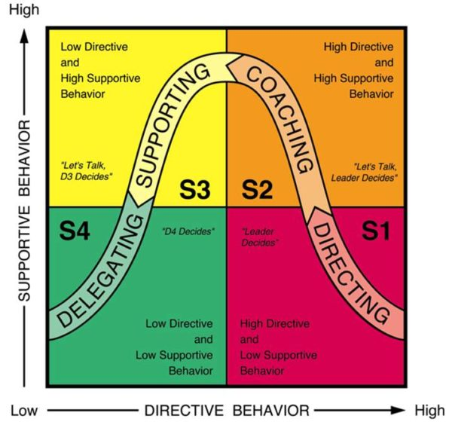
Figure 5 Situational Leadership [5]

Figure 5 show the supportive and directive behaviour. The author is unsure how this management approach could work in a software development team. Situational management is based on experience on preforming a task, with software development the task is changing as new projects start. Using the situational theory, the start of every project the team would be back to S1. Adapting the theory and taking parts of it could work, if the application of the theory is not so ridged. Instead of using the theory for tasks use it for team member for their development, direct, coach and support on how the follower would start the task, build up their confidence and self-esteem and they can become a S4 team. Critics of the theory seem weak with their criticisms, citing lack of studies in the area to justify the assumptions set by the approach. Criticising the lack of details from Paul Hersey and Ken Blanchard on how to implement the approach. The approach can cause the leader to lose sight of long term goals thus making it more of a management approach that leader approach. [32] The only valid point would be from Bennis, about losing sight of long term goals. Lack of research and details not so. With any approach the leader should take what will work in their environment and adapt.

Coaching and Mentoring
Coaching is a process of helping another person to realise their personal and professional goals. The coach fosters self-awareness in the person using conversation aimed at self-direction learning. While mentoring is performed by senior experienced individuals where they share their skills and knowledge with less experienced individuals. Mentoring can be formal or informal, formal mentoring include performance observations with feedback from a senior in a structured way. Informal mentoring includes peer appraisals and observations, with learning community’s setup. A structure should be setup that makes both coaching and mentoring possible, mentoring can be achieved within the team from senior developers in an informal approach while coaching can be performed by senior member within the company. This approach should be rolled out company wide.

Conclusion
While Autocratic leadership and Transformational leaderships styles are not suitable in a software development team, adapting situational leadership, coaching and mentoring would be a suitable approach. Using situational leadership for the development for the team and not to control the tasks will help develop the individuals into a high-performance team. Coaching and mentoring should be an approach used not just for the development team but companywide.
The benefits for the staff from being coached from a senior manager would develop self-awareness in that individual. Mentoring should be encouraged by the senior staff members to share their skills and experience with less experienced individuals within the company.

Executive Summery

Swansea Knowledge Factors Ltd is a software development company in Swansea South Wales. Swansea Knowledge Factors Ltd specialises in AI (Artificial Intelligence) and big data analysis. This paper has been written to address the issues highlighted by senior management around the performance of the development team. The paper looks at motivational techniques, Maslow’s Hierarchy of Needs understanding the needs of a person, by identifying and meeting these needs giving the individual a feeling of belonging to get them to the next stage of self-esteem and self-actualisation to improve performance. Utilising McGregor’s Theory X and Y on developers will enable the manager to map the employee to Maslow’s Hierarchy of Needs to identify where they are in their career to target the next steps to be taken. To help build self-confidence and a sense of belonging Edwin Locke’s goal setting theory should be used. Locke’s research evidences that setting difficult goals and getting them to agree to that goal builds confidence and improves performance. The recommendation should be to use all three theories’ together taking the best parts of each.

To help accelerate the development of the team two approaches are discussed, BELBIN for teams and Myers Briggs type indicator. These instruments through psychometric and psychological type testing can identify the characteristics of the team members. BELBIN and Myers Briggs instruments can identify the personality and using these instruments the team can be balanced to improve performance. Placing the developers in the correct role on a project will improve quality and performance. The use of both tools is recommended as BELBIN will identify the role of the individual in the team while Myers Briggs will identify the individual’s traits, this will aid in development of the individual.

The options for evaluating the staff would be a continuation of the development section, BELBIN and Myers Briggs evaluations will be used with a staff appraisal. Appraisals fit in with Goal setting theory by Locke. An effective appraisal system can be a positive experience for the individual and discussions about performance and training needs will give the person a feeling of belonging within the organisation. Individuals that have feedback and goals has been shown by Edwin Locke to have a positive effect. Targets KPI’s and compliance will also be measured to ensure legal compliance.

The leadership approaches to be taken would include an element of situational leadership. Taking parts of this theory best suits a development team. The original theory is based around level of competence in a task, as we require the team to be operating at high performance adapting the theory to work on the team development will aid the turnaround of projects. Coaching and mentoring has also been recommended, but not just as a team development but for the whole organisation. Coaching of individuals from senior managers will help them realise there personal and professional goals. Mentoring from senior employees sharing their skills and knowledge with less experienced individuals helps create a team ethos and ensures development of junior staff.

We should start to see an improvement in performance after three months of implementation full results should be seen between six months to one year.

7. Reference List

[1] S. Mcleod, “Maslow’s Hierarchy of Needs | Simply Psychology.” [Online]. Available: https://www.simplypsychology.org/maslow.html. [Accessed: 12-Apr-2018].
[2] “theory-x-and-theory-y.jpg (1679×944).” [Online]. Available: https://frontlinemanagementexperts.files.wordpress.com/2015/08/theory-x-and-theory-y.jpg. [Accessed: 12-Apr-2018].
[3] “Belbin For Teams Roles.” [Online]. Available: https://www.google.co.uk/search?q=belbin+for+teams&safe=strict&source=lnms&tbm=isch&sa=X&ved=0ahUKEwj7kMWD88XaAhXGCcAKHTZRCTEQ_AUICigB&biw=1353&bih=927#imgrc=ilYf0ka0QleQZM: [Accessed: 19-Apr-2018].
[4] “Myers Briggs Type Indicator Grid.” [Online]. Available: https://www.google.co.uk/search?q=mbti&safe=strict&source=lnms&tbm=isch&sa=X&ved=0ahUKEwjWm8qp88XaAhXrA8AKHR9_DE8Q_AUICigB&biw=1353&bih=927#imgrc=DTGClhnzlvgBrM: [Accessed: 19-Apr-2018].
[5] “situational leadership - Google Search.” [Online]. Available: https://www.google.co.uk/search?q=situational+leadership&safe=strict&source=lnms&tbm=isch&sa=X&ved=0ahUKEwiTrpKN3tXaAhVCBsAKHahLCrYQ_AUICigB&biw=1148&bih=927&dpr=1#imgrc=l4KgEWW79XamXM: [Accessed: 25-Apr-2018].
[6] M. A. H., A Theory of Human Motivation. Martino Fine Books, 1943.
[7] D. Mcgregor, The Human Side of Enterprise. McGraw-Hill Education; Annotated edition edition (16 Feb. 2006), 1960.
[8] E. A. Locke and G. P. Latham, New Developments in Goal Setting and Task Performance. Routledge; 1 edition (8 Jan. 2018).
[9] T. Gale, “Maslow, Abraham H - Dictionary definition of Maslow, Abraham H | Encyclopedia.com: FREE online dictionary.” [Online]. Available: https://www.encyclopedia.com/psychology/arts-construction-medicine-science-and-technology-magazines/maslow-abraham-h. [Accessed: 12-Apr-2018].
[10] “Acceptance and Belonging - It’s impact on performance.” [Online]. Available: https://www.makeadentleadership.com/acceptance-and-belonging.html. [Accessed: 12-Apr-2018].
[11] M. Tools, “Locke’s Goal-Setting Theory - Goal Setting Training From MindTools.com.”
[12] “Belbin Team Roles | Belbin.” [Online]. Available: http://www.belbin.com/about/belbin-team-roles/. [Accessed: 12-Apr-2018].
[13] “The Myers &amp; Briggs Foundation - My MBTI® Personality Type.” [Online]. Available: http://www.myersbriggs.org/my-mbti-personality-type/. [Accessed: 12-Apr-2018].
[14] “Our Methodology | Belbin.” [Online]. Available: http://www.belbin.com/about/our-methodology/. [Accessed: 16-Apr-2018].
[15] “History &amp; Research | Belbin.” [Online]. Available: http://www.belbin.com/about/history/. [Accessed: 16-Apr-2018].
[16] R. D. Belbin, R.M., Aston, RR and Mottram, “Building Effective Management Teams,” J. Gen. Manag., vol. 3, no. 3, pp. 23–29, 1976.
[17] M. Belbin, Management Teams, Why They Succeed or Fail. 1981.
[18] V. Dulewicz, “A Validation of Belbin’s Team Roles from 16PF and UPQ Using Bosses,” J. Occup. Organ. Psychol., 1995.
[19] M. Belbin, “Team Roles at Work,” 1993.
[20] C. Jung, “Psychological Types,” 1921.
[21] “The Myers &amp; Briggs Foundation - The 16 MBTI® Types.” [Online]. Available: http://www.myersbriggs.org/my-mbti-personality-type/mbti-basics/the-16-mbti-types.htm?bhcp=1. [Accessed: 17-Apr-2018].
[22] M. H. Myers, I. B., & McCaulley, A guide to the development and use of the Myers-Briggs Type Indicator. 1989.
[23] L. Tischler, “The MBTI factor structure.,” J. Psychol. Type, 1994.
[24] “How Much Time Should Be Spent on an Employee Evaluation? | Chron.com.” [Online]. Available: http://smallbusiness.chron.com/much-time-should-spent-employee-evaluation-30453.html. [Accessed: 19-Apr-2018].
[25] A. Redman, T, & Wilkinson, Contemporary Human Resource Management, 3rd ed. Pearon Education, 2009.
[26] K. Grint, “What is wrong with performance appraisals? A critique and a suggestion,” Hum. Resour. Manag. J., pp. 67–77, 1993.
[27] “Leadership and approaches to leadership.”
[28] J. Morgan, “The Top 10 Factors For On-The-Job Employee Happiness.” [Online]. Available: https://www.forbes.com/sites/jacobmorgan/2014/12/15/the-top-10-factors-for-on-the-job-employee-happiness/#51bbc8c25afa. [Accessed: 19-Apr-2018].
[29] B. M. Bass, “The ethics of transformational leadership,” 1997.
[30] K. Stone, A.G., Russell, R.F., & Patterson, Transformational versus servant leadership – a difference in leader focus. 2003.
[31] C. F. Lussier, R.N. & Achua, Leadership: theory, application, skill development (2nd ed.). 2004.
[32] W. Bennis, “More praise for On Becoming a Leader,” 2009.

