THE CORONAVIRUS PANDEMIC AND ITS EFFECT ON INFORMATION TECHNOLOGY SYSTEMS AND PATIENT CARE WITHIN THE NHS
by
Giovanni Thompson-Nathaniel

MBA Information Management
UWTSD
18/10/2020


Master’s Degrees by Examination and Dissertation
Declaration Form.
1. This work has not previously been accepted in substance for any degree and is not being concurrently submitted in candidature for any degree.
Signed…… G.Nathaniel.………………………...………………………………...
Date ………18/10/2020…………………………………………………………...
2. This dissertation is being submitted in partial fulfilment of the requirements for the degree of Master in Business Administration.
Signed ……G.Nathaniel………………………………………………………….
Date ………18/10/2020…………………………………………..…………...
3. This dissertation is the result of my own independent work/investigation, except where otherwise stated.
Other sources are acknowledged by footnotes giving explicit references.
A bibliography is appended.
Signed candidate: …… G.Nathaniel ……………………….……………….
Date: ………18/10/2020……………………………….……………………….
4. I hereby give consent for my dissertation, if accepted, to be available for photocopying, inter- library loan, and for deposit in the University’s digital repository
Signed (candidate)…… G.Nathaniel ………….…….………….…………...
Date……18/10/2020……………………………….…………….……………..
Supervisor’s Declaration.
I am satisfied that this work is the result of the student’s own efforts.
Signed: ……Dr. Gladius Kulothungan………………………………………..
Date: ………18/10/2020………………………………………………………...

University of Wales: Trinity Saint David

E-Thesis Deposit Agreement

Details of the Work
I would like to deposit the following item in the digital repository maintained by the University, and/or in any other repository authorized for use by the University:

Title: THE CORONAVIRUS PANDEMIC AND ITS EFFECT ON INFORMATION TECHNOLOGY SYSTEMS AND PATIENT CARE WITHIN THE NHS

This item is a product of my own research endeavours and is covered by the agreement below in which the item is referred to as “the Work”. It is identical in content to that deposited in the Learning Resources Centre, subject to point 4 below.

I agree that the University of Wales: Trinity Saint David may electronically store, copy or translate the Work to any approved medium or format for the purpose of future preservation and accessibility. The University is not under any obligation to reproduce or display the Work in the same formats or resolutions in which it was originally deposited.

UW: TSD Digital Repository
I understand that work deposited in the digital repository will be accessible to a wide variety of people and institutions, including automated agents and search engines via the World Wide Web.

I understand that once the Work is deposited, the item and its metadata may be incorporated into public access catalogues or services, such as national databases of electronic theses.

I agree as follows:
- That I am the author or have the authority of the author/s to make this agreement and do hereby give the University of Wales: Trinity Saint David the right to make available the Work in the way described above.
- That the electronic copy of the Work deposited in the digital repository and covered by this agreement, is identical in content to the paper copy of the Work.
- That I have exercised reasonable care to ensure that the Work is original, and to the best of my knowledge, does not breach any laws including those relating to defamation, libel and copyright.
- That I have, in instances where the intellectual property of other authors or copyright holders is included in the Work, gained explicit permission for the inclusion of that material in the Work, and in the electronic form of the Work as accessed through the open access digital repository, or that I have identified and removed that material for which adequate permission has not been obtained and which will be inaccessible via the digital repository
- That University of Wales: Trinity Saint David does not hold any obligation to take legal action on behalf of the Depositor, or other rights holders, in the event of a breach of intellectual property rights, or any other right, in the material deposited.
- That I undertake to indemnify the University of Wales: Trinity Saint David against all actions, suits, proceedings, claims, demands and costs occasioned by the University in consequence of any breach of this agreement

Signature ……G.Nathaniel………….

Date …18/10/2020……………

Abstract
The COVID-19 pandemic has been a critical healthcare challenge among multiple healthcare systems in the world. Information technology systems have been widely used in healthcare systems such as in the NHS for various purposes such as communication and data transmission. However, the knock-on effects of the pandemic on information technology systems have not been investigated in detail. This study aimed to explore the knock-on effect of the novel coronavirus pandemic on ICT systems in the NHS and how it has reshaped patient care strategies. The study employed a questionnaire to collect data from 23 participants in the NHS, including medical experts and staff in administration roles. The findings indicated that the emergence of COVID-19 affected ICT systems in multiple ways, such as increased recognition and acceptance of technology in the healthcare sector, digital transformation through virtual communications and employees working remotely, and improved usage of patient care systems daily. The study recommended future explorers to explore the pandemic's knock-on effect on the overall operations of NHS.

Keywords: Coronavirus, COVID-19 pandemic, NHS, information technology systems, healthcare.

Table of Contents
Abstract 2
Chapter 1: Introduction 4
Background of the study 4
Problem statement 6
Rational and significance of the study 7
Aim and objectives 7
Objectives 8
Research question 8
Sub-questions 8
Dissertation structure 9
Chapter 2: Literature Review 10
Introduction 10
Impact of COVID-19 on Health Systems 10
ICT Challenges in the COVID-19 Risk Management 12
Technology and COVID-19 pandemic management in NHS and other healthcare systems 15
The concept of working from home (remote services) 19
Communication between doctors and patients during the COVID-19 pandemic 21
Patient information security during COVID-19 pandemic 23
Gap in literature 26
Chapter 3: Methodology 27
Research philosophy 27
Research approach 27
Research design 29
Data collection method and sources of data 30
Data analysis method 31
Ethical issues' considerations 32
Limitations 33
Chapter 4: Results, data analysis, and discussion 34
Results and data analysis 34
Discussion 44
Chapter 5: Conclusion and recommendations 49
Conclusions 49
Recommendations 51
Future study 52
Reference List 54

Chapter 1: Introduction

Background of the study
The coronavirus pandemic has been a critical health threat that has affected multiple countries. Due to the rapid increase of the virus's spread, various governments established different policies such as restricting air travel, contact tracing for infected people, and whom they have interacted with, lockdowns, and closure of critical businesses (Gould and Lewis, 2020). These response mechanisms have negatively and significantly impacted multiple economies since the businesses could not be conducted normally. Most healthcare systems such as the NHS were threatened with the upsurge in the number of cases leading to the implementation of new measures to protect healthcare workers, hospital staff, and the public. According to Gould and Lewis (2020), the NHS has embraced the significant utilisation of technology to help manage the COVID-19 pandemic risks and save lives. On the other hand, Burgess (2020) indicates that although the busiest London NHS Trust devised different mechanisms to manage an emergency after running the number of beds and saved lives, the COVID-19 pandemic caused a knock-on effect which significantly affected the normal operations of the trust.
As the spread of the coronavirus increased, the NHS trusts were overwhelmed, and the introduction of new hospital management techniques were introduced. According to Burgess (2020), the NHS proposed introducing a technology system allowing virtual visits of patients to limit the number of visitors at the healthcare facilities. In this case, the system could offer a platform to facilitate the booking of video calls between the patients and their families and relatives. On the other hand, Donnelly (2020) noted that social care and the NHS have significantly embraced digital technology, unlike the previous years. This investigation indicated that compared to the previous crises, the COVID-19 outbreak's response had utilised digital technologies more. For instance, due to the overwhelming rate in the number of hospital visitors, digital technologies such as video calls and consultations involving doctor or nurse engagement with the patient were helpful. The video calls facilitated virtual face to face meetings, which critically helped to efficiently implement some of the proposed healthcare measures such as social distancing and the reduction in the impact on the environment (Donnelly, 2020). Moreover, some NHS staff offered clinical services from home under self-isolation, an issue that could be difficult without the new technologies.
Based on an investigation conducted by Gould and Lewis (2020) to determine how digital contact launched by the NHS helped save lives, the findings indicated that the contact tracing system was helpful to trace all people that the coronavirus patients have interacted with and perform testing. In this case, the application developers had to integrate multiple measures and functions that incorporate elements of traditional techniques to ensure seamless operations, protection of vulnerable groups, and individuals unable to access technology devices and systems (Gould and Lewis, 2020). On the other hand, key NHS stakeholders recognised the importance of implementing information systems that will accurately gather real-time information to help the NHS respond to the challenges of the COVID-19 pandemic effectively (Gould, Joshi, and Tang, 2020). However, follow-up evaluation of the system's effectiveness noted that several additional requests for data caused more stress since multiple and complex sources must be considered to ensure accurate information is shared. The system performed a critical role in gathering and analysing data, which shaped the NHS's approach to respond to the pandemic challenges effectively.

Problem statement
The implementation of new systems was aimed at facilitating the use of real-time data for proper decision making and enabled the NHS to stay ahead of the coronavirus, thus resulting in the establishment of new measures to flatten the spread rate curve. However, uncertainties and inconsistencies in information systems such as the real-time data collecting and monitoring system possibly cost lives (Gould, Joshi and Tang, 2020). According to Gould and Lewis (2020), doctors and scientists suggest making changes to the contact tracing application for making sure that it benefits the NHS and individuals to manage the COVID-19 pandemic efficiently. Besides, the new systems seem to be unable to adequately serve the NHS, as more changes are proposed to be included in future implementations. For example, medical stakeholders suggested that the application should, in the future, offer additional information for the NHS for easy identification of the trends and hotspots.
Additionally, doctors and scientists suggested that the application must provide a function for using and deleting data by NHS care, research, and management (Gould and Lewis, 2020). However, some of these suggestions may pose new challenges such as security threats and compromise of personal information privacy. Besides, more technologies such as Bluetooth low energy applications and video consultations were implemented to maintain best practices and care for patients and maintain public safety from the impacts of coronavirus (Gould and Lewis, 2020). The key problem emerging from these investigations is the lack of information on how information technology systems helped the NHS manage the pandemic and the effectiveness of the solutions in enabling staff and nurses to respond to the coronavirus efficiently as well as manage patient information.

Rational and significance of the study
A study into the knock-on effects of the COVID-19 pandemic on IT systems within NHS and patient care is crucial and relevant to determine how the implementation of certain IT systems played a significant role in the healthcare sector. Additionally, the study helps determine the specific technologies adopted among various healthcare systems and to critically evaluate their effectiveness during the coronavirus pandemic. Notably, few researchers have investigated the impact of the coronavirus in healthcare systems from the perspective of technology and innovation (Baynham and Hudson, 2020; Burgess, 2020). Hence, this study's findings will help extract vital information to fill the under-researched or not-researched gap in the literature. Besides, the findings will be utilised by key healthcare stakeholders to gather insights on how technology systems could help manage crises and help safeguard public health safety.
Moreover, the healthcare stakeholders could use the findings of this study as a basis of proposing effective IT solutions to manage future challenges posed by any crisis, either health or financial. GDPR (General Data Protection Regulation) compliance during the pandemic is also examined to ensure that the technologies used by the NHS safeguarded patient information privacy and data was shared responsibly. Finally, this study is significant for investigation since it helps the NHS recognise and determine the impacts of technologies such as the Patient Information Management Software (PIMS) and remote communications compared to other solutions employed by healthcare systems in other countries.

Aim and objectives
This dissertation aims to explore the knock-on effect the COVID-19 pandemic has had on information technology systems used in NHS and care for patients.

Objectives
- To investigate and identify key technology solutions adopted by NHS during the pandemic.
- To critically examine the impact of technology adoption in the healthcare sector, staff, and patients.
- To explore and critically compare and contrast how healthcare systems (e.g., NHS) worldwide are using digital technology in fighting COVID-19.
- To investigate how healthcare systems are innovating and adopting new systems to care for patients during COVID-19.

Research question
How has the impact of COVID-19 reshaped the NHS and the way patients are cared for?

Sub-questions
- What new software and hardware technologies have been introduced and implemented, and what is their impact on healthcare treatment and users' efficiency?
- How effective has the healthcare sector used technology during the crisis?
- To what extent has the COVID-19 pandemic affected NHS staff and nurses?
- What are the current strategies employed by the NHS to address the challenges of COVID-19, and how will they affect the healthcare sector in the future?

Dissertation structure
After the introduction chapter, the dissertation comprises of four more chapters. Chapter Two reviews and critically explore previous and relevant studies to identify the existing gap in the literature. Chapter Three provides the methods and techniques the researcher adopted to explore the topic and answer the research questions. Chapter Four entails an analysis of the findings and discussion of their implications compared to previous studies. Chapter Five concludes the dissertation, identifies key recommendations for practices and suggests areas of future exploration.

Chapter 2: Literature Review

Introduction
This chapter entails a critical examination of the previous studies related to the research topic. The chapter is organised thematically to extensively explore COVID-19 management issues and the impact of technology systems adoption. The issues investigated in this chapter include the impact of COVID-19 on healthcare systems, and ICT challenges in the COVID-19 risk management. The utilisation of technology solutions (hardware and software) in the NHS and other healthcare systems to manage the COVID-19 pandemic, emerging concepts such as 'work from home' using remote connection technologies, and patient information security during the COVID-19 pandemic will be discussed.

Impact of COVID-19 on Health Systems
A study by conducted by Hellowell et al. (2020) noted that the ability of a health system within a country to rapidly reorganise and respond to an emerging health crisis like the coronavirus while maintaining decent working conditions for the health workers, continuity of the provision of other medical services like consultations and mobilising the health workers is critical in managing a crisis such as the COVID-19 pandemic. This pandemic has put all health systems around the world in the limelight in terms of their response to and preparedness in handling a global medical crisis. Notably, the health systems have always encountered challenges of recruiting, deploying and retaining well-trained health workers even before the outbreak of the COVID-19 pandemic, according to WHO (2020). The COVID-19 pandemic has put pressure on the already understaffed health systems of the majority of countries, thereby calling the need for the health practitioners to work longer hours than recommended. Similarly, Ducarme (2020) argued that for developing countries, the health systems are usually extremely understaffed and the COVID-19 pandemic has affected the ability of most of the health workers in these countries to effectively handle the coronavirus spread while maintaining other health services such chemotherapy appointments.
Lodesani (2020) avers that the private sector has been a huge contributor to improving health systems within countries and across the globe by providing access to state of the art facilities. However, the commercialisation of the health system has led to individuals who are from poor backgrounds depending on public health facilities which offer affordable and substandard services. On the onset of the COVID-19 pandemic, private health facilities were incorporated into the public health system in countries like Spain and Ireland for the period of the pandemic (Lodesani, 2020). Similarly, Soreide et al. (2020) speculates that such incorporation has led to the access of quality care for coronavirus patients across the countries. Moreover, this incorporation of private facilities to the public health systems boosts the capacity of public health facilities to handle the crisis by providing more beds for inpatient care and also increases the capacity of the health system to handle testing and treatment of COVID-19 patients. On the other hand, the study by ReliefWeb (2020) claims that some private enterprises took the initiative to boost the health systems’ response to the coronavirus by modifying their business models to contribute in the production of medical supplies such as personal protective equipment and ethanol to be used in the production of hand sanitizers.
ILO (2020) posits that all health systems in the world show the unequal distribution and a shortage of health workers which impacts their effectiveness in responding and managing an outbreak of a fast transmitting disease like the coronavirus. Consequently, health systems such as in the US that were ranked as the most prepared in handling the coronavirus are at breaking points due to the rapid increase in a number of the infections of and patients in need of medical care with the coronavirus. The findings by Roberton et al. (2020) support the claims by ILO (2020) that for countries that were unprepared to handle the coronavirus are in critical need of support from the international community in terms of staff and medical equipment to aid in their response towards managing the coronavirus. Furthermore, the available resources such as laboratories and disease surveillance mechanisms are operating at maximum capacity and require upscaling across all health systems around the globe during the COVID-19 pandemic to ensure efficient service delivery.
WHO (2020) noted that the health systems of countries around the world had had gaps in terms of protecting the health worker whenever they are sick. Health coverage and sickness benefits gaps to health care providers who are self-employed or in alternatives forms of health care have been exposed during the COVID-19 pandemic. Due to the risk of losing income, some health workers end up working even when they are ill risking spreading the coronavirus to their clientele. Furthermore, a study by Lodesani (2020) avers that the measures that minimise contact with patients and encourage rescheduling of patients’ follow up visits adopted by countries such as Germany, Italy, and Switzerland have led to a decreased patient visits to private practices such as dental practices reducing the income of such practices despite the recurring operational costs. Moreover, hospitals in these countries were encouraged to reschedule some procedures such as surgeries and discharge patients to create more space for coronavirus patients thereby reducing the income of such facilities according to Ooms (2020).

ICT Challenges in the COVID-19 Risk Management
Based on the study of Wynants et al. (2020), despite the contribution of technologies such as mobile phone applications in the aiding of tracing, screening, and monitoring the spread of the coronavirus, encouraging the use of the devices that support these technologies has amplified socio-economic discrimination and has furthered healthcare differences. Notably, for digital health to be effective, the population of a country needs to have access to smart devices such as internet-enabled mobile phones which is not possible. The financial capabilities of individuals limit access to such smart devices as high-income individuals recording higher use of such devices and accessing the internet as compared to middle-income and low-income individuals as noted by Hollander and Carr (2020). Consequently, the social status that countries are divided into has resulted in low-income and middle-income areas having trouble accessing broadband signals and internet-enabled devices that are crucial in the implementation of digital health technologies such as telehealth. Similarly, the study by Ting et al. (2020) posits that for some remote regions, infrastructure development is far behind such that mobile phone devices barely receive cell signals. As a result, the use of automated text messages, cloud-based tools that are implemented to manage COVID-19 are virtually ineffective.
Torous et al. (2020) postulates that some of the measures such as tracking and contact tracing of individuals that were employed by the government while using digital technology and platforms like mobile phone applications that enforce quarantine protocols violate the privacy of individuals by tracking their every movement. Additionally, such technologies, especially those that enforce quarantine protocols, violate fundamental human rights such as restricting access to food and water and also increases the risk of individuals developing mental illnesses such as anxiety. Pan (2020) supported the findings of Torous et al. (2020) that such mass data collection by the government infuses fear amongst the citizens as their movements are under constant monitoring and government officials can easily track them and enforce COVID-19 prevention measures such as self-isolation. Besides, such data collection by governments using mobile phone applications has been noted to go against several civil liberties such as the freedom of movement as the government restricts the movement of individuals who are potentially exposed to the coronavirus.
The study by Fagherazzi et al. (2020) noted that the implementation of digital health technologies such as telehealth requires a significant investment in technological infrastructure such as Internet of Things (IoT) devices like mobile phones. At a time when the income of various health facilities and companies has been affected due to the spread of the coronavirus due to reducing production and working from home policies, it is difficult for most institutions to raise the capital needed to invest in the required infrastructure that would enable digital management of risks associated with the COVID-19 pandemic such as the rapid spread of the coronavirus and well as the associated deaths due to the virus. Similarly, Budd et al. (2020) argue that in cases where an institution is capable of investing in such digital infrastructure, the training of the workforce takes up valuable time and resources that would otherwise be used to manage the virus. Consequently, there is limited trained personnel that can operate the technologies such as monitoring machine learning applications across the globe, thereby discouraging the uptake of digital technologies such as medical AIs to help mitigate the COVID-19 pandemic.
Lee (2020) contends that despite the numerous benefits of digital technology such as Bluetooth enabled data collection mobile phone applications in contact tracing of individuals potentially exposed to the coronavirus, and individuals can easily get around the technology by leaving their phones at home. In such cases, it is difficult for the governments to track the movement of the citizens across the country, and their interactions with other people. Similarly, Ienca and Vayena (2020) claim that despite the effectiveness of digital technologies such as web-based applications like COVIDCheck in tracking the exposure of individuals to the coronavirus, not all exposure requires quarantine and self-isolation recommendations. In cases where individuals wear personal protective equipment or are in rooms separated by thin walls where cell signals can pass through, recommendations for quarantine and self-isolation are baseless especially if the data collected by the COVID-19 tracking mobile phone applications indicate they were exposed to the coronavirus. Furthermore, research done by Beaunoyer et al. (2020) noted that for the digital contact tracing applications for the coronavirus to be effective more than 65% of a country’s population must be using the mobile phone applications. Therefore, each technology employed during the COVID-19 pandemic encountered unique challenges that require unique approaches to addressing emerging issues.

Technology and COVID-19 pandemic management in NHS and other healthcare systems
The study by Manjunath (2020) notes that the application of digital technologies such as telehealth plays a significant role in managing issues associated with a crisis such as the COVID-19 pandemic. Health institutions and technology firms have formed partnerships to develop solutions such as machine learning that would ensure the medical processes like the diagnosis of diseases are not disrupted during this pandemic as social distancing and quarantine are in effect worldwide. Ocampo and Yamagishi (2020) supported Manjunath (2020) by noting that the application of digital technologies has contributed to the government efforts to curb COVID-19. Technology solutions have been used in contact tracing of individuals who might have been exposed to the pandemic, testing samples, monitoring quarantine efforts, and surveillance of the spread of the virus. Mitigation and containment measures enforced by the government, such as quarantine are effective with the application of digital technologies (Ocampo and Yamagishi, 2020). For instance, Budd et al. (2020) noted that a country such as South Korea had experienced lower deaths than the US, which was ranked as the best country in its preparedness in managing the COVID-19 pandemic. The lower number of deaths in South Korea compared to the US is attributed to the extensive application of digital technologies such as artificial intelligence to aid in the diagnosis, virtual care, and automation of telemedicine platforms (Budd et al., 2020).
NHS Digital (2020) noted that the number of individuals turning to digital platforms such as mobile applications for information about COVID-19 increased exponentially within the UK. The NHS website showed that immediately after the announcement of COVID-19 as a global pandemic by the World Health Organisation (WHO) in March 2020, the number of visits recorded daily quadrupled with the majority of the information being sought after relating to COVID-19 (NHS Digital, 2020). Similarly, a study conducted by InfoNET (2020) showed that the NHS application's demand increased with over 110% newer logins on the declaration of COVID-19 as a pandemic. Additionally, the number of prescriptions made by the NHS application increased by over 97% while the number of views for patient records also increased by about 60%, according to Saran (2020). Thayyil et al. (2020) suggests that the NHS electronic Referral Service (e-RS), a system that makes it easier for patients to make appointments with general practitioners (GPs) and for GPs to make referrals to specialists, indicated that there were more appointments made to GPs than referrals to specialists since the onset of the COVID-19 pandemic. However, Adepoju (2020) argues that the increase in the number of appointments can be due to patients' cancellation and subsequent re-booking attempts due to the government's advice to avoid crowding of hospitals.
Murray et al. (2020) asserted that the use of artificial intelligence has helped analyse the large data collected from individuals to facilitate the tracking of people and the coronavirus and the preparedness of governments in handling the COVID-19 pandemic. Data collected from social media sites, mobile payment applications, and migration maps provided a basis for real-time analysis of people's movement and the spread of the virus from the epicentre of the coronavirus in Wuhan, China. Similarly, Whitelaw et al. (2020) noted that countries such as Taiwan and Sweden used immigration records for passengers from foreign countries together with the real-time health care system to access patient records to identify individuals to test for the coronavirus and track their movements within the country. These countries' governments also set up online platforms for medical professionals to give real-time data on patients with COVID-19, personal protective equipment, and other resource usages. This data has enabled the governments to monitor the state of all health facilities' and plan on how to increase the resources to overwhelmed health institutions across the two countries. However, Evenstad (2020) claims that the data sets utilised to train the AIs used to track and manage COVID-19 across the globe were obtained from the Chinese data, which is not accurate for all parts of the world. Besides, some of the data obtained from social media sites are unstructured, making the projections of the AI inaccurate.
The study by Sarbadhikari and Sarbadhikari (2020) examines clinical procedures such as CT scans that require technology to have been integrated with artificial intelligence to help streamline such processes. Sarbadhikari and Sarbadhikari (2020) argued that artificial intelligence use has increased during the COVID-19 pandemic to aid in the diagnosis and risk prediction of the coronavirus's spread. Additionally, CT scans performed on potential coronavirus patients can rapidly be identified using a cloud-based CT scan AI by differentiating the scans from other lung infections such as tuberculosis. Consequently, UN (2020) and Ozturk et al. (2020) claim that the development of the COVID-net, a cloud-based neural network available to doctors across the world, has enabled rapid differentiation in chest x-rays of COVID-19 cases and other respiratory infections like pneumonia. Machine learning prediction models being implemented in China and around the world help identify the chances of COVID-19 patients developing acute respiratory distress and critical illness and thereby help in resource allocation, identification of medical facilities in need of medical supplies, and critical care resources, and decision-making making within the facility. On the other hand, Nash and Geng (2020) argue that remote care platforms have been utilised during the COVID-19 pandemic to prevent coronavirus exposure. Countries such as Canada, the USA, and Australia have recorded an increase of 1000 visits per day in doctor-patient consultations through remote care platforms, according to Saran (2020), since the outbreak of the COVID-19 pandemic.
Xiao and Fan (2020) postulate that countries such as South Korea have implemented rigorous contact tracing procedures with technology like GIS systems. The country utilises facial recognition software, security footage, GPS data, and bank card records from mobile devices and vehicles to obtain real-time data on the movement of individuals across the country. Consequently, the country sends out text messages to the citizens informing them of new COVID-19 infections in their region and encouraging testing of the citizens who might have been exposed to the coronavirus. Also, a study by Marx and Padmanabhan (2020) notes that the use of mobile applications that utilise Bluetooth connectivity to collect data of individuals who are in proximity have been deployed across Singapore. The data collected by these applications are stored and alert individuals if they were in contact with someone with the coronavirus, thereby prompting them to get tested and adopt the necessary measures such as self-isolation to prevent the coronavirus's further spread. Osteopathic Research Centre (2020) surmounts that Germany also developed smartwatches to collect data regarding body temperature, sleep patterns, and heart rates, which is then saved to mobile applications. Such data is accessible to doctors across the country and the authorities, enabling them to identify and track potential COVID-19 cases.
Smith and Mennis (2020) examined that digital technologies like digital thermometers have been implemented in the screening and testing of the coronavirus. Web-based and cloud-based tools such as COVIDCheck in Virginia, US have been used in China and the world to screen individuals and assist them. Additionally, these tools have also been utilised to offer directions to individuals who need to access medical centres for samples to be taken physically and the relevant COVID-19 resources such as PPEs. On the other hand, NHS Digital (2020) noted that governments such as the Taiwanese and Singapore governments use infrared thermal cameras and thermometers at the airports, schools, workplaces, and public transport facilities to capture individuals' thermal images and measure temperatures. This data is used to identify individuals with a fever entering the country and track emerging hotspots for the COVID-19 spread. NHS Digital (2020) confirmed that Iceland had utilised mobile applications to test asymptomatic individuals and use the data collected with clinical and genomic datasets to identify how the virus spreads and its pathology.

The concept of working from home (remote services)
The concept of working from home has been widely adopted during the coronavirus pandemic (Migrator, 2019). According to InfoNet (2020), working from home is a modern-day concept whereby an employee gets to work from home or remotely. This concept is enabled by the use of the internet and devices that are internet enabled. This concept is also known as working remotely or telecommuting, implying that the employee is working from a remote location while telecommunicating with their bosses. Similarly, Harris (2016) argues that working from home is a concept that enables employees to complete their work without necessarily being present in the office. It also enables employees to balance their home and work life based on their schedules. Moreover, this concept provides employees with flexible work hours without the supervision of their bosses. A company can adopt this concept at any time or during pandemics like the current COVID-19 pandemic as indicated by Migrator (2019). Each work from home policy differs from company to company based on the company requirements. The developments in technology like video conferencing have helped to revolutionise working from home. Companies like Google and Microsoft have developed tools like Skype and Microsoft Teams to enable working from home easier. Therefore, Tudy (2018) asserted that as technological advancements continue and with the spread of COVID-19, the need for tools such as Team Viewer that enable working from home will continue to be in demand.
On the other hand, Team MBA (2020) argued that working from home is important as it improves the productivity of an employee. The employee usually has time to be with their family and handle personal issues while maintaining goals to be achieved for their employers. Moreover, the concept of working from home is important as it gives employees time to recuperate in cases of illness, thereby ensuring that there is no backlog of work during their health leave times. Similarly, Cook (2020) posits that working from home is beneficial to employees who are constrained by location and movement to access the office easily. Employees who have disabilities enjoy the benefits of working from home as they do not have to incur additional costs to travel to work. Tudy (2018) supported the claims of Cook (2020) and Team MBA (2020) that working from home provides more work-life balance as employees concentrate more when their working environment is peaceful. Additionally, working from home provides a friendlier and quieter environment increasing the productivity of the employer.
A study conducted by Cook (2020) claimed that working from home despite the benefits offers a huge challenge when it comes to monitoring and supervising the work being done by the employees. Since there is no presence of the bosses at home, employees may not complete the work assigned to them according to the required standards, thereby making it difficult to assure the quality of work done. Moreover, Kretchmer (2020) agrees with Cook (2020) by stating that working from home adds an extra cost to the employer. Implementing and acquiring the infrastructure such as internet-enabled devices and software like Microsoft Teams to adopt working from home is extremely expensive. Such costs are sometimes incurred by the employee and thereby not being ideal. Similarly, Harris (2016) asserts that working from home exposes company data to cybersecurity risks like hacking. Since cybersecurity is not as strict as at the company or organisation's premises, cyber-attacks are more prone in such cases as the infrastructure used during telecommuting is not secure, thereby the risk of it being hacked is high. However, Migrator (2019) noted that even though working from home is a suitable concept, not all jobs such as construction are ideal for this concept. Completion of assignments in some cases requires that the employee be physically present at the company premises.

Communication between doctors and patients during the COVID-19 pandemic
Based on the study of Vidal-Alaball et al. (2020), the coronavirus has impacted the way patients and doctors communicate. Face to face appointments with doctors and patients have been discouraged, and patients are encouraged not to visit hospitals to help prevent the spread of the coronavirus disease to other patients or themselves. As a result, medical practitioners have been found to employ creative means of keeping in touch with their patients and disseminating information such as telehealth that would help in curbing the spread of the coronavirus. Thayyil et al. (2020) argue that the use of social media sites, especially WhatsApp, has been exploited by both doctors and patients to keep in contact. Text messages, voice, and video calls through the platform provides a faster and efficient way of passing information and having consultations between patients and doctors. Additionally, results of patients and photographs of infected body parts can be sent to the patients and doctors, respectively thereby eliminating the need of having a face to face meetings. Contrarily, Ohannessian et al. (2020) claim that for patients that are in critical need of hospital visits can always be scheduled to visit the doctors via these telehealth platforms for them to be treated before being released. Such telehealth communication measures help to control the medical resources, especially hospital beds and space for more serious cases and handling the exposure of patients and health professionals to the coronavirus disease.
Hollander and Carr (2020) assert that medical practitioners have also been identifying and screening for patients who are most at risk of contracting the coronavirus disease through web-based platforms like COVIDCheck. Automated survey text messages are sent out to these patients as a way of digitally screening them to identify and prioritise those most vulnerable to contracting the coronavirus. Additionally, with the use of electronic patient health information, doctors across the UK, and the US, doctors have been able to identify high-risk patients and screen them for the coronavirus disease through digital platforms like Microsoft Health Bot. Similarly, the study of Li et al. (2020) indicated that having an automated patient communication system such as auto-texting is effective in passing information to patients and the public. Health facilities utilise the preferred communication methods of the patients, including emails in their databases to share updates and information regarding the coronavirus disease. Furthermore, an automated communication system would also enable doctors to have responses to questions regarding other diseases as they focus on attending to the more serious cases within the hospital. D'mello (2020) argues that in a bid to ensure that the public fully understands the relevant information about the COVID-19 pandemic, simplification of medical terms in any information released to the public is important. Medical practitioners, in a strive to empower the public, have had to use simple and plain language as they pass information regarding the coronavirus. This helps to prevent constant queries for clarification which occupies more time of the doctors in a time where medical resources are in high demand.
According to Hajj (2020), the nature of information shared by medical practitioners is also crucial during the COVID-19 pandemic. Information that will give patients a general view of the coronavirus disease is essential. Such information shared through websites of hospitals, government websites, social media sites, and newsletters helps to give the public and patients an understanding of the disease, its symptoms, and how to prevent infections. Similarly, D'mello (2020) asserts that information about the response strategies of the hospitals and medical practitioners to the pandemic is important as it gives the patients and public an insight into the operations of the medical facilities and its operations. Additionally, any changes that may affect regular processes such as chemotherapy appointments, surgeries should be sent out to the patients immediately they occur to prevent inconveniencing the affected patients. Harris (2016) supports the claims of D'mello (2020) and Hajj (2020) by stating that patients should be informed on the measures the medical practitioners are taking to protect them from further infections and new infections of the coronavirus.

Patient information security during COVID-19 pandemic
Srivastava (2016) posits that after the announcement of COVID-19 as a global pandemic by the World Health Organisation, there was an increase in the cyber-attacks on the systems of health institutions across the globe. The rapid increase in cyber-attacks on health facilities was the highest ever recorded within the United Kingdom and the United States recording a record of 150% rise in such attacks. However, Hajj (2018) argued that in the Czech Republic, access to health systems was disrupted to the extent that ransomware attacks delayed the results of COVID-19 tests being relayed to patients. In the UK and US, the health systems experienced Distributed Denial of Service (DDoS) attacks. The National Cyber Security Center (NCSC) in the UK and the Cyber Security and Infrastructure Security Agency (CISA) in the USA have been noted to warn health professionals to be keen on how they protect the data of the patients (Whitelaw et al., 2018). On the other hand, Al-Shamsi et al. (2020) noted that cyber protection measures such as regularly changing access passwords and implementing two-factor security authentication for health systems are some of the measures encouraged by these agencies. Additionally, Interpol has noted that cyber-attacks are on the rise as most of the health facilities have been deploying remote networks to enable access to health services. Similarly, Kretchmer (2020) claimed that these remote networks are not well protected against cyber-attacks due to their rapid deployment, making them easily susceptible.
Ford (2020) argued that despite the strict measures to protect health systems from cyber-attacks, the use of cloud computing and collaborative tools have made it easy for data from these systems to be stolen as it is a lot easier to save and copy data from health systems through these tools. With the COVID-19 pandemic, the vulnerability of these systems increased exponentially due to the stress and demands on the health professionals who use these systems since they may be distracted and not implement the cybersecurity measures recommended to them by the IT personnel. Ford's (2020) assertions are supported by Harris's (2016) results which stated the strain put on health professionals during the pandemic is a major factor contributing to the increase in cyber-attacks on health facilities. The possibility of any of the health professionals leaving the systems vulnerable to an attack increased with the COVID-19 pandemic. Similarly, Ohannessian et al. (2020) noted that with the increased use of telehealth, exposes essential patient data to security breaches. Each new device connected health systems is an additional loophole for a potential breach as they are not installed with the relevant cyber-security protection protocols. Moreover, the transmission of data between health professionals is done across insecure infrastructure, increasing the vulnerability of such data to hackers. Such vulnerabilities have been exploited during the COVID-19 pandemic and thereby an increase in cyber-attacks on health systems.
In the study of Morris (2019), to secure the health systems from cyber-attacks, the health care industry must embrace cyber awareness. Educating the health care professionals on practices such as changing login passwords regularly that will ensure that cyber-attacks are prevented is a critical step in securing the health systems during the COVID-19 pandemic. Moreover, enlightening the health professionals on their roles in ensuring the security of patient's data during the COVID-19 pandemic is a crucial step in providing cyber awareness. Similarly, Morris (2019) avers that health care organisations should adopt a zero-trust policy when it comes to cybersecurity. Such a policy will help in limiting the number of individuals accessing the electronic personal health information of patients. Therefore, such a policy will help to reduce the attacks on the health systems by ensuring that only authorised individuals can access the health care systems.
The findings of Davis (2020) indicated that during the COVID-19 pandemic, it is essential for the IT team to develop and maintain health care systems and to segment health networks. Segmentation of the network prevents communication between devices except for those devices that are crucial in maintaining medical services. Furthermore, in case of an attack on the network, the attacker cannot access other parts of the network that have access to essential patient information. However, D'mello (2020) suggests that healthcare organisations need to deploy healthcare IoT security programs. Automated security programs make it easy to deploy security measures during a cyber-attack. Moreover, these programs help to integrate the security measures deployed by the IT team by learning the cyber-security responses within the medical centre. Besides, the IoT security programs learn the behaviour of the personnel within the medical centre and adopt measures to protect the system from security loopholes left by the health professionals like forgetting to log out from the systems.

Gap in literature
COVID-19 is an acute health crisis that affected numerous countries that sought different alternatives to manage and contain the virus's spread. Technology solutions have been utilised in several healthcare systems, such as in NHS, for contact tracing, communication, remote services, and information sharing (Gould and Lewis, 2020; Morris, 2019). However, studies have not indicated the effectiveness of information technology systems used in the NHS and how patients were cared for. Previous studies have not indicated the knock-on effect of COVID-19 on the technologies used in the NHS and other healthcare systems, such as in the United States. This study intends to explore different technologies, how they were used in NHS for supporting staff, protecting patients, and improving the efficiency of operations and estimate their effectiveness.

Chapter 3: Methodology
The chapter presents the approaches and techniques employed by the researcher to explore the topic. Moreover, the methods of data collection and analysis, research design and sources of data, ethical issues and limitations are identified and discussed in this chapter.

Research philosophy
This section identifies the researcher's belief about how data should be collected, examined, and utilised in the study (Tumele, 2015). Interpretivism philosophy, commonly used for studies involving small samples of data, was adopted in this study. Moreover, interpretivism enables the researcher to conduct a subjective interpretation of the data, thus facilitating adequate comprehension of the investigated phenomena. Hence, the researcher employed this philosophy to explore the knock-on effect of COVID-19 from the perspective of information technology systems in a broader perspective by considering multiple stakeholders' inputs and collecting data associated with several aspects of the NHS's technology implementations such as the impact of innovative solutions in offering patient care and support. According to Žukauskas et al. (2018), Chowdhury (2016), and Potrac, Jones, and Nelson (2014), interpretivism philosophy assumes that the researcher is actively engaged in the study to observe various aspects of the social world. Therefore, the researcher actively engaged the participants (employees of NHS) and collected specific information of interest. In this case, the researcher avoided distractions and eliminated unnecessary data, not of interest nor associated with the topic under study.

Research approach
The deductive research approach was employed to explore the research topic, identify specific data that can be used for generalisation about the impact of COVID-19 on ICT systems in the NHS, the application and effectiveness of technologies used by the NHS to care for patients and reduce the risks of infection. Deductive research approaches are commonly utilised in quantitative research methodology. Researchers employ deductive reasoning techniques to generate conclusive results based on results from observations (Antwi and Hamza, 2015). The approach can be experimental, quasi-experimental, correlational, or descriptive (Chudleigh and Smith, 2015). In this study, the researcher adopted deductive reasoning to present the data in a descriptive nature where the perceptions of the participants regarding issues such as the impacts of COVID-19 on technology systems is classified percentages. The data was then displayed graphically using a pie chart that divides a circle into various sections based on the percentage number of participants supporting, uncertain or not supporting the impacts and other issues examined in the study.
Additionally, deductive research approach was the most suitable for this study since it has more power of description than inductive approach (Zalaghi and Khazaei, 2016). Hence, the approach enabled to not only explain the impact of the pandemic on ICT systems using numerical data but also enabled the researcher to describe the phenomenon based on the observations of participant behaviour patterns. The researcher employed a questionnaire to collect data about the various technologies, including software and hardware used in the NHS, how the technologies affected the NHS employees in performing their duties, how the solutions changed the way of managing the COVID-19 health crisis, and how the pandemic affected the participant’s perception regarding to technology adoption in the healthcare sector. As a result, the researcher collected specific information that can be utilised to recommend possible solutions to be utilised in managing any emerging health threat within the NHS and the entire healthcare sector.

Research design
The research design highlights the researcher's specific plan to collect appropriate data towards answering the study's questions (Leavy, 2017). The study focused on answering four research questions associated with the knock-on effect of COVID-19 on ICT systems and the effectiveness of new technologies in the NHS. To answer the research questions more effectively, the researcher employed an exploratory research design. According to Abramova and Bohme (2016), exploratory research design can be used to perform factor analysis based on the items investigated in a survey. Therefore, the design helped to assess and identify the specific factors contributing to the acceptance and adoption of technology solutions in the NHS. Conducting factor analysis of the benefits associated with technology use in the NHS to handle the challenges posed by the pandemic helped estimate the levels of interaction and issues influencing the staff to opt for ICT solutions. Moreover, exploratory research techniques work effectively with the selected interpretivism philosophy, making it more suitable study for exploring a case of an information systems application or adoption (Queirós, Faria, and Almeida, 2017).
According to Leonard et al. (2015), exploratory studies offers flexibility for the researcher to adopt an iterative data collection process which engages all the stakeholders or participants of different levels. Hence, the researcher has the opportunity of collecting data from various focus groups including the NHS staff, and nurses from NHS trusts and departments. Since the study specifically focused on assessing ICT solutions adoption in the NHS to address the COVID-19 pandemic challenges (from the perspective of NHS staff and nurses), an explorative research design was most applicable to explore the case. The research design offered a flexible model of data collection without the researcher being restricted to a specific approach. As a result, the researcher examined the topic in a wider scope by using a questionnaire to extract data on the participant's perception of how NHS leveraged new technology solutions' opportunities. The researcher had an opportunity to collect subjective data, organise, and identify the analysis method without limitations on how the data should be structured to answer the study's questions.

Data collection method and sources of data
Primary data was collected for this dissertation. The main source of data was the responses from NHS employees. The NHS employees, such as nurses and other staff working in various departments, acted as the main focus groups that provided feedback for the questionnaire. These focus groups were selected due to the experience working as the frontline leaders working to combat the coronavirus pandemic's challenges. Healthcare workers and all hospital personnel acted as the frontline workers during the pandemic to protect the public against coronavirus infections (Ong et al., 2020; Sarpond et al., 2020; Du et al., 2020). Besides, the employees had an exclusive experience working with the various technologies introduced by the NHS and recommended by the government to manage the pandemic's impacts. Additionally, primary data collected based on the feedback from the NHS employees offered the researcher an opportunity to collect first-hand and reliable information, which were analysed to estimate NHS workers' productivity and satisfaction levels on ICT systems in the healthcare sector. The data was useful to enable the researcher to determine and suggest possible solutions applicable in the healthcare sector to manage a crisis and its impacts and potential technologies that can be maintained or eliminated to enhance the efficiency of operations in NHS.
The primary data collection tools utilised in this dissertation was a questionnaire. According to Taherdoost et al. (2016), a questionnaire is a popularly used tool for collecting data, especially in social sciences. The tool enables the researcher to collect sufficient and most relevant data validly and reliably (Taherdoost, 2016). The questionnaire was useful to explore issues such as determining whether ICT in healthcare was detrimental or helpful during the crisis, the advantages and disadvantages of innovative solutions in the NHS during the coronavirus pandemic, the efficiency created by new technologies, adherence to the healthcare, and privacy standards while adopting new technology solutions and whether there existed an information management plan in the NHS for foreseeing future pandemics compared to other healthcare systems such as the United States. The researcher administered the questionnaire as a survey to collect a significant amount of data from a large sample. The researcher objectively designed a closed-ended questionnaire to gather critical data about the various employees' experiences about technology systems employed at various NHS departments and trusts during the COVID-19 pandemic.
The questionnaire survey was utilised in this study due to the following benefits; the tool is not expensive to administer, and it was designed to collect data only associated with the topic objectively. The researcher used the Google Forms online tool to collect data, which is quite similar to the popular Survey Monkey tool. The tool was efficient and useful, especially to collect data without limitations such as social distancing and lockdowns imposed by the government. During the pandemic, internet services have been widely popularised, including online surveys widely used to collect data for various research (Liu et al., 2020). For instance, Survey Monkey online tool has been widely used to conduct surveys and collect data during the COVID-19 pandemic (Halcomb et al., 2020; Ramirez et al., 2020; Tashkandi et al., 2020).

Data analysis method
Data analysis entails evaluating and interpreting the data collected to answer the specific question posed in the study. The NHS employees from various trusts and departments may have encountered varied experiences and have unique perceptions of how effective ICT systems helped during the crisis and the impact of the COVID-19 pandemic on the systems. Pie charts were used in this study since they are utilised in depicting similar information in different proportions (relative frequencies) in a complete circle. Additionally, pie charts helps the researcher to obtain information faster and easily infer information about the issue under question (Tolbert et al., 2019). The pie charts are subdivided into sectors between 0 and 100% and each part corresponds to the data points representing a percentage of the total population (Alsbury et al., 2014; Lyons et al., 2016). Therefore, the researcher was able to describe the results with evidence of the proportions of responses to a specific question. If the pie chart shows 100% on a specific issue such as an agreement for the NHS to develop innovation plans, these imply that all the participants and generally NHS staff supports strategies of ICT systems innovation.
The differences and similarities of the data's responses helped the researcher identify and differentiate results based on what is considered effective or not or what proportion of the participants supported a specific issue under question. Opposing opinions or choices from the participant's feedback helped infer the specific perceptions of ICT systems used during the NHS pandemic. The researcher easily identified ICT systems applicable and not applicable to the healthcare sector. Therefore, to avoid interaction failure in the future, technologies not supported by the staff would be eliminated from the healthcare systems, or new research is conducted to establish the reasons for rejection to make adjustments for increasing ICT system's acceptability among the NHS staff. Interaction failure is one of the critical elements that must be considered to ensure the success of information systems implementations (Dwivedi et al., 2015).

Ethical issues' considerations
Ethical considerations are essential, especially when the research entails primary data collection. The researcher observed all the research ethics in multiple ways. First, the researcher sought ethical approval from the ethics committee and the university faculty, which authorised gathering primary data to answer the study's questions. Second, the researcher informed all the participants about the intentions of the study through an email and promised them anonymity, thus enabling the participants to respond to the questionnaire without influence such as concerns of confidentiality, but to address this challenge, the researcher maintained complete anonymity of participant's credentials. Third, the researcher collected only data associated with the topic without asking the participants about their personal information. Finally, the data collected from the participants was destroyed to avoid third-party misuse in case it is accessed.

Limitations
The researcher collected data in an objective approach, and per the researcher's interests, thus the data may be subject to bias. Additionally, the study was conducted during the COVID-19 pandemic associated with multiple restrictions, which limited the researcher's ability to collect first-hand information through face-to-face participant interaction. A complex questionnaire may be tedious for participants to answer all the questions, thus limiting the results' quality and reliability. Conducting a questionnaire survey is also a critical limitation to the findings since the questionnaire may not access the anticipated number of participants. The researcher also does not have the emails of majority of the NHS employees, meaning the data was extracted using participants well-known to the researcher. Finally, unconscientious responses from the participants in the survey may limit the validity of the results.

Chapter 4: Results, data analysis, and discussion

Results and data analysis
Based on the observations of the patterns of responses from the participants, data was analysed using the frequency of responses and the relative frequency. Relative frequency is calculated as frequency/total sample multiplied by 100% was used to estimate the proportion of users supporting a specific issue in the questionnaire or the proportion percentage of observations within each category. The participant’s feedback was categorised into various proportions to determine the significance level or population supporting of not supporting technology use in NHS. For instance, the participant age groups or number of workers who used technologies such as Zoom during the COVID-19 pandemic can be categorised into groups (those who have used, those who have not used the technology, and others). These findings helped estimate the reliability of the results about the knock-on effect of COVID-19 on healthcare technology in NHS.
The study used data collected from 23 participants classified in different age groups where the largest population is aged between 25-34 years (34.8%), followed by 35-44 years (30.4%), 45-54 years (13.0%), 55 – 64 years (13.0%), and participants aged between 16 – 24 years (4.3%) and 65-74 years (4.3%) were the least. The higher number of respondents aged between 25-44 years indicates that the NHS has a larger number of youthful employees comprising the middle-aged class. Younger and elderly respondents were significantly lower, meaning that the majority are in school and have not been employed while others are retiring. Besides, the participants emerged from three critical areas of the healthcare sector that includes administrative services (39.1%), medical and dental services (39.1%), and allied health professionals (21.7%), as indicated in the pie chart in Figure 1 below.
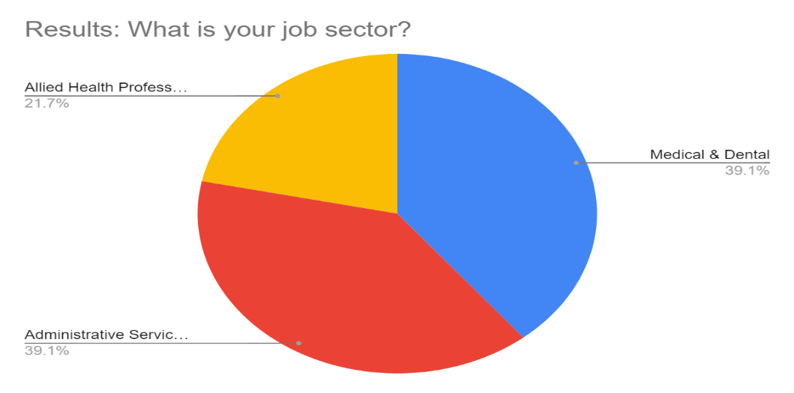
Figure 1: Participant job sector (Author, 2020)
Based on the above results, the participants emerged from the critical sectors working in the NHS to manage COVID-19 issues. Notably, since COVID-19 is a respiratory disease, and the spread has been increasing rapidly, the NHS administrative services and medical professionals have been busy and have significantly interacted with the patients. Interaction with the patients regularly means that the participants recorded patient information in ICT systems for efficient management; thus, the respondents offered reliable feedback about their experience while working with ICT systems for patient information storage and its effectiveness to increase the NHS's operational efficiency. These findings provide partial evidence for answering the research question (II), which focuses on examining the effectiveness of ICT technologies in NHS.
To answer research question III, the study examined one of the key concepts that have emerged during the pandemic, work from home. The concept of working from home was introduced as one factor that will reduce direct or physical contact with the patients and minimise the spread of coronavirus. In the NHS context, most participants (73.9%) indicated that they were not provided with the option of working from home during the pandemic. In comparison, 26.1% noted that they were offered opportunities for working from home. Doctors and healthcare professionals acted as the main frontline workers during the pandemic, which means that working from home is difficult since they must interact with the patients for testing and providing appropriate treatment. Hence, unlike other professionals, medical experts, nurses, and other staff members in the NHS did not have the opportunity of working from home.
However, through the utilisation of technology systems, participants such as those working in administrative services can perform their roles online, especially in data entry, financial management, and other services not requiring face to face interaction with the patients, thus showing a lower percentage of those who had the option to work from home. On the other hand, out of the participants who indicated to have worked from home during the pandemic, a significant population (52.2%) indicated that their productivity was not affected by the concept of working from home, while 43.5% were unsure how they were affected by the pandemic and 4.3% indicated that their performance was affected while working from home as shown in Figure 2 below. The results suggest that the work from home concept may not be a significant factor determining the NHS's workers' productivity. However, these findings did not indicate whether the NHS staff working from home were negatively or positively affected by their productivity. Hence, this study shows a gap requiring further study to determine precisely the knock-on effect of COVID-19 on the productivity of staff working from home.
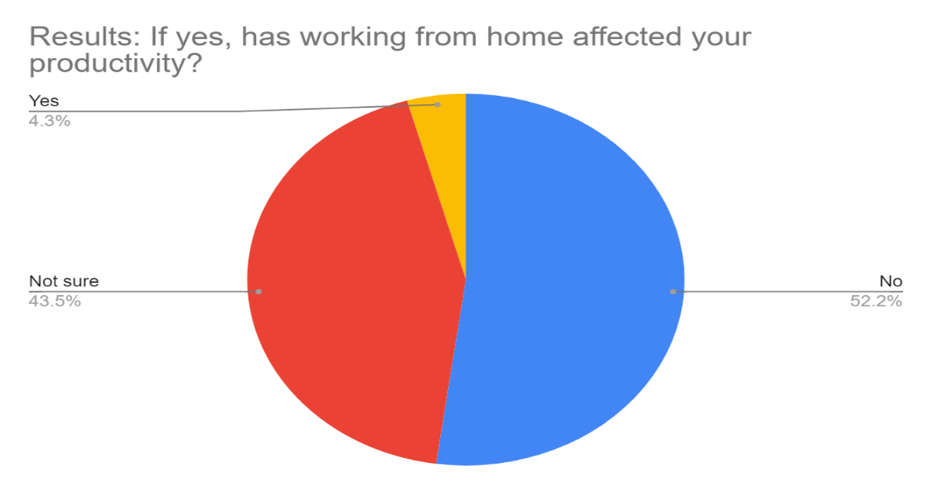
Figure 2: Impact of work from home concept on NHS staff productivity (Author, 2020).
During the pandemic, the results indicated that most participants were not allowed to access the patient information outside the workplace through medical software. An evaluation of patient information accessibility from external environments helped estimate the level of privacy of personally identifiable information (PII) and compliance of NHS with the GDPR requirements. Information security management is one of the critical elements that must be addressed effectively while using ICT systems to store, process, and transmit data. A larger population of participants are offered the opportunity of accessing patient information from external environments without considerations of the best security mechanism. The data is vulnerable to exploitation and theft by unauthorised people. These findings imply that the NHS's medical software systems comply with GDPR protocols in patient information protection during the pandemic. Therefore, it can be concluded that the pandemic did not affect information security in the NHS information technology systems and software applications and the results provide evidence for answering research question IV as limited external access of patient information shows one of the security strategies employed by NHS to minimise sensitive information exploitation and unauthorised access.
Research question I of this study sought to identify and analysis various software and hardware technologies used in the NHS. A significant population of participants (91.3%) indicated that they used patient information management systems (PIMS), EPR, and other patient care systems daily. On the other hand, 8.7% noted that they do not use patient care systems daily, although the results did not clearly indicate the frequency of usage for the NHS staff who noted lower rates of use (Figure 3). However, a higher population of the participants supporting patient care and PIMS utilisation provided evidence for answering research questions I and II by identifying the software systems in the NHS and indicating the increased rate of technology use among NHS staff to manage issues associated with the pandemic.
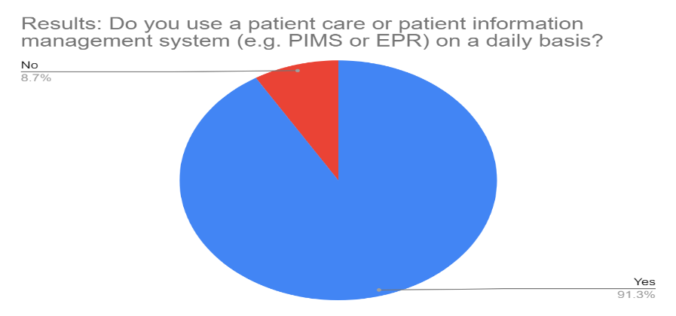
Figure 3: Patient information management system and patient care system use in NHS (Author, 2020)
Additionally, 100% usage (refer to Figure 4) of video conferencing technologies (such as Zoom) by the employees in their respective departments indicated the significant knock-on effect of COVID-19 on the utilisation of new virtual communication technologies. These findings answered the first research question by identifying the communication technology used in the NHS and research question II that indicates increased video conferencing technology adoption to attend meetings online.
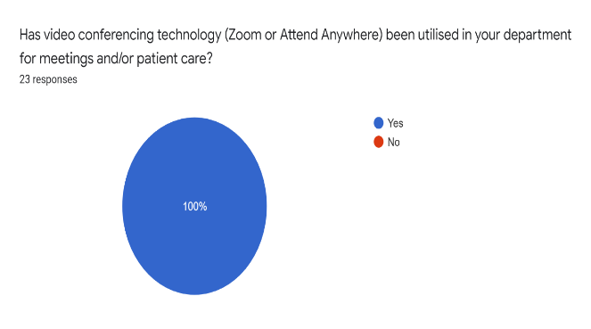
Figure 4a: Video conferencing use in NHS departments (Author, 2020).
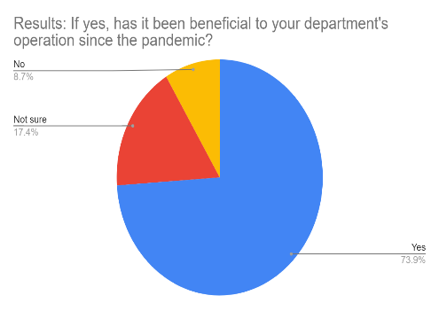
4b: Benefits of Zoom conference for NHS departments (Author, 2020).
Research question II is supported by the participants showing their perceptions of the benefits gained using video conferencing systems. As indicated in Figure 4b above, 73.9% noted that they have greatly benefited from video conferences, thus proving the technology's effectiveness during the pandemic. The 17.4% who indicated that they are not sure how they benefited from the video conference systems implies that some staff may have benefited while others did not. Still, the findings are insignificant as the largest population noted its positive impacts for efficient and reliable communication.
The results indicated that 43.5% of participants believe that after the pandemic is over, their NHS departments will manage the patient demands more effectively. However, 30.4% and 26.1% note that their departments may not address the patient demands, and others are not sure, as shown in Figure 5. These findings highlight the pandemic's knock-on effects on NHS operational efficiency since more than 50% of the participants indicate that they are uncertain whether normal services will resume after the epidemic. Moreover, the results raise a significant issue that NHS key stakeholders must explore to determine why most staff members are not sure or do not think they will manage the patient's demands.
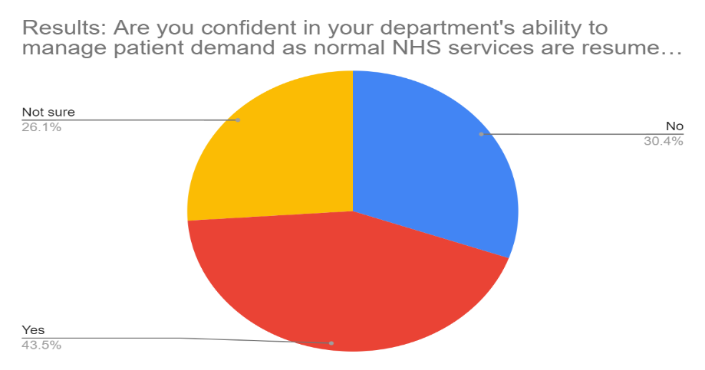
Figure 5: Confidence levels of staff about department capability to manage patient demands (Author, 2020).
Similarly, the participants noted almost the same behaviour about their perception about their department’s capability to manage the patients' demands in case of a second wave of COVID-19 , as shown in Figure 6. The findings show that most of the staff members working in NHS trusts and the entire healthcare sector have not indicated appropriate and suitable strategies for managing future pandemic incidents. Besides, the higher percentage of uncertainties implies that the staff and nurses at the NHS could not predict how technology systems in the healthcare sector may significantly help contain future pandemics. Hence, these results answered research question IV and concluded that the NHS's current strategies had not shown the potential of handling emerging challenges associated with the pandemic.
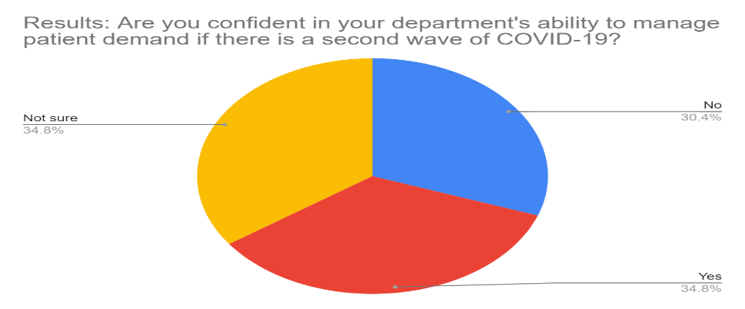
Figure 6: Department confidence on second wave of covid-19 management (Author, 2020).
The study examines the effectiveness of workstations and ICT systems in the various departments the participants emerged from. 54.5% of participants indicated that ICT systems significantly helped in increasing the efficiency of the departments in handling the patient demands, while 31.8% and 13.6% noted that IT systems did not help or they are not sure about the systems’ impacts, respectively. However, based on the participant responses, it is inferred that technology is recognised as a critical solution for increasing service delivery efficiency in the NHS. Besides, 65.2% of participants indicated that they had received up-to-date training on operating the software systems needed to perform their daily duties and responsibilities (figure 7). These findings answer research question II about the effectiveness of technology systems. Additionally, training is vital for ensuring that workers use the new technologies adopted in their departments and the healthcare sector at large. Suppose a larger population is trained effectively, and they understand the significance of using the specific technology. There is a likelihood of improved efficiency in executing duties and addressing challenges facing the patients.
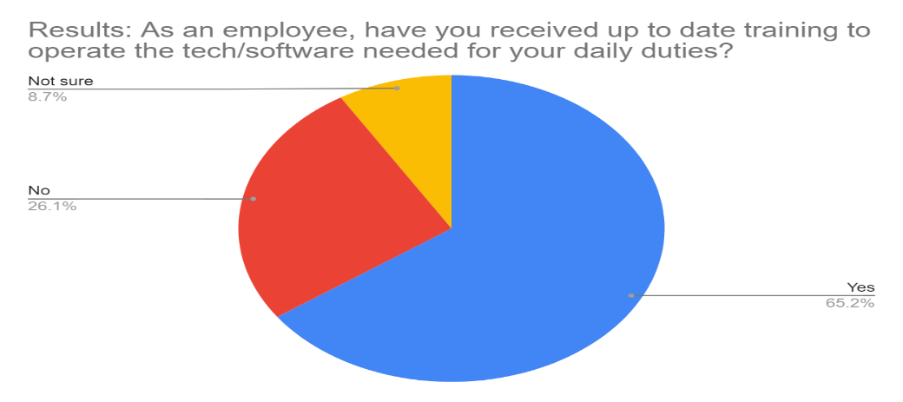
Figure 7: NHS staff training to use technology during covid-19 pandemic (Author, 2020).
Furthermore, to answer research question IV, the study examined how the NHS’s innovation plan to invest in new technology systems may help overcome the backlog of patients due to COVID-19 and the possibility of new technology systems in boosting communication among the patients. 43.5%, 34.8%, and 21.7% of the participants indicated that the innovation plan could be a suitable solution for addressing the challenges. Others are not sure, and the rest think it cannot help manage the backlog, as indicated in Figure 8. Additionally, 87.0% of the participants agreed that new information systems could increase communication efficiency among patients. Based on this feedback, the study concluded that new technology systems and innovation plans must be included in the core plan of managing future pandemics and enabling the NHS to address the challenges posed by covid-19. The findings also indicated a positive knock-on effect of the pandemic on various information technology systems such as software applications and communication tools’ recognition and increased utilisation in the healthcare sector.
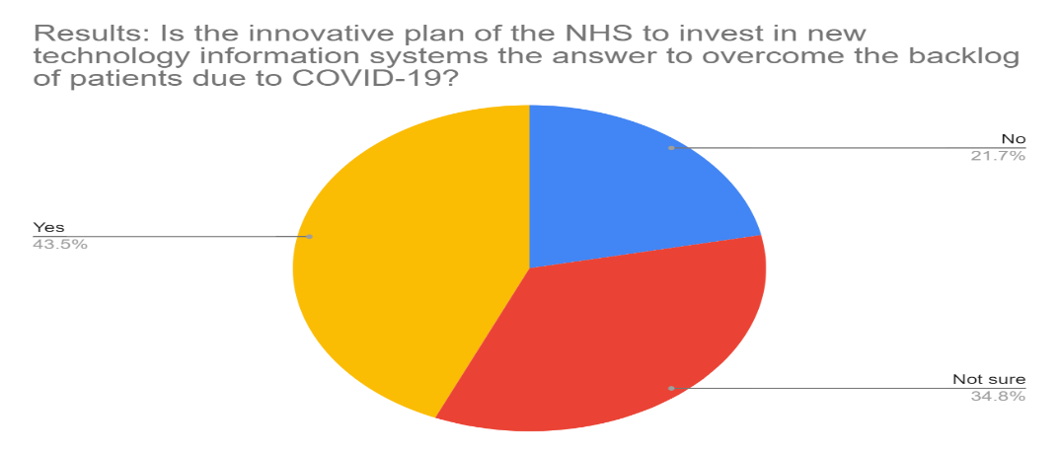
Figure 8: NHS innovation plan as a solution to manage patients backlog (Author, 2020)
The study further examined the significance of digital transformation in the healthcare sector. Digital transformation, in this case, includes adopting various technologies and digital solutions that can be integrated into the industry to support patient needs, the efficiency of service delivery, and financial management. 87.0% of the participants supported the idea of the NHS investing in digital transformation. Hence, these findings are critical in informing the NHS decision-makers on the strategies for current and future management of a health pandemic. On the other hand, 73.9% of the respondents agreed that technology in the healthcare sector would become more advanced after the epidemic is over, as indicated in Figure 9. The findings suggest that the NHS experienced the positive impact of technology solutions in most of their operations. Additionally, based on these results, the knock-on effect of the pandemic includes the increased acceptance of information technology systems in the healthcare industry. The pandemic has also contributed to technology identified as a tool used for the progression of healthcare services delivery.
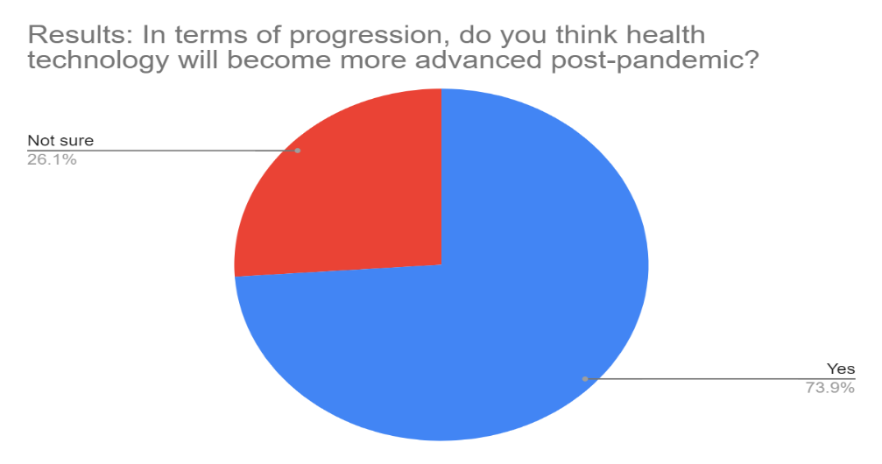
Figure 9: Healthcare technology advancement in the post-pandemic (Author, 2020)
Finally, this study's main aim is met by the evaluation of the participant’s perception of the revolutionary impact of the COVID-19 on information technology systems used in patient care and management of clinics. The findings indicated that 56.5% of the participants supported the knock-on effect of COVID-19 on healthcare technology use. In comparison, 21.7 % and 21.7% of participants were not sure or do not think COVID-19 revolutionised technology use in the NHS. From these results, it is concluded that; the emergence of the pandemic contributed to increasing adoption of healthcare technology systems for communication, patient information management, and improvement of the efficiency of services in the NHS. However, it is not clear how the NHS will benefit from new technologies as more advanced solutions emerge in the market. The results further suggest that majority of the NHS staff and nurses have experience in working with new technology solutions; thus, plans to integrate new systems may not encounter challenges as long as the staff is regularly trained on how to use the solutions in their workplace.

Discussion
Based on this study's findings, it is evident that ICT systems were widely utilised to manage the impacts and activities for controlling the pandemic by the NHS. Besides, the pandemic's onset resulted in increased adoption of various innovative technology solutions in NHS, contributing to more stakeholders recognising their significance in enhancing productivity, operational efficiency, and patient support. The results also indicated the emergence of workplace models due to the pandemic's impacts, such as working from home, a concept that was widely embraced in multiple departments. However, a significant population of medical professionals in the NHS did not have the chance to work from home since they worked as the key frontline workers to manage coronavirus spread.
The concept of working from advocates of workers offers the opportunity to complete all their tasks at homes through the help of technology solutions, as indicated by Harris (2016). However, the healthcare sector entails the provision of critical services, and the workers, such as nurses and patients, must interact face to face to ensure all needs are met. This justifies why a significant population of the medical professionals working in the NHS indicated having had no chance of working from home. Hence, the findings of this study do not support the assertions of Migrator (2019), InfoNet (2020), and Harris (2019), and it can be concluded that the concept of working from home or remotely is not suitable for healthcare workers, especially during the pandemic. However, since the findings indicated 26.1% of the participants have worked from home, the findings suggest that employees working on activities not requiring human interaction may leverage the benefits of the concept of working remotely and ensure normal operations are maintained.
Although a minimal population of participants or employees of NHS worked from home, they retained and improved their productivity. These results imply that the introduction of the ‘work from home’ concept does not affect the workers' overall performance. The results support the assertions of Team MBA (2020), which emphasised the positive impacts of introducing the concept in workplaces to safeguard the NHS employees' health safety. Similarly, the findings of Cook (2020) are supported in this study as the participants noted the importance of working remotely, such as avoiding the limitations of distance and fears associated with contracting the coronavirus. However, the findings do not indicate how the participants worked remotely with the help of technology and the types of ICT solutions they employed to perform their tasks and how the NHS (employer) was affected by allowing some staff to work remotely. Based on these arguments, the employer's issues incurring extra cost, as noted by Cook (2020) and Kretchmer (2020), could not be established in this study and suggests future exploration about how employers were affected by staff working from home.
The study results proved that the utilisation of technology solutions such as communication tools (e.g., Zoom) significantly helped the NHS workers interact and share information more efficiently and reliably. Unlike the traditional approaches where the employees are required to conduct face-to-face meetings, the findings show the knock-on effect of the pandemic on staff communication as more virtual meetings were held technologically. The results supported the findings of Vidal-Alaball et al. (2020) and Thayyil et al. (2020) by noting that the emergence of the pandemic resulted in more interaction among doctors and patients through ICT systems. Hence, the doctors and NHS could offer services such as monitoring the patients' wellbeing at home and providing prescriptions without necessarily interacting with the patient physically. Therefore, the adoption of technology solutions helped protect medical practitioners against infection, while patients with other illnesses were supported efficiently during the COVID-19 health crisis.
The effect of the COVID-19 pandemic is also witnessed by the increased population of NHS staff members in the utilisation of patient care or patient management information systems daily. The PIMS or EPR systems significantly help the doctors and nurses access medical records of the patients and offer appropriate medical services to the patients. These findings supported the claims of Li et al. (2020) and Carr (2020), who indicated the significance of using patient support technology solutions such as an automated communication system between the patient and the doctors and COVIDCheck, which are some of the key ICT systems utilised during the pandemic. Therefore, it is concluded that COVID-19 influenced the NHS staff to recognise the significance of utilising technology solutions to offer daily support to the patients and regularly review their medical status.
Patient personal information is also a critical element that must be considered during the pandemic as more ICT systems were integrated into the healthcare industry. Malicious individuals, hackers, and cyber attackers are likely to take advantage of vulnerable systems to steal sensitive healthcare systems information. This study’s participants noted that a significant population of the NHS staff were not offered permission for accessing patient information through the utilisation of medical software from outside the workplace. These findings indicate the strategies established by the NHS to safeguard patient information security based on the strict access control mechanisms. The findings support Whitelaw et al. (2018) 's suggestions for healthcare organisations and professors to observe strict measures during the pandemic. However, the results did not indicate the specific access control measures and security protocols employed by NHS to limit unauthorised access to patient information; thus, the assertions of Al-Shamsi et al. (2020) could not be supported by the findings. Besides, the findings do not show the security measures employed to ensure no security or privacy violation of patient data in the NHS's internal environments.
The results of this dissertation noted that ICT workstations and systems utilised in the NHS during the pandemic helped improve the efficiency of addressing patient needs, although some participants indicated otherwise. These findings support the assertions of Wynants et al. (2020), who noted the importance of ICT solutions in the healthcare industry, although their implications show varied perceptions on the impact in the workplaces. However, the significant population of participants who noted that the provision of up to date training helped healthcare workers in NHS interact with ICT solutions and perform their tasks more efficiently. These findings correlate with the claims of Budd et al. (2020) who advocated for workforce training on how to use digital systems adapted to ensure ICT systems effectively helps the healthcare workers manage the impacts of the coronavirus. Therefore, to increase the acceptance levels of technology solutions and eliminate uncertainties about ICT systems impacts, the results proved that workforce training is vital.
The assertions of Team MBA (2020) are supported in this study based on the findings that suggested utilising ICT systems to overcome the backlog of patients because of the pandemic. Based on these findings, COVID-19 established a knock-on effect that encourages innovation and integration of more ICT solutions to address emerging challenges during the pandemic. Finally, a significant population of participants in this study confirmed the effect of the pandemic in encouraging a change of service delivery strategies and mechanisms during the post- COVID-19 period.

Chapter 5: Conclusion and recommendations

Conclusions
This dissertation’s focus was to explore and investigate the knock-on effect of the COVID-19 pandemic on ICT systems within the NHS. The study was driven by four main objectives and three research questions, which were all answered sufficiently. Since the onset of the pandemic, the study noted that the
NHS had adopted new technology solutions for various purposes, such as communication, remote communication, and virtual service delivery. Technology has been widely embraced in most NHS departments, which proves the significance of ICT solutions and their key impacts on worker’s productivity and operational efficiency of the healthcare industry. Based on the results of this dissertation, it is evident that since the onset of the COVID-19 pandemic, the healthcare sectors has been completely reshaped through the emergence of new work models such as the ‘work from home’ concept, video conferencing as a supplementary means to the traditional face to face interaction and holding meetings among the workers of an organisation.
The study utilised participants aged between 24 and 75 years, where the vast majority of respondents included medium-aged staff working as medical professionals, dental healthcare experts, and administration. The participants noted that in the NHS, and their respective departments, utilise different categories of software applications such as medical software, patient care systems, EPR, PIMS, and Zoom to track patient progress, communicate and share information. The software systems impact the healthcare service delivery by increasing the efficiency of providing services, capturing patient records, and tracking progress without physical interaction. Hence, these ICT solutions helped maintain one of the key requirements for preventing the coronavirus spread, which is social distancing.
Moreover, based on the findings, this study noted that the knock-on effects of COVID-19 on ICT systems in the case of the NHS are many. Firstly, the pandemic contributed to the emergence of some NHS staff members working from home through the utilisation of digital and virtual technologies such as Zoom and cloud-based solutions. Before the pandemic, these technology solutions were rarely used, but due to the emergence of the pandemic, most of the interactions were transformed into digital platforms to minimise the spread of coronavirus. Second, increased patient care system usage was vital for storing, processing, and transmitting data. In this case, the rapid spread of the virus and increased population of patients requiring NHS care contributed to the high healthcare workers' high rates using systems such as PIMS daily. Hence, a high percentage of PIMS system use implies that there was increased transparency of all hospitals and trusts’ transactions.
Third, the pandemic facilitated the increased acceptance and recognition of technology as a core solution for addressing major healthcare challenges. For instance, it is noted from the results that most of the participants agree that IT solutions and workstations helped them to care for patients more efficiently. Additionally, the findings indicated that NHS staff recognised the role of technology solutions implying that NHS workers appreciate ICT contributions during the pandemic. Fourth, the study helped identify technologies suitable in a specific department of the NHS. For example, all the participants agreed that Zoom was a beneficial tool in enabling the staff to interact without limitations of their location or workplace. Besides, patient care systems were recognised as appropriate solutions that can be employed to store patient records and monitor the progress of patient treatment through integration with advanced information-gathering tools. Fifth, COVID-19 helped estimate the acceptance levels of new technology adoption and innovation in the NHS. Finally, the pandemic's onset was helpful in identifying the user requirements and factors to consider before adopting or integrating new technology into the healthcare system. For instance, the findings indicated that most NHS staff need up to date training on how to use ICT tools in their workplace. These findings imply that strategic measures must consider training, the suitability of the technology, acceptance by users, and its effectiveness in safeguarding patients’ personal information.

Recommendations
Considering this study’s results and implications, the following are recommendations that can be integrated into practice to leverage ICT systems' benefits in managing the COVID-19 pandemic and any other health crisis in the future. Firstly, the NHS and the entire healthcare system must recognise the roles played by ICT systems in various departments and determine the factors contributing to the adoption of any technology solution. The factors help the NHS stakeholders determine and assess the current problem's level and identify the best solution to the problem. Secondly, after the adoption of new technology in the healthcare industry, strategic plans must be established to provide guidelines for regular and up to date training of workers. This strategy will help avoid interaction failure and promote acceptance of the new technology solutions. Thirdly, NHS should always be prepared for new changes due to the emergence of different issues and challenges such as the coronavirus outbreak. Having a flexible change management framework is crucial to ensure the required changes are implemented without opposition by the key users of innovative solutions. Finally, all information systems adopted in the NHS and the healthcare sector must adhere to the requirements of GDPR, thus avoiding privacy and security violations and avoiding potential data breaches associated with poor protection systems.

Future study
The study indicated that NHS maintained limited access to patient information from a remote environment, not providing the staff permissions to using medical software. However, the findings did not indicate security measures established to protect sensitive patient information in the internal environment and networks. The future researcher may investigate the security measures used by the NHS to safeguard patient information in all its trusts and how data collected was stored in the organisation’s networks in compliance with GDPR guidelines. Future explorers may also explore the knock-on effects of COVID-19 on the entire operations of NHS.

Reference List
Abramova, S. and Böhme, R., 2016. Perceived benefit and risk as multidimensional determinants of bitcoin use: a quantitative exploratory study.
Adepoju, P., 2020. Africa's COVID-19 health technologies' watershed moment. The Lancet Digital Health, 2(7).
Alsbury, Q. and Becerra, D., MeLLmo Inc, 2014. Displaying pie charts in a limited display area. U.S. Patent 8,810,574.
Al‐Shamsi, H.O. et al., 2020. A practical approach to the management of cancer patients during the novel coronavirus disease 2019 ( COVID ‐19) Pandemic: An International Collaborative Group. The Oncologist, 25(6).
Antwi, S.K. and Hamza, K., 2015. Qualitative and quantitative research paradigms in business research: a philosophical reflection. European Journal of Business and Management, 7(3), pp.217-225.
Baynham, D., and Hudson, M., 2020. Rollout Of Video Consultation Across General Practice - Technology In The NHS. [Online] Available at: <https://healthtech.blog.gov.uk/2020/03/26/rollout-of-video-consultation-across-general-practice/> [Accessed 14 July 2020].
Beaunoyer, E., Dupéré, S. and; Guitton, M.J., 2020. COVID-19 and digital inequalities: Reciprocal impacts and mitigation strategies. Computers in Human Behavior, 111, p.106424.
Budd, J., Miller, B.S., Manning, E.M. et al. Digital technologies in the public-health response to COVID-19. Nat Med 26, 1183–1192 (2020). [Online] Available at: https://www.nature.com/articles/s41591-020-1011-4#citeas [Accessed 2 October 2020].
Burgess, M., 2020. How Novel coronavirus Reshaped The NHS. [Online] Available at: <https://www.wired.co.uk/article/nhs-novel coronavirus-technology> [Accessed 14 July 2020].
Chowdhury, M.F., 2014. Interpretivism in aiding our understanding of the contemporary social world. Open Journal of Philosophy, 2014.
Chudleigh, J. and Smith, J., 2015. Research essentials. Nursing Children and Young People (2014+), 27(3), p.12.
Cook, J., 2020. The ultimate guide to working from home. Investopedia. [Online] Available at: https://www.investopedia.com/personal-finance/work-from-home-guide/ [Accessed September 3, 2020].
D’mello, A., 2020. COVID-19: What healthcare IoT cybersecurity learned from the first wave. IoT Now - How to run an IoT enabled business. [Online] Available at: https://www.iot-now.com/2020/07/06/103739-COVID-19-what-healthcare-iot-cyber-security-learned-from-the-first-wave/ [Accessed September 3, 2020].
Davis, J., 2020. COVID-19 cybersecurity: building resilience beyond the crisis. HealthITSecurity. [Online] Available at: https://healthitsecurity.com/news/COVID-19-cybersecurity-building-resilience-beyond-the-crisis [Accessed September 3, 2020].
Davis, J., 2020. COVID-19 impact on ransomware, threats, healthcare cybersecurity. HealthITSecurity. [Online] Available at: https://healthitsecurity.com/news/COVID-19-impact-on-ransomware-threats-healthcare-cybersecurity [Accessed September 3, 2020].
Donnelly, T., 2020. How the NHS is innovating as part of its fight against novel coronavirus. [Online] Available at: <https://www.nhsx.nhs.uk/blogs/how-nhs-innovating-part-its-fight-against-novel coronavirus/> [Accessed 14 July 2020].
Du, J., Dong, L., Wang, T., Yuan, C., Fu, R., Zhang, L., Liu, B., Zhang, M., Yin, Y., Qin, J. and Bouey, J., 2020. Psychological symptoms among frontline healthcare workers during the COVID-19 outbreak in Wuhan. General hospital psychiatry.
Ducarme, T., 2020. Impact of the Covid-19 pandemic on healthcare systems? Deloitte France. [Online] Available at: https://www2.deloitte.com/fr/fr/pages/covid-insights/articles/impact-covid19-healthcare-systems.html [Accessed September 8, 2020].
During the COVID-19 Pandemic. JAMA Otolaryngology-Head and Neck Surgery, 146(6), p.579.
Dwivedi, Y.K., Wastell, D., Laumer, S., Henriksen, H.Z., Myers, M.D., Bunker, D., Elbanna, A., Ravishankar, M.N. and Srivastava, S.C., 2015. Research on information systems failures and successes: Status update and future directions. Information Systems Frontiers, 17(1), pp.143-157.
Evenstad, L., 2020. COVID-19: NHS tackles the novel coronavirus crisis with the help of tech. ComputerWeekly.com. [Online] Available at: https://www.computerweekly.com/news/252480271/COVID-19-NHS-tackles-novel coronavirus-crisis-with-the-help-of-tech [Accessed September 5, 2020].
Fagherazzi, G. et al., 2020. Digital health strategies to fight COVID-19 worldwide: challenges, recommendations, and a call for papers. Journal of Medical Internet Research, 22(6).
Ford, P., 2020. Why a data security sting lurks in COVID-19's long tail. Healthcare IT News. [Online] Available at: https://www.healthcareitnews.com/news/europe/why-data-security-sting-lurks-COVID-19-s-long-tail [Accessed September 3, 2020].
Gould, M., and Lewis, D., 2020. Digital contact tracing: protecting the NHS and saving lives - technology in the NHS. [Online] Healthtech.blog.gov.uk. Available at: <https://healthtech.blog.gov.uk/2020/04/24/digital-contact-tracing-protecting-the-nhs-and-saving-lives/> [Accessed 14 July 2020].
Gould, M., Joshi, D., and Tang, M., 2020. The power of data in a pandemic - technology in the NHS. [Online] Healthtech.blog.gov.uk. Available at: <https://healthtech.blog.gov.uk/2020/03/28/the-power-of-data-in-a-pandemic/> [Accessed 14 July 2020].
Hajj, A.A., 2020. Cyber security in the age of COVID-19: an analysis of cyber-crime and attacks. International Journal for Research in Applied Science and Engineering Technology, 8(8), pp.1476–1480.
Halcomb, E., Williams, A., Ashley, C., McInnes, S., Stephen, C., Calma, K. and James, S., 2020. The support needs of Australian primary health care nurses during the COVID‐19 pandemic. Journal of Nursing Management.
Harris, D. (2016). On company time: American modernism in the big magazines. Columbia University Press.
Hellowell, M. et al., 2020. How COVID-19 (coronavirus) affects private health care providers in developing countries. World Bank Blogs. [Online] Available at: https://blogs.worldbank.org/health/how-covid-19-coronavirus-affects-private-health-care-providers-developing-countries [Accessed September 8, 2020].
Hollander, J.E., and Carr, B.G., 2020. Virtually perfect? Telemedicine for COVID-19. New England Journal of Medicine, 382(18), pp.1679–1681.
Ienca, M. and; Vayena, E., 2020. On the responsible use of digital data to tackle the COVID-19 pandemic. Nature Medicine, 26(4), pp.463–464.
ILO, 2020. COVID-19 and the health sector. [Online] Available at: https://www.ilo.org/sector/Resources/publications/WCMS_741655/lang--en/index.htm [Accessed September 8, 2020].
InfoNet, 2020. Technology and innovation: the great COVID-19 innovation challenge. Infonet Africa. [Online] Available at: http://infonet.global/infonet/the-great-COVID-19-innovation-challenge/ [Accessed September 5, 2020].
Kretchmer, H., 2020. Tracking tech pioneers – 8 ways entrepreneurs are fighting COVID-19. World Economic Forum. [Online] Available at: https://www.weforum.org/agenda/2020/06/8-technology-entrepreneurs-fighting-COVID-19/ [Accessed September 5, 2020].
Leavy, P., 2017. Research design: quantitative, qualitative, mixed methods, arts-based, and community-based participatory research approaches. Guilford Publications.
Lee, A.C., 2020. COVID-19 and the advancement of digital physical therapist practice and telehealth. Physical Therapy, 100(7), pp.1054–1057.
Leonard, N.R., Gwadz, M.V., Ritchie, A., Linick, J.L., Cleland, C.M., Elliott, L. and Grethel, M., 2015. A multi-method exploratory study of stress, coping, and substance use among high school youth in private schools. Frontiers in Psychology, 6, p.1028.
Li, J.-P.O. et al., 2020. Preparedness among ophthalmologists: during and beyond the COVID-19 pandemic. Ophthalmology, 127(5), pp.569–572.
Liu, S., Yang, L., Zhang, C., Xiang, Y.T., Liu, Z., Hu, S., and Zhang, B., 2020. Online mental health services in China during the COVID-19 outbreak. The Lancet Psychiatry, 7(4), pp.e17-e18.
Lodesani, C., 2020. Coronavirus COVID-19 brings challenges to developed healthcare systems: MSF. Médecins Sans Frontières (MSF) International. [Online] Available at: https://www.msf.org/new-approach-public-health-big-change-needed-fight-covid-19 [Accessed September 8, 2020].
Lyons, A., Bilker, W.B., Hines, J. and Gross, R., 2016. Effect of format on comprehension of adherence data in chronic disease: a cross-sectional study in HIV. Patient education and counseling, 99(1), pp.154-159.
Manjunath, B.S., 2020. COVID-19: 8 ways in which technology helps pandemic management - ET CIO. ETCIO.com. [Online] Available at: https://cio.economictimes.indiatimes.com/news/next-gen-technologies/COVID-19-8-ways-in-which-technology-helps-pandemic-management/75139759 [Accessed September 5, 2020].
Marx, E.W. and; Padmanabhan, P., 2020. How the COVID-19 Pandemic reshaped healthcare with technology. Healthcare Digital Transformation, pp.1–38.
Migrator, 2019. Advantages and disadvantages of employees working at home. nibusinessinfo.co.uk. [Online] Available at: https://www.nibusinessinfo.co.uk/content/advantages-and-disadvantages-employees-working-home [Accessed September 3, 2020].
Morris, S., 2019. What's the difference between working from home and working remotely? Skillcrush. [Online] Available at: https://skillcrush.com/blog/working-from-home-versus-coworking/ [Accessed September 3, 2020].
Murray, C.J.L. et al., 2020. Digital public health and COVID-19. The Lancet Public Health, 5(9).
Nash, D. and; Geng, E., 2020. Goal-aligned, epidemic intelligence for the public health response to the COVID-19 pandemic. American Journal of Public Health, 110(8), pp.1154–1156.
NHS Digital. 2020. NHS E-Referral Service (E-RS) Open Data Dashboard - NHS Digital. [Online] Available at: <https://digital.nhs.uk/dashboards/ers-open-data#caveats-and-notes> [Accessed 30 August 2020].
NHS Digital. 2020. Novel coronavirus (COVID-19) Increase In Use Of NHS Digital Tech - NHS Digital. [Online] Available at: <https://digital.nhs.uk/novel coronavirus/nhs-digital-tech-analytics> [Accessed 30 August 2020].
NHS Digital. 2020. Progression Dashboard - NHS Digital. [Online] Available at: <https://digital.nhs.uk/dashboards/progression> [Accessed 30 August 2020].
Ocampo, L. and; Yamagishi, K., 2020. Modeling the lockdown relaxation protocols of the Philippine government in response to the COVID-19 pandemic: an intuitionistic fuzzy DEMATEL analysis. Socio-Economic Planning Sciences, p.100911.
Ohannessian, R., Duong, T.A., and Odone, A., 2020. Global telemedicine implementation and integration within health systems to fight the COVID-19 pandemic: a call to action. JMIR Public Health and Surveillance, 6(2).
Ong, J.J., Bharatendu, C., Goh, Y., Tang, J.Z., Sooi, K.W., Tan, Y.L., Tan, B.Y., Teoh, H.L., Ong, S.T., Allen, D.M. and Sharma, V.K., 2020. Headaches associated with personal protective equipment–a cross‐sectional study among frontline healthcare workers during COVID‐19. Headache: The Journal of Head and Face Pain, 60(5), pp.864-877.
Ooms, G., 2020. COVID-19 and its health impacts in sub-Saharan Africa. Health Action International. [Online] Available at: https://haiweb.org/covid-19-far-reaching-impact/ [Accessed September 8, 2020].
Osteopathic Research Centre, 2020. COVID-19 pandemic highlights advantages of digital technology in clinical research. [Online] Available at: https://www.newswise.com/novel coronavirus/COVID-19-pandemic-highlights-advantages-of-digital-technology-in-clinical-research/?article_id=732521 [Accessed September 5, 2020].
Ozturk, T., Talo, M., Yildirim, E. A., Baloglu, U. B., Yildirim, O., & Acharya, U. R., 2020. Automated detection of COVID-19 cases using deep neural networks with X-ray images. Computers in Biology and Medicine, 103792.
Pan, X.-B., 2020. Application of personal-oriented digital technology in preventing transmission of COVID-19, China. Irish Journal of Medical Science (1971 -), 189(2).
Potrac, P., Jones, R.L., and Nelson, L., 2014. Interpretivism. Research methods in sports coaching (pp. 31-41). Routledge.
Queirós, A., Faria, D., and Almeida, F., 2017. Strengths and limitations of qualitative and quantitative research methods. European Journal of Education Studies.
Ramirez, G.A., Gerosa, M., Beretta, L., Bellocchi, C., Argolini, L.M., Moroni, L., Della Torre, E., Artusi, C., Nicolosi, S., Caporali, R. and Bozzolo, E.P., 2020, June. COVID-19 in systemic lupus erythematosus: data from a survey on 417 patients. In Seminars in arthritis and rheumatism. WB Saunders.
ReliefWeb, 2020. Continuing essential medical services during COVID-19 - World. ReliefWeb. [Online] Available at: https://reliefweb.int/report/world/continuing-essential-medical-services-during-covid-19 [Accessed September 8, 2020].
Roberton, T. et al., 2020. Early estimates of the indirect effects of the COVID-19 pandemic on maternal and child mortality in low-income and middle-income countries: a modelling study. The Lancet Global Health, 8(7).
Saran, C., 2020. Novel coronavirus readiness: three technology-led steps the NHS is taking. ComputerWeekly.com. [Online] Available at: https://www.computerweekly.com/news/252479531/Novel coronavirus-readiness-Three-technology-led-steps-the-NHS-is-taking [Accessed September 5, 2020].
Saran, C., 2020. Novel coronavirus: NHS to roll out Microsoft Teams to hospitals. ComputerWeekly.com. [Online] Available at: https://www.computerweekly.com/news/252480273/Novel coronavirus-NHS-to-roll-out-Microsoft-Teams-to-hospitals [Accessed September 5, 2020].
Sarbadhikari, S. and; Sarbadhikari, S., 2020. The global experience of digital health interventions in COVID-19 management. Indian Journal of Public Health, 64(6), p.117.
Sarpong, N.O., Forrester, L.A., and Levine, W.N., 2020. What’s important: redeployment of the orthopaedic surgeon during the COVID-19 pandemic: perspectives from the trenches. The Journal of Bone and Joint Surgery. American Volume.
Smith, C.D. and; Mennis, J., 2020. Incorporating geographic information science and technology in response to the COVID-19 pandemic. Preventing Chronic Disease, 17.
Søreide, K. et al., 2020. The immediate and long-term impact of the COVID-19 pandemic on the delivery of surgical services. British Journal of Surgery.
Srivastava, K., 2016. To study the Indian perspective on the concept of work from home. Indian Journal of Science and Technology, 9(1), pp.1–9.
Taherdoost, H., 2016. Validity and reliability of the research instrument; how to test the validation of a questionnaire/survey in research. How to Test the Validation of a Questionnaire/Survey in a Research (August 10, 2016).
Tashkandi, E., Zeeneldin, A., AlAbdulwahab, A., Elemam, O., Elsamany, S., Jastaniah, W., Abdullah, S., Alfayez, M., Jazieh, A.R. and Al-Shamsi, H.O., 2020. Virtual management of patients with cancer during the COVID-19 pandemic: web-based questionnaire study. Journal of Medical Internet Research, 22(6), p.e19691.
Team, M.B.A.S., 2020. Work from home definition, importance, advantages, steps, and overview: human resources (HR) dictionary. MBA Skool-Study.Learn.Share. [Online] Available at: https://www.mbaskool.com/business-concepts/human-resources-hr-terms/16870-work-from-home.html [Accessed September 3, 2020].
Thayyil, J., Kuniyil, V. and; Cherumanalil, J.M., 2020. COVID-19: digital contact tracing technologies and ethical challenges. International Journal Of Community Medicine And Public Health, 7(7), p.2854.
Ting, D.S.W. et al., 2020. Digital technology and COVID-19. Nature Medicine, 26(4), pp.459–461.
Tolbert, E., Brundage, M., Bantug, E., Blackford, A.L., Smith, K., Snyder, C. and Board, P.D.P.S.A., 2019. In proportion: approaches for displaying patient-reported outcome research study results as percentages responding to treatment. Quality of Life Research, 28(3), pp.609-620.
Torous, J. et al., 2020. Digital mental health and COVID-19: using technology today to accelerate the curve on access and quality tomorrow. JMIR Mental Health, 7(3).
Tudy, R., 2018. Earning while working from home: a new employment opportunity in the Philippines. Proceedings of the 35th International Academic Conference, Barcelona.
Tumele, S., 2015. Case study research. International Journal of Sales, Retailing & Marketing, 4(9), pp.68-78.
UN, 2020. Digital technologies critical in facing COVID-19 pandemic | UN DESA Department of Economic and Social Affairs. United Nations. [Online] Available at: https://www.un.org/development/desa/en/news/policy/digital-technologies-critical-in-facing-COVID-19-pandemic.html [Accessed September 5, 2020].
Vidal-Alaball, J. et al., 2020. Telemedicine in the face of the COVID-19 pandemic. Atención Primaria, 52(6), pp.418–422.
Whitelaw, S., Mamas, M., Topol, E., and Van Spall, H., 2020. Applications Of digital technology in COVID-19 pandemic planning and response. [Online] The Lancet Digital Health. Available at: <https://www.thelancet.com/journals/landig/article/PIIS2589-7500(20)30142-4/fulltext#seccestitle50> [Accessed 30 August 2020].
WHO, 2020. COVID-19 significantly impacts health services for non-communicable diseases. World Health Organization. [Online] Available at: https://www.who.int/news-room/detail/01-06-2020-covid-19-significantly-impacts-health-services-for-noncommunicable-diseases [Accessed September 8, 2020].
WHO, 2020. Digital technology for COVID-19 response. World Health Organization. [Online] Available at: https://www.who.int/news-room/detail/03-04-2020-digital-technology-for-COVID-19-response [Accessed September 5, 2020].
WHO, 2020. The impact of the COVID-19 pandemic on non-communicable disease resources and services: results of a rapid assessment.
Wynants, L. et al., 2020. Prediction models for diagnosis and prognosis of COVID-19: a systematic review and critical appraisal. BMJ, 369(8242).
Xiao, Y. and; Fan, Z., 2020. 10 tech trends getting us through the COVID-19 pandemic. World Economic Forum. [Online] Available at: https://www.weforum.org/agenda/2020/04/10-technology-trends-novel coronavirus-COVID19-pandemic-robotics-telehealth/ [Accessed September 5, 2020].
Zalaghi, H. and Khazaei, M., 2016. The role of deductive and inductive reasoning in accounting research and standard setting. Asian Journal of Finance & Accounting, 8(1), pp.23-37.
Žukauskas, P., Vveinhardt, J., and Andriukaitienė, R., 2018. Philosophy and paradigm of scientific research. Management Culture and Corporate Social Responsibility, p.121.

