UWTSD
Investigate the Effect of Noise in SSB-SC and DSB-SC Systems
Radio Frequency Systems – ACDA5019
Lewy Harrison (2321772)
22/11/2025

Introduction
Modern communication systems depend fundamentally on modulation techniques to enable the efficient transmission of information-bearing signals over physical channels. Since baseband information signals typically occupy low-frequency ranges, direct transmission is impractical due to poor radiation efficiency, interference, and antenna size constraints. Modulation addresses this problem by shifting the frequency content of the message signal to a higher frequency range through combination with a carrier waveform. Among the earliest and most influential analogue modulation schemes are Amplitude Modulation (AM), Double Sideband Suppressed Carrier (DSB-SC), and Single Sideband Suppressed Carrier (SSB-SC), each of which represents a distinct trade-off between implementation simplicity, bandwidth efficiency, power utilisation, and noise performance.
The objective of this report is to investigate and compare the performance of AM, DSB-SC, and SSB-SC modulation schemes through simulation using MATLAB 2025 and Simulink. The study involves the implementation of complete transmitter and receiver chains for each modulation technique, analysis of their time-domain and frequency-domain characteristics, evaluation of their behaviour under varying modulation indices, and assessment of their sensitivity to additive noise. The results obtained from Tasks 1 to 4 are synthesised to determine which modulation technique offers superior performance under different operating conditions, with conclusions supported by spectral, power, and noise analyses.

Background Research
Amplitude modulation is one of the most fundamental analogue modulation techniques and serves as the basis from which more advanced modulation schemes have evolved. In conventional AM, the instantaneous amplitude of a high-frequency carrier signal is varied in proportion to the message signal, resulting in a transmitted waveform that contains the carrier frequency and two symmetrically spaced sidebands. Although this structure enables simple envelope detection at the receiver, it is inherently inefficient because the carrier itself conveys no information and a significant portion of transmitted power is wasted [1]. This inefficiency has been widely documented in classical communication systems literature, where AM is often presented as a pedagogical tool rather than an optimal transmission method.
To improve power efficiency, Double Sideband Suppressed Carrier modulation removes the carrier component entirely, transmitting only the upper and lower sidebands. While this approach eliminates carrier power wastage, it introduces additional receiver complexity because envelope detection is no longer possible, and coherent demodulation is required to recover the original message signal accurately [2]. This requirement makes DSB-SC more sensitive to phase and frequency errors between the transmitter and receiver oscillators, particularly in noisy channels, where imperfect carrier recovery can lead to severe distortion.
Single Sideband Suppressed Carrier modulation represents a further refinement in efficiency by transmitting only one of the two sidebands. By eliminating both the carrier and one redundant sideband, SSB-SC achieves the minimum bandwidth necessary to transmit the message signal and significantly improves power utilisation [3]. However, the generation and detection of SSB-SC signals require precise phase manipulation and filtering, increasing system complexity. Despite this, SSB-SC has been widely adopted in long-distance and spectrum-constrained communication systems, such as high-frequency radio links and telephony, where bandwidth efficiency is of paramount importance [4].

Literature Review
The theoretical foundations of analogue modulation techniques have been extensively explored in classical communication systems literature. Haykin provides a rigorous treatment of amplitude modulation, emphasising the inefficiencies associated with conventional AM and the motivation for suppressed-carrier techniques such as DSB-SC and SSB-SC [1]. His work presents detailed mathematical descriptions of modulated signals in both time and frequency domains, forming a strong theoretical basis for performance evaluation.
Proakis and Salehi further extend this discussion by analysing the power spectral density and noise performance of analogue modulation schemes under additive white Gaussian noise conditions [2]. Their analysis demonstrates that while suppressed-carrier systems achieve higher power efficiency, they are significantly more sensitive to carrier synchronisation errors, particularly during coherent demodulation. These findings are directly relevant to the simulations performed in this work, where noise was intentionally introduced to observe its impact on demodulated signals.
Schwartz, Bennett, and Stein adopt a system-level perspective, discussing analogue modulation techniques within the broader context of communication system design and channel impairments [3]. Their work highlights the trade-offs between implementation complexity and performance, particularly when comparing AM with more spectrally efficient schemes such as SSB-SC. More recent instructional material published by MathWorks provides simulation-oriented guidance on implementing modulation systems using MATLAB and Simulink, including spectrum analysis and noise modelling techniques that closely align with the methodology adopted in this report [4]. Collectively, these sources establish both the theoretical justification and practical relevance of the comparative study undertaken.

Circuit Design and Block Diagram
The block diagrams implemented in Simulink provide a high-level representation of signal flow through each modulation system. In the AM block diagram, a sinusoidal message source feeds a gain and summing stage to produce the modulating waveform, which is then multiplied by a carrier signal. The output is simultaneously connected to a time-domain scope and a spectrum analyser to observe waveform shape and frequency content. The demodulation path includes an envelope detector and low-pass filter block.
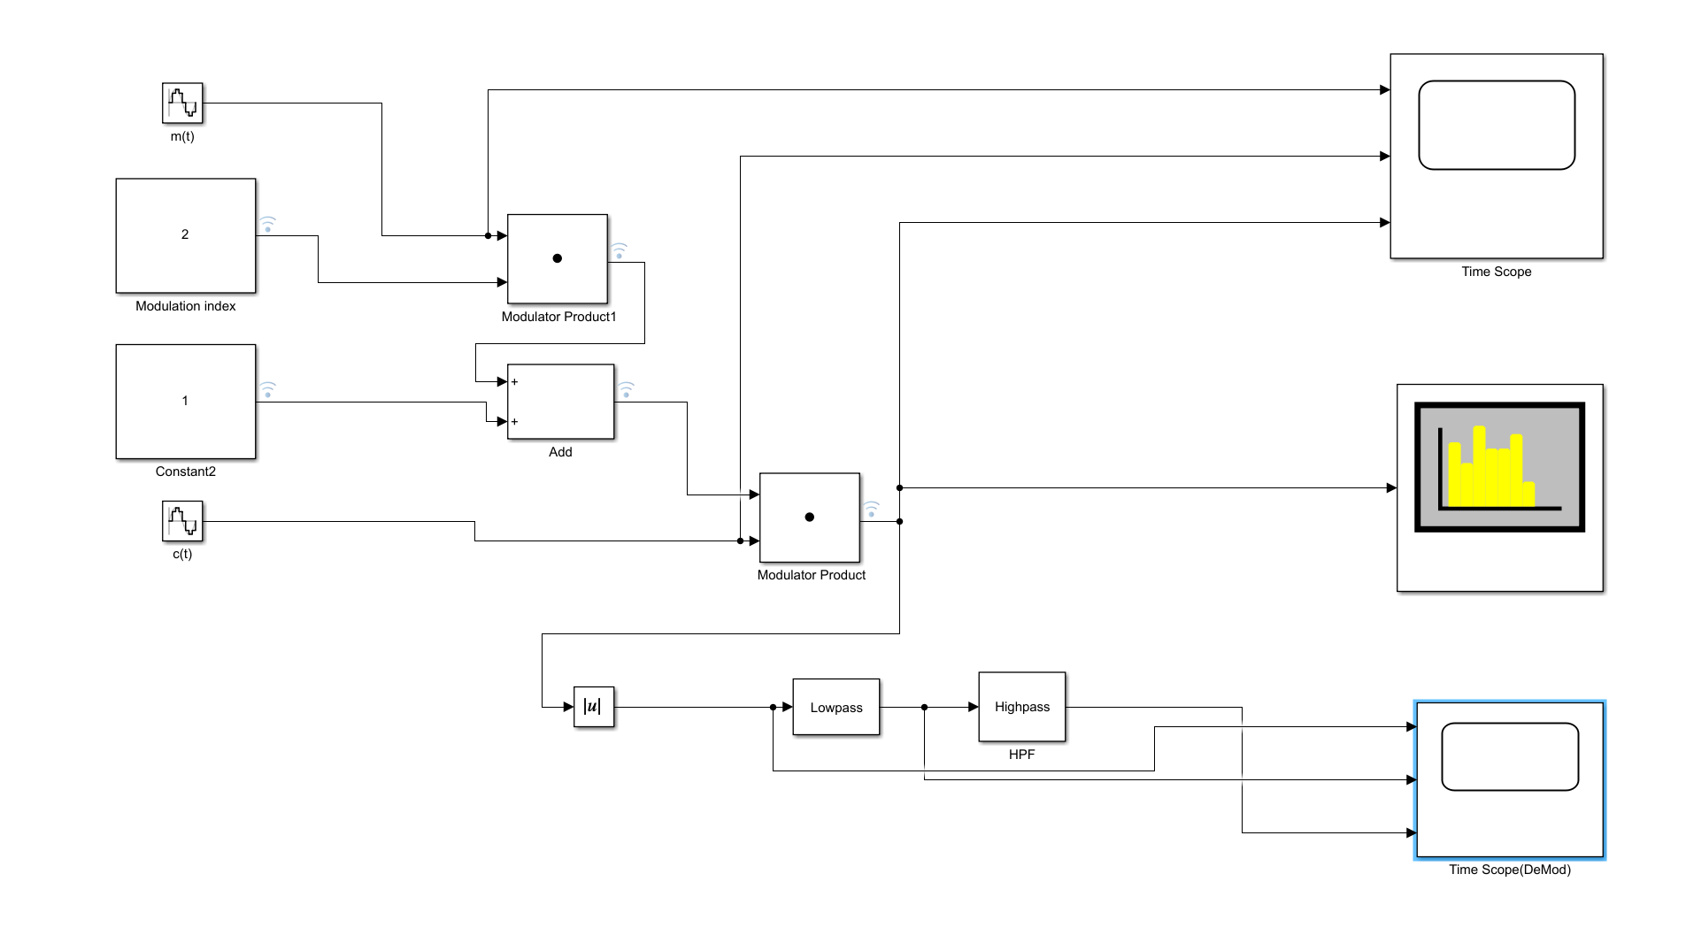
Figure 1: AM circuit drawn in Simulink.
For the DSB-SC system, the block diagram consists of a message source and carrier source feeding a product block that functions as a balanced modulator. The output signal is analysed using time and frequency scopes before being passed to a coherent demodulator that multiplies it with a locally generated carrier. A low-pass filter removes high-frequency components, yielding the recovered message.
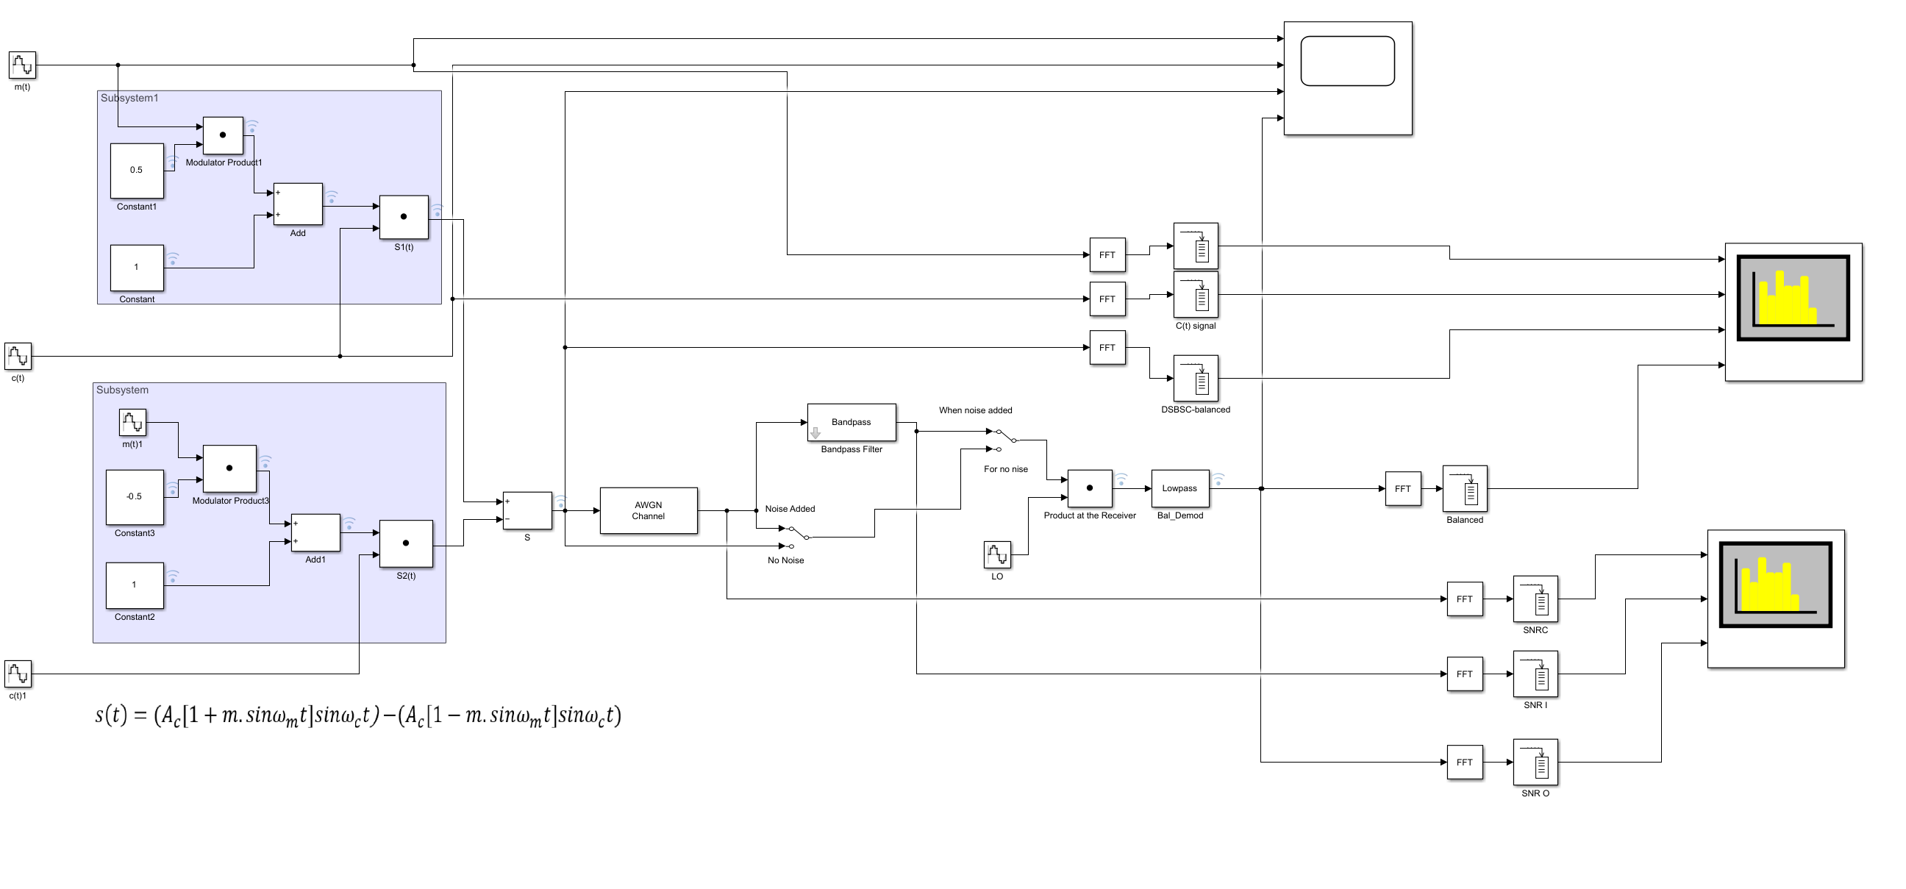
Figure 2: DSB-SC circuit with noise added.
The SSB-SC block diagram is the most elaborate. Two carrier sources in phase quadrature are used, and their respective products with the message components are combined to suppress one sideband. The receiver block diagram mirrors the DSB-SC structure but demands higher accuracy in carrier phase alignment.
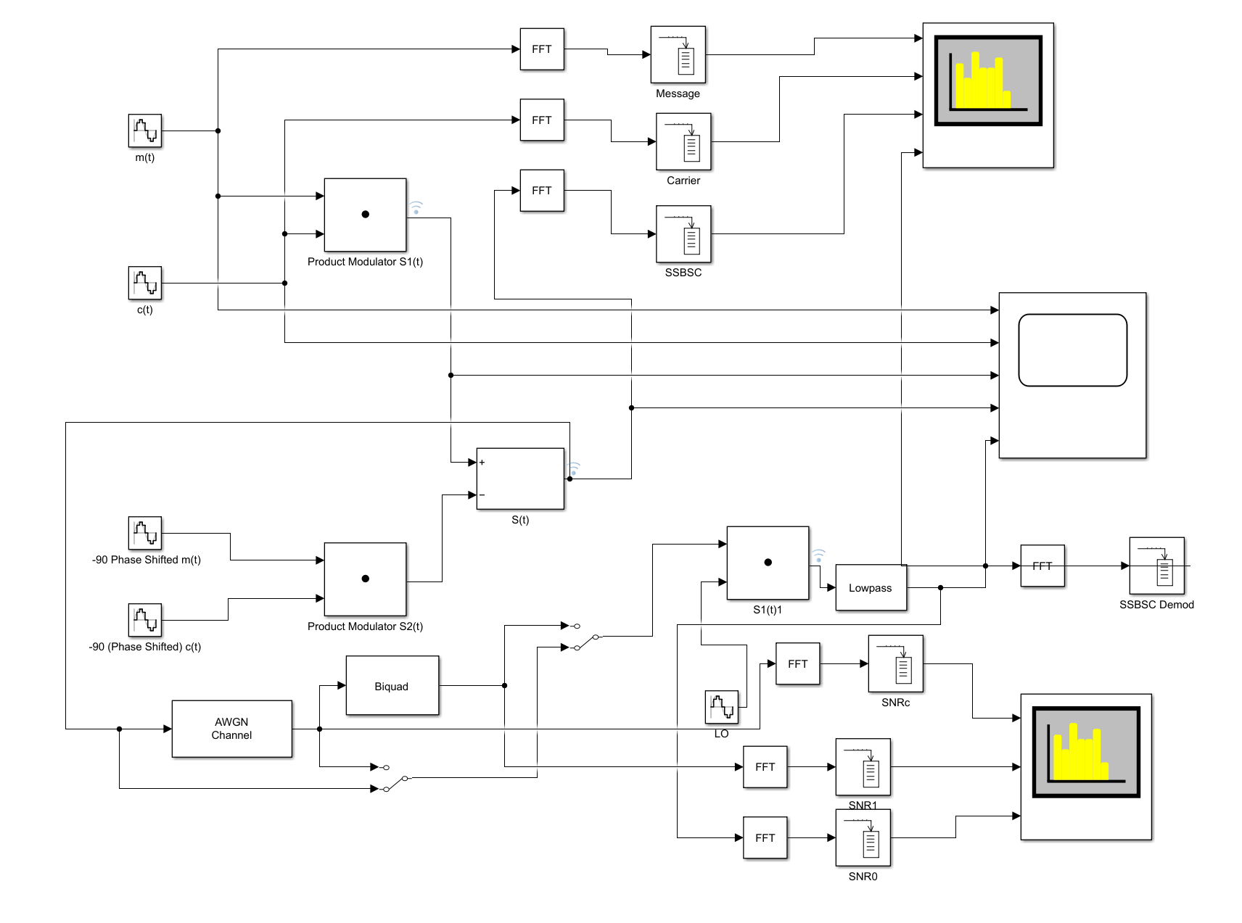
Figure 3: SSB-SC circuit with a phase discriminator with noise added

Transmitter and Receiver Architecture
The transmitter architecture of a conventional AM system is characterised by simplicity, consisting of a message source, modulator, and RF transmission stage. The receiver architecture relies on envelope detection, making it robust and easy to implement but inefficient in terms of power usage. In contrast, the DSB-SC transmitter eliminates the carrier through balanced modulation, while the receiver employs synchronous detection, increasing sensitivity to noise and phase errors.
The SSB-SC transmitter architecture integrates phase-shifting networks and precise signal combining to achieve single sideband transmission. The receiver architecture similarly requires coherent detection and accurate carrier recovery. While this increases complexity, it enables superior performance in bandwidth-limited and power-constrained environments.

Simulated Outputs and Analysing Results
Task 1: AM Simulation and Analysis
In Task 1, a conventional Amplitude Modulation (AM) system was implemented and analysed using MATLAB 2025 and Simulink to examine its behaviour in both the time and frequency domains. The modulating signal was defined as a low-frequency sinusoidal waveform with a frequency of 10 Hz, while the carrier signal was selected as a higher-frequency sinusoid at 100 Hz. These values ensured a clear separation between the message and carrier spectra, allowing the effects of modulation to be clearly observed using time-domain scopes and spectrum analysers. The AM modulator was implemented using a multiplier-based approach, where the message signal was scaled by the modulation index and combined with a DC offset before multiplication with the carrier signal, thereby producing a standard AM waveform.
The initial simulation was conducted with a modulation index of 0.2 to represent an under-modulated condition. Time-domain observations showed that the envelope of the AM signal followed the shape of the modulating waveform accurately, without touching or crossing the zero-amplitude axis. This confirmed that the carrier amplitude remained sufficiently larger than the modulating signal, resulting in distortion-free modulation. The frequency-domain analysis using the spectrum analyser revealed a strong carrier component at 100 Hz, accompanied by two smaller sideband components located symmetrically at 90 Hz and 110 Hz. These sidebands correspond to the sum and difference frequencies of the carrier and modulating signals, and their relatively low amplitudes were consistent with the small modulation index used.
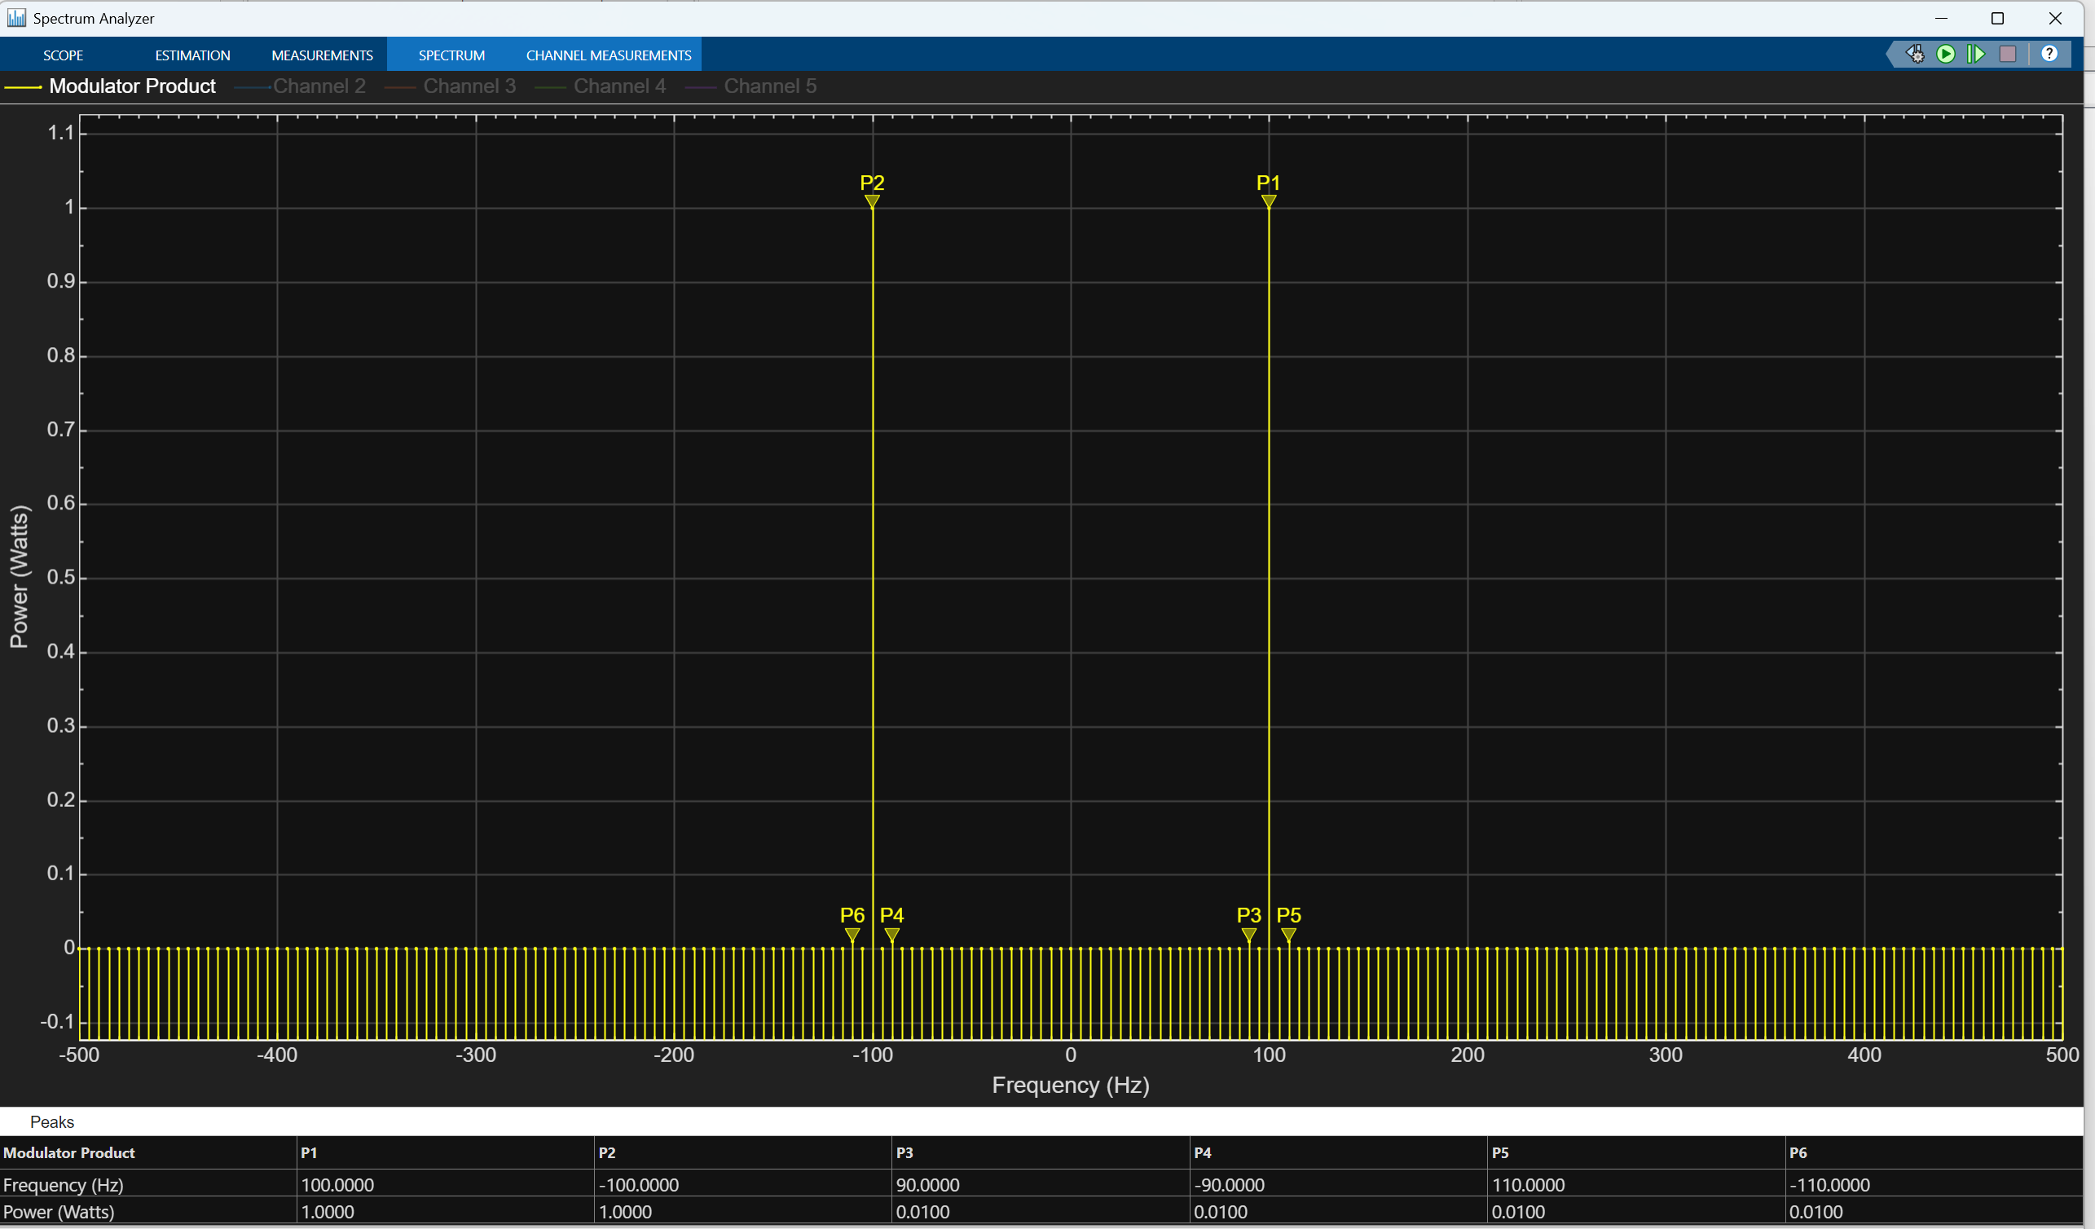
Figure 4 AM simulation with Modulation Index = 0.2 (under modulation)
Following the initial analysis, the modulation index was varied systematically to investigate the effects of under-modulation, critical modulation, and over-modulation on the AM waveform. As the modulation index was increased towards unity, the envelope of the AM signal expanded until it just touched the zero-amplitude axis, corresponding to the condition of critical modulation. At this point, the transmitted signal achieved maximum modulation depth without introducing envelope distortion. Further increasing the modulation index beyond unity resulted in over-modulation, which was clearly visible in the time-domain waveform as envelope inversion and distortion. In this condition, the envelope no longer accurately represented the original message signal, indicating that reliable envelope detection at the receiver would not be possible.
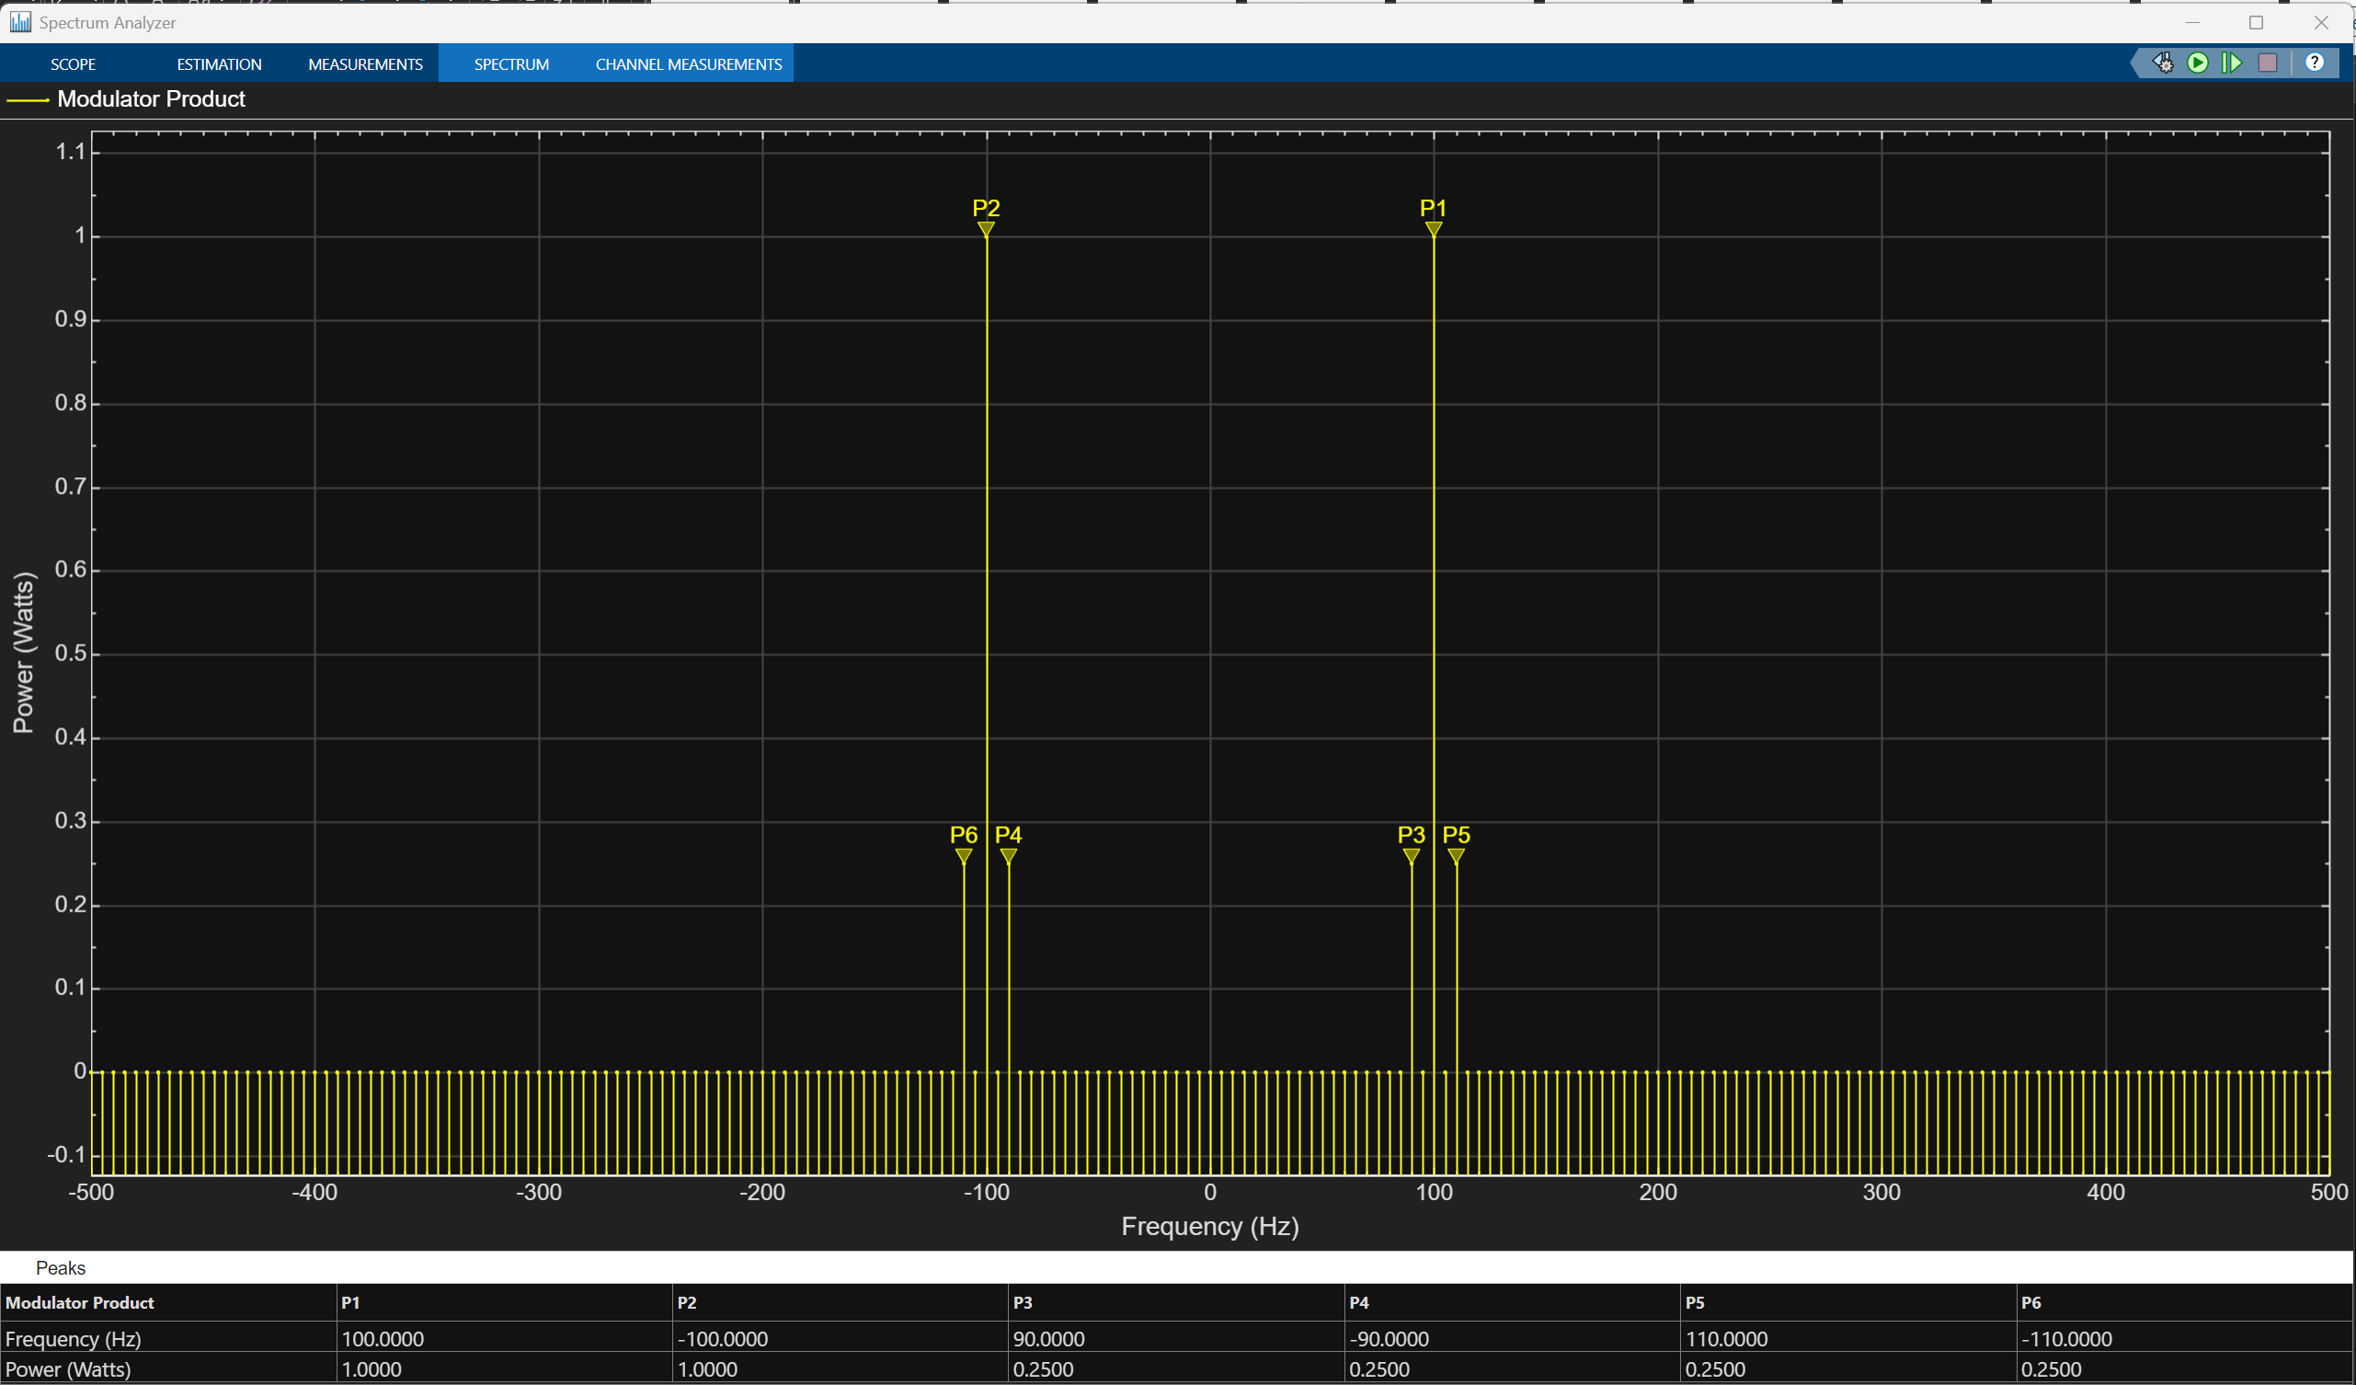
Figure 5 Modulation Index = 1 (critical modulation)
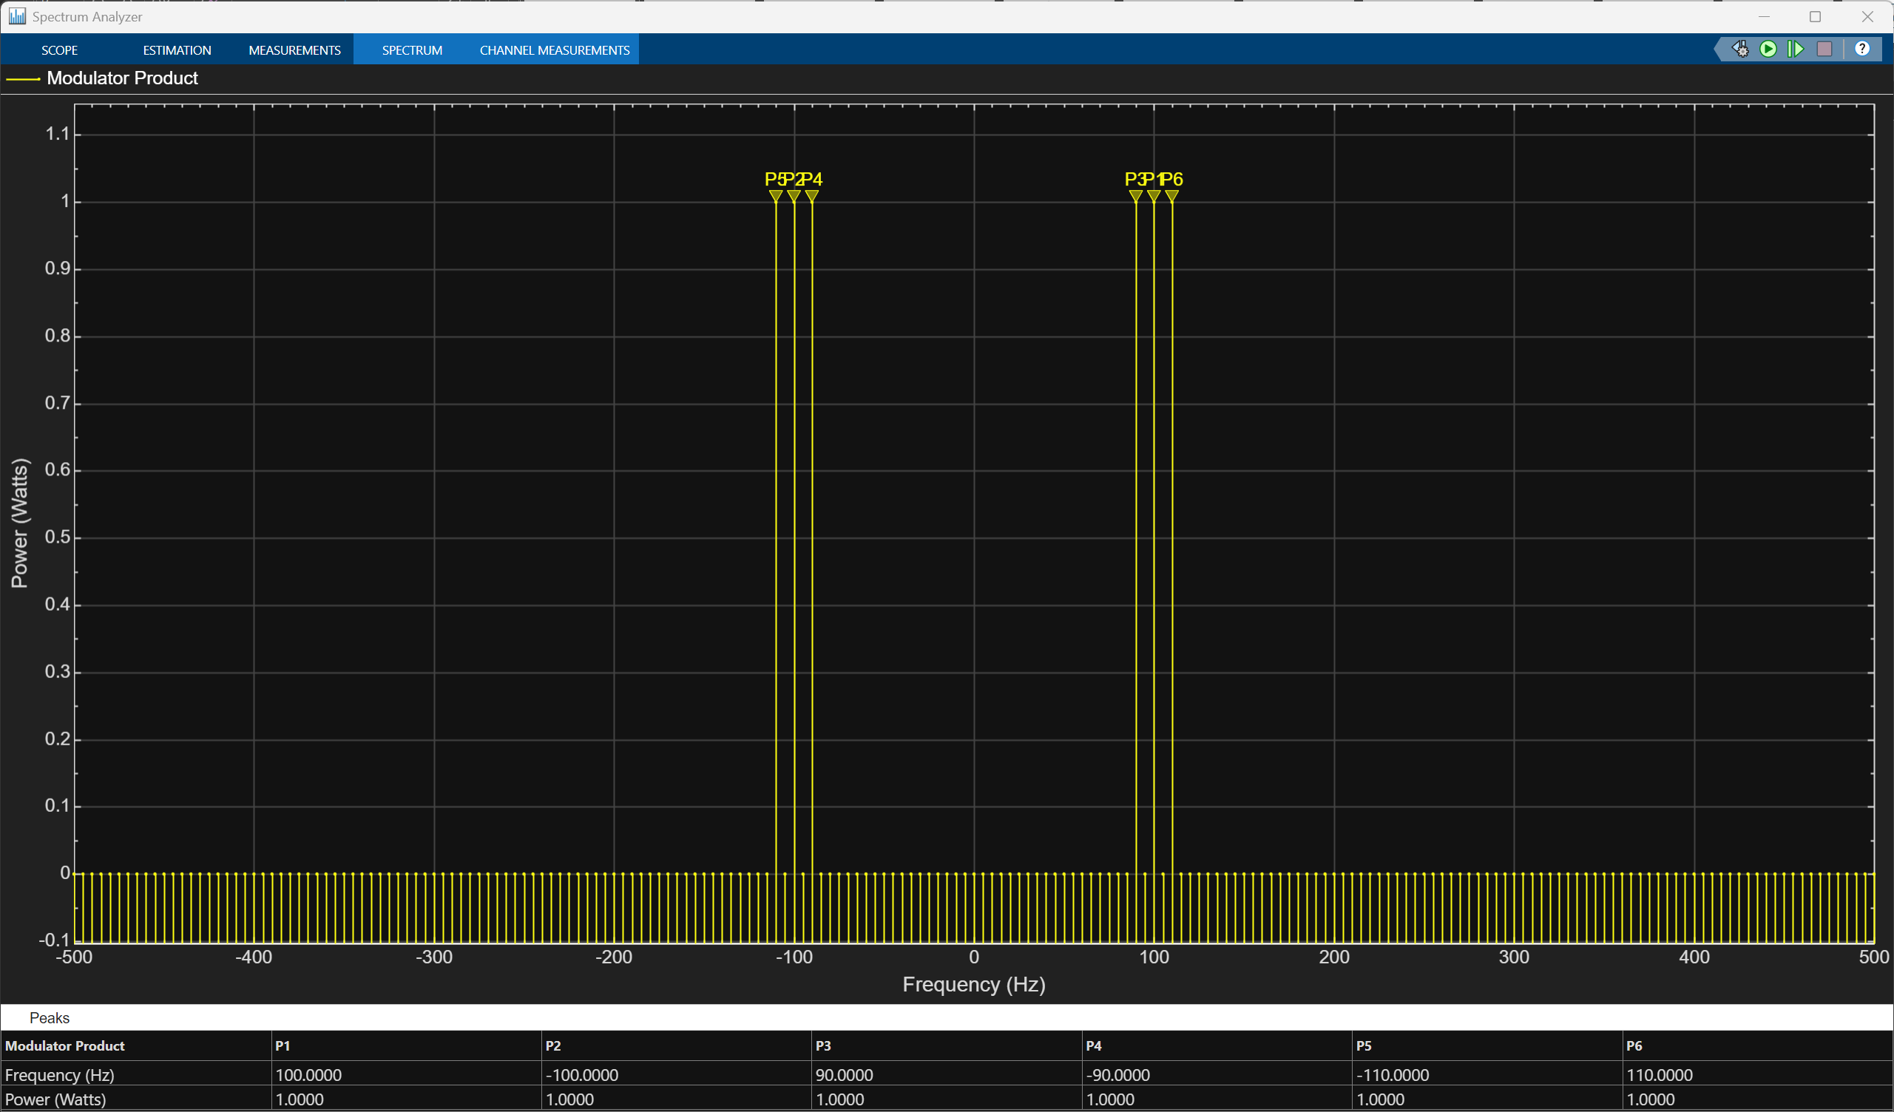
Figure 6 Modulation Index = 2 (over modulation)
In addition to analysing the modulated waveform, the AM signal was demodulated using an envelope detector consisting of a rectification stage followed by a low-pass filter. For under-modulated and critically modulated cases, the demodulated output closely resembled the original message signal, both in waveform shape and frequency content, apart from minor amplitude scaling. However, in the over-modulated case, significant distortion was observed in the recovered signal, demonstrating the practical limitation of envelope detection when the modulation index exceeds unity. These results highlight the importance of selecting an appropriate modulation index in AM systems and illustrate the inherent trade-off between modulation depth and signal fidelity.
Task 2: DSB-SC Modulation and Noise Analysis
In Task 2, a Double Sideband Suppressed Carrier (DSB-SC) modulation system was implemented in MATLAB 2025 and Simulink using a balanced modulator in order to investigate the effects of carrier suppression on spectral efficiency, power utilisation, and noise sensitivity. The modulating signal and carrier signal frequencies were maintained at 10 Hz and 100 Hz respectively to ensure consistency with Task 1 and to enable direct performance comparison between conventional AM and suppressed-carrier modulation. The balanced modulator was realised using a product block that directly multiplied the baseband message signal with the carrier waveform, a process which inherently removes the carrier component from the transmitted spectrum due to the absence of a DC term in the modulating signal [1].
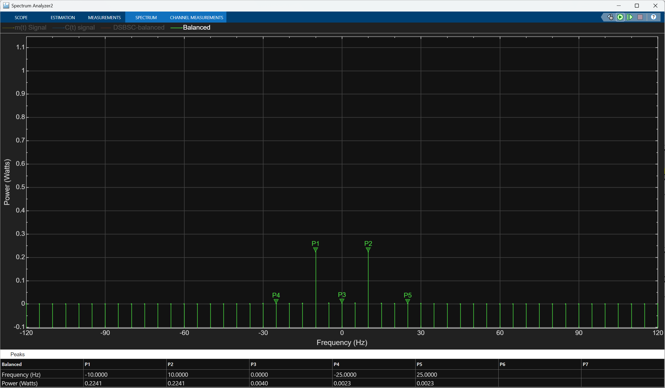
Figure 7 Spectrum analysis of a balanced DSB-SC signal
Time-domain observation of the DSB-SC signal revealed a waveform that appeared symmetrical about the zero-amplitude axis and lacked a clearly defined envelope, confirming that envelope detection is unsuitable for this modulation scheme. This observation is consistent with theoretical expectations, as the carrier component required to form an envelope is intentionally removed. Frequency-domain analysis using a spectrum analyser showed that the transmitted signal consisted solely of two sidebands located at 90 Hz and 110 Hz, with no spectral component present at the carrier frequency of 100 Hz. This result demonstrated that, although DSB-SC occupies the same bandwidth as conventional AM, it achieves improved power efficiency by transmitting only information-bearing components [2].
To recover the original message signal, coherent demodulation was employed at the receiver by multiplying the received DSB-SC signal with a locally generated carrier that was synchronised in both frequency and phase with the transmitter carrier. The output of this multiplication contained both baseband and high-frequency components, and a low-pass filter was therefore applied to remove unwanted high-frequency terms. In the absence of noise, the demodulated signal closely matched the original message waveform, aside from a predictable scaling factor, validating the effectiveness of coherent detection when ideal synchronisation conditions are met.
Subsequently, additive random noise was introduced into the channel between the modulator and demodulator to evaluate the noise tolerance of the DSB-SC system. Time-domain plots showed that the modulated signal became increasingly irregular as noise power increased, while frequency-domain analysis revealed a raised noise floor across the spectrum, partially masking the sideband components. After demodulation, the recovered message signal exhibited noticeable distortion and noise fluctuations, demonstrating that DSB-SC is particularly vulnerable to noise because the demodulation process translates noise components directly into the baseband region [3]. These results highlight a key limitation of DSB-SC systems, namely their reliance on accurate carrier synchronisation and their reduced robustness in noisy environments.
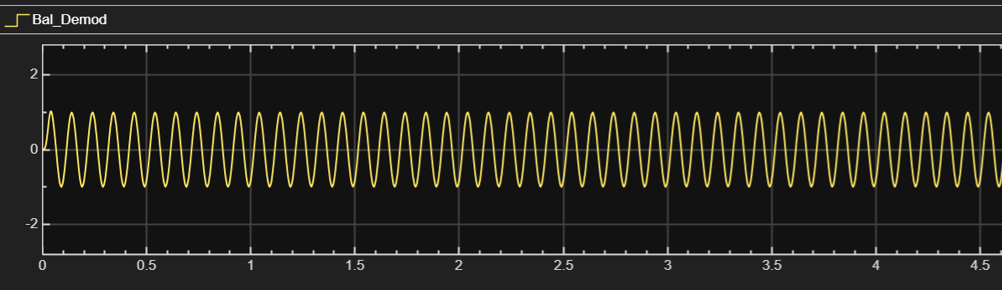
Figure 8 DSB-SC signal without noise added.

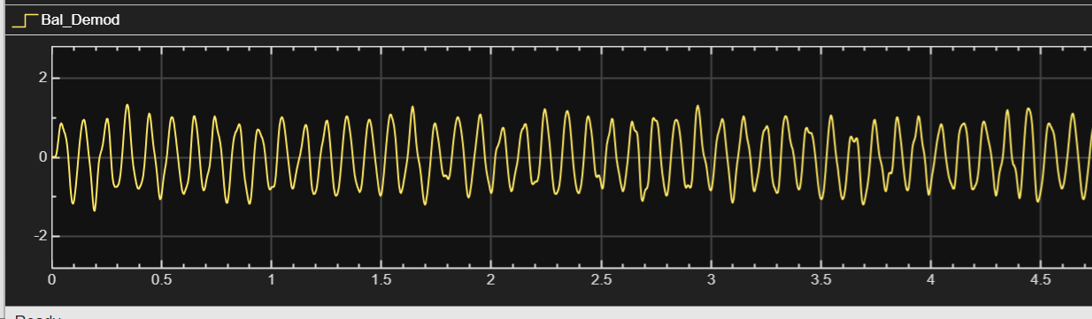
Figure 9 DSB-SC signal with noise added.
Task 3: SSB-SC Modulation Using the Phase Discrimination Method
Task 3 focused on the implementation and analysis of a Single Sideband Suppressed Carrier (SSB-SC) modulation system using the phase discriminator, or phasing, method. This approach was selected because it provides a clear demonstration of how one sideband can be eliminated through precise phase manipulation rather than sharp filtering. As in previous tasks, the message and carrier frequencies were fixed at 10 Hz and 100 Hz respectively, and a modulation index of 0.5 was employed to ensure sufficient signal strength without introducing non-linear distortion.
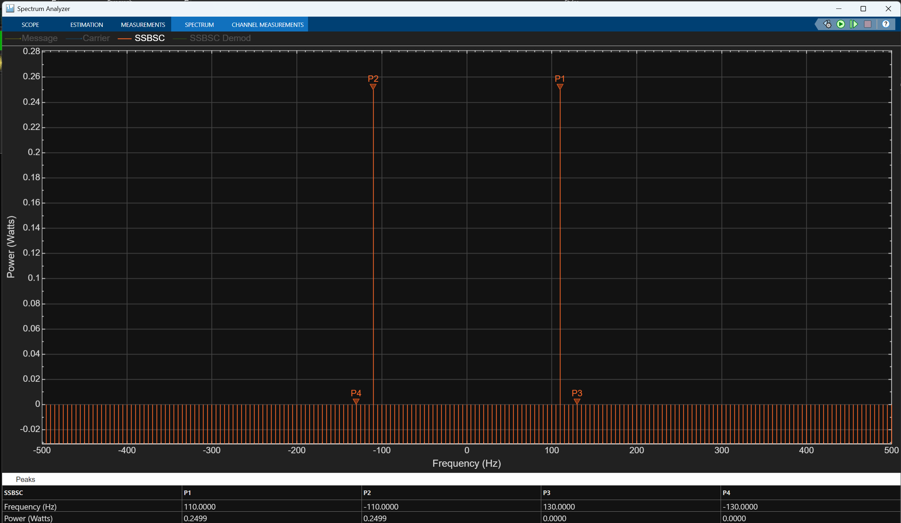
Figure 10 shows the SSB-SC signal
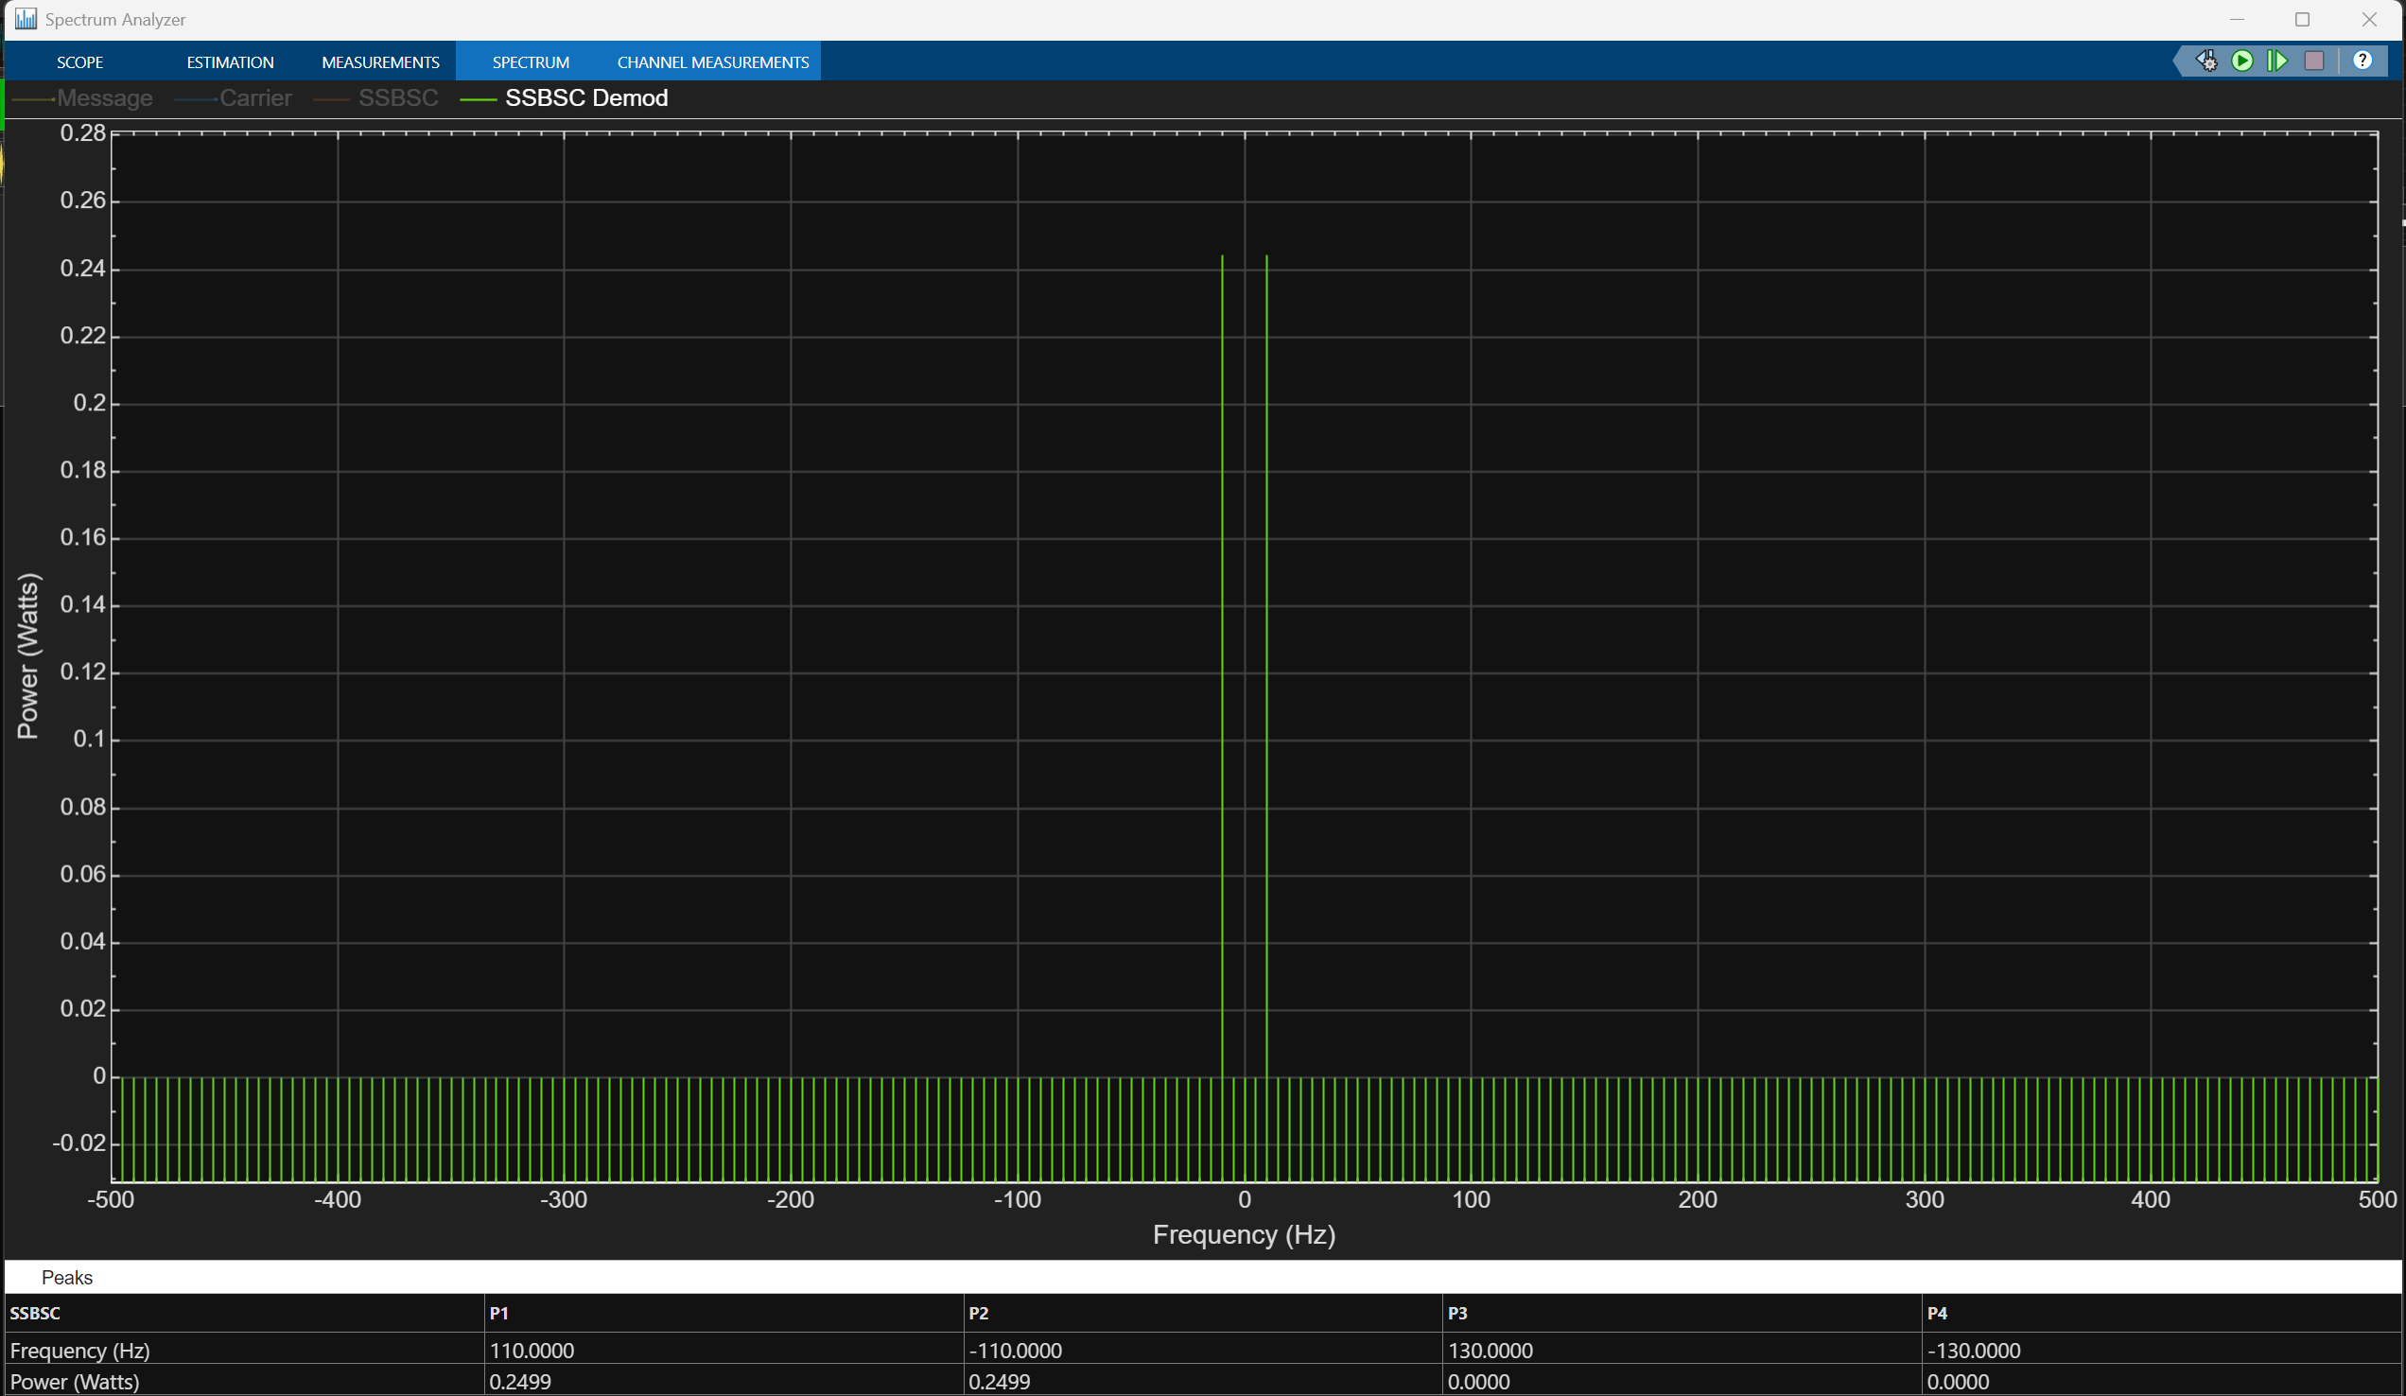
Figure 11 shows the SSB-SC signal with demodulation
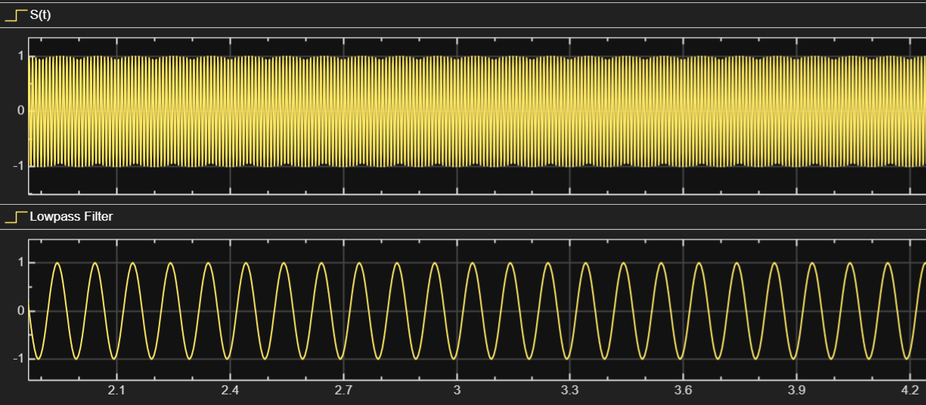
Figure 12 time domain inspection of SSB-SC signal and demodulated signal
The SSB-SC modulator was implemented by splitting the message signal into two parallel paths, one of which passed through a Hilbert transform block to generate a version of the message signal phase-shifted by 90 degrees. These two message components were then multiplied by carrier signals in phase quadrature, typically a sine and cosine waveform, before being algebraically combined. By appropriately adding or subtracting the resulting signals, one of the sidebands was cancelled while the other was preserved, producing an SSB-SC waveform with no carrier component [1]. This process required careful phase alignment, as even small phase errors can result in incomplete sideband suppression.
Time-domain inspection of the SSB-SC signal revealed a complex waveform with no obvious envelope, similar in appearance to DSB-SC but with reduced overall spectral content. Frequency-domain analysis confirmed the successful generation of a single sideband, with only one spectral component present at either 90 Hz or 110 Hz depending on whether the lower or upper sideband was selected. The absence of both the carrier and the redundant sideband demonstrated the superior bandwidth efficiency of SSB-SC compared to both AM and DSB-SC, reducing the required transmission bandwidth to that of the original message signal [2].
At the receiver, coherent demodulation was again employed by multiplying the received SSB-SC signal with a synchronised carrier and applying a low-pass filter to extract the baseband message. Under noise-free conditions, the demodulated signal closely resembled the original modulating waveform, confirming that SSB-SC can achieve high-fidelity transmission when accurate carrier synchronisation is maintained. However, when random noise was introduced into the channel, the recovered signal exhibited distortion and amplitude fluctuations, particularly when noise overlapped the message bandwidth. Although SSB-SC demonstrated improved noise performance relative to DSB-SC due to its narrower bandwidth, it remained sensitive to phase errors and noise introduced during transmission, reinforcing the importance of precise synchronisation in practical SSB systems [3].
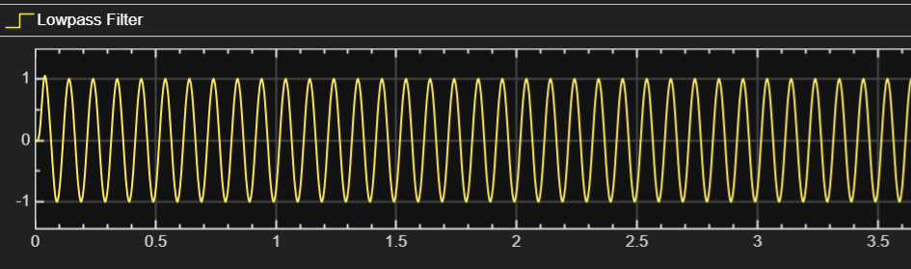
Figure 13 SSB-SC signal without noise
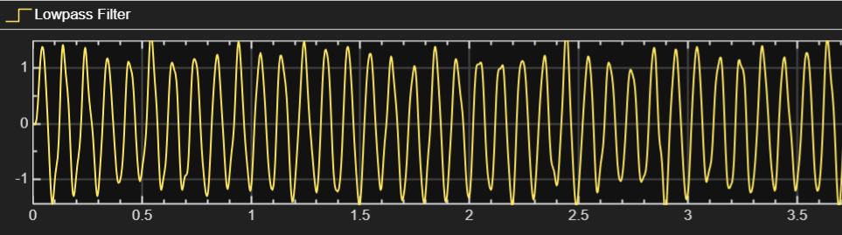
Figure 14 SSB-SC signal with noise

Task 4: Performance Comparison and System Evaluation
Task 4 involved a comprehensive comparison of the AM, DSB-SC, and SSB-SC modulation schemes based on spectral characteristics, power utilisation, and noise tolerance, using results obtained from previous simulation tasks. Spectrum analysers were used to examine the frequency-domain behaviour of each modulation technique under identical operating conditions, allowing direct comparison of bandwidth occupancy. The results showed that both AM and DSB-SC occupied a bandwidth equal to twice the message frequency, whereas SSB-SC required only a single message bandwidth, confirming its superior spectral efficiency [1].
Power spectral density analysis further revealed significant differences in how transmitted power was distributed among spectral components. In conventional AM, a large proportion of the total transmitted power was concentrated in the carrier component, which carries no information, resulting in poor power efficiency. In contrast, DSB-SC eliminated carrier power entirely, allocating all transmitted power to the sidebands, while SSB-SC further improved efficiency by transmitting only one sideband. These findings are consistent with established theoretical results, which show that SSB-SC provides the highest information-to-power ratio among the three schemes [2].
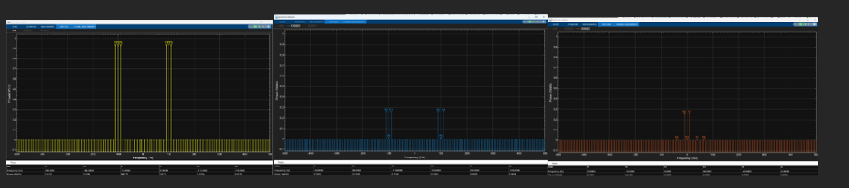
Figure 15 (left to right) power of AM, DSB-SC and SSB-SC
Noise tolerance was assessed by introducing identical noise conditions across all systems and analysing the resulting demodulated signals. The AM system demonstrated moderate robustness due to the presence of the carrier, which aids envelope detection, but suffered from poor spectral efficiency. The DSB-SC system exhibited the greatest sensitivity to noise, as coherent demodulation directly translated noise into the baseband signal. The SSB-SC system showed improved noise performance compared to DSB-SC due to its reduced bandwidth, which limited the amount of noise entering the receiver, although its performance remained highly dependent on accurate carrier synchronisation [3].
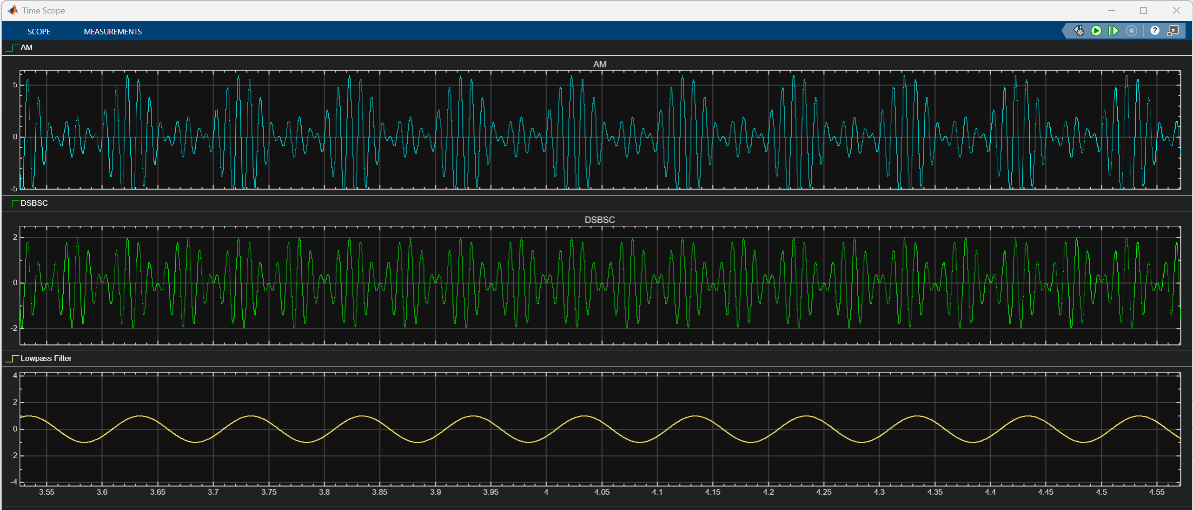
Figure 16 (top to bottom) time scope of AM, DSB-SC and SSB-SC
Overall, the comparative analysis demonstrated that no single modulation scheme is universally optimal, but rather that performance depends on system constraints and application requirements. AM offers simplicity and ease of implementation, DSB-SC provides improved power efficiency at the cost of noise sensitivity, and SSB-SC delivers the highest overall performance in terms of bandwidth efficiency and power utilisation, making it the preferred choice in bandwidth-limited and power-constrained communication systems.

Conclusion
This study has demonstrated that while conventional AM offers simplicity and robustness, it is highly inefficient in both bandwidth and power utilisation. DSB-SC improves power efficiency but remains bandwidth inefficient and vulnerable to noise. SSB-SC achieves the highest overall performance, offering optimal bandwidth usage, superior power efficiency, and improved noise resistance at the cost of increased system complexity. The simulation results validate theoretical expectations and highlight the practical trade-offs inherent in analogue modulation system design.

References

References

[1] | S. Haykin, “Communication Systems,” WIley, New York, 2009.
[2] | J. G. P. a. M. Salehi, Digital Communications, New York: McGraw-Hill, 2014.
[3] | W. R. B. a. S. S. M. Schwartz, Communication Systems and Techniques, New York: McGraw-Hill, 2005.
[4] | MathWorks, “DSP and Communications Toolbox User Guide,” MATLAB R2025.

