- Job advertisement
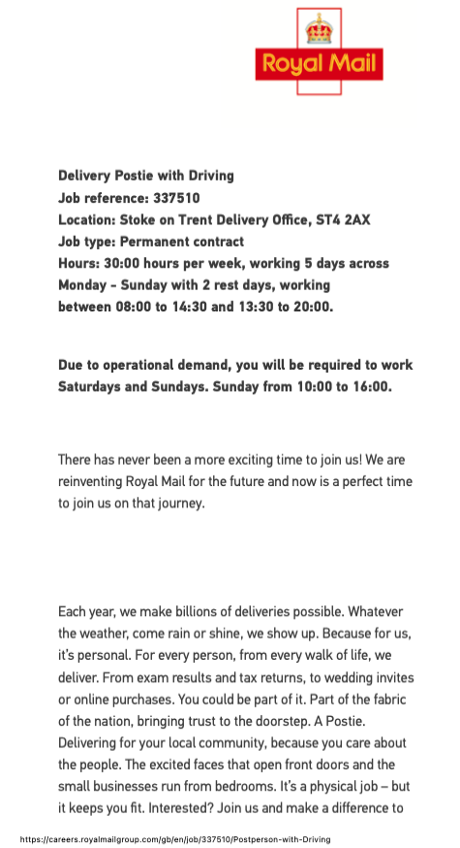
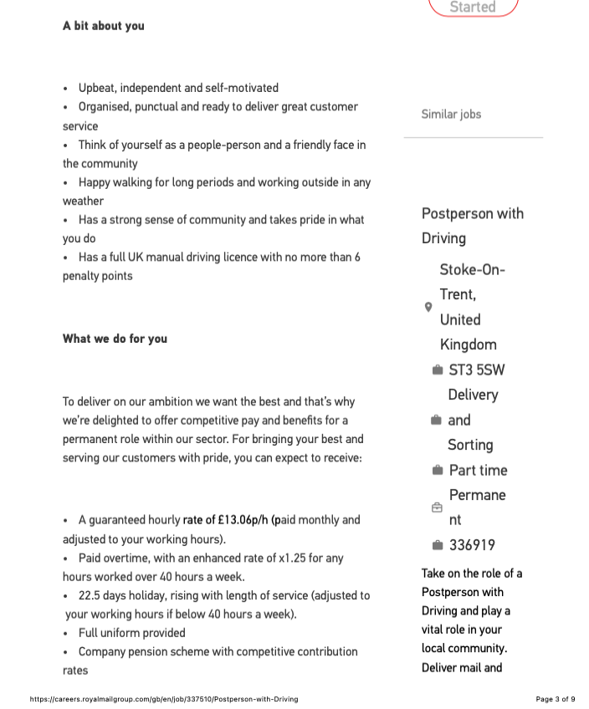
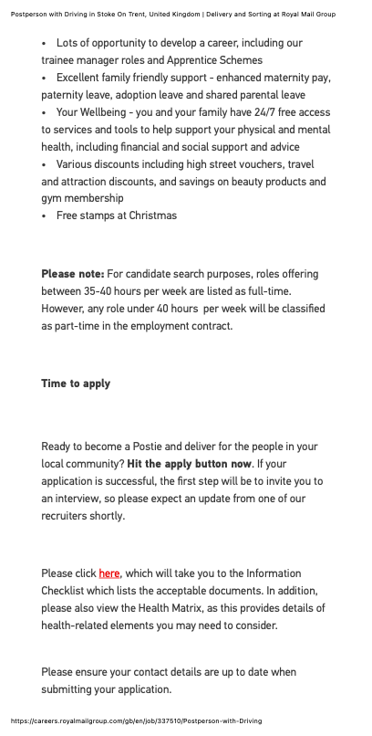
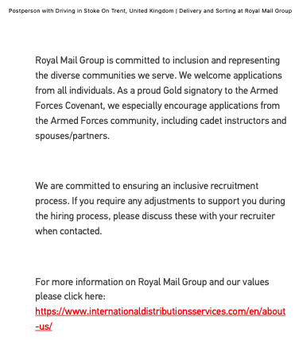

- Curriculum vitae

CURRICULUM VITAE
PERSONAL INFORMATION
Full Name: Mr. Edwin Akaolisa
Address: 179 Oldfield Street
Stoke-on-Trent
ST4 3PG

Mobile: 07488320199
Email: edwineze2000@yahoo.com

I am currently a business management student at University of Wale Trinity Saint David, Birmingham campus (UWSTD). I am applying for parcel delivery job that you are advertising on your website because I have a lot of experience for parcel delivery that enable me to add value to your prestigiors organisation.

EMPLOYMENT HISTORY
2016–present: Self-Employed
Courier services worked with Amazon and DHL as a parcel delivery driver, and Man and Van services.

2012–2016: Care Logistics, Right Support Management Ltd
Being incharge of driving staffs to their duty post and distributing equipments to homes as directed by the management. In addition, I am always stand by for any emmagency call out.

2004–2012: Data Centre Specialist, Iron Mountain UK Ltd
Taking request from customers, sourcing their order, getting order pepper work ready and assigning it to transport for delivery.

EDUCATION
2025-present: University of Wales Trinity Saint David, Level 4, Business Management
2024-2025: Stoke on Trent College, Functional Skills Level 2
2002-2006: Institute of Leadership and Management, Lambert College, ILM Level 2
1993-1997: Boys high school Azia

KEY SKILLS
- Full UK manual driving licence
- Customer Service
- Manual handling
- Time management
- Rout planning and navigation

INTERESTS
- Driving
- Travelling
- Socializing

REFERENCE
Obinna Eze
Line Manager
Iron Mountian UK LTD

Trinh Nguyen
Lecturer
UWTSD, Birmingham campus

- Cover letter

Edwin Akaolisa
179 Oldfield Street, Stoke-on-Trent, ST4 3PG

Royal Mail, Stoke on Trent Delivery office, ST4 2AX

10/6/2026

Dear sir/Madam

I am applying for the royal mail parcel delivery job here in stoke on Trent, after accessing my work experience as it stated in my CV, and residing in stoke on Trent am convinced that am more qualify to offer the job opportunity.

I have had a manual UK driving licence for over 14yrs, no point, and no any driving conviction. I have a lot of driving, sorting, and delivery experience after working with company like Amazon Flex and DHL.

Base on your job advertisement you want person who is independent, self -motivation, Organise and punctual. I can assure you that I posses those skills, and will be delighted to add value to your reputable Organisation.

I am a hardworking and reliable person with good time management skill, good communication and customer service skills. I work well under pressure, in a team and independently.

I am available to work weekdays, weekends, overtime, and flexible shifts. In addition, I live local it will be easy to do the job since I understand the terrain better than most.

I will be committed to providing excellent services and maintaining a professional attitude while representing Royal Mail if the opportunity is given to me.

Yours faithfully,

Edwin

