EFFECTIVE TEAMWORK AND COMMUNICATION

STUDENT NAME: ILEANA IOANA CHIS
STUDENT ID: 1818454
LECTURER NAME: DR. GULNAR ALI

TABLE OF CONTENTS
INTRODUCTION 3
MODELS OF COMMUNICATION 4
SHANNON AND WEAVER 4
SCHRAMM MODEL 5
BERLO MODEL 6
EXAMPLES OF POOR COMMUNICATION 7
KEY WORKPLACE COMMUNICATION SKILLS 8
VERBAL COMMUNICATION 8
NON-VERBAL COMMUNICATION 8
LISTENING 9
CONCLUSION 10
REFERENCES 11
APPENDICES 13

INTRODUCTION
Communication tells about the method of exchange of information or knowledge between individuals, which can be both verbal, non-verbal and written form. Communication is the key to organizational success as it defines how well each department is aware of all the happenings, and how well they are integrated (Lutgen and Tracy, 2012). The technological revolution has made workplace communication even more efficient, as organizations now can communicate in lightning-fast speed, with anyone and from anywhere. Apart from that, communication is also important for customer satisfaction and vital for gaining competitive advantage for organizations in the high competition (Lam et al. 2014). This report will discuss the models of communication, the examples of poor communication and the key communication skills of the workplace, to make it more effective and beneficial for both the employee and the employer. The report will discuss these aspects along with examples to develop a critical understanding.

MODELS OF COMMUNICATION

SHANNON AND WEAVER
The Shannon and Weaver were published in "A Mathematical Theory of Communication" article in 1948 by Claude Elwood Shannon. According to Al-Fedaghi (2012), the concepts of this model are:
Sender: from where the information to be exchanged originates
Encoder: from where the information is encoded in a transmissible format
Channel: Through which the information travels from the sender to the receiver
Receiver: the destination of the information transmitted
Decoder: which is responsible for decoding and converting the message in a format which can be read by the receiver
Noise: the elements of disturbances which reduces the clarity or quality of the information transmitted, making it hard to understand for the receiver
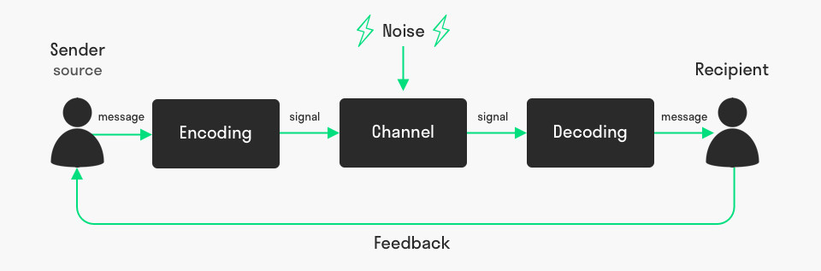
Figure 1: CONCEPTS OF SHANNON AND WEAVER MODEL
SOURCE: [Mudler, 2017]
This model takes a mathematical approach towards understanding the elements of effective communication, hence vital (Junod et al. 2015). Taking the example of Maria and Pedro, where Maria asks Pedro to bring chicken while coming back home, but he misunderstood chicken with kitchen. This miscommunication was caused by due to noise as Pedro was working on a building site. Another example is a phone call, in which the caller is the sender, the telephone or cellphone acts as the encoder, the network acts as the medium and the telephone or cellphone of the receiver is the decoder (Al-Fedaghi, 2012).
Thus, this model covers the entire process of communication, from the generation of the information from the sender end to the receiving of information by the receiver. There are many strengths of this model, such as the noise concept for understanding the disturbances and enhancing the quality of communication. Also, this model demonstrates communication as a two-way process, hence applicable to all kinds of conversation, suggesting that both the parties act as the sender and the receiver (McQuail and Windahl, 2015). In the context of workplaces, this type of conversation is necessary for better decision-making in terms of employee care practices and organizational objectives. This model considers the significance of collecting employee's feedbacks due to its two-way concept, hence making communication a quantified entity. However, the critics of this model suggest that this model is suitable for one-to-one or small scale communication, not for mass communication (McQuail and Windahl, 2015). It also prioritizes the role of the sender as primary and that of the receiver as secondary. This model also doesn't talk anything about feedback, which is also an essential part of effective communication.

SCHRAMM MODEL
This model takes a more detailed approach towards effective communication, by considering other factors having influences on the effectiveness of communication such as the background of the sender and the receiver, the exchange of feedback, and so on (Katori, 2016).
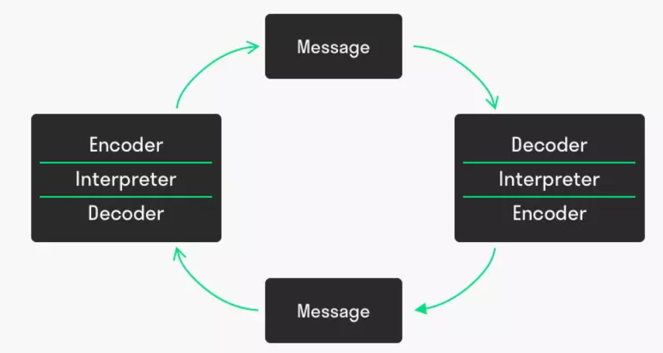
Figure 2: SCHRAMM MODEL of communication
Source: [Janse, 2019]
This model emphasizes the significance of encoding and decoding of the message, as without having proper encoding and decoding, the communication is of no use even if it is successfully transmitted. This model also highlights the significance of feedback from the receiver to the sender of the message, which is a confirmation that the message has been successfully transmitted and decoded (Katori, 2016). For example, relating it with the case of communication between Maria and Pedro, the communication could have been successful if Maria would have asked Pedro to repeat what he heard, and then corrected him on the same call. The feedbacks can also be seen in direct communication, in which the sender seeks affirmation from the listener through eye contact, head nodding, leaning towards the speaker, and so on. Thus, this model is strongly related to workplace communication, such as during any briefing or meeting (Norrenbrock et al. 2013). The background influences of the sender and the receiver denote the ability to encode and decode the message as intended. This is also of great significance for modern workplaces, with diverse backgrounds of employees.

BERLO MODEL
This model further digs into the various kinds of influences on each element of communication. The elements of communication. According to this model, there are 4 elements: the sender, the message, the channel and the receiver (Jensen, 2013). Further, it highlights the various influences as shown in the figure below:
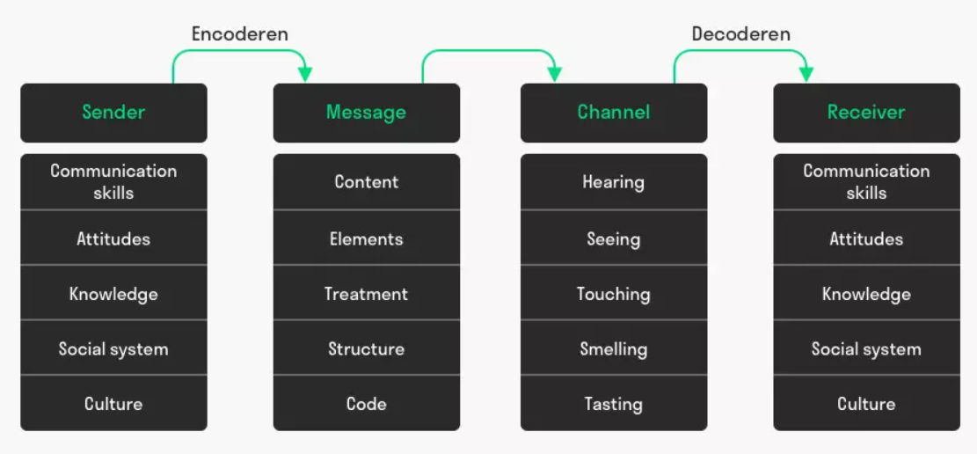
Figure 3: Berlo’s SMCR Model of Communication
Source: [Janse, 2019]
The figure above highlights the various factors which affect the overall quality of the communication, and therefore important to consider to ensure effective communication at workplaces. For example, referring to the case of the professor and the village, in which the professor was asking for help from the villagers to save his house from fire. In that case, the professor would repeatedly say “the edifice is being consumed by a great conflagration!", which means "the house is being consumed by great fire!". None of the villagers could understand him due to such highly academic words instead of using simple and more understandable terms, hence led to ineffective communication and consecutively, the destruction of his house from fire. This model can also be applied to the strategic marketing planning in organizations, in which the analyst has to first understand the cultural preferences, social lifestyle, product/service preferences, religious sentiments, etc. Thus, it will determine how the advertisement creates a long-lasting impact and gain brand awareness and reputation (Jensen, 2013).

EXAMPLES OF POOR COMMUNICATION
I used to work for the Sainsbury supermarket chain as a store representative, and my role was to guide customers through purchasing by giving information about them. During a discount period, the store manager asked one of the employees to tell others that we were giving a discount of 15% on groceries for a newly launched brand. As due to other offers during the discount period, the stores were heavily crowded and due to a lot of noise communication was difficult. Because of this, the employee misunderstood 15% with 19% and communicated the same to us. After we sold around 50 units with a 19% discount, the manager found out the issue and made us realize the mistake we did.
Another instance of poor communication happened in the workplace of my friend, who works as a bartender at a bar. During new year's eve when he had to deal with the crowd and heavy demands for drinks, the bar manager should from one opposite corner "serve alcohol-free drinks to the people on table number 3", but my friend misunderstood it as "serve free drinks to the people on table number 3 and did the same. Since he said the drinks were free to the customer, they finished and left without paying. Later, the manager accepted that the mistake was from his end as he should have come closer instead of shouting from far away.
In both the examples of my personal experience and my friend's case mentioned above, poor communication was due to being non-attentive during listening and noise. Also, it can be noted that the losses caused due to mistakes in both cases could have been avoided if the speaker would have asked to repeat what the listener had heard. These instances also represent that effective communication requires the contribution of both the message sender and the receiver. This is the reason why professional communication is often done in a written form, as it is more effective in conveying the exact message without it undergoing various influences as mentioned in the Berlo’s Model of Communication.

KEY WORKPLACE COMMUNICATION SKILLS
Having effective communication is extremely vital for organizational effectiveness, as it will denote how much the workforce is informed and empowered. Communication serves to organizational growth in several ways, which can be direct (communicating with customers and provide direct services) or indirect (empowering employees and improving their job satisfaction factor, to retain their motivation and dedication towards their roles) (Robles, 2012). Mainly, there are 3 communication skills which are essential for effective workplace communication. They are:

VERBAL COMMUNICATION
Verbal communication takes place through words which are either spoken or written by the sender. This communication skill covers all kinds of direct communication, which can be personal, professional, short term, long term, one-to-one, one-to-many, etc. Thus, is of great importance for organizations, such as during reporting, meetings or presentation (Keyton et al. 2013).
There are many important elements to this method such as maintaining eye contact, nodding in agreement to show attention, relaxation, sincerity, clarity, empathy, etc. which are important for verbal communication to be effective. These elements play an important role in effective communication because they ensure that both the speaker and the receiver are interested in the session and hence keeps both the ends motivated (Keyton et al. 2013).

NON-VERBAL COMMUNICATION
This comprises of all the type of communication which doesn't involve written or spoken words, such as gestures, sign language, body language, pitch and tone of the voice, etc. This is important for the listeners as they have to give consistent feedback that they are attentively listening and understanding everything told/taught to them (Robles, 2012). These communication skills also cover few aspects of professional behaviour or workplace etiquettes, such as avoiding talking when someone is already talking, maintaining eye contact with the speaker, maintaining the right posture while listening, and so on (Sasaki et al. 2017).

LISTENING
Listening skills is another key professional communication skill, which ensures that the message being sent by the sender is being received and decoded by the receiver in the right way. For active listening, the listener should attentively listen to the speaker and keep irrelevant thoughts aside (Coffelt and Smith, 2020). The listening should be such a way that it keeps the speaker motivated and interested in speaking. It is of 3 types:
Informational listening:This denotes the gathering of information and knowledge while listening, such as learning to use any safety equipment or listening to an announcement. This helps in transferring knowledge and skills (Keyton et al. 2013).
Critical listening:This denotes listening for making-decision, such as listening to the employees to draft better HRM policies, or listening to the customers to decide what they want and help them better (Robles, 2012).
Empathetic listening: This denotes the ability of the listener to sense the emotions and feelings of the speaker through their voice tone and appearance. This is important for organizational communication, to convey messages which cannot be conveyed directly, thus allows the employees to sense the vision of their leaders behind the organizational goals (Keyton et al. 2013).

CONCLUSION
The report above shed lights on the various aspects of workplace communication, by discussing the various model of communication and relating it with real-life examples. The Shannon and Weaver model stated that communication requires a sender, an encoder, a medium, a decoder and a receiver, while noises reduce the quality of the message. The Schramm Model of communication further highlighted another key element of effective communication which is the feedback, thus highlighted the limitations of Shannon and Weaver's model. Further, Berlo’s model of communication took an in-depth approach of the various factors such as the background of the speaker and listener, influencing the effectiveness of communication. Overall, all 3 models discussion concluded effective communication is a two-way process. Later, the report presented a few examples of poor communication at workplaces, and the key communication skills required for effective professional communication. The discussion overall concluded that both the listener and the speaker must be attentive, clear and show interesting behaviour to keep them engaged, as it determines the professional as well as interpersonal relations between the employees.

REFERENCES
Al-Fedaghi, S., 2012. A conceptual foundation for the Shannon-Weaver model of communication. International Journal of Soft Computing, 7(1), pp.12-19.
Coffelt, T.A. and Smith, F.L., 2020. Exemplary and Unacceptable Workplace Communication Skills. Business and Professional Communication Quarterly, p.2329490620946425.
Janse, B., 2019. Berlo’s SMCR Model of Communication. (Online) Available at: https://www.toolshero.com/communication-skills/berlos-smcr-model-of-communication/ (Accessed on 22 August 2020)
Janse, B., 2019. Schramm Communication Model (Online) Available at: https://www.toolshero.com/communication-skills/schramm-communication-model/ (Accessed on 22 August 2020)
Jensen, K.B. ed., 2013. A handbook of media and communication research: Qualitative and quantitative methodologies. routledge.
Junod Perron, N., Sommer, J., Louis-Simonet, M. and Nendaz, M., 2015. Teaching communication skills: beyond wishful thinking. Swiss Medical Weekly, 145(0708).
Katori, M., 2016. Bessel processes, Schramm-Loewner evolution, and the Dyson model (Vol. 11). Springer.
Keyton, J., Caputo, J.M., Ford, E.A., Fu, R., Leibowitz, S.A., Liu, T., Polasik, S.S., Ghosh, P. and Wu, C., 2013. Investigating verbal workplace communication behaviors. The Journal of Business Communication (1973), 50(2), pp.152-169.
Lam, P.W., Cheng, W. and Kong, K.C., 2014. Learning English through workplace communication: An evaluation of existing resources in Hong Kong. English for Specific Purposes, 34, pp.68-78.
Lutgen-Sandvik, P. and Tracy, S.J., 2012. Answering five key questions about workplace bullying: How communication scholarship provides thought leadership for transforming abuse at work. Management Communication Quarterly, 26(1), pp.3-47.
McQuail, D. and Windahl, S., 2015. Communication models for the study of mass communications. Routledge.
Mudler, P., 2017. Communication Cycle model by Shannon and Weaver . (Online) Available at: https://www.toolshero.com/communication-skills/communication-cycle-shannon-weaver/ (Accessed on 22 August 2020)
Norrenbrock, C., Melchert, O. and Hartmann, A.K., 2013. Paths in the minimally weighted path model are incompatible with Schramm-Loewner evolution. Physical Review E, 87(3), p.032142.’
Robles, M.M., 2012. Executive perceptions of the top 10 soft skills needed in today’s workplace. Business communication quarterly, 75(4), pp.453-465.
Sasaki, N., Somemura, H., Nakamura, S., Yamamoto, M., Isojima, M., Shinmei, I., Horikoshi, M. and Tanaka, K., 2017. Effects of brief communication skills training for workers based on the principles of cognitive behavioral therapy: a randomized controlled trial. Journal of Occupational and Environmental Medicine, 59(1), p.61.

APPENDICES
In-class exercise
Maria and Pedro case study
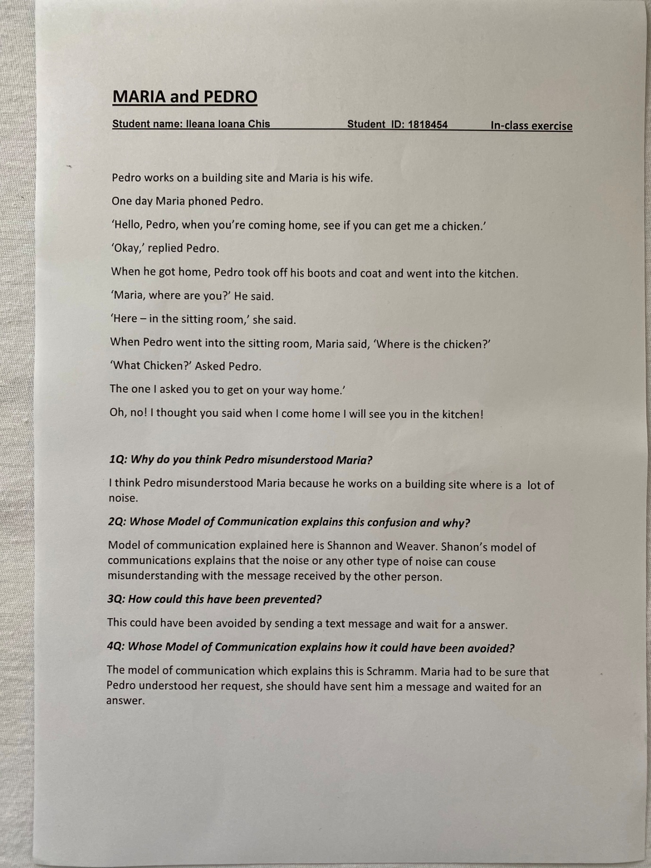

The professor and the village people case study
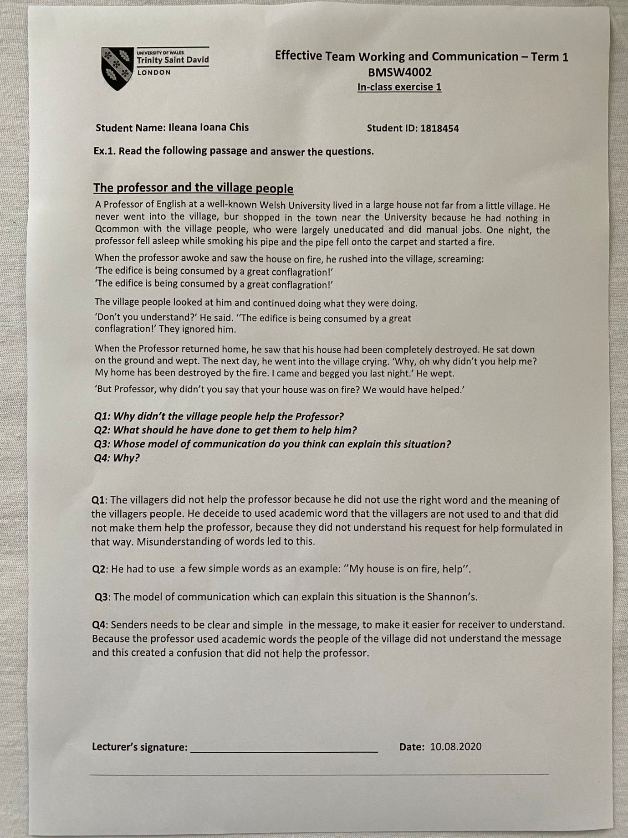

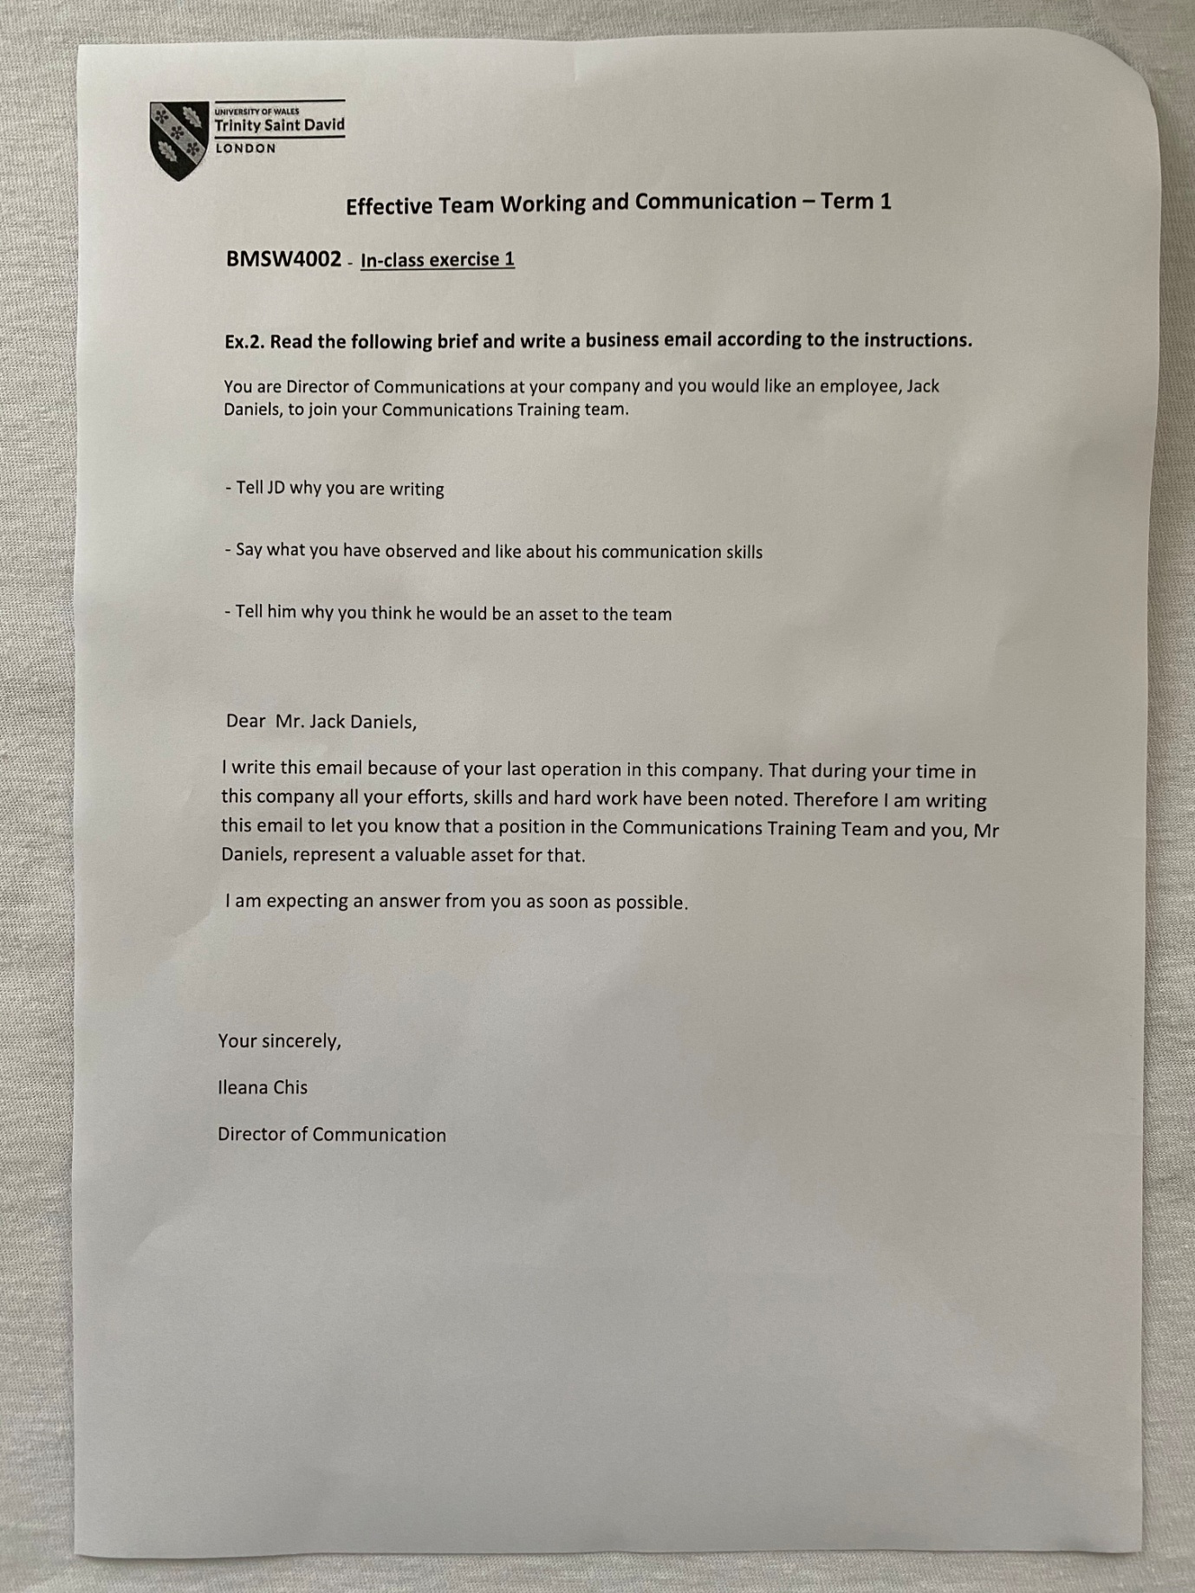

A day with the chief case study




