Reflective journal

This is a reflective journal based on a course of SKIP sessions carried out with a mixed Nursery and Reception class in Christchurch CIW Primary School. I have been at the school since January 2012 in various roles from Nursery to Year 6. It is a small church school situated in the Sandfields area of Swansea, we have no green spaces and a shared yard. There are 30 Nursery and Reception children on role. It is a diverse class with multiple home languages spoken and a number of children identified as having additional learning needs. It has been noted that due to various barriers including the current Covid pandemic and socioeconomic factors the children are experiencing significant delays in their learning and development. As a school we were very keen to bridge this gap.

As staff we believe that the children in our class are not accessing the experiences and opportunities afforded to their peers and that a significant number were spending more time on electronic devices than engaging in physically enriching activities. This is acknowledged in a theory by Goddard Blythe in which he states “We have seen how movement is an essential ingredient for a child’s development and capacity to learn, but children of today have less movement opportunities in their daily lives than any other generation” (Goddard Blythe, 2005: 130). This correlates with Ayres’ theory that all children have an inbuilt drive to develop their sensory integration. Ayres states that “Children are designed to enjoy activities that challenge them to experience new sensations and develop new sensations and develop new motor functions.” (Ayres, 2005: 14). After reading these theories I began to reflect on the reasons why children’s development of sensory integration is being inhibited in this generation. Was it changes in society or something else? Parents working longer hours, lockdowns hindering children’s opportunities to experience visits to the park or soft play areas, a “cotton wool culture” with parents scared to let their children take risks and despite living within walking distance of the local beach and various parks over half had never been except with school. It inspired me to investigate further as to whether their lack of experiences for rich movement was impeding on other aspects of their development both academically and physically later on. This theory is supported by Goddard et al in which they state “If children cannot proficiently run, jump, catch, throw etc. then they will have limited opportunities for engagement in physical activity later in their lives because they will not have the prerequisite skills to be active.” (Stodden et al, 2012: 291)

Across our SKIP project we aimed to foster the children’s physical development through a series of locomotor and object control skills sessions. We set out to see the correlation of their physical development and concentration levels, focus and motivation for classroom learning as noted by Goddard Blythe “Something happens to attention, behaviour and motivation when children and young people become active.” (Goddard Blythe, 2005: 133)

From personal reflections of my baseline and observations, I noted that skills we perceive as normal and every-day tasks were challenging for the majority of the children in my class. For example, a number of the Nursery children were throwing using a chopping action i.e. a stage 1 thrower, but were not releasing the object. However, the majority of pupils across both classes were able to run as a stage 2 runner, in an upright position with their arms at middle guard and some in a low guard position but not yet using the heel-toe contact needed to make them a stage 3 runner. Using the four locomotor stages of jumping as supported by Gallahue et al’s (2012) literature I could see that the children are at the initial stage of jumping with a number of them unable to take off from two feet. Therefore, supporting my belief that the children’s physical development has been inhibited by their lack of opportunities during early childhood as described in Seefeldt’s ‘Progression of Motor Proficiency Skills Level’ model (see diagram below).

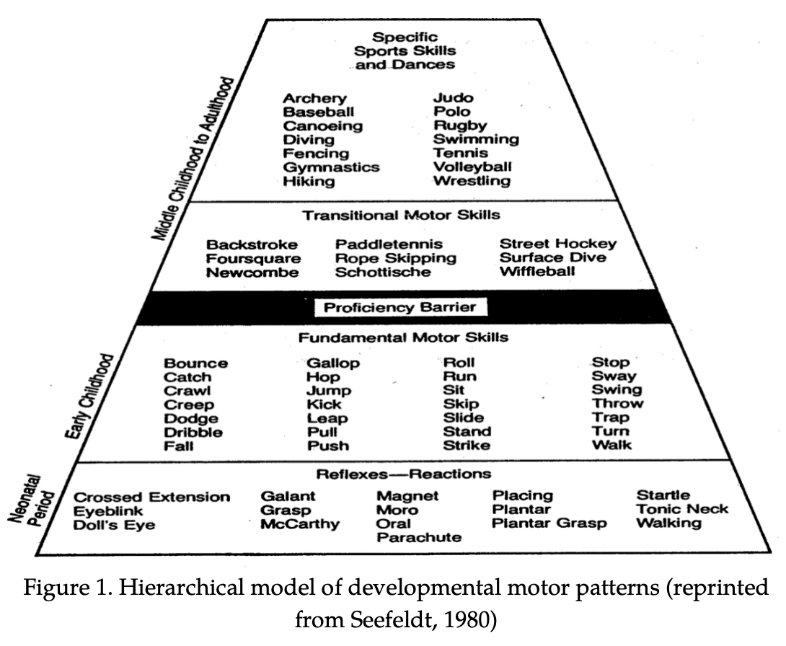

Through my SKIP sessions I aim to provide the children with a rich and varied range of movement opportunities in order for them to break through the proficiency barrier in middle childhood.

Cycle one

At the beginning of each session the children participated in a warm-up game such as the zoo game. These games encouraged the children to move in different directions, at different levels and using different body shapes. When we began playing the game the children all moved around in a circle in clusters with their friends. I intervened and I re-introduced the concept of a personal bubble, showing that even if I stretch out as far as possible, I would not be able to touch anyone. The use of coloured spots as a visual reminder of where the children should stand helped to support this. In order to encourage the children to move in different directions and at different levels I chose a range of animals such as a crab, flamingo, giraffe, lion and snail, with each animal encouraging a distinctive type of creative movement. I alternated and adapted the warm-up to encourage the children to think creatively, often asking members of the class to demonstrate a new animal and way of moving, which we then integrated into the game. I used verbal cues to develop their movements and included lots of praise when I saw effective movements.

As the sessions were a new experience for the children, I found that the majority of the children were all engaged and enthusiastic about trying the new equipment. As adults we encouraged them to try new ways of moving, either by demonstrating them ourselves or by asking a child with an effective way of moving to show the others. As the sessions progressed, I noticed that the children were beginning to praise and challenge each other to try something new “Look Alfie I can slide across on my bottom.” “I’m using one foot to balance.” “I really like your balance Scarlett.” “Look Elinor is using two hands and one foot.” It was enjoyable to see all the children engaged and the range of activities worked well, however it was noted that more space was needed to carry out more than one garden within our classroom.

In order to progress the children through the different stages of locomotor skills it became evident that there would be a number constraints as highlighted in Newell’s Model (see below.) Due to the size of the school I had a variety of environmental constraints as well as individual constraints to overcome. In order to overcome these challenges I adapted the tasks and completed sessions with smaller numbers of gardens and/or pupils and used the yard as much as possible, this achieved the desired outcomes with regards to the environmental constraints and the children’s confidence grew.

Newell’s Model of Constraints
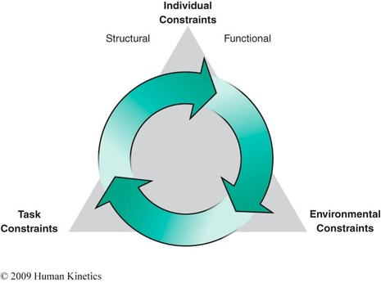

As I progressed through the sessions, I was more aware of how the task might be constraining the individual child’s ability to succeed and was able to adjust or adapt it suit their needs. I also gained more confidence myself in using the correct cues in order to help the children achieve their goals.

During the first cycle of sessions, where possible, I always set up at least two gardens. The first of which was an obstacle course where the children would have familiar items of equipment that they could use in order to develop and practise skills I had previously taught, such as throwing using a rainbow throw, jumping, hopping, balancing and using a range of ways to travel. To add challenge and to keep the children engaged I would add or change an activity within this garden each session. The children responded very well to the obstacle course gardens and as the sessions progressed, they became more independent using the equipment. On reflection of the obstacle course gardens it became apparent that a lot of the children had great difficulty in maintaining a balance and even those that could do a balance for a short time on one leg, weren’t able to balance on different body parts. Following on from my observations this became a focus for my adult led gardens and warm up games.

The other garden was an adult led garden in which they would be developing a specific locomotor or object control skill through games such as battleships, eggs and nests, washing day and teddy bears’ ball rolling. These activities often brought up individual constraints in that the children with additional needs or limited English in the class weren’t always able to follow the set of instructions, so games had to be broken down further and ‘taught’ step by step, sometimes over a few days. Working with smaller groups in the gardens gave me a better knowledge of the children’s abilities and meant I was able to set small achievable targets for them to work on. It allowed me to reflect in the moment and adjust the activities to suit the individual child. One garden that I found particularly interesting was the throwing garden completed in week two. On personal reflection as a parent and teacher, I assumed that all of children would be able to throw an object such as a soft ball or beanbag. I was amazed to see how many children in my class, particularly in Nursery weren’t able to release the object, which leads me to believe they have not yet integrated their Palmer reflex. With the help of my TA we had to go back and teach the children to intentionally release objects before they would be able to throw. I also used other pupils in the class as well as adults and older children to model and reinforce a good rainbow throw technique.

Due to a number of factors in school such as the weather, space and absences not all of the children have participated in every session. However this has not held us back and we have adapted activities to fit in any available space within the school. Despite the challenges and constraints, I could already see a difference in their attention span during these sessions and for the most part in the classroom when they return after a SKIP session and they were always eager to participate. “Something happens to attention, behaviour, and motivation when children and young people become active.” (Goddard Blythe, 2005:133)

Cycle Two

After reflecting on my first cycle of SKIP sessions I looked at the key locomotor and object control skills that needed to be developed further within the class. I was more confident in my approach to these sessions and was more conscious of and more able to identify the needs of the children and the stages of their locomotive and object control skills. Therefore, identifying their next steps and ultimately reacting and adapting the activities in the moment, which in turn boosted the child’s self-esteem and self-confidence in the task as they felt they were achieving. Fundamentally it meant that the sessions were accessible to all pupils no matter their needs or abilities. This had a positive impact in the sessions as the children were engaged and were excited to join in. As a significant number of children were still finding throwing activities difficult, I used this as a focus for my adult led gardens and integrated it into activities within the continuous provision in the classroom.

Conclusion

The SKIP course has significantly enhanced my understanding of the importance for children to have rich physical activity and the long-term implications when they have been deprived of it. The theory I have learned as part of this project has provided me with the knowledge I need to support and foster my children’s physical development and it has been fully embedded into our routines and practice within the early years class. I have now identified two key next steps to take this project further. My first is to invite the parents in to ‘stay and play’ sessions where they can come and join in with SKIP sessions with their child and learn different activities that they can try at home. I hope to share the children’s enthusiasm for SKIP with their parents and foster an enjoyment for physical activity that they will continue at home as part of their daily lives. I also hope to train support staff within my classroom to understand the benefits of physical activity and for them to co-deliver sessions with me so that we can provide more variety of skills opportunities within a session.

Reference list (Moodle reading)

Ayres, A. J., & Robbins, J. (2005). Sensory integration and the child: Understanding hidden sensory challenges. Western Psychological Services.
Clark, J. E., & Metcalfe, J. S. (2002). The mountain of motor development: A metaphor. Motor development: Research and reviews, 2(163-190), 183-202.
Gallahue, D., Ozmun, J. and Goodway, J. (2012). Understanding motor development: Infants, children, adolescents, adults. 7th ed. New York: McGraw Hill Higher Education.
Goodway, J.D. & Branta, C.F. (2003). ‘Influence of a motor skill intervention on fundamental motor skill development of disadvantaged preschool children’, Research Quarterly for Exercise and Sport, 74(1), 36-46.
Goodway, J.D., Crowe, H. & Ward, P. (2003). ‘Effects of Motor Skill Instruction of Fundamental Motor Skill Development’, Adapted Physical Activity Quarterly, 20(3), pp. 298-314.
Haywood, K. M., & Getchell, N. (2019). Life span motor development. Human kinetics.
Seefeldt, V. (1980). Developmental motor patterns: Implications for elementary school physical education. Psychology of motor behavior and sport, 36(6), 314-323.
Stodden, D. F., Goodway, J. D., Langendorfer, S. J., Roberton, M. A., Rudisill, M. E., Garcia, C., & Garcia, L. E. (2008). A developmental perspective on the role of motor skill competence in physical activity: An emergent relationship. Quest, 60(2), 290-306.

