Student name: Isaac Owen Saer
P Number: 2501869
Programme of Study: Graphic Design BA (Hons)
Module: Ways of Perceiving (ADDA4023/C)

Task: Curate an Exhibition – 1451 Words

For this assessment, I confirm that I have not used Generative AI to support me in structuring my submission, including creating a draft argument structure, identifying parts and headings. I confirm that I have not used Generative AI to create text for my submission. I confirm that I have not used Generative AI for creative materials, such as images.

The Significance of Colour in a Grey World
This exhibition has been curated to show how, in a world where uniformity and dullness are increasingly normalised—whether through urban concrete landscapes, minimalism, or emotional desensitisation—colour emerges as a powerful agent of disruption, communication, and meaning. The Significance of Colour in a Grey World is an exhibition that explores how artists and designers have used colour not only for aesthetic purposes, but as a language for expression, resistance, identity, and perception. Rather than treating colour as a purely aesthetic feature, this exhibition positions it as something that shapes meaning and experience. As Josef Albers observes, “in visual perception a color is almost never seen as it really is” (Albers, 1963, p. 27), reminding us that colour is relational and context dependent. Building on this idea, the exhibition considers how artists use colour to create feeling, signal identity, challenge systems, and change perception.
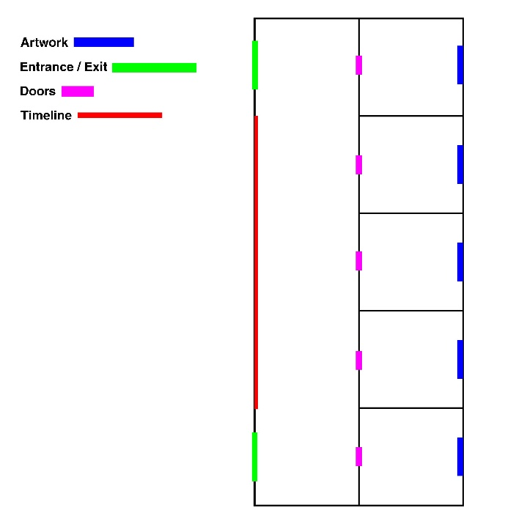
Fig 1, (Saer, 2026, The Significance of Colour in a Grey World Floorplan)
The structure of the exhibition will be five closed rooms, allowing visitors to be immersed in five distinct environments. Rooms are designed to symbolise each piece: dimmed, warm lighting for Rothko to encourage contemplation, a darker, quieter, dimly lit space for Picasso, a neutral setting for Dass, a bold and graphic environment for the Guerrilla Girls, and a softly lit, atmospheric space for Monet.
A central corridor runs parallel to the rooms, featuring a timeline of colour theory (Newton, Goethe, Albers), providing academic context for the works and referencing key developments in both scientific and perceptual understandings of colour (Goethe, 1840; Itten, 1970).
While occasional references can be made to broader movements such as Modernism and later contemporary practices, the primary focus remains on how colour is experienced and understood by the viewer. This ensures that the exhibition remains accessible, while still grounded in theory.
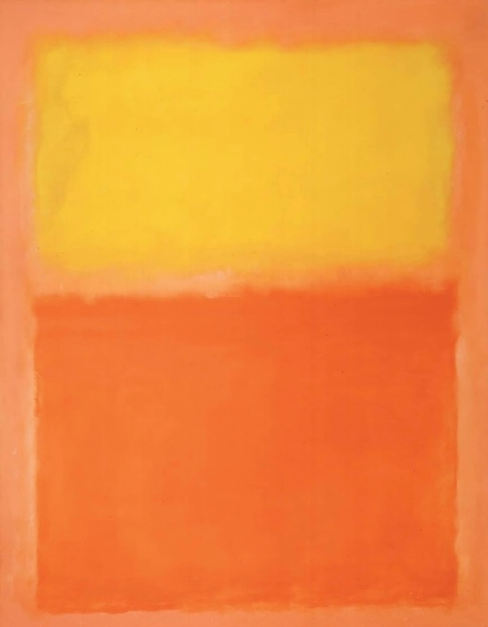
Fig 2, (Rothko, 1956, Orange and Yellow)
The opening section of the exhibition explores how colour operates as an emotional language, capable of communicating feelings beyond words. Mark Rothko’s Orange and Yellow (1956) demonstrates how colour can function as a direct emotional experience. Composed of large, softly edged rectangles luminous in colour, the painting immerses the viewer in warm tones, evoking an emotional response, rather than being merely observed.
Not simply depicting recognisable forms, "Rothko utilized vast fields of color to create immersive, contemplative experiences" (Gage, 1999, p. 9). The relationship between orange and yellow creates a sense of intensity and stillness simultaneously, encouraging prolonged contemplation. Rothko sought to convey fundamental human emotions, particularly intense and existential states.
Although often associated with late Modernist abstraction, the significance of this work lies less in its stylistic category and more in its ability to transform colour into an immersive, emotional environment for the viewer.
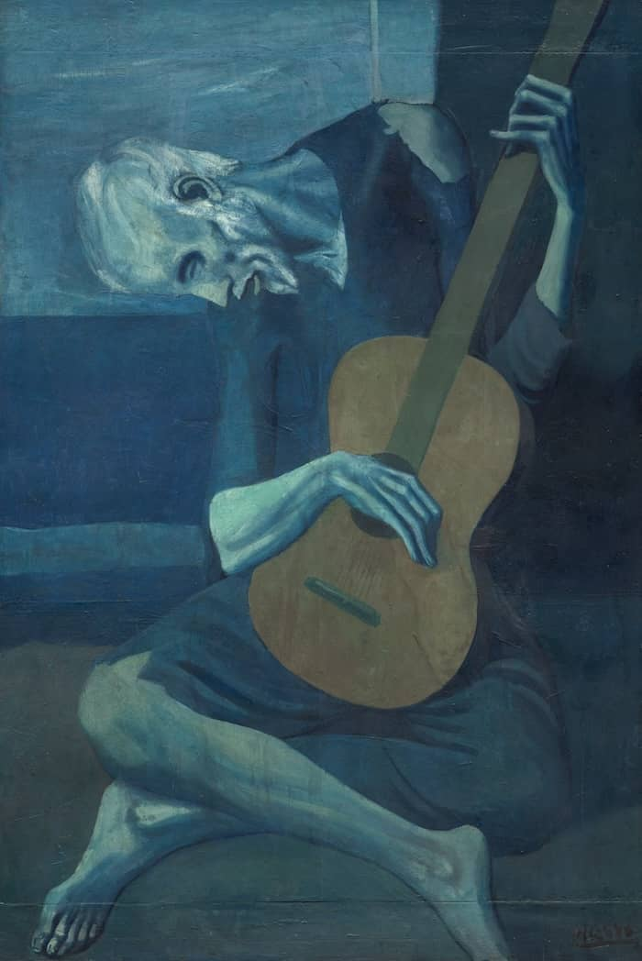
Fig 3, (Picasso, 1903-1904, The Old Guitarist)
Pablo Picasso’s The Old Guitarist reveals how the restriction of colour can be equally expressive. Painted during his Blue Period, the work is dominated by cool blue tones that represent isolation, poverty, and misery. The restricted palette intensifies the emotional impact, as “Color is the most relative medium in art” (Albers, 1963, p. 92), emphasising how even limited colour can affect psychological response.
The figure appears thin and stretched, heightening a feeling of physical and emotional fragility, completing the portrayal of human suffering. The otherwise cool blue palette is interrupted only by the brown guitar, which brings a slight warmth to the painting and draws the eye. Although still dark in tone, this subtle contrast demonstrates how small colour shifts can influence interpretation and direct the viewer’s focus.
This work is in contrast to Rothko’s, showing that colour’s significance lies not only in vibrancy but also in its absence.
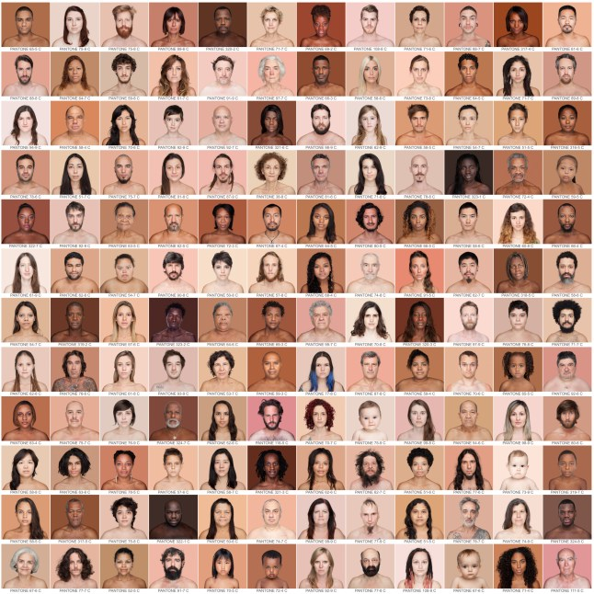
Fig 4, (Dass, 2012-ongoing, Humanae)
Angelica Dass's Humanae explores colour as a direct, socially engaged way of representing identity. The project consists of a large series of photographic portraits in which each subject's skin tone is paired to a matching Pantone background colour. This method removes the concept of racial or hierarchical classifications and instead presents human skin as part of a continuous colour spectrum.
Dass challenges socially constructed ideas of race and difference by transforming skin colour into a standard colour code. The portraits emphasise subtle tonal variations, prompting viewers to reevaluate their assumptions of identity and classification. In this context, colour serves as both a visual and conceptual tool, revealing how colour meaning is shaped through linguistic and cultural systems (Berlin and Kay, 1969)
The Pantone system is especially significant as it stems from commercial design and global standardisation. By using it on human skin, Dass shows how systems of classification can both help and hurt understanding. This change from subjective perception to coded classification highlights the conflict between being unique and being put into groups.
The same neutral expression, direct gaze, and framing in each portrait purely emphasise the colour. This repetition strengthens the argument that identity is not fixed or binary but rather exists within a wide and intricate spectrum. The work also reflects broader contemporary concerns with representation and inclusivity, as Batchelor wrote, “colour has been the object of extreme prejudice in Western culture” (Batchelor, 2000, p. 22).
Unlike the expressive or symbolic use of colour in painting, Humanae employs colour analytically and systematically. It turns colour into a language of equality, where differences are recognised without hierarchy. The work highlights the social and political dimensions of colour, which strengthens its role as a powerful tool for shaping how people see and understand their own identities.
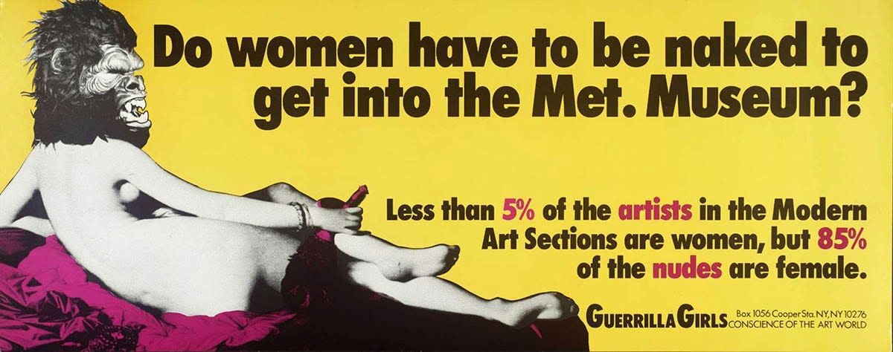
Fig 5, (Guerrilla Girls, 1989, Do Women Have To Be Naked To Get Into The Met. Museum?)
The Guerrilla Girls' poster demonstrates how colour can be used to protest and perform visual activism. The contrast between a bright yellow background and sharp black text creates an immediate visual impact, bringing attention to the subject matter, gender inequality in the art world.
The high-contrast colours are similar to those used in advertising and mass communication, which makes the message clear and direct. The work doesn't use colour as emotional expression; instead, it uses it strategically to draw attention and encourage a sense of urgency. This method aligns with the broader changes in art in the late 20th century that aimed to reach more people and to question institutional power structures (Foster, 1996). The poster highlights that colour can be used for more than just decoration; it can also be a means to criticise societal norms and political intervention.
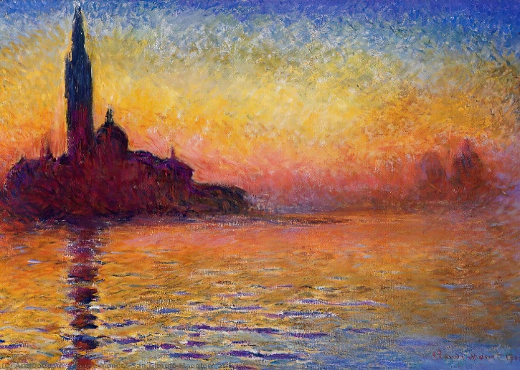
Fig 6, (Monet, 1908-1912, San Giorgio Maggiore at Dusk)
Claude Monet's San Giorgio Maggiore at Dusk (1908–1912) shows colour as something that changes with light and time. Monet painted this while he was in Venice. The painting shows how the colours change at dusk. By using soft violets, blues, and warm oranges. Monet doesn't show a fixed view of the buildings; rather, he blends the outlines of the buildings into the surrounding colour, letting light and atmosphere take centre stage.
The blurry layers of colour give the painting depth, not through use of lines; instead, by use of tonal variation. The church's silhouette slowly becomes clear against the colours around it, demonstrating how we see things, depends more on contrast and small colour differences, than on clear lines. This fits with the idea that colour is relational and influenced by its context (Albers, 1963).
Monet's brushwork is still loose and flowing, which supports the idea that the scene is fluid and constantly evolving. The colours shift from warm to cool, suggesting the transition from day to night and highlighting how perception is always changing. Arnheim writes
“Rather, in looking at an object, we reach out for it. With an invisible finger we move through the space around us, go out to the distant places where things are found, touch them, catch them, scan their surfaces, trace their borders, explore their texture. Perceiving shapes is an eminently active occupation.” (Arnheim, R. 1974, p. 43)
Monet's painting necessitates that the observer visually reconstructs the scene from these disjointed impressions.
The Significance of Colour in a Grey World intends to demonstrate that colour is a dynamic and complex element of visual culture. Through five carefully selected works, the exhibition reveals how colour can evoke emotion, signify identity, challenge power structures, and transform perception. In contrast to centring on a single historical narrative, the exhibition emphasises the lived and sensory experience of colour. It shows that colour is never neutral; it is shaped by context, meaning, and interaction, as widely discussed in both art historical and scientific studies of colour (Gage, 1993; Albers, 4 1963). In a world that often feels visually and emotionally muted, this exhibition invites viewers to reconsider colour as a powerful and transformative force.

Bibliography
Albers, J. (1963) Interaction of Color. New Haven: Yale University Press. Available at: Interaction of color : text of the original edition with selected plates (Accessed: 14 April 2026).
Arnheim, R. (1974) Art and Visual Perception: A Psychology of the Creative Eye. Berkeley: University of California Press. Available at: Arnheim_Rudolf_Art_and_Visual_Perception_1974.pdf (Accessed: 25 April 2026).
Batchelor, D. (2000) Chromophobia. London: Reaktion Books. Available at: Chromophobia → David Batchelor (Accessed: 16 April 2026).
Berlin, B. and Kay, P. (1969) Basic Color Terms: Their Universality and Evolution. Berkeley: University of California Press. Available at: Color Terms: Universality and Evolution | PDF | Lexicon | Human Communication (Accessed: 16 April 2026).
Foster, H. (1996) The Return of the Real. Cambridge, MA: MIT Press. Available at: Foster_Hal_The_Return_of_the_Real_1996.pdf (Accessed: 23 April 2026).
Gage, J. (1999) Color and Meaning: Art, Science, and Symbolism. Berkeley: University of California Press. Available at: Color and Meaning (Accessed: 14 April 2026).
Goethe, J.W.V. (1810) Goethe’s Theory of Colours. Translated by C. Eastlake (1840). London: Project Gutenberg. Available at: Goethe's theory of colours : Johann Wolfgang von Goethe : Free Download, Borrow, and Streaming : Internet Archive (Accessed: 14 April 2026).
Itten, J. (1970) The Elements of Color. New York: Van Nostrand Reinhold Company. Available at: The Elements of Color (Accessed: 14 April 2026).
List of Figures
Dass, A. (2012- Ongoing) Humanae. Available at: Angélica Dass's Humanae project proves colour isn't just 'black and white' | Metro News (Accessed: 16 April 2026).
Guerrilla Girls (1989) Do Women Have To Be Naked To Get Into the Met. Museum?. Available at: The Rise of the Women Movement: 7 Feminist Art Pieces You Should Know | TheCollector (Accessed: 23 April 2026).
Monet, C. (1908–1912) San Giorgio Maggiore at Dusk. Available at: San Giorgio Maggiore at Dusk by Claude Monet - Art Print – Zapista (Accessed: 25 April 2026).
Picasso, P. (1903–1904) The Old Guitarist. Available at: The Power of Colour: How Artists Use It to Tell Stories (Accessed: 14 April 2026).
Rothko, M. (1961) Orange and Yellow. Available at: The Power of Colour: How Artists Use It to Tell Stories (Accessed: 14 April 2026).
Saer, I. (2026) The Significance of Colour in a Grey World Floorplan.

