Steffan Wilkins
2101242
Computing (Games Development)
Graphics and Games Programming
ACCA6021

Contents
Task 1 3
Task2 9
Appendix 10
References 10
Code 10

Task 1

For an object to be rendered within a computer it must begin as a 3D model a “graphics pipeline is the process of turning that 3D model into what the computer displays.”[1] The first step of the pipeline is to set an object into local space, where the object's coordinates are set to its local origin. In this stage, an object can be rotated in local space which has a different effect than when it's rotated in world space. During this stage, if a complex shader is used when converted into world space or if many objects are created at once this could slow down the vertex processing, the way to solve this is by using modern GPUs that “have a small first in, first out cache”,[2] this will allow for many transformation vertices that are used a lot to be quickly retrieved to speed up processing time.
The world space is the next stage of the graphics pipeline as it's the first stage to be contextualised with the viewpoint and other objects. Without this stage, all objects will be located in the same space, when a model matrix is applied to the object in local space it is then moved via rotations, translations or scaling that is required. In world space, many actions may still be applied to an object such as translation rotations and scaling, when these are conducted in world space they are all centred on the origin of the world, this mainly impacts rotations as instead of the object rotating around itself it will move around the world origin. The main bottleneck for calculation in world space arises when complex geometry transformations occur, or when an object that's being transformed has a high polygon count as the amount of points that need to update increases making processing time longer. Ways to prevent these problems are to make sure to use efficient geometry data structures to speed up calculations.
In the next stage, a view matrix is applied to the object in world space so that the object can be seen from the point of view of the camera or viewpoint, this is done by using the viewpoint location along with its look at point to determine the direction the camera is looking, then the cameras upwards orientation is used to determine its orientation.[3] In this stage when an object needs to be displayed in front of the viewpoint the whole world coordinates are transformed and rotated to allow that. There a many issues that can occur during the view space stage such as rendering high polygon models at a large distance making the workload larger without being able to experience the benefits, a solution to this is commonly done by using several models that are made for different ranges becoming simpler and less defined over time. Another problem found during view space is having too many objects rendered at once whilst performing a rotation calculation or translation calculation. A way to lower the workload of this is to make sure to have an effecting culling frustum.
The stage of the graphics pipeline where you obtain the normalized device coordinates of an object is when you apply the projection matrix. The way a projection matrix is obtained is by using the camera’s field of view and the aspect ratio of the desired window, alongside the distance of the closest and farthest planes. What this matrix does is create the effect of an object getting smaller the further it is away allowing for realistic depiction of space.

- In this image, I am translating my vertex by using my translation matrix within world space.
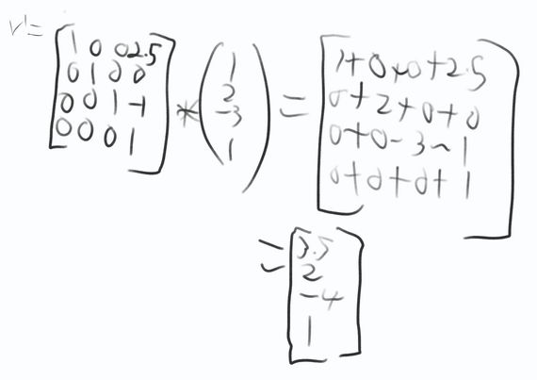

In the image below I am taking the vector that I created from the first image and I'm rotating it around the x-axis by 30 degrees.

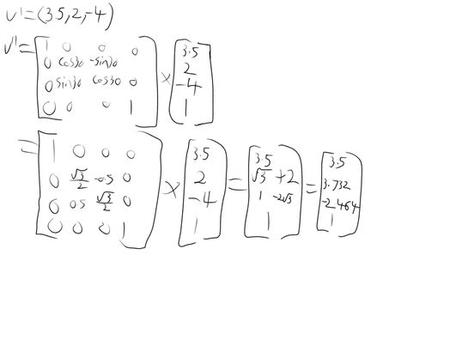
2. In this image I am taking the viewpoint vector and subtracting it from the look-at point. Once that is complete I normalise the result to obtain the forward vector. With the forward vector of the camera, I then do a cross-product with the opposite forward vector and an estimated upward vector, which I then normalize to create the side vector.
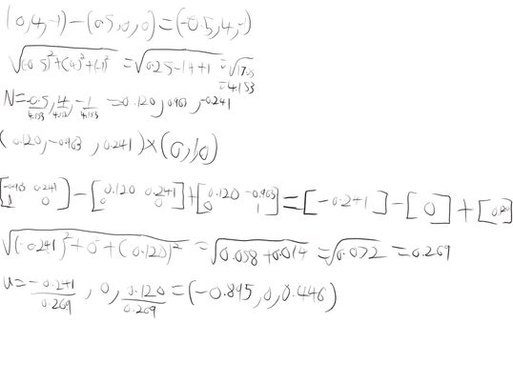
Once I obtain the side vector I then do another cross-product with the side vector and the negative forward vector which I again normalize to obtain the up vector. Once the three vectors are calculated I create a look-at matrix by multiplying the rotations in the camera by the inverse camera position in the world.
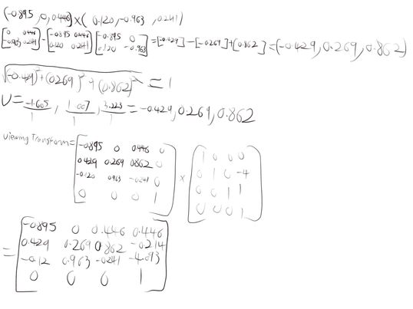
Then I multiplied my look-at matrix with my vertex in world space to transform it into view space.
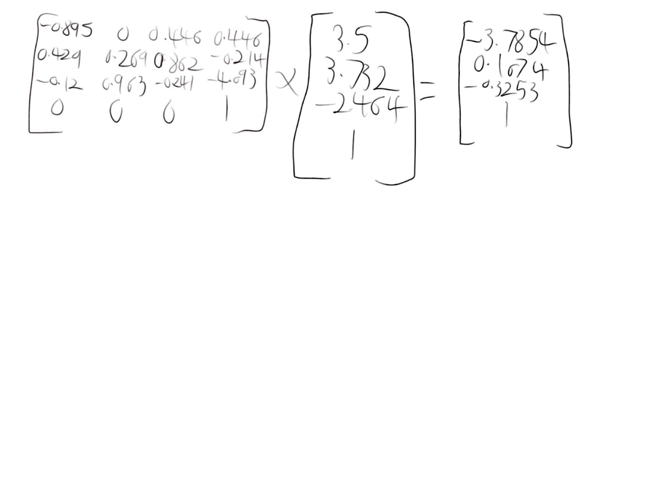

3. In this Image I am creating the value needed to create a perspective matrix. The value q is calculated by inverting the tan of the field of view halved, and A is calculated by dividing the value q by the aspect ratio, B is calculated by dividing the sum of the distance from the far plain and the distance from the near plain against the distance of the near plain subtracted by the far plain. C is calculated by dividing the twice the sum of the distance from the far plain and the distance from the near plain against the distance of the near plain subtracted by the far plain.
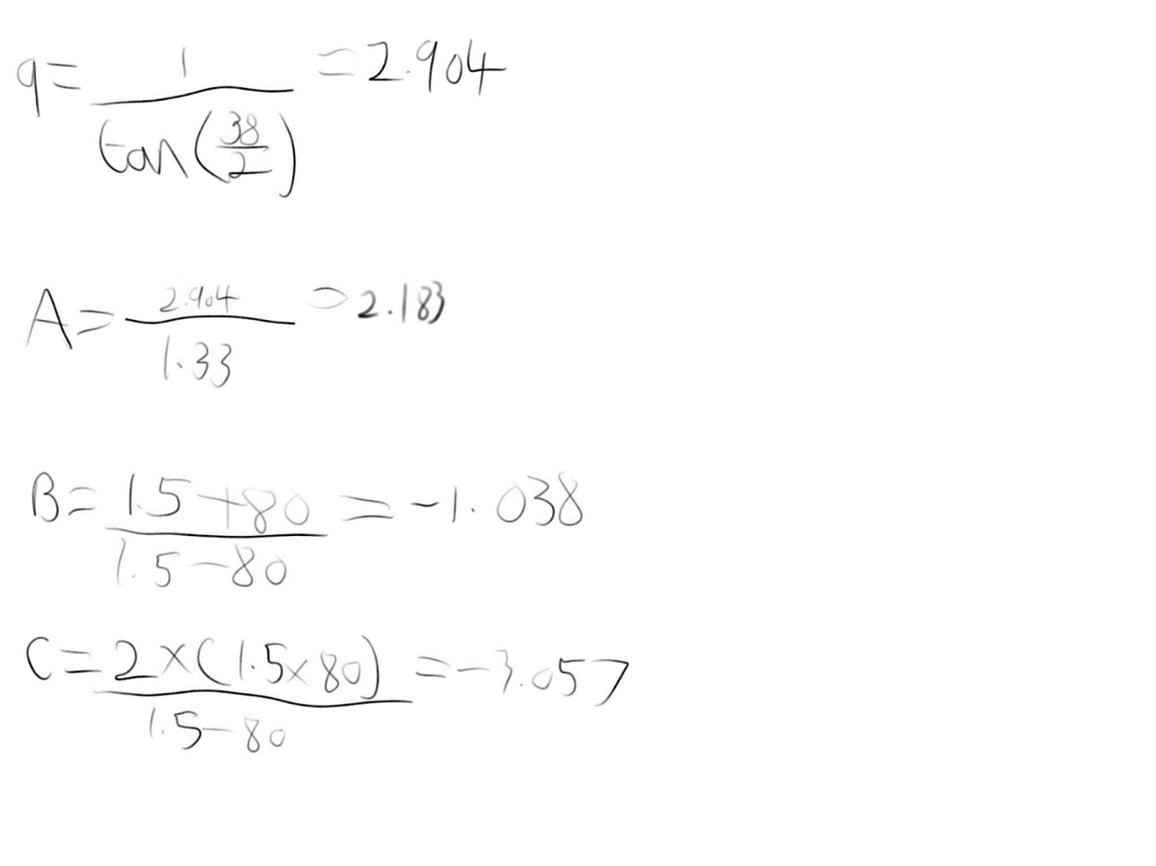
In this image, I put the values into the perspective matrix which I can then multiply by the vertex in view space to get the vertex into perspective space.
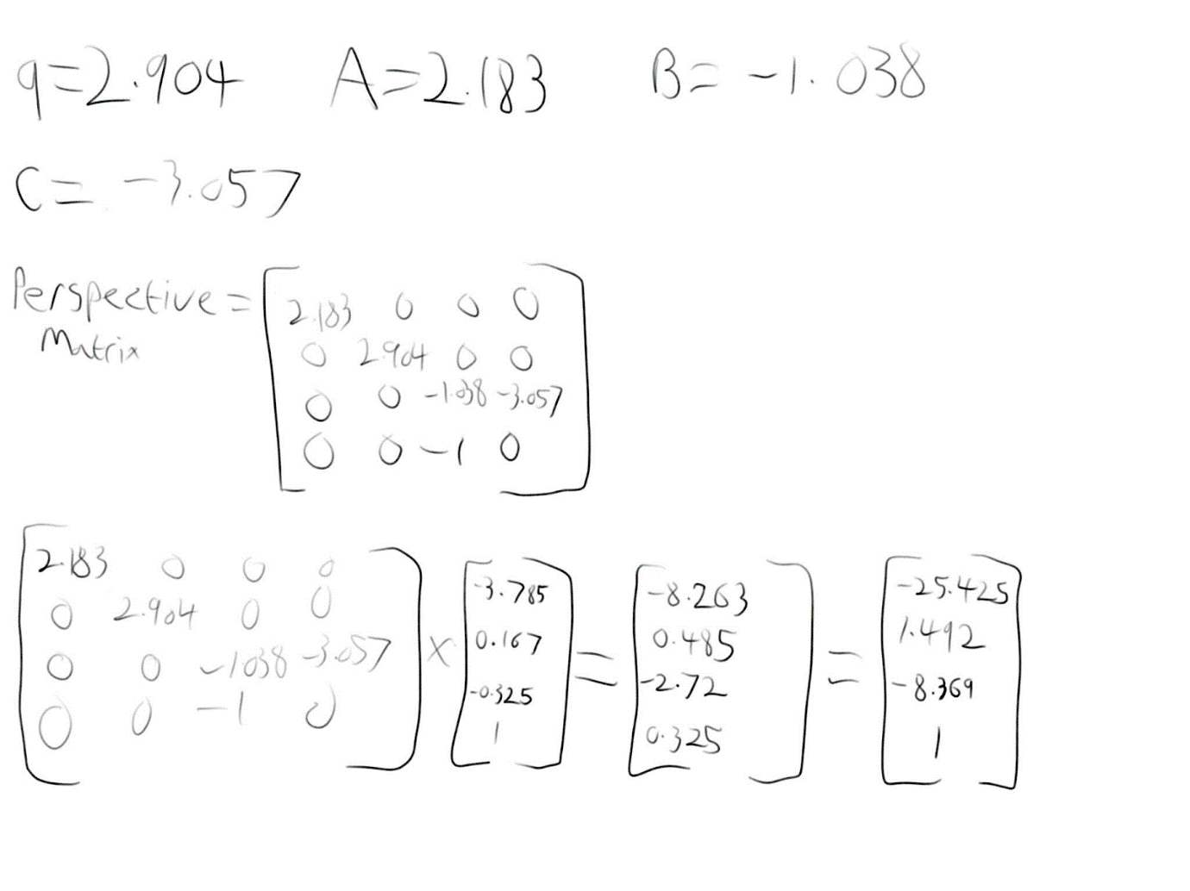

When calculating my vertex in screen space I received a result of (-25.425, 1.492, -8.369, 1). I believe this will not be within the view volume as with a viewpoint of (0, 4, -1), and a look at point of (0.5, 0, 0), the camera will be facing positively in the x-axis, negatively in the y-axis and positively in the z-axis. This would mean that my vertex is located in the opposite direction where the camera is facing

Task2

.
When determining if the vertex should be culled, I made several assumptions. My first assumption was that the object was not large enough to change the result. Another assumption is that the culling plane represented the near plane because the distance between P0 and the viewpoint isn’t close to being the distance from the far plane of 80, this will change how the result is interpreted. From the vertex into the plane equation, I have calculated the distance as +12, from this result I have determined that the vertex has not been culled.

Task 2
In this image, I calculate the distance and the orientation of the vertex against the culling plain.
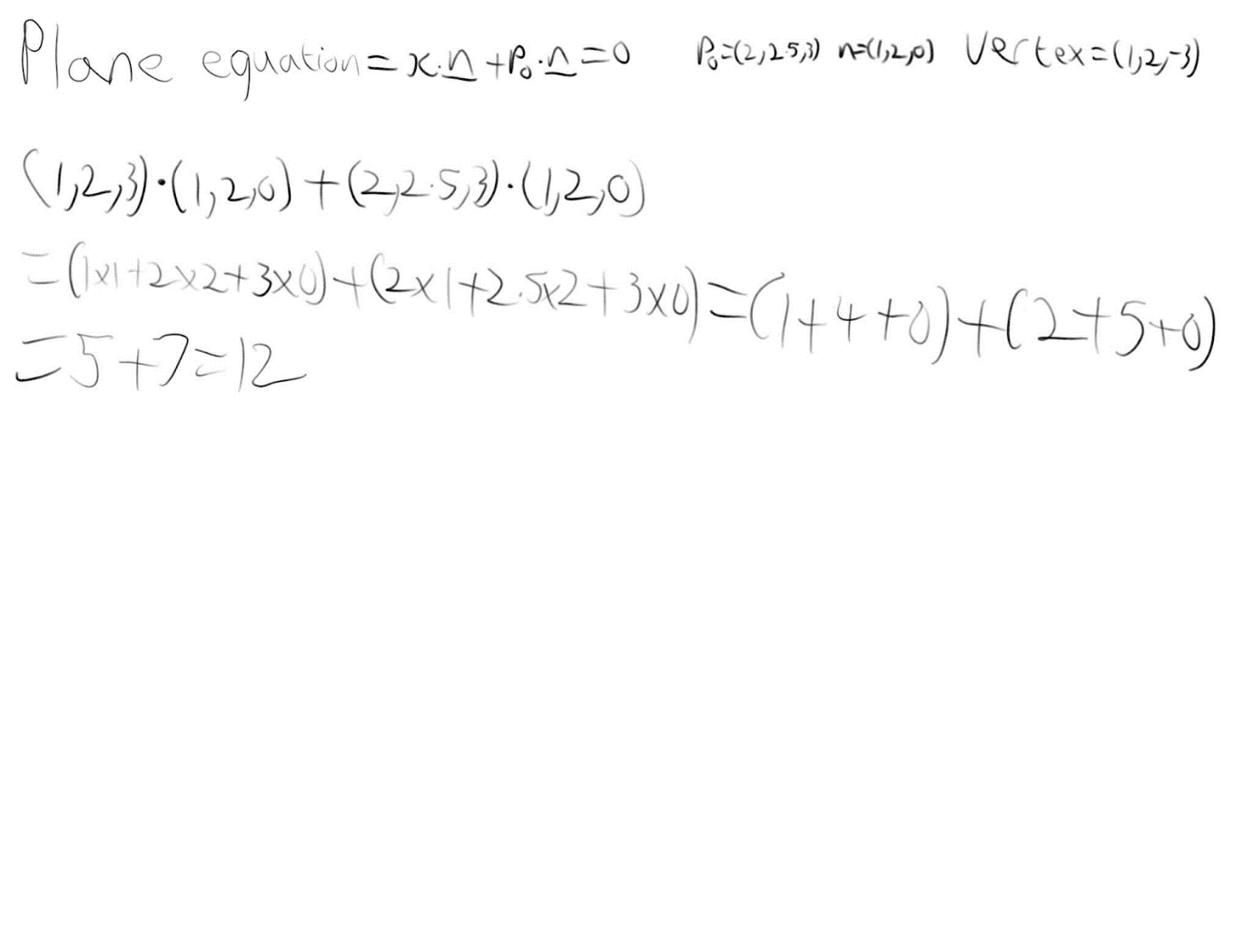

Appendix

References

[1] Jack, “Graphics pipeline”, Medium, Nov. 17, 2022. [Online] Available: https://medium.com/@rakadian/graphics-pipeline-9e4bb2d28f58 [Accessed Nov. 14, 2022]
[2] C. Cebenoyan, “Chapter 28. Graphics Pipeline Performance”, Nvidia Developer, [Online] Available: https://developer.nvidia.com/gpugems/gpugems/part-v-performance-and-practicalities/chapter-28-graphics-pipeline-performance#:~:text=Modern%20GPUs%20have%20a%20small,done%20earlier%20in%20the%20pipeline. [Accessed Nov. 14, 2022]
[3] “Coordinate Systems”, Learnopengl, [Online] Available: https://learnopengl.com/Getting-started/Coordinate-Systems#:~:text=By%20convention%2C%20OpenGL%20is%20a,through%20your%20screen%20towards%20you. [Accessed Nov.17, 2022]

Code

#include "GL/glew.h"
#include <math.h>
#include "glm/glm.hpp"
#include "GLFW/glfw3.h"
#include <iostream>
#include "glm/ext.hpp"
#include "./glm/gtx/string_cast.hpp"

int main(void) {

glm::vec4 Vertex(1.0, 2.0, -3.0, 1.0); // Creating the Vertix point with the homogeneous cord

glm::mat4 Transform = glm::translate(glm::mat4(1.0f), glm::vec3(2.5f, 0.0f, -1.0f)); // Creating a tranformation matrix
glm::vec4 Vi = Transform * Vertex; // Translate the vertex
glm::mat4 Vertex1 = glm::mat4(Vi, glm::vec4(0.0f), glm::vec4(0.0f), glm::vec4(0.0f));
float theta = glm::radians(30.f); // Turning the andle from degrees to radians

glm::mat4 Rotation = glm::rotate(glm::mat4(1.0f), theta, glm::vec3(1.0f, 0.0f, 0.0f)); // Creating a roatation matrix
glm::mat4 Vii = Rotation * Vertex1;// Rotating the vertex

glm::vec3 CameraPoint(0, 4, -1); //Sets the viewpoint of the camera
glm::vec3 LookAtPoint(0.5, 0, 0); //Sets the point where the camera will be looking at
glm::vec3 UpVector(0, 1, 0); // Sets the up vector for the camera

glm::mat4 ViewSpace = lookAt(CameraPoint, LookAtPoint, UpVector); //Creats a viewing transformation based on the location and the rotation of the camera
glm::vec4 ViewableVertex = ViewSpace * Vii; // This applys the viewing tranformation to the Vertex

float FOV = glm::radians(38.0f); //Converts FOV into radians from degrees
float NearPlaneDis = 1.5; // Distance from the camera to the close plane
float FarPlaneDis = 80; // Distance from the camera to the far plane

//This was me trying to calulate the aspect ratio as i was unsure what it was. I eventually went with 1.33 as its the one ive seen in class
//float DisToLookAt = glm::distance(CameraPoint, LookAtPoint);
//float HalfWidth = tan(FOV / 2) * NearPlaneDis;

glm::mat4 PerspectiveMat = glm::perspective(FOV, 1.33f, NearPlaneDis, FarPlaneDis); //Build a perspective matrix
glm::vec4 VertexInViewport = PerspectiveMat * ViewableVertex; //Applies Perspective matrix to the Vertex in View space

VertexInViewport = VertexInViewport / VertexInViewport.w; // Sets the homogenous to 1

glm::vec3 p0(2.0, 2.5f, 3.0f); //Point on the plane
glm::vec3 n(1.0f, 2.0f, 0.0f); // Normal of the plane
glm::vec3 V(1, 2, -3); //Vertext given in Appendix 1

float DisToPlane = glm::dot(V, n) + glm::dot(p0, n); //Equation of the given line

std::cout << "Vertex after trasnsformation: " << glm::to_string(Vi) << std::endl;
std::cout << "Vertex after Rotation: " << glm::to_string(Vii) << std::endl;
std::cout << "Vertex in view space: " << glm::to_string(ViewableVertex) << std::endl;
std::cout << "Vertex in screen space: " << glm::to_string(VertexInViewport) << std::endl;
std::cout << "Distance form Vertex to plane: " << DisToPlane << std::endl;

return 0;
}

